Supplementary Information

Suppl. Fig.1: Dot-blot hybridisation assay in Ae. speltoides derived lines viz., Sel. 2427 & Easy Thresh using digoxigenin-labelled Ae. speltoides DNA as probe

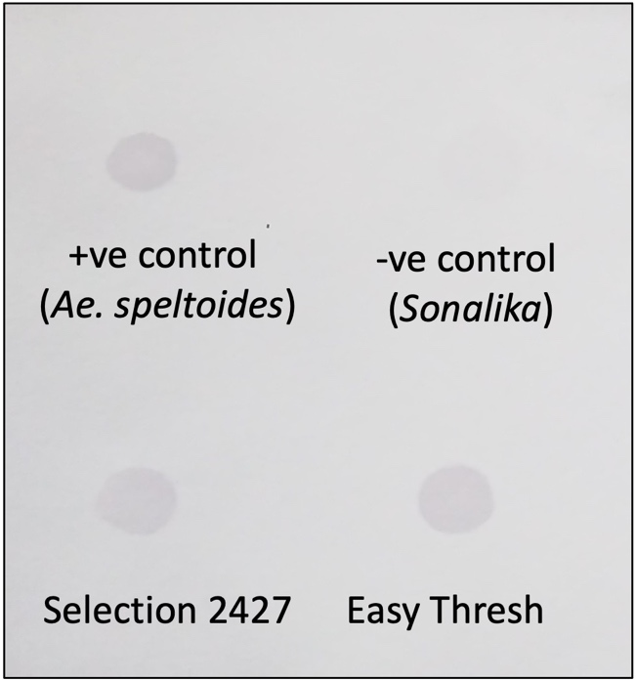

Suppl. Fig. 2: PMCs of mutants and their F₁ generation showing normal 21 bivalent configurations (a) T300-67-6-4; (b) F1(HD2932 X T300-67-6-4); (c) T300-67-12-1; (d) F1(HD2932 X T300-67-12-1); (e & f) T300-67-113-17; (g & h) F1(HD2932 X T300-67-113-17)

Suppl. Fig. 3: The mapping population F₂ (Agra Local X Sel. 2427) (a) Out of 700 F2 seeds, 519 plants survived and (b) only 496 plants reached the spike emergence stage. Frequency distribution of the population for traits (c) Pollen fertility (%) (d) Average seed set per spike (e) Seed shrivelling index (f) Percentage of empty spikelets. QTL analysis and candidate gene identification for (g) average seed set per spike & percentage of empty spikelets (h) seed shrivelling index.

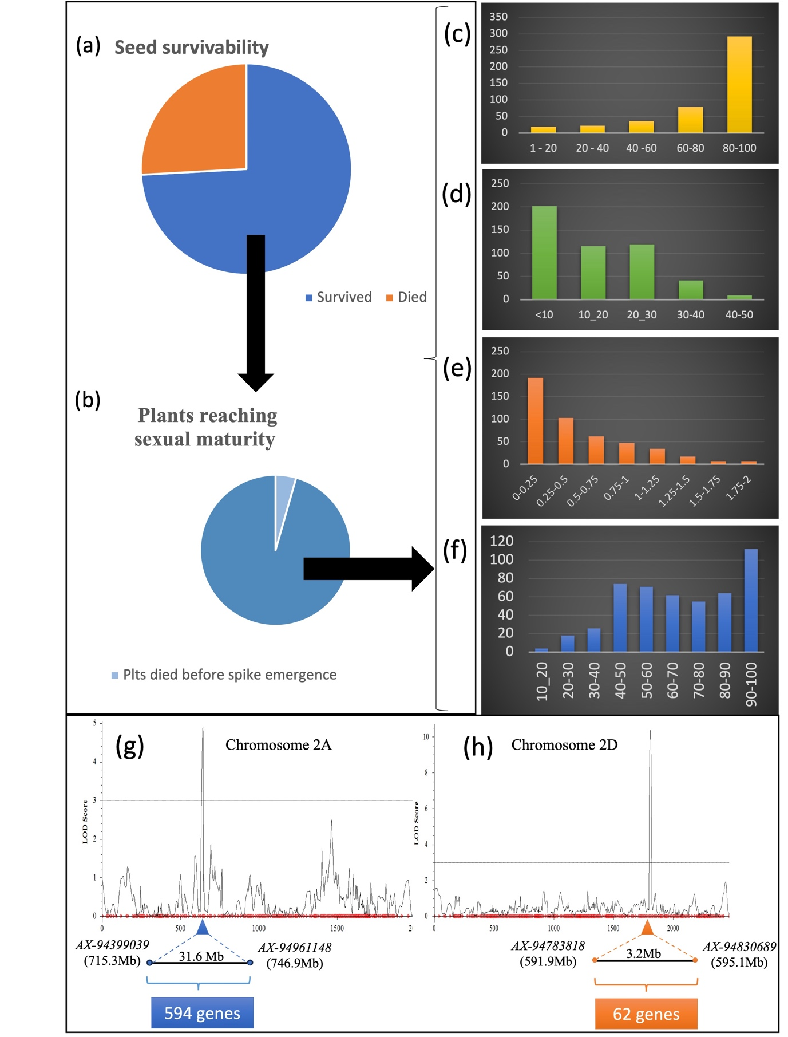

Suppl. Table1: ANOVA of average seed set per spike for RBD analysis
2020-21
Sources of variation | Df | SS | MS | F value
Replication | 2 | 138.16 | 69.08 | 3.39
Treatment | 199 | 233370.36 | 1172.72 | 57.50
Error | 398 | 8117.32 | 20.39
Total | 599 | 241625.85
2021-22
Sources of variation | Df | SS | MS | F value
Replication | 2 | 230.08 | 115.04 | 4.52
Treatment | 199 | 216520.76 | 1088.04 | 42.75
Error | 398 | 10130.04 | 25.45
Total | 599 | 226880.88

Suppl. Table2: ANOVA of empty spikelet percentage for RBD analysis
2020-21
Sources of variation | Df | SS | MS | F value
Replication | 2 | 98.10 | 49.05 | 1.09
Treatment | 199 | 179687.58 | 902.95 | 20.01
Error | 398 | 17959.48 | 45.12
Total | 599 | 197745.15
2021-22
Sources of variation | Df | SS | MS | F value
Replication | 2 | 57.84 | 28.92 | 0.40
Treatment | 199 | 160834.09 | 808.21 | 11.22
Error | 398 | 28681.39 | 72.06
Total | 599 | 189573.33

Suppl. Table3: ANOVA for F₂ mapping population in Augmented design
Source | df | SS | MS | F | Prob>F
Block (adj.) | 2 | 6.33 | 3.17 | 0.21 | 0.83
Treatment (adj.) | 487 | 61495.64 | 126.27 | 8.33 | 0.11
Among controls | 1 | 368.17 | 368.17 | 24.27 | 0.04
Among tests | 485 | 58207.22 | 120.01 | 7.91 | 0.11
Test vs control | 1 | 2920.25 | 2920.25 | 192.54 | 0.005
Error | 2 | 30.33 | 15.17

Suppl. Table 4: Number of PMCs showing different configurations in gamma mutants, their F₁s and control, Sel. 2427 & F₁(Sel. 2427 × AL)

Genotype/mutant | Number of PMCs observed | Number of PMCs with 21^{ll} | Number of PMCs with configuration other than 21^{ll}
T300-67-12-1 | 49 | 49 | 0
F₁(HD2932 X T300-67-12-1) | 20 | 20 | 0
T300-67-113-17 | 58 | 57 | 1 (${20}^{II}+2^{I}$)
F₁(HD2932 X T300-67-113-17) | 24 | 23 | 1 (${20}^{II}+2^{I}$)
T300-67-6-4 | 13 | 13 | 0
F₁(HD2932 X T300-67-6-4) | 15 | 12 | 3(${20}^{II}+2^{I}$)
F₁(HD2932 X T300-67-102-11) | 15 | 15 | 0
F₁(HD2932 X T300-67-64-60) | 15 | 15 | 0
Sel. 2427 | 28 | 21 | 7(${20}^{II}+2^{I}$, ${19}^{II}$+${1^{III}+1}^{I}$ , 19^{II}+1^{IV}, 20^{II}+1^{I}+1^{iso})
F₁(Sel. 2427 × AL) | 20 | 2 | 18 (20^{II} + 2^{I}, 17^{II} + 8^{I}, 20^{II}+1^{I}+1^{iso}, 18^{II}+3^{I}+1^{III})

