Supplementary materials

Table S1. Standard deviations for reference standards used at three stable isotope labs: Appalachians Stable Isotope Facility (AL), Chesapeake Biological Laboratory (CBL), and University of Florida (UF)

 | AL |  |  | CBL |  | UF
 | Porcine keratin | Cocoa | Caffeine | Casein | Acetanilide | USGS40 | USGS41a | UF Scute Standard
δ¹³C | 0.30‰ | 0.36‰ | 0.33‰ | 0.08‰ | 0.45‰ | 0.11‰ | 0.13‰ | 0.11‰
δ¹⁵N | 0.19‰ | 0.35‰ | 0.20‰ | 0.14‰ | 0.85‰ | 0.07‰ | 0.09‰ | 0.07‰

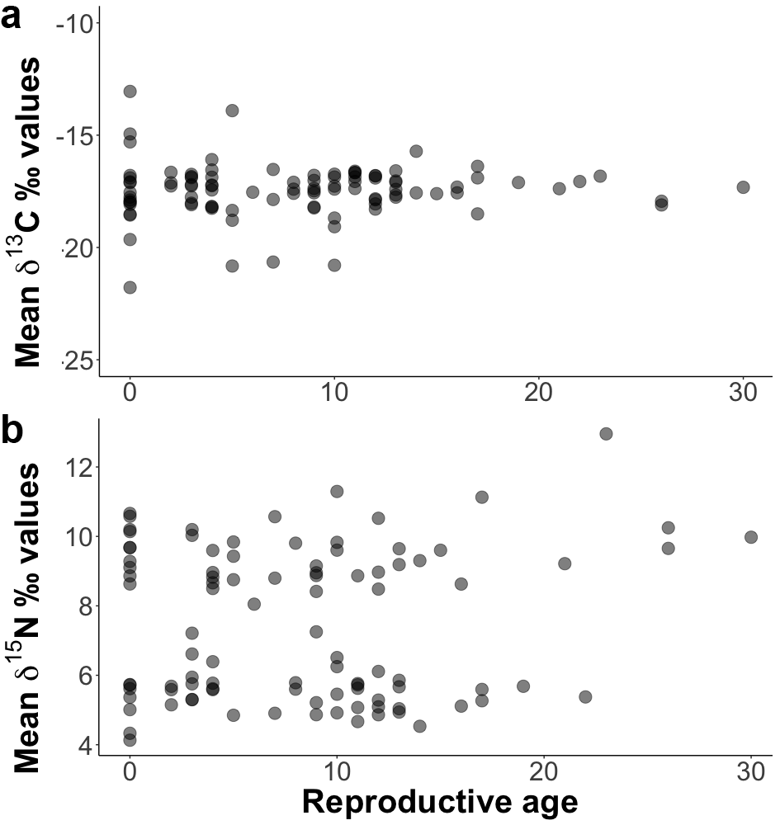
Fig. S1. Reproductive age and a. mean δ¹³C and b. mean δ¹⁵N values of sampled adult female hawksbills

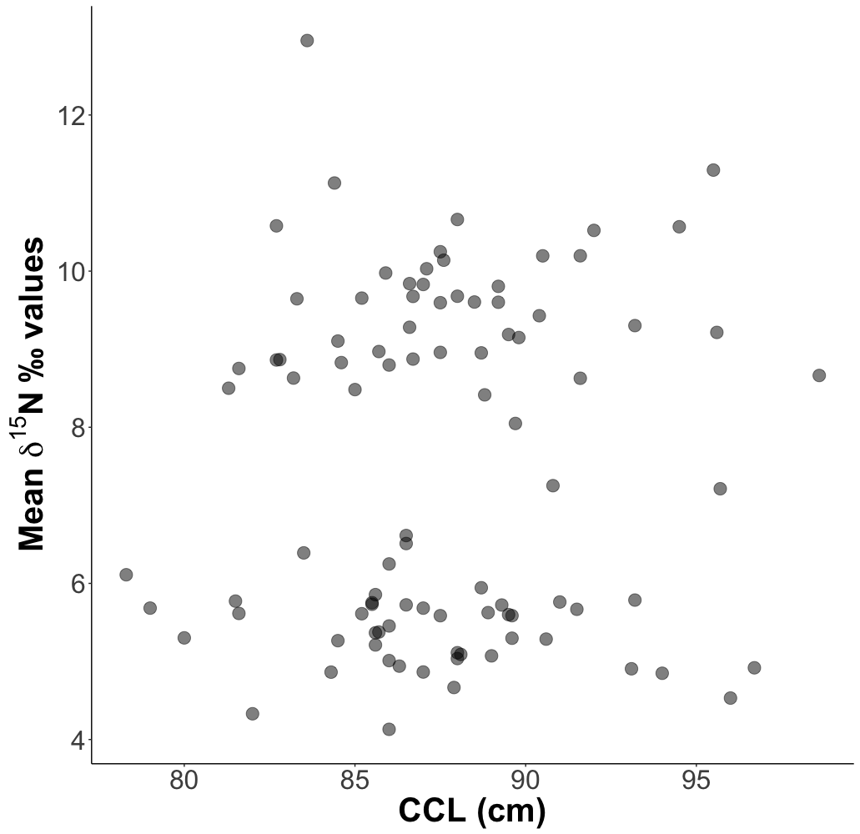
Fig. S2. Curved carapace length (CCL) and mean δ¹⁵N values of sampled adult female hawksbills

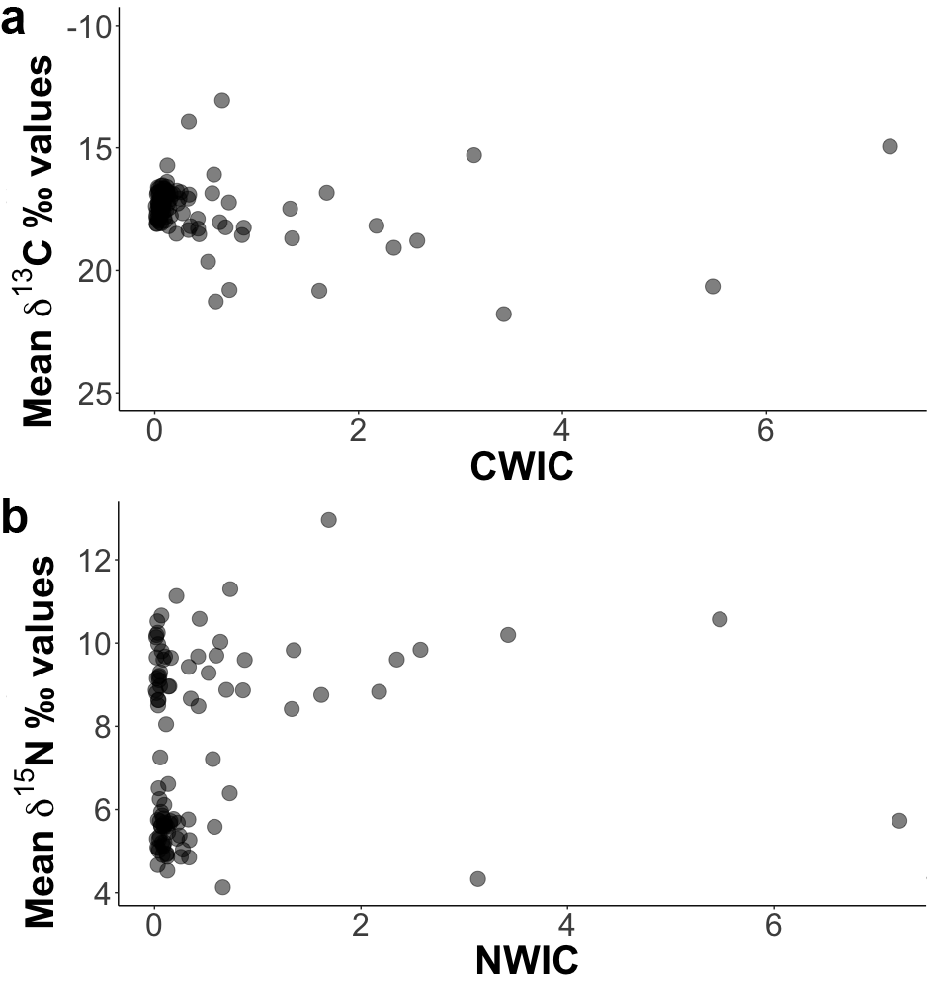
Fig. S3. a. Mean δ¹³C values and CWIC and b. mean δ¹⁵N values and NWIC of sampled adult female hawksbills
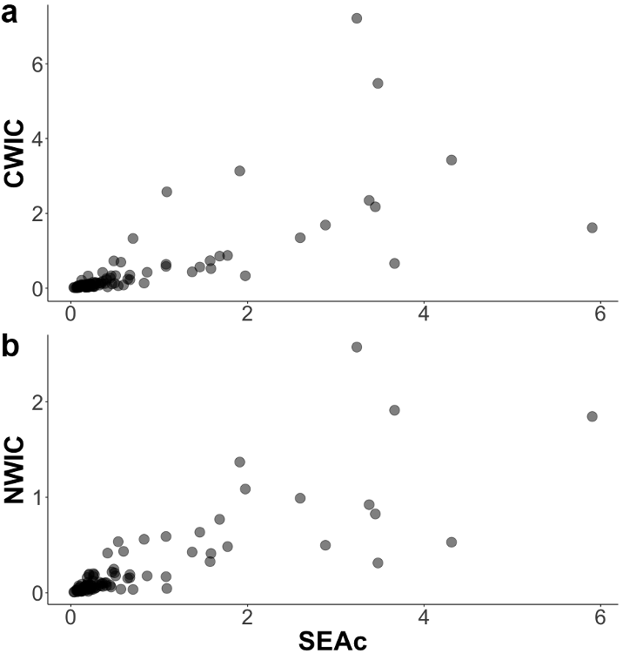
Fig. S4. Relationships between the three niche width metrics: SEAc and a. CWIC and b. NWIC
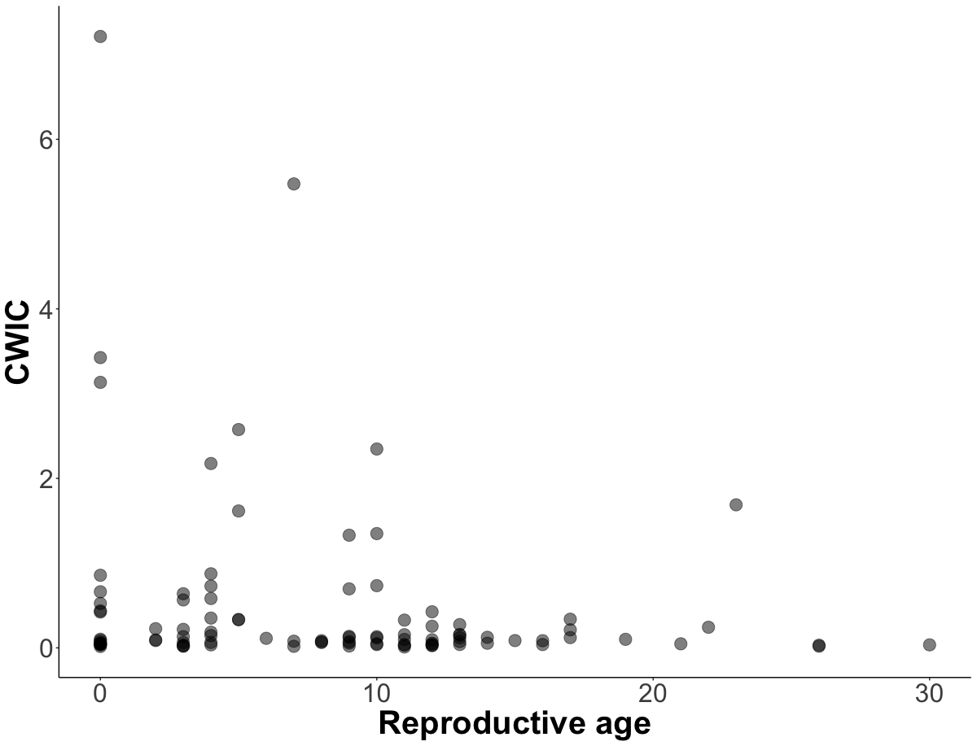
Fig. S5. Relationship between reproductive age and CWIC.

