Supplemental figures
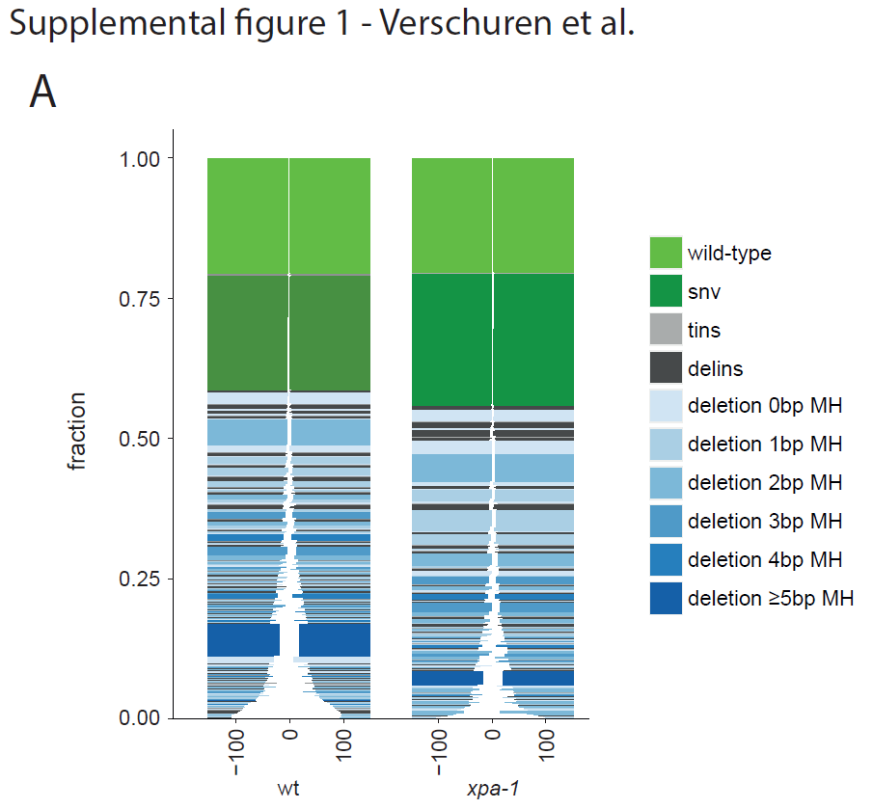
Supplemental figure 1. A) Tornado plot representing the mutational spectrum for wild-type and xpa-1 mutant animals.
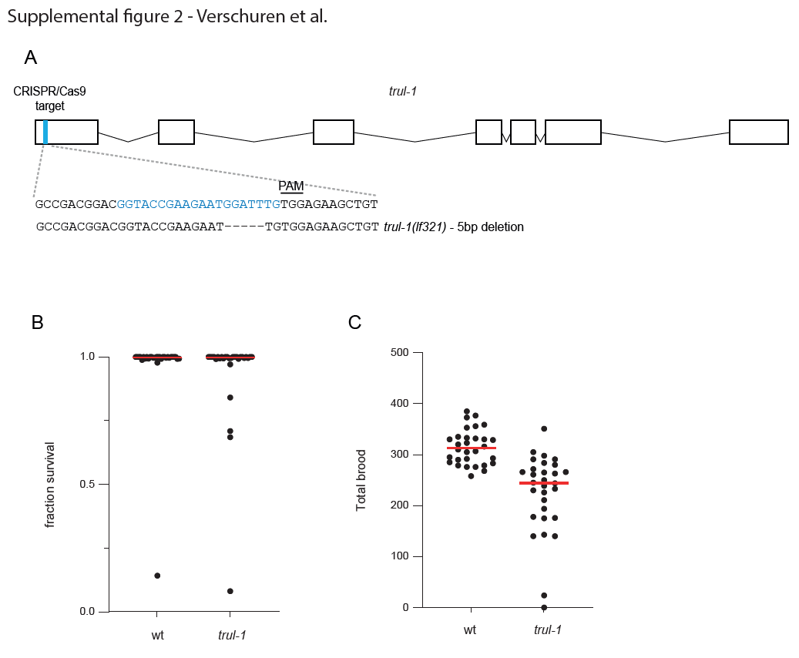
Supplemental figure 2. A) Schematic representation of the trul-1 mutant used in this study, including the sequence of the sgRNA (blue-colored sequence) and PAM site used for CRISPR/Cas9-based mutagenesis. The sequence that is lost in the lf321 allele (a 5bp deletion) is indicated. B) Progeny survival of the indicated genotype is calculated as the number of hatched eggs divided by the brood size. Red line denotes median. C) Quantification of brood size for the indicated genotype. Each data point represents the brood of a single hermaphrodite.

