SUPPLEMENTARY MATERIAL

Metabolomics-based Investigation of Primary Biliary Cholangitis: A Cholestatic Liver Disease
Juliana Magalhães de Oliveira¹, Thais de Assis Lopes¹, Alex Castro^{1,2}, Étore De Favari Signini³, Aparecida Maria Catai³, Antonio Gilberto Ferreira², Eduardo Luiz Rachid Cançado^{4,5*}, Regina Vincenzi Oliveira^{1*}
¹SEPARARE - Núcleo de Pesquisa em Cromatografia, Department of Chemistry, Federal University of São Carlos, São Carlos, SP, 13565-905, Brazil.
²Laboratory of Nuclear Magnetic Resonance, Department of Chemistry, Federal University of São Carlos, São Carlos, SP, 13565-905, Brazil.
³Department of Physiotherapy, Federal University of São Carlos, São Carlos, SP, 13565-905, Brazil.
⁴Department of Gastroenterology, University of São Paulo School of Medicine, São Paulo, Brazil.
⁵Institute of Tropical Medicine, University of São Paulo School of Medicine, São Paulo, Brazil.
*Correspondence: oliveirarv@ufscar.br (R.V.O); eduardocancado@usp.br (E.L.R.C.)

FIGURES
Figure S1 Multivariate analysis of the plasma metabolomic data. Principal component analysis (PCA) 2D score plot.
Figure S2 Multivariate analysis of the urine metabolomic data. Principal component analysis (PCA) 2D score plot.
Figure S3. Untargeted metabolomics multivariate analysis using PLS-DA for plasma samples.
Figure S4. Untargeted metabolomics multivariate analysis using PLS-DA for urine samples.
Figure S5. Heatmap of hierarchical clustering comparing 47 metabolite peak-pairs (PBC and HC groups) for plasma samples.
Figure S6. Heatmap of hierarchical clustering comparing 58 metabolite peak-pairs (PBC and HC groups) for urine samples.
Figure S7. Metabolic pathway mapping of the impacted metabolic network identified between PCB and HC groups in plasma samples.
Figure S8. Metabolic pathway mapping of the impacted metabolic network identified between PCB and HC groups in urine samples.
Figure S9. (A) Boxplots show differential LPCs levels in PBC patients compared to healthy controls (p < 0.05).
Table S2. Prediction models from the logistic regression and the ROC analysis of the individual metabolites from plasma and urine samples (AUC) > 0.907.

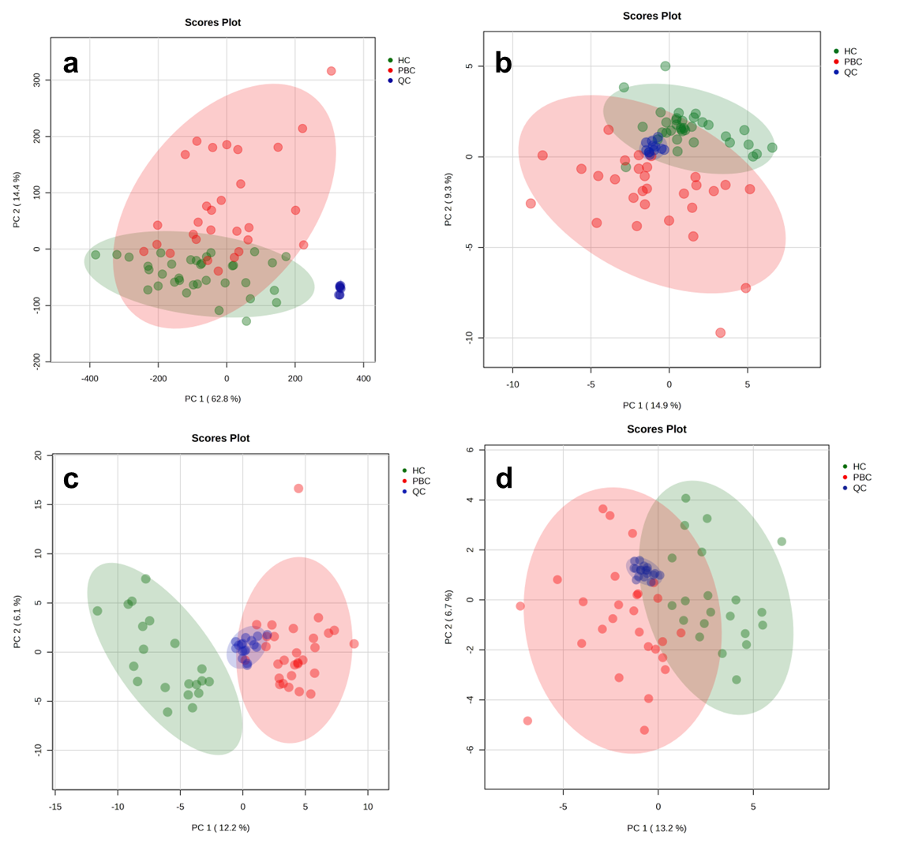
Figure S1 Multivariate analysis of the plasma metabolomic data. Principal component analysis (PCA) 2D score plot from the dataset with all the features expected to be endogenous metabolites with statistical difference. The green (controls) and red (patients) areas represent the 95% confidence interval regions for each group. Blue represents the quality controls group (QCs).
(a) RPLC (ESI+)
(b) RPLC (ESI-)
(c) HILIC (ESI+)
(d) HILIC (ESI-)

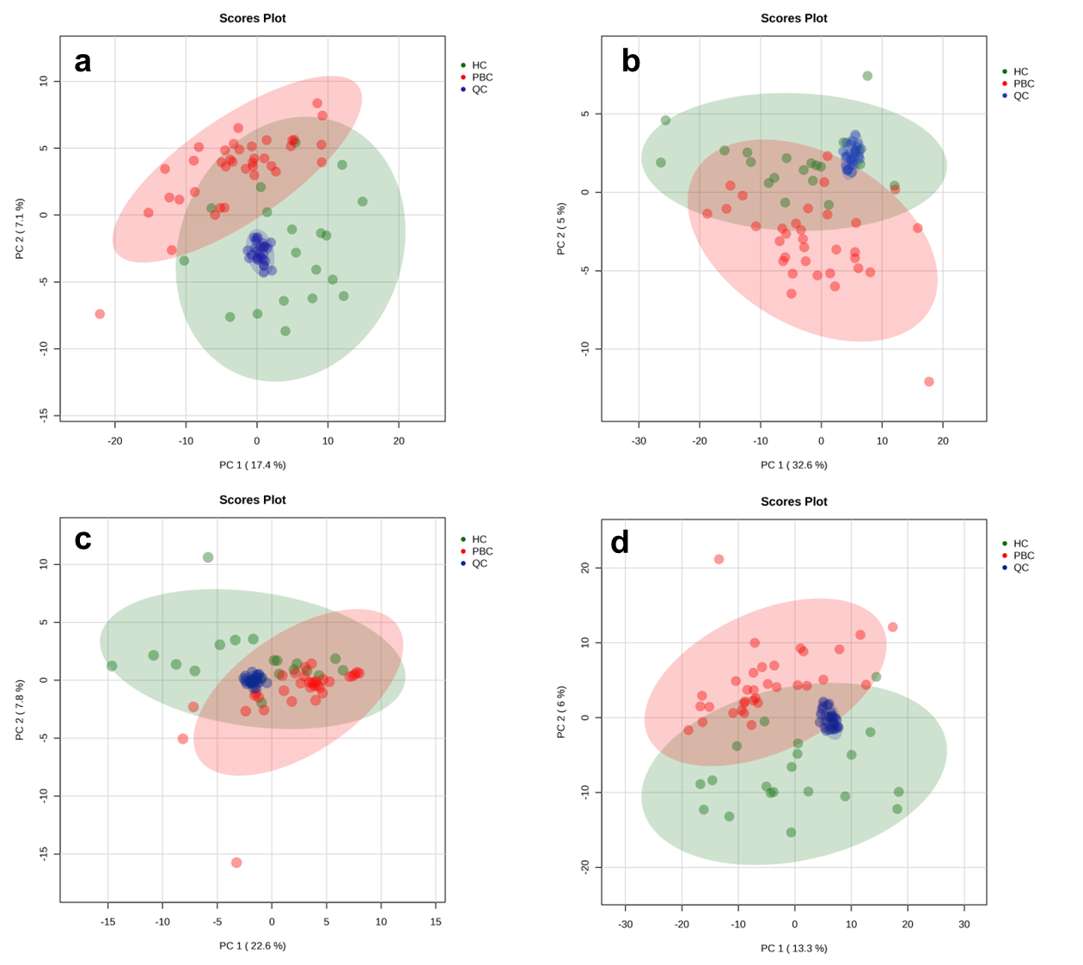
Figure S2 Multivariate analysis of the urine metabolomic data. Principal component analysis (PCA) 2D score plot from the dataset with all the features expected to be endogenous metabolites with statistical difference. The green (controls) and red (patients) areas represent the 95% confidence interval regions for each group. Blue represents the quality controls group (QCs).
(a) RPLC (ESI+)
(b) RPLC (ESI-)
(c) HILIC (ESI+)
(d) HILIC (ESI-)

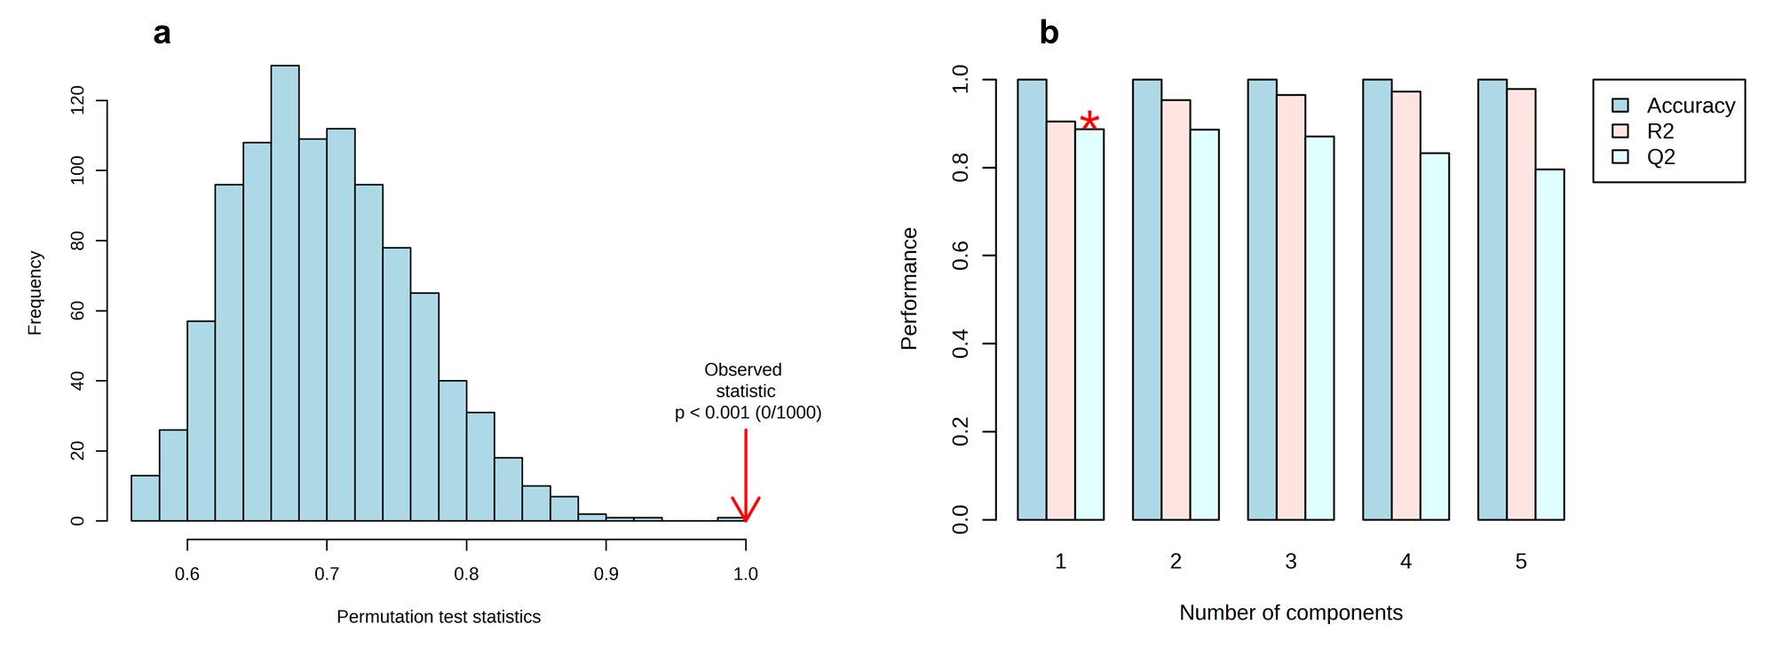
Figure S3. Untargeted metabolomics multivariate analysis using PLS-DA for plasma samples.
(a) Histogram representing the results of the permutation tests. (b) Bar plots showing the three performance measures (prediction accuracy, R2 and Q2) using different number of components.
* Indicates the best values of the currently selected measures (Q2).
Parameters of the modeling for plasma samples, Q2 = 0.887, R2Y = 0.905, R2X = 0.979 (cum) and p<0.001.

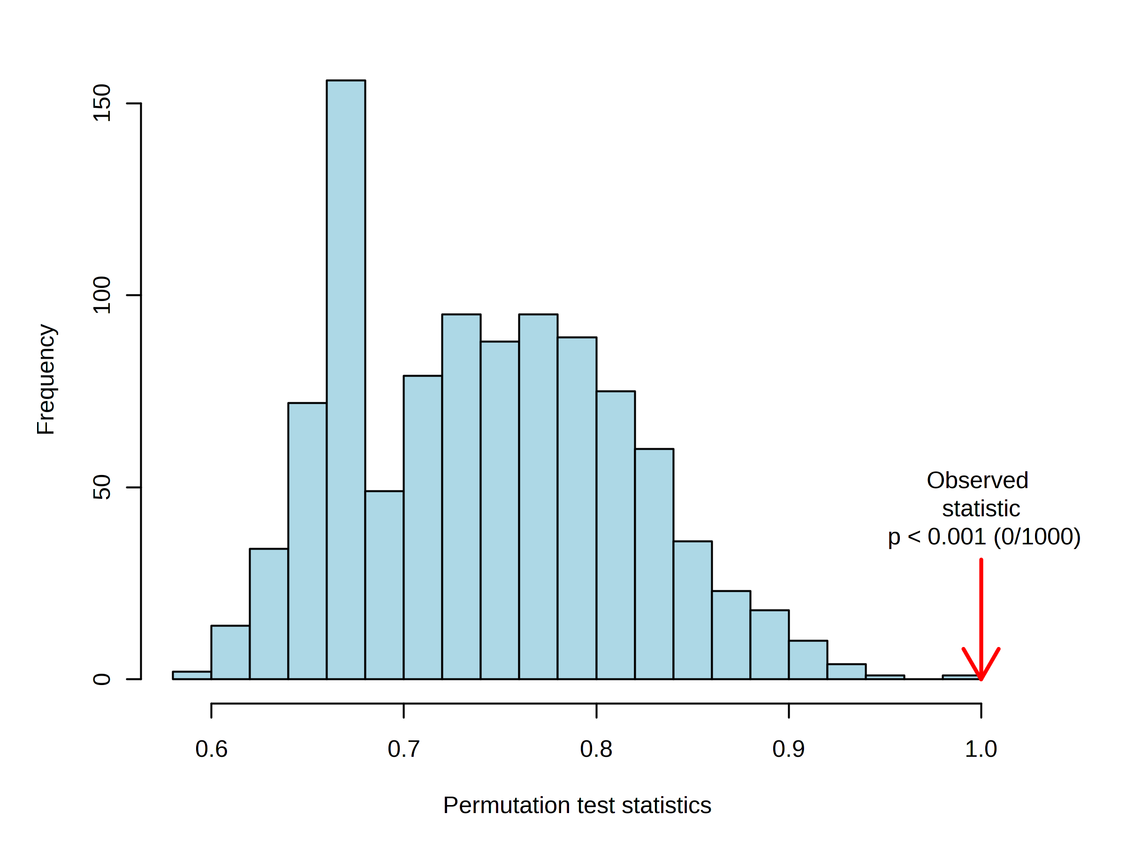
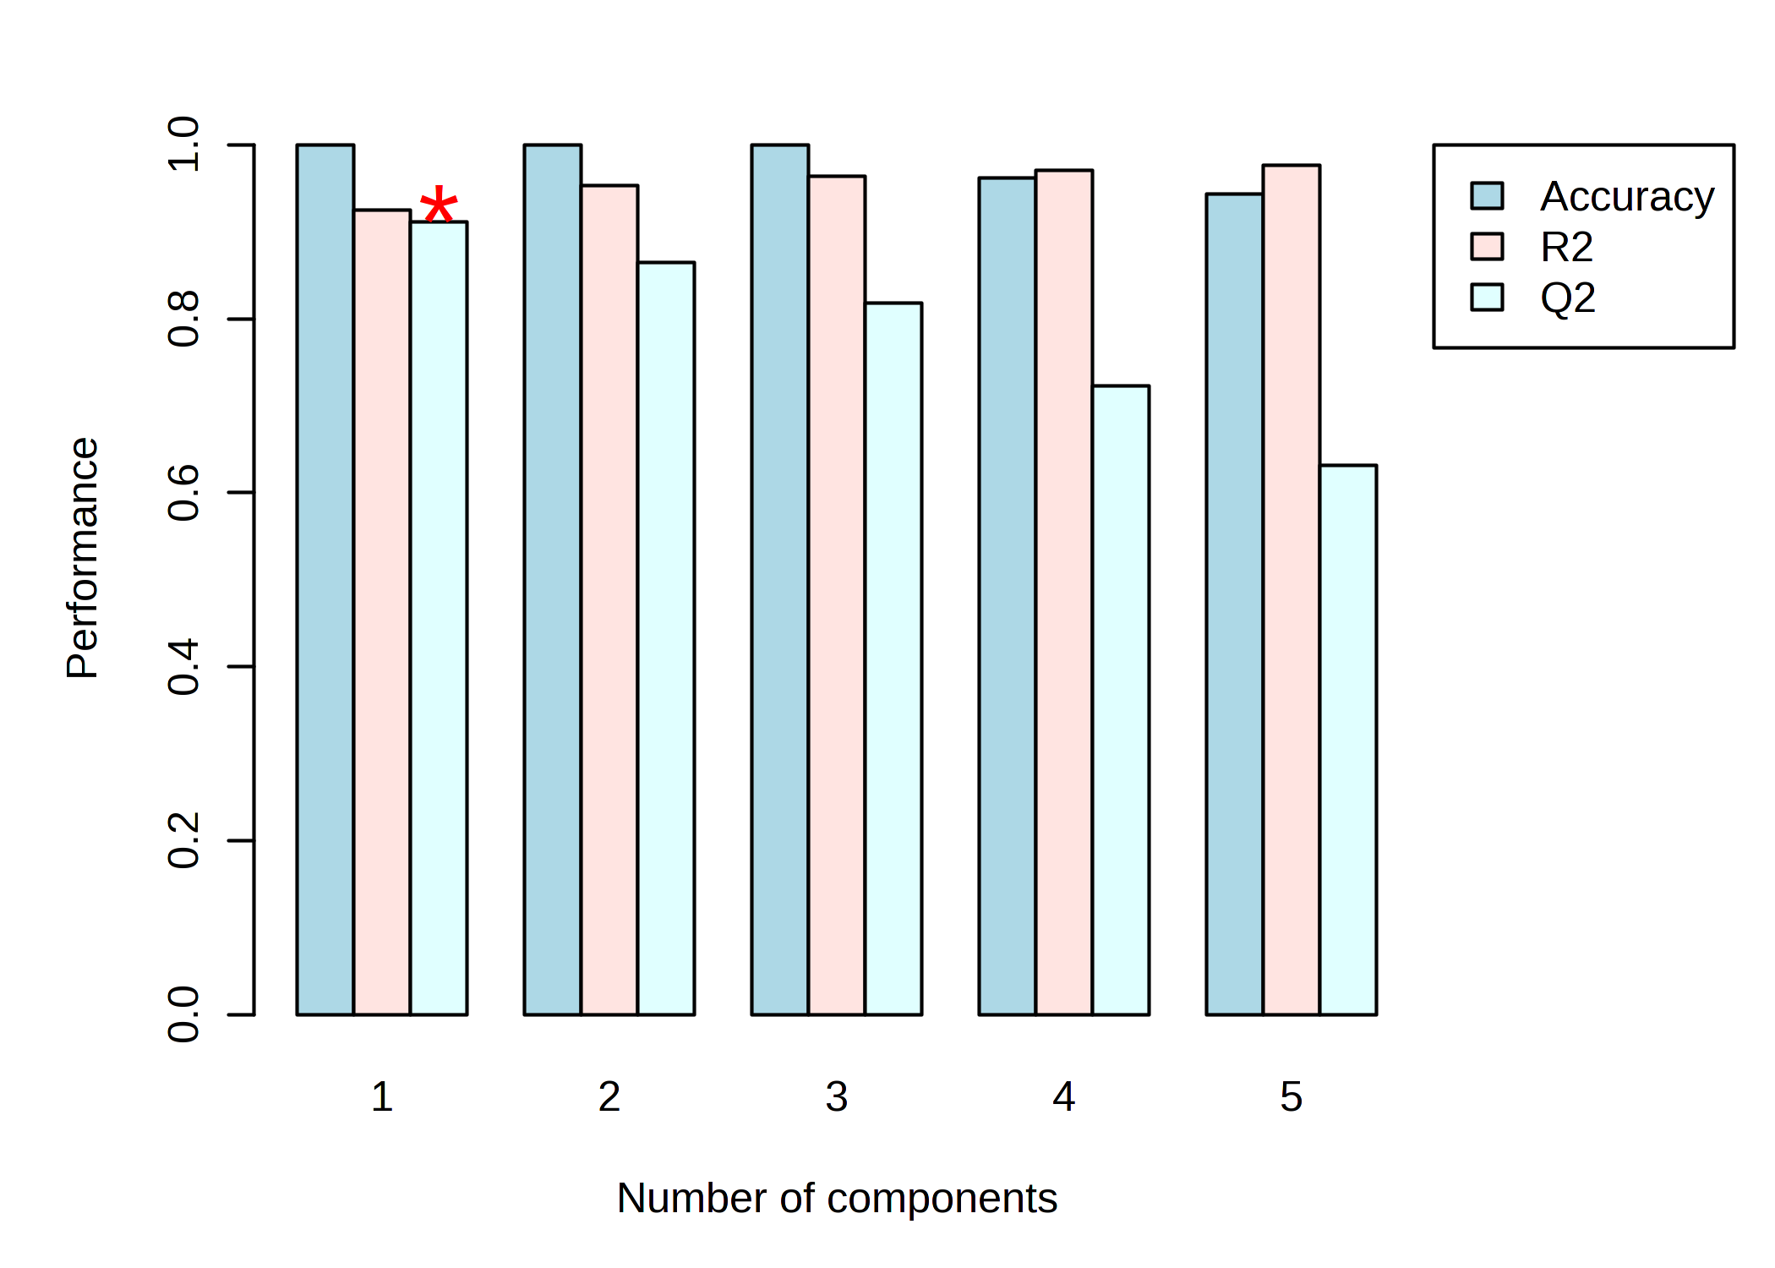
a
b
Figure S4. Untargeted metabolomics multivariate analysis using PLS-DA for urine samples.
(a) Histogram representing the results of the permutation tests. (b) Bar plots showing the three performance measures (prediction accuracy, R² and Q²) using different number of components.
* Indicates the best values of the currently selected measures (Q²).
Parameters of modeling for urine samples, Q² = 0.911, R²Y = 0.925, R²X = 0.977 (cum) and p<0.001.

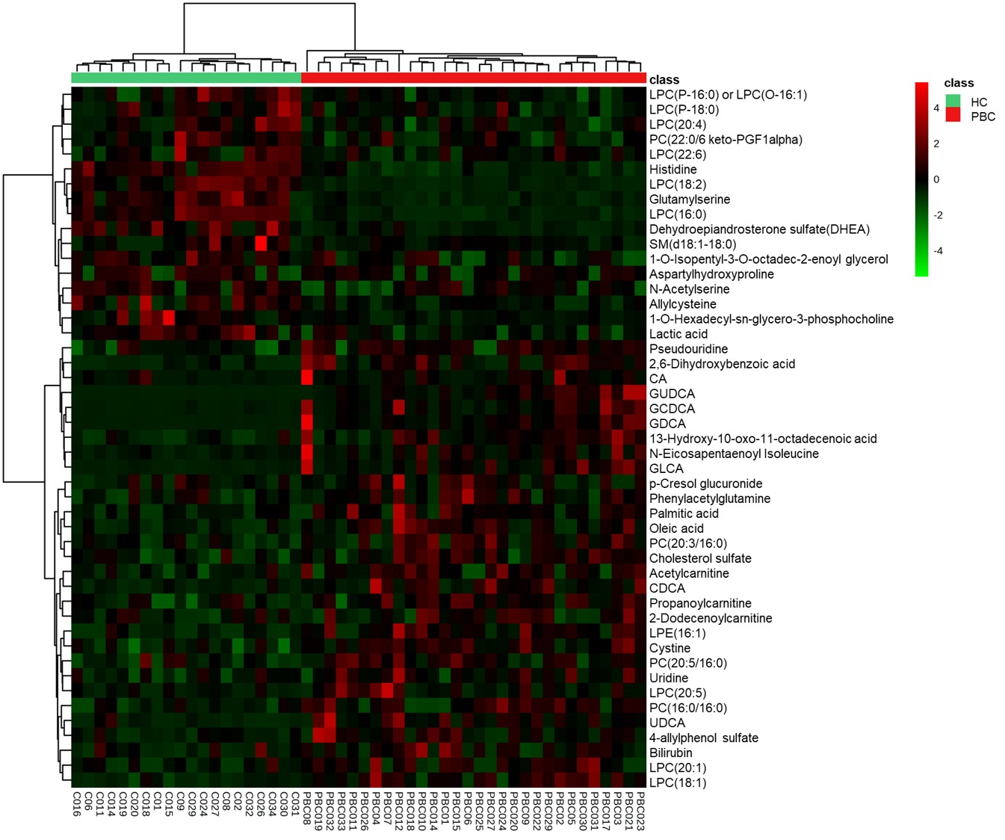

Figure S5. Heatmap of hierarchical clustering comparing 47 metabolite peak-pairs (PBC and HC groups) for plasma samples. Each column represents a sample, and each row represents a metabolite. Red demonstrates that the relative content of metabolites is high and green demonstrates that they are low.

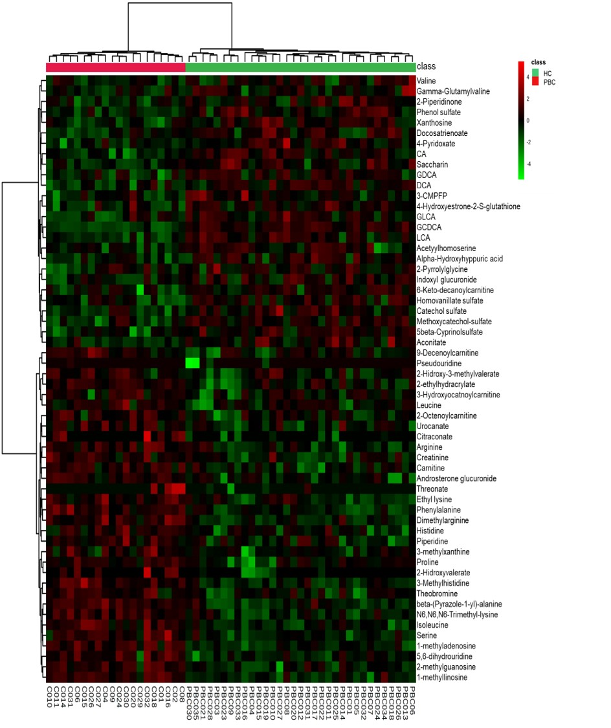
Figure S6. Heatmap of hierarchical clustering comparing 58 metabolite peak-pairs (PBC and HC groups) for urine samples. Each column represents a sample, and each row represents a metabolite. Red demonstrates that the relative content of metabolites is high and green demonstrates that they are low.

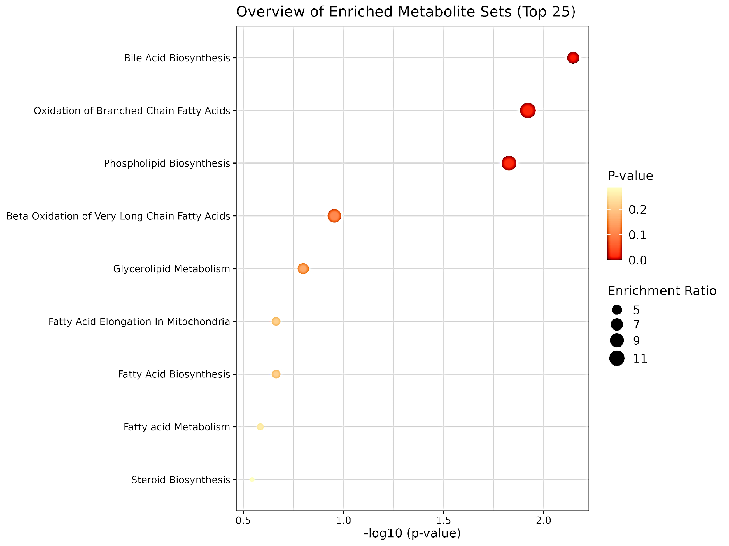
Figure S7. Metabolic pathway mapping of the impacted metabolic network identified between PCB and HC groups in plasma samples. The x-axis represents the pathway impact, and the y-axis represents the –log(p). The colour ranges from light yellow to dark red, indicating the level of enrichment significance, and the size of the circle reflects the level of the enrichment ratio.
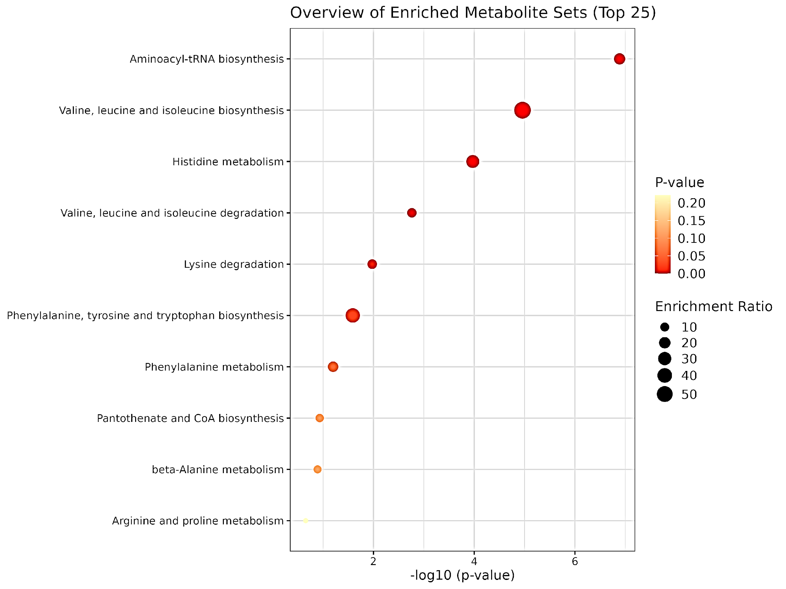
Figure S8. Metabolic pathway mapping of the impacted metabolic network identified between PCB and HC groups in urine samples. The x-axis represents the pathway impact, and the y-axis represents the –log(p). The colour ranges from light yellow to dark red, indicating the level of enrichment significance, and the size of the circle reflects the level of the enrichment ratio.

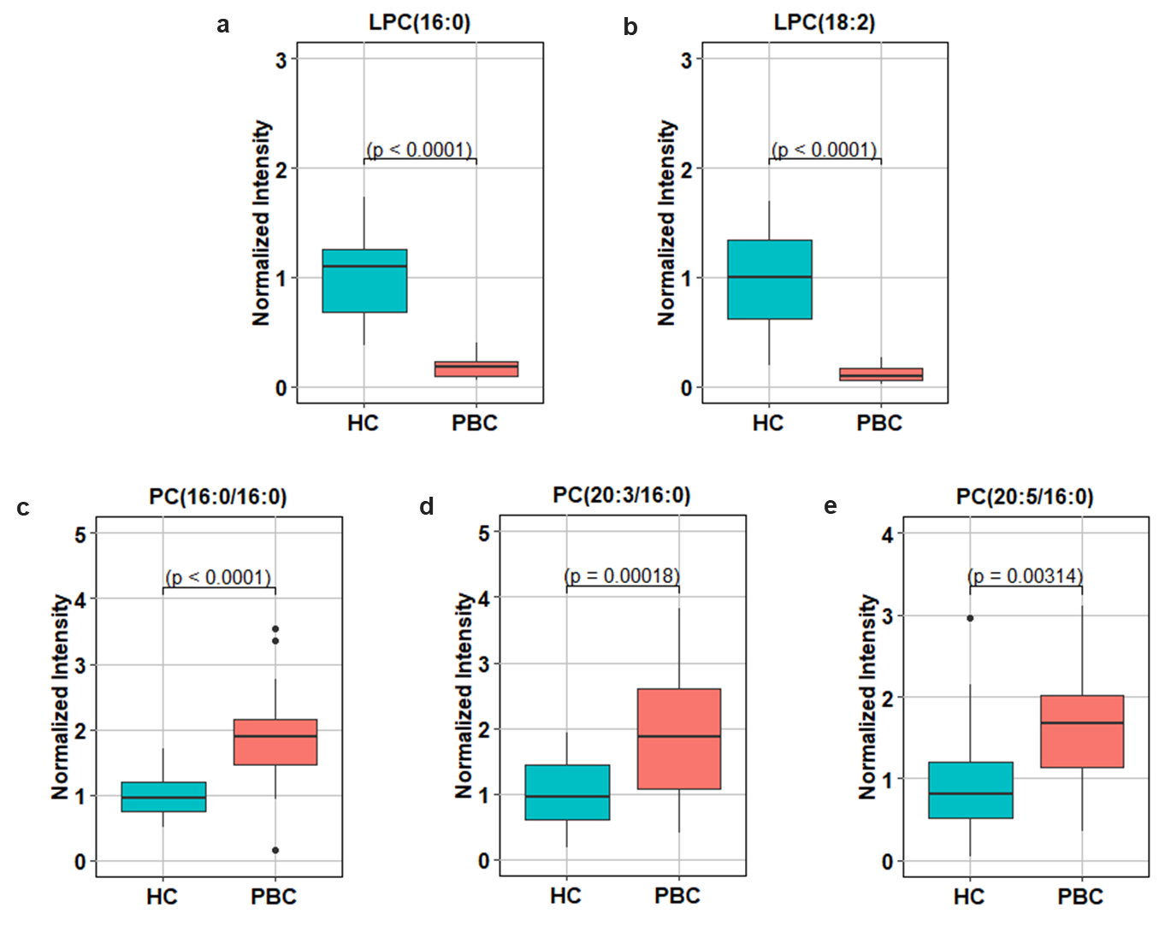
Figure S9. Box-and-whisker plots of the five phospholipids in plasma samples from PBC and HC groups. The y axis represents the normalized intensities of the metabolites.
(a) LPC(16:0); (b) LPC(18:2); (c) PC(16:0/16:0); (d) PC(20:3/16:0), and (d) PC(20:5/16:0). The box in the plot represents the interquartile range (IQR), encompassing most of the data, while the whiskers extend to the extreme values. Statistical significance was assessed using Student's t-test, with a threshold of p < 0.05.

Table S2. Prediction models from the logistic regression and the ROC analysis of the individual metabolites from plasma and urine samples (AUC) > 0.907.
Metabolites | AUC | 95% CI | Sensitivity | Specificity | Matrix
Glutamylserine | 0.993 | 0.971 - 1 | 0.967 (0.9-1) | 0.9 (0.774-1) | Plasma
GCDCA 3-sulfate | 0.992 | 0.970 - 1 | 0.848(0.758-0.955) | 1(1-1) | Urine
GUDCA 3-sulfate | 0.972 | 0.913 - 1 | 0.567(0.433-0.751) | 1 (1-1) | Plasma
GDCA | 0.972 | 0.915 - 1 | 0.6 (0.483-0.767) | 1 (1-1) | Plasma
LPC(0:0/18:2) | 0.971 | 0.915 - 1 | 0.967 (0.9-1) | 0.85(0.7-0.976) | Plasma
LPC(16:0/0:0) | 0.967 | 0.888 - 1 | 1 (1-1) | 0.85 (0.7-1) | Plasma
Histidine | 0.955 | 0.859 - 1 | 0.933 (0.849-1) | 0.95 (0.85-1) | Plasma
β-(Pyrazole-1-yl)-alanine | 0.941 | 0.858 - 1 | 0.788(0.636-0.909) | 1 (1-1) | Urine
3-methyl-histidine | 0.938 | 0.860 – 0.985 | 0.818(0.667-0.939) | 0.95(0.824-1) | Urine
1-methyl-adenosine | 0.936 | 0.841 – 0.987 | 0.818(0.681-0.939) | 0.85 (0.70-1) | Urine
Phenylalanine | 0.935 | 0.857 – 0.986 | 0.727(0.606-0.848) | 0.9(0.75-1) | Urine
1-methyl-inosine | 0.924 | 0.842 – 0.988 | 0.879(0.742-0.97) | 0.9 (0.75-1) | Urine
N6,N6,N6-Trimethyl-lysine | 0.921 | 0.835 – 0.979 | 0.818(0.667-0.909) | 0.95(0.824-1) | Urine
GCDCA 3-glucuronide | 0.920 | 0.817 – 0.983 | 0.5(0.333-0.667) | 1 (1-1) | Plasma
LPE(16:1/0:0) | 0.913 | 0.795 – 0.987 | 0.533(0.367-0.717) | 0.95(0.9-1) | Plasma
Dimethylarginine | 0.907 | 0.803 – 0.974 | 0.788(0.667-0.925) | 0.9(0.8-1) | Urine
GCDCA 3-sulfate: glycochenodeoxycholic acid-3-sulfate; GUDCA 3-sulfate: glycoursodeoxycholate 3-sulfate; GDCA: glycodeoxycholic acid; LPC: lysophosphatidylcholine; GCDCA 3-glucuronide: glycochenodeoxycholic acid-3-glucuronide; LPE: lysophosphatidylethanolamine

