In vitro and in silico anticoccidial activity of the seeds of Lepidium sativum red and black varieties

Yonatan Alebachew^{†1}, Kebede Wondu^{†2}, Tigist Getachew³, Debora Tilahun³, Meskerem Adamu^{3*}, Tsige Gebre-Mariam²

¹Department of Pharmaceutical Chemistry and Pharmacognosy, School of Pharmacy, College of Health Sciences, Addis Ababa University, Ethiopia
²Department of Parmaceutics and Social Pharmacy, School of Pharmacy, College of Health Sciences, Addis Ababa University, Ethiopia.
³Bio and Emerging Technology Institute, Addis Ababa, Ethiopia

†First authors: equally contributed
*Corresponding authors: Meskerem Adamu
Tel.: +251935963110 e-mail: madchere@gmail.com

Fig. S1. The¹H, ¹³C NMR and DEPT-135 spectra of compound 1 (methyl sinapate).

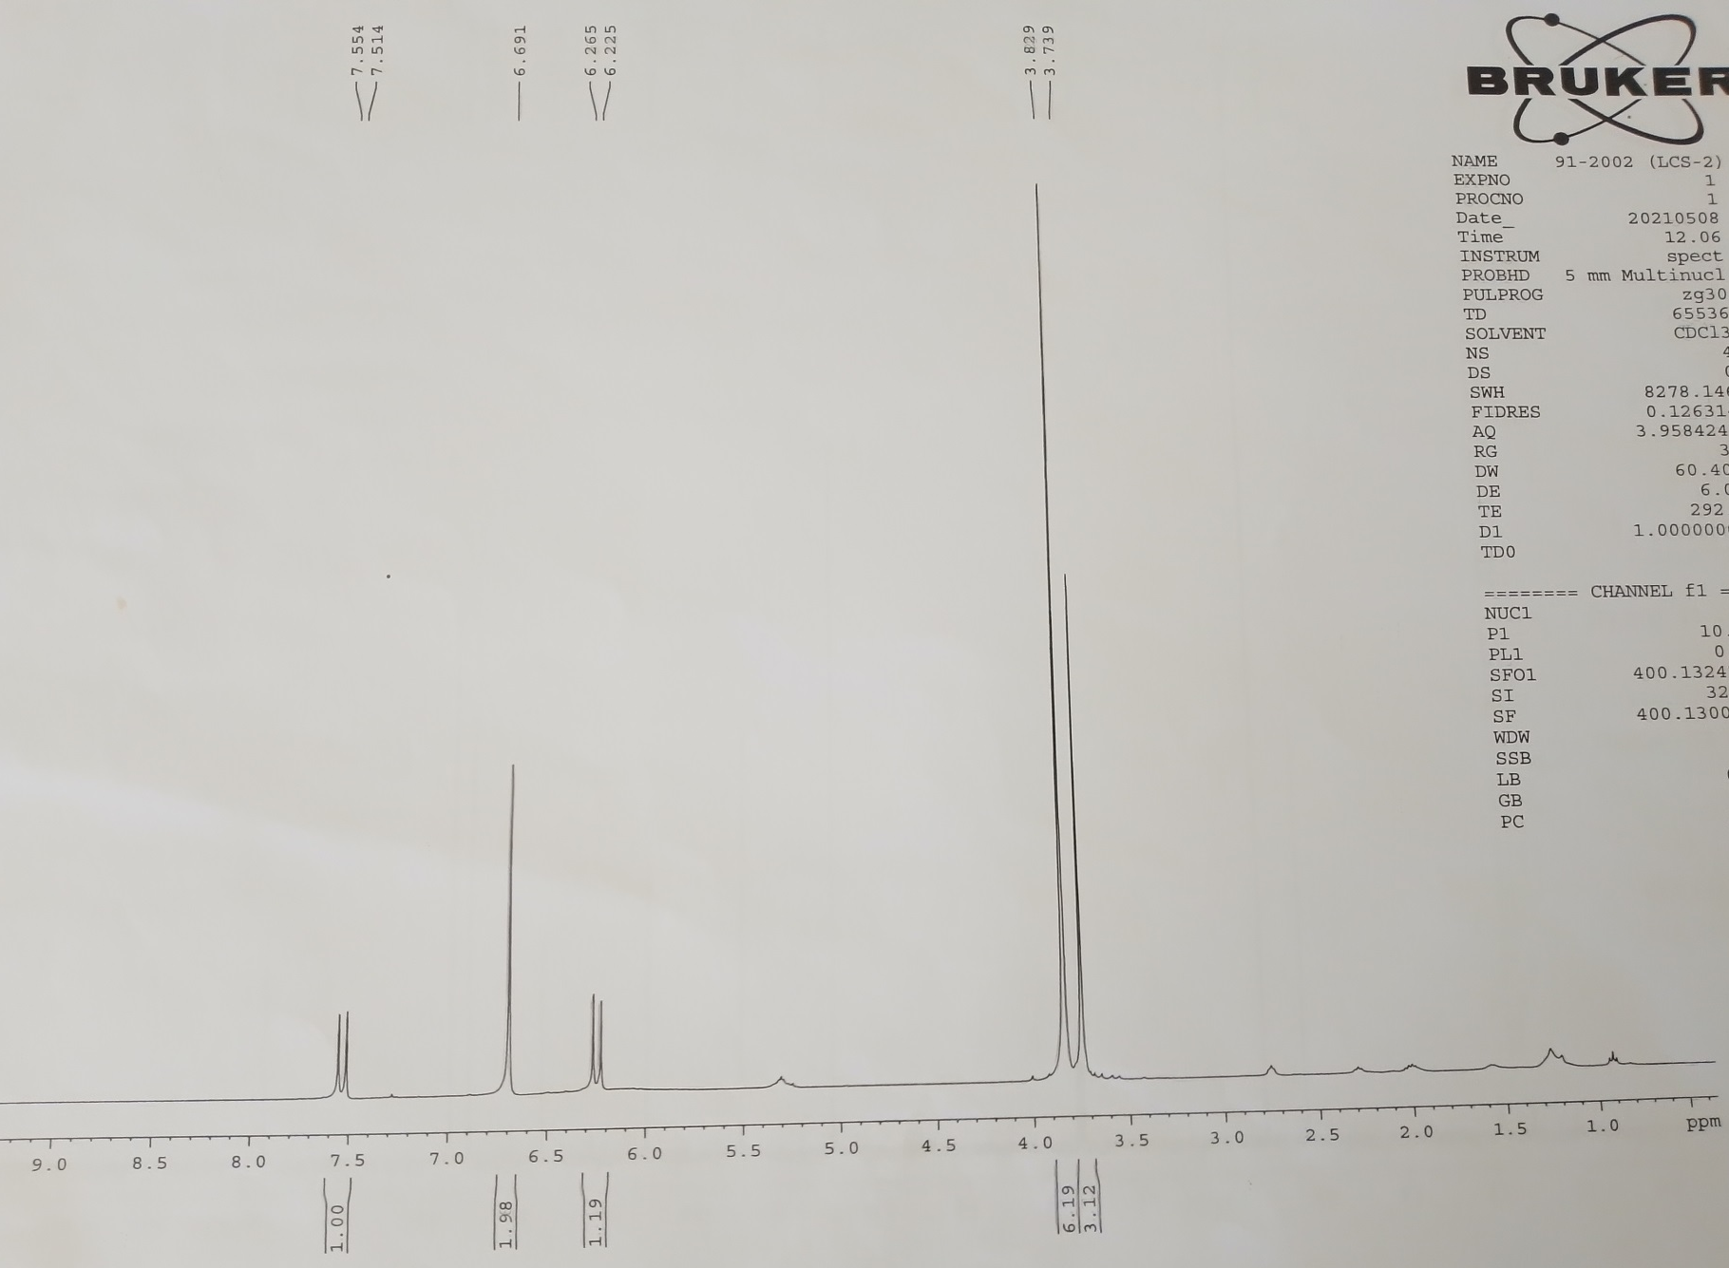

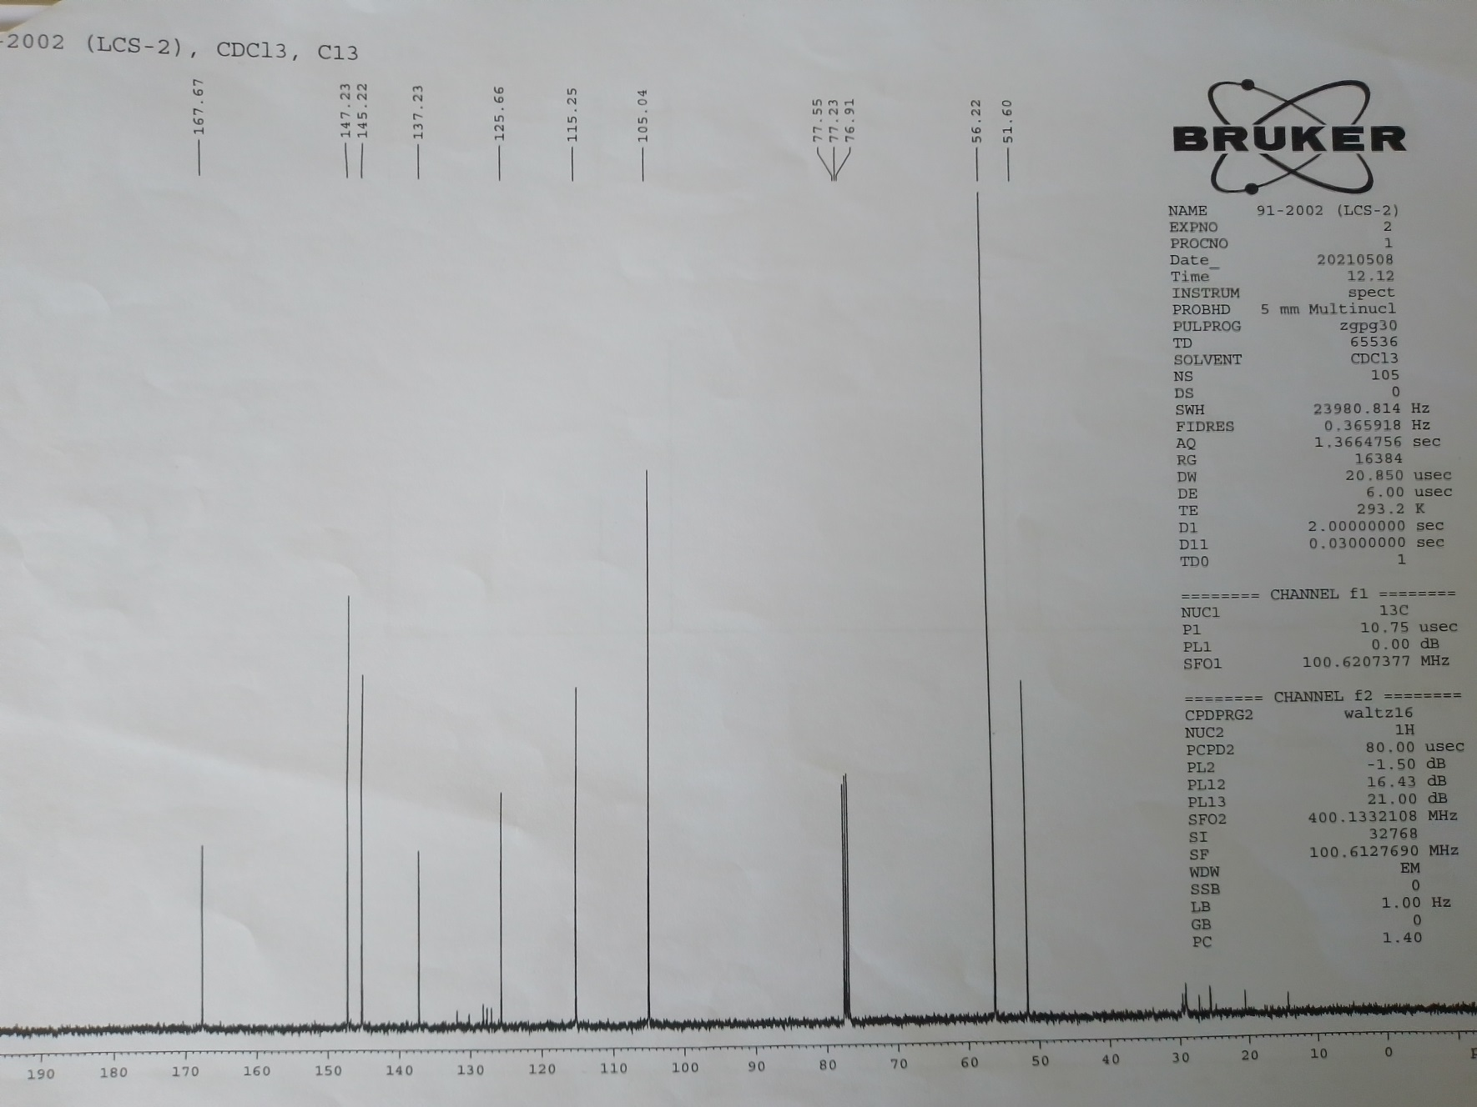

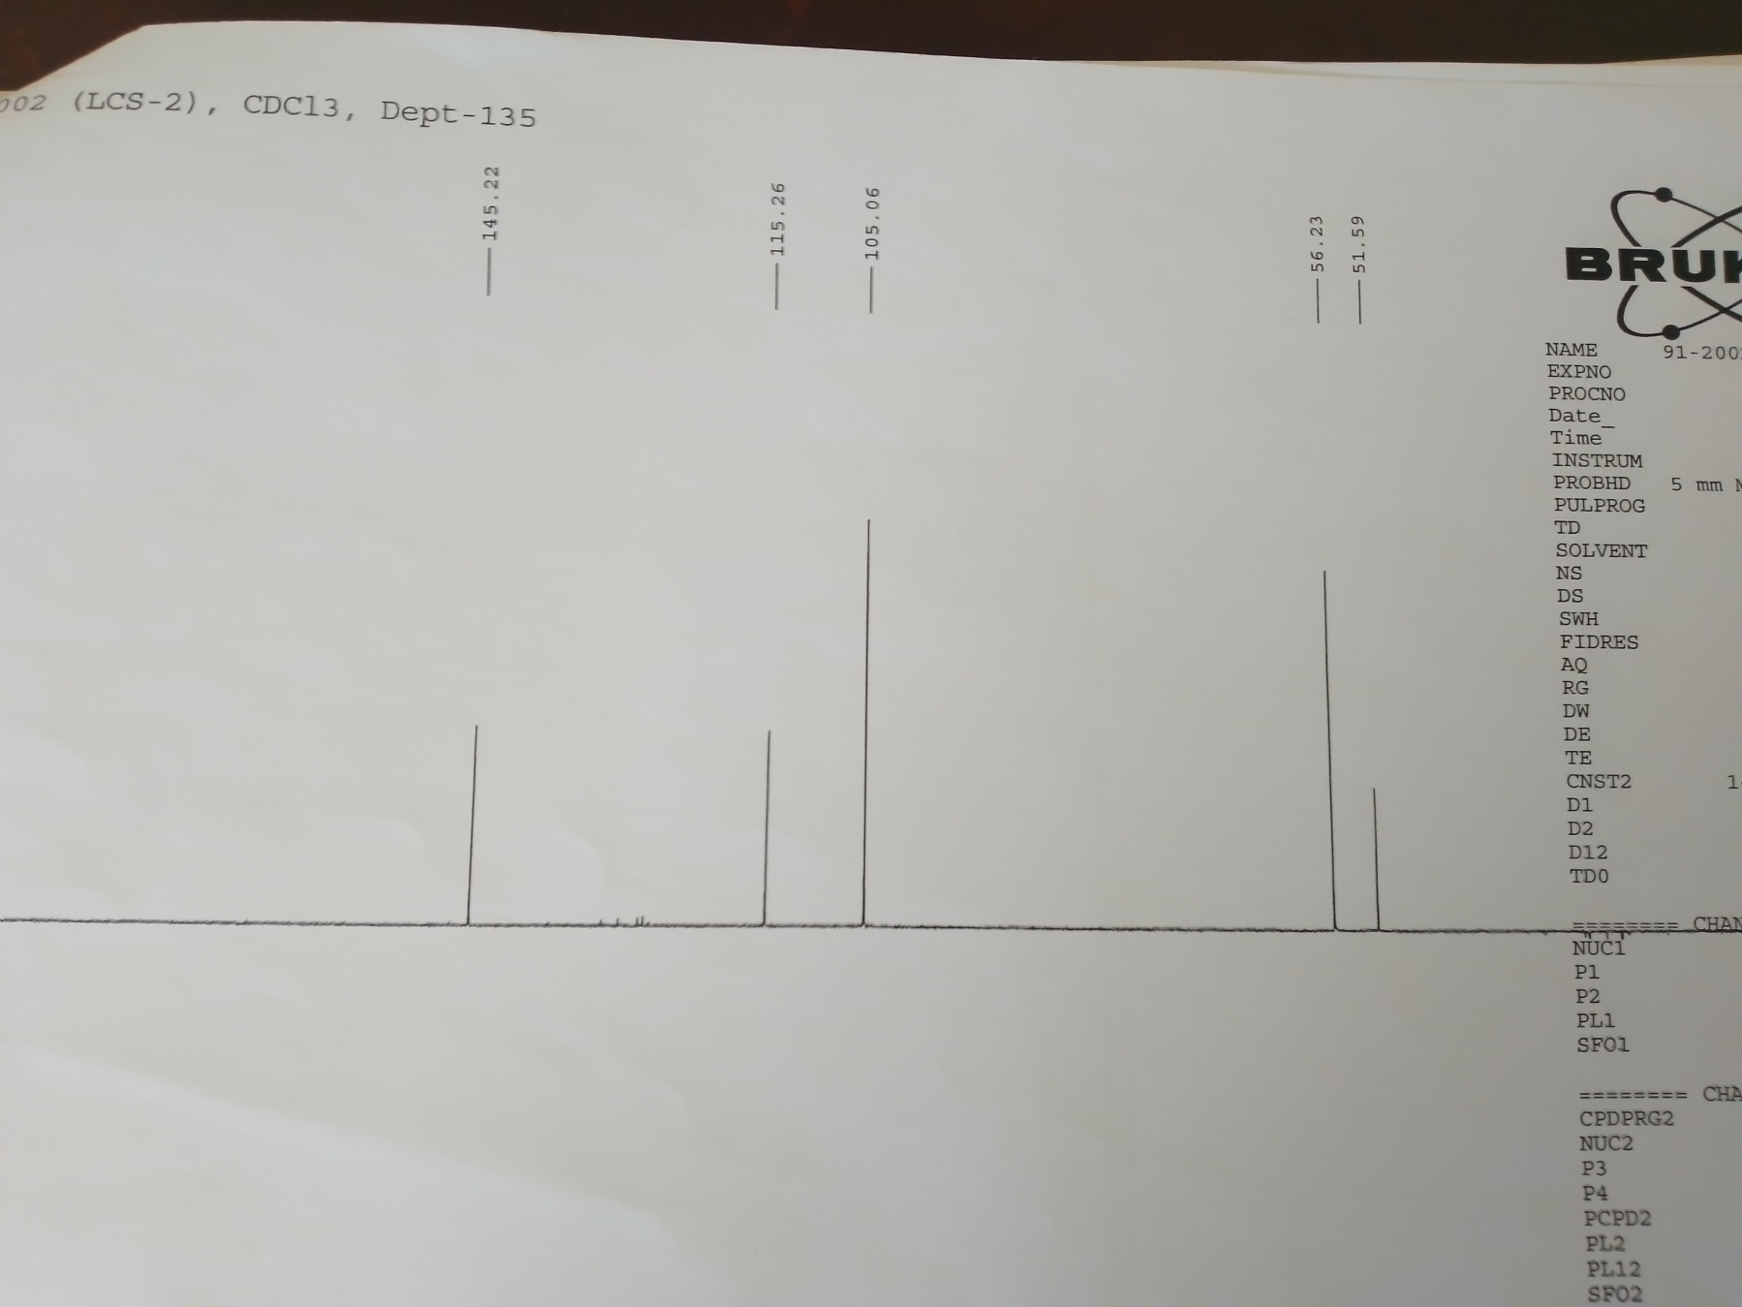

Fig. S2. The¹H, ¹³C NMR and DEPT-135 spectra of compound 1 and 2 (linoleic acid and alpha-linolenic acid).

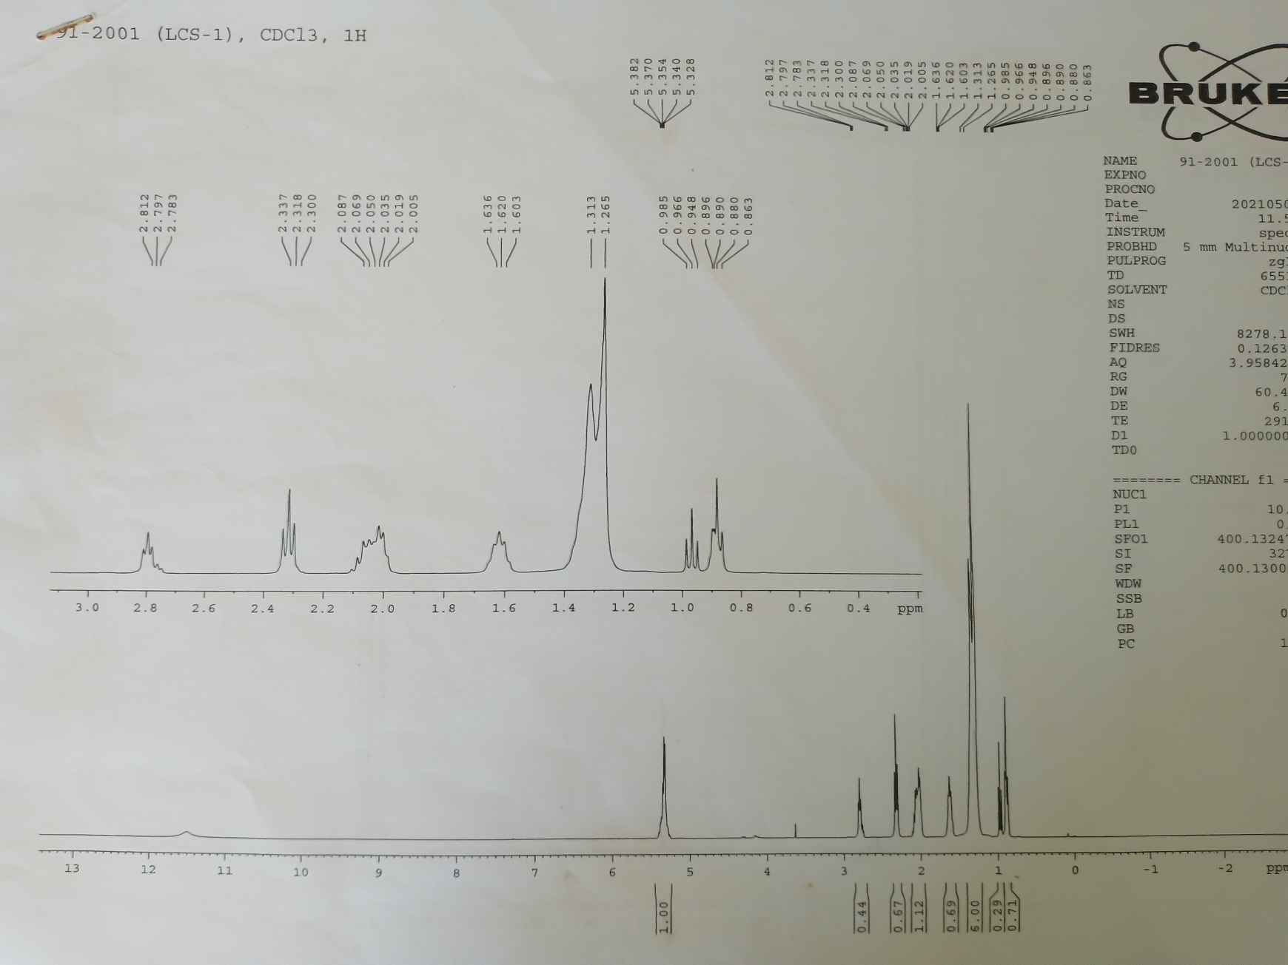
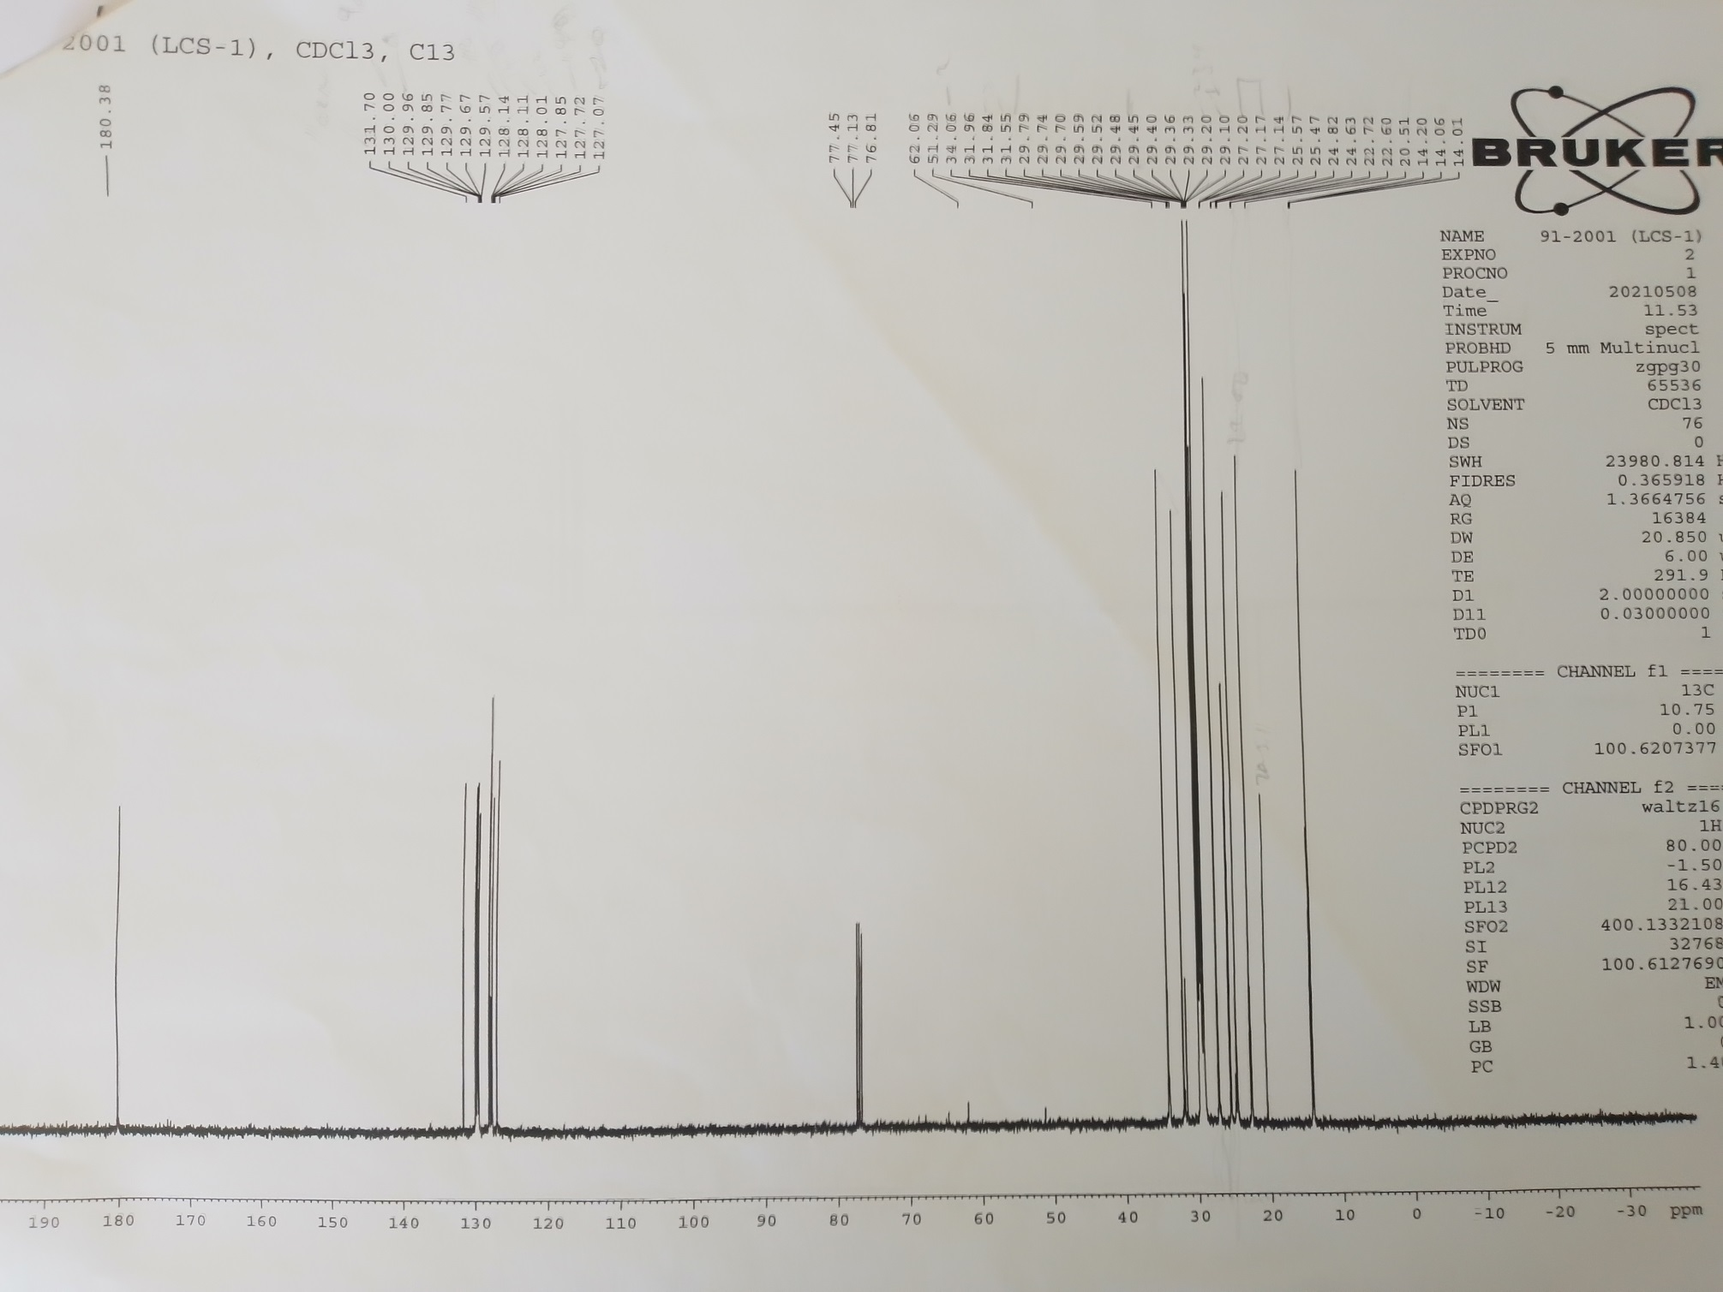
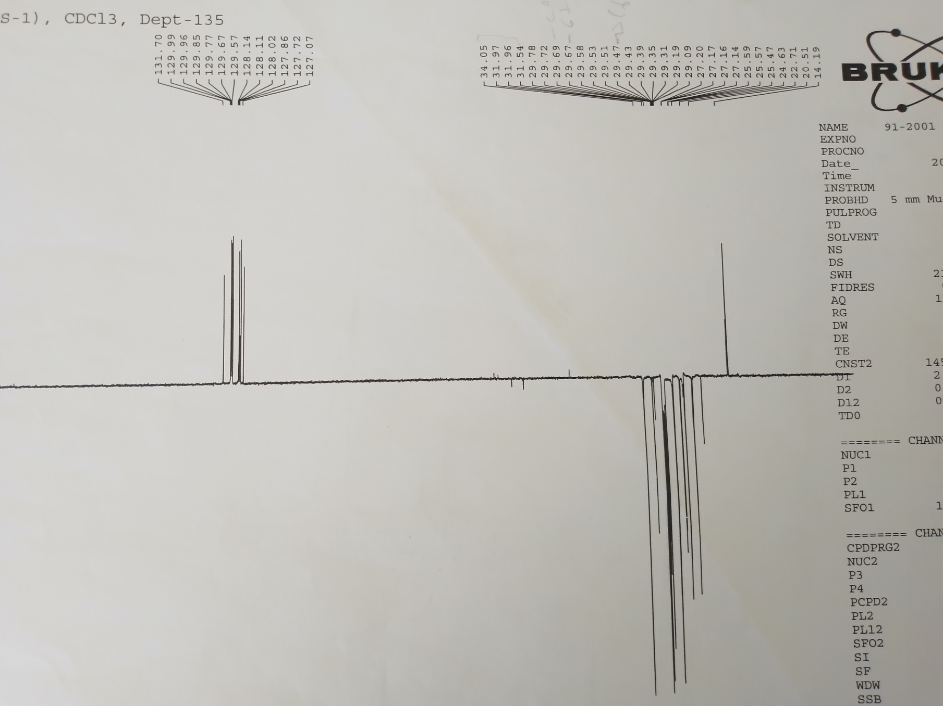
Table S1. Prediction of partition coefficient Log P, aqueous solubility Log S, partition coefficient for partially dissociated compounds Log D and hERG toxicity of the isolated compounds (1-3), anti-coccidial drugs and coenzymes (4-21) carried out using SeeSar12.1.0 (Narcissus) software (BioSolveIT, Sankt Augustin, Germany).
Compounds | Structure |  | Lop opt | Log P | Log S | Log D | hERG  plC₅₀
1 | 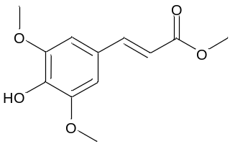  Methyl sinapate |  | 1.832 | 1.60 | 3.726 | 1.832 | 4.315
2 | 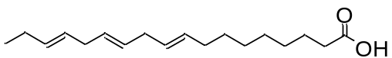  Alpha-linolenic acid |  | 5.295 | 4.33 | 1.633 | 1.465 | 5.526
3 | 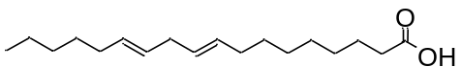  Linoleic acid |  | 5.752 | 4.55 | 1.441 | 1.446 | 5.511
4 | 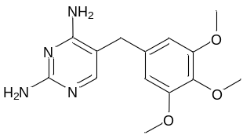  Trimethoprim |  | 1.520 | 1.26 | 3.140 | 0.500 | 4.120
5 | 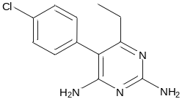Pyrimethamine |  | 2.543 | 2.52 | 2.358 | 2.440 | 4.305
6 | 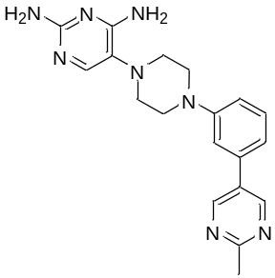 |  | 2.363 | 1.73 | 1.444 | 2.381 | 5.225
7 | 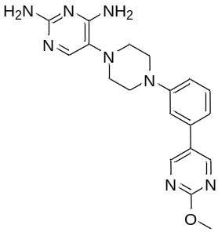 |  | 2.268 | 1.43 | 1.644 | 2.433 | 5.256
8 | 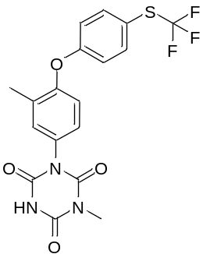 |  | 2.504 | 5.10 | 3.132 | 2.504 | 5.068
9 | 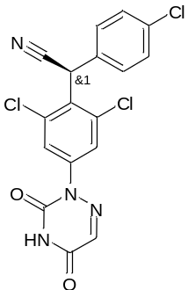 |  | 3.049 | 3.54 | 0.789 | 3.049 | 4.983
10 | 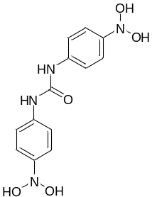 |  | 2.961 | 3.15 | 1.584 | 2.961 | 5.234
11 | 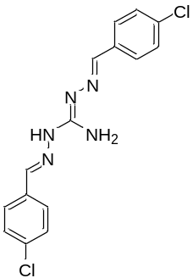 |  | 3.296 | 1.66 | 1.618 | 2.062 | 4.267
12 | 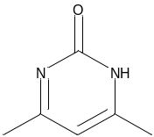 |  | -.768 | 0.39 | 5.841 | -0.768 | 3.830
13 | 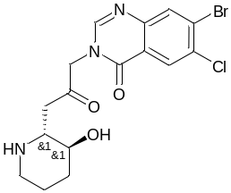 |  | 2.329 | 0.86 | 2.042 | 0.671 | 5.030
14 | 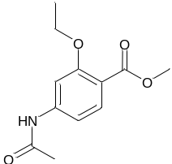 |  | 1.642 | 1.83 | 3.799 | 1.642 | 4.125
15 | 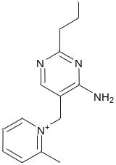 |  | 2.992 | 1.66 | 2.233 | -0.263 | 4.828
16 | 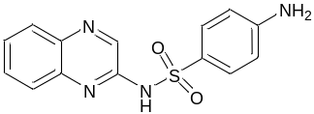 |  | 1.680 | 2.66 | 1.827 | 0.738 | 5.612
17 | 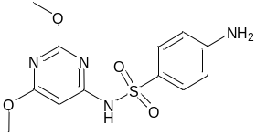 |  | 1.630 | 1.53 | 3.379 | 0.203 | 5.078
18 | 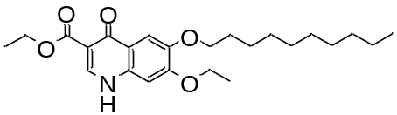 |  | 6.084 | 5.66 | 0.268 | 6.084 | 6.006
19 | 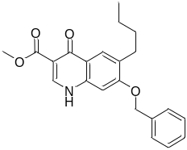 |  | 4.068 | 4.27 | 0.844 | 4.068 | 5.367
20 | 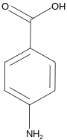 |  | 0.830 | -0.37 | 4.650 | -1.770 | 3.287
21 | 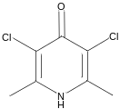 |  | 2.342 | 2.10 | 2.904 | 2.342 | 3.843

