SUPPLEMENTAL FIGURE S1

Integrating uterine microbiome and metabolome to advance the understanding of the uterine environment in dairy cows with metritis
S. Casaro¹, J. G. Prim², T. D. Gonzalez¹, F. Cunha¹, R. S. Bisinotto¹, R. C. Chebel¹, J. E. P. Santos^{3,4}, C. D. Nelson³, S. J. Jeon⁵, R. C. Bicalho⁶, J. P. Driver⁷, K. N. Galvão^{1,4}*

¹Department of Large Animal Clinical Sciences, University of Florida, Gainesville, FL
²Department of Clinical Sciences, Auburn University, Auburn, AL
³Department of Animal Sciences, University of Florida, Gainesville, FL
⁴D. H. Barron Reproductive and Perinatal Biology Research Program, University of Florida, Gainesville, FL
⁵Department of Veterinary Biomedical Sciences, Long Island University, Brookville, NY
⁶FERA Diagnostics and Biologicals, College Station, TX
⁷Division of Animals Sciences, University of Missouri, Columbia, MO

*Corresponding author: Klibs N. Galvão: galvaok@ufl.edu

Declarations of interest: none

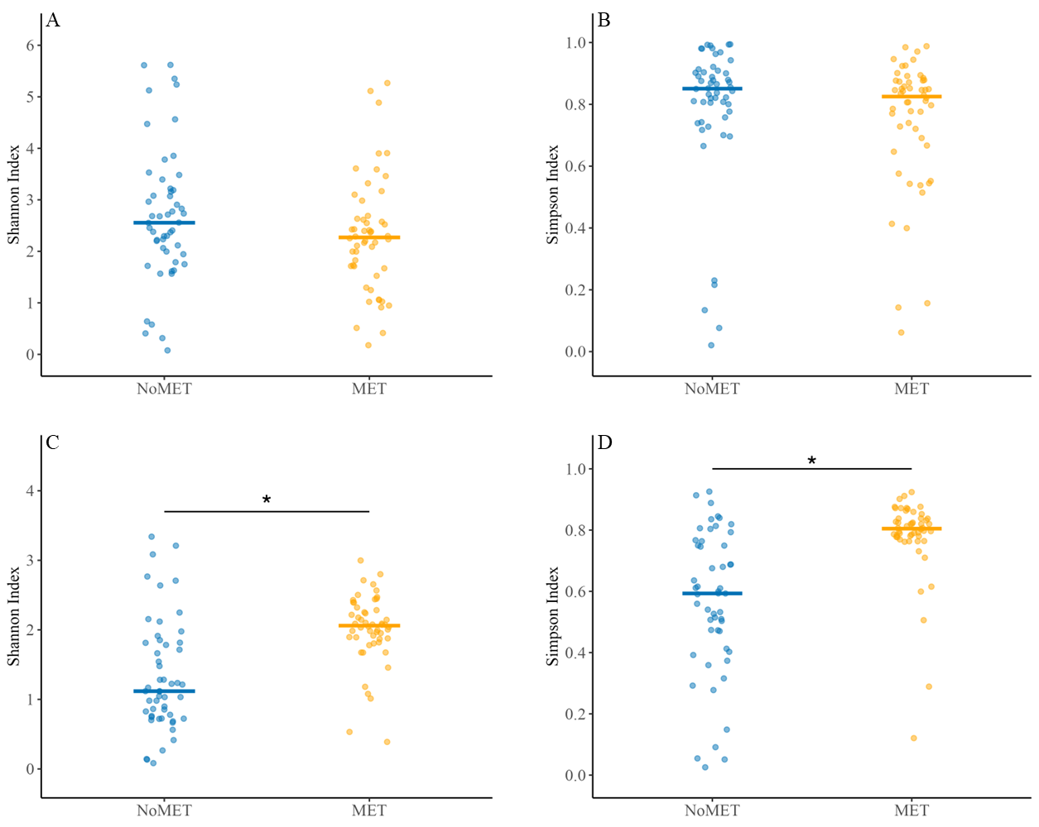Supplemental Figure S1. Comparison of uterine microbiome alpha diversity at calving (A, B) and on the day of metritis diagnosis (7±2 days after calving; C, D) between dairy cows that developed metritis (MET; orange; n = 52) and dairy cows that did not develop metritis (NoMET; blue; n = 52). The uterine microbiome was identified by amplification of the V4 hypervariable region of the bacterial/archaeal 16S rRNA. Horizontal lines represent median value for each group. The effect of metritis was analyzed on each index using the Wilcoxon test. Asterisks correspond to P < 0.05. Figures were created using the ggplot2 package of Rstudio Version 2023.06.1+524 (RStudio, PBC, Boston, MA).

