Supplementary Figures
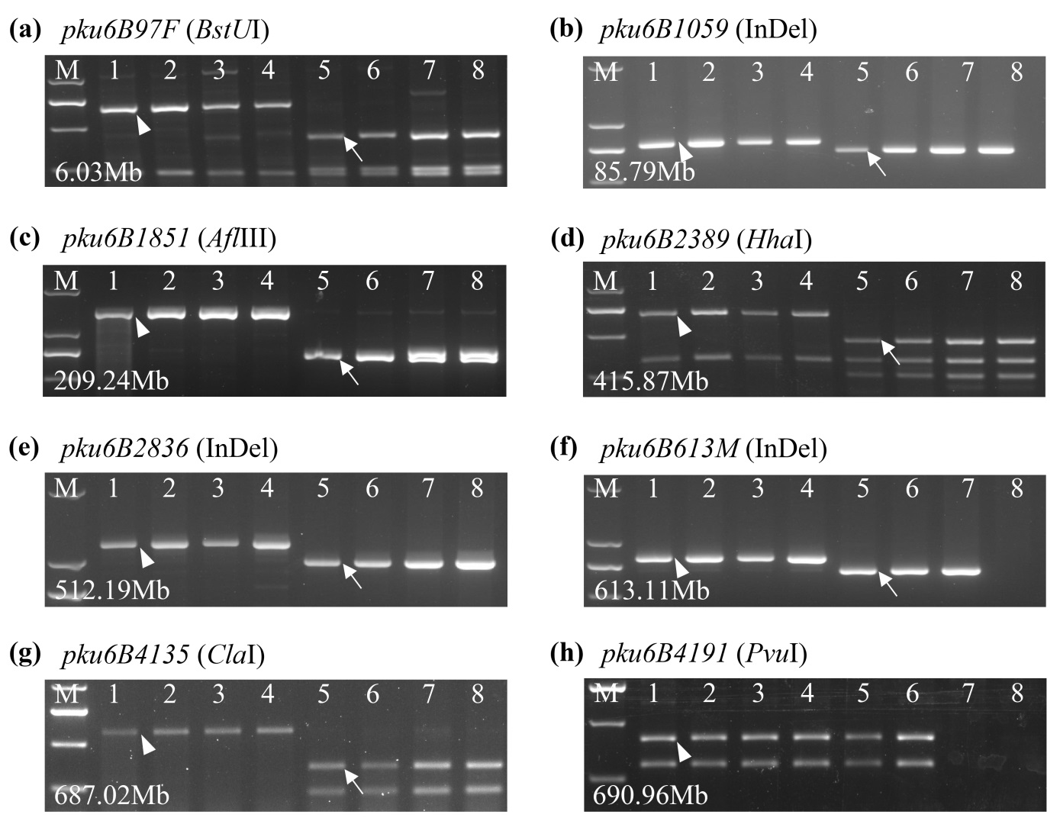
Fig. S1 CAPS markers and InDel markers used to characterize the alien segment present in 98M71. (a) CAPS marker pku6B97F (6.03 Mb, BstUI); (b) InDel marker pku6B1059 (85.79 Mb); (c) CAPS marker pku6B1851 (209.24 Mb, AflIII); (d) CAPS marker pku6B2389 (415.87 Mb, HhaI); (e) InDel marker pku6B2836 (512.19 Mb); (f) InDel marker pku6B613M (613.11 Mb); (g) CAPS marker pku6B4135 (687.02Mb, ClaI); and (h) CAPS pku6B4191 (690.96 Mb, PvuI). The marker pku6B4191 was located outside the introgressed segment and was developed based on the T. aestivum allele. 1, CS; 2, Avocet-S; 3, Kronos; 4, Zavitan; 5, 98M71; 6, Thatcher-Lr53; 7, TH02 (Ae. sharonens); 8, TL05 (Ae. longissima). M, markers. Coordinates are based on CS RefSeq v1.1. Arrowheads represent wheat bands and arrows represent Ae. sharonens/Ae. longissima bands.

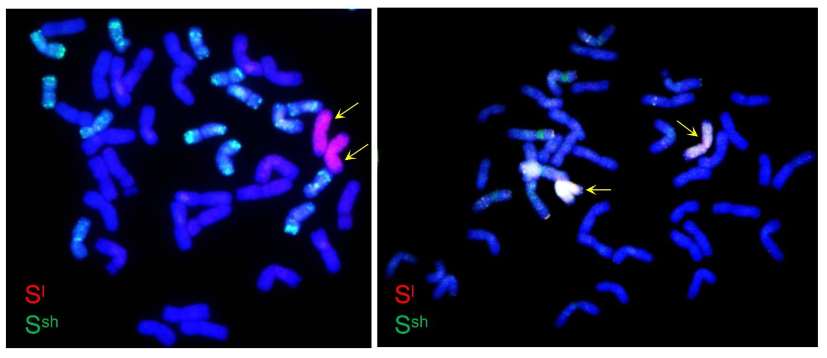
Fig. S2 GISH images of the wheat line 98M71. Genomic DNA of Ae. longissima (S^{l}S^{l}) and Ae. sharonensis (S^{sh}S^{sh}) were labelled by the Atto550 NT labelling kit (red) and Atto488 NT labelling kit (green), respectively. Yellow arrows indicate the introgressed 6S chromosomes.

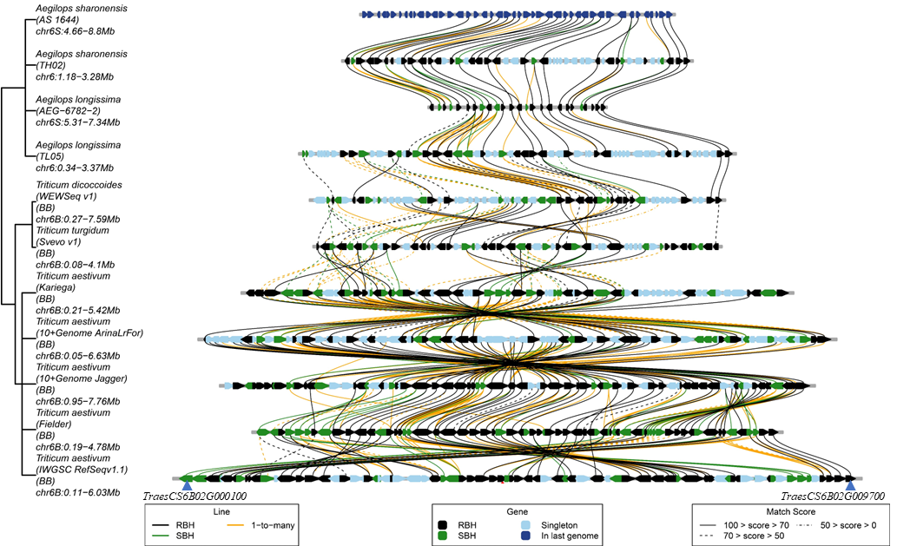

Fig. S3 Micro-collinearity analysis of the Lr53 and Yr35 candidate region among different Triticeae genomes. Candidate genes for our target region were identified from the genome sequences of Ae. sharonensis (TH02 and AS_1644), Ae. longissima (TL05 and AEG-6782-2), T. dicoccoides (Zavitan, WEW), T. durum (Svevo), and T. aestivum (Kariega, ArinaLrFor, Jagger, Fielder, CS = IWGSC). Genes are represented by pentagons. Lines indicate similarity among genes. The figure was generated using the Triticeae-GeneTribe database (http://wheat.cau.edu.cn/TGT/) (Chen et al. 2020).

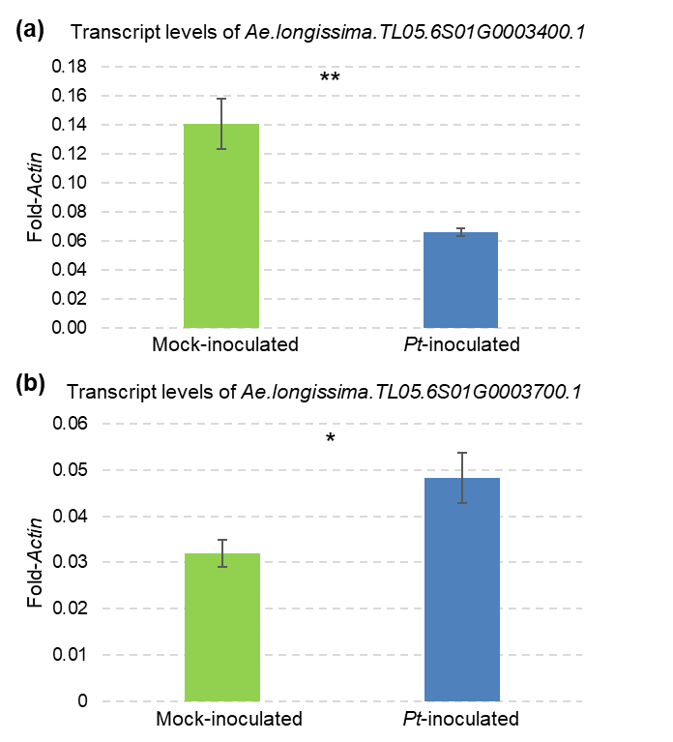
Fig. S4 Transcript levels of (a) Ae.longissima.TL05.6S01G0003400.1 and (b) Ae.longissima.TL05.6S01G0003400.1 in mock-inoculated (green) and Pt-inoculated (blue) plants of 98M71 at 6 d post-inoculation (dpi). Seedlings of 98M71 was inoculated with Pt race THDB and mock inoculated in two independent growth chambers and leaf samples from different plants were collected at 6 dpi. Transcript levels were expressed as fold-Actin (n = 4). Error bars represent standard errors of the mean. *P < 0.05; **P < 0.01.

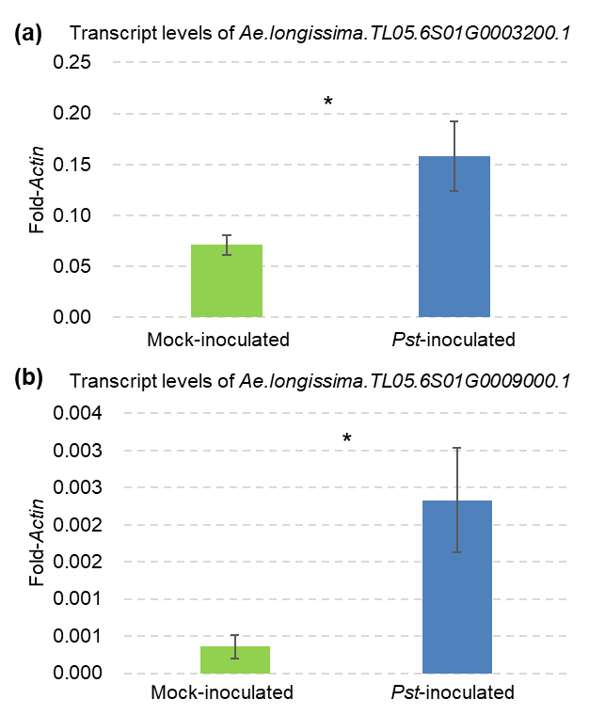
Fig. S5 Transcript levels of (a) Ae.longissima.TL05.6S01G0003200.1 and (b) Ae.longissima.TL05.6S01G0009000.1 in mock-inoculated (green) and Pst-inoculated (blue) plants of 98M71 at 6 dpi. Seedlings of 98M71 was inoculated with Pst race CYR34 and mock inoculated in two independent growth chambers and leaf samples from different plants were collected at 6 dpi. Transcript levels were expressed as fold-Actin (n = 4). Error bars represent standard errors of the mean. *P < 0.05.

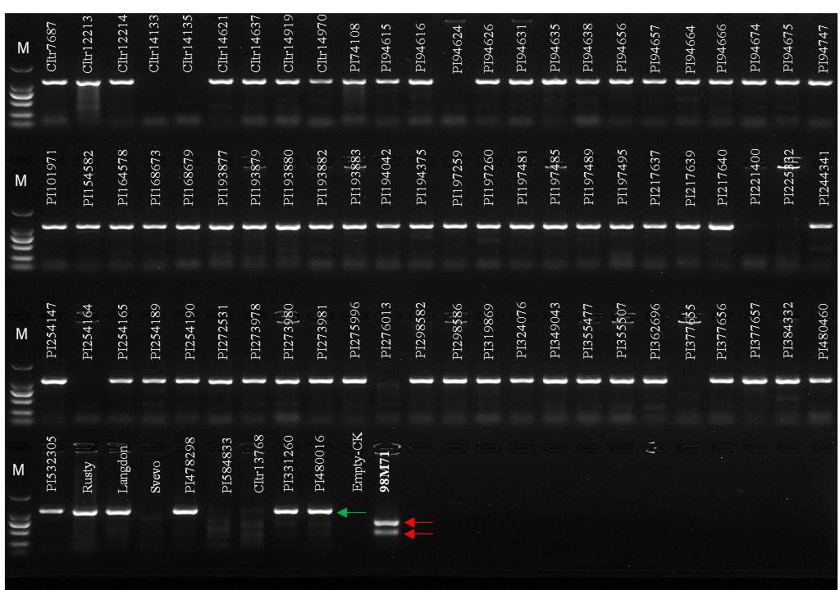
Fig. S6 PCR amplification with the marker pku6B3127 and treatment of the amplified PCR products with restriction enzyme AvaI. The bands of 418-bp and 700-bp (red arrow) are present only in the introgression line 98M71 (Table S14). No amplification product was found in 11 tested T. turgidum (e.g. PI 221400, PI225332, and PI 254164). Treatment of the amplified PCR products with restriction enzyme AvaI generated a single 1118-bp (green arrow) band for the other tetraploid wheat accessions (e.g. CItr7687, CItr12213, and CItr12214). M, DNA ladders.

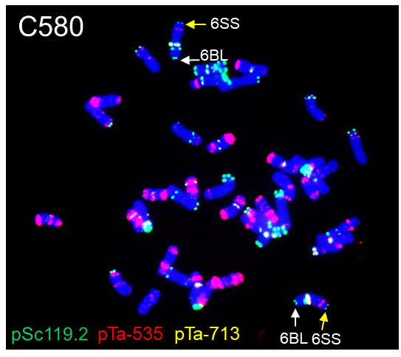
Fig. S7 Fluorescence in situ hybridization (FISH) image of the resistant recombinant line C580. Probes pSc119.2 (green), pTa535 (red), and pTa713 (yellow) were used for the hybridization experiments. Yellow arrows indicate the Oligo-pSc119.2 signals in the telomeric region of the alien chromosome arm 6SS and white arrows represent the Oligo-pSc119.2 signals in the telomeric region of wheat (CS) chromosome arm 6BL.

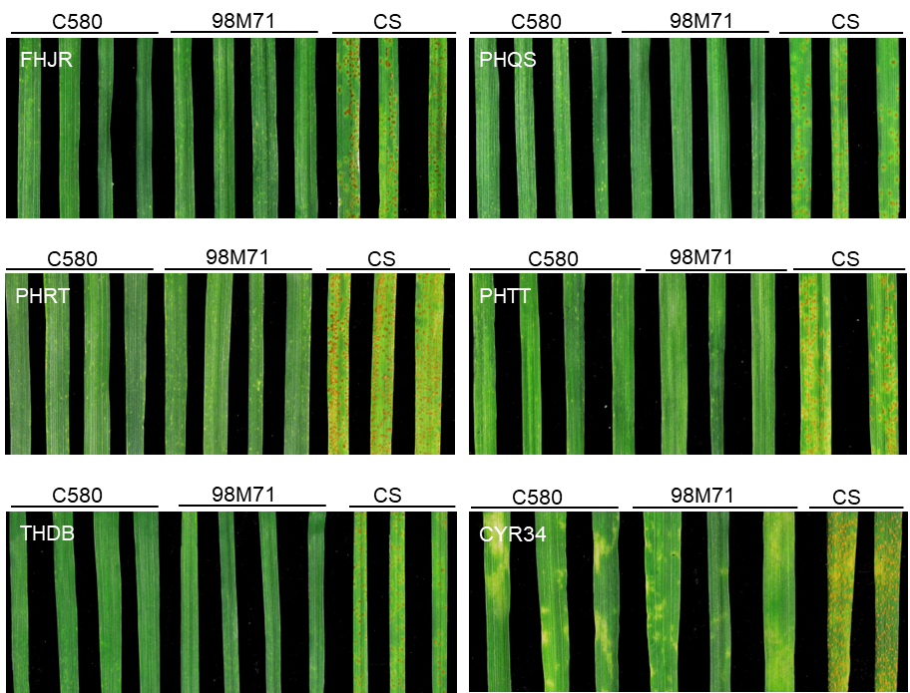
Fig. S8 Infection types observed in the recombinant line C580, the original introgression line 98M71, and the recurrent parent CS (Chinese Spring). Plants were challenged with five Pt races (FHJR, PHQS, PHRT, PHTT, and THDB) and one Pst race (CYR34).

References
Chen Y, Song W, Xie X, Wang Z, Guan P, Peng H, Jiao Y, Ni Z, Sun Q, Guo W (2020) A collinearity-incorporating homology inference strategy for connecting emerging assemblies in the Triticeae tribe as a pilot practice in the plant pangenomic era. Molecular Plant 13:1694-1708

