Apolipoprotein-1-mediated transport and regulation of MMP2 activity in the blood

Hassan Sarker^{1#}, Rashmi Panigrahi^{1#}, Ana Lopez-Campistrous², Todd McMuellen², Ken Reyes¹, Elena Anderson¹, Vidhya Krishnan¹, Samuel Hernandez-Anzaldo³, J N Mark Glover¹, Eugenio Hardy⁴, Carlos Fernandez-Patron¹*

¹Department of Biochemistry, Faculty of Medicine and Dentistry, University of Alberta.
²Department of Oncology, Faculty of Medicine and Dentistry, University of Alberta, Edmonton, AB T6G 2H7, Canada.
³Department of Inorganic Chemistry, Institute of Sciences, Benemérita Universidad Autónoma de Puebla.⁴Center of Molecular Immunology, P.O. Box 16040, Havana, Cuba.
# Equal contributions

*Correspondence:
Carlos Fernandez-Patron: cf2@ualberta.ca
Department of Biochemistry
Faculty of Medicine and Dentistry
University of Alberta
Edmonton, AB T6G 2H7, Canada

Materials and Methods
Study cohort
Human plasma: Plasma samples of six healthy adult males aged 25-35 were acquired from the Canadian BioSample Repository (CBSR), University of Alberta, Edmonton, AB, Canada. An additional plasma sample was collected from a healthy adult male aged 29 with informed consent.
Mouse plasma: Plasma from a total of fifteen different WT male mice aged 7-15 weeks (CBL57/B6) and six ApoA1 KO male mice aged 7-8 weeks were used in this study. The plasma samples were purchased from The Jackson Laboratory (Maine, US).

Materials:
- Human ApoA1 6x_His Tag (Cat# AP1-H5225, Acrobiosystems, USA)
- Apolipoprotein A1 (Cat# 178452-500UG, Sigma-Aldrich, USA)
- Recombinant Human MMP-2 6x_His Tag (Cat# NBP2-53037-50ug, Novus Biologicals, USA)
- DQ Gelatin Fluorescein Conjugate (Cat# D12054, Thermofisher Scientific, USA)
- High Density Lipoproteins, Human Plasma (Cat# 437641-10MG, Sigma-Aldrich, USA)
- BS3 (bis(sulfosuccinimidyl)suberate) (Cat# A39266, Thermofisher Scientific, USA)
- TIMP2 (Cat# SRP3174-10UG, Sigma-Aldrich, USA)
- MMP2 active (Cat# SRP3118-10UG, Sigma-Aldrich, USA)
- Apolipoprotein A2 (Cat# SRP6300-500UG, Sigma-Aldrich, USA)
- Apolipoprotein E (Cat# ab280330, Abcam, UK)
- MMP-2 (catalytic domain) (Cat# BML-SE237-0010, Enzo life sciences, USA)
- α-2-macroglobulin (Cat# SRP6314-1MG, Sigma-Aldrich, USA)
- MMP2 Polyclonal Antibody (Cat# 10373-2-AP, Thermofisher Scientific, USA)
- Fib-PEX Lys 359-Cys 660 (Cat# PDEH100254, ElabScience, USA)
- MMP2 PEX domain (Cat# G04MP02H, GiottoBiotech, Italy)
- ApoA1 antibody (Cat# Ab7614, Abcam, UK)
- ApoE antibody (Cat# ab183597, Abcam, UK)
- Cholesterol-SL assay (Cat# 234-60, Sekisui, Japan)
- Bovine Serum Albumin (Cat# A2153, Sigma-Aldrich, USA)
- Human Serum Albumin (Cat# A8763, Sigma-Aldrich, USA)
- 1X Phospohate saline buffer (PBS) (Cat# 10010023, Thermofisher Scientific, USA)
- Thin film for visual interference colour assay (Cat# STA-0023, Pavonis Diagnostics, CANADA)
Fractionation of plasma by fast protein liquid chromatography (FPLC): Fractionations were performed at the University of Alberta Faculty of Medicine & Dentistry Lipidomics Core (RRID: SCR_019176). 100 μL of EDTA-treated plasma was injected by autosampler into an Agilent 1200 high performance liquid chromatography instrument equipped with a Superose 6 Increase 10/300 gel-filtration FPLC column (Cytiva Life Sciences), which separates the intact lipoproteins by size. Separation was performed isocratically at 400 μL/min using 150 mM NaCl with 3 mM NaN 3 as the mobile phase. To maintain the same flow rate as cholesterol or triglyceride profiling, pure deionized water was also pumped into the post-column stream at a rate of 200 μL /min. Effluent was monitored in real-time at 280 nm and the data collected and analyzed using Agilent Chemstation software. 2-minute fractions were collected and stored at 4 °C within 20 minutes.
Size exclusion chromatography of MMP2 complexes with ApoA1: Active recombinant MMP2 (Cat# SRP3118-10UG, Sigma-Aldrich, USA), ApoA1 (Cat# 178452-500UG, Sigma-Aldrich, USA) or their mixture (MMP2:ApoA1 = 1:10 molar ratio) was applied on a Superdex 200 increase 5/150 GL column operated by an AKTA purifier. The column was preequilibrated with a buffer containing Tris pH 7.5, 100 mM NaCl, 3 mM CaCl₂. Fractions were collected at 2-minute intervals and were analyzed by gelatin zymography (to detect MMP2) or SDS-PAGE/WB to detect ApoA1.

Microscale thermophoresis (MST) to study MMP2-ApoA1 interaction: For the MST experiments, a concentration series of MMP2 (Cat# SRP3118-10UG, Sigma-Aldrich, USA) was prepared using a 1:1 serial dilution in buffer supplemented with 20 mM Hepes (pH 7.5), 50 mM NaCl, 3 mM CaCl₂, and 0.05% Tween 20. The range of MMP2 concentration was from 4 μM to a final 1.95 nM, over 11 serial diluted Monolith NT.115 premium capillaries (NanoTemper) with 10 μL samples. The ApoA1 (Cat# AP1-H5225, Acrobiosystems, USA) was labeled using His-tag labeling kit RED-tris-NTA 2nd generation. The interaction for MST experiments was initiated by the addition of 10 μL of 0.6 μM His tag – labeled ApoA1. Control experiments to identify the role of calcium, similar experiments were carried out with dilution buffer without calcium. The MMP2 concentration range used for these control experiments was 30 μM to 0.9 nM. The measurements were performed on a Monolith NT.115 (NanoTemper) using standard capillaries at 25 °C with 90% Excitation power, high MST power. Data were analyzed by MO. Control and MO. Affinity software (NanoTemper). The experiments were performed in triplicate.

Visual interference colour assay to study MMP2-ApoA1 interaction:
Protein deposition onto anodized alumina surface: Lyophilized MMP2, MMP2 Hemopexin-like domain or MMP2 catalytic domain were first reconstituted in deionized water and then diluted to the indicated concentrations. Typically, 18-μL drops of protein solution at varying concentrations were deposited onto 7 mm diameter circles on the surface of the thin films (Cat# STA-0023, Pavonis Diagnostics, CANADA) and incubated under 100% relative humidity at 4ºC overnight to prevent autolysis. The slide was rinsed thoroughly with deionized water. MMP2 antibody or ApoA1 were diluted in deionized water as indicated and binding to their targets was analyzed by incubation under 100% relative humidity at room temperature for 30 minutes.
Color detection: The detection of binding was photographed with the use of a polarizing film to eliminate p-polarized light off the device surface and viewed at an incidence angle of 75° to generate the strongest color contrast by matching s-polarized light reflection intensities off the alumina and underlying surfaces. The red, green, and blue (RGB) coordinate system was used to quantitatively define the visible colors. The color difference or distance (dC) was calculated according to the formula:
distance²=(R2-R1)²+(G2-G1)²+(B2-B1)².

Detection and quantitation of MMP2 protein amounts and activity: MMP2 protein and/or activity were detected and quantitated using western immunoblotting, in-gel gelatin zymography assay, in-solution gelatinase assay (fluorescein-conjugated gelatin as substrate, Cat# D12054, Thermofisher Scientific, USA) and multiplex protein detection assays following protocols previously described by us^{1,2}. MMP2 lysis bands in zymograms were quantitated by densitometry scanning using the ImageJ software (NIH, USA).

Detection and quantitation of Apolipoproteins: ApoA1 and ApoE in FPLC/SEC fractions of mouse or human plasma were detected by western immunoblotting following electrophoretic separation by SDS-PAGE using their respective antibodies: ApoA1 antibody (Cat# Ab7614, Abcam, UK) and ApoE antibody (Cat# Ab183597, Abcam, UK). Immunoblot protein bands were quantitated by densitometry scanning using the ImageJ software (NIH, USA).

Quantitation of cholesterol in FPLC/SEC fractions: Total cholesterol in SEC fractions were measured using a cholesterol-SL assay (Cat# 234-60, Sekisui, Japan) following the manufacturer’s instructions. Fractions were mixed with the cholesterol reagent at a 1:10 ratio (v/v) and incubated at 25°C for 20 minutes before reading absorbance at 505 nm.

2D BN-PAGE/Gelatin zymography to separate MMP2/HDL complex:
Sample preparation: Recombinant active MMP2 (Cat# SRP3118-10UG, Sigma-Aldrich, USA) at a final concentration of 0.4 µM was added to increasing concentrations (0 µM, 0.4 µM, 4 µM, and 8 µM) of HDL (Cat# 437641-10MG, Sigma-Aldrich, USA) in separate tubes. The final volume was brought up to 20 µL with 1x enzyme buffer (0.05 M Tris-HCl (pH 7.4), 0.15 M NaCl, 0.013 M CaCl2, 0.003 NaN3). The samples were incubated at 25°C for 30 minutes. The loading buffer (75 mM 6-aminocaproic acid, 15 mM BisTris, 0.3% Coomassie blue G-250 (Cat# 35050, Serva, USA)) was then added to the samples before loading onto the gel.
Blue-Native PAGE: Our Blue-Native PAGE protocol was adapted from standard BN-PAGE protocols previously described by Wittig et al.³ and Thangthaeng et al.⁴. Gels were prepared with 4.7 mL gel buffer solution (500 mM 6-aminocaproic acid, 50 mM BisTris (pH 7.1)), 1.2 mL of 40% Acrylamide/bisacrylamide (crosslinking ratio: 29:1) (Cat# 161-0146, Bio-rad, USA), 45 µL 10% (w/v) ammonium persulfate, 3 µL TEMED (Cat# T9281-25ML, Sigma-Aldrich, USA). The anode buffer was composed of 50 mM BisTris (pH 7.1), and the cathode buffer was composed of 50 mM tricine, 15 mM BisTris (pH 7.1), 0.025% Coomassie blue G-250. Then the electrophoretic separation of the proteins/complexes was performed. The individual lanes were excised and placed on a 10% acrylamide gelatin zymography gel for a second dimensional separation and detection of MMP2 or on a 10% acrylamide SDS-PAGE followed by western immunoblot to detect HDL (by immunodetection of ApoA1).

Chemical cross-linking of MMP2 and its interactors: Active recombinant MMP2 (Cat# SRP3118-10UG, Sigma-Aldrich, USA) was pre-incubated with vehicle (1x PBS with 500 µM O-phenanthroline) or interactor proteins including ApoA1 (Cat# 178452-500UG, Sigma-Aldrich, USA), ApoA2 (Cat# SRP6300-500UG, Sigma-Aldrich, USA), ApoE (Cat# ab280330, Abcam, UK), Albumin (Cat# A8763, Sigma-Aldrich, USA), α-2-macroglobulin (Cat# SRP6314-1MG, Sigma-Aldrich, USA) or TIMP2 (Cat# SRP3174-10UG, Sigma-Aldrich, USA) at a 1:5 molar ratio (MMP2:interactor) for 60 minutes on ice followed by addition of freshly prepared 5 mM BS3 (bis(sulfosuccinimidyl)suberate) solution (in 1x PBS) and incubation at 25°C for 30 minutes. After the incubation, the reaction was quenched by adding 50 mM Tris-HCl (pH 7.4). The reaction mixtures were analyzed by gelatin zymography to detect MMP2 and MMP2 complexes.

In silico Structural Modeling:
The Artificial Intelligence (AI) system, AlphaFold, developed by DeepMind, was used to model the structures of active MMP2 homodimer, proMMP2-Timp2 heterodimer, active MMP2-Timp2 heterodimer, MMP2-ApoA1 heterodimer and FibPEX-ApoA1 heterodimer. AlphaFold incorporates both physical and biological understandings of protein structure by integrating multi-sequence alignments into the framework of its deep learning algorithm. AlphaFold, has been ranked as more accurate than competing methods by the Critical Assessment of protein Structure Prediction (CASP) experiments⁵. CASP is a biennially held gold standard assessment for the accuracy of structure prediction⁶. AlphaFold2-multimer⁷ was executed within a Colab notebook v1.5.3^{5,8}, leveraging Amber99sb force fields⁹, to meticulously ensure the peptide bond geometry's accuracy after prediction. This resulted in the complex adopting a more relaxed structural configuration. Each run used the multimer_V2 weights, 48 cycles and yielded 5 models. The AlphaFold2 used MMseq2 algorithm. The plots showing the sequence coverage information used in modeling can be found in the supplemental section. The structures were analyzed using PyMOL v.2.5.4 (Schrödinger, LLC.).
AlphaFold assessed the intra-domain confidence or the quality of protein as a per residue pLDDT score. Models with scores > 90 are high confidence. Models with scores < 70 are low confidence. The predicted template modeling score (pTM) represent the global confidence score and depends on the quality of template used for modeling. The pTM score >0.5 is considered high enough to make inference. The PAE plot indicates the interdomain confidence where higher score indicates better prediction accuracy (Supplementary Figure 18).

Validation of AlphaFold method by comparing AlphaFold generated models with existing x-ray crystallography data:
The crystal structure of human proMMP2 (PDB: 1CK7) illustrates the existence of three domains: the catalytic domain, followed by three fibronectin-like repeats, and the C-terminal hemopexin domain (Supplementary Figure 15B)¹⁰. The catalytic site of MMP2 contains three conserved histidine residues sequentially as His-Glu-X-X-His-X-X-Gly-X-X-His¹¹ that coordinate the catalytic zinc ion (Supplementary Figure 26A). The glutamate residue within this motif activates zinc-bound water which acts as a nucleophile to cleave peptide bonds. The pro form of MMP2 contain an N-terminal propeptide Ser³² – Asn¹⁰⁹ (Supplementary Figure 15C) which is cleaved to generate active MMP2.
To confirm the precision of the AlphaFold-generated models for MMP2 in complex with its interactors, we first examined the side chain orientations of the MMP2 amino acids responsible for coordinating and positioning the metal ions using proMMP2 crystal structure (PDB: 1CK7) as a reference structure. In this crystal structure there are two zinc ions and four calcium ions. Despite not receiving any information about the position of these metal ions, AlphaFold accurately positioned the side chains on the output model (Supplementary Figure 26B-F), providing confidence in the protocol and predicted model.
MMP2 forms a homodimer both in pro and active form. In the absence of an experimental structure the active MMP2 dimer model predicted by this AI-based modeller had high confidence scores (86.6 (pLDDT) and 0.525 (pTM)) (Supplementary Figures 16-18). These scores did not improve even after providing templates comprising of crystal structures of active MMP2 or proMMP2. The presence of PEX domain led to slight reorientation of the MMP2 dimer interaction interface, in contrast to the proMMP2 crystal structure (PDB: 1CK7), however has a cavity for the propeptide (Supplementary Figure 19A-B).

Validation of our AlphaFold workflow using reported MMP2 - TIMP2 complex crystal structure:
To validate our AlphaFold workflow, and evaluate the model confidence, we modeled the TIMP2 – proMMP2 complex with and without template and compared the model with the reported crystal structure of TIMP2 bound to the C-terminal PEX domain of proMMP2 (PDB: 1GXD)¹² (Supplementary Figure 25A-B). The template did not significantly affect the confidence scores, confirming our modeling protocol. The pLDDT and the pTM scores for the TIMP2 – proMMP2 complex were 90.3 and 0.859 respectively. The crystal structure and the modeled structure superimposed on each other completely with an RMSD (root mean square deviation) of 1.9 Å (Supplementary Figure 25A). Interaction interface between MMP2 PEX domain and the C-terminal of TIMP2 comprises of hydrogen bonding and salt bridge interactions (Supplementary Figure 25B and Supplementary Table 5).
Furthermore, we generated AlphaFold models of TIMP2 and active MMP2 using PDB100 template database in AlphaFold in the absence of any reported crystal structure of the complex (Supplementary Figure 25C). TIMP2 shares an interaction interface with the catalytic domain and the PEX domain of active MMP2 which is held in place by hydrogen bonds and salt bridges (Supplementary Figure 25D-E and Supplementary Table 6). The model had high pLDDT (89.1) and pTM (0.826) scores indicating high confidence of the model (Supplementary Figure 12D, Supplementary Figure 26, Supplementary Figure 27). The model showed that TIMP2 binds and blocks the catalytic site of active MMP2, consistent with the known function of TIMP2 as an inhibitor of MMP2 (Figure 5A).

AlphaFold workflow for MMP2 - ApoA1 and Fib-PEX - ApoA1 complex
Experimental structures for the ApoA1 – MMP2 complex are yet to be deciphered. To elucidate the structural basis of ApoA1 interactions with MMP2, we used a crystal structure of lipid-free human ApoA1 (PDB: 1AV1) (25) as template for AlphaFold modeling. The model had higher scores only when the template was provided i.e., 73.1 (pLDDT) and 0.676 (pTM). The confidence scores of the ApoA1-MMP2 complex interaction interface ranged between 60 – 80 (pLDDT), denoted by the green color for the b-factor palette on the AlphaFold model (Supplementary Figure 20). The prediction scores for Fib-PEX – ApoA1 were 57 (pLDDT) and 0.517 (pTM), which were low compared to that observed for active MMP2 – ApoA1 heterodimer (Supplemental Figure 23-24, Supplementary Table 4).

Statistical Analyses
SigmaPlot 14.0 (Systat Software, San Jose, CA) was used to conduct statistical analysis on the results and plot graphs. We performed one way ANOVA, where appropriate (as indicated in the figure legends), to determine statistical significance in the difference when comparing two conditions. For all experiments, the n value presented in the figure legends refer to distinct and independent sample measurements. Data are presented as mean ± standard error of mean.

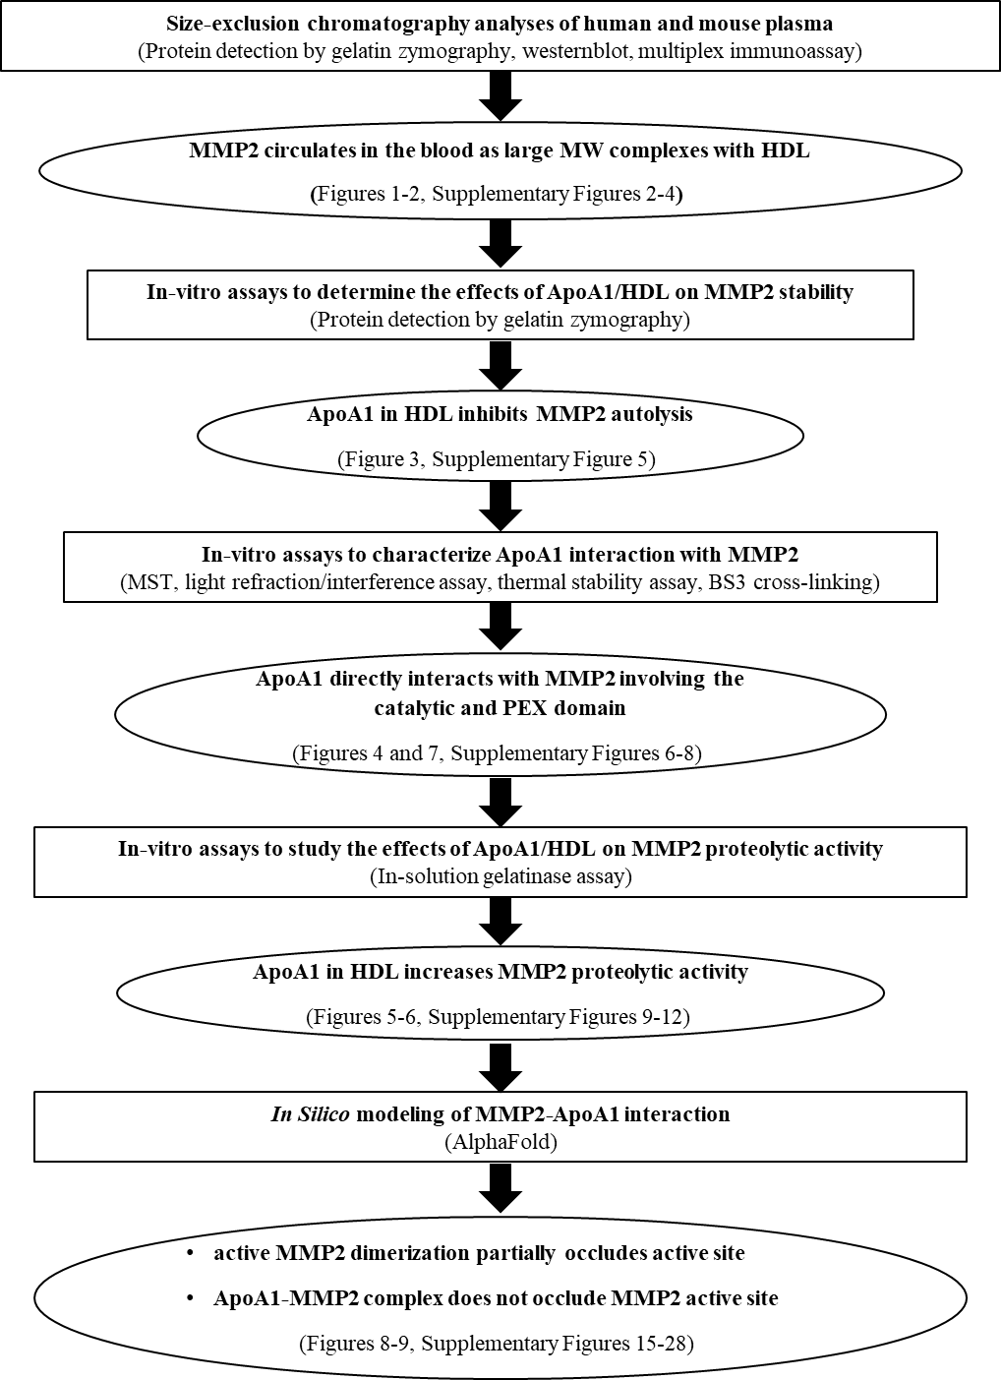

Supplementary Figure 1: Flow diagram showing the experimental approach in this study.

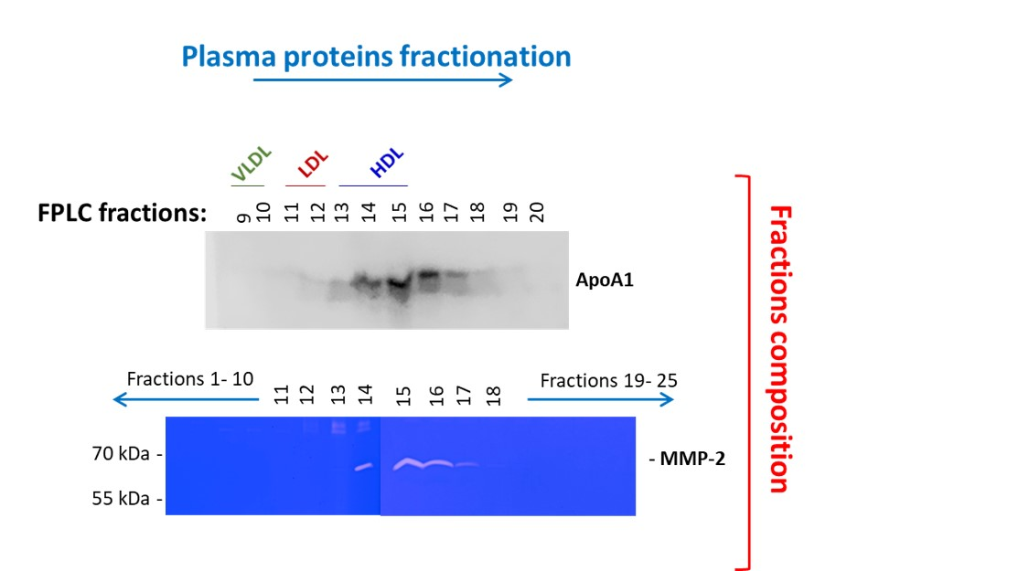

Supplementary Figure 2: FPLC analyses of human plasma show that MMP2 co-fractionates with ApoA1. (A) A pooled sample of plasma from healthy adult human donors (n=5) was subjected to FPLC (size-exclusion) fractionation and the fractions were analyzed for presence of ApoA1 (by western immunoblot) and MMP2 (in-gel gelatin zymography).

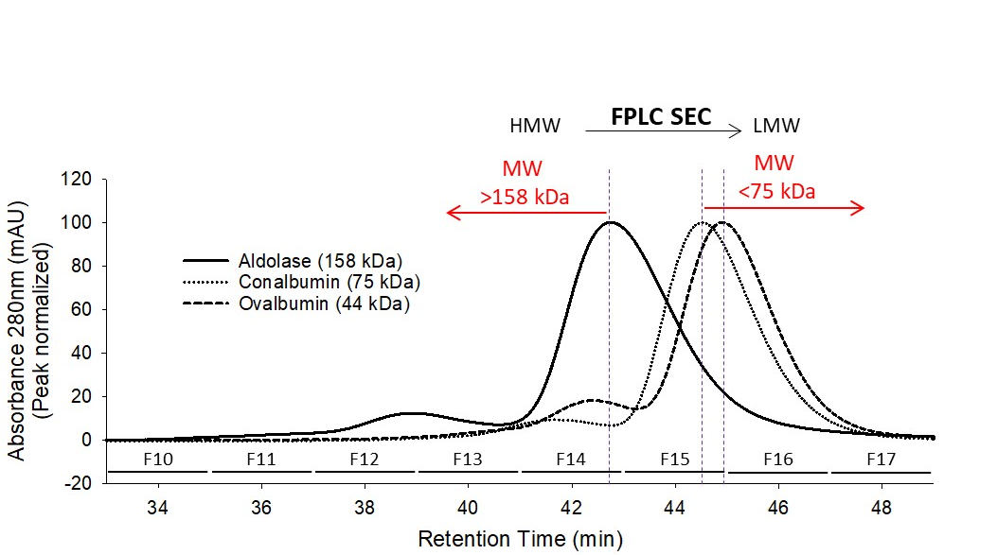

Supplementary Figure 3: FPLC traces of standard proteins for reference of molecular weights in collected fractions.

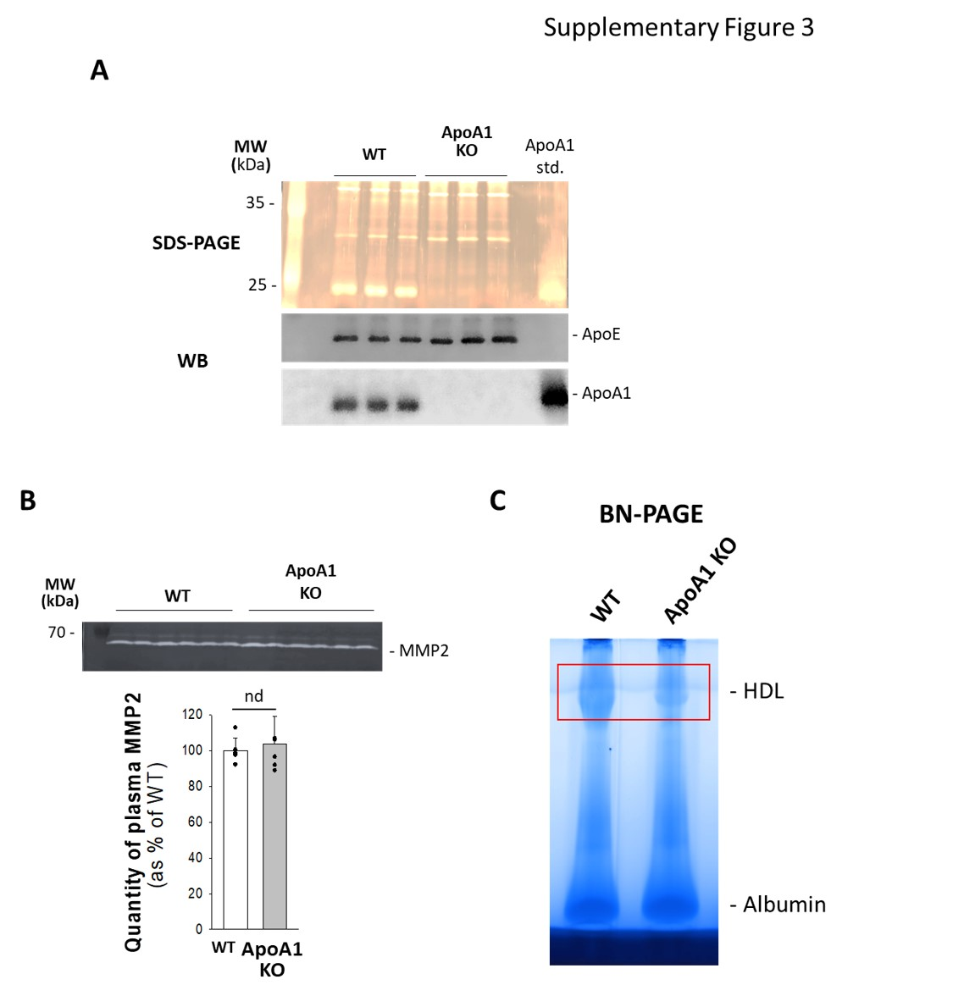

Supplementary figure 4: Analysis of ApoA1 KO and WT mouse plasma. (A) SDS-PAGE and WB analyses of mouse plasma confirming absence of ApoA1 in the plasma of ApoA1 KO mice compared to WT. (B) Quantitation of plasma MMP2 in ApoA1 KO and WT mice by gelatin zymgraphy. (C) 1D BN-PAGE of WT and ApoA1 KO mouse plasma.

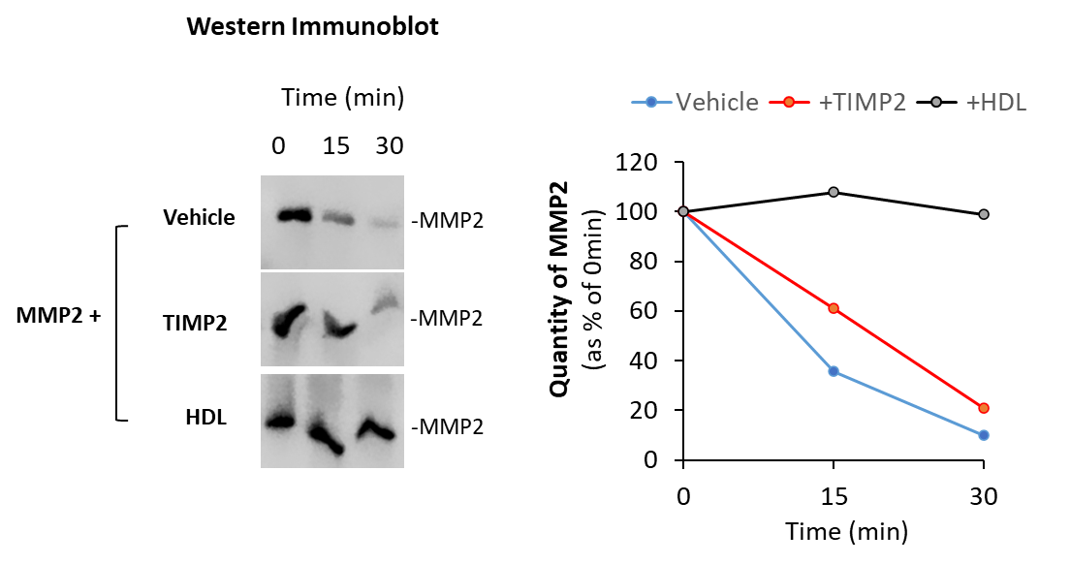

Supplementary Figure 5: The effect of vehicle, TIMP2 or HDL on the autolysis of MMP2. Recombinant active MMP2 was incubated with vehicle or HDL at a 1:10 (MMP2 : reagent) molar ratio and incubated at 37°C for 0, 30 or 60 minutes followed by detection of MMP2 by SDS-PAGE/ Western immunoblot.

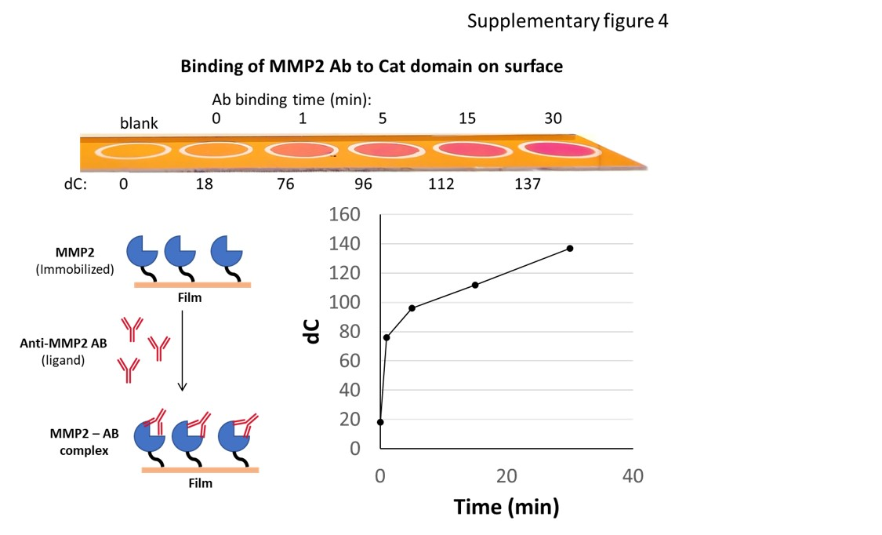

Supplementary Figure 6: visual interference colour binding assay validation using the binding of MMP2 antibody to MMP2 catalytic domain.

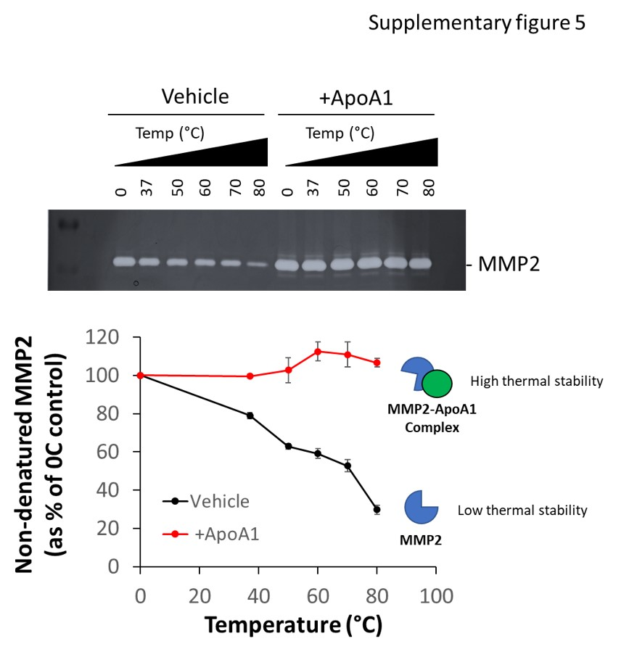

Supplementary Figure 7: Thermal stability assay demonstrating the effect of ApoA1 on the thermal stability of recombinant active MMP2.

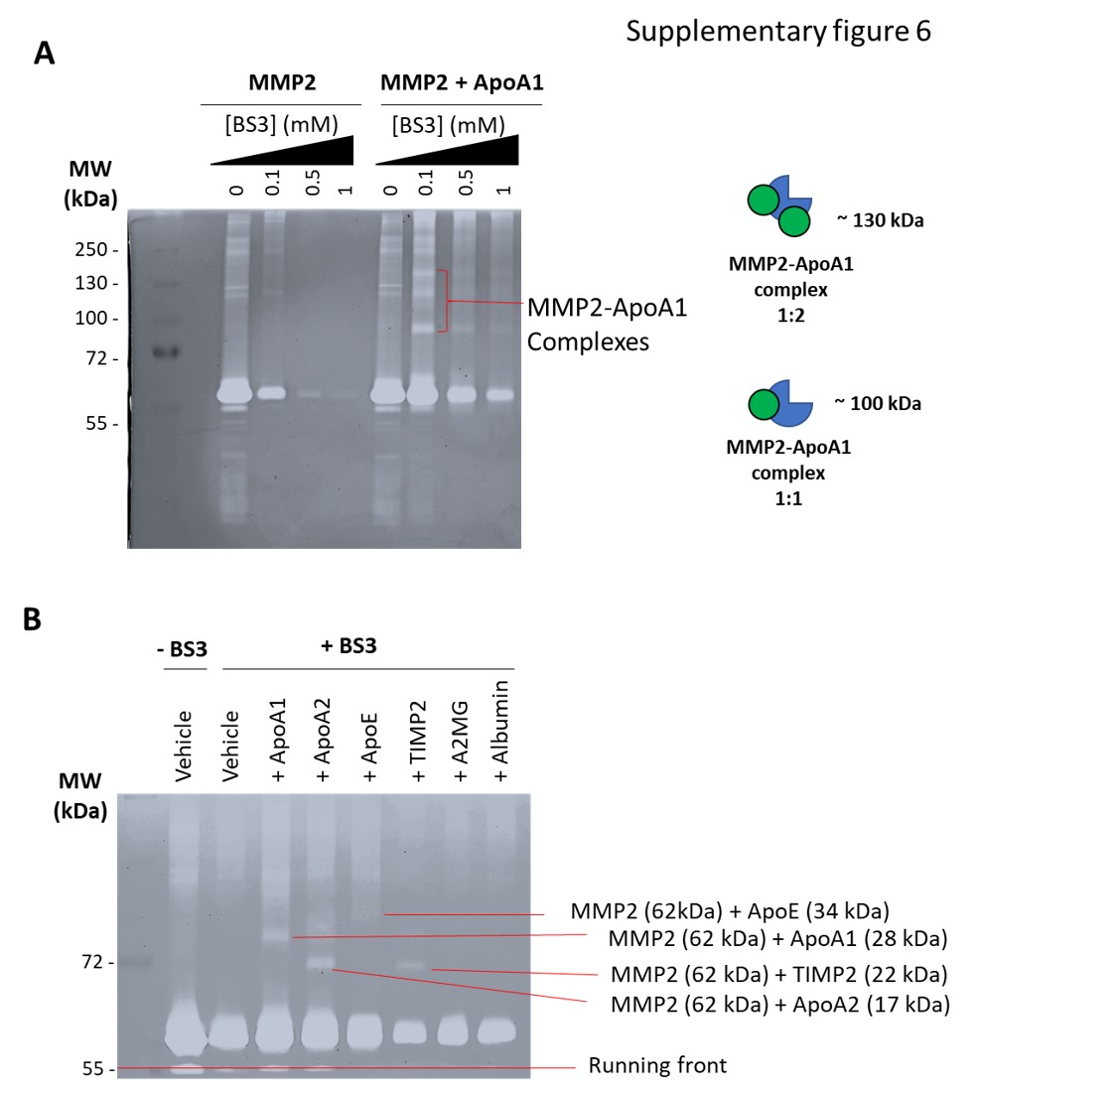

Supplementary figure 8: Chemical cross-linking experiments to determine the stoichiometry of MMP2-Apolipoprotein complexes. (A) Zymogram showing MMP2 complexes formed with BS3 cross-linker in the absence or presence of ApoA1. (B) Zymogram showing MMP2 complexes formed with BS3 cross-linker in the presence of ApoA1, ApoA2, ApoE, TIMP2, A2MG or Albumin.

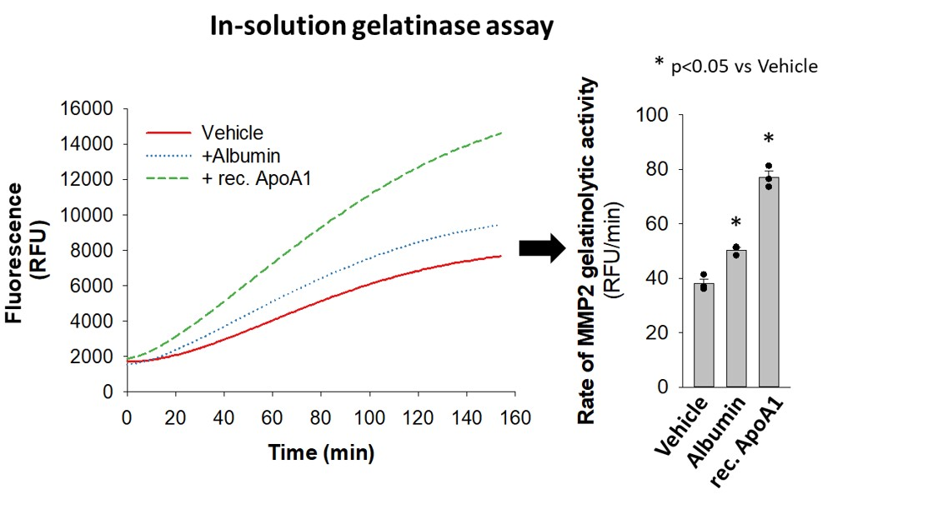

Supplementary Figure 9: Quantitation of MMP2 activity using in-solution gelatinase assay in the presence of vehicle, Albumin or recombinant ApoA1.

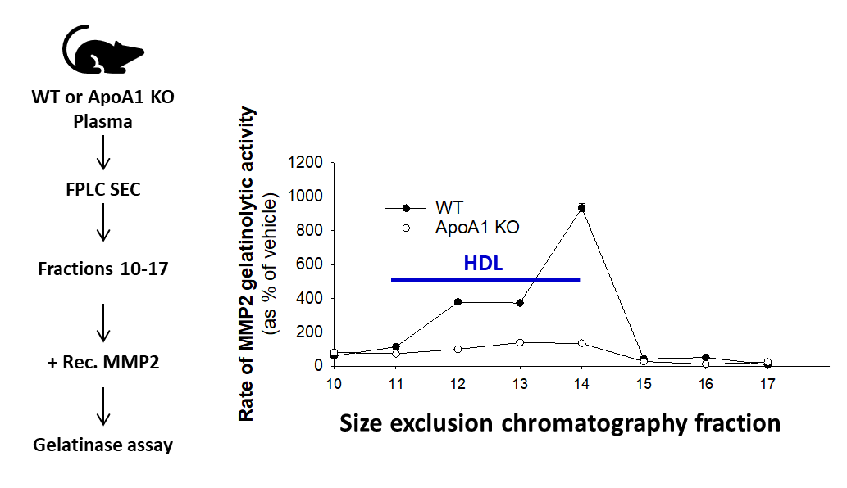

Supplementary Figure 10: WT or ApoA1 KO mice plasma were subjected to size-exclusion chromatography fractionation and a range of fractions including fractions containing HDL were added separately to recombinant active MMP2 and gelatinolytic activity was measured. The line plot compares the effect of the selected WT and ApoA1 KO fractions on the rate of MMP2 gelatinolytic activity.

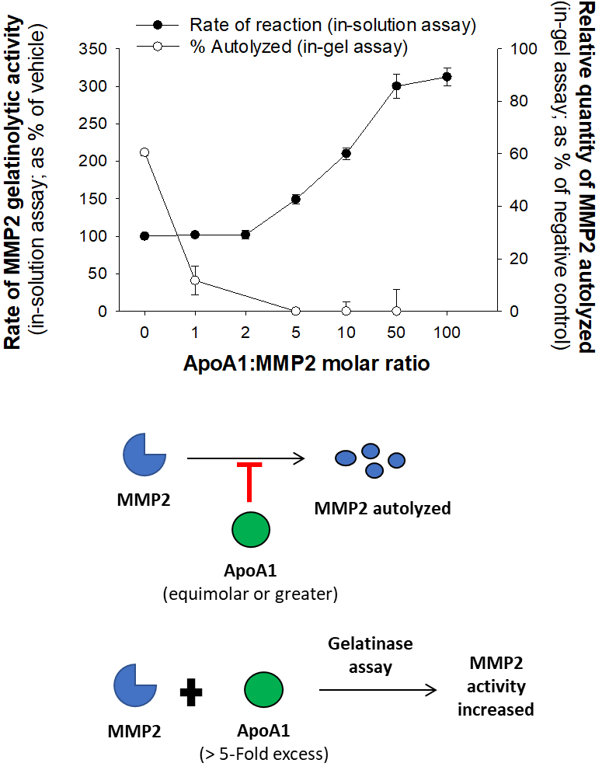

Supplementary Figure 11: Line-plots showing the effect of increasing concentrations of ApoA1 on the proteolytic activity of MMP2 (measured by in-solution gelatinase assay) and inhibition of MMP2 autolysis (measured by in-gel zymography). Measurements were taken at least in triplicates. Data presented as mean ± standard error.

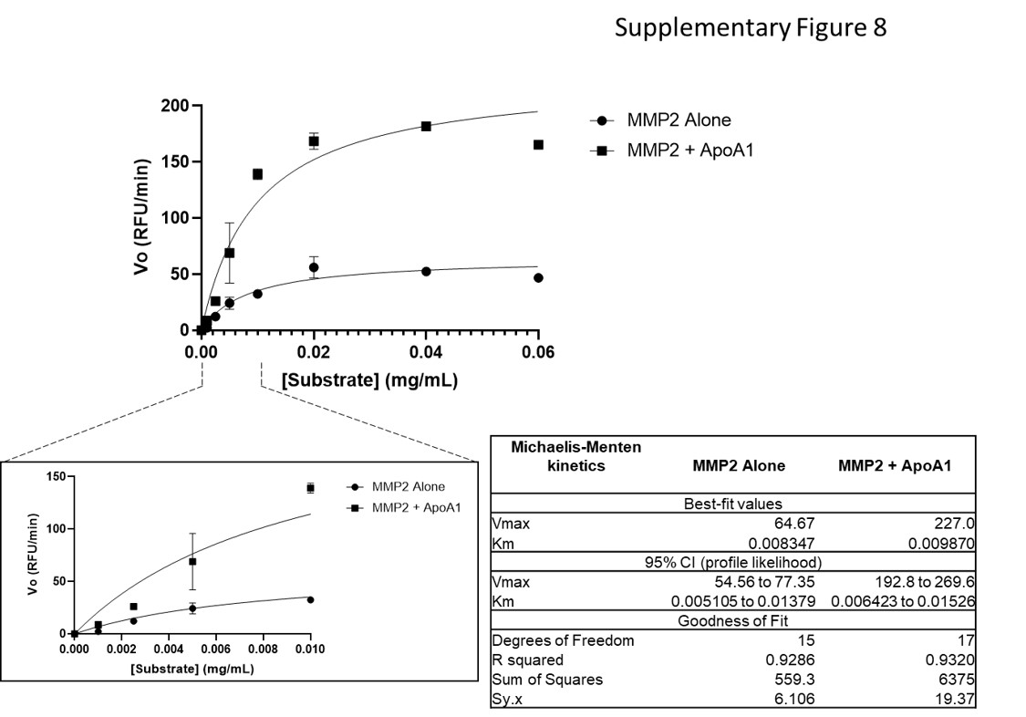

Supplementary Figure 12: Kinetic analyses of the effect of ApoA1 on MMP2 activity. MMP2 proteolytic activity was measured in the presence of vehicle or ApoA1 (at 1:10 molar ratio) with increasing concentration of substrate (fluorescein-conjugated gelatin). The data was fit into Michaelis-Menten model and presented as line/scatter plots. Measurements were taken at least in triplicates. Data presented as mean ± standard error.

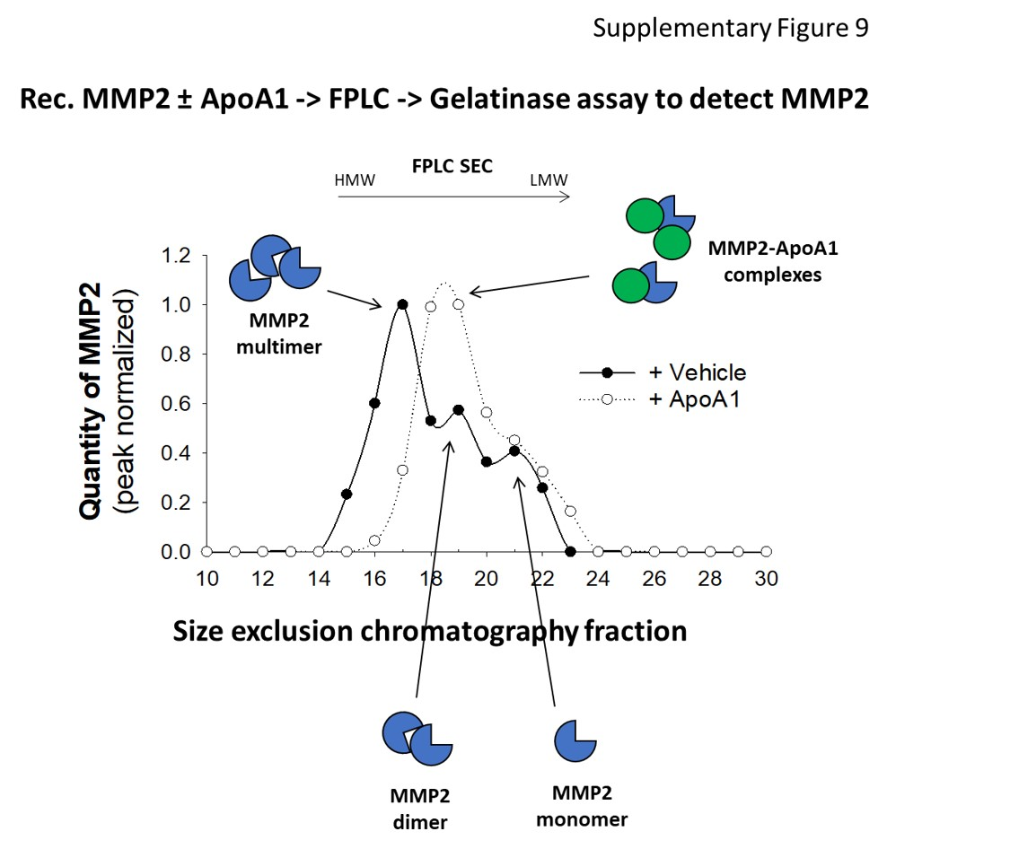

Supplementary Figure 13: Size exclusion chromatography trace of MMP2 with vehicle or ApoA1. The protein mixtures were applied on a Superdex 200 increase 5/150 GL column operated by an AKTA purifier. The column was pre-equilibrated with a buffer containing Tris pH7.5, 100 mM NaCl, 3 mM CaCl2.

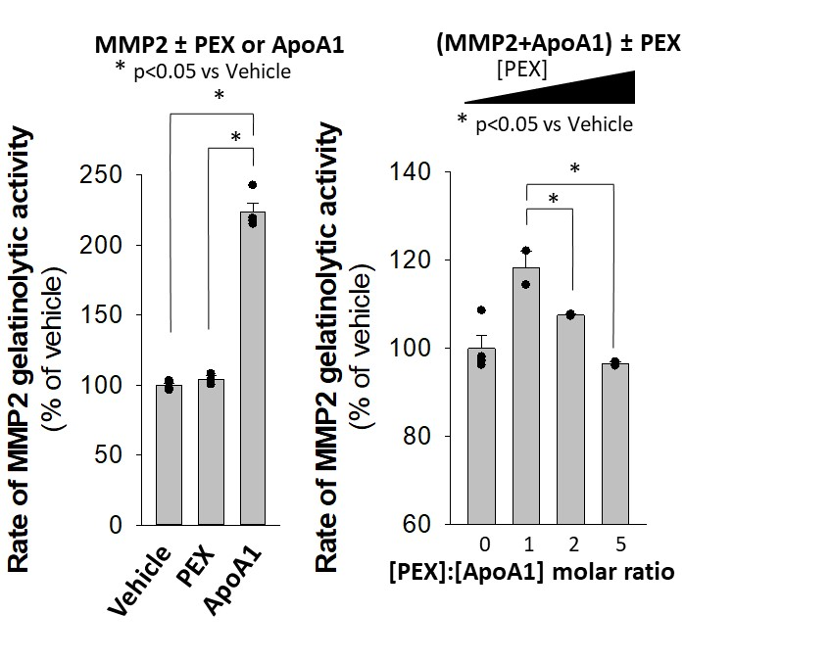

\\

\

Supplementary Figure 14: The effect of PEX on the proteolytic activity of MMP2 in the presence or absence of ApoA1.

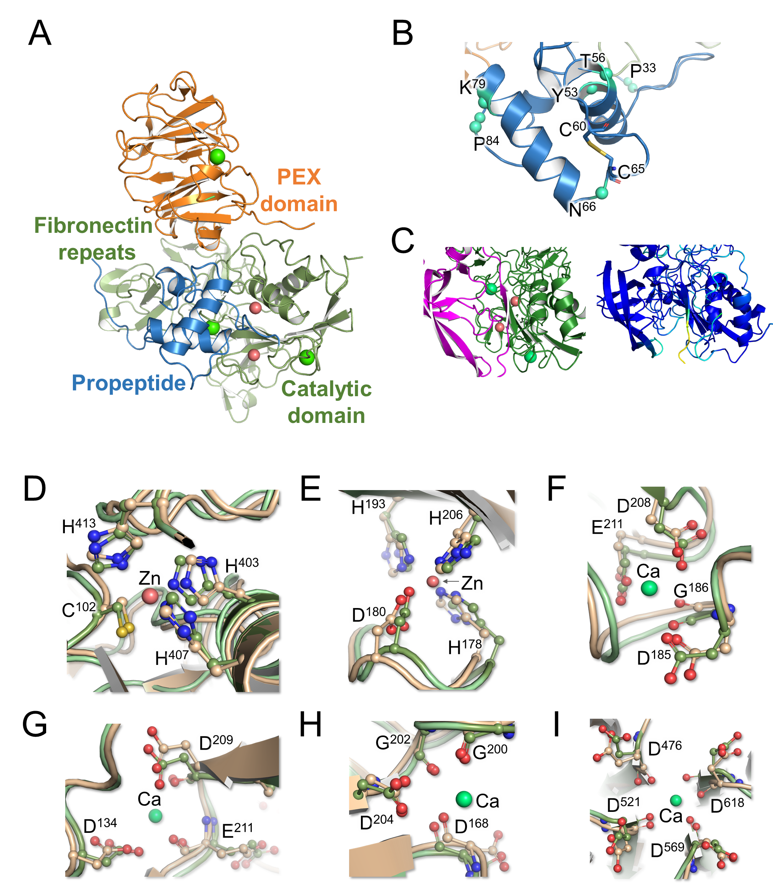

Supplemental Figure 15. Structural insights into proMMP2.
(A) Domain organization of proMMP2 (PDB: 1CK7). The crystal structure of proMMP2 is shown with its various domains highlighted ie., Propeptide (blue), catalytic domain and fibronectin repeat (green) and PEX domain (orange). The calcium and zinc ions are shown in green and salmon red respectively. Inset shows the domain organization of proMMP2 with annotated residue numbers. (B) Propeptide (Ser32 – Asn109) cleavage sites crucial for generating active MMP2. The cleavage sites (Pro33, Tyr53, Thr56, Asn66, Lys79, Pro84) are in the loop regions that connect the three helices in the propeptide. The loops containing Cys60 – Cys65 disulphide bond and the one between F81 – I94 are cleaved during the autoproteolytic activation to form active MMP2 (C) Zoom in view on TIMP2 (pink) blocking the catalytic site of active MMP2 (green). The inset in right shows the interface with the pLDDT coloring. The interface coloring shows high confidence of AlphaFold model. (D-I) Validation of the AlphaFold model (wheat) for MMP2. The crystal structure of MMP2 (PDB: 1CK7) is used as the reference structure (green color). Orientation of the coordinating residues around catalytic Zinc (D), non-catalytic zinc (E) and four calcium ions (F, G, H and I) are shown. The location of the metals, Zinc (deep salmon color) and Calcium (green) are indicated as spheres.

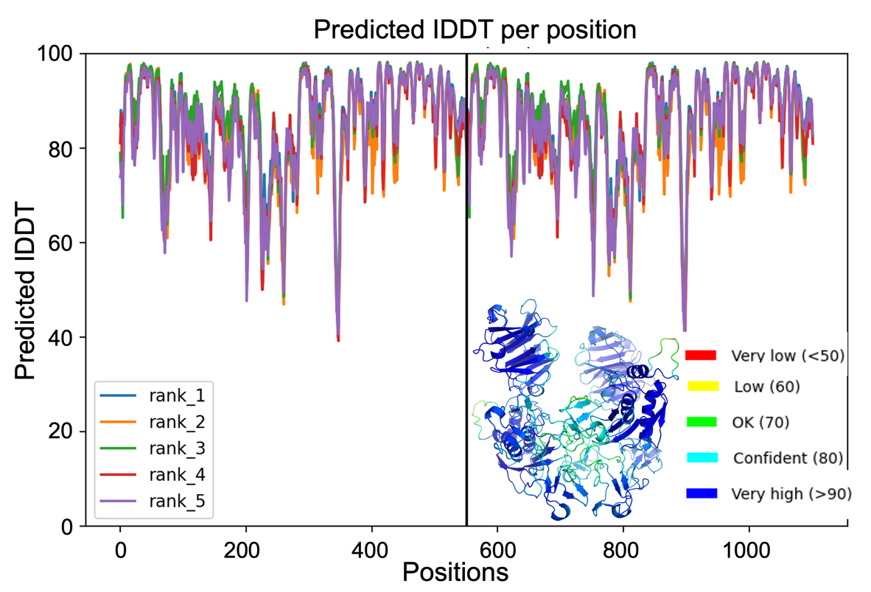

Supplemental Figure 16: The predicted IDDT scores for all residues of the five predicted structures for active MMP2 homodimer. The top-ranking structure used for the analysis is shown as inset. The color code used in the structure is the b-factor palette for AlphaFold shown as inset. AlphaFold assessed the intra-domain confidence or the quality of protein as a per residue pLDDT score. Models with scores > 90 are high confidence. Models with scores < 70 are low confidence. The overall pLDDT score of the selected homodimer model was 86.6 (good confidence). The inset shows this complex colored based on the pLDDT score.

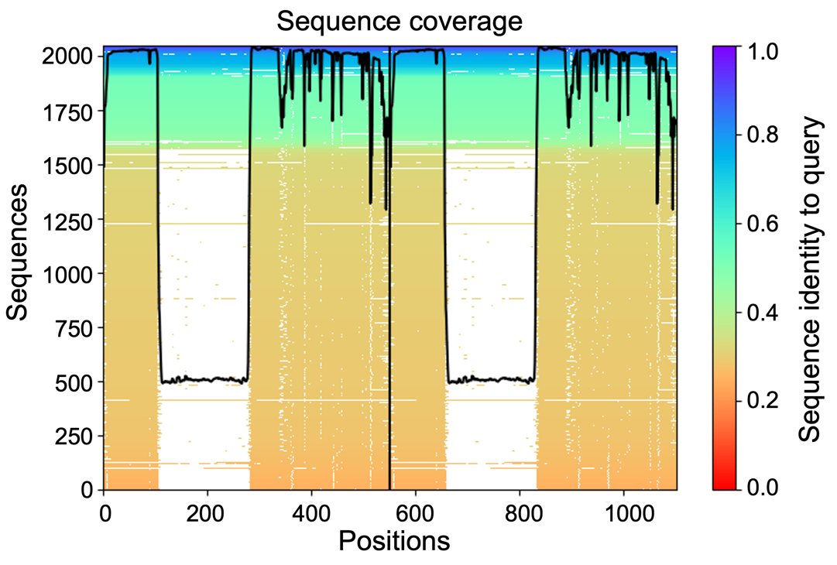

Supplementary Figure 17: Plot for active MMP2 homodimer predicted by AlphaFold shows the relative coverage of its sequence with respect to total number of aligned sequence.
The predicted template modeling score (pTM) represent the global confidence score and depends on the quality of template used for modeling. The pTM score >0.5 is considered high enough to make inference. The pTM value for the selected MMP2 homodimer was 0.525 and presence of template did not improve this value.

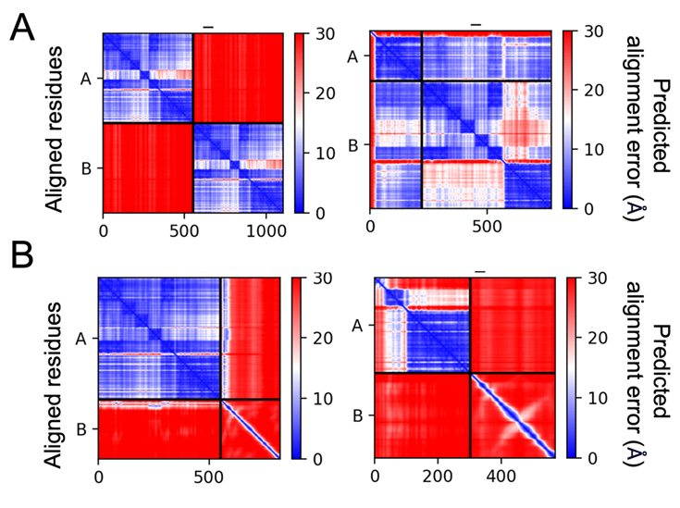

Supplementary Figure 18: The plots show the predicted aligned error for each of the five models predicted by AlphaFold. The predicted aligned error (PAE) is used to measure the average distance between the predicted and true residue positions in a protein structure. Higher PAE score indicates better prediction accuracy. (A) Active MMP2 homodimer (left panel) and Active MMP2 – TIMP2 heterodimer (right panel); (B) Active MMP2 - ApoA1 complex (left panel) and Fib-PEX – ApoA1 (right panel).

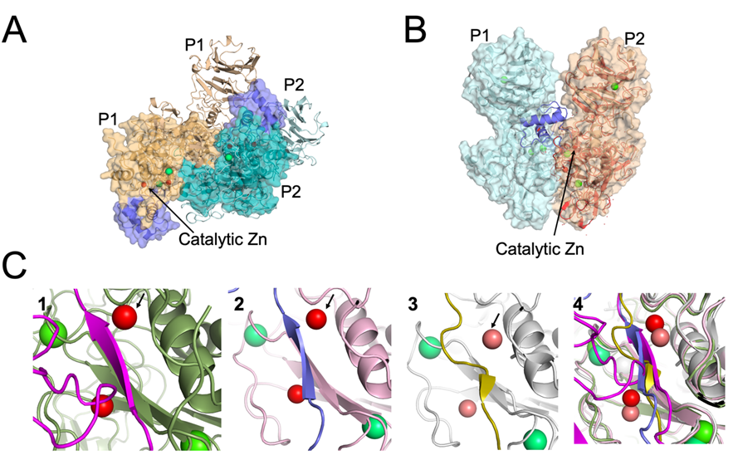

Supplementary Figure 19: Overall structural analysis of AlphaFold models.
(A) Overlay of crystal structure of proMMP2 dimer (PDB: 1EAK) without PEX domain (surface representation) on AlphaFold-generated active MMP2 dimer with PEX domain (cartoon representation). Propetide is shown in slate blue. Protomer (P) from both complexes are marked. Zinc and calcium ions are shown in red and lime green respectively.
(B) AlphaFold generated model of active homodimer can partially accommodate propeptide. Active MMP2 homodimer are shown in surface representation. The crystal structure of proMMP2 (PDB: 1CK7) in red was overlayed on the P2 protomer of the dimer to verify the positioning of the propeptide (blue).
(C) Interaction interface of catalytic site of MMP2 for TIMP2 (pink), ApoA1 (blue), APPIP inhibitor peptide (dirty yellow) shown in insets 1, 2 and 3 respectively. Overlay of all structures of MMP2 Position of catalytic zinc is pointed with black arrow. Calcium ions are shown in lime green.
Our analysis suggests that MMP2 homodimer in the presence of PEX domain may adopt similar conformation in the presence or absence of the propeptide occluding the active site and limiting the substrate accessibility which could lead to reduced activity.

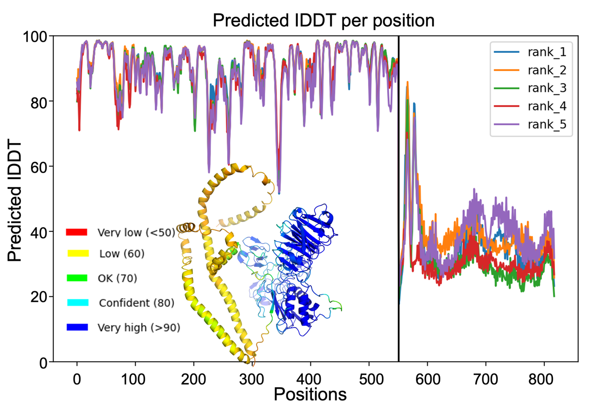

Supplementary Figure 20: The predicted IDDT scores for all residues of the five predicted structures for active MMP2-ApoA1 heterodimer. The top-ranking structure used for the analysis is shown as inset. The color code used in the structure is the b-factor palette for AlphaFold shown as inset.

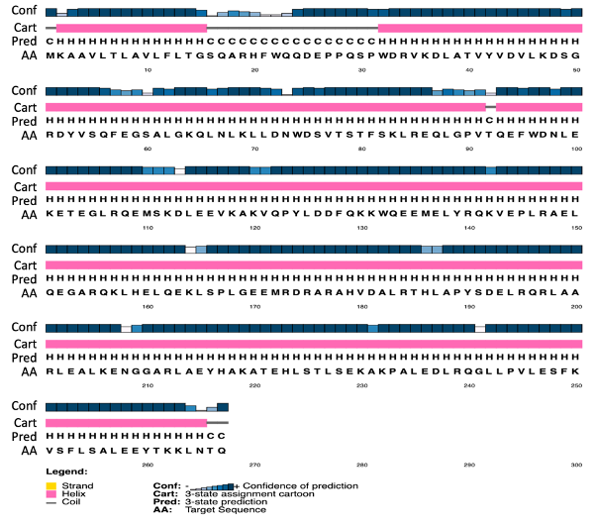

Supplemental Figure 21: Secondary structure prediction of human ApoA1 as an output of PSSpred. The amino acid sequence (AA), confidence score (conf) and prediction of helix (H) and coil (C) are shown.

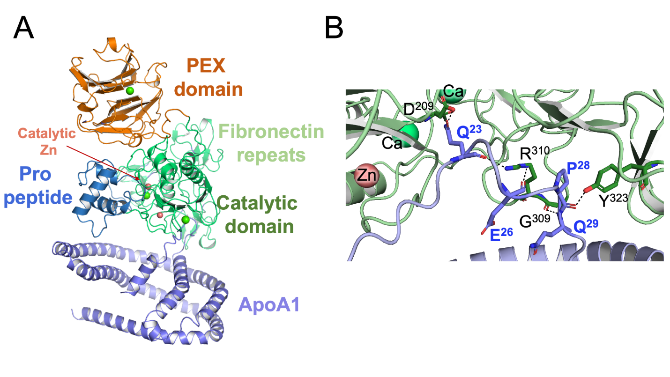

Supplemental Figure 22: Interaction of proMMP2 with ApoA1. A. Structure of the complex modeled using AlphaFold; B. Interaction interface of the two partners. Catalytic zinc and all domains are color coded. ApoA1 interacts with proMMP2 at a distinctly different site compared to that observed with active MMP2.

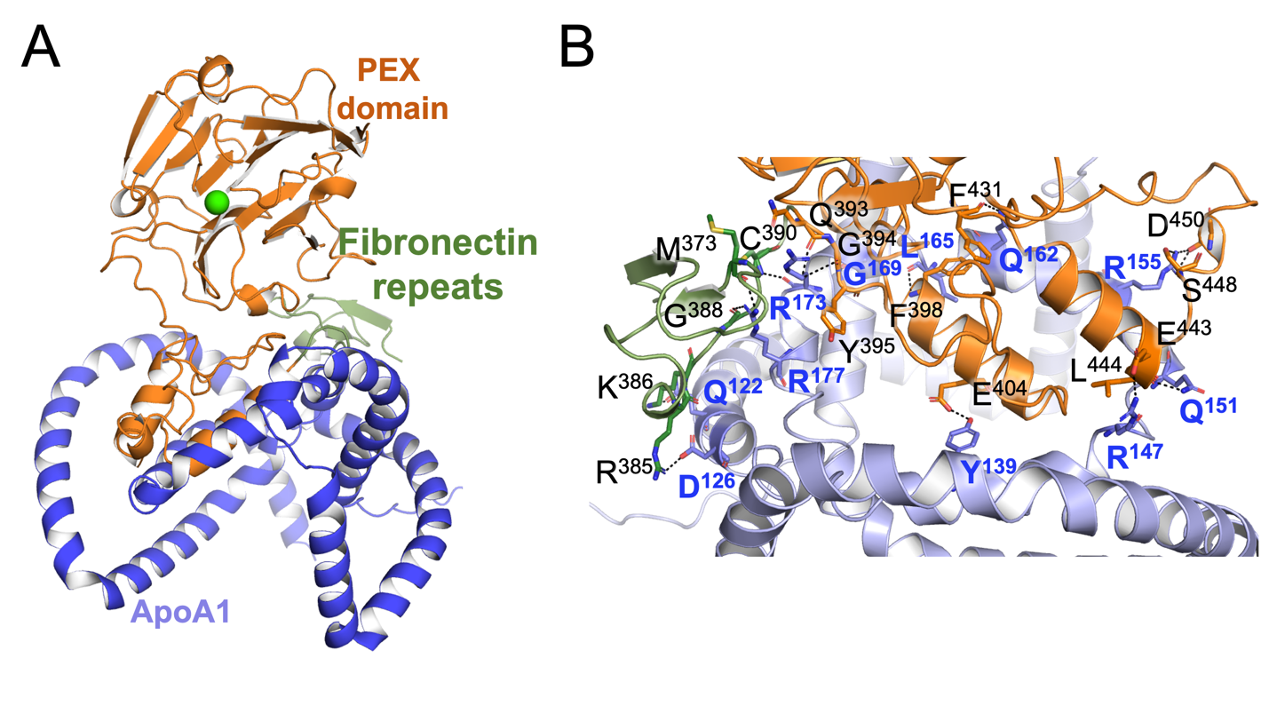

Supplemental Figure 23: Fib-PEX-ApoA1 complex modelled using AlphaFold. A. PEX, Fibronectin and ApoA1 are color coded. B. The interacting residues forming the interface of ApoA1 between PEX/Fibronectin are highlighted in blue and black fonts respectively. The bonding atoms are connected by black dash lines.

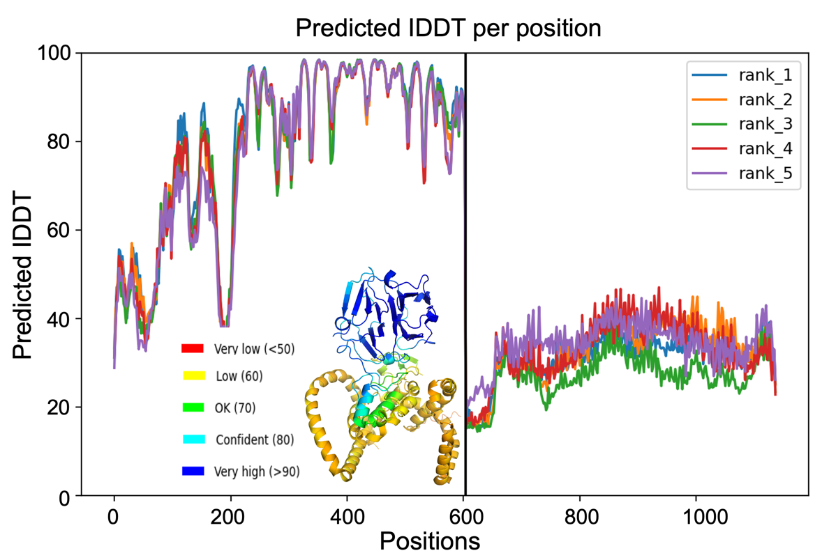

Supplemental Figure 24: The predicted IDDT scores for all residues of the five predicted structures for the Fib-PEX- ApoA1 heterodimer. The top-ranking structure used for the analysis is shown as inset. The color code used in the structure is the b-factor palette for AlphaFold shown as inset.

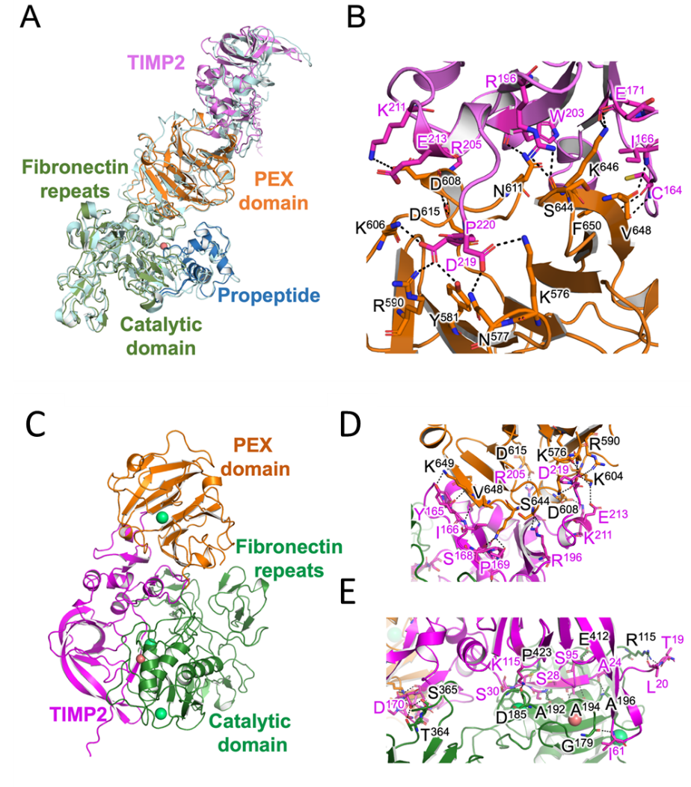

Supplementary Figure 25: Structure of TIMP2-proMMP2 complex. (A) The crystal structure of the complex (cyan) and the AlphaFold output are superimposed. The different domains of the complex are color coded. (B) Some residues forming the interaction interface are displayed for TIMP2 (pink fonts) and proMMP2 (black fonts). The bonding atoms are connected by black dash lines.
(C-E) TIMP2-activeMMP2 complex modeled using AlphaFold. (C) The domains of MMP2 are color coded along with catalytic zinc ions (salmon red) and structural calcium ions (light green). TIMP2 is shown in pink. (D) The interacting residues forming the interface of TIMP2 between the PEX domain of MMP2 are highlighted in pink and black fonts respectively. (E) The interacting residues forming the interface of TIMP2 between the catalytic domain of MMP2 are highlighted in pink and black fonts, respectively. The bonding atoms are connected by black dash lines. The N-terminal segment Leu20 – Ser30 forms an antiparallel beta sheet and forms interchain hydrogen bond interaction with its partner from the catalytic domain of MMP2 encompassing residues Leu191 – Ala196.

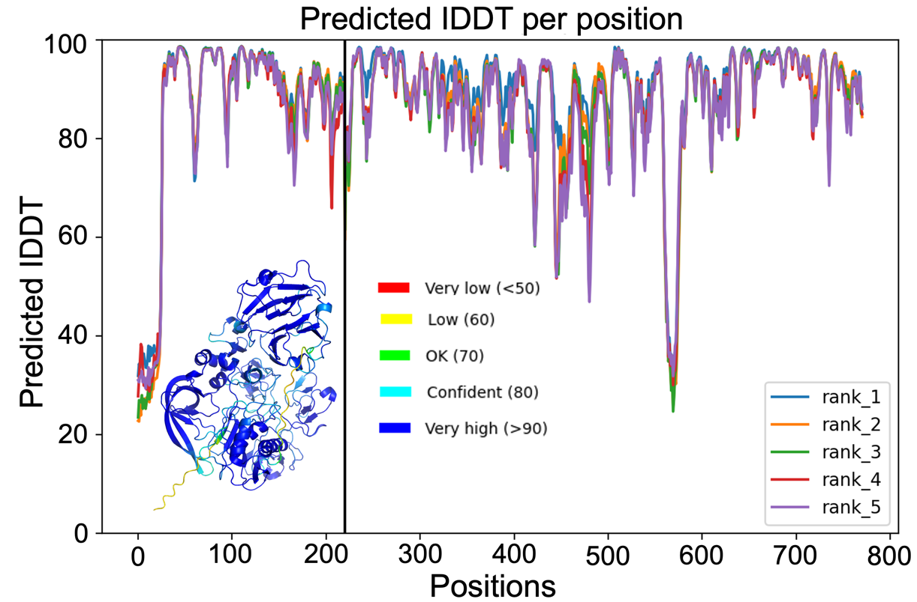

Supplemental Figure 26: Predicted IDDT per position for all residues of TIMP2 – activeMMP2 complex in the relaxed structure. The inset shows pLDDT coloring for the complex showing that the predicted structure has high confidence. The pLDDT and pTM scores indicated the high confidence score for the predicted model.

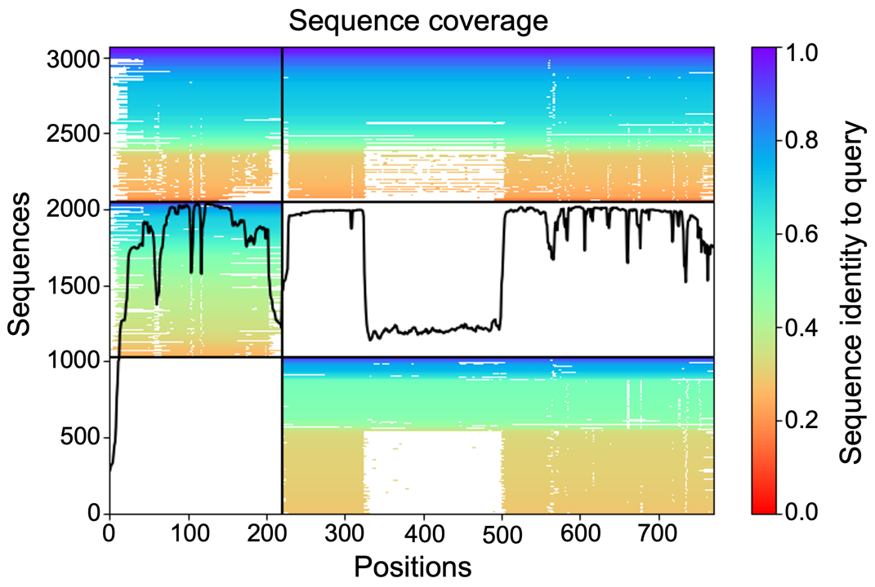

Supplementary Figure 27: Sequence coverage plot for TIMP2 – active MMP2 heterodimer predicted by AlphaFold.

Tables
Supplementary Table 1: Residues forming the interaction interface of proMMP2 homodimer without PEX domain.
ProMMP2 | ProMMP2 | ProMMP2 | ProMMP2
Hydrogen bonds |  | Salt bridges
Gln²⁹⁸ | Glu¹⁷⁷ | Arg²⁹⁶ | Asp²⁰⁹
Arg²⁹⁶ | Asp²⁰⁹ | Arg²⁹⁶ | Arg²¹⁰
Arg²⁹⁶ | Asp²¹⁰ | Arg¹⁷⁵ | Asp³²²
Arg¹⁷⁵ | Gln²⁹⁸ | Asp³²² | Arg¹⁷⁵
Thr³⁰⁶ | Thr³⁰⁰ | Asp³²⁴ | Arg¹⁷⁵
Asp³⁰³ | Ser³⁰¹ | Asp²⁰⁹ | Arg²⁹⁶
Ser³⁰⁴ | Ser³⁰¹ | Asp²¹⁰ | Arg²⁹⁶
Ser³⁰¹ | Ser³⁰⁴
Arg¹⁷⁵ | Asp³²²
Arg¹⁷⁵ | Asp³²⁴
Gln²⁹⁸ | Arg¹⁷⁵
Asp³²² | Arg¹⁷⁵
Asp³²² | Trp¹⁷⁶
Asp²⁰⁹ | Arg²⁹⁶
Ser³⁰¹ | Ser³⁰³
Ser³⁰³ | Ser³⁰¹

Table 2: Residues from interaction interface of active MMP2 homodimer. It has been shown using alanine substitution followed by MMP2 activity studies that fibronectin repeats are crucial for substrate (gelatin) positioning and gelatinolysis. Alanine mutations of residues Arg³⁶⁸, Phe²⁹⁷, Arg²⁵² from the three fibronectin repeats were found to decrease the activity of the enzyme. Analysis of our model show that Q²⁹⁸ which is next to the above-mentioned residues is involved in proMMP2 dimer formation. This suggest that F²⁹⁷ is not completely available for gelatin substrate positioning, supporting the observation regarding reduced activity in MMP2 dimer.
MMP2 | MMP2
Hydrogen bonds
Gln²⁹⁸ | Gln²⁹⁸
Asn³⁴³ | Glu¹⁷⁷
Tyr³⁸¹ | Gly¹⁸¹
Arg³⁸⁵ | Asp¹⁸⁰
Gly³⁶⁷ | Tyr¹⁸²
Gln²⁹⁸ | Gln²⁹⁸
Glu¹⁷⁷ | Asn³⁴³

Supplementary Table 3: Residues of MMP2 and ApoA1 that form hydrogen bonds and one salt bridge to form the interacting interface as predicted by AlphaFold.
MMP2 | ApoA1
Hydrogen bonds
Ala¹⁹⁶ | Phe¹²
Ala¹⁹⁴ | Thr¹⁴
Leu¹⁹¹ | Ser¹⁶
Tyr⁴²⁵ | Gln¹⁷
Gly²³³ | Asp²⁵
Arg³⁶⁸ | Glu²⁶
Tyr³⁸¹ | Pro²⁸
Ala¹⁹⁴ | Thr¹⁴
Glu⁴⁰⁴ | Ser¹⁶
Pro⁴²³ | Gln¹⁷
Gly¹⁸⁹ | Ala¹⁸
Thr⁵¹¹ | Arg¹⁹
Gly³⁶⁷ | Gln²⁹
Arg³⁶⁸ | Arg³⁴
Glu³⁶⁷ | Arg³⁴
Salt bridge
Arg³⁸⁵ | Asp³³

Supplemental Table 4: Residues of Fib-PEX and ApoA1 that form hydrogen bonds and salt bridges to form the interacting interface as predicted by AlphaFold.
Fib-PEX | ApoA1 | Fib-PEX | ApoA1
Hydrogen bonds |  | Salt bridges
Lys³⁸⁶ | Gln¹²² | Arg³⁸⁵ | Asp¹²⁶
Arg³⁸⁵ | Asp¹²⁶ | Glu⁴⁴³ | Arg¹⁴⁷
Phe³⁹⁸ | Leu¹⁶⁵ | Asp⁴⁵⁰ | Arg¹⁵⁵
Tyr³⁹⁵ | Gly¹⁹⁶
Cys³⁹⁰ | Arg¹⁷³
Glu⁴⁰⁴ | Tyr¹³⁹
Glu⁴⁴³ | Arg¹⁴⁷
Leu⁴⁴⁴ | Gln¹⁵¹
Ser⁴⁴⁸ | Arg¹⁵⁵
Asp⁴⁵⁰ | Arg¹⁵⁵
Phe⁴³¹ | Gln¹⁶²
Gln³⁹³ | Arg¹⁷³
Gly³⁹⁴ | Arg¹⁷³
Met³⁷³ | Arg¹⁷⁷
Gly³⁸⁸ | Arg¹⁷⁷

Supplementary Table 5: The residues forming the interface between TIMP2 and proMMP2.
TIMP2 | proMMP2
Hydrogen bonds
Cys¹⁶⁴ | Phe⁶⁵⁰
Ile¹⁶⁶ | Val⁶⁴⁸
Arg¹⁹⁶ | Ser⁶⁴⁴
Arg²⁰⁵ | Asp⁶¹⁵
Pro¹⁶⁹ | Lys⁶⁴⁶
Glu¹⁷¹ | Lys⁶⁴⁶
Trp²⁰³ | Asn⁶¹¹
Asp²¹⁹ | Lys⁵⁷⁶
Asp²¹⁹ | Asn⁵⁷⁷
Pro²²⁰ | Arg⁵⁹⁰
Pro²²⁰ | Tyr⁵⁸¹
Pro²²⁰ | Lys⁶⁰⁴
Salt bridges
Arg²⁰⁵ | Asp⁶¹⁵
Lys²¹¹ | Asp⁶⁰⁸
Glu²¹³ | Lys⁶⁰⁴
Asp²¹⁹ | Lys⁵⁷⁶
Pro²²⁰ | Arg⁵⁹⁰
Pro²²⁰ | Lys⁶⁰⁴

Supplementary Table 6: Residues forming the interaction interface between TIMP2 and active MMP2.
TIMP2 | Active MMP2 | TIMP2 | Active MMP2
Hydrogen bonds |  | Salt bridges
Ile⁶¹ | Gly¹⁷⁹ | Lys¹¹⁵ | Asp¹⁸⁵
Lys¹¹⁵ | Asp¹⁸⁵ | Lys²¹¹ | Asp⁶⁰⁸
Ser³⁰ | Gly¹⁹⁹ | Arg²⁰⁵ | Asp⁶¹⁵
Ser²⁸ | Ala¹⁹² | Glu²¹³ | Lys⁶⁰⁴
Ala²⁶ | Ala¹⁹⁴ | Pro²²⁰ | Arg⁵⁹⁰
Ser¹⁶⁸ | Cys³⁶³ | Pro²²⁰ | Lys⁶⁰⁴
Ser⁹⁵ | Glu⁴¹²
Cys²⁹ | Pro⁴²³
Lys²¹¹ | Asp⁶⁰⁸
Arg²⁰⁵ | Asp⁶¹⁵
Arg¹⁹⁶ | Ser⁶⁴⁴
Ile¹⁶⁶ | Val⁶⁴⁶
Cys¹⁶⁴ | Phe⁶⁵⁰
Thr¹⁹ | Arg¹¹⁵
Leu²⁰ | Arg¹¹⁵
Ala²⁴ | Ala²⁸³
Ala²⁶ | Ala²⁸¹
Cys²⁷ | His⁴⁰³
Ser²⁸ | Leu¹⁹¹
Cys²⁹ | Tyr⁴²⁵
Cys¹⁶⁴ | Phe⁶⁵⁰
Tyr¹⁶⁵ | Lys⁶⁴⁹
Ser¹⁶⁸ | Lys⁶⁴⁶
Pro¹⁶⁹ | Lys⁶⁴⁶
Asp¹⁷⁰ | Ser³⁶⁵
Asp¹⁷⁰ | Thr³⁶⁴
Glu¹⁷¹ | Lys⁶⁴⁶
Asp²¹⁹ | Lys⁵⁷⁶
Asp²¹⁹ | Asn⁵⁷⁷
Pro²²⁰ | Arg⁵⁹⁰
Pro²²⁰ | Tyr⁵⁸¹
Pro²²⁰ | Lys⁶⁰⁴

References
1 Sarker, H. et al. Identification of fibrinogen as a natural inhibitor of MMP-2. Sci Rep 9, 4340 (2019). https://doi.org/10.1038/s41598-019-40983-y
2 Sarker, H. et al. Comparative Serum Analyses Identify Cytokines and Hormones Commonly Dysregulated as Well as Implicated in Promoting Osteolysis in MMP-2-Deficient Mice and Children. Front Physiol 11, 568718 (2020). https://doi.org/10.3389/fphys.2020.568718
3 Wittig, I., Braun, H. P. & Schagger, H. Blue native PAGE. Nat Protoc 1, 418-428 (2006). https://doi.org/10.1038/nprot.2006.62
4 Thangthaeng, N., Sumien, N., Forster, M. J., Shah, R. A. & Yan, L. J. Nongradient blue native gel analysis of serum proteins and in-gel detection of serum esterase activities. J Chromatogr B Analyt Technol Biomed Life Sci 879, 386-394 (2011). https://doi.org/10.1016/j.jchromb.2010.12.026
5 Jumper, J. et al. Highly accurate protein structure prediction with AlphaFold. Nature 596, 583-589 (2021). https://doi.org/10.1038/s41586-021-03819-2
6 Kryshtafovych, A., Schwede, T., Topf, M., Fidelis, K. & Moult, J. Critical assessment of methods of protein structure prediction (CASP)-Round XIII. Proteins 87, 1011-1020 (2019). https://doi.org/10.1002/prot.25823
7 Richard Evans, M. O. N., Alexander Pritzel, Natasha Antropova, Andrew Senior, Tim Green, Augustin Žídek, Russ Bates, Sam Blackwell, Jason Yim, ProfileOlaf Ronneberger, Sebastian Bodenstein, Michal Zielinski, Alex Bridgland, Anna Potapenko, Andrew Cowie, Kathryn Tunyasuvunakool, Rishub Jain, Ellen Clancy, Pushmeet Kohli, John Jumper, Demis Hassabis. Protein complex prediction with AlphaFold-Multimer. bioRxiv (2022). https://doi.org/10.1101/2021.10.04.463034
8 Bisong, E. Building Machine Learning and Deep Learning Models on Google Cloud Platform: A Comprehensive Guide for Beginners., (2019).
9 Hornak, V. et al. Comparison of multiple Amber force fields and development of improved protein backbone parameters. Proteins 65, 712-725 (2006). https://doi.org/10.1002/prot.21123
10 Morgunova, E. et al. Structure of human pro-matrix metalloproteinase-2: activation mechanism revealed. Science 284, 1667-1670 (1999). https://doi.org/10.1126/science.284.5420.1667
11 Ra, H. J. & Parks, W. C. Control of matrix metalloproteinase catalytic activity. Matrix Biol 26, 587-596 (2007). https://doi.org/10.1016/j.matbio.2007.07.001
12 Morgunova, E., Tuuttila, A., Bergmann, U. & Tryggvason, K. Structural insight into the complex formation of latent matrix metalloproteinase 2 with tissue inhibitor of metalloproteinase 2. Proc Natl Acad Sci U S A 99, 7414-7419 (2002). https://doi.org/10.1073/pnas.102185399

