Extended Data
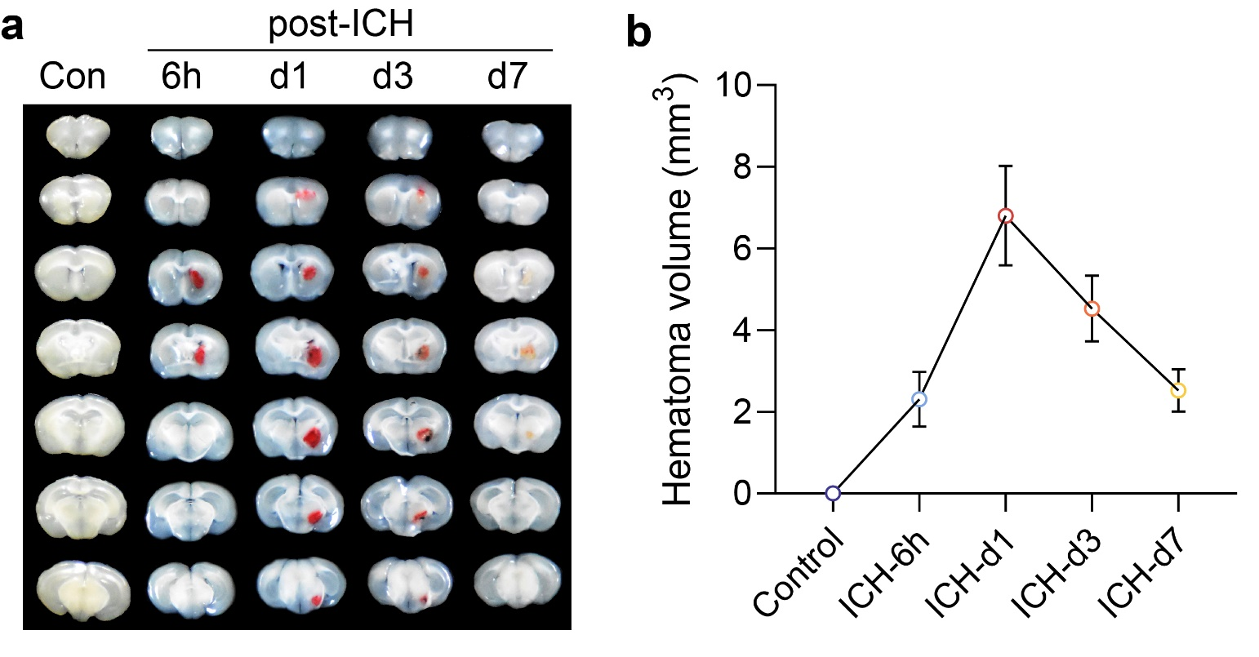
Extended Data Fig. 1. Changes of hematoma size at different time points after ICH induction by collagenase. a, The position and size of hematoma at 6 h, d 1, d 3, and d 7 post-ICH, respectively, were shown in continuous coronal brain sections of mice. The thickness of each brain slice was 200 μm. b, Statistics of hematoma size at different time point after collagenase-induced hemorrhage. Data displayed mean values and SD.

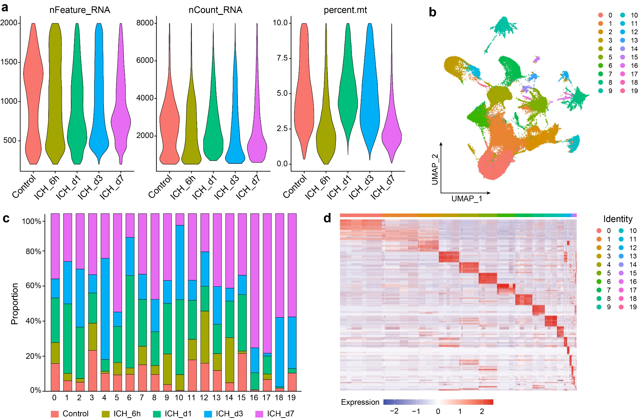
Extended Data Fig. 2. Quality Control and Clustering Analysis of Single-Cell RNA Sequencing. a, The number of detected genes per cell, the total number of molecules detected in the cell and the percentage of mitochondrial genes for each sample. b, UMAP clustering distribution of high-quality cells after quality control. Each point represents a cell, colored by cell cluster. c, Distribution of cell clusters across different samples. d, Relative expression levels of the top 10 marker genes in each cell cluster.

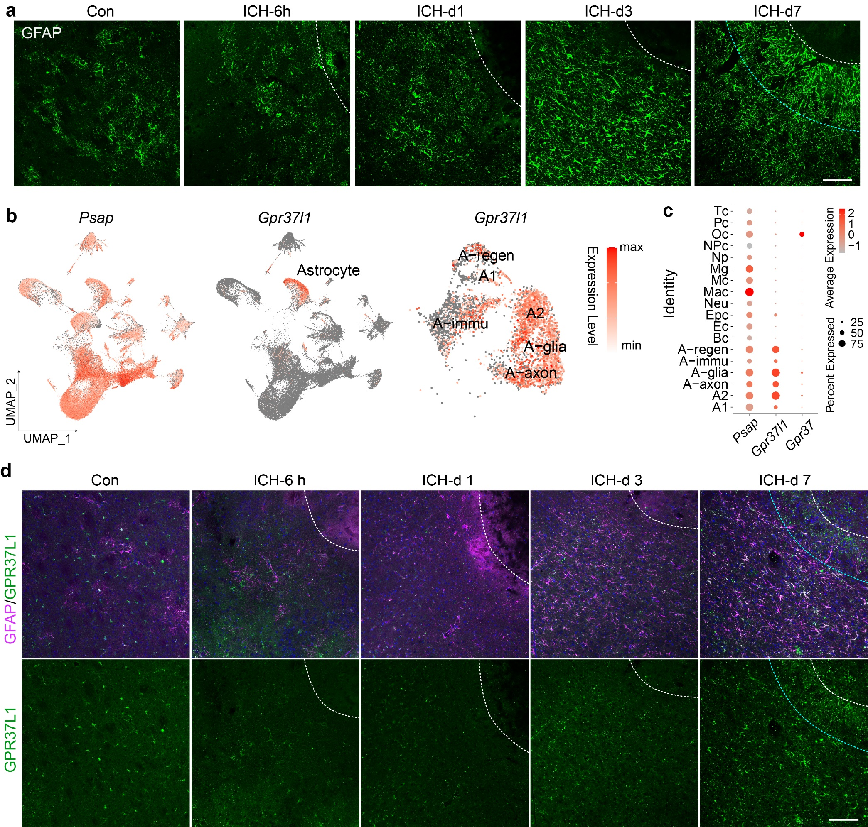
Extended Data Fig. 3. Morphological changes of astrocytes and expression pattern of PSAP-GPR37L1 signal in astrocytes in perihematomal lesions after ICH. a, Immunofluorescence staining using GFAP antibody was performed to label the morphological changes of astrocytes in normal striatum around hematoma at different times after ICH. The white dotted line outlined the hematoma's boundary to the upper right. GFAP+ astrocytes formed a distinct glial scar structure around the hematoma at d 7 after ICH, and the astrocytes adjacent to the hematoma were arranged in a palisading pattern (between white and cyan dashed lines). Scale bar: 100 μm. b, UMAP displayed the expression of Psap and Gpr37l1 in all cell populations and astrocyte subtypes, respectively. c, Bubble map showed the gene expression patterns of Psap, Gpr37, and Gpr37l1 in PSAP pathway in different cell types. d, Expression of GPR37L1 in GFAP⁺ astrocytes in control group and ICH groups at different time points were revealed by immunofluorescence staining. Scale bar: 100 μm.

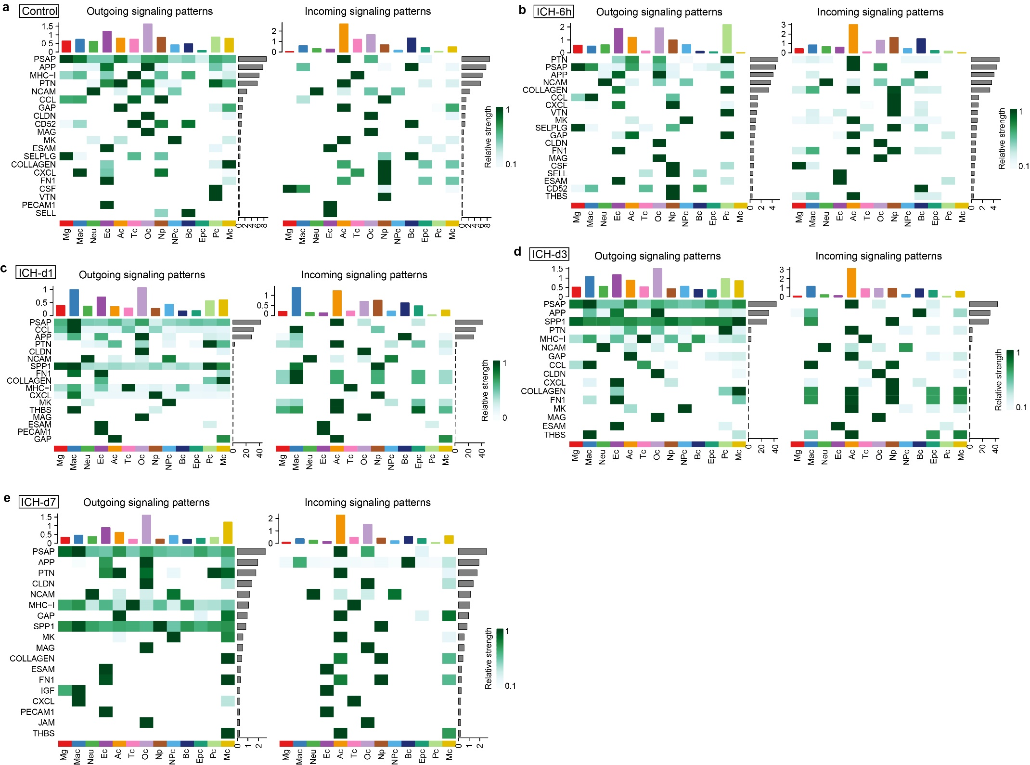
Extended Data Fig. 4. Cell-cell communication analysis of intercellular outgoing and incoming signaling patterns in control group and ICH groups by CellChat. The heat maps showed the relative strength of the signaling pathways sent (outgoing) and received (incoming) between cell types in control (a) and at 6 h (b), d 1 (c), d 3 (d), and d 7 (e) post-ICH, respectively.

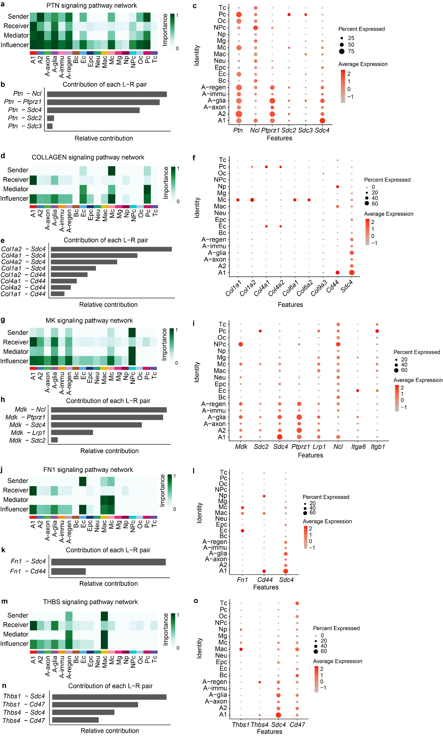
Extended Data Fig. 5. The intercellular communication signal networks received by astrocytes and the contribution of ligand-receptor pairs. Heatmap showed the relative importance of each cell group based on the computed four network centrality measures of PTN (a), COLLAGEN (d), MK (g), FN1 (j) and THBS (m) signaling network, respectively. Relative contribution of main ligand-receptor pairs to the overall communication network of PTN (b), COLLAGEN (e), MK (h), FN1 (k) and THBS (n) signaling pathway. Dot plots showed the expression distribution of signaling genes involved in the inferred PTN (c), COLLAGEN (f), MK (i), FN1 (l) and THBS (o) signaling pathway.

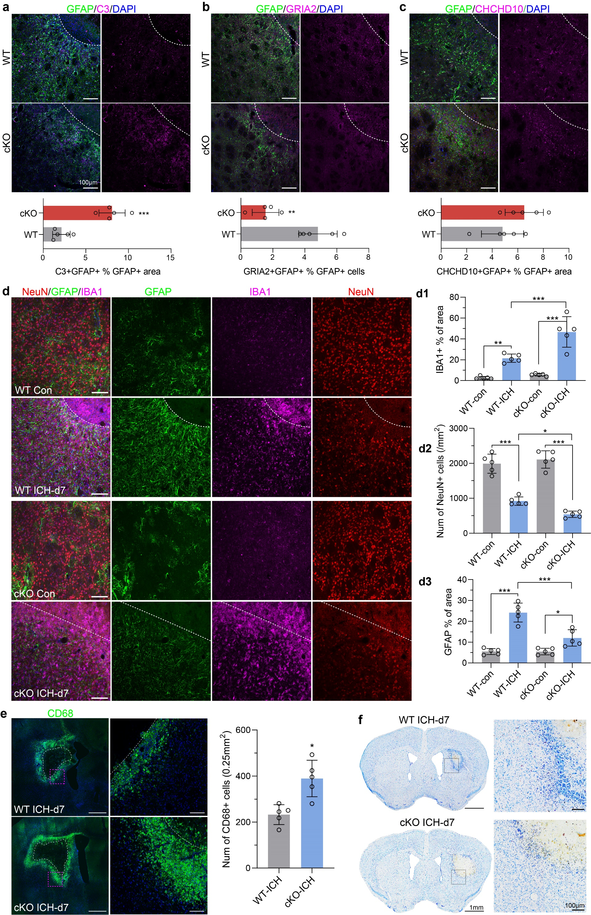
Extended Data Fig. 6. Deletion of astrocyte Gpr37l1 aggravated nerve injury and inflammatory response after ICH. a-c, Distribution of A1 (a, C3+/GFAP+), A-axon (b, Gria2+/GFAP+) and A-immu (c, CHCHD10+/GFAP+) astrocytes in perihematomal lesions of WT and Gpr37l1-cKO mice at d 7 post-ICH by immunofluorescence staining. Scale bar: 100 μm. The bar plots showed the ratio of the three subtypes in GFAP+ astrocytes with mean, SD and individual points. n = 5 WT and Gpr37l1-cKO mice per group, two-tailed Mann–Whitney U-test. **p < 0.01, U = 0 (a); ** p < 0.01, U = 0 (b); p ＞0.05, U=0 (c), cKO vs WT. d, Immunofluorescence staining showed distribution of microglia (IBA1+), astrocytes (GFAP+) and neurons (NeuN+) in control and perihematomal lesions of WT and Gpr37l1-cKO mice at d 7 post-ICH, respectively. Scale bar: 100 μm. The bar plots showed the relative ratio of microglia, astrocytes and neurons as percentage of IBA1+ area, percentage of GFAP+ area and number of NeuN+ cells per mm² area around the hematoma, with mean, SD and individual points. n= 5 WT and Gpr37l1-cKO mice per group. d1, two-way ANOVA with Tukey’s multiple comparisons test, F (1, 16) = 16.90, p = 0.0008, cKO vs WT. d2, two-way ANOVA with Tukey’s multiple comparisons test, F (1, 16) = 2.109, p = 0.1658, cKO vs WT. d3, two-way ANOVA with Tukey’s multiple comparisons test, F (1, 16) = 18.34, p = 0.0006, cKO vs WT. ***p ˂ 0.001, **p <0.01, *p < 0.05, comparisons between the indicated groups. e, Immunofluorescence staining of macrophages labelled by CD68 around the hematoma in WT and Gpr37l1-cKO mice at d 7 post-ICH. Dotted white lines outlined the hematoma. Scale bar: 500 μm. The magnifications (magenta dotted area) at right showed perihematomal macrophages. Scale bar: 100 μm. The bar plots showed a statistics of macrophages number per 0.25mm² area around the hematoma with mean, SD and individual points. n = 5 WT and Gpr37l1-cKO mice per group, two-tailed Mann–Whitney U-test. *p < 0.05, U = 1. f. Nissl staining showed the hematoma area and perihematomal scar in WT and Gpr37l1-cKO mice at d 7 post-ICH. Scale bar: 1 mm. The magnifications (dotted area) showed at right. Scale bar: 100 μm.

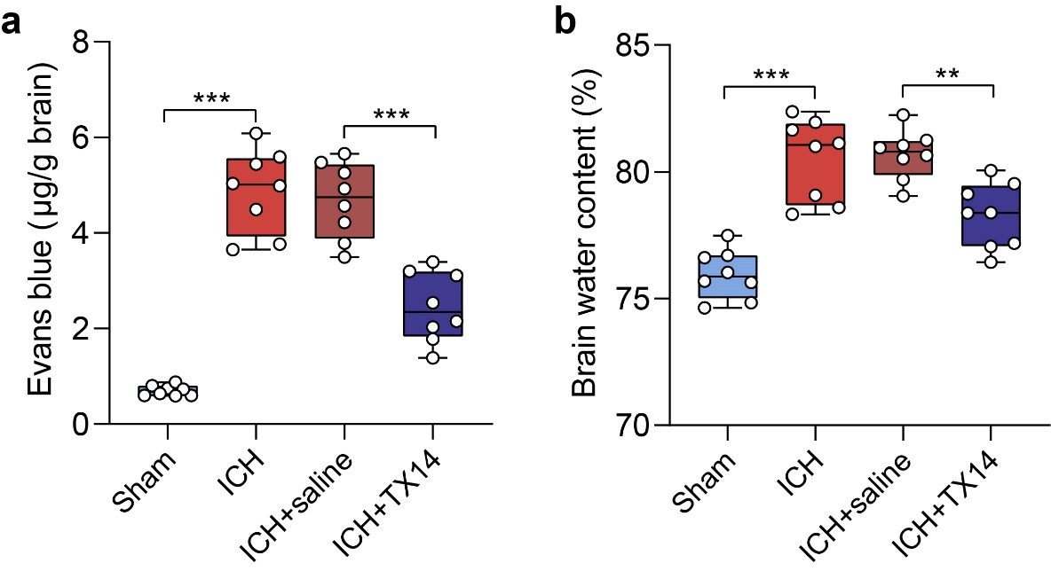
Extended Data Fig. 7. TX14 treatment alleviated BBB destruction and brain edema in ICH mice. a, BBB integrity was assessed by the Evan blue extravasation measurement, with mean, SD and individual points. b, The severity of cerebral edema was reflected by measuring brain water content, with mean, SD and individual points. n = 8 mice per group, one-way ANOVA with correction for Tukey’s multiple comparisons test. ***p < 0.001, **p < 0.01, comparisons between the indicated groups.

