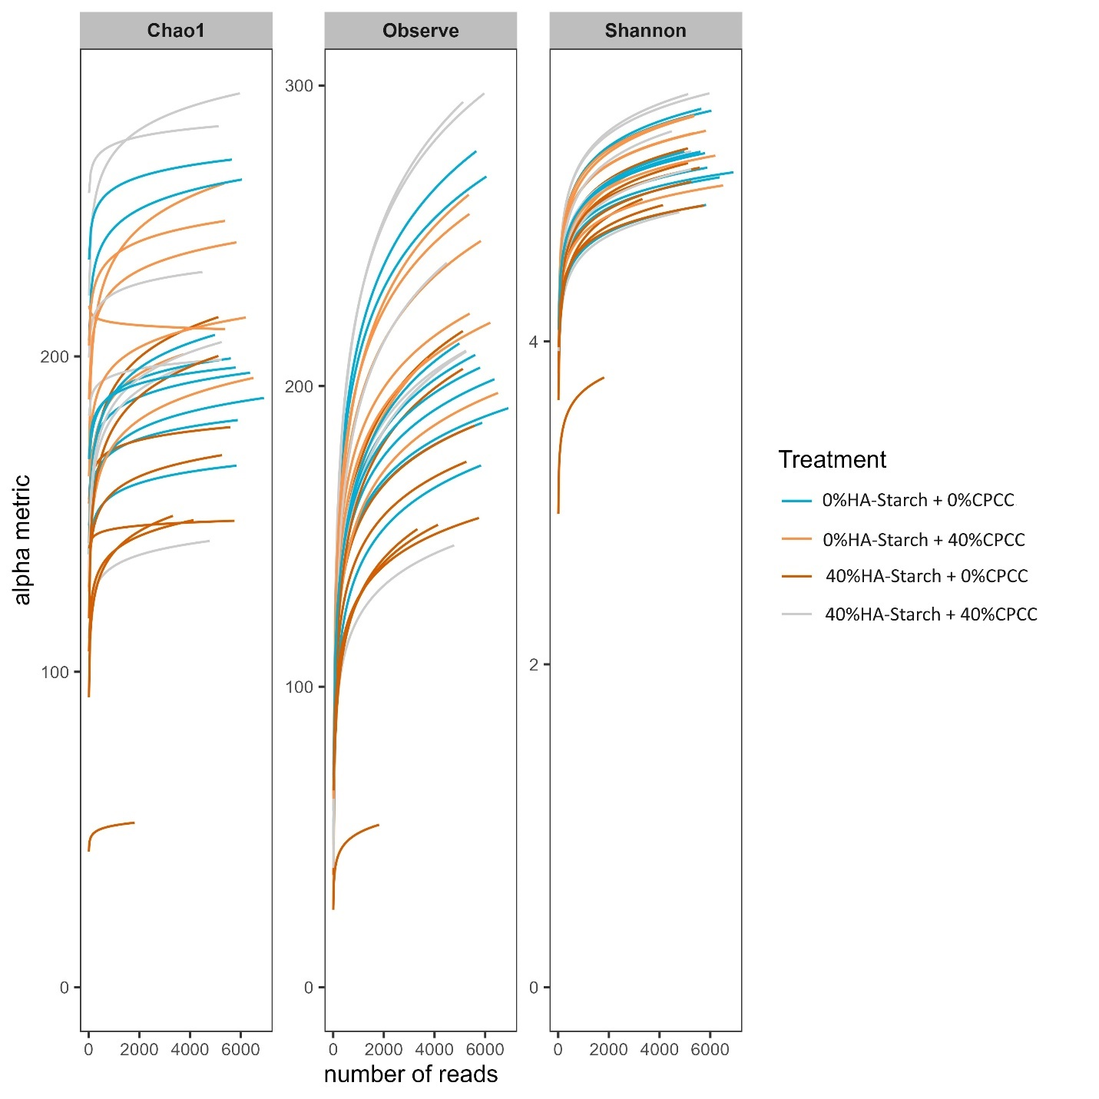
Supplementary Fig 1: Rarefied read abundance based on alpha diversity matrices.

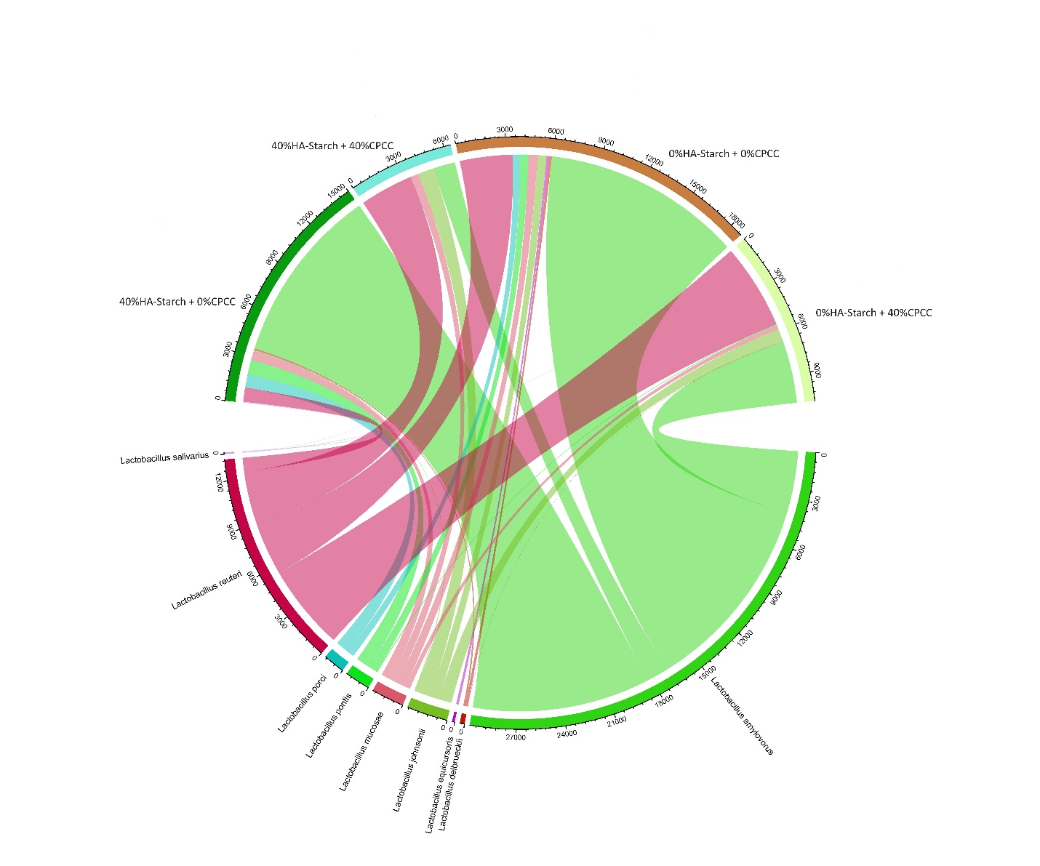

Supplementary Fig 2. Circos plot of total read abundance of Lactobacillus species in the treatment group.

