Relationships between yield and agronomic traits among geographic groups of barley landraces grown under high yielding conditions
Journal: Genetic Resources and crop evolution
P.N. Hoebe^{1, 2*}, R. Alegria Terrazas^{3, 4}, S.P. Hoad¹, C.F.E. Topp¹
¹ Scotland’s Rural College, Edinburgh, UK
² Earthwatch Europe, Oxford, UK
³ Plant Sciences, School of Life Sciences, University of Dundee, Dundee, UK
⁴ Sustainable Soils and Crops, Rothamsted Research, Harpenden, UK
*Corresponding author: phoebe@earthwatch.org.uk
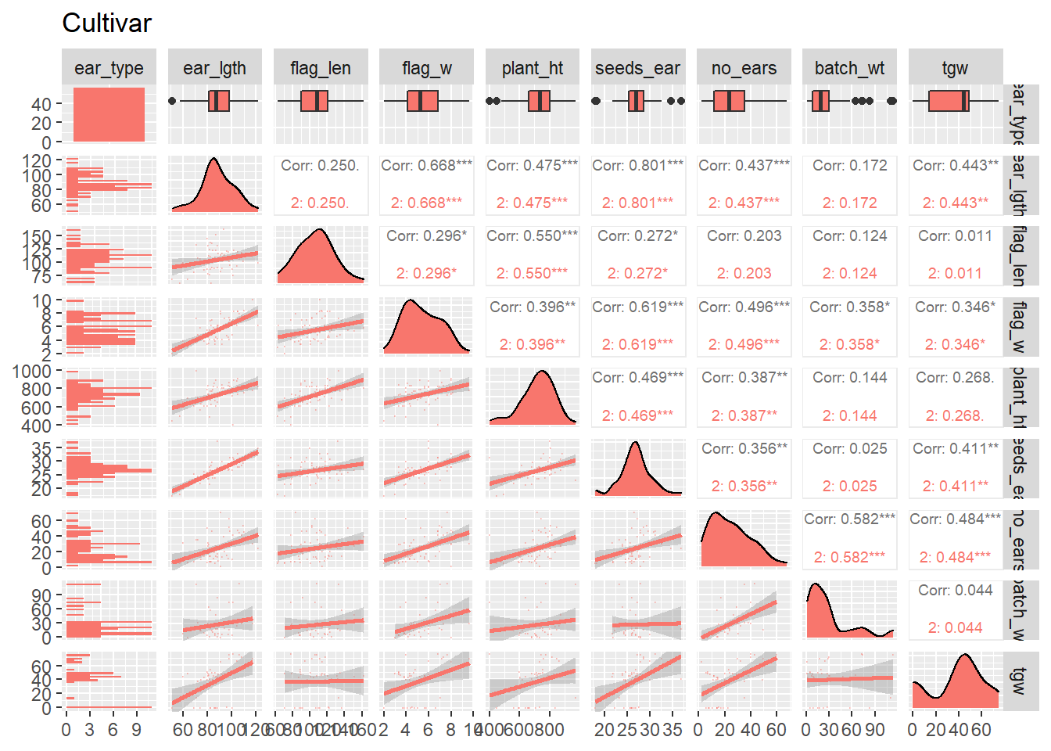
Fig 3a correlations between agronomic traits (ear length, flag leaf length, flag leaf width, plant height, seeds per ear, number of ears, batch weight (grain yield), thousand grain weight) for modern cultivars for each ear type (2-6 row)
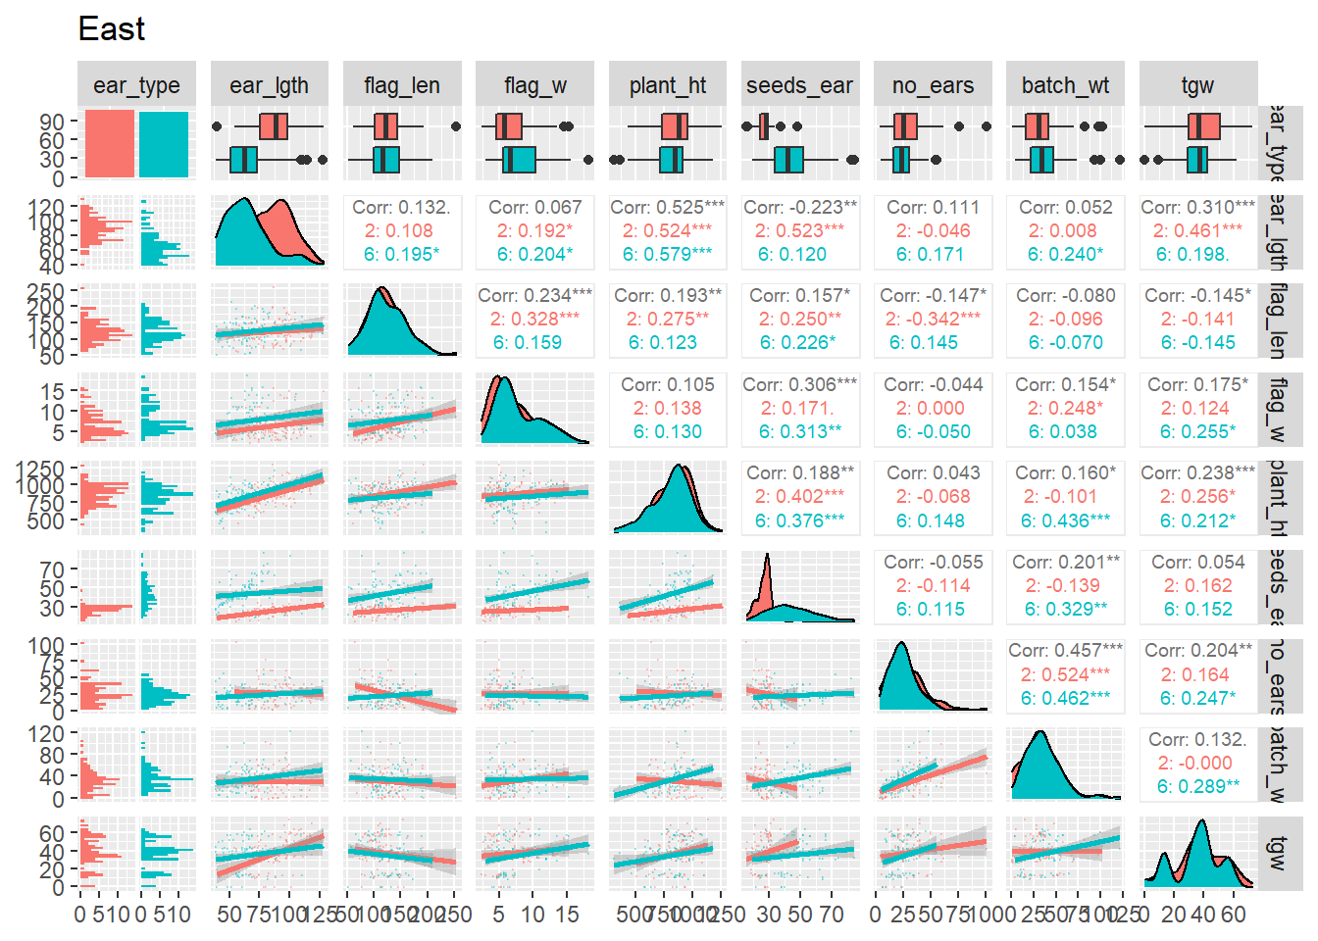
Fig 3b correlations between agronomic traits for East European barley landraces

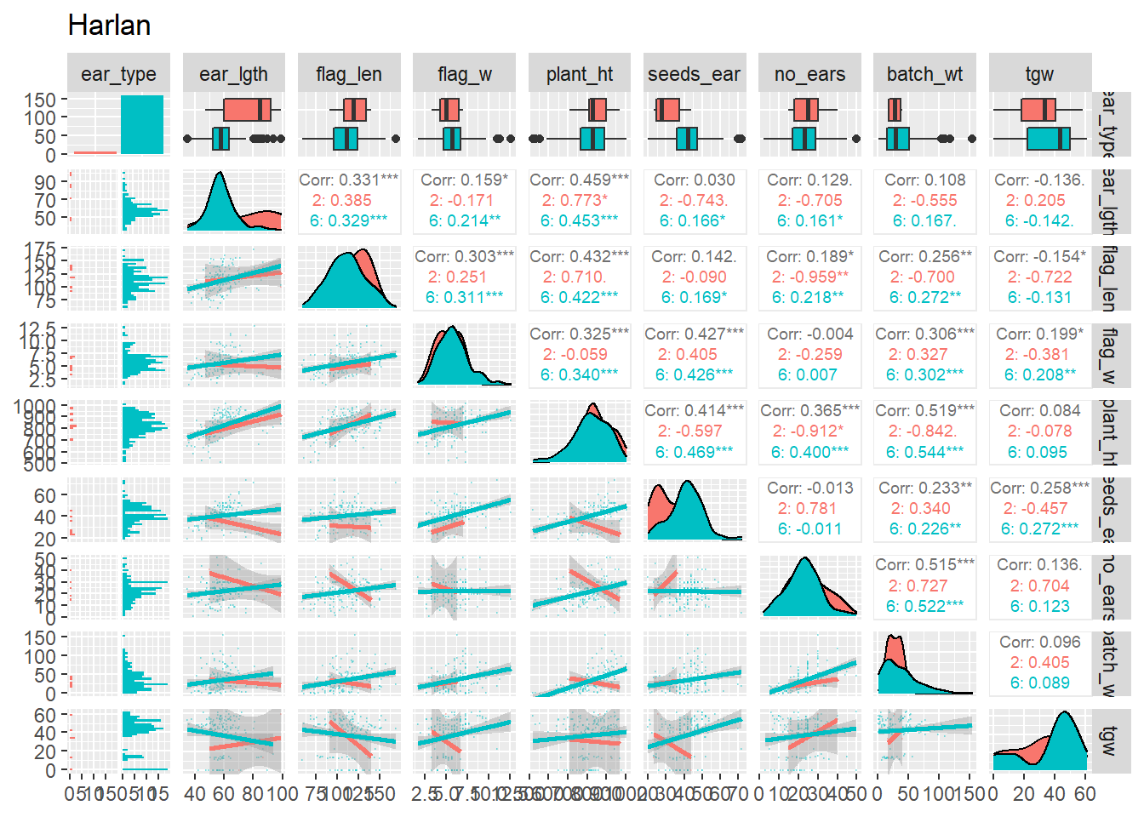
Fig 3c correlations between agronomic traits for Harlan composite cross lines
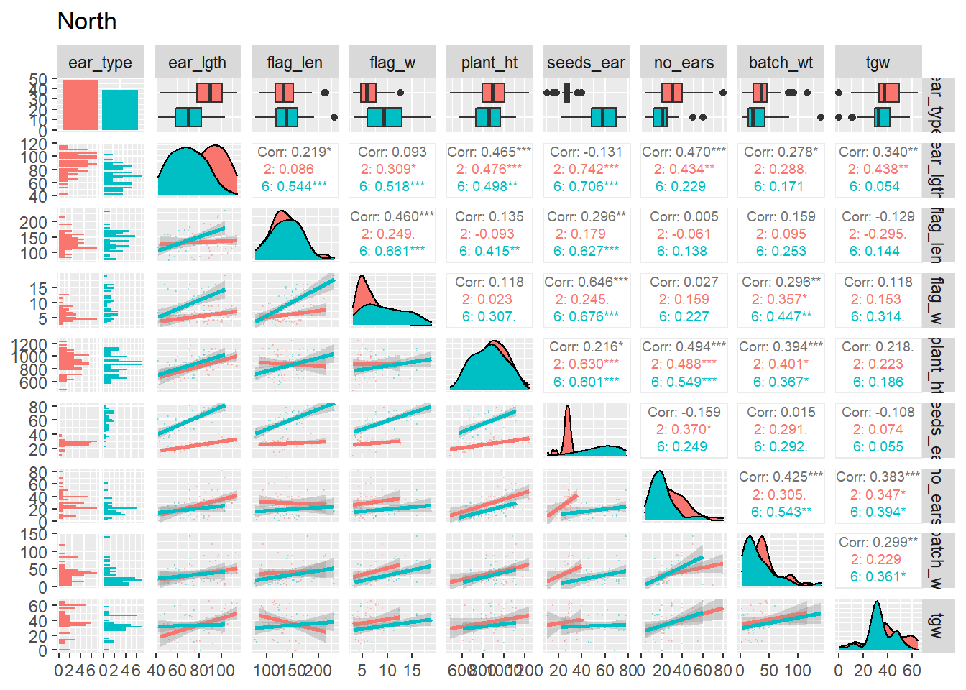
Fig 3d correlations between agronomic traits for North European barley landraces

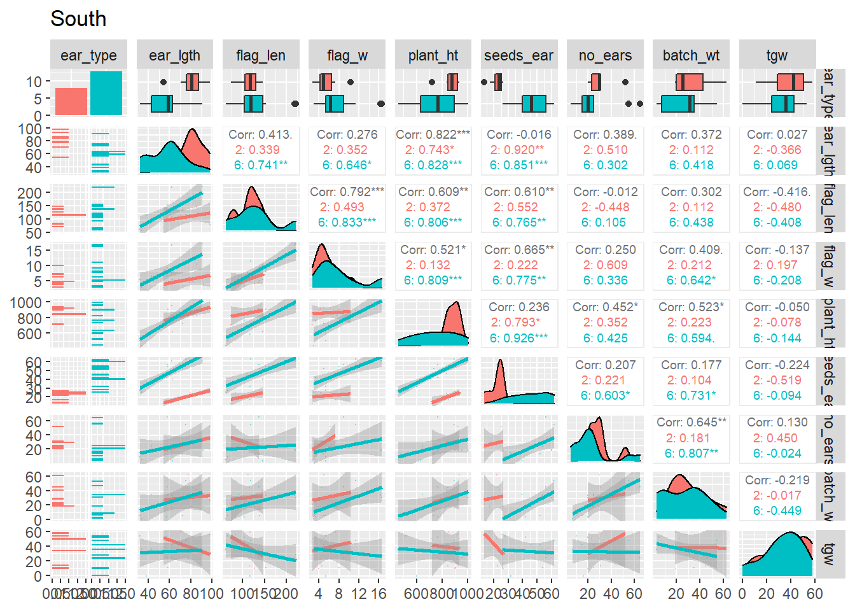
Fig 3e correlations between agronomic traits for South European barley landraces
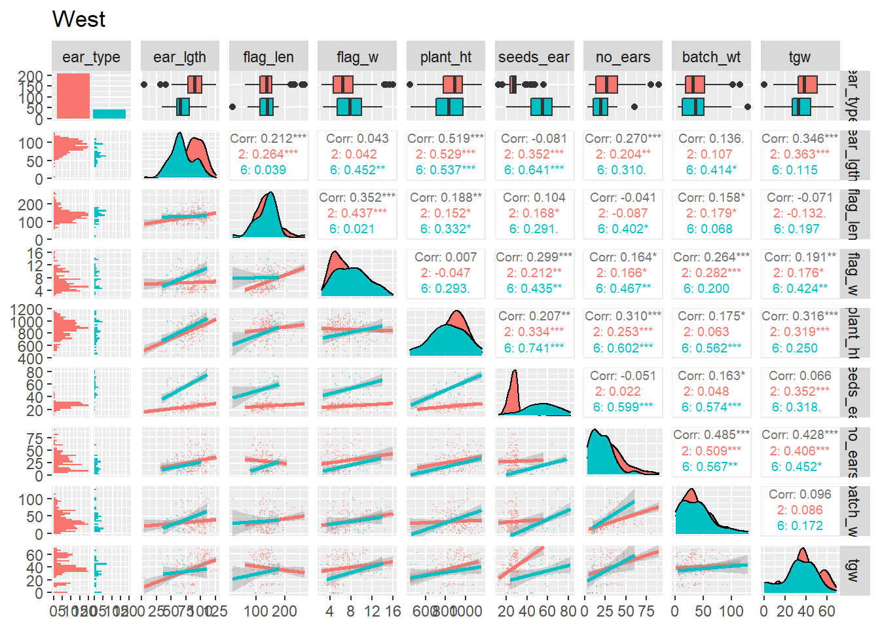

Fig 3f correlations between agronomic traits for West European barley landraces
Table 3a REML table ear length explained by EU region and ear type
Df Sum Sq Mean Sq F value Pr(>F)
## eu_region 5 81311 16262 71.81 <2e-16 ***
## ear_type 1 52312 52312 231.00 <2e-16 ***
## Signif. codes: 0 '***' 0.001 '**' 0.01 '*' 0.05 '.' 0.1 ' ' 1
- b)
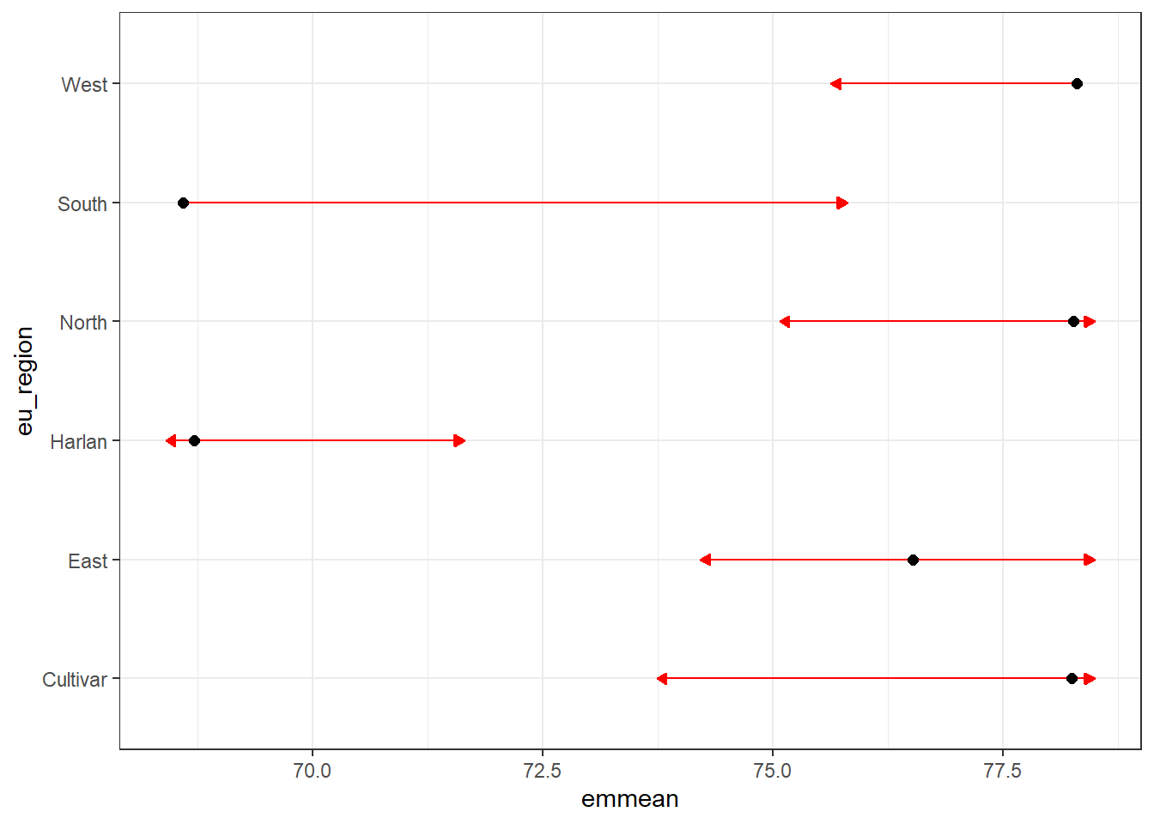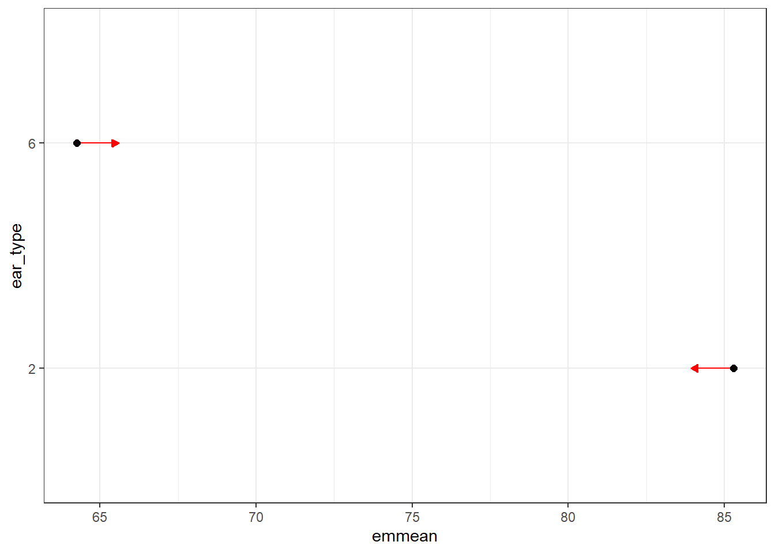
Fig 4a REML post hoc test ear length between different EU regions and b) ear type

Table 3b REML table flag leaf length explained by EU region and ear type
## Df Sum Sq Mean Sq F value Pr(>F)
## eu_region 5 94230 18846 20.602 < 2e-16 ***
## ear_type 1 26 26 0.029 0.866

c) d)
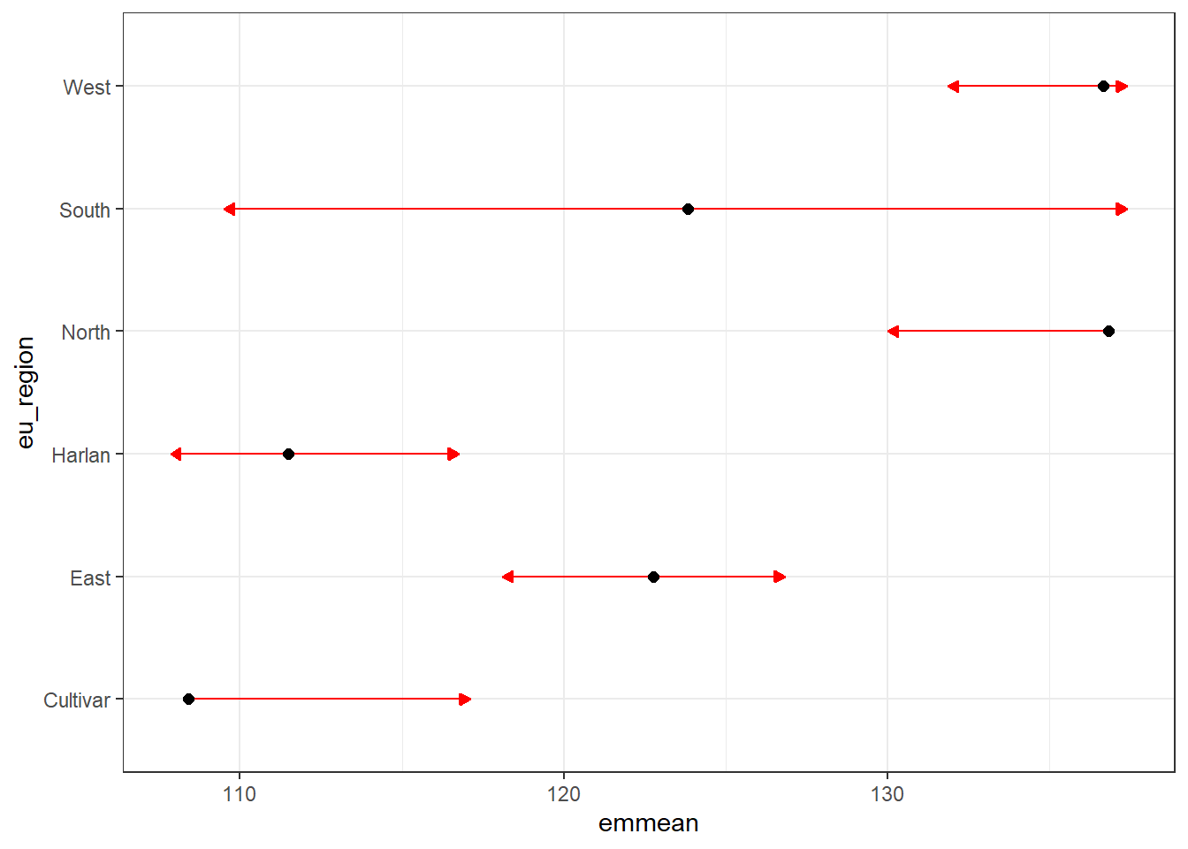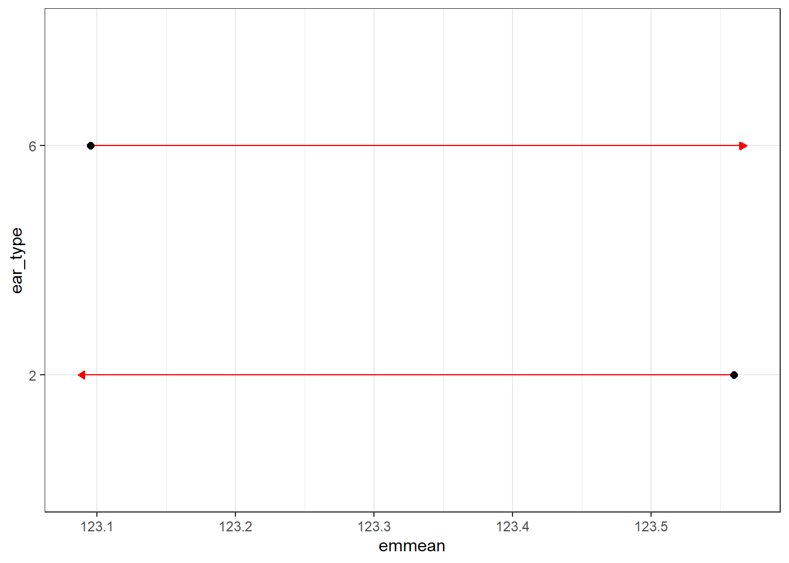
Fig 4c REML post hoc test flag leaf length between different EU regions and d) ear tpe

Table 3c REML table flag leaf width explained by EU region and ear type
## Df Sum Sq Mean Sq F value Pr(>F)
## eu_region 5 281 56.2 12.91 4.31e-12 ***
## ear_type 1 321 320.7 73.66 < 2e-16 ***
e) f)
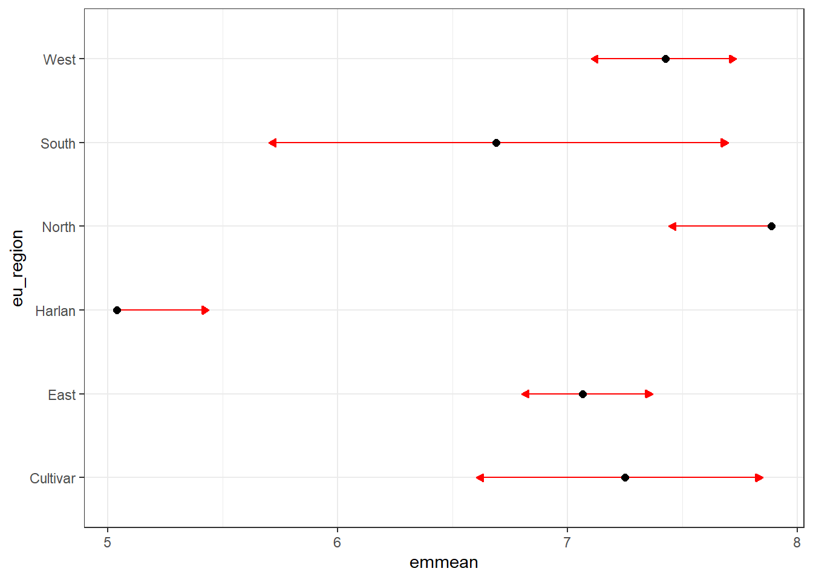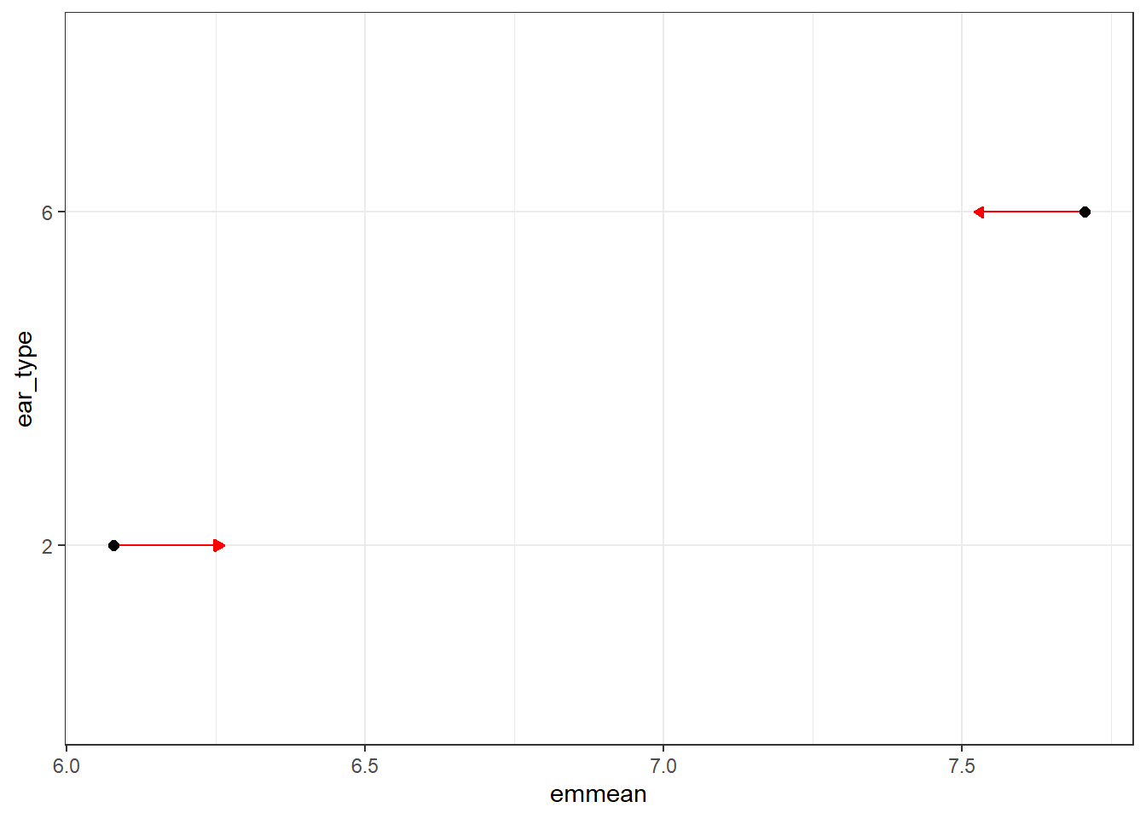
Fig 4 e REML post hoc test flag leaf length between different EU regions and f) ear type

Table 3d REML table plant height explained by EU region and ear type
## Df Sum Sq Mean Sq F value Pr(>F)
## eu_region 5 1018097 203619 11.29 1.56e-10 ***
## ear_type 1 226590 226590 12.57 0.000416 ***
g) h)
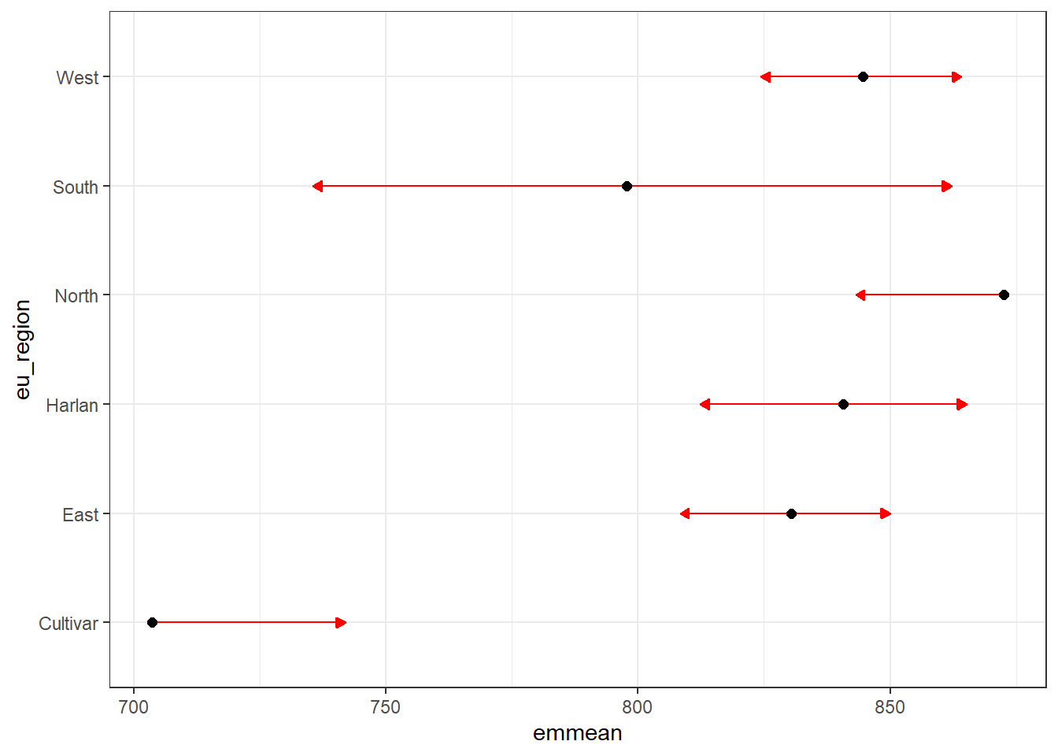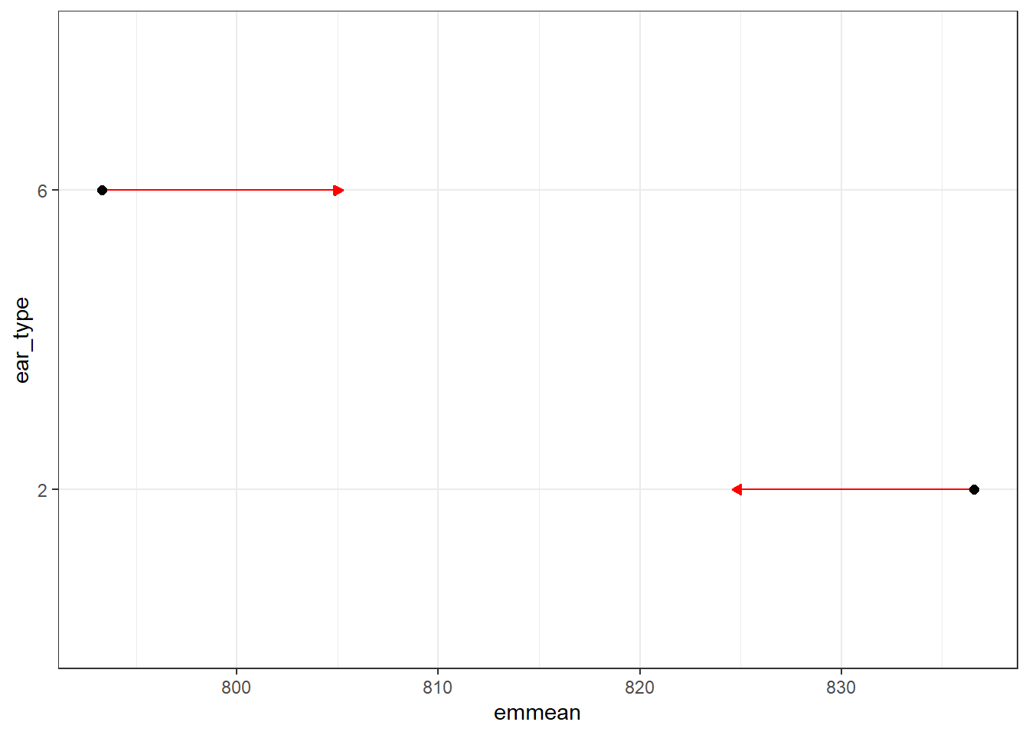
Fig 4 g REML post hoc test flag leaf length between different EU regions and h) ear type

Table 3e REML table seeds per ear explained by EU region and ear type
## Df Sum Sq Mean Sq F value Pr(>F)
## eu_region 5 14305 2861 37.78 <2e-16 ***
## ear_type 1 57497 57497 759.29 <2e-16 ***

i) j)
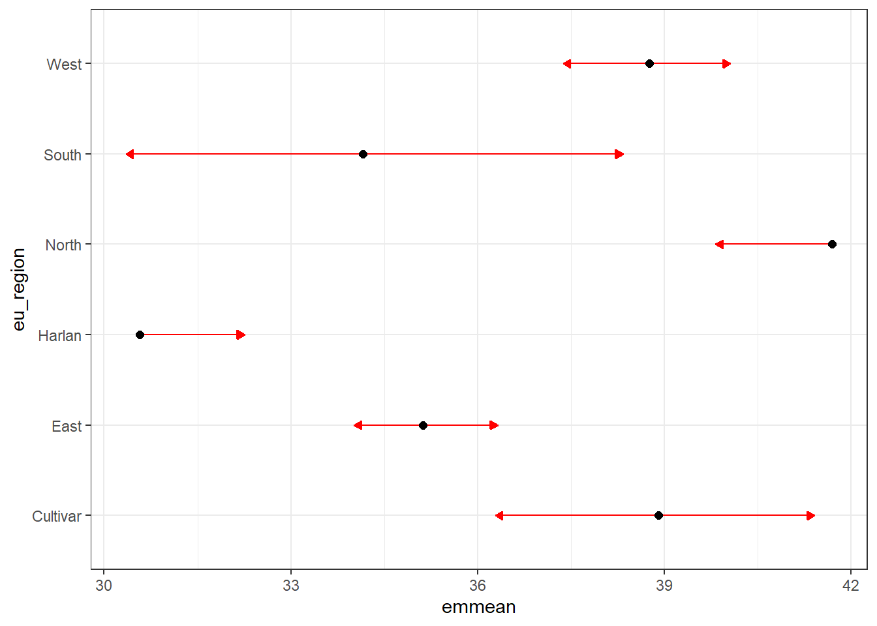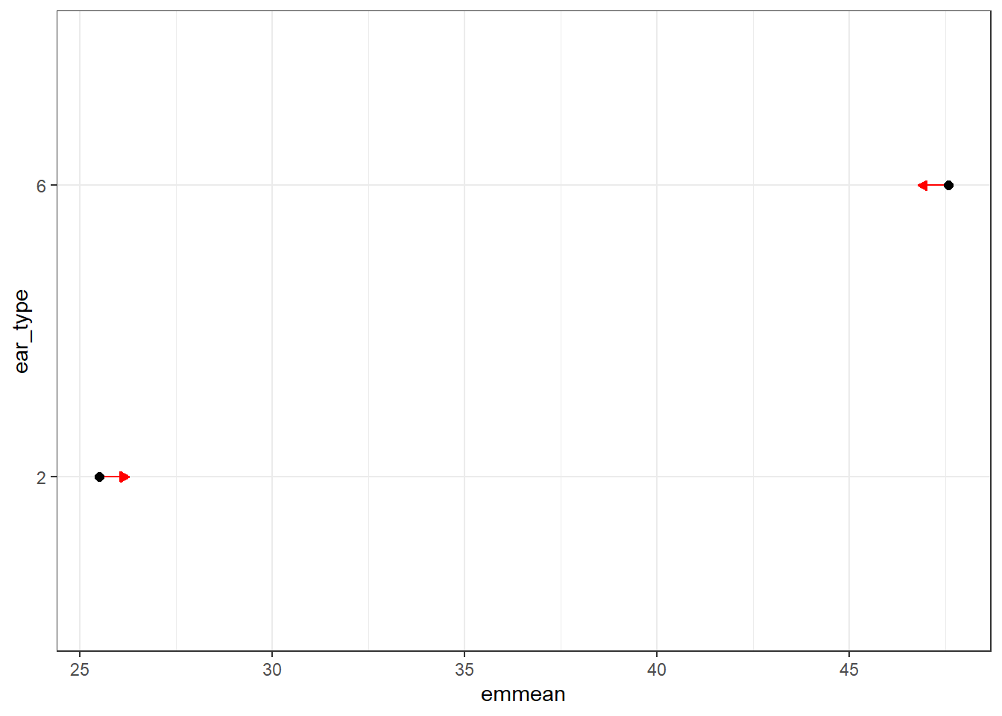
Fig 4 i REML post hoc test flag leaf length between different EU regions and j) ear type

Table 3f REML table number of ears explained by EU region and ear type
## Df Sum Sq Mean Sq F value Pr(>F)
## year_site 3 20729 6910 37.92 < 2e-16 ***
## eu_region 5 2269 454 2.49 0.0301 *
## ear_type 1 3852 3852 21.14 5.07e-06 ***
k) l)
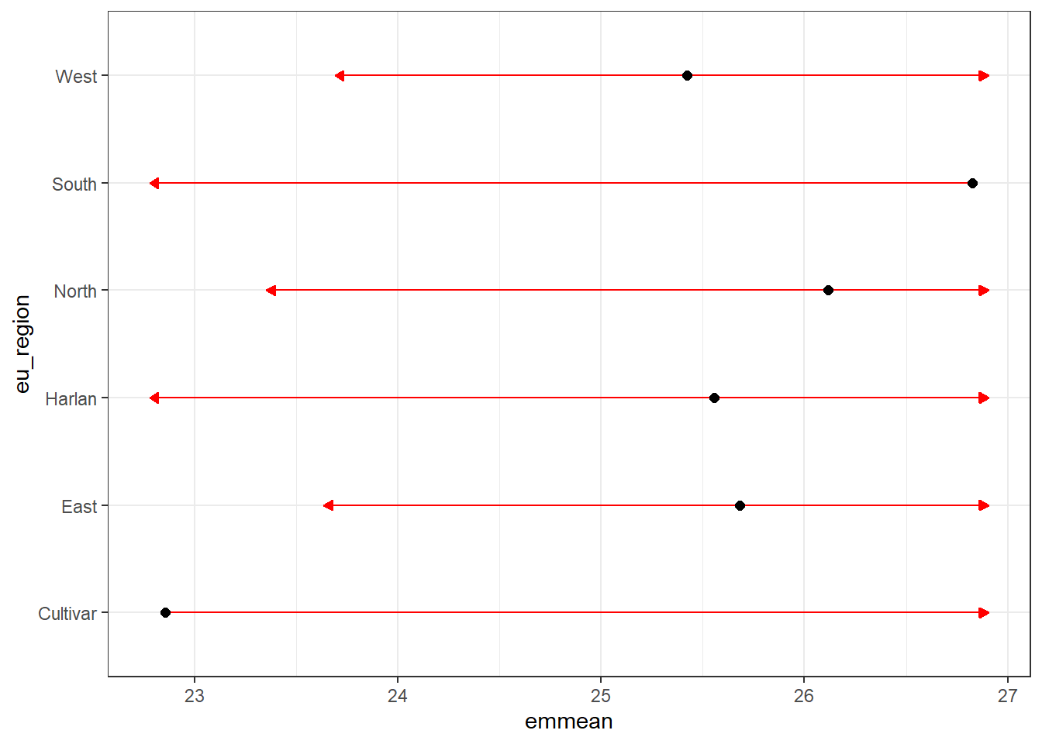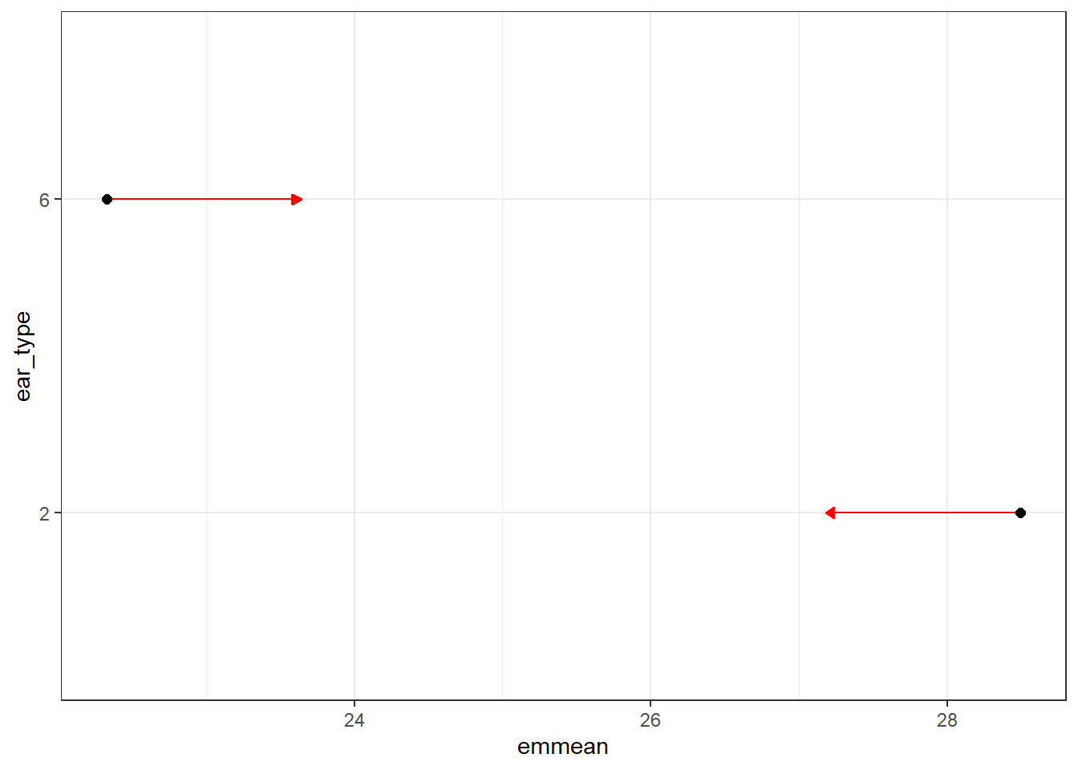
Fig 4 k REML post hoc test number of ears between different EU regions and l) ear type

Table 3g REML table grain yield explained by EU region and ear type
## Df Sum Sq Mean Sq F value Pr(>F)
## eu_region 5 2113 423 0.810 0.543
## ear_type 1 40 40 0.077 0.781

m) n)
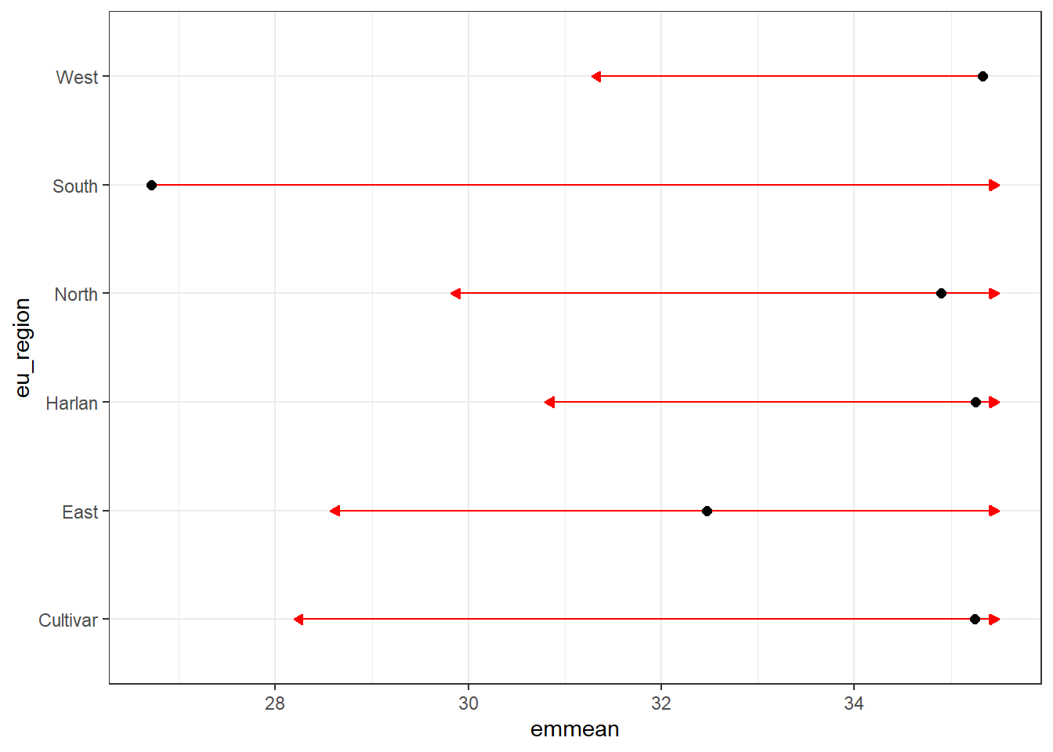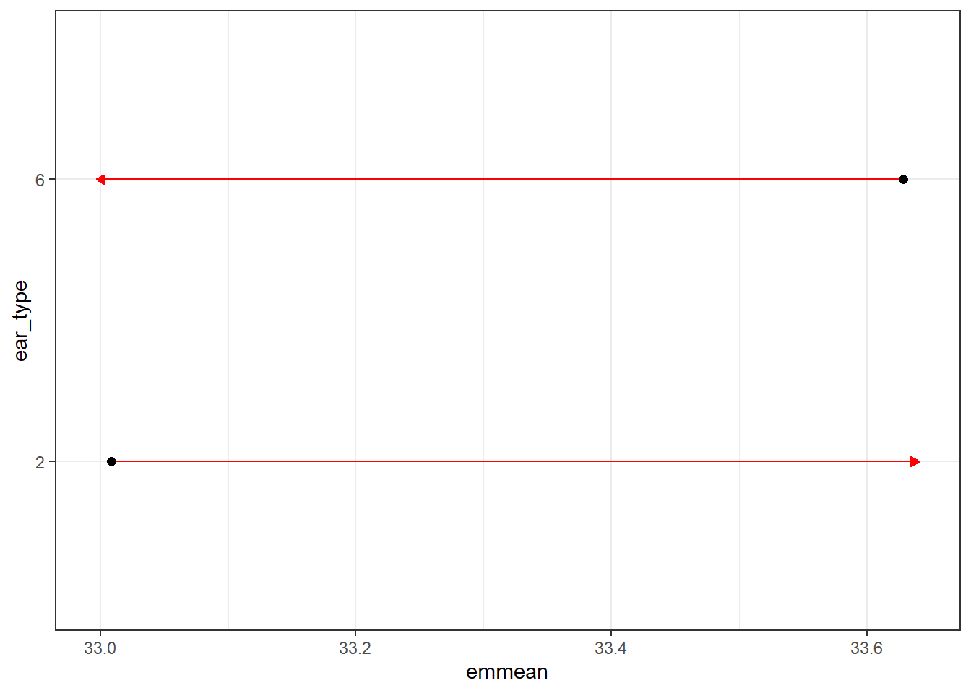
Fig 4 g REML post hoc test grain yield between different EU regions and h) ear type

Table 3h REML table TGW explained by EU region and ear type
## Df Sum Sq Mean Sq F value Pr(>F)
## eu_region 5 3163 633 11.97 3.76e-11 ***
## ear_type 1 876 876 16.58 5.20e-05 ***
o) p)
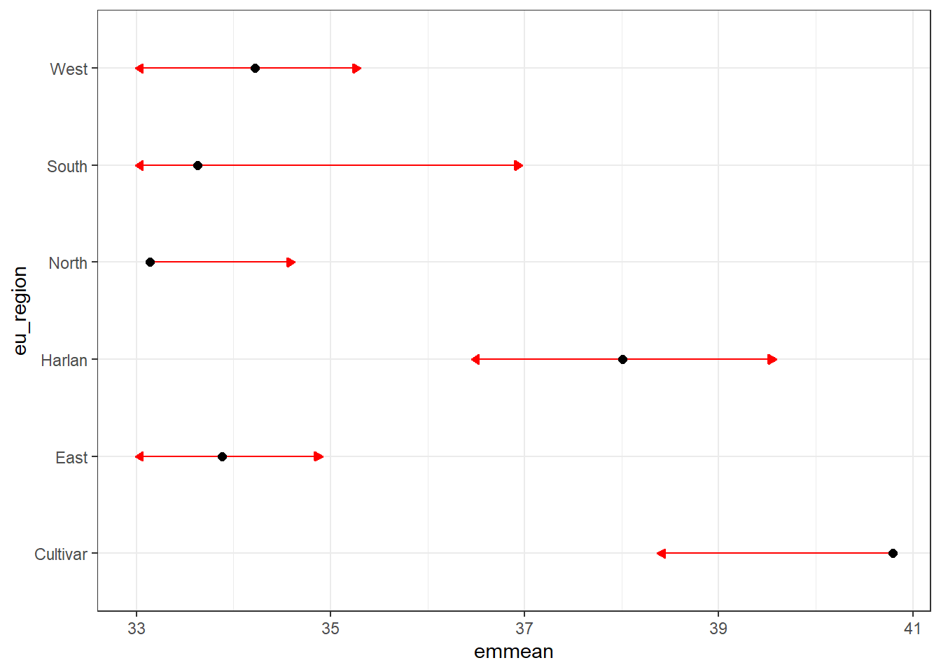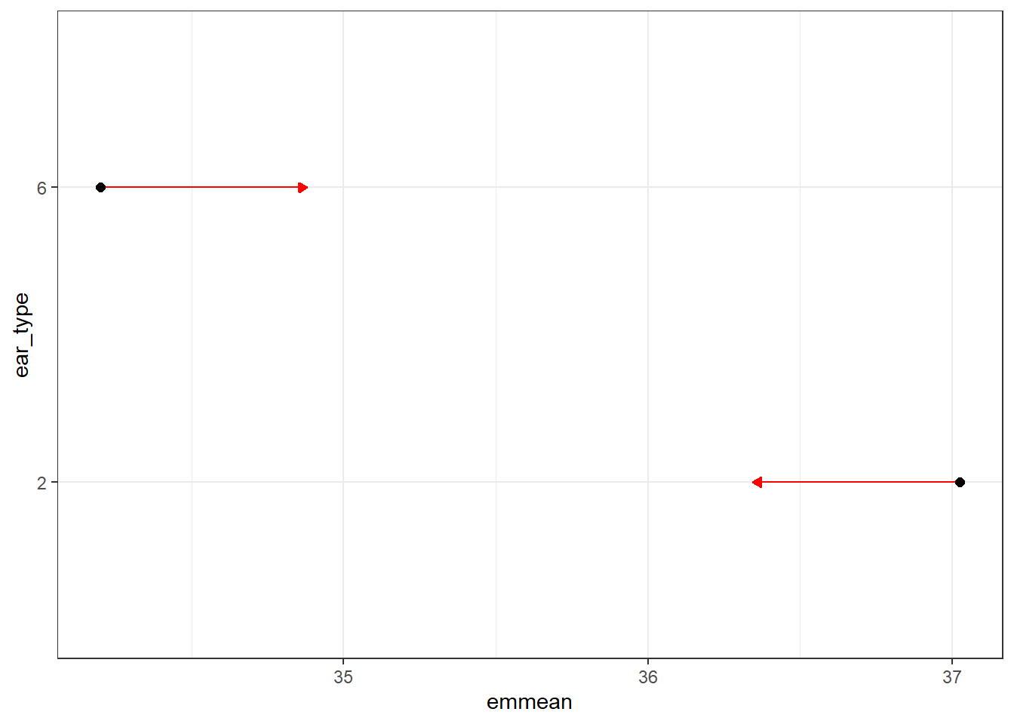
Fig 4 o REML post hoc test TGW between different EU regions and p) ear type

