Supplementary Information - S1

S1.1. Framework
Figure S1 provides the modeling framework adopted in this study. Our study included several stages, each aimed at the optimization potential of building construction practices. Firstly, we assessed the primary material demand and environmental impact associated with building construction (Figure S1a). Next, we integrated construction data with various land use and land cover (LULC) options to gain insights into their effects on ecosystem service provision (Figure S1b). Finally, we examined how building construction strategies can be optimized for both building materials and ecosystem services (Figure S1c).
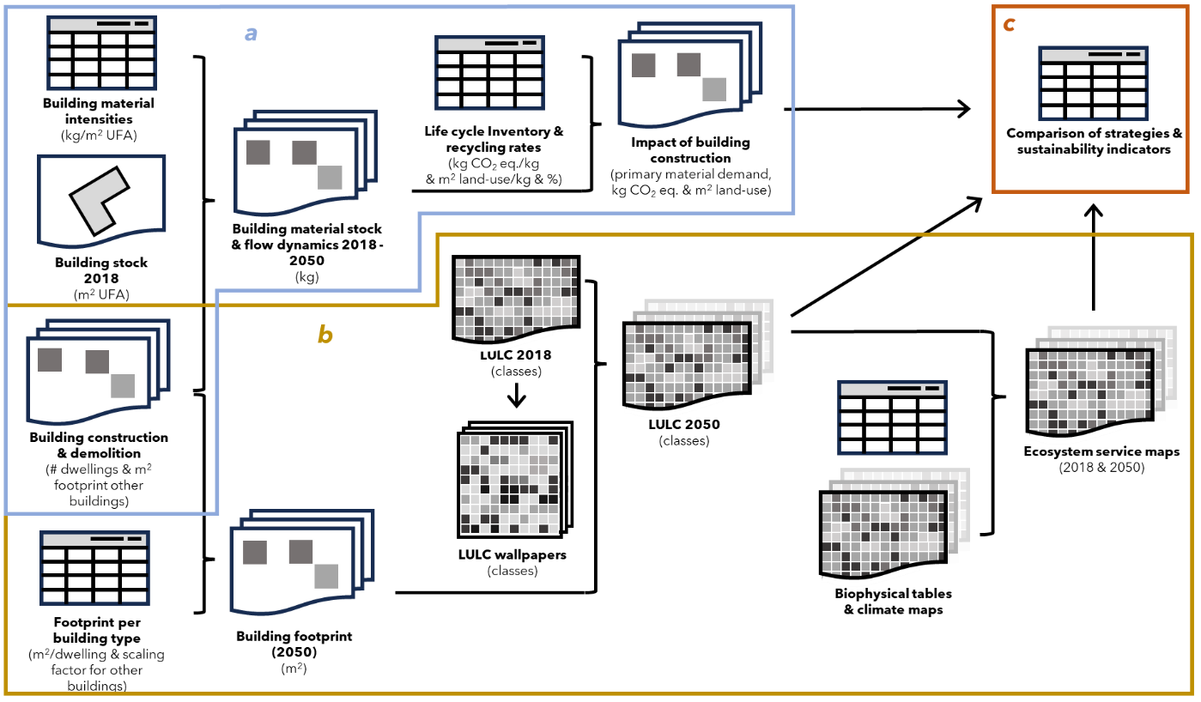
Figure S1. a) presents the approach for resource use calculation, b) presents the approach for land use and land cover (LULC) change and ecosystem service calculation, c) presents a comparison of the sustainability indicators and urbanization strategies.

S1.2. Building material impact

In this study we combined spatial modeling with Material Flow Analysis (MFA) to assess material stock dynamics in the Dutch building sector. MFA is a widely used method to quantify material stocks and flows. Building stock dynamics were modeled between 2018 and 2050 for two urbanization strategies: Dense and Sparse. These were included in three building strategy scenarios (Conventional, Biobased and Circular), specific for 21 construction materials (S2.4.2., S2.4.3., S2.4.4.). We assessed recycling rates and recycled content potential of the inflow, and linked material demand with LCA data to calculate GHG emissions and land use related to material production.
We distinguished three types of dwellings: detached houses, row houses, and apartments, and four non-residential building types: industry, offices, retail and services. We used a bottom-up approach to calculate the building stock in 2018, based upon the BAG dataset¹. This GIS-based dataset contains all buildings in the Netherlands with information on location, building type, useful floor area (UFA) and construction year. We linked this dataset to material intensities specified for Dutch buildings for four building cohorts (< 1945, 1945-1970, 1970-2000, 2000-2018), derived from Arnoldussen et al. (2019)² (S2.4.5).
The building stock in 2018 was used as a starting point for urbanization strategies for cumulative building construction and demolition between 2018 and 2050, modeled on a 100 by 100 meter resolution. The intensity and location of building activities were modeled for two urbanization strategies and were based upon land-use indicators (land use type, building characteristics and building density) and socio-economic indicators (population and economic growth) and³. Data was provided in number of dwellings and m² footprint for other building types. To determine the UFA per dwelling or m² footprint in the urbanization pathway data, we applied the reference values from RVO⁴ for dwellings and calculated the mean values per building type for non-residential building stock in 2018¹ (S2.4.6). We assumed a constant floor area per dwelling or footprint between 2018 and 2050. The urbanization strategies in terms of UFA were then linked to building material intensities in kg of specific materials per m² UFA for three building strategy scenarios (Conventional, Biobased and Circular). The material intensities can be found in Supplementary Information S2.4.2, S2.4.3. and S2.4.5.
We calculated the share of the demolition waste, per material, that can be reused for new constructions. A distinction was made between end-of-life recycling rates (RR) and maximum recycled contents (MRC). RR refers to the fraction of waste material that is (or could be) recycled, MRC refers to the maximum share of recycled material in the total supply. RR and MRC were based upon literature and current practices in the Dutch and European recycling industry (S2.4.7.). If the availability of recyclable materials from demolition is smaller than the maximum share of secondary materials in construction (demand), all recyclable materials can be used. If secondary supply is larger than MRC, a part of the demolition flow cannot be reused within the building sector. In our previous study, we specified actual recycling rates, based on current practices in the Netherlands and Europe, and best practice recycling rates, presenting the current maximum. We also specified how the results change when applying a 100% recycling rate. In this study we applied best-practice recycling rates.
We assessed GHG-emissions related to material production on the basis of the life cycle inventory (LCI) database EcoInvent version 3.6⁵ and supplemented the dataset where needed with values from scientific literature (S2.4.10.). For primary material production, we assessed the impact from cradle to material production. For secondary material production, we assessed the GHG emissions for building demolition, material transportation, recycling and secondary material production. In addition to GHG-emissions, land-use associated with wood production is assessed (S2.4.11), again based on land-use impact as specified in EcoInvent version 3.6⁵.
The python models used for assessment of the building material impacts can be found in files 4_1, 4_2, 3_3, and 5_1 on GitHub⁶. Additional details on the building model can be found in our previous paper⁷.

S1.3. Land use change
Compiling the land use / land cover (LULC) map
The land use / land cover (LULC) map was compiled by combing a detailed land use map of the Netherlands, the Registration Large-Scale Topography⁸,with coverage maps of trees, shrubs and grasses^{9–11}. The resulting map presents detailed information on land use and green infrastructure coverage on a 10 by 10 meter resolution. We make a distinction between 22 land cover types, which are listed in table S2.3.1.
The python model used to adjust and combine the input maps can be found in the file 7 on GitHub⁶.
Identifying land use change locations
We explored the current land-use map to find suitable land-use “tiles” for the Green and Grey strategy, specific for each of the building footprint classifications (<10%, 10-40%, >40%). The tiles present 10x10 = 100 land-use cells that fit in one tile of the building construction and demolition dataset of PBL. We clipped the tiles and used them as input for wallpapering.
Calculating building footprints & defining land-use strategies
The land use composition of the transformed area depends on (1) the area required for buildings and (2) design of the remaining the area.
We first determined how much of the cell is used for building construction: The urbanization data is provided as a 100 x 100 meter raster dataset of the Netherlands. The construction and demolition data is provided in number of dwellings and m² footprint for nonresidential buildings constructed/demolished. Together with the data for the current building stock¹, we determined the total area that will be designated to building space in 2050. The construction and demolition strategies contain information on the number of dwellings and the building footprint in square meters for non-residential buildings. While the latter can be directly applied to the land use strategies, the dwelling data must first be converted into building footprint. To accomplish this, we used building specifications as defined by the Netherlands Enterprise Agency⁴ (refer to S2.4.1. for details). Two critical factors that determine the area of ground used for buildings are the building’s UFA and, in case of apartment buildings, the number of dwellings per floor. For apartments, we assumed six apartments per floor⁴. For high-rise buildings with more over 100 apartments, we multiplied the building ground area by 1.5, and for buildings with over 200 apartments, we multiplied it by 2. These assumptions are based on the dimensions of recently constructed high-rise buildings in the Netherlands.
The python model used to translate the PBL data to building footprints can be found in file 1, on GitHub⁶
We defined two strategies for the land use of the remaining redeveloped area. "Grey” is characterized by less than 5% low vegetation per cell (100 x 100 meters); and "Green," with more than 30% continuous green space consisting of grass, shrubs, and at least 10% trees. The "Green" strategy adhered to the 3-30-300 rule set by the European Commission, aiming for a minimum of 10% tree cover in urban environments.
To analyze LULC changes between 2018 and 2050, we translated construction strategies into building footprints and linked them with LULC scenarios using the "wallpapering model" (WP) developed by Lonsdorf et al. (2021) ¹². For the LULC scenarios (see details below), we identified suitable compositions on the original LULC map, clipped the designated area to a rectangular “tile”, replicated the tile in a grid to create a “wallpaper” and switched the LULC within every cell that shows construction activities between 2018 and 2050. We classified building footprints into three groups based on their share within each 100 x 100 meter gridcell: less than 10%, 10-40% and greater than 40%. This classification limited the number of tiles to three per land-use scenario. The python model used for creating the new LULC maps can be found in file 2 and 3 on GitHub⁶.
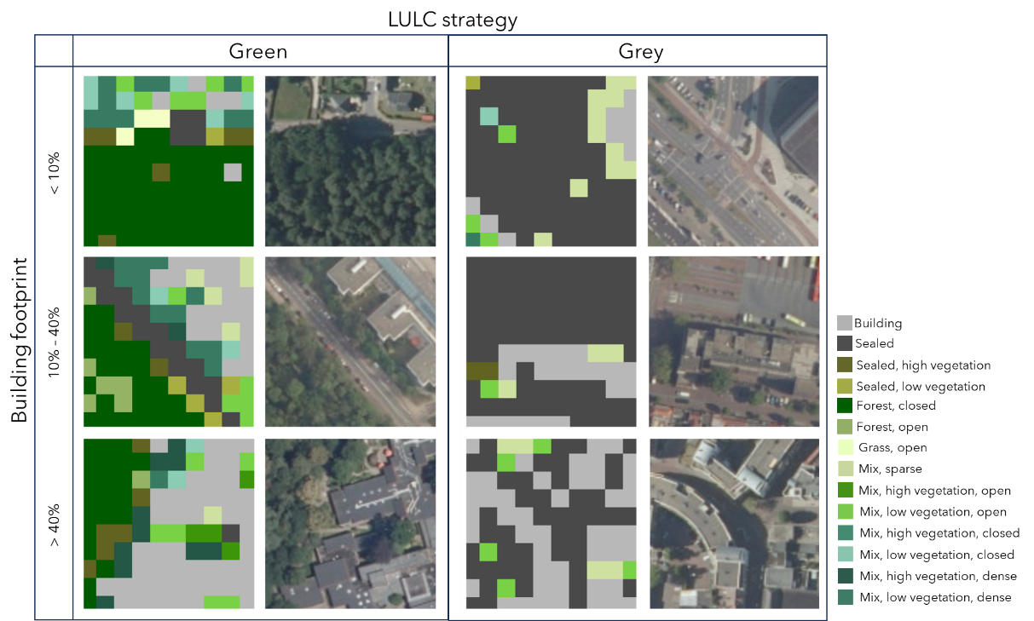
Figure S2. LULC composition for transformed areas for strategy Green and Grey. These LULC "tiles" are pasted into the transformed areas. The tile selection depends on the strategy and footprint of the constructed building (<10%, 10-40% or >40%).

S1.4. Ecosystem service analysis
We used the LULC maps to assess changes in land-use and ecosystem services between 2018 and 2050. Based on the new land-cover map, we calculated the total area of green infrastructure lost or added for each strategy. Second, we assessed the area of green infrastructure within a 500 meter radius, as a measure for green infrastructure availability. Furthermore, we assessed the effect of green infrastructure on the temperature and ability to store stormwater. For urban cooling and stormwater retention, we used the InVEST model ¹³. InVEST is an open-source software developed by the Natural Capital Project and Stanford University for mapping and valuing ecosystem services. InVEST combines land use and land cover data with additional information to provide output values for ecosystem services in biophysical and/or economic units.
We assess ecosystem services for newly constructed areas and for the whole building stock. We also zoom in to assess the ecosystem results more closely. We zoom in on the area of Leiden that shows both an urbanized part of Leiden (historic center and newer building developments) and its surrounding area which is characterized by mostly agricultural land.

Total area of green infrastructure
We calculated the total area of green infrastructure to calculate nature lost, preserved or created. S2.3.4. provides an overview of the LULC types that were considered as green infrastructure. We used a simple python model to calculate the total area of green infrastructure in 2018 and in 2050, for each of the strategies. The model can be found in file 8 on GitHub⁶.

Green infrastructure availability
Table S2.3.4provides an overview of landcover types considered as green infrastructure. The Netherlands set the target of a minimum green infrastructure provision of 60 m² per-capita within a 500 m radius around households¹⁴. Here we adapted the 500 meter radius to assess the total area of green infrastructure around dwellers. File 6 on GitHub⁶ presents the python code used to create population maps for 2050. The population map for 2020 was obtained through personal communication with RIVM. We calculated both the total area of green infrastructure around dwellers, as well as the area of green infrastructure per capita (m2 GI within 500 meter radius/number of dwellers in the specified cell). For the final results, we only used the prior, because we argue that the number of dwellers does not limit the services provided by green infrastructure. File 10 on GitHub⁶ presents the python code used to assess the green infrastructure availability per dweller. We first used Reclassify (ArcPy plugin) to exclude landcover types that are not considered as green infrastructure, and then used the focal statistics tool (ArcPy plugin) to calculate the total availability of green infrastructure.

Urban cooling
We used the InVEST model to calculate changes in air temperature, using the following assumptions (refer to S2.3.3. for the biophysical table). Crop coefficients and shade values were obtained from literature^{15,16}. The annual reference evaporation map is obtained from the Royal Netherlands Meteorological Institute (KNMI)¹⁷, which is modeled for the year 2050. As a reference temperature, we take 26.5 ºC which is the modeled hottest summer day per year for 2050 in the Climate scenarios of KNMI¹⁸. For the maximum urban heat island effect we take the highest increase in temperature from the urban heat island map of the Netherlands, which is 2.8 ºC¹⁹. We assume an air blending distance of 500 meter, which is based on the suggested value in InVEST manual. We take 450 meters as the maximum cooling distance, again based on suggested value in InVEST manual. From the created output maps, we use the air temperature maps to assess changes in temperature between 2018 and 2050.

Stormwater retention
We used the InVEST model to assess changes in stormwater retention (refer to S2.3.2. for the biophysical table), using the following model assumptions. The annual precipitation map was obtained from KNMI, modeled for the year 2050²⁰. Hydrologic soil groups were obtained from Distributed Active Archive Center for biochemical dynamics²¹. Biophysical values were calculated on the basis on literature. Curve numbers were obtained from USDA (1986). We calculated the retention capacity based on a rain event of 100 mm in a day, which is a very extreme event for the Netherlands²³.

References

1. BAG. Basisregistratie Adressen en Gebouwen (Basic registration of addresses and buildings). https://www.geobasisregistraties.nl/basisregistraties/adressen-en-gebouwen (2018).
2. Arnoldussen, J. et al. Materiaalstromen, Milieu-Impact En Energieverbruik in de Woning- En Utiliteitsbouw. Uitgangssituatie En Doorkijk Naar 2030. https://circulairebouweconomie.nl/wp-content/uploads/2020/02/Rapport-Materiaalstromen-in-de-woning-en-utiliteitsbouw-klein.pdf (2019).
3. PBL. Grote opgaven in een beperkte ruimte. Ruimtelijke keuzes voor een toekomstbestendige lefomgeving. 169 (2021).
4. RVO. Referentie Gebouwen BENG (Bijna EnergieNeutrale Gebouwen). (2016).
5. Wernet, G. et al. The ecoinvent database version 3 (part I): overview and methodology. Int J Life Cycle Assess 21, 1218–1230 (2016).
6. van Oorschot, J. Optimization_sustainble_urbanizaiton. GitHub https://github.com/JannekevanOorschot/Optimization_sustainable_urbanization
7. van Oorschot, J., Sprecher, B., Roelofs, B., van der Horst, J. & van der Voet, E. Towards a low-carbon and circular economy: Scenarios for metal stocks and flows in the Dutch electricity system. Resources, Conservation and Recycling 178, 106105 (2022).
8. Nationaal Georegister. Basisregistratie Grootschalige Topografie (BGT). (2022).
9. Nationaal Georegister. Bomen in Nederland. (2020).
10. Nationaal Georegister. Struiken in Nederland. (2020).
11. Nationaal Georegister. Lage vegetatie in Nederland. (2020).
12. Lonsdorf, E. V., Nootenboom, C., Janke, B. & Horgan, B. P. Assessing urban ecosystem services provided by green infrastructure: Golf courses in the Minneapolis-St. Paul metro area. Landscape and Urban Planning 208, 104022 (2021).
13. Sharp, R. et al. InVEST 3.10.2 User’s Guide. (2020).
14. Roo, M. D., Kuypers, V. H. M. & Lenzholzer, S. The Green City Guidelines: Techniques for a Healthy Liveable City. http://library.wur.nl/WebQuery/wurpubs/fulltext/178666 (2011).
15. Bosch, M. et al. A spatially explicit approach to simulate urban heat mitigation with InVEST (v3.8.0). Geosci. Model Dev. 14, 3521–3537 (2021).
16. Veerkamp, C. J., Loreti, M., Benavidez, R., Jackson, B. & Schipper, A. M. Comparing three spatial modeling tools for assessing urban ecosystem services. Ecosystem Services 59, 101500 (2023).
17. KNMI. Jaarlijkse referentieverdamping. Klimaateffectenatlas. https://www.klimaateffectatlas.nl/nl/ (2016).
18. KNMI. KNMI’14-Klimaatscenario’s Voor Nederland; Leidraad Voor Professionals in Klimaatadaptatie. (2015).
19. Atlas Natuurlijk Kapitaal. Stedelijk Hitte Eiland Effect. https://www.klimaateffectatlas.nl/nl/ (2017).
20. KNMI. Jaarlijkse Neerslag. https://www.klimaateffectatlas.nl/nl/ (2015).
21. EarthData. Global Hydrologic Soil Groups (HYSOGs250m) for Curve Number-Based Runoff Modeling. https://daac.ornl.gov/SOILS/guides/Global_Hydrologic_Soil_Group.html (2020).
22. USDA. Urban Hydrology for Small Watersheds. (1986).
23. KNMI. Extreme neerslag. https://www.knmi.nl/kennis-en-datacentrum/uitleg/extreme-neerslag.

