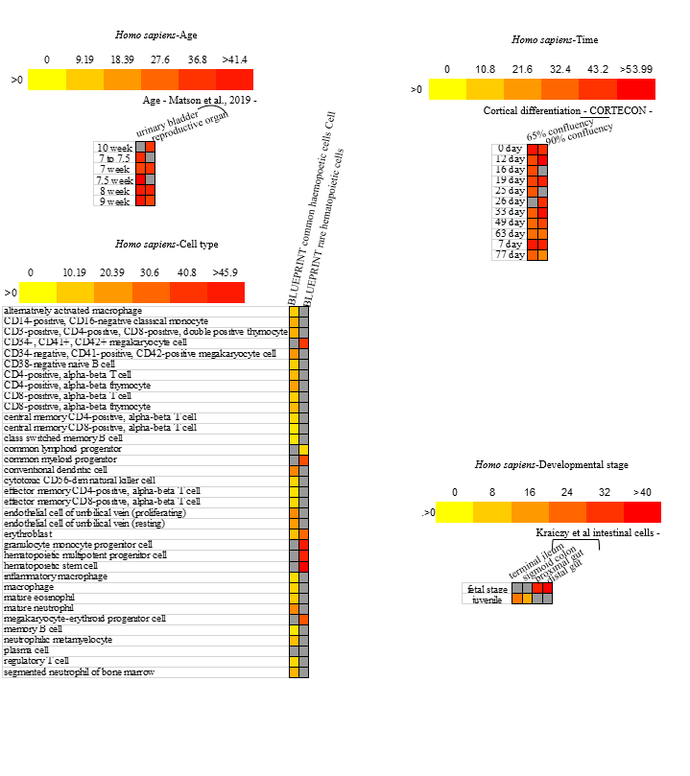
Figure S1 Homo sapiens age, cell type, time and development stage transcriptomics expressions.

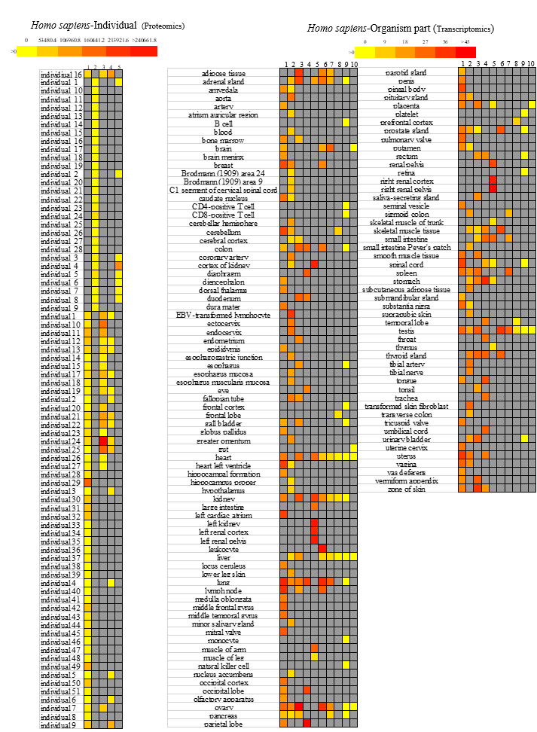
Figure S2 Homo sapiens individual proteomics and organism part transcriptomics expressions. 1-5 in Homo sapiens-Individual represented Proteomics - Tissue - Breast cancer - Pozniak et al. - breast - neoplasm, Proteomics - Tissue - Prostate cancer – neoplasm, Proteomics - Tissue - Breast cancer - Pozniak et al. - breast - normal tissue adjacent to tumor, Proteomics - Tissue - Breast cancer - Pozniak et al. - lymph node- neoplasm, Proteomics - Tissue - Prostate cancer - normal tissue adjacent to tumor. 1-10 in Homo sapiens Organism part mean 68 FANTOM5 project - adult, GTEx, 32 Uhlen's Lab, 68 FANTOM5 project - fetal, 19 NIH Epigenomics Roadmap, Illumina Body Map, ENCODE (M. Snyder lab), Mammalian Kaessmann, Human Proteome Map – adult, Human Proteome Map - fetus.

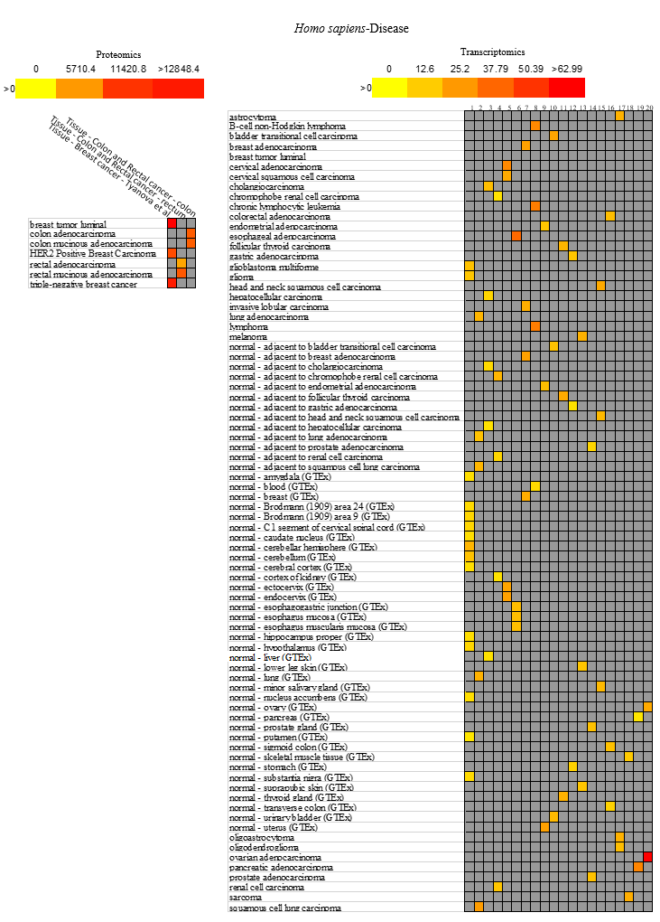
Figure S3 Homo sapiens disease proteomics and transcriptomics expressions. 1-20 in disease transcriptomics represented Pan-Cancer Analysis of Whole Genomes- brain, Pan-Cancer Analysis of Whole Genomes - lung, Pan-Cancer Analysis of Whole Genomes - liver, Pan-Cancer Analysis of Whole Genomes - kidney, Pan-Cancer Analysis of Whole Genomes - uterine cervix, Pan-Cancer Analysis of Whole Genomes - esophagus, Pan-Cancer Analysis of Whole Genomes - breast, Pan-Cancer Analysis of Whole Genomes - blood, Pan-Cancer Analysis of Whole Genomes - uterus, Pan-Cancer Analysis of Whole Genomes - urinary bladder, Pan-Cancer Analysis of Whole Genomes - thyroid gland, Pan-Cancer Analysis of Whole Genomes - stomach, Pan-Cancer Analysis of Whole Genomes - skin, Pan-Cancer Analysis of Whole Genomes - prostate gland, Pan-Cancer Analysis of Whole Genomes - mouth mucosa, Pan-Cancer Analysis of Whole Genomes - large intestine 3 Glioma subtypes, Pan-Cancer Analysis of Whole Genomes - skeletal muscle tissue, Pan-Cancer Analysis of Whole Genomes -pancreas, Pan-Cancer Analysis of Whole Genomes - ovary.

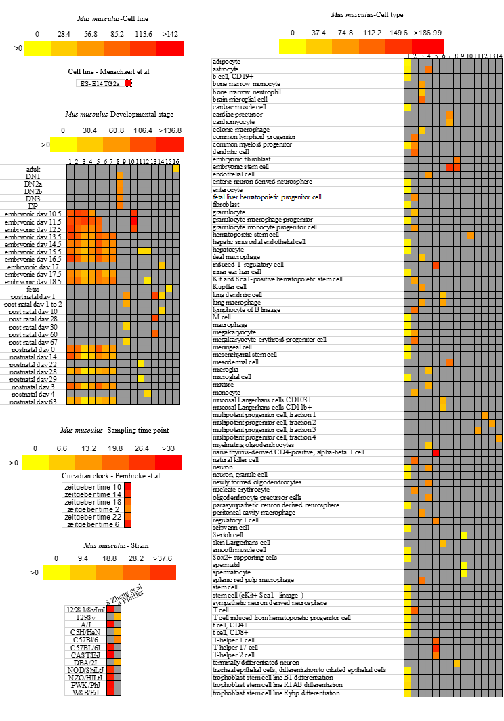

Figure S4 Mus musculus cell line, developmental stage, sampling time point, strain and cell type transcriptomics expressions. Mus musculus-Developmental stage 1-16 mean Tissues-developmental stages - Mouse - Moreira et al – testis, Tissues- developmental stages - Mouse - Moreira et al – ovary, Tissues - developmental stages - Mouse - Moreira et al – liver, Tissues - developmental stages - Mouse - Moreira et al – heart, Tissues-developmental stages - Mouse - Moreira et al – kidney, Tissues- developmental stages - Mouse - Moreira et al – hindbrain, Tissues-developmental stages - Mouse - Moreira et al – forebrain, 5, Cell Types-Developing heart – cardiomyocyte, Tissues-developmental stages - Mouse - Moreira et al – brain, Developmental stages - Schmitt et al – liver, Developmental stages - Schmitt et al – brain, Cell Types - Developing heart – fibroblast, Cell Types - Developing heart - cells of ventricle, Developmental stages - 4 – liver, Developmental stages - 4 - bone marrow. Mus musculus-cell type 1-14 mean Cell Types - 35 FANTOM5 project, Cell type - Paulson et al, Cell types - Lavin et al, Cell Types - Cerebral cortex, Cell Types - Six T cell subtypes, Cell types - Capucha et al, Cell type - Wamstad et al, Cell types - 3 Lienert et al, Cell type - Soumillon et al, Cell type - Cabezas-Wallscheid et al - Lin neg Sca-1+ c-Kit+, LSK, CD34- CD135- CD150+ CD48-, Cell type - Cabezas-Wallscheid et al - LSK CD34+ CD135- CD150- CD48+, Cell type - Cabezas-Wallscheid et al - LSK CD34+ CD135- CD150+ CD48-, Cell type - Cabezas-Wallscheid et al - LSK CD34+ CD135- CD150+ CD48+, Cell type - Cabezas-Wallscheid et al - LSK CD34+ CD135+ CD150- CD48+.

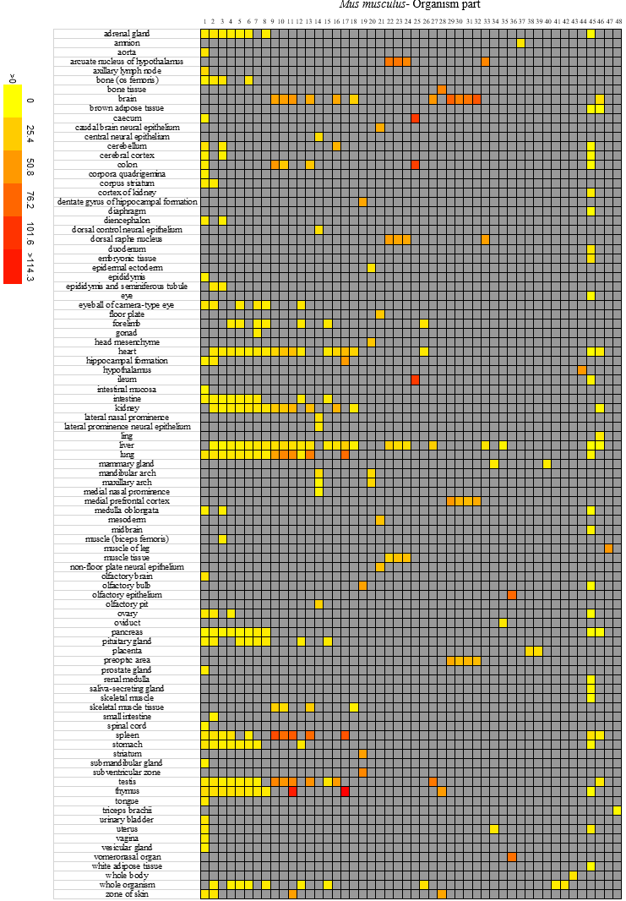
Figure S5 Mus_musculus organism part transcriptomics expressions. Mus_musculus-Organism part 1-48 represented 49 FANTOM5 project – adult, 49 FANTOM5 project – neonate, 49 FANTOM5 project – juvenile, 49 FANTOM5 project - embryonic day 18, 49 FANTOM5 project - embryonic day 17, 49 FANTOM5 project - embryonic day 16, 49 FANTOM5 project - embryonic day 15, 49 FANTOM5 project - embryonic day 14 9 in 3 strains - DBA/2J 9 in 3 strains - CD1, 9, 49 FANTOM5 project - embryonic day 12, 9 in 3 strains - C57BL/6, 14 - embryonic day 10.5, 49 FANTOM5 project - embryonic day 13, Mammalian Kaessmann, 6, Vertebrates, 4, 14 - embryonic day 9.5, 14 - embryonic day 8.5, 4 Bonthuis et al – CastEiJ, 4 Bonthuis et al - (CastEiJ X C57BL/6J)F1, 4 Bonthuis et al - (C57BL/6J X CastEiJ)F1, Developing gut, 49 FANTOM5 project - embryonic day 11, 3 Soumillon et al, 3, Gregg et al - CAST/EiJ, Gregg et al - C57BL/6J, Gregg et al - (CAST/EiJ X C57BL/6J)F1, Gregg et al - (C57BL/6J X CAST/EiJ)F1, 4 Bonthuis et al - C57BL/6J, 49 FANTOM5 project - pregnant adult day 19, 49 FANTOM5 project - pregnant adult day 1, 2, 49 FANTOM5 project - pregnant adult day 17.5, 49 FANTOM5 project - pregnant adult day 17, 49 FANTOM5 project - pregnant adult day 10, 49 FANTOM5 project - lactating adult day 2, 49 FANTOM5 project - embryonic day 17.5, 49 FANTOM5 project - embryonic day 14.5, 49 FANTOM5 project – embryo, 4 Bonthuis et al - Idaho derived wild mouse, Organism part - Geiger et al, Organism part - Huttlin et al, Skeletal muscle - Deshmukh et al - myotube - C2C12 Skeletal, muscle - Deshmukh et al -.
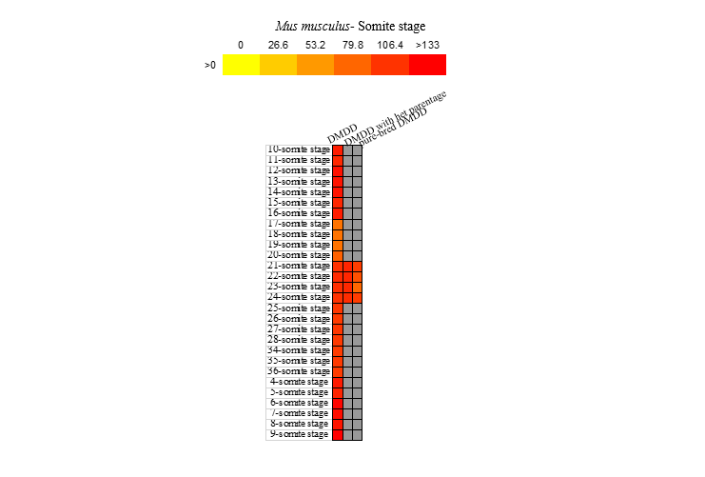
Figure S6 Mus_musculus somite stage transcriptomics expressions.
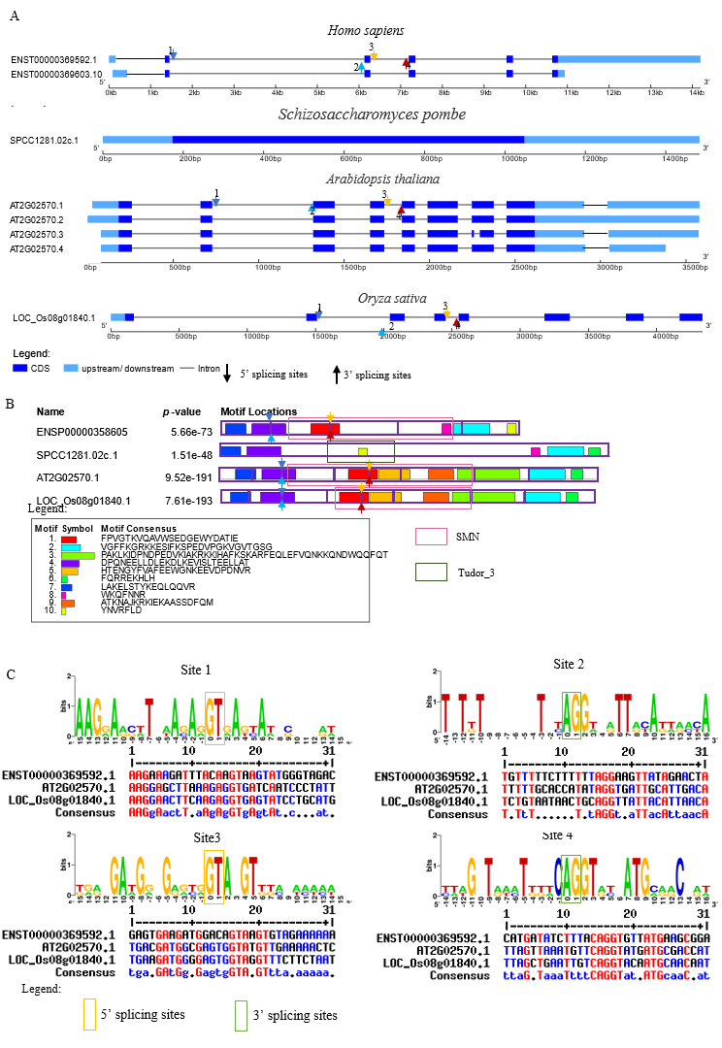
Figure S7. Comparison of SMNDC1s in human, yeast, arabidopsis and rice.
(A) SMNDC1s AS events in human, yeast, Arabidopsis and rice. (B) SMNDC1s conserved motif in human, yeast, Arabidopsis and rice. Different colored arrows present different splicing sites. (C) SMNDC1s conserved splicing sites analyze. Colored arrow represented conserved splicing sites labeled at （A）and (B).

