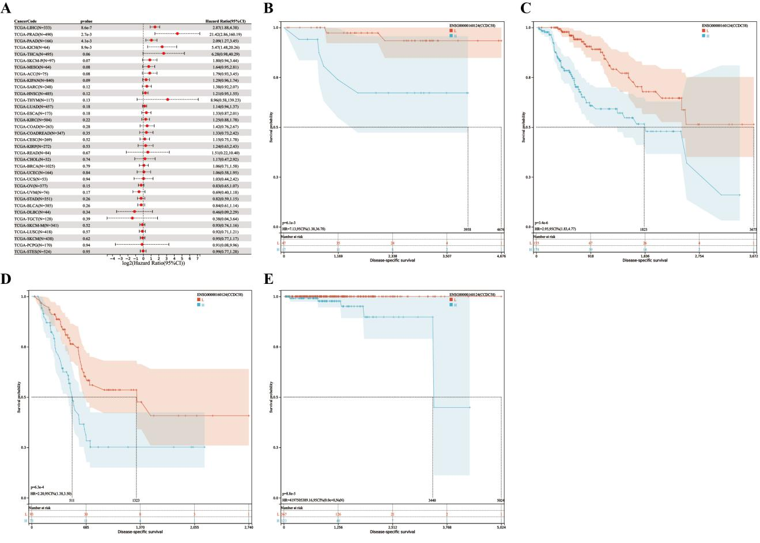
Figure S1: Association of CCDC58 expression with disease-free survival (DSS). (A) Forest plot showing the correlation between DSS and CCDC58 expression in 36 tumor types. Kaplan-Meier analysis of the association between CCDC58 expression and DSS in (B) Kidney Chromophobe (KICH), (C) Liver hepatocellular carcinoma (LIHC), (D) Pancreatic adenocarcinoma (PAAD), (E) Prostate adenocarcinoma (PRAD).

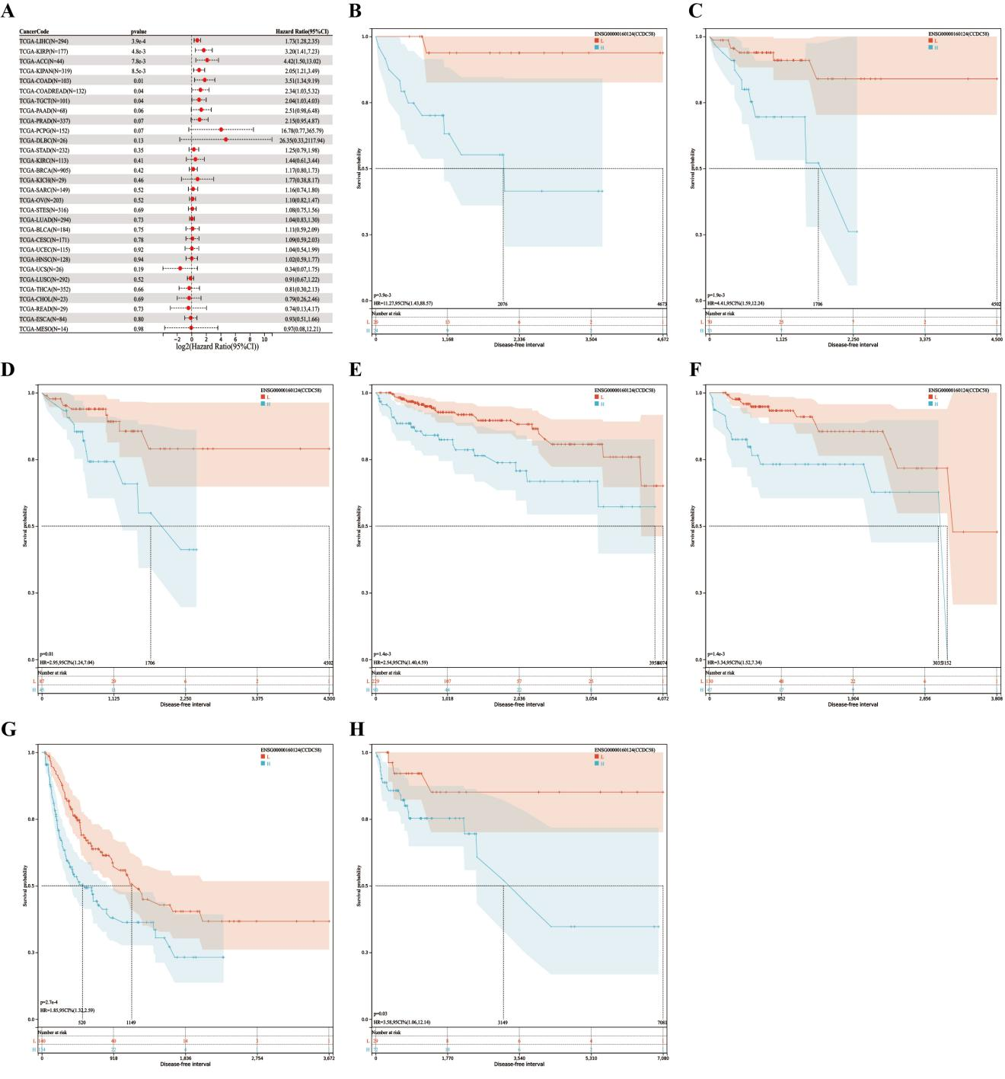
Figure S2: Correlation of CCDC58 expression with disease-free interval (DFI). (A) Forest plot showing the relationship between CCDC58 expression and DFI in 36 tumor types. Kaplan-Meier analysis of the association between CCDC58 expression and DFI in (B) Adrenocortical carcinoma (ACC), (C) Colon adenocarcinoma (COAD), (D) Colon adenocarcinoma/Rectum adenocarcinoma Esophageal carcinoma (COADREAD), (E) Pan-kidney cohort (KICH + KIRC + KIRP) (KIPAN), (F) Kidney renal hepatocellular carcinoma (KIRP), (G) hepatocellular carcinoma (LIHC), and (H) Testicular Germ Cell Carcinoma (TGCT).
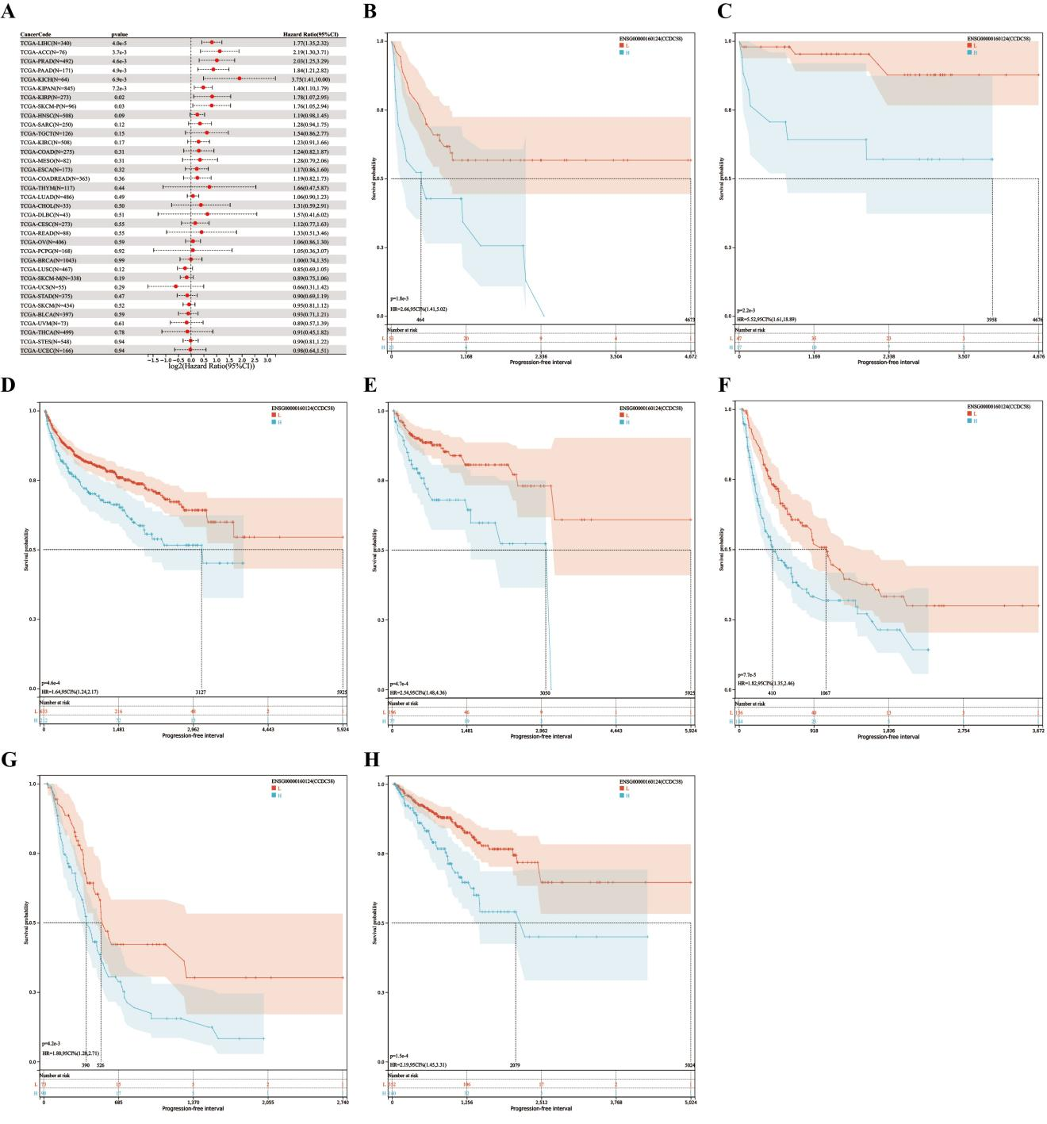
Figure S3: Association of CCDC58 expression with progression-free interval (PFI). (A) Forest plot showing the association of CCDC58 expression with PFI in 36 tumor types. Kaplan-Meier analysis of the association between CCDC58 expression and PFI in (B) Adrenocortical carcinoma (ACC), (C) Kidney Chromophobe (KICH), (D) Pan-cohort (KICH + KIRC + KIRP) (KIPAN), (E) Kidney renal papillary kidney cell carcinoma (KIRP), (F) Liver hepatocellular carcinoma (LIHC), (G) Pancreatic adenocarcinoma (PAAD), and (H) Prostate adenocarcinoma (PRAD).

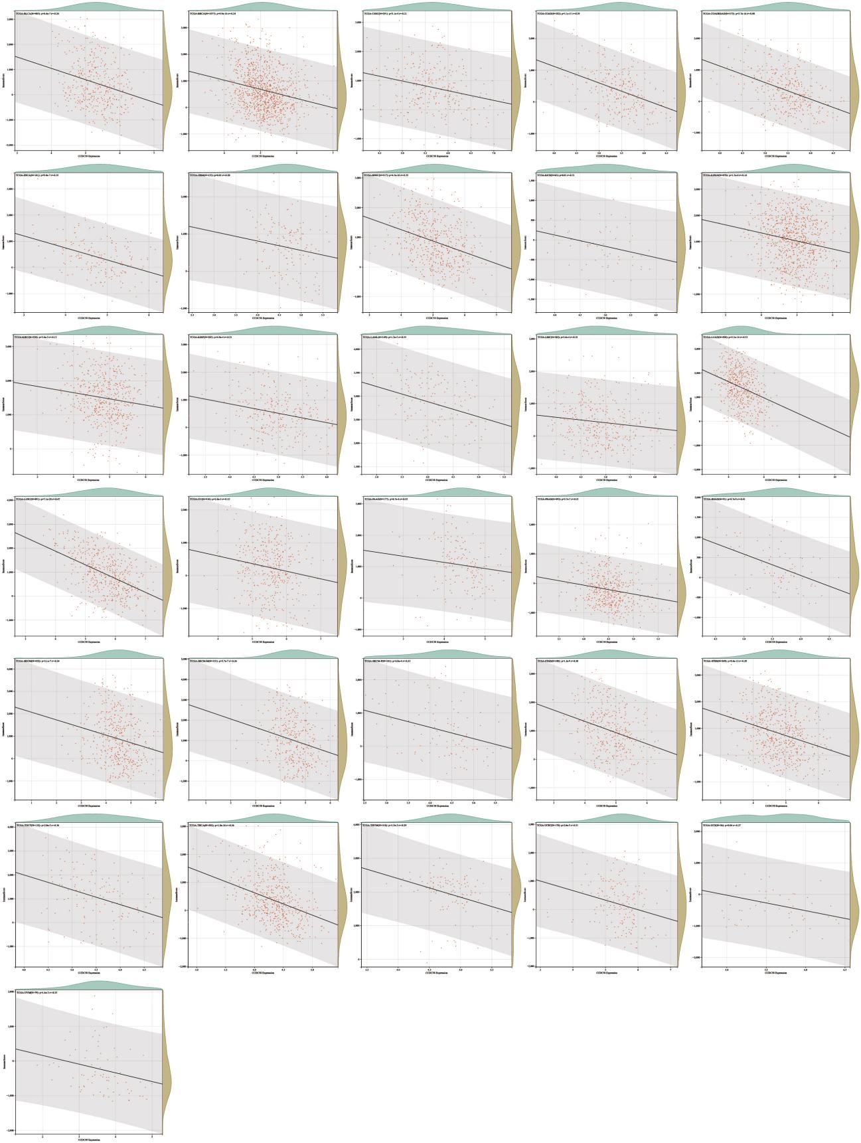
Figure S4: Correlation between CCDC58 expression and pan-cancer immune score. CCDC58 expression was negatively correlated with stromal scores for BLCA, BRCA, CESC, COAD, COADREAD, ESCA, GBM, HNSC, KICH, KIPAN, KIRC, KIRP, LAML, LIHC, LUAD, LUSC, OV, PAAD, PRAD, READ, SKCM, SKCM-M, SKCM-P, STAD, STES, TGCT, THCA, THYM, UCEC, UCS, and UVM.

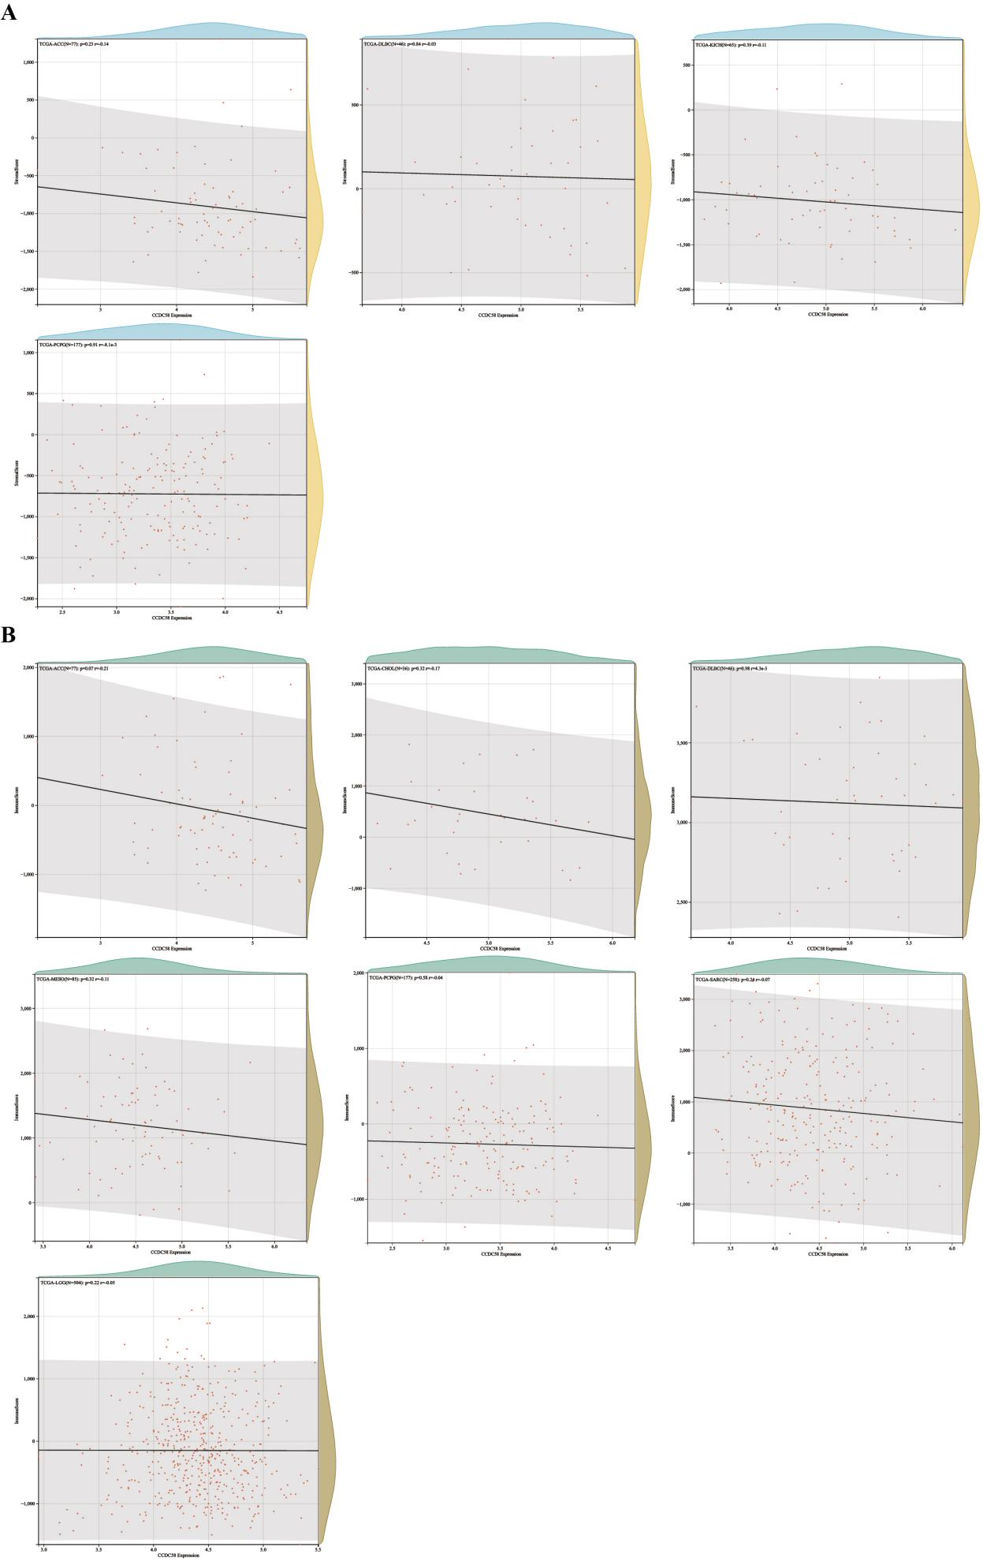
Figure S5: Correlation between CCDC58 expression and pan-cancer stromal score, immune score. (A) No significant differences were found in ACC, DLBC, KICH, and PCPG. (B) No significant differences were found in ACC, CHOL, DLBC, MESO, PCPG, SARC, and LGG.

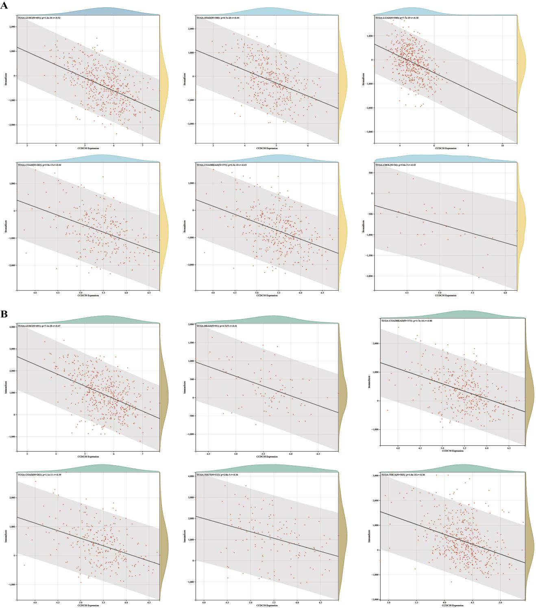
Figure S6: Relationship between CCDC58 expression and tumor microenvironment factors. (A) CCDC58 expression was negatively correlated with stromal scores in LUSC, STAD, LUAD, COAD, COADREAD, and CHOL. (B) CCDC58 expression was negatively correlated with immune scores of LUSC, READ, COADREAD, COAD, TGCT, and THCA.

