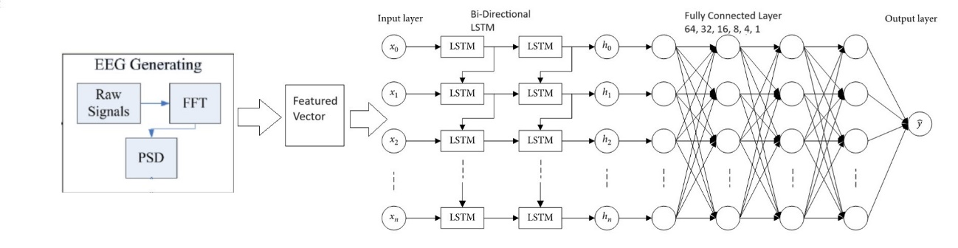
Supplementary Fig. 1 Schematic representation of the proposed EEG prediction methodology. Features are extracted from 0.001 s long EEG segments and are fed into the bidirectional- LSTM network for classification.

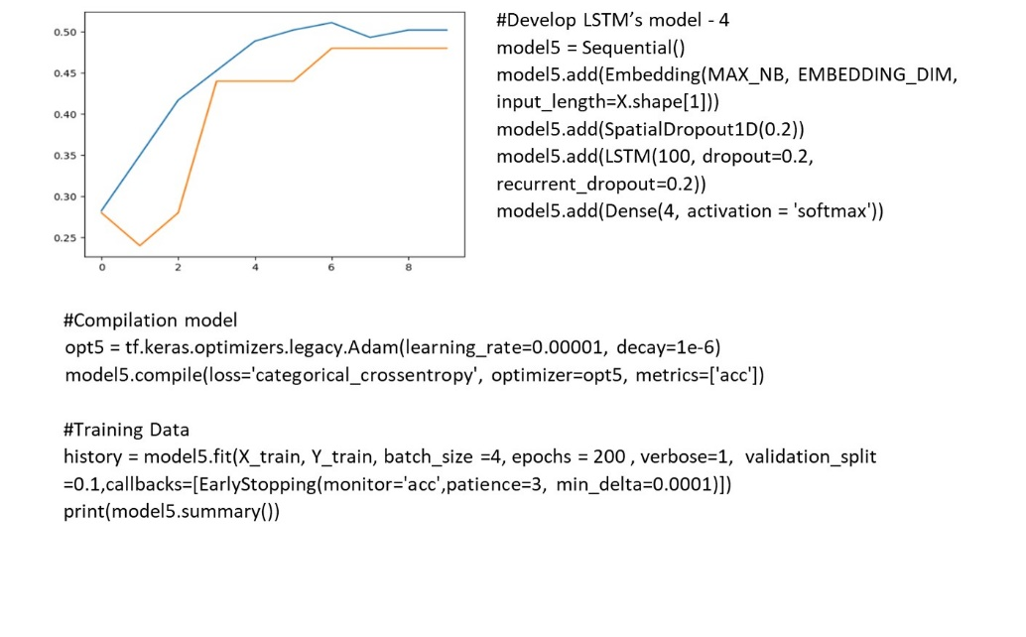
Supplementary Fig. 2 The best hyper-parameter tuning after grid search.

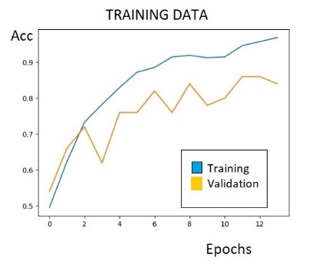
Supplementary Fig. 3 Training results of prediction model #3. This result shows a maximum training accuracy of 0.9472 (94.72%) and a maximum validation accuracy of 87.68%. Epochs are represented by 10 times for each scale in the figure, indicating that this model achieves maximum and stable accuracy after 120 epochs.

