Supplementary Information

A review on future of bioplastics and their physical, chemical and biological characteristic through bibliometric Analysis
Dhrushi Pansuriya¹, D. S. Kaul^{1*}, Pravin Kodgire^{2*}, Akanksha Nema¹
¹Department of Civil Engineering, PanditDeendayal Energy University, Gandhinagar, India
²Department of Chemical Engineering, PanditDeendayal Energy University, Gandhinagar, India

*Corresponding authors: dayashankar.kaul@sot.pdpu.ac.in; pravin.kodgire@sot.pdpu.ac.in

Annexure A
Table A: Comparison based on database supported by the software
Database  Software | Web of Science | Scopus | Dimensions | Microsoft Academic | Google  Scholar | Crossref | Others
VOSviever |  |  |  |  |  |  | RIS, CSV, EndNote, RefWorks PMC, Semantic Scholar, Open Citation, WikiData
CiteNet
Explore
CiteSpace |  |  |  |  |  |  | ADS, arXiv, CNKI, Cssci, Derwent Patents, NSF, ProQuest, Fulltext, CSV
Bibexcel |  |  |  |  |  |  | ProCite, Bibexcel
Publish or
Perish

Table B: Comparison based on bibliometric networks associated with software
Software  Analysis  Techniques |  | VOSviever | CiteNet  Explore | CiteSpace | Bibexcel | Publish or  Perish
Co-occurrence
Co-author | Author
Co-author | Country
Co-author | Institution
Co-citation | Author
Co-citation | Document
Co-citation | Journal
Bibliographic Coupling | Author
Bibliographic Coupling | Document
Bibliographic Coupling | Journal

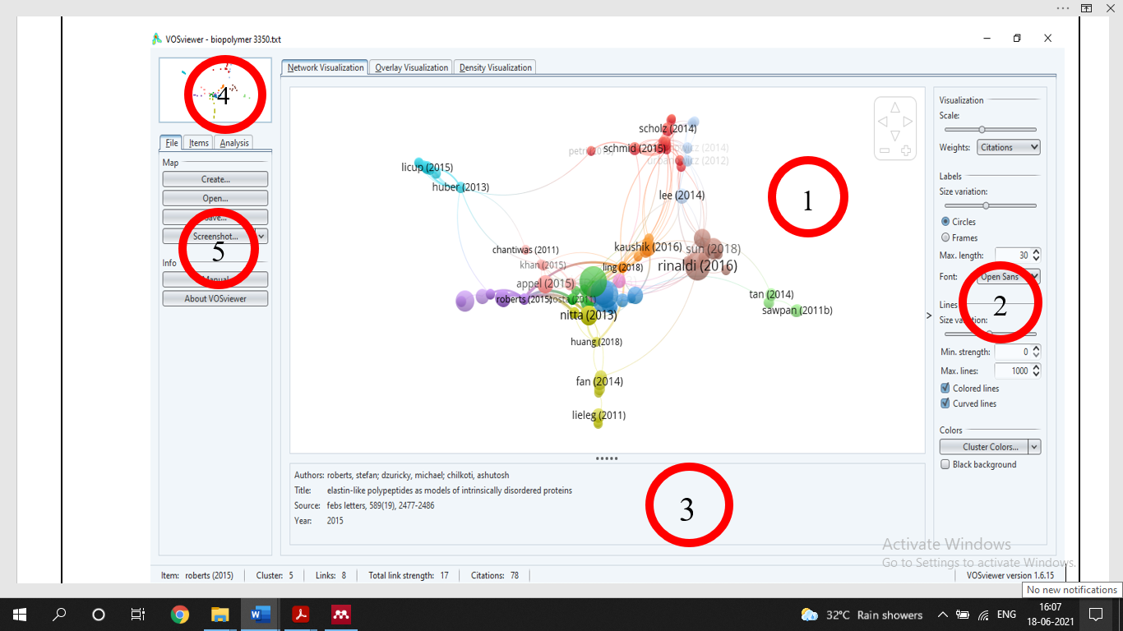
Fig. A: Main window of VOSviewer (Five panels: 1. Main panel, 2. Option panel, 3. Information panel, 4. Overview panel, 5. Action panel)

Table C. Types of data and data sources supported by the VOSviewer
Type of data
  Data source | Supported file types/APIs
Network data
  - VOSviewer
  - GML
  - Pajek
Bibliographic data
  - Bibliographic database files | Web of Science, Scopus, Dimensions, PubMed
  - Reference manager files | RIS, EndNote, RefWorks
  - APIs | Microsoft Academic, Crossref, Europe PMC, Semantic Scholar, OCC, COCI, Wikidata
Text data
  - VOSviewer files | VOSviewer, corpus, scores files
  - Bibliographic database files | Web of Science, Scopus, Dimensions, PubMed
  - Reference manager files | RIS, EndNote, RefWorks
  - APIs | Microsoft Academic, Crossref, Europe PMC, Semantic Scholar, OCC, COCI, Wikidata

Annexure B
Table A. Group of keywords and number of results obtained per keywords' group
No. | Group of keywords | Number of results  obtained
 | Keywords based on general term bioplastic | 12898
 | Keywords based on manufacturing material | 4474
   | Related to biobased material | 3319
   | Related to plasticizer | 565
   | Related to agricultural and food waste | 165
   | Related to microbial biopolymer | 104
   | Related to oils and proteins | 127
   | Related to nanoparticles | 194
 | Keywords based on bioplastics’ properties | 1275
 | Keywords based on manufacturing process | 361
 | Keywords based on bioplastics’ applications | 974

Annexure C
Table A. List of the search strings and number of results obtained in an individual search string
No. | Keyword search | Number of results  obtained
(1)
Keywords based on general term bioplastic:
1. | “bioplastic” | 1136
2. | “bioplastics” | 1493
3. | "bio-plastics" | 131
4. | “biobased plastics” | 70
5. | “bio-based plastics” | 144
6. | “biodegradable plastic” | 659
7. | “biodegradable plastics” | 902
8. | (“bioplastic” OR “bioplastics” OR “bio-plastics” OR “biobased plastics” OR “bio-based plastics” OR “biodegradable plastic” OR “biodegradable plastics”) | 3802
9. | (“bioplastic” OR “bioplastics” OR “bio-plastics” OR “biobased plastics” OR “bio-based plastics” OR “biodegradable plastic” OR “biodegradable plastics”) AND (“biopolymer” OR “biopolymers” OR “bio-based polymer” OR “biodegradable polymer” OR “biodegradable polymers”) | 769
10. | (“bioplastic” OR “bioplastics” OR “bio-plastics” OR “biobased plastics” OR “bio-based plastics” OR “biodegradable plastic” OR “biodegradable plastics”) AND (“biodegradable film” OR “biodegradable films” OR “biofilm” OR “biofilms” OR “edible films”) | 197
11. | (“bioplastic” OR “bioplastics” OR “bio-plastics” OR “biobased plastics” OR “bio-based plastics” OR “biodegradable plastic” OR “biodegradable plastics”) AND (“edible” OR “edible coating” OR “edible coatings”) | 115
12. | (“bioplastic” OR “bioplastics” OR “bio-plastics” OR “biobased plastics” OR “bio-based plastics” OR “biodegradable plastic” OR “biodegradable plastics”) AND (“bio composite” OR “biocomposite” OR “biocomposites” OR “bionanocomposite” OR “bio-nanocomposite” OR “bio-nanocomposites”) | 298
13. | (“bioplastic” OR “bioplastics” OR “bio-plastics” OR “biobased plastics” OR “bio-based plastics” OR “biodegradable plastic” OR “biodegradable plastics”) AND (“composite” OR “composites” OR “nanocomposite” OR “wood polymer composites” OR “composite bioplastic”) | 759
14. | (“bioplastic” OR “bioplastics” OR “bio-plastics” OR “biobased plastics” OR “bio-based plastics” OR “biodegradable plastic” OR “biodegradable plastics”) AND (“compostable plastic” OR “compostable plastics” OR “compostable polymers” OR “compostable materials” OR “compostable mulch”) | 18
15. | (“bioplastic” OR “bioplastics” OR “bio-plastics” OR “biobased plastics” OR “bio-based plastics” OR “biodegradable plastic” OR “biodegradable plastics”) AND (“biodegradability” OR “biodegradable” OR “biodegradation”) | 2115
16. | (“bioplastic” OR “bioplastics” OR “bio-plastics” OR “biobased plastics” OR “bio-based plastics” OR “biodegradable plastic” OR “biodegradable plastics”) AND (“compost” OR “compostability” OR “composting”) | 171
17. | (“bioplastic” OR “bioplastics” OR “bio-plastics” OR “biobased plastics” OR “bio-based plastics” OR “biodegradable plastic” OR “biodegradable plastics”) AND (“eco-friendly” OR “eco-friendly polymer”) | 119
(2)
Keywords based on manufacturing material:
(i) Related to biobased material
18. | (“bioplastic” OR “bioplastics” OR “bio-plastics” OR “biobased plastics” OR “bio-based plastics” OR “biodegradable plastic” OR “biodegradable plastics”) AND (“biodegradable materials” OR “biofibers”) | 95
19. | (“bioplastic” OR “bioplastics” OR “bio-plastics” OR “biobased plastics” OR “bio-based plastics” OR “biodegradable plastic” OR “biodegradable plastics”) AND (“polysaccharides” OR “biodegradable polyester” OR “glycolipid” OR “soy-based polyol”) | 107
20. | (“bioplastic” OR “bioplastics” OR “bio-plastics” OR “biobased plastics” OR “bio-based plastics” OR “biodegradable plastic” OR “biodegradable plastics”) AND (“aliphatic polyesters” OR “aliphatic polyester”) | 53
21. | (“bioplastic” OR “bioplastics” OR “bio-plastics” OR “biobased plastics” OR “bio-based plastics” OR “biodegradable plastic” OR “biodegradable plastics”) AND (“starch” OR “cassava starch” OR “corn starch” OR “rice starch” OR “plasticized starch” OR “thermoplastic starch” OR “tapioca” OR “sago” OR “starch based polymers”) | 575
22. | (“bioplastic” OR “bioplastics” OR “bio-plastics” OR “biobased plastics” OR “bio-based plastics” OR “biodegradable plastic” OR “biodegradable plastics”) AND (“cellulose” OR “cellulose acetate” OR “cellulose acetate butyrate” OR “cellulose nanofiber” OR “CMC” OR “microcrystalline cellulose” OR “nano-celluloses”) | 436
23. | (“bioplastic” OR “bioplastics” OR “bio-plastics” OR “biobased plastics” OR “bio-based plastics” OR “biodegradable plastic” OR “biodegradable plastics”) AND (“PLA” OR “polylactic acid” OR “poly(lactic acid)” OR “poly(lactic acid) (PLA)” OR “polylactic acid (PLA)” OR “polylactide”) | 671
24. | (“bioplastic” OR “bioplastics” OR “bio-plastics” OR “biobased plastics” OR “bio-based plastics” OR “biodegradable plastic” OR “biodegradable plastics”) AND (“PHA” OR “polyhydroxyalkanoate” OR “polyhydroxyalkanoates” OR “poly(hydroxyalkanoate)s” OR “polyhydroxyalkanoates (PHA)” OR “polyhydroxyalkanoates (PHAs)” OR “PHA biopolyesters”) | 728
25. | (“bioplastic” OR “bioplastics” OR “bio-plastics” OR “biobased plastics” OR “bio-based plastics” OR “biodegradable plastic” OR “biodegradable plastics”) AND (“PHB” OR “polyhydroxybutyrate”) | 499
26. | (“bioplastic” OR “bioplastics” OR “bio-plastics” OR “biobased plastics” OR “bio-based plastics” OR “biodegradable plastic” OR “biodegradable plastics”) AND (“PVA” OR “poly (vinyl-alcohol) (PVA)” OR “PVA blends” OR “PVA nanocomposites”) | 46
27. | (“bioplastic” OR “bioplastics” OR “bio-plastics” OR “biobased plastics” OR “bio-based plastics” OR “biodegradable plastic” OR “biodegradable plastics”) AND (“PCL” OR “polycaprolactone” OR “poly(caprolactone)s”) | 109
(ii) Related to plasticizer
28. | (“bioplastic” OR “bioplastics” OR “bio-plastics” OR “biobased plastics” OR “bio-based plastics” OR “biodegradable plastic” OR “biodegradable plastics”) AND “plasticizer” | 221
29. | (“bioplastic” OR “bioplastics” OR “bio-plastics” OR “biobased plastics” OR “bio-based plastics” OR “biodegradable plastic” OR “biodegradable plastics”) AND (“glycerol” OR “glyceric acid” OR “polyglycolic acid”) | 344
(iii) Related to agricultural and food waste
30. | (“bioplastic” OR “bioplastics” OR “bio-plastics” OR “biobased plastics” OR “bio-based plastics” OR “biodegradable plastic” OR “biodegradable plastics”) AND (“agricultural waste” OR “agro-polymer” OR “food waste”) | 93
31. | (“bioplastic” OR “bioplastics” OR “bio-plastics” OR “biobased plastics” OR “bio-based plastics” OR “biodegradable plastic” OR “biodegradable plastics”) AND “natural fiber” | 49
32. | (“bioplastic” OR “bioplastics” OR “bio-plastics” OR “biobased plastics” OR “bio-based plastics” OR “biodegradable plastic” OR “biodegradable plastics”) AND (“aloe vera” OR “aloe verafibers (AVF)”) | -
33. | (“bioplastic” OR “bioplastics” OR “bio-plastics” OR “biobased plastics” OR “bio-based plastics” OR “biodegradable plastic” OR “biodegradable plastics”) AND “coconut husk” | 1
34. | (“bioplastic” OR “bioplastics” OR “bio-plastics” OR “biobased plastics” OR “bio-based plastics” OR “biodegradable plastic” OR “biodegradable plastics”) AND (“banana peel waste”) | 1
35. | (“bioplastic” OR “bioplastics” OR “bio-plastics” OR “biobased plastics” OR “bio-based plastics” OR “biodegradable plastic” OR “biodegradable plastics”) AND “jackfruit waste” | 1
36. | (“bioplastic” OR “bioplastics” OR “bio-plastics” OR “biobased plastics” OR “bio-based plastics” OR “biodegradable plastic” OR “biodegradable plastics”) AND “corn silage” | 5
37. | (“bioplastic” OR “bioplastics” OR “bio-plastics” OR “biobased plastics” OR “bio-based plastics” OR “biodegradable plastic” OR “biodegradable plastics”) AND “cotton linters” | 3
38. | (“bioplastic” OR “bioplastics” OR “bio-plastics” OR “biobased plastics” OR “bio-based plastics” OR “biodegradable plastic” OR “biodegradable plastics”) AND “flax fibers” | 10
39. | (“bioplastic” OR “bioplastics” OR “bio-plastics” OR “biobased plastics” OR “bio-based plastics” OR “biodegradable plastic” OR “biodegradable plastics”) AND (“yam bean” OR “jicama”) | 2
(iv) Related to microbial biopolymer
40. | (“bioplastic” OR “bioplastics” OR “bio-plastics” OR “biobased plastics” OR “bio-based plastics” OR “biodegradable plastic” OR “biodegradable plastics”) AND “microbial polyester” | 4
41. | (“bioplastic” OR “bioplastics” OR “bio-plastics” OR “biobased plastics” OR “bio-based plastics” OR “biodegradable plastic” OR “biodegradable plastics”) AND “chitosan” | 96
42. | (“bioplastic” OR “bioplastics” OR “bio-plastics” OR “biobased plastics” OR “bio-based plastics” OR “biodegradable plastic” OR “biodegradable plastics”) AND “fish gelatin” | 4
(v) Related to oils and proteins
43. | (“bioplastic” OR “bioplastics” OR “bio-plastics” OR “biobased plastics” OR “bio-based plastics” OR “biodegradable plastic” OR “biodegradable plastics”) AND “essential oils” | 14
44. | (“bioplastic” OR “bioplastics” OR “bio-plastics” OR “biobased plastics” OR “bio-based plastics” OR “biodegradable plastic” OR “biodegradable plastics”) AND “carrageenan” | 9
45. | (“bioplastic” OR “bioplastics” OR “bio-plastics” OR “biobased plastics” OR “bio-based plastics” OR “biodegradable plastic” OR “biodegradable plastics”) AND (“soy protein”) | 104
(iv) Related to nanoparticles
46. | (“bioplastic” OR “bioplastics” OR “bio-plastics” OR “biobased plastics” OR “bio-based plastics” OR “biodegradable plastic” OR “biodegradable plastics”) AND “nanoclay” | 20
47. | (“bioplastic” OR “bioplastics” OR “bio-plastics” OR “biobased plastics” OR “bio-based plastics” OR “biodegradable plastic” OR “biodegradable plastics”) AND (“nanofiller” OR “nanoparticles”) | 152
48. | (“bioplastic” OR “bioplastics” OR “bio-plastics” OR “biobased plastics” OR “bio-based plastics” OR “biodegradable plastic” OR “biodegradable plastics”) AND “TiO2” | 17
49. | (“bioplastic” OR “bioplastics” OR “bio-plastics” OR “biobased plastics” OR “bio-based plastics” OR “biodegradable plastic” OR “biodegradable plastics”) AND “ZnO nanoparticle” | 1
50. | (“bioplastic” OR “bioplastics” OR “bio-plastics” OR “biobased plastics” OR “bio-based plastics” OR “biodegradable plastic” OR “biodegradable plastics”) AND (“amorphous SiO2” OR “layered silicates”) | 4
(3)
Keywords based on bioplastics’ properties:
51. | (“bioplastic” OR “bioplastics” OR “bio-plastics” OR “biobased plastics” OR “bio-based plastics” OR “biodegradable plastic” OR “biodegradable plastics”) AND (“antibacterial” OR “antimicrobial” OR “antimicrobial activity” OR “microbial resistance”) | 86
52. | (“bioplastic” OR “bioplastics” OR “bio-plastics” OR “biobased plastics” OR “bio-based plastics” OR “biodegradable plastic” OR “biodegradable plastics”) AND “thermal resistance” | 11
53. | (“bioplastic” OR “bioplastics” OR “bio-plastics” OR “biobased plastics” OR “bio-based plastics” OR “biodegradable plastic” OR “biodegradable plastics”) AND (“mechanical properties” OR “physical properties” OR “mechanical strength”) | 958
54. | (“bioplastic” OR “bioplastics” OR “bio-plastics” OR “biobased plastics” OR “bio-based plastics” OR “biodegradable plastic” OR “biodegradable plastics”) AND (“barrier performance” OR “barrier properties”) | 153
55. | (“bioplastic” OR “bioplastics” OR “bio-plastics” OR “biobased plastics” OR “bio-based plastics” OR “biodegradable plastic” OR “biodegradable plastics”) AND (“hydrophilicity” OR “hydrophobicity”) | 57
56. | (“bioplastic” OR “bioplastics” OR “bio-plastics” OR “biobased plastics” OR “bio-based plastics” OR “biodegradable plastic” OR “biodegradable plastics”) AND “economic feasibility” | 10
(4)
Keywords based on manufacturing process:
57. | (“bioplastic” OR “bioplastics” OR “bio-plastics” OR “biobased plastics” OR “bio-based plastics” OR “biodegradable plastic” OR “biodegradable plastics”) AND (“casting” OR “extrusion” OR “injection moulding” OR “compression moulding”) | 361
(5)
Keywords based on bioplastics’ applications:
58. | (“bioplastic” OR “bioplastics” OR “bio-plastics” OR “biobased plastics” OR “bio-based plastics” OR “biodegradable plastic” OR “biodegradable plastics”) AND (“biodegradable cutlery” OR “applications”) | 750
59. | (“bioplastic” OR “bioplastics” OR “bio-plastics” OR “biobased plastics” OR “bio-based plastics” OR “biodegradable plastic” OR “biodegradable plastics”) AND (“packaging materials” OR “food packaging” OR “bioplastic packaging”) | 224

Table B. List of Literature used for data mining
1. Alashwal BY, Saad Bala M, Gupta A, et al (2020) Improved properties of keratin-based bioplastic film blended with microcrystalline cellulose: A comparative analysis. J King Saud Univ - Sci 32:853–857. https://doi.org/10.1016/j.jksus.2019.03.006
2. Al-Tayyar NA, Youssef AM, Al-hindi R (2020) Antimicrobial food packaging based on sustainable Bio-based materials for reducing foodborne Pathogens: A review. Food Chem 310:125915. https://doi.org/10.1016/j.foodchem.2019.125915
3. Álvarez-Castillo E, Bengoechea C, Guerrero A (2020) Composites from by-products of the food industry for the development of superabsorbent biomaterials. Food Bioprod Process 119:296–305. https://doi.org/10.1016/j.fbp.2019.11.009
4. Amin MR, Chowdhury MA, Kowser MA (2019) Characterization and performance analysis of composite bioplastics synthesized using titanium dioxide nanoparticles with corn starch. Heliyon 5:. https://doi.org/10.1016/j.heliyon.2019.e02009
5. Arrieta MP, López J, López D, et al (2016) Effect of chitosan and catechin addition on the structural, thermal, mechanical and disintegration properties of plasticized electrospun PLA-PHB biocomposites. Polym Degrad Stab 132:145–156. https://doi.org/10.1016/j.polymdegradstab.2016.02.027
6. Atarés L, Chiralt A (2016) Essential oils as additives in biodegradable films and coatings for active food packaging. Trends Food Sci Technol 48:51–62. https://doi.org/10.1016/j.tifs.2015.12.001
7. Athanasiou KA, Agrawal CM, Barber FA, Burkhart SS (1998) Orthopaedic applications for PLA-PGA biodegradable polymers. Arthroscopy 14:726–737. https://doi.org/10.1016/S0749-8063(98)70099-4
8. Avérous L (2004) Biodegradable multiphase systems based on plasticized starch: A review. J Macromol Sci - Polym Rev 44:231–274. https://doi.org/10.1081/MC-200029326
9. Babalola OA, Olorunnisola AO (2019) Evaluation of Coconut (Cocos nucifera) Husk Fibre as a Potential Reinforcing Material for Bioplastic Production. By-Products Palm Trees Their Appl 11:195–200. https://doi.org/10.21741/9781644900178-14
10. Bajer D, Janczak K, Bajer K (2020) Novel Starch/Chitosan/Aloe Vera Composites as Promising Biopackaging Materials. J Polym Environ 28:1021–1039. https://doi.org/10.1007/s10924-020-01661-7
11. Bandopadhyay S, Martin-Closas L, Pelacho AM, DeBruyn JM (2018) Biodegradable plastic mulch films: Impacts on soil microbial communities and ecosystem functions. Front Microbiol 9:1–7. https://doi.org/10.3389/fmicb.2018.00819
12. Bátori V, Åkesson D, Zamani A, et al (2018) Anaerobic degradation of bioplastics: A review. Waste Manag 80:406–413. https://doi.org/10.1016/j.wasman.2018.09.040
13. Borreani G, Tabacco E (2015) Bio-based biodegradable film to replace the standard polyethylene cover for silage conservation. J Dairy Sci 98:386–394. https://doi.org/10.3168/jds.2014-8110
14. Brodhagen M, Peyron M, Miles C, Inglis DA (2015) Biodegradable plastic agricultural mulches and key features of microbial degradation. Appl Microbiol Biotechnol 99:1039–1056. https://doi.org/10.1007/s00253-014-6267-5
15. Brodin M, Vallejos M, Opedal MT, et al (2017) Lignocellulosics as sustainable resources for production of bioplastics – A review. J Clean Prod 162:646–664. https://doi.org/10.1016/j.jclepro.2017.05.209
16. Castro-Aguirre E, Auras R, Selke S, et al (2018) Enhancing the biodegradation rate of poly(lactic acid) films and PLA bio-nanocomposites in simulated composting through bioaugmentation. Polym Degrad Stab 154:46–54. https://doi.org/10.1016/j.polymdegradstab.2018.05.017
17. Chan CM, Vandi LJ, Pratt S, et al (2018) Composites of Wood and Biodegradable Thermoplastics: A Review. Polym Rev 58:444–494. https://doi.org/10.1080/15583724.2017.1380039
18. Chanprateep S (2010) Current trends in biodegradable polyhydroxyalkanoates. J Biosci Bioeng 110:621–632. https://doi.org/10.1016/j.jbiosc.2010.07.014
19. Chen Y, Ding H, Sun S (2017) Preparation and characterization of ZnO nanoparticles supported on amorphous SiO2. Nanomaterials 7:. https://doi.org/10.3390/nano7080217
20. Chidambarampadmavathy K, Karthikeyan OP, Heimann K (2017) Sustainable bio-plastic production through landfill methane recycling. Renew Sustain Energy Rev 71:555–562. https://doi.org/10.1016/j.rser.2016.12.083
21. Cock F, Cuadri AA, García-Morales M, Partal P (2013) Thermal, rheological and microstructural characterisation of commercial biodegradable polyesters. Polym Test 32:716–723. https://doi.org/10.1016/j.polymertesting.2013.03.015
22. Comaniţă ED, Ghinea C, Hlihor RM, et al (2015) Challenges and oportunities in green plastics: An assessment using the electre decision-aid method. Environ Eng Manag J 14:689–702. https://doi.org/10.30638/eemj.2015.077
23. Cooper TA (2013) Developments in bioplastic materials for packaging food, beverages and other fast-moving consumer goods. Woodhead Publishing Limited
24. Dehouche N, Idres C, Kaci M, et al (2020) Effects of various surface treatments on Aloe Vera fibers used as reinforcement in poly(3-hydroxybutyrate-co-3-hydroxyhexanoate) (PHBHHx) biocomposites. Polym Degrad Stab 175:. https://doi.org/10.1016/j.polymdegradstab.2020.109131
25. Fahim IS, Chbib H, Mahmoud HM (2019) The synthesis, production & economic feasibility of manufacturing PLA from agricultural waste. Sustain Chem Pharm 12:100142. https://doi.org/10.1016/j.scp.2019.100142
26. Farah S, Anderson DG, Langer R (2016) Physical and mechanical properties of PLA, and their functions in widespread applications — A comprehensive review. Adv Drug Deliv Rev 107:367–392. https://doi.org/10.1016/j.addr.2016.06.012
27. Farmer N (2013) Present status and trends in innovations in packaging for food, beverages and other fast-moving consumer goods. Woodhead Publishing Limited
28. Fieschi M, Pretato U (2018) Role of compostable tableware in food service and waste management. A life cycle assessment study. Waste Manag 73:14–25. https://doi.org/10.1016/j.wasman.2017.11.036
29. Flax NJ, Currey CJ, Litvin AG, et al (2018) Aesthetic quality and strength of bioplastic biocontainers at different substrate volumetric water contents. HortScience 53:483–490. https://doi.org/10.21273/HORTSCI12605-17
30. Fukuoka T, Habe H, Kitamoto D, Sakaki K (2011) Bioprocessing of glycerol into glyceric acid for use in bioplastic monomer. J Oleo Sci 60:369–373. https://doi.org/10.5650/jos.60.369
31. Fukuoka T, Morita T, Saika A, Habe H (2018) Application of glycolipid biosurfactants as surface modifiers in bioplastics. J Oleo Sci 67:1609–1616. https://doi.org/10.5650/jos.ess18116
32. George A, Sanjay MR, Srisuk R, et al (2020) A comprehensive review on chemical properties and applications of biopolymers and their composites. Int J Biol Macromol 154:329–338. https://doi.org/10.1016/j.ijbiomac.2020.03.120
33. Gere D, Czigany T (2020) Future trends of plastic bottle recycling: Compatibilization of PET and PLA. Polym Test 81:106160. https://doi.org/10.1016/j.polymertesting.2019.106160
34. Ghorpade VM, Gennadios A, Hanna MA (2001) Laboratory composting of extruded poly(lactic acid) sheets. Bioresour Technol 76:57–61. https://doi.org/10.1016/S0960-8524(00)00077-8
35. Gill M (2014) Bioplastic : a Better Alternative To Plastics. Impact Journals 2:115–120
36. Gomes LP, Souza HKS, Campiña JM, et al (2019) Edible chitosan films and their nanosized counterparts exhibit antimicrobial activity and enhanced mechanical and barrier properties. Molecules 24:. https://doi.org/10.3390/molecules24010127
37. Gupta AP, Kumar V (2007) New emerging trends in synthetic biodegradable polymers - Polylactide: A critique. Eur Polym J 43:4053–4074. https://doi.org/10.1016/j.eurpolymj.2007.06.045
38. H. Judawisastra, R.D.R Sitohang, D.I. Taufiq M (2018) THE FABRICATION OF YAM BEAN (PACHYRIZOUS EROSUS) STARCH BASED BIOPLASTICS. Int J Technol 10:345–352
39. Hosseini SF, Gómez-Guillén MC (2018) A state-of-the-art review on the elaboration of fish gelatin as bioactive packaging: Special emphasis on nanotechnology-based approaches. Trends Food Sci Technol 79:125–135. https://doi.org/10.1016/j.tifs.2018.07.022
40. Jain R, Tiwari A (2015) Biosynthesis of planet friendly bioplastics using renewable carbon source. J Environ Heal Sci Eng 13:1–5. https://doi.org/10.1186/s40201-015-0165-3
41. Jandas PJ, Mohanty S, Nayak SK (2013) Surface treated banana fiber reinforced poly (lactic acid) nanocomposites for disposable applications. J Clean Prod 52:392–401. https://doi.org/10.1016/j.jclepro.2013.03.033
42. Jandas PJ, Prabakaran K, Mohanty S, Nayak SK (2019) Evaluation of biodegradability of disposable product prepared from poly (lactic acid) under accelerated conditions. Polym Degrad Stab 164:46–54. https://doi.org/10.1016/j.polymdegradstab.2019.04.004
43. Jiménez A, Fabra MJ, Talens P, Chiralt A (2012) Edible and Biodegradable Starch Films: A Review. Food Bioprocess Technol 5:2058–2076. https://doi.org/10.1007/s11947-012-0835-4
44. Kahramanoğlu I, Chen C, Chen J, Wan C (2019) Chemical constituents, antimicrobial activity and food preservative characteristics of aloe vera gel. Agronomy 9:. https://doi.org/10.3390/agronomy9120831
45. Kanatt SR, Makwana SH (2020) Development of active, water-resistant carboxymethyl cellulose-poly vinyl alcohol-Aloe vera packaging film. Carbohydr Polym 227:115303. https://doi.org/10.1016/j.carbpol.2019.115303
46. Kane SN, Mishra A, Dutta AK (2016) Preface: International Conference on Recent Trends in Physics (ICRTP 2016). J Phys Conf Ser 755:. https://doi.org/10.1088/1742-6596/755/1/011001
47. Karamanlioglu M, Preziosi R, Robson GD (2017) Abiotic and biotic environmental degradation of the bioplastic polymer poly(lactic acid): A review. Polym Degrad Stab 137:122–130. https://doi.org/10.1016/j.polymdegradstab.2017.01.009
48. Kasirajan S, Ngouajio M (2012) Polyethylene and biodegradable mulches for agricultural applications: A review. Agron Sustain Dev 32:501–529. https://doi.org/10.1007/s13593-011-0068-3
49. Krishnamurthy A, Amritkumar P (2019) Synthesis and characterization of eco-friendly bioplastic from low-cost plant resources. SN Appl Sci 1:1–13. https://doi.org/10.1007/s42452-019-1460-x
50. Li M, Witt T, Xie F, et al (2015) Biodegradation of starch films: The roles of molecular and crystalline structure. Carbohydr Polym 122:115–122. https://doi.org/10.1016/j.carbpol.2015.01.011
51. Liliani, Tjahjono B, Cao D (2020) Advancing bioplastic packaging products through co-innovation: A conceptual framework for supplier-customer collaboration. J Clean Prod 252:119861. https://doi.org/10.1016/j.jclepro.2019.119861
52. Luo X, Yu Z, Cai Y, et al (2019) Facile fabrication of environmentally-friendly hydroxyl-functionalized multiwalled carbon nanotubes/soy oil-based polyurethane nanocomposite bioplastics with enhancedmechanical, thermal, and electrical conductivity properties. Polymers (Basel) 11:. https://doi.org/10.3390/polym11050763
53. Mannina G, Presti D, Montiel-Jarillo G, Suárez-Ojeda ME (2019) Bioplastic recovery from wastewater: A new protocol for polyhydroxyalkanoates (PHA) extraction from mixed microbial cultures. Bioresour Technol 282:361–369. https://doi.org/10.1016/j.biortech.2019.03.037
54. Marichelvam MK, Jawaid M, Asim M (2019) Corn and rice starch-based bio-plastics as alternative packaging materials. Fibers 7:1–14. https://doi.org/10.3390/fib7040032
55. Mostafa NA, Farag AA, Abo-dief HM, Tayeb AM (2018) Production of biodegradable plastic from agricultural wastes. Arab J Chem 11:546–553. https://doi.org/10.1016/j.arabjc.2015.04.008
56. N Sundara, S Ananda Kumara, A Pavithraa SG (2020) Studies on Semi-crystalline Poly Lactic Acid (PLA) as a Hydrophobic Coating Material on Kraft Paper for Imparting Barrier Properties in Coated Abrasive Applications. Prog Org Coatings 145:. https://doi.org/10.1016/j.porgcoat.2020.105682
57. Navarro-Baena I, Sessini V, Dominici F, et al (2016) Design of biodegradable blends based on PLA and PCL: From morphological, thermal and mechanical studies to shape memory behavior. Polym Degrad Stab 132:97–108. https://doi.org/10.1016/j.polymdegradstab.2016.03.037
58. Nuriyah L, Saroja G, Rohmad J (2019) The Effect of Calcium Carbonate Addition to Mechanical Properties of Bioplastic Made from Cassava Starch with Glycerol as Plasticizer. IOP Conf Ser Mater Sci Eng 546:6–11. https://doi.org/10.1088/1757-899X/546/4/042030
59. OKCU Z, YAVUZ Y, KERSE S (2018) Edible Film and Coating Applications in Fruits and Vegetables. Alınteri Zirai Bilim Derg 33:221–226. https://doi.org/10.28955/alinterizbd.368362
60. Pandey JK, Pratheep Kumar A, Misra M, et al (2005) Recent advances in biodegradable nanocomposites. J Nanosci Nanotechnol 5:497–526. https://doi.org/10.1166/jnn.2005.111
61. Rosseto M, Krein DDC, Balbé NP, Dettmer A (2019) Starch–gelatin film as an alternative to the use of plastics in agriculture: a review. J Sci Food Agric 99:6671–6679. https://doi.org/10.1002/jsfa.9944
62. Rubio-López A, Olmedo A, Díaz-Álvarez A, Santiuste C (2015) Manufacture of compression moulded PLA based biocomposites: A parametric study. Compos Struct 131:995–1000. https://doi.org/10.1016/j.compstruct.2015.06.066
63. Rujnić-Sokele M, Pilipović A (2017) Challenges and opportunities of biodegradable plastics: A mini review. Waste Manag Res 35:132–140. https://doi.org/10.1177/0734242X16683272
64. Saharan B, Sharma D (2015) Bioplastics-For Sustainable Development : A Review Bioplastics-For Sustainable Development : A Review. 1:10–23
65. Sengupta S, Manna S, Roy U, Das P (2020) Manufacturing of Biodegradable Poly Lactic Acid (PLA): Green Alternatives to Petroleum Derived Plastics. Elsevier Ltd.
66. Sharif Hossain ABM, Ibrahim NA, AlEissa MS (2016) Nano-cellulose derived bioplastic biomaterial data for vehicle bio-bumper from banana peel waste biomass. Data Br 8:286–294. https://doi.org/10.1016/j.dib.2016.05.029
67. Sharma R, Jafari SM, Sharma S (2020) Antimicrobial bio-nanocomposites and their potential applications in food packaging. Food Control 112:107086. https://doi.org/10.1016/j.foodcont.2020.107086
68. Sintim HY, Bary AI, Hayes DG, et al (2020) In situ degradation of biodegradable plastic mulch films in compost and agricultural soils. Sci Total Environ 727:138668. https://doi.org/10.1016/j.scitotenv.2020.138668
69. Siwek P, Domagała-Świątkiewicz I, Bucki P, Puchalski M (2019) Biodegradable agroplastics in 21st century horticulture. Polimery/Polymers 64:480–486. https://doi.org/10.14314/polimery.2019.7.2
70. Su Y, Yang B, Liu J, et al (2018) Prospects for Replacement of Some Plastics in Packaging with Lignocellulose Materials: A Brief Review. BioResources 13:4550–4576
71. Suryanto H, Rahmawan AW, Solichin, et al (2019) Influence of Carrageenan on the Mechanical Strength of Starch Bioplastic Formed by Extrusion Process. IOP Conf Ser Mater Sci Eng 494:. https://doi.org/10.1088/1757-899X/494/1/012075
72. Toyama K, Soyama M, Tanaka S, Iji M (2015) Development of cardanol-bonded cellulose thermoplastics: high productivity achieved in two-step heterogeneous process. Cellulose 22:1625–1639. https://doi.org/10.1007/s10570-015-0601-7
73. Tsang YF, Kumar V, Samadar P, et al (2019) Production of bioplastic through food waste valorization. Environ Int 127:625–644. https://doi.org/10.1016/j.envint.2019.03.076
74. Tsou CH, Suen MC, Yao WH, et al (2014) Preparation and characterization of Bioplastic-Based green renewable composites from tapioca with acetyl tributyl citrate as a plasticizer. Materials (Basel) 7:5617–5632. https://doi.org/10.3390/ma7085617
75. Urtuvia V, Villegas P, González M, Seeger M (2014) Bacterial production of the biodegradable plastics polyhydroxyalkanoates. Int J Biol Macromol 70:208–213. https://doi.org/10.1016/j.ijbiomac.2014.06.001
76. Vaverková MD, Adamcová D (2015) Biodegrability of bioplastic materials in a controlled composting environment. J Ecol Eng 16:155–160. https://doi.org/10.12911/22998993/2949
77. Vieira AC, Vieira JC, Guedes RM, Marques AT (2010) Experimental Degradation Chararcterization of PLA-PCL, PGA-PCL, PDO AND PGA fibers. Mater Sci Forum 636:825–832
78. Vinod A, Sanjay MR, Suchart S, Jyotishkumar P (2020) Renewable and sustainable biobased materials: An assessment on biofibers, biofilms, biopolymers and biocomposites. J Clean Prod 258:. https://doi.org/10.1016/j.jclepro.2020.120978
79. Wang XL, Yang KK, Wang YZ (2003) Properties of starch blends with biodegradable polymers. J Macromol Sci - Polym Rev 43:385–409. https://doi.org/10.1081/MC-120023911
80. Yates MR, Barlow CY (2013) Life cycle assessments of biodegradable, commercial biopolymers - A critical review. Resour Conserv Recycl 78:54–66. https://doi.org/10.1016/j.resconrec.2013.06.010
81. Yeh C-H, Lücke F-K, Janssen J (2015) Bioplastics: Acceptable for the Packaging of Organic Food? A Policy Analysis. J Agric Food Syst Community Dev 6:95–105. https://doi.org/10.5304/jafscd.2015.061.009
82. Yeo JCC, Muiruri JK, Thitsartarn W, et al (2018) Recent advances in the development of biodegradable PHB-based toughening materials: Approaches, advantages and applications. Mater Sci Eng C 92:1092–1116. https://doi.org/10.1016/j.msec.2017.11.006
83. Yu J (2009) Production of green bioplastics from agri-food chain residues and co-products. Handb Waste Manag Co-Product Recover Food Process 2:515–536. https://doi.org/10.1533/9781845697051.4.515
84. Zainab Waheed Abdullah, Yu Dong, Ian Jeffery Davies SB (2017) PVA, PVA blends and their nanocomposites for biodegradable packaging application. Polym Plast Technol Eng 56:1307–1344
85. Zhang C, Show PL, Ho SH (2019) Progress and perspective on algal plastics – A critical review. Bioresour Technol 289:121700. https://doi.org/10.1016/j.biortech.2019.121700

Annexure D
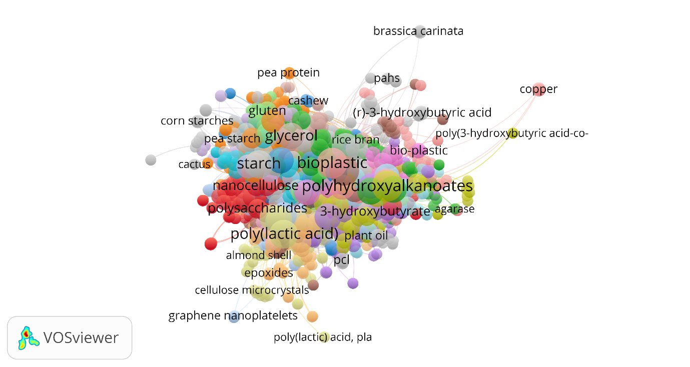
Fig. D.1: Mostly used materials for manufacturing of bioplastics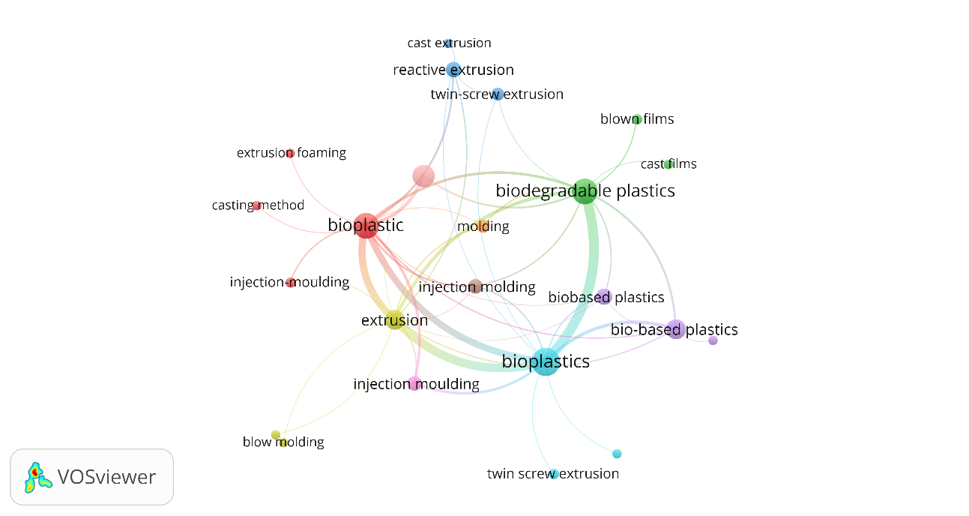Fig. D.2: Mostly opted manufacturing process for bioplastics
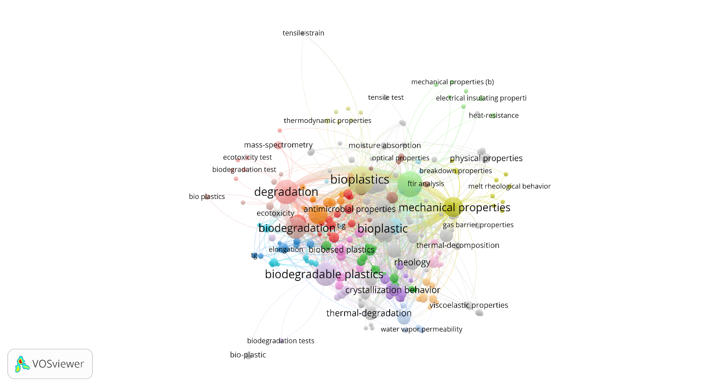
Fig. D.3: Mostly tested Properties of manufactured bioplastics
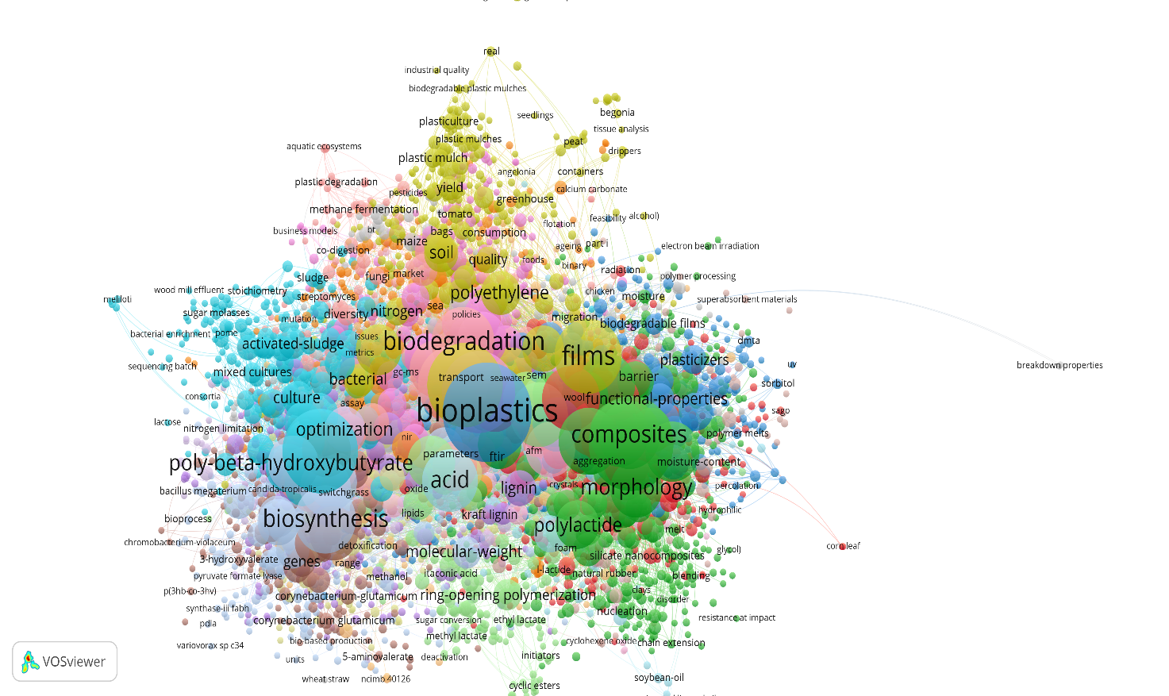
Fig. D.4: Most frequently used keywords
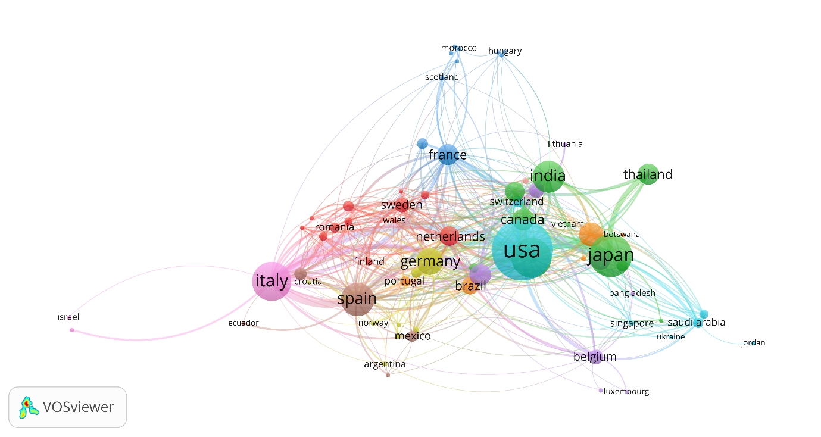
Fig. D.5: Most productive country
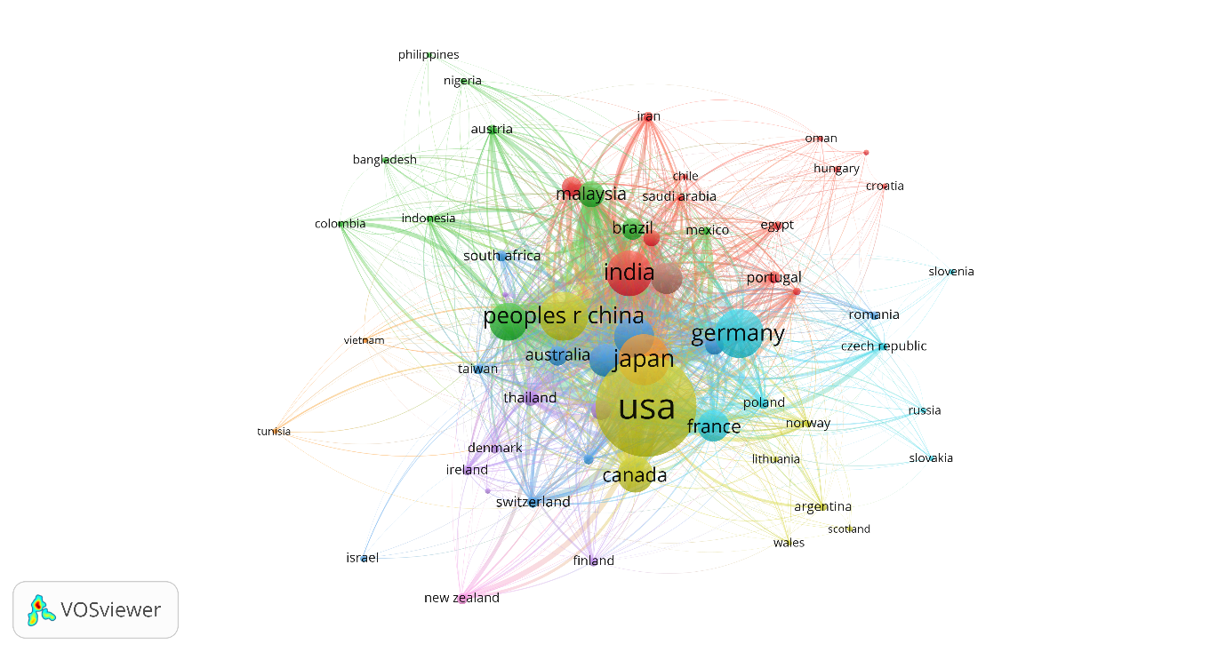
Fig. D.6: Most cited country

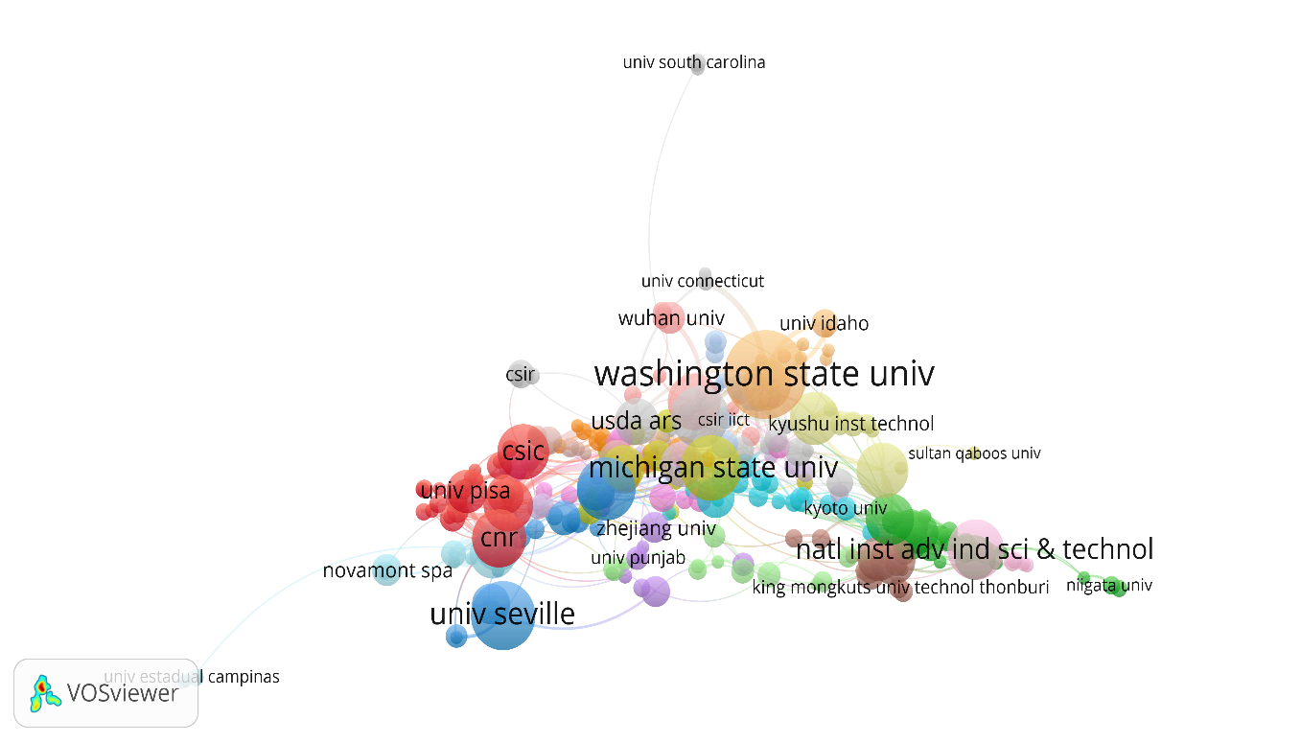
Fig. D.7: Most productive organisation
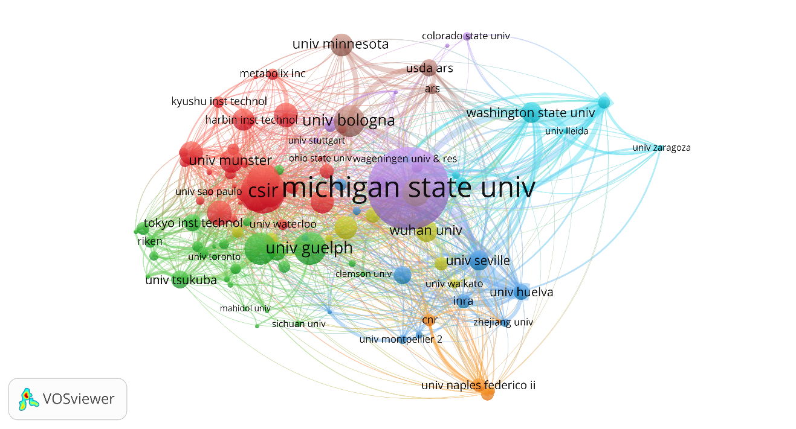
Fig. D.8: Most cited organisation

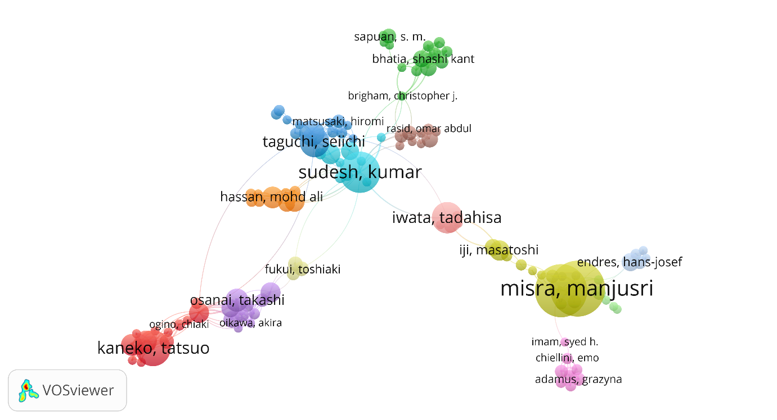
Fig. D.9: Most productive author
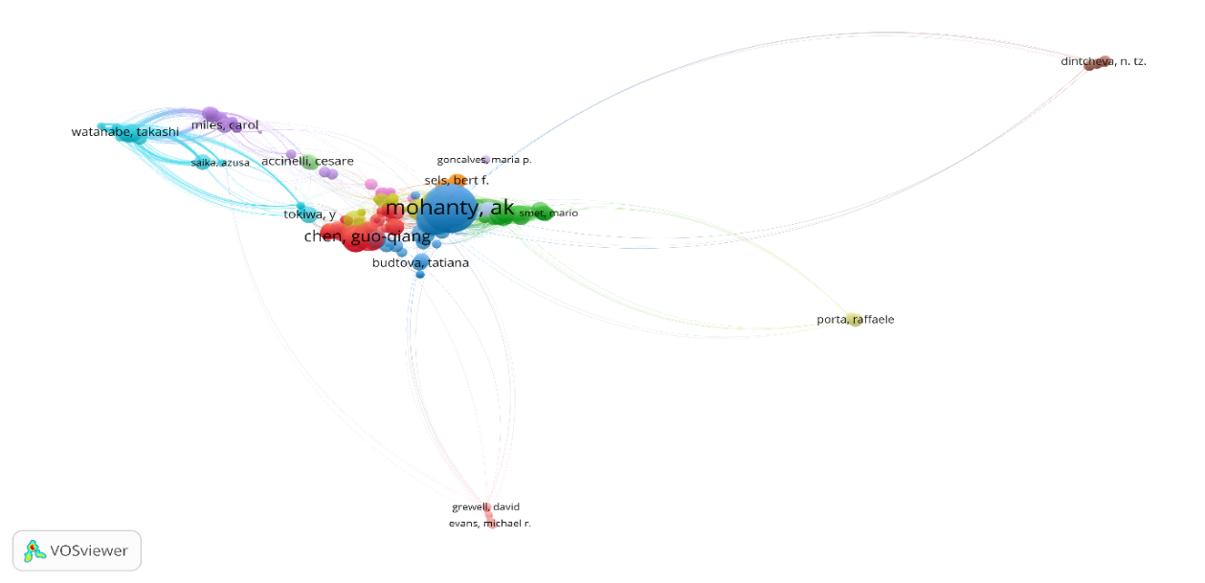
Fig. D.10: Most cited author
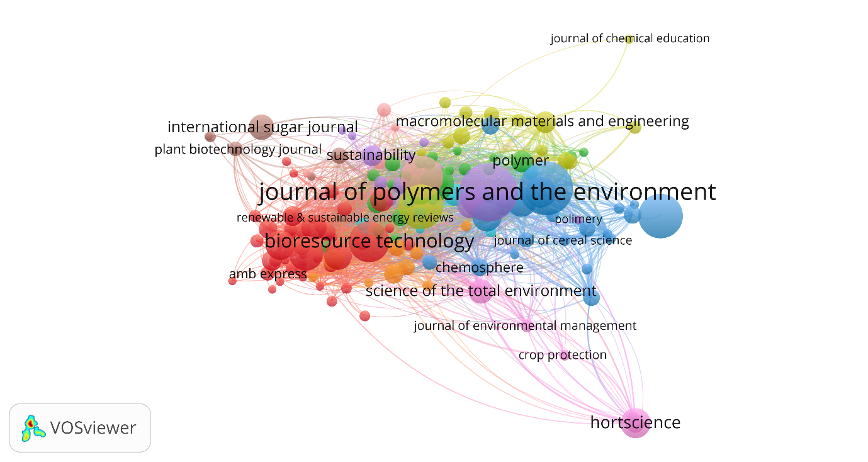
Fig. D.11: Most productive journal
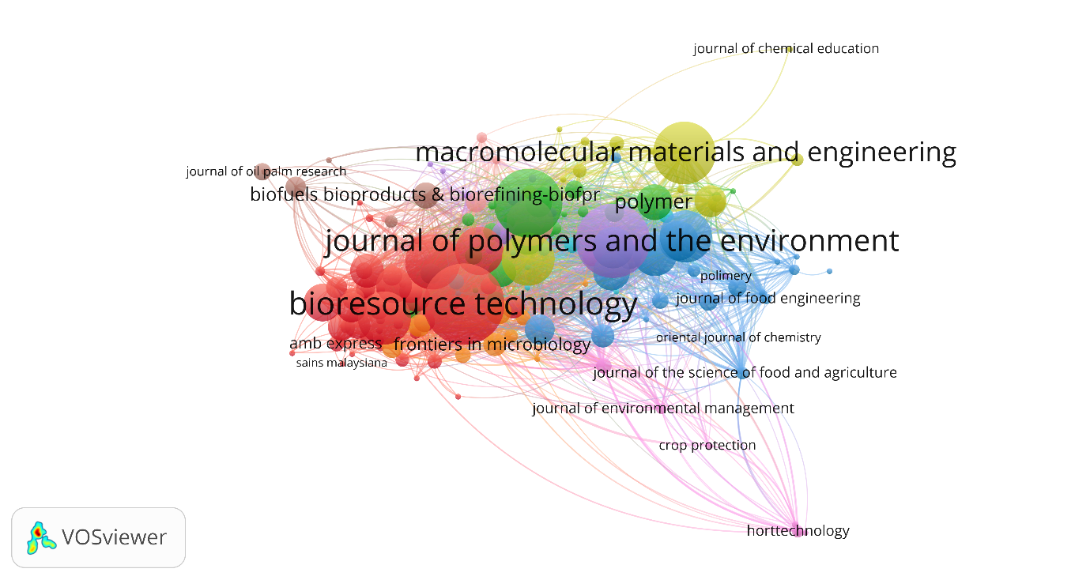
Fig. D.12: Most cited journal
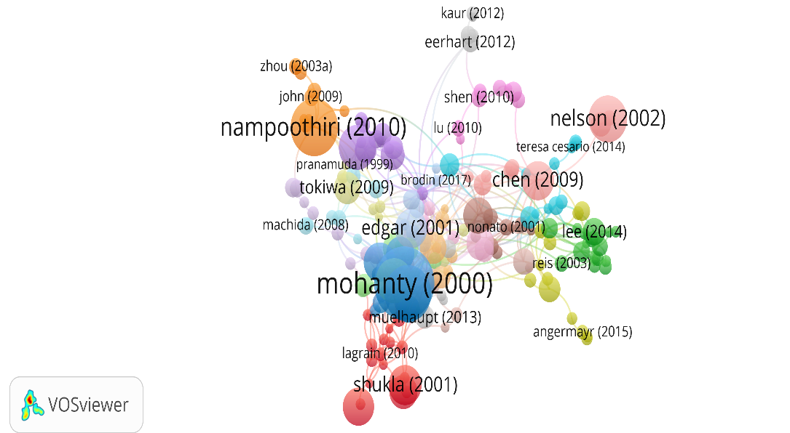
Fig. D.13: Most impactful publication

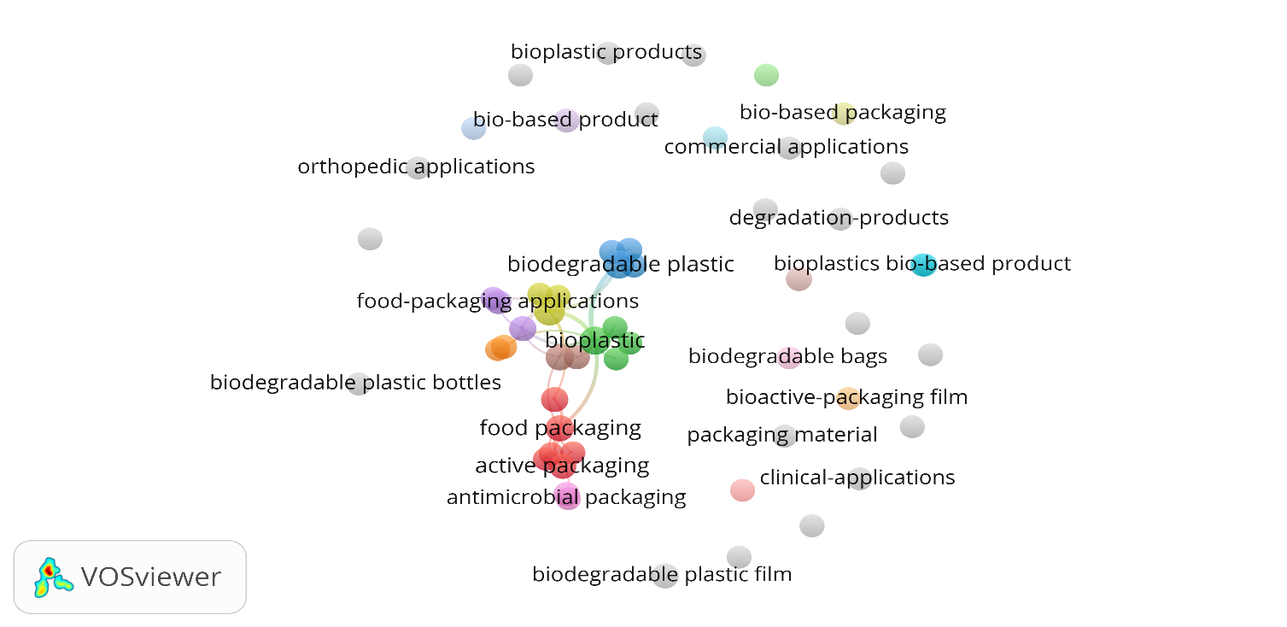
Fig. D.14: Applications of bioplastics

