Article title:
The Association between Intracranial Atherosclerotic Stenosis and Post-stroke Mild Behavioral Impairment
Journal name:
Journal of Neurology
Author names and affiliations：
- Zhengxin Liu¹，MM; Email: 21211280021@m.fudan.edu.cn
- Wenshi Wei¹, Ph.D.; Email: wenshiwei1999@163.com
¹ Department of Neurology, Cognitive Disorders Center, Huadong Hospital affiliated to Fudan University, No. 221, West Yan An Road, Shanghai, China.
Corresponding Authors:
Wenshi Wei, Email: wenshiwei1999@163.com;

Supplementary Table 1 The associations between ICAS and MoCA, frailty, and fatigue.
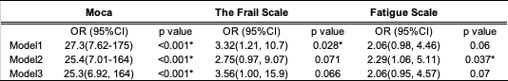 Abbreviations: Model 1: unadjusted; Model 2: adjusted for age and sex; Model 3: adjusted for age, sex, education level, history of hypertension, diabetes, atrial fibrillation, stroke, smoking, drinking, and laboratory tests of FBI, CRP, WBC, N, L, PLT, ESR. OR indicates odds ratio; CI, confidence interval; ICAS, intracranial atherosclerotic stenosis. *p<0.05.

Supplementary Table 2 The associations between cortical thickness and MBI
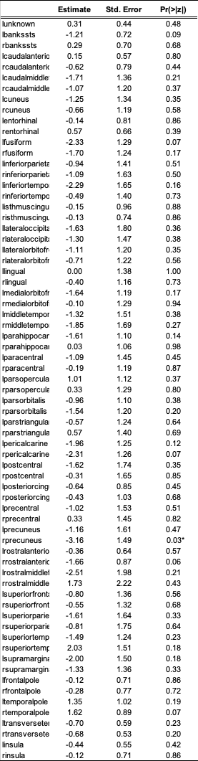
Supplementary Table 3 The associations between gray matter volume and MBI
