Supplementary Information for

Igniting interest in insight

Kazutaka Ueda, Xiaoxiang Wu, Hideyoshi Yanagisawa*

*Corresponding author: hide@mech.t.u-tokyo.ac.jp

The PDF file includes:

Supplementary Figs. 1 to 3

Other Supplementary Information for this manuscript include the following:

Supplementary Videos
Stimulus.xlsx: The order between the high-difficulty and low-difficulty conditions was counterbalanced among the participants, with 10 participants for each order. The file "stimulus.xlsx" lists the video filenames used for each condition. For instance, for participants (N=10) who underwent the high-difficulty condition first followed by the low-difficulty condition, they viewed the videos in the sequence of v1_1.avi, v1_1.avi, v3_1.avi for the high-difficulty condition, followed by v1_2.avi, v1_2.avi, v3_2.avi, continuing up to v1_6.avi, v1_6.avi, v3_6.avi (a total of 6 trials). For the subsequent low-difficulty condition, they viewed videos in the sequence of v1_7.avi, v2_7.avi, v3_7.avi, followed by v1_8.avi, v2_8.avi, v3_8.avi, continuing up to v1_12.avi, v2_12.avi, v3_12.avi (a total of 6 trials).

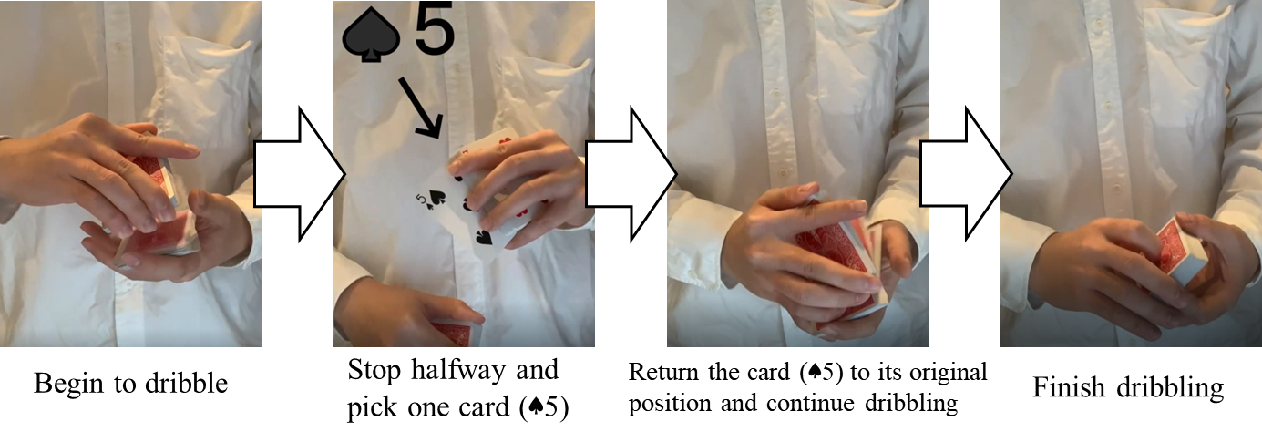

Supplementary Fig. 1. Example of the flow of Supplementary Video 1 of the card magic trick (spectator's point of view).
First, the magician held a deck of cards facing down in his right hand. Subsequently, the cards were individually dropped onto the left hand. This technique is known as dribbling (leftmost figure). The dribble stopped midway, and a card was selected and shown to the camera. The card indicated by an arrow was the target card (five of spades) (second figure from the left). The target card was then returned to its original position, and the dribbling continued (third from left). The magic trick ended when the top card dropped onto the left hand (rightmost view).

Supplementary Fig. 2. Example of the flow of Supplementary Video 2 of the card magic trick (spectator's point of view where the position of the card can be easily checked).
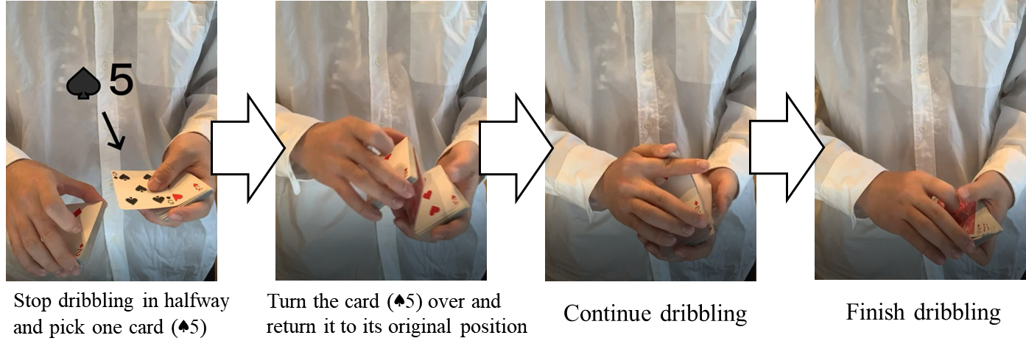
In the high-difficulty condition, participants rewatched Supplementary Video 1. However, in the low-difficulty condition, participants watched the same technique as in Supplementary Video 1, but from a different audience perspective. Supplementary Video 2 for the low-difficulty condition was created so that the final position of the target card could be easily confirmed. Specifically, the target card was selected from the middle of a deck of face-up cards and displayed to the camera (leftmost figure). Next, the target card was turned over and returned to its original position. Only the target card was turned face down (second figure from the left). Subsequently, as shown in Supplementary Video 1, the cards held in the right hand were dropped individually into the left hand using a dribble (third from left). At the end of the video, a face-down card was placed on top of the deck (rightmost view). This was the target card, which was supposed to be in the middle of the deck; however, it was moved to the topmost position of the deck.

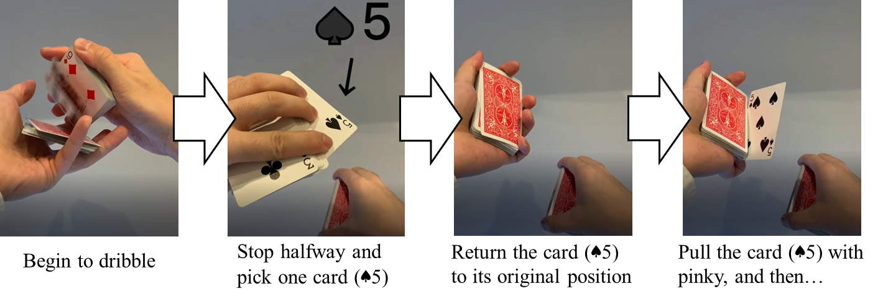
Supplementary Fig. 3. Example of the flow of Supplementary Video 3 of Trump Magic (magician's point of view).
In Supplementary Video 3, a card held in the right hand was dropped individually into the left hand using a card dribble (leftmost figure). Next, the magician stopped midway and selected a card (the target card) to be shown to the camera (second figure from the left). The player then returned the target card to its original position and continued the dribbling (third from left). The technique was the same as that in Supplementary Video 1, except from a different perspective. Just before continuing to dribble, the little finger pulled the target card to a vertical position. Supplementary Video 3 ended at this stage (rightmost view).

Supplementary Video Legends
Supplementary Video 1. These videos served as the first viewing material for the participants in both the high- and low- difficulty conditions. The combinations of video files presented in each condition are detailed in 'Stimulus.xlsx.'

Supplementary Video 2. In the low-difficulty condition, these videos were presented second to the participants, designed to facilitate easier estimation of the true position of the target card.

Supplementary Video 3. These videos were presented third to the participants in both the high- and low- difficulty conditions. These were designed to reveal hints of the card magic technique from 9 seconds after the beginning of the video until the end.

