Molecular dynamics simulations reveal differences in the conformational stability of FtsZs derived from Staphylococcus aureus and Bacillus subtilis
Taichi Takasawa¹, Takashi Matsui^{1,2,*}, Go Watanabe^{3,4,*}, and Yoshio Kodera^{1,4}

¹ Department of Physics School of Science, Kitasato University, 252-0373, Japan
² Center for Disease Proteomics, School of Science, Kitasato University, 252-0373, Japan
³ Department of Data Science, School of Frontier Engineering, Kitasato University, 252-0373, Japan
⁴ Kanagawa Institute of Industrial Science and Technology (KISTEC), 243-0435, Japan

*Correspondence: Dr. Takashi Matsui, e-mail: matsui@kitasato-u.ac.jp, Postal address: 1-15-1 Kitasato, Minami-ku, Sagamihara, Kanagawa 252-0373, Japan. Prof. Go Watanabe, e-mail: go0325@kitasato-u.ac.jp, Postal address: 1-15-1 Kitasato, Minami-ku, Sagamihara, Kanagawa 252-0373, Japan

Supplementary Table S1. Size of boxes used for MD simulations.
 |  | Cell size (nm³) | No of water molecules | No. of sodium ions
SaFtsZ | Relax-GDP | 10 × 9 × 10 | 28,319 | 18
 | Relax-GTP | 9 × 9 × 9 | 22,802 | 19
 | Tense-GDP | 10 × 10 × 10 | 31,565 | 20
 | Tense-GTP | 10 × 10 × 10 | 31,564 | 21
BsFtsZ | Relax-GDP | 10 × 9 × 10 | 28,349 | 13
 | Relax-GTP | 10 × 9 × 10 | 28.348 | 14
 | Tense-GDP | 10 × 10 × 10 | 31,573 | 13
 | Tense-GTP | 10 × 10 × 10 | 31,571 | 14

Supplementary Table S2. Inter-subdomain distances of reference structures.
Reference structure (Relax-form)
Organism | Sa | Bs | Kp | Ec | Mj | Average
PDB ID | 5H5G  mol B | 2VXY | 6LL5 | 6LL6 | 1W59  mol A
Intersubdomain Distance (Å) | 26.6 | 25.7 | 26.8 | 26.1 | 25.7 | 26.2±0.5
Reference structure (Tense-form)
Organism | Sa |  | Se | Average
PDB ID | 5H5G  mol A | 3VOA | 4M8I
Intersubdomain Distance (Å) | 28.3 | 28.4 | 28.4 | 28.4±0.1
Sa; Staphylococcus aureus, Bs; Bacillus subtilis, Kp; Klebsiella pneumoniae, Ec; Escherichia coli, Mj; Methanocaldococcus jannaschii, Se; Staphylococcus epidermidis.

Supplementary Table S3. Inter-subdomain angles of simulation structures derived from SaFtsZ, with the reference structures.
Reference structure (Relax-form)
Organism | Sa | Bs | Kp | Ec | Mj
PDB ID | 5H5G  mol B | 2VXY | 6LL5 | 6LL6 | 1W59  mol A
Relax-form  GDP | 6.8˚±1.8˚ | 2.0˚±1.0˚ | 7.9˚±1.8˚ | 5.7˚±1.8˚ | 2.1˚±1.0˚
Relax-form  GTP | 2.8˚±1.1˚ | 5.1˚±1.1˚ | 6.9˚±1.2˚ | 4.2˚±1.2˚ | 4.5˚±1.1˚
Tense-form  GDP | 4.7˚±1.6˚ | 10.9˚±2.1˚ | 5.8˚±2.2˚ | 5.7˚±2.1˚ | 11.0˚±1.9˚
Tense-form  GTP | 7.4˚±1.4˚ | 12.1˚±2.0˚ | 5.8˚±2.6˚ | 6.9˚±2.0˚ | 12.5˚±1.8˚
Reference structure (Tense-form)
Organism | Sa |  | Se
PDB ID | 5H5G  mol A | 3VOA | 4M8I
Relax-form  GDP | 10.9˚±1.9˚ | 10.0˚±1.9˚ | 9.5˚±1.9˚
Relax-form  GTP | 7.3˚±1.1˚ | 6.6˚±1.2˚ | 6.3˚±1.2˚
Tense-form  GDP | 2.7˚±1.6˚ | 3.0˚±1.5˚ | 3.3˚±1.5˚
Tense-form  GTP | 3.6˚±1.6˚ | 3.8˚±1.6˚ | 3.9˚±1.7˚
Sa; Staphylococcus aureus, Bs; Bacillus subtilis, Kp; Klebsiella pneumoniae, Ec; Escherichia coli, Mj; Methanocaldococcus jannaschii, Se; Staphylococcus epidermidis.

Supplementary Table S4. Inter-subdomain angles of simulation structures derived from BsFtsZ, with the reference structures.
Reference structure (Relax-form)
Organism | Sa | Bs | Kp | Ec | Mj
PDB ID | 5H5G  mol B | 2VXY | 6LL5 | 6LL6 | 1W59  mol A
Relax-form  GDP | 6.0˚±1.3˚ | 2.0˚±1.0˚ | 7.7˚±1.3˚ | 5.4˚±1.4˚ | 1.9˚±1.0˚
Relax-form  GTP | 5.2˚±1.4˚ | 2.4˚±1.2˚ | 6.8˚±1.1˚ | 4.5˚±1.2˚ | 2.5˚±1.1˚
Tense-form  GDP | 9.9˚±1.9˚ | 12.2˚±1.4˚ | 4.8˚±1.4˚ | 7.3˚±1.5˚ | 13.4˚±1.4˚
Tense-form  GTP | 6.0˚±1.3˚ | 10.9˚±1.5˚ | 5.2˚±1.5˚ | 5.6˚±1.5˚ | 11.5˚±1.4˚
Reference structure (Tense-form)
Organism | Sa |  | Se
PDB ID | 5H5G  mol A | 3VOA | 4M8I
Relax-form  GDP | 9.7˚±1.4˚ | 8.9˚±1.4˚ | 8.9˚±1.4˚
Relax-form  GTP | 9.0˚±1.3˚ | 8.1˚±1.3˚ | 7.6˚±1.3˚
Tense-form  GDP | 6.7˚±2.3˚ | 6.1˚±2.2˚ | 5.7˚±2.1˚
Tense-form  GTP | 2.1˚±1.2˚ | 2.1˚±1.1˚ | 2.2˚±1.2˚
Sa; Staphylococcus aureus, Bs; Bacillus subtilis, Kp; Klebsiella pneumoniae, Ec; Escherichia coli, Mj; Methanocaldococcus jannaschii, Se; Staphylococcus epidermidis.

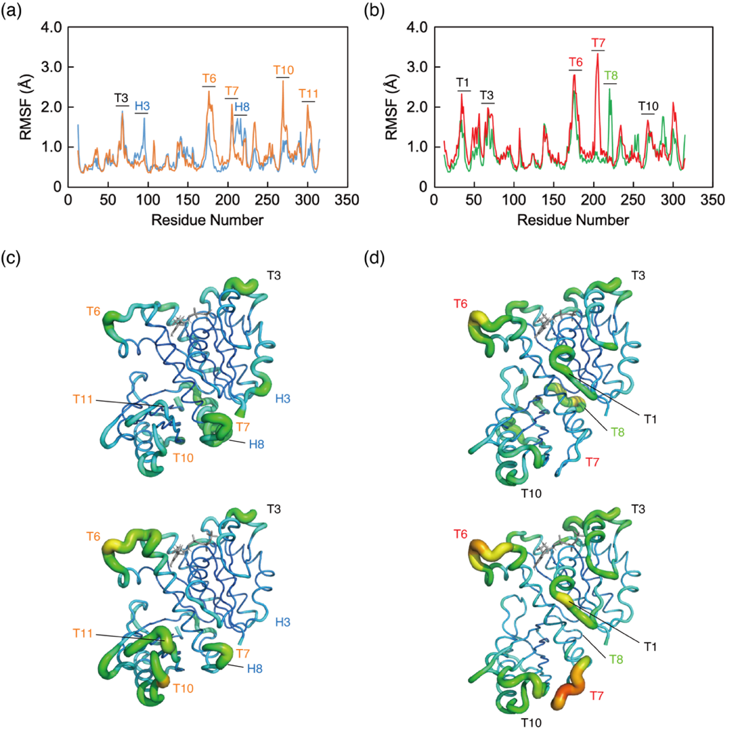
Supplementary Figure S1. RMSF values mapped on the structures. (a, b) RMSF values of (a) relaxed-form and (b) tense-form SaFtsZ across residues 12-316 during the last 50 ns of MD simulations. (a) Relaxed conformation bound to GTP and GDP drawn as orange and blue lines, respectively. (b) Tense conformation bound to GTP and GDP depicted as red and green lines, respectively. (c, d) RMSF values mapped onto the crystal structures (upper; bound to GDP, lower; bound to GTP). RMSF values indicated in panels (a) and (b) mapped onto the crystal structure (PDB 5H5G, mol B, and A), respectively. Differences in RMSF values between binding of GTP and GDP are indicated in each panel. The fluctuation is shown as continuous scaled color (higher; red, lower; blue).
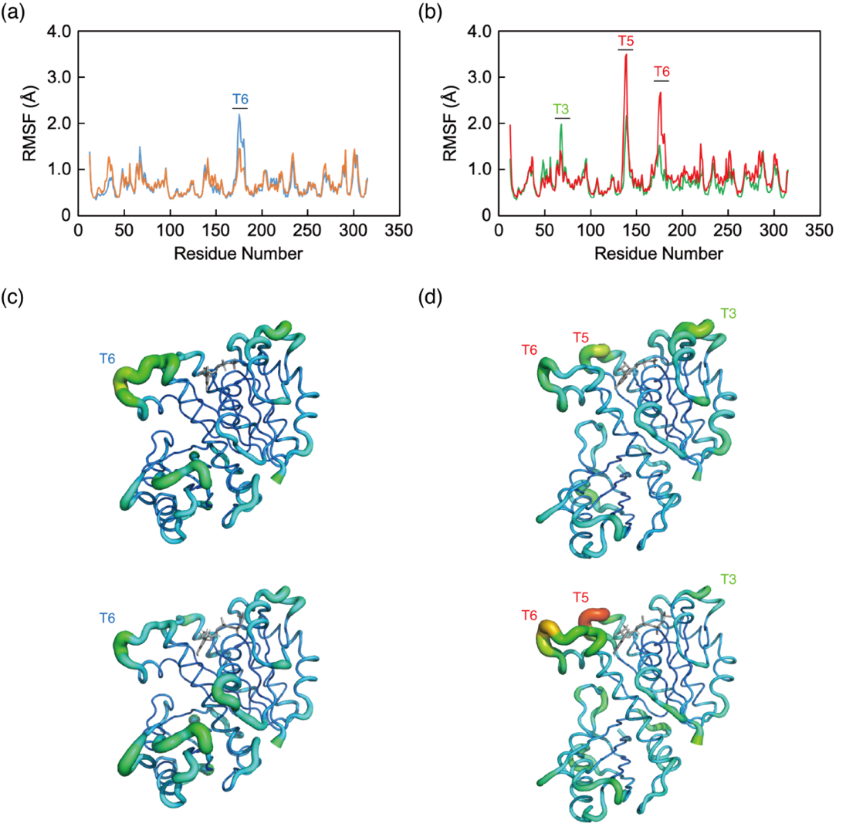
Supplementary Figure S2. RMSF values mapped onto the structures. (a, b) RMSF values of (a) relaxed-form and (b) tense-form BsFtsZ across residues 12-316 during the last 50 ns of MD simulations. (a) Relaxed conformation bound to GTP and GDP drawn as orange and blue lines, respectively. (b) Tense conformation bound to GTP and GDP depicted as red and green lines, respectively. (c, d) RMSF values mapped onto the crystal structure (upper; bound to GDP, lower; bound to GTP). RMSF values indicated in panels (a) and (b) mapped onto the crystal structure (PDB 5H5G, mol B, and A), respectively. Differences in RMSF values between binding of GTP and GDP are indicated in each panel. The fluctuation is shown as continuous scaled color (higher; red, lower; blue).
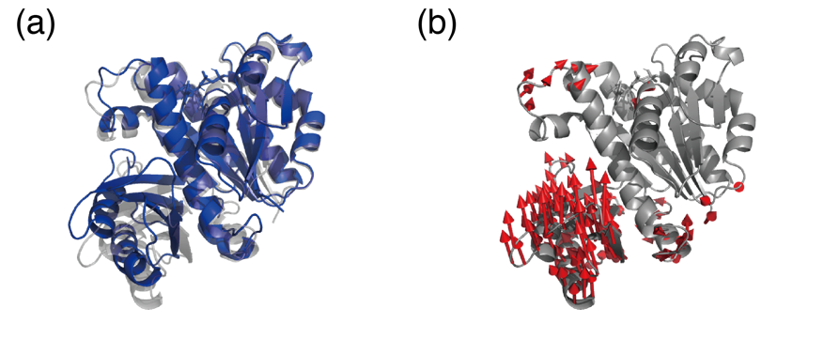
Supplementary Figure S3. Average structure during the last 50 ns of MD simulations, compared with the crystal structure. (a) Average structure of the relaxed form bound to GDP during the MD simulation compared with the crystal structure (PDB 5H5G mol B¹²). (b) Conformational changes from the crystal structure to the average structure indicated in panel (a) are illustrated as vectors. Coordinate differences >2.0 Å are indicated by red arrows.

