Robust Transfer Learning for High-Dimensional Linear Regression with t distributed Error
Supplementary Materials

1. Further simulation results
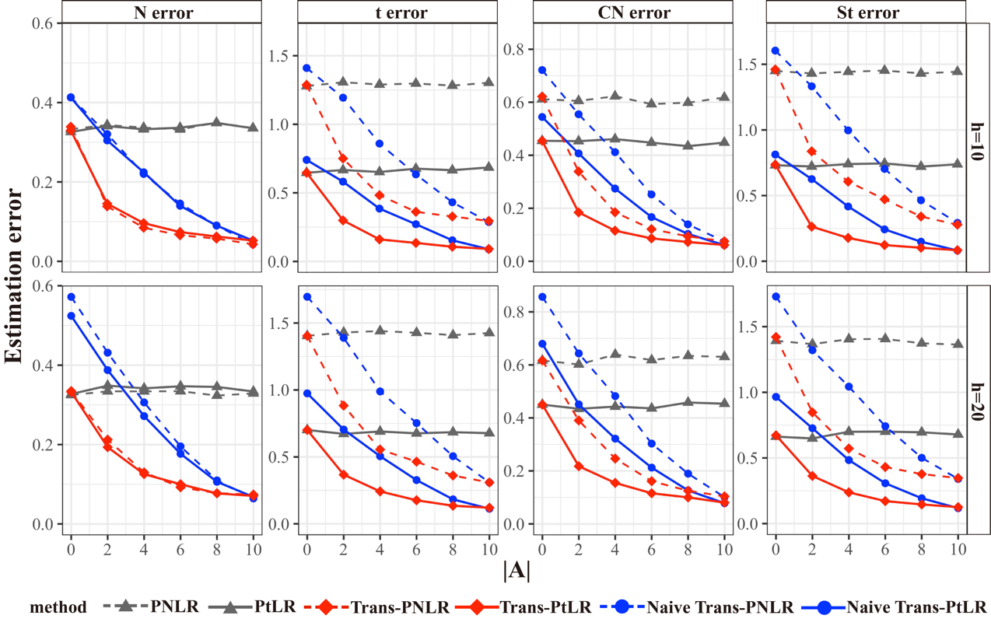
Figure 1$l2$-estimation error of various methods under two different heterogeneity levels scenarios and four different error settings with a t-threshold of 0.05, averaged over 100 replications. The estimation error is defined as ${\left\|{\hat{β}}_{ }^{ }-β\right\|}_{2}^{2}$.
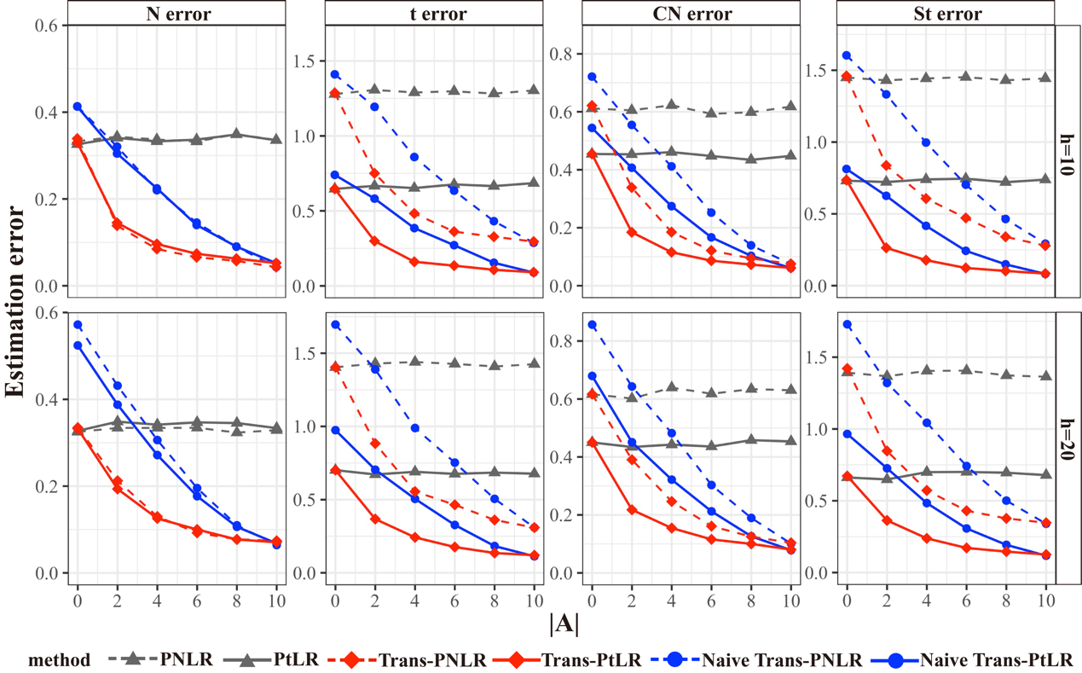
Figure 2 $l2$-estimation error of various methods under two different heterogeneity levels scenarios and four different error settings with a t-threshold of 0.15, averaged over 100 replications. The estimation error is defined as ${\left\|{\hat{β}}_{ }^{ }-β\right\|}_{2}^{2}$.

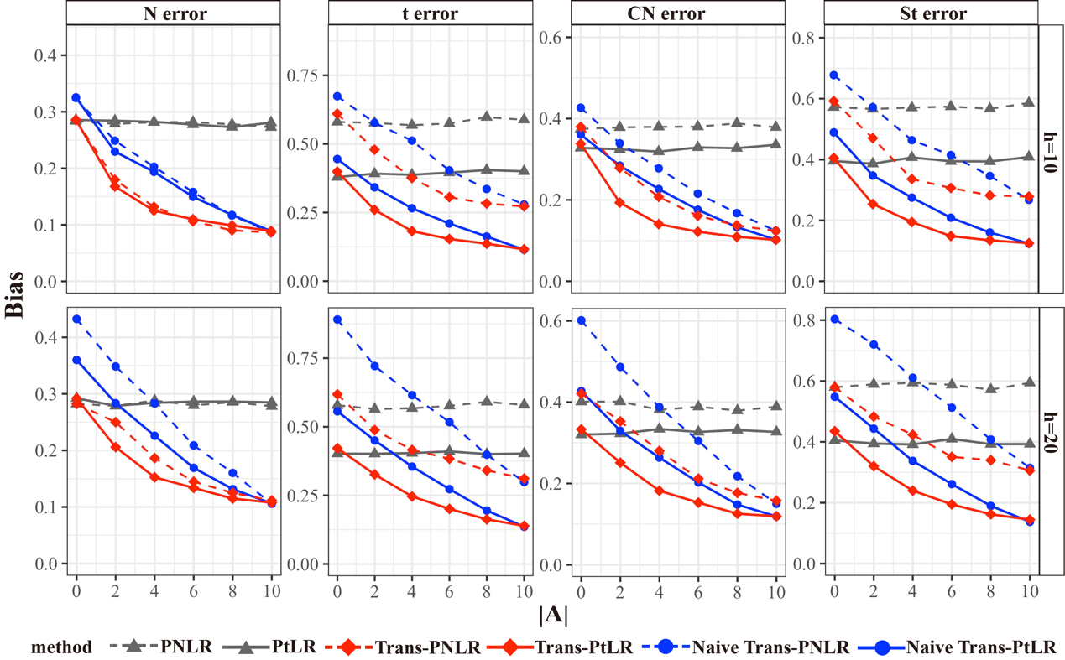
Figure 3 Bias of various methods under two different heterogeneity levels scenarios and four different error settings with a t-threshold of 0.05, averaged over 100 replications. The bias is defined as $\frac{\left\|{\hat{β}}_{ }^{ }-β\right\|}{\left\|β\right\|}$.

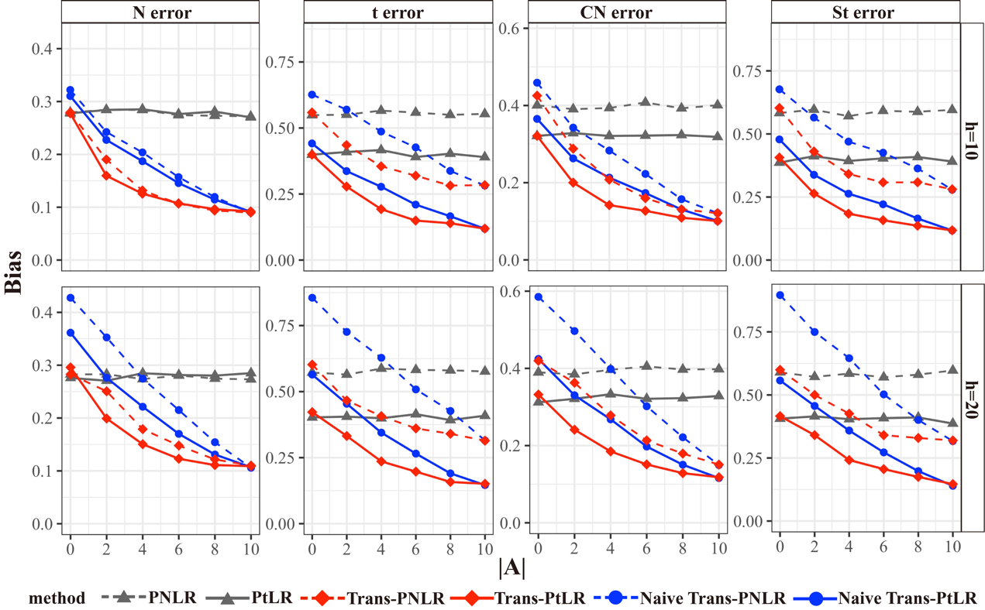
Figure 4 Bias of various methods under two different heterogeneity levels scenarios and four different error settings with a t-threshold of 0.15, averaged over 100 replications. The bias is defined as $\frac{\left\|{\hat{β}}_{ }^{ }-β\right\|}{\left\|β\right\|}$.

2. Supporting information on data application
Table 1 The accuracy of the transferable source detection algorithm in correctly identifying transferable datasets.
 |  |  | Trans-PNLR  t error |  |  |  | Trans-PtLR  CN error
t | h | $$\left|A\right|$$ | N error | t error | St error | CN error | N error | t error | St error | CN error
0.05 | 10 | 0 | 99.4 | 97.16 | 96.84 | 98.12 | 99.5 | 96.83 | 97.25 | 98.84
 |  | 2 | 99.8 | 96.43 | 95.95 | 98.89 | 99.3 | 97.93 | 97.68 | 99.36
 |  | 4 | 99.5 | 95.22 | 95.6 | 98.37 | 99.4 | 97.33 | 97.08 | 98.38
 |  | 6 | 99.2 | 95.71 | 95.51 | 98.5 | 99.39 | 98.21 | 96.84 | 99
 |  | 8 | 99.9 | 95.1 | 96.11 | 98.9 | 99.8 | 98 | 96.77 | 99.2
 |  | 10 | 100 | 96.5 | 96.1 | 99.6 | 99.7 | 98.5 | 99.4 | 99.9
 | 20 | 0 | 100 | 98.65 | 98.54 | 100 | 100 | 98.9 | 99.28 | 100
 |  | 2 | 98.3 | 96.91 | 97.19 | 98.7 | 99.6 | 98.18 | 98.9 | 99.1
 |  | 4 | 97.5 | 97.73 | 97.53 | 98.5 | 99.3 | 98 | 98.69 | 98.9
 |  | 6 | 96.4 | 96.06 | 95.57 | 97.7 | 98.5 | 97.8 | 96.9 | 98.1
 |  | 8 | 94.5 | 95.7 | 96.1 | 96.7 | 99 | 97.5 | 98.3 | 97.9
 |  | 10 | 92.8 | 94.4 | 94.4 | 95.9 | 98.1 | 95.4 | 96.7 | 98.1
0.1 | 10 | 0 | 99.5 | 96.67 | 96.03 | 98.23 | 99.1 | 97.72 | 97.12 | 98.65
 |  | 2 | 99.7 | 95 | 95 | 98.32 | 99.6 | 97.18 | 97.44 | 98.98
 |  | 4 | 99.8 | 96.32 | 93.98 | 99.09 | 99.39 | 97.5 | 97.41 | 99.08
 |  | 6 | 99.8 | 96.85 | 96.15 | 99.39 | 99.7 | 97.31 | 97.61 | 99.49
 |  | 8 | 99.8 | 96.02 | 94.64 | 99.5 | 99.5 | 97.35 | 98.35 | 99.4
 |  | 10 | 99.9 | 96.8 | 97.3 | 99 | 99.9 | 98.5 | 98 | 99.9
 | 20 | 0 | 100 | 98.35 | 98.6 | 100 | 100 | 99.28 | 99.39 | 100
 |  | 2 | 99 | 98.74 | 97.01 | 99.2 | 99.4 | 99 | 99.3 | 99.7
 |  | 4 | 97.6 | 96.43 | 96.74 | 98.8 | 99.8 | 97.7 | 98.5 | 99
 |  | 6 | 97.5 | 94.9 | 96 | 97.6 | 98.9 | 97.7 | 98.7 | 98.2
 |  | 8 | 94.2 | 96 | 96.5 | 97 | 98.9 | 95.7 | 95.8 | 97.7
 |  | 10 | 90.1 | 95.5 | 95.3 | 97.2 | 97.3 | 95.7 | 96.7 | 98
0.15 | 10 | 0 | 99.8 | 96.03 | 96.43 | 98.42 | 99.1 | 97.47 | 97.68 | 98.65
 |  | 2 | 99.6 | 96.62 | 95.66 | 98.54 | 99 | 96.28 | 96.74 | 99.26
 |  | 4 | 99.39 | 95.56 | 95.57 | 99.4 | 99.08 | 97.07 | 97.19 | 98.89
 |  | 6 | 99.8 | 96.11 | 96.78 | 99.09 | 99.39 | 96.67 | 97.28 | 99.39
 |  | 8 | 100 | 95.71 | 92.96 | 98.48 | 99.8 | 96.43 | 96.97 | 99.6
 |  | 10 | 100 | 96.4 | 96.1 | 99.2 | 99.7 | 99.3 | 99.1 | 99.9
 | 20 | 0 | 100 | 98.62 | 99.14 | 100 | 100 | 99.79 | 99.7 | 100
 |  | 2 | 98.8 | 98.84 | 98.44 | 99.1 | 99.8 | 98.67 | 98.14 | 99.6
 |  | 4 | 98.2 | 96.7 | 96.49 | 98.1 | 99.3 | 98.16 | 97.68 | 99
 |  | 6 | 96.6 | 96.29 | 96.87 | 97.9 | 99.4 | 98.08 | 97.24 | 98.1
 |  | 8 | 95.6 | 96.8 | 95.1 | 97.4 | 98.6 | 97.5 | 95.8 | 98.3
 |  | 10 | 92.9 | 94.9 | 95.2 | 96.7 | 97.3 | 96.9 | 96.2 | 98

Table 2 The list of 54 tissues in GTEx dataset corresponding to their sample sizes.
no. | Tissue | Sample Size
1 | Brain amygdala | 152
2 | Brain anterior cingulate cortex BA24 | 176
3 | Brain caudate basal ganglia | 246
4 | Brain cerebellar hemisphere | 215
5 | Brain cerebellum | 241
6 | Brain cortex | 255
7 | Brain frontal cortex BA9 | 209
8 | Brain hippocampus | 197
9 | Brain hypothalamus | 202
10 | Brain nucleus accumbens basal ganglia | 246
11 | Brain putamen basal ganglia | 205
12 | Brain spinal cord cervical | 159
13 | Brain substantia nigra | 139
14 | Adipose subcutaneous | 663
15 | Adipose visceral omentum | 541
16 | Adrenal gland | 258
17 | Artery aorta | 432
18 | Artery coronary | 240
19 | Artery tibial | 663
20 | Bladder | 21
21 | Breast mammary tissue | 459
22 | Cells cultured fibroblasts | 504
23 | Cells ebv-transformed lymphocytes | 174
24 | Cervix ectocervix | 9
25 | Cervix endocervix | 10
26 | Colon sigmoid | 373
27 | Colon transverse | 406
28 | Esophagus gastroesophageal junction | 375
29 | Esophagus mucosa | 555
30 | Esophagus muscularis | 515
31 | Fallopian tube | 9
32 | Heart atrial appendage | 429
33 | Heart left ventricle | 432
34 | Kidney cortex | 85
35 | Kidney medulla | 4
36 | Liver | 226
37 | Lung | 578
38 | Minor salivary gland | 162
39 | Muscle skeletal | 803
40 | Nerve tibial | 619
41 | Ovary | 180
42 | Pancreas | 328
43 | Pituitary | 283
44 | Prostate | 245
45 | Skin not sun exposed suprapubic | 604
46 | Skin sun exposed lower leg | 701
47 | Small intestine terminal ileum | 187
48 | Spleen | 241
49 | Stomach | 359
50 | Testis | 361
51 | Thyroid | 653
52 | Uterus | 142
53 | Vagina | 156
54 | Whole blood | 755

