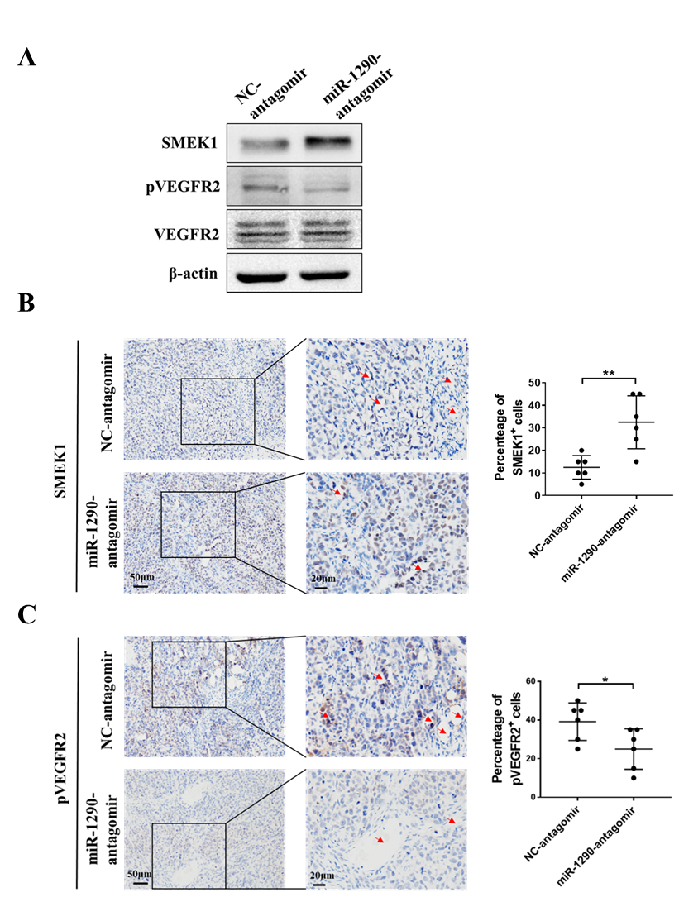
Figure S1: miR-1290 targets SMEK1 in SMMC-7721 xenografts. 2 × 10⁶ SMMC-7721 cells were subcutaneously injected into male NOD-SCID mice. Tumor development was allowed to occur for 10 days, and then mice (n=6) were peritumorally treated with 10 nmol miR-1290 antagomir or NC antagomir (once every three days) for another 15 days. A, The expression of SMEK1 and pVEGFR2 in miR-1290 antagomir or NC antagomir treated xenografts were detected via Western blot. B and C, The expression of SMEK1 (B) and pVEGFR2 (C) in miR-1290 antagomir or NC antagomir treated xenografts were detected via IHC. Red arrow indicates blood vessel. *p < 0.05; **p < 0.01.

