Supplementary Information for
Probing Sequence-Structure Paradigms in Complex Carbohydrates – A Case Study on Rhamnogalacturonan-II
Sabina Koj¹, Lintao Bu², Michael F. Crowley², Deepak Sharma³, Breeanna R. Urbanowicz^{3,4}, Malcolm A. O’Neill³, Maria J. Peña^{3*}, Vivek Bharadwaj^{2*}

Author affiliations:
¹Hirszfeld Institute of Immunology and Experimental Therapy, 53-114 Wroclaw, Poland
²Renewable Resources and Enabling Sciences Center, National Renewable Energy Laboratory, 16253 Denver West Parkway, Golden CO 80401, USA.
³Complex Carbohydrate Research Center, The University of Georgia, 315 Riverbend Road, Athens, GA, 30602, USA
⁴Department of Biochemistry and Molecular Biology, University of Georgia, 315 Riverbend Road, Athens, GA 30602, USA.

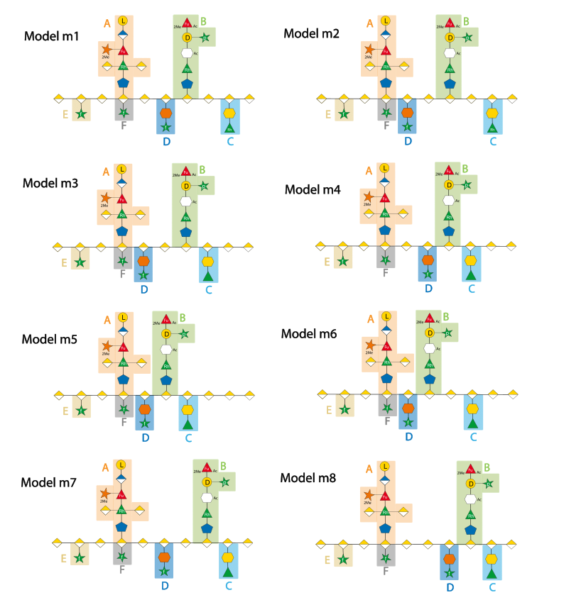
Figure S1. The eight RG-II Models depicting different sidechain locations along the polygalacturonic acid backbone for the celery RG-II monomer. Model 1 was originally proposed in the Ndeh et al The positions of sidechains E, A and F are invariant for all models.

Figure S2. Structural analysis of the RG-II FAD Fragment from ¹³C Rosa RG-II that consists of chains A, D and F attached to galacturonan backbone. A structural schematic of the FAD fragment and the associated nomenclature scheme used herein for the residues is shown in Figure 2. Signals for all identified residues are labelled with arrows and indicated using the RG-II nomenclature. Assignment of signals in ¹H,¹³C HSQC (A), HSQC-TOCSY (B) and HMBC (C) spectra is described below. The cross peaks that enabled the establishment of the linkages of the 2,3,4-linked α-ᴅ-GalA residue (G1) to 3’-Api (A1) and Araf (F1) are correlated between HSQC-TOCSY and HMBC spectra by dashed lines (B, C). Chain D is linked to 3,4-linked α-ᴅ-GalpA residue at position O-3 and was identified in the fragment by the presence of characteristic H-3 ax and H-3 eq resonances that correspond to spin system of →5)-ᴅ-Dhap-(2→3 (D1, δH3a,b/C3 1.845, 2.137/35.86 ppm) and intensive six resonances of β-L-Araf-(1→5 (D2, δH/C-1 4.959/103.9 ppm) observed in the HSQC-TOCSY cross-section taken through H1. Configuration of the residues, coupling constants and chemical shifts are consistent with the published values.^{1, 2} Chain A is an octasaccharide containing an apiosyl residue attached to the galacturonan backbone at O-2 of 2,3,4-GalA (G1, G-A, δH/C-1 5.219/94.71). Apiose →3’)-β-d-Apif-(1→2 was identified as spin system A1 (δH/C-1 5.09/110.9 ppm) with the characteristic 3 isolated spin systems (H1/H2, H-3’a/H3’b, H-4a/H4b), including the two pairs of geminal protons. Highly substituted Rha was assigned as an →2,3,4)-l-Rhap-(1→3’ with spin system A2 (δH/C-1 4.8/99.8 ppm) substituted by GalpA residues -α-ᴅ-GalpA A2’ at position O-2 (with δH/C-1 5.1/99.6 ppm) and at O-3 with β-ᴅ-GalpA A2’’ (δH/C-1 4.57/104.7 ppm). The Rha is substituted at O-4 with a residue established as a highly branched 3,4-Fucose with spin system A3 (δH/C-1 5.39/100.6 ppm). The A3 residue is further substituted by terminal α-ᴅ-OMe-Xylose-(1→3 (A3’, δH/C-1 5.36/98.2 ppm) and a disaccharide α-L-Galp-(1→2)-β-ᴅ-GlcpA-(1→4 that are represented by spin systems A5 (δH/C-1 5.65/98.2 ppm) and A4 (δH/C-1 4.77/101.9 ppm). Chain F consists of a single residue F1 that is an α-L-Araf-(1→3 identified as a spin system with δH/C-1 4.986/109.8 ppm. All six resonances of F1 were observed in the HSQC-TOCSY cross section traced from H1/C1 (B). The F1 linkage position was confirmed as O-3 of 2,3,4-GalpA residue (G1) based on HMBC and HSQC-NOESY spectra.

Figure S3: ¹H,¹³C HSQC-NOESY spectrum of rose C-13 FAD fragment. Interchain NOEs used to determine the sequence of chains A, D, F are indicated by arrows.
Table S1. Chemical shifts of the RGII monomer

Residue | Chemical shifts [ppm]
Residue | H1/C1 | H2/C2 | H3/C3 | H4/C4 | H5/C5  (Api-H3/C3’) | H6/C6  (OMe)
A1 →3’)-β-ᴅ-Apif-(1→ | 5.126  110.9 | 4.086  76.18 | nd | 3.890, 4.223  74.42 | 3.541, 4.039  71.56
A2 2,3,4)-L-Rhap-(1→3’ | 4.812  99.41 | 4.376  81.38 | 4.173  82.55 | 3.815  76.54 | 3.838  68.63 | 1.386  17.85
A2’ α-ᴅ-GalA-(1→2 | 5.11  99.97 | 3.771  68.63 | 4.024  69.29 | 4.336  70.83 | 4.447  70.75 | nd
A2” β-ᴅ-GalA-(1→3 | 4.624  104.8 | 3.512  71.93 | 3.65  74.05 | 4.153  71.05 | 4.08  74.50 | 173.3
A3 →3,4)-α-L-Fucp-(1→4 | 5.325  100.4 | 4.062  68.48 | 3.793  74.64 | 4.123  79.25 | 4.082  68.34 | 1.483  16.38
A3’ 2-O-Me-α-ᴅ-Xyl-(1→3 | 5.369  98.09 | 3.237  81.31 | 3.768  72.44 | 3.488  70.53 | 3.632  61.74 | 3.5  58.15
A4 →2)-β-ᴅ-GlcpA-(1→4 | 4.757  102.04 | 3.707  74.86 | 3.806  76.54 | 3.64  72.29 | 3.805  77.72 | 174.4
A5 α-L-Galp | 5.658  98.16 | 3.862  69.29 | 4.077  68.96 | 3.903  70.16 | 4.451  70.46 | 3.791  61.37
D1 -5)-β-ᴅ-Dhap-(2→3 | 174.6 | 97.5 | 1.875, 2.20  36.17 | 4.181  65.04 | 4.123  79.3 | 4.952  76.10
D2 β-L-Araf -(1→5 | 4.99  103.8 | 4.142  76.76 | 4.150  72.44 | 3.854  81.60 | 3.66, 3.77  60.57
F1 α-L-Araf -(1→3 | 5.022  109.6 | 4.006  81.31 | 4.062  82.19 | 3.733  77.06 | 3.608, 3.839  62.4
G →4)-α-ᴅ-GalpA-(1→4 | 5.117  100.1 | 3.771  68.63 | 4.024  69.29 | 4.481  78.74 | 4.962  72.0 | 175.4
G1 2,3,4)-α-ᴅ-GalA-(1→4 | 5.253  95.45 | 3.875  76.18 | 4.080  74.49 | 4.67  78.67 | 4.775  74.12 | nd
NonRed. α-ᴅ-GalpA | 5.09  nd | 3.718  nd | 4.127  nd | 4.375  nd | nd | nd
Red. →4)-β-ᴅ-GalpA | 4.642  96.77 | 3.512  71.93 | 3.77  72.44 | 4.404  78.0 | 4.245  74.12 | 173.3
Red. →4)-α-ᴅ-GalpA | 5.345  92.81 | 3.838  68.63 | 4.024  69.29 | 4.468  78.74 | 4.328  71.05 | 173.8
C1 -5)-α-Kdo-(2→3 | 174.9 | 96.46 | 1.928, 2.167  34.19 | 4.20  67.6 | 4.173  73.9
C2 α-L-Rhap-(1→5 | 5.244  101.9 | 4.128  70.9 | 3.934  69.95 | 3.456  72.66 | 3.85  69.93 | 1.293  17.42
B1 →3’)-β-ᴅ-Apif-(1→2 | 5.215  110.62 | 4.107  77.86 | 82.2 | 3.839, 4.055  74.78 | 3.61, 3.898  70.24
B2 →3)-L-Rhap-(1→3’ | 4.901  100.1 | 4.216  67.38 | 3.763  76.32 | 3.60  70.83 | 3.78  69.14 | 1.316  17.26
B3 →2)-α-L-AcefA-(1→3 | 5.394  98.01 | 4.497  87.02 | 83.41 | 4.709  78.67 | 173.8 | 1.217  13.96
B4 -2,4)-β-ᴅ-Galp-(1→2 | 4.671  102.7 | 3.776  74.0 | 3.987  75.15 | 4.025  77.57 | 3.763  75.59 | 3.763  75.59
B4’ 2-O-Me-α-L-Fucp-(1→2 | 5.689  95.89 | 3.486  78.01 | 3.973  68.78 | 3.808  72.44 | 4.263  66.87 | 1.227  15.94
B5 α-L-Arap-(1→4 | 4.632  104.82 | 3.666  72.29 | 3.76  73.68 | 4.159  66.7 | 3.678, 3.82  64.5

Table S2. Chemical shifts of the FAD fragment

Residue | Chemical shifts [ppm]
Residue | H1/C1 | H2/C2 | H3/C3 | H4/C4 | H5/C5  (Api-H3/C3’) | H6/C6  (OMe)
A1 →3’)-β-D-Apif-(1→2 | 5.091  110.9 | 4.071  75.94 | 79.21 | 3.800, 4.164  74.96 | 3.499, 4.085  71.64
A2 2,3,4)-L-Rhap-(1→3’ | 4.8  99.79 | 4.318  81.61 | 4.127  80.63 | 3.811  76.72 | 3.825  68.90 | 1.39  17.68
A2’ α-ᴅ-GalA-(1→2 | 5.101  99.59 | 3.77  68.7 | 4.021  69.49 | 4.23  72.6 | 4.442  70.66 | 175.2
A2” β-ᴅ-GalA-(1→3 | 4.57  104.7 | 3.5  71.0 | 3.578  73.99 | 4.127  71.05 | 4.084  74.57 | 174.8
A3 →3,4)-α-L-Fucp-(1→4 C13 | 5.398  100.57 | 4.049  68.12 | 3.734  74.96 | 4.158  79.07 | 4.094  68.12 | 1.539  16.32
A3’ 2-O-Me-α-ᴅ-Xyl-(1→3 C13 | 5.355  98.23 | 3.245  81.22 | 3.742  72.42 | 3.437  70.66 | 3.639, 3.824  61.47 | 3.5  58.15
A4 →2)-β-ᴅ-GlcpA-(1→4 C13 | 4.77  101.9 | 3.688  74.77 | 3.791  77.89 | 3.615  72.42 | 3.708  77.89 | 176.5
A5 α-L-Galp | 5.652  98.23 | 3.827  68.71 | 4.083  69.10 | 3.84  69.89 | 4.508  70.27 | 3.749  60.89
D1 -5)-β-ᴅ-Dhap-(2→3 | nd | nd | 1.845, 2.137  35.86 | 4.137  64.99 | 4.123  79.65 | 4.976  76.33
D2 β-L-Araf -(1→5 | 4.959  103.9 | 4.137  76.14 | 4.191  71.83 | 3.857  81.41 | 3.674, 3.78  60.11
F1 α-L-Araf | 4.971  109.76 | 3.938  81.61 | 3.773  81.22 | 3.688  76.14 | 3.495, 3.848  62.45
G →4)-α-ᴅ-GalpA-(1→4 | 5.101  99.59 | 3.825  68.9 | 4.021  69.49 | 4.442  78.29 | 4.941  72.03 | 172.02
G1 2,3,4)-α-ᴅ-GalA-(1→4 | 5.219  94.71 | 3.811  76.72 | 4.038  74.38 | 4.685  79.46 | 4.617  73.2 | 3.855  53.45, 176.7
NonRed. α-ᴅ-GalpA | 5.038  100.96 | 3.73  68.31 | 3.953  69.68 | 4.353  70.66 | 4.94  72.03 | 3.855  53.45, 172.0
Red. →4)-β-ᴅ-GalpA | 4.611  96.66 | 3.499  71.1 | 3.77  68.61 | 4.39  77.7 | 4.08  74.6 | 174.8
Red. →4)-α-ᴅ-GalpA | 5.316  92.56 | 3.825  68.90 | 4.021  69.49 | 4.442  78.29 | 4.442  70.66 | 175.3

Section S1: Removing the Araf of chain D effects the conformation of the RG-II monomer
Our NOE data suggested that some of the residues of chains A and D, are in close in space to one another. Since this was unexpected, we decided to enzymatically modify chain D by treating the celery monomer with a recombinant version of the Araf/Dha-hydrolase (BT1020, CAZy family GH143) from B. thetaiotaomicron³. We then determined if the NMR spectra were altered by this modification. Our NMR analysis confirmed that the hydrolase only removes the β-Araf residue of chain D of the intact monomer³. We observed changes in the chemical shifts of the β-Dha (D2) residue to which the β-Araf had been attached and the backbone α-GalA (GD). There was also a substantial upfield shift in the methyl protons of the α-Fuc (A3) residue (Figure S4 & Table S3). This indicates that their chemical environment changed when the β-Araf (D2) was removed and that α-Fuc (A3) is close in space to chain D. This is consistent with the strong NOE interaction observed between H6 of α-Fuc (A3) and H1/C1 of the β-Araf (D2) (Table 1). No substantial changes in chemical shifts were observed for other residues including β-Api (A1) that are seemingly closer to β-Araf (D2). Our data, when taken together, suggest that in the monomer the D and A3 residues are close in space.
Figure S4. NMR of glycoform lacking the Araf residue of sidechain D: Enzymatic removal of the terminal β-Araf from the sidechain D changes the chemical environment of the sidechain A fucose. A) Analysis by NMR of celery monomer RGII after the treatment with showing unexpected changes in chemical shifts of the α-Fuc in chain A. B) Schematic model of celery RGII monomer. The β-Araf (D2) removed by the enzyme is marked with purple circle and the α-Fuc (A3) with a green circle.

Table S3. Changes in chemical shifts of the RGII monomer A, F, and D chains after removal of the β-Araf from the side chain D by the DHA-hydrolase.
Residue | Chemical shifts [ppm] Celery RG-II monomer
Residue | H1/C1 | H2/C2 |  | H3/C3 | H4/C4 |  |  | H5/C5  (H3/C3’)* | H6/C6
D1 -5)-β-d-Dhap-(2→3 | na | na |  | 1.88, 2.21  35.9 | 4.19  65.1 |  |  | 4.12  79.0 | 4.98  76.5
D2 β-l-Araf-(1→5 | 4.97  104.2 | 4.11  81.9 |  | 4.19  72.0 | 3.85  81.5 |  |  | 3.66, 3.78  60.1
A1 3’-β-d-Apip-(1→2 | 5.12  111.1 | 4.08  76.7 |  | na  78.5 | 4.23^{b},3.81ª  74.9 |  |  | *4.06^{b},3.58ª  71.8
A2 2,3,4-α-l-Rhap-(1→3’ | 4.77  103.9 | 4.3  nd |  | 4.18  nd | 3.86  nd |  |  | 3.82  nd | 1.4  18.2
A3 3,4-α-l-Fucp-(1→4 | 5.35  100.7 | 4.05  68.5 |  | 3.84  75.1 | 3.83  79 |  |  | 4.08  68.2 | 1.55  16.7
A4 3 2-β-d-Glcp-(1→4 | 4.78  102.3 | 3.69  nd |  | 3.71  nd | 3.85  nd |  |  | 4.03  nd
F1 α-l-Araf-(1→3 | 4.99  110.0 | 3.99  81.3 |  | 4.11  77.4 | 4.12  81.8 |  |  | 3.84, 3.50  62.8
Residue | After DHA-Hydrolase treatment
Residue | Chemical shifts [ppm] Celery RG-II monomer
Residue | H1/C1 | H2/C2 | H3/C3 |  |  | H4/C4 | H5/C5 |  |  | H6/C6
D1 -5)-β-d-Dhap-(2→3 | na | na | 1.87, 2.21  35.06 |  |  | 4.16  65.99 | 4.25  79.0 |  |  | 4.86  76.66
D2 β-l-Araf-(1→5 | na | na | na |  |  | na | na
A1 3’-β-d-Apip-(1→2 | 5.14  111.1 | 4.08  76.7 | na  78.5 |  |  | 4.22^{b},3.82ª  74.8 | *4.06^{b},3.57ª  72.0
A2 2,3,4-α-l-Rhap-(1→3’ | 4.79  100.1 | 4.3  nd | 4.18  nd |  |  | 3.86  nd | 3.82  nd |  |  | 1.4  18.2
A3 3,4-α-l-Fucp-(1→4 | 5.37  100.5 | 4.04  68.5 | 3.84  75.1 |  |  | 3.83  79 | 4.08  68.2 |  |  | 1.46  16.4
A4 3 2-β-d-Glcp-(1→4 | 4.74  102.2 | 3.69  nd | 3.71  nd |  |  | 3.85  nd | 4.03  nd
F1 α-l-Araf-(1→3 | 5.01  109.8 | 3.99  81.5 | 4.11  77.4 |  |  | 4.12  81.8 | 3.83, 3.58  62.2

Section S2: Parameterization of the CHARMM carbohydrate forcefield to enable RG-II molecular models

The molecular modeling of RG-II using the CHARMM carbohydrate force field⁴⁻⁸ requires significant additions to the standard carbohydrate residue topologies and parameters due to non-standard residues and linkages. The list of needed residues and patches to create linkages is in table SI-FF1. The residue topology and parameter files (rg2_cgenff_monomer.rtf and rg2_cgenff_monomer.prm) are available for download and need to be loaded in addition to loading the standard topology files (top_all36_carb.rtf and top_all36_cgenff.rtf) and parameter files (top_all36_carb.prm and top_all36_cgenff.prm) and streaming the standard toppar_water_ions.str file.

Table S4. Residues and Patches needed for building an RG-II monomer. Charges and parameters were generated either by CGENFF or by analogy to other residues and parameters in CHARMM-36 standard carbohydrate parameter and topology files (all36_carb). These are all found in rg2_cgenff_monomer.rtf and rg2_cgenff_monomer.prm files.

New Residue | New Patch | Charges | New Parameters
Galacturonan Backbone Chain
 | alpha 1-4 glycosidic linkage: existing all36_carb patch 14AA | existing all36_carb | analogy
 | Uronic acid patch: URON | CGENFF for URON patch | CGENFF
 | Protonate GalA to adjust for pH patch:  GALAPP | analogy | analogy
Chain A
D-apiose: DAPI | beta-1,2 glycosidic linkage: CA1 | CGENFF | CGENFF
 | alpha-1,3' rhamnose-apiose linkage: CA2 | CGENFF | CGENFF
 | Methylate O2 on Xylose:  patch OMX2 | analogy | analogy
Chain B
Aceric Acid: ACER |  | CGENFF | CGENFF
 | alpha 1,3 linkage Aceric to Rhamnose: BACE | CGENFF | CGENFF
 | acetylating ACER at C3: GOR3AC | CGENFF | CGENFF
 | Acer O2 to Gal C1:  patch CHB4 | analogy | analogy
L-Arabinopyranose: ARBP |  | analogy | analogy
 | beta-1,2 arabinofuranose linkage to Rhamnose:  patch 12AF | analogy | analogy
Chain C
KDO: DKDO |  | CGENFF | CGENFF
 | alpha-2-3 KDO to Gala: patch CC1 | CGENFF | CGENFF
 | alpha-1-5 Rha to KDO: patch CC2 | CGENFF | CGENFF
 | Deprotonate to adjust pH:  patch KDOup | analogy | analogy
Chain D
DHA (Unprotonated): DDHA |  | CGENFF | CGENFF
DHA (Protonated): DDHH |  | CGENFF | CGENFF
 | beta-2-3 DHA to Gala  patch: DHG2 | CGENFF | CGENFF
 | beta-1-5 Araf to DHA  patch: DC3 | CGENFF | CGENFF
Chains E and F
 | 1,3 alpha-arabinofuranose patch: 13AF | analogy | analogy

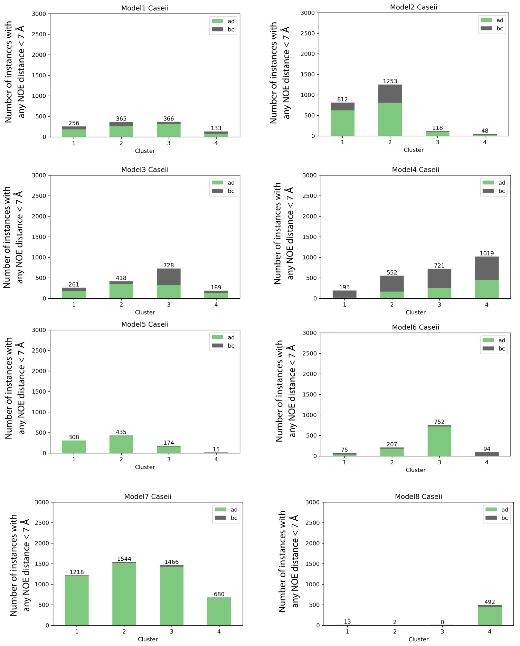
Figure S5: Cluster analysis of close-contact frequencies: Comparisons of NOE Close-contacts for the four most populated clusters for each of the eight RG-II variants. The cluster analysis was performed for all configurations observed at 300K during the REMD simulations.

Table S5: Cluster populations observed at 300K during the REMD simulations for models 1 through 8. NOE close-contact analysis was conducted over these populations is depicted above.

RG-II variant | Model1 | Model2 | Model3 | Model4 | Model5 | Model6 | Model7 | Model 8
Cluster 1 | 2113 | 2238 | 2653 | 1236 | 2522 | 1538 | 1737 | 2675
Cluster 2 | 2584 | 2056 | 1668 | 1602 | 1784 | 1435 | 2715 | 3146
Cluster 3 | 1908 | 1617 | 1648 | 1978 | 2154 | 1667 | 1317 | 2419
Cluster 4 | 1483 | 1361 | 2809 | 1914 | 1740 | 2062 | 2651 | 678
Sum C1 to C4 | 8088 | 7272 | 8778 | 6730 | 8200 | 6702 | 8420 | 8918

References
1. Vidal, S.; Doco, T.; Williams, P.; Pellerin, P.; York, W. S.; O’Neill, M. A.; Glushka, J.; Darvill, A. G.; Albersheim, P., Structural characterization of the pectic polysaccharide rhamnogalacturonan II: evidence for the backbone location of the aceric acid-containing oligoglycosyl side chain. Carbohydrate research 2000, 326 (4), 277-294.
2. Puvanesarajah, V.; Darvill, A. G.; Albersheim, P., Structural characterization of two oligosaccharide fragments formed by the selective cleavage of rhamnogalacturonan II: evidence for the anomeric configuration and attachment sites of apiose and 3-deoxy-2-heptulosaric acid. Carbohydrate Research 1991, 218, 211-222.
3. Ndeh, D.; Rogowski, A.; Cartmell, A.; Luis, A. S.; Baslé, A.; Gray, J.; Venditto, I.; Briggs, J.; Zhang, X.; Labourel, A., Complex pectin metabolism by gut bacteria reveals novel catalytic functions. Nature 2017, 544 (7648), 65-70.
4. Guvench, O.; Greene, S. N.; Kamath, G.; Brady, J. W.; Venable, R. M.; Pastor, R. W.; Mackerell Jr, A. D., Additive empirical force field for hexopyranose monosaccharides. Journal of computational chemistry 2008, 29 (15), 2543-2564.
5. Guvench, O.; Hatcher, E.; Venable, R. M.; Pastor, R. W.; MacKerell Jr, A. D., CHARMM additive all-atom force field for glycosidic linkages between hexopyranoses. Journal of chemical theory and computation 2009, 5 (9), 2353-2370.
6. Hatcher, E.; Guvench, O.; MacKerell Jr, A. D., CHARMM additive all-atom force field for aldopentofuranoses, methyl-aldopentofuranosides, and fructofuranose. The Journal of Physical Chemistry B 2009, 113 (37), 12466-12476.
7. Raman, E. P.; Guvench, O.; MacKerell Jr, A. D., CHARMM additive all-atom force field for glycosidic linkages in carbohydrates involving furanoses. The Journal of Physical Chemistry B 2010, 114 (40), 12981-12994.
8. Guvench, O.; Mallajosyula, S. S.; Raman, E. P.; Hatcher, E.; Vanommeslaeghe, K.; Foster, T. J.; Jamison, F. W.; MacKerell Jr, A. D., CHARMM additive all-atom force field for carbohydrate derivatives and its utility in polysaccharide and carbohydrate–protein modeling. Journal of chemical theory and computation 2011, 7 (10), 3162-3180.

