Supplementary Information for

Management and climate effects to global changes in crop yield stability

Toshichika Iizumi, Toru Sakai, Yoshimitsu Masaki, Kei Oyoshi, Takahiro Takimoto, Hideo Shiogama, Yukiko Imada, David Makowski

The PDF file includes:
Methods
Supplementary Text S1 to S2
References
Figs. S1 to S17
Tables S1 to S4

Methods

Data
Crop yield
We used annual yield data for the period 1961–2020 from the FAO statistical database for maize, rice, wheat, and soybean. In addition, we used the 0.5° grid global dataset³⁸ of historical yields (GDHY)^{39, 40}, which was updated to include data from 1981 to 2020 in the Northern Hemisphere and data of the 2019/2020 season in the Southern Hemisphere. The GDHY dataset are derived from satellite-derived vegetation index and national agricultural census and has been used for analyzing and modeling climate-yield relationships at continental and global scales^{40–46}. Effective grid yield data are available in 76–92% of the global harvested area with variations by crop and lacking when crop calendar information used in the dataset compilation⁴⁷ is missing. In the GHDY dataset, data are available for two seasons for maize and rice (major and secondary), and for wheat (winter and spring). In contrast, only data for a single major season are available for soybean.

Climate
We used 0.5° grid daily data on maximum and minimum air temperatures and precipitation, covering three distinct climate conditions for the historical period: actual, factual, and counterfactual. The actual climate refers to observation-based conditions. The factual climate represents a modelled approximation of the actual climate, influenced by both human activities and natural forces (e.g., volcanic eruptions and solar activity). In contrast, the non-warming counterfactual climate is a modeled preindustrial climate condition that lacks any appreciable human impacts on the global climate.
The actual climate data for the period 1981–2020 were obtained from global retrospective meteorological forcing datasets and used for the model training (see Random forest models). Specifically, we used the JRA55-CDFDM-S14FD data (referred to as JCS for simplicity)⁴⁸ to include information up to 2020. The JCS dataset is a bias-corrected version of the Japanese 55-year Reanalysis (JRA-55)^{49, 50}, using the cumulative distribution function-based downscaling and bias-correction method (CDFDM)⁵¹ and the reference forcing dataset S14FD⁵².
For the factual and counterfactual climate data, we used a large ensemble of long-term climate simulations with and without historical trends in external forcing to the global climate. The climate simulations were conducted using the Meteorological Research Institute Atmospheric General Circulation Model, version 3.2 (MRI-AGCM3.2)⁵³ with a grid interval of 60 km. These simulations are accessible in the Database for Policy Decision Making for Future Climate Change (d4PDF)^{54, 55}. Each of the factual and counterfactual simulations has 100 ensemble members associated with slightly different initial conditions and small perturbations in sea surface temperatures that represent observational uncertainties. Comparisons between the factual and counterfactual simulations enable one to conduct a robust detection and attribution analysis of the effects of human activities on average climate conditions and extreme climate events^{56–59}, as well as to assess the impacts of human-induced climate change on crop yields^{60, 61}. The daily outputs from the AGCM were interpolated to a 0.5° resolution and bias-corrected using the CDFDM method along with the S14FD reference forcing dataset, as described in Iizumi et al.⁶⁰. The bias-corrected d4PDF factual and counterfactual climate data were just recently extended to 2019⁴⁸. Therefore, we focused on the period 2001–2019 in assessing the changes in yield stability.

Agricultural R&D expenditure
Public agricultural R&D generally includes government, higher education, and nonprofit entities, but excludes the private for-profit sector⁶². Total agricultural R&D spending includes salaries, operating and program costs, and capital investments for all entities, excluding the private for-profit sector, involved in agricultural R&D in a country.
For the Organisation for Economic Co-operation and Development (OECD) member economies, we sourced annual data on gross domestic expenditure on R&D expressed as a percentage of gross domestic production (GDP) from the Main Science and Technology Indicators (MSTI) database⁶³. In addition, we collected country-level annual GDP and the agricultural share of GDP from the World Development Indicators⁶⁴. We then estimated the agricultural R&D expenditure for OECD member economies by multiplying the GDP share of domestic R&D expenditure, the agricultural share of GDP, and the total GDP, following the methodology of a previous study⁶⁵. Country annual data on agricultural R&D expenditure were obtained for 88 low and middle-income countries from the International Food Policy Research Institute (IFPRI)’s Agricultural Science and Technology Indicators (ASTI) database⁶². We estimated agricultural R&D expenditure for countries where data were not reported, following Iizumi et al.⁶⁵.
Since the agricultural R&D expenditure data collected were not limited to the four crops considered here, we assumed that annual R&D expenditure dedicated for these crops was proportional to the share of value derived from production of the four crops to total value of agricultural production. For this, we collected country annual data on value of production for the four crops and entire agriculture from FAO database³⁸.
In the accumulation of annual R&D expenditures, the duration of research and the obsolescence of technology were taken into account:
$R_{i, t}=S_{i,t-6}∙E_{i,t-6}+\left(1-δ\right)R_{i,t-1}$ (1)
where R_{i,t} is the R&D expenditure for the four crops for country i accumulated from 1995 to year t (constant 2015 USD), S is the value share of the four crops to total agriculture, E is the country annual public R&D expenditure in agriculture, and δ is the obsolescence rate of technology (0.1)^{65, 66}. The lag time between research and technology adoption by producers was set at six years, although lag time may vary by country and over time^{28, 67}.

Analysis
Detection of changes in yield stability
In this study, changes in yield stability were measured based on the approach of Iizumi and Ramankutty¹². For each grid cell, a 40-year annual yield time series (1981–2020) was detrended with a cubic smoothing spline representing time-varying average yield (fig. S10 A). The cubic smoothing spline method was selected due to its flexibility in accommodating nonlinear trends and its advantage of not reducing sample size at the beginning and end of the time series, as compared to the moving averaging method. Yield anomalies (in tonnes per hectare) were computed as the differences between the original yield time series and the fitted trends (fig. S10 B). By applying a 9-year centered moving window, 32-year time series of the coefficient of variance (CV) of yield anomaly (1985–2016) were derived as the ratio between the standard deviation (SD) of yield anomalies and the 9-year moving average of average yields provided by the fitted cubic smoothing splines. For each grid cell, a regression line was then fitted to the recent portion (2005–2016) of the yield anomaly CV series, and the estimated slope was used to assess the annual rate of change in yield anomaly CV in each grid cell (fig. S10 C). We focused on the recent changes in yield anomaly CV in 2005–2016 that were calculated based on yield anomalies in 2001–2020 (fig. S10 C). Significant positive (negative) slopes were used to identify grid cells with increasing (decreasing) yield anomaly CV. The null hypothesis of no monotonic trend in the CV time series over 2005–2016 was examined using the two-sided Mann-Kendall trend test (68). Monotonic trends in 9-year moving average of average yield and yield anomaly SD series in 2005–2016 were tested in the same manner as the yield anomaly CV series.
To aid visualizing multi-season and multi-crop results as a single map, the detected changes in yield stability for individual seasons and crops were combined according to the following rules. The major season result was selected as the representative when both major (winter) and secondary (spring) seasons were operated. When only one season was operated, the result for that season was considered even when it was the secondary (spring) season. Then the number of crops with specific yield change (either of a significant increase in yield anomaly CV, significant increase in yield anomaly SD, and significant increase in average yield), out of four (maize, wheat, rice, soybean), was counted and divided by the number of crops grown for a given location (the number of crops grown varied by location, as shown in the lower right panel of fig. S4).

Random forest models
Machine learning models were developed to relate yield anomaly to climate, soil, and management conditions. We used random forest regression models⁶⁹ and did not explore alternative machine learning approaches as random forests are straightforward to implement and have often outperformed or been comparable to other approaches in climate-yield relationship analysis^{47, 70, 71}.
Before modeling, we calculated the z-score values of yield anomaly by dividing annual yield anomaly by the SD of yield anomaly calculated for the period 1981–2020 (fig. S10 D). The z-scored yield anomaly was then related to climate, soil, and management variables as well as geographic variables using random forest (table S2). These explanatory variables include longitude, latitude, and elevation as well as the growing-season relative count of crop exposure hours to particular temperature bin or exposure days to specific precipitation bin, the irrigation intensity, the time-invariant topsoil organic carbon content (SOC), and the year term that represents progress in yield-stabilizing management practices other than irrigation expansion. Additional details of the explanatory variables are provided in the subsequent sections.
A specific model was constructed for each crop. Data from major and secondary maize seasons were combined and used to develop a single maize model. Similarly, the data for the major and secondary rice seasons were combined in the same manner as maize. However, the winter and spring wheat models were developed separately due to potential differences in the yield responses to environmental conditions because winter and spring wheat has different growing seasons and physiological characteristics.
Model fitting was conducted using the statistical software R⁷², using the randomForest package⁷³ with the following settings: number of trees (ntree = 500), number of predictors sampled at each split (mtry = 3), and minimum size of terminal nodes (nodesize = 5). These hyperparameter settings were selected based on the package’s default values. The model performances under actual current climate conditions (see act run in table S3) were assessed using out-of-bag samples. The model evaluation was focused on whether the models with d4PDF factual climate data can reasonably reproduce the global pattern of changes in yield anomaly SD.
We assessed the relative importance of the predictors of the random forest models. Following to literature^{70, 71}, we used two methods, the permutation method and the node purity method that rely on the residual sum of squares and the Gini index as the measure, respectively.

Climate variables
Temperature and precipitation were considered to be the primary climatic drivers of interannual variations in yield. Relative counts of hourly temperature exposure for a growing season were calculated using 9 bins with constant 5 °C intervals (T<0, 0≤T<5, 5≤T<10, … , 25≤T<30, 30≤T<35, and 35≤T). Hourly temperature values were obtained by fitting a sine curve to daily maximum and minimum temperatures. Relative counts of daily precipitation exposure during the growing season were also calculated using 5 bins with unequal intervals (P<1, 1≤P<5, 5≤P<20, 20≤P<30, and 30≤P). The growth periods were fixed based on the planting and harvesting dates in 2000⁴⁷. For winter wheat only, the period before the completion of vernalization was excluded from the calculation by identifying the first date at which the fraction of growing-degree days to the crop total thermal requirements exceeds 0.1; this was estimated using the crop phenology model with the crop-specific base (0 °C) and maximum temperature (26 °C) set for winter wheat. Using each of the actual, factual, and counterfactual climate data, these climate variables were calculated for the period 1982–2020 (the climate data from 1981 to 1982 was necessary to calculate data for the 1981/1982 season in the Southern Hemisphere).

Soil variable
In arid and semiarid agricultural regions of the world, a relatively high SOC content has been shown to improve the soil water holding capacity and moderate drought damage to crops^{74, 75}. The topsoil (0–30 cm) SOC data in 1990 were obtained from the Global Soil Organic Carbon (GSOC) map compiled by the FAO and the Intergovernmental Technical Panel on Soils (ITPS)⁷⁶. The 30 arc-second grid data were aggregated to a 5 arc-minute resolution to ensure that the resolution was the same as that of the harvested area maps in 2010 (SPAM2010)⁷⁷. These data were then converted to a 0.5° grid by area-weighted averaging to represent the average SOC over the harvested area.

Management variables
In addition to reducing drought damage to crops, irrigation mitigates heat stress through evaporative cooling of the crop canopy⁷⁸. The irrigation intensity used in this study considered changes due to the expansion of the irrigation-equipped area which was based on the global historical irrigation dataset for the period of 1900–2005 (HID)⁷⁹ and crop-specific variations based on the global monthly irrigated and rainfed crop areas around the year 2000 (MIRCA2000)⁸⁰. Due to the lack of data, irrigation intensity values for the period 2006–2020 were extrapolated using a linear regression based on the data from 1998 to 2005. The 5 arc-minute grid data were aggregated to a 0.5° grid using the area-weighted averaging method.

Simulation experiments
Experimental design
Several simulation experiments were conducted using the random forest models (fig. S1). As described in table S3, the fc and ct runs were used to compare yield stability under factual and non-warming counterfactual climate conditions and determine climate contributions to the change in yield stability under actual improvement of management practices. The fc and fc.em runs were used to compare yield stability estimates under actual management conditions (that improved over time) and under earlier management conditions kept constant over time, respectively. These contrasting management conditions were compared to quantify the recent contributions of management practices to changes in yield stability under climate change.

Assessing climate contribution
The change in yield stability associated with human-induced climate change was detected through a comparison of fc and ct runs (fig. S1, table S3). Using 100 samples of the slope value of yield anomaly SD derived based on the 100-member ensemble simulation of climate model, a histogram was derived for each of the factual and counterfactual yields (fig. S11). When the average slope value of factual yield is higher (lower) than that of counterfactual yield, it indicates that climate change contributed to the direction of increasing (decreasing) yield instability in 2001–2019. The two-sided Wilcoxon rank sum test⁸¹ was used to test the null hypothesis that the two types of slope were equal.

Detecting the contributions of management practices
The contribution of management practices after 2008 to the change in yield anomaly SD was estimated through a comparison of the fc and fc.em runs (fig. S1, table S3). We assumed that the random forest models used in the fc run, which included the management variables (irrigation and year), reflect actual advancement in management practices. Then, we performed a counterfactual run in which improvements in management practices are lacking to varying degrees. To do so, we set the management variables values to change along with time and then turned to be constant at a certain year level. In the first model specification (M1), the management variables values were set to be 1982 to calculate yield anomalies from 1982 to 2019, while in the last model specification (M27), the management variables values changed until 2008 and kept constant afterward (fig. S12). This model setting resulted in 27 specifications of model per crop (M1 to M27). Using 2,700 slope values consisting of 100 members in the d4PDF factual climate and 27 model specifications, a histogram of the slope value was derived for earlier management practices for comparison with a histogram of the slope value for actual management conditions, consisting of 100 members from the d4PDF factual climate and single set of models (fig. S13). When the average slope value of the recent management conditions is significantly higher than that without improved management conditions, it indicates that recent progress in management practices increased yield stability, and therefore that improvements in management practices has kept pace with the manifestation of climate change impacts. When a significant difference in the average slope value was not obtained, it indicates that recent improvements in management practices have lagged behind climate change, adversely affecting maintaining and improving yield stability.

Supplementary Text S1
Model performance
The random forest models explained 24% (rice) to 48% (soybean) of the variance observed in the z-scored yield anomaly between the studied locations and seasons when out-of-bug samples were evaluated. The corresponding results were 30% for maize, 33% for winter wheat, and 39% for spring wheat. More importantly, the models with d4PDF factual climate were able to reproduce the geographic pattern of increases in yield anomaly SD across the crops, with moderate agreement with the observed pattern, as indicated by Cohen’s kappa (κ) of 0.55 (fig. S14 C). The agreement with the observed pattern was as high as κ=0.76 when JCS actual climate was used as the input to the models (fig. S14 B). These results indicated that the trends in factual yield anomaly SD derived based on the models and d4PDF factual climate are a reasonable representation of the observed trends in yield anomaly SD and a reliable means in estimating the contributions of climate and management practices to the changes in yield stability.

Variable importance
Although the estimated average ranks across the crops varied by method, the year term that represents levels of management practices other than irrigation was commonly identified as being the primary factors affecting the yield anomalies (table S4). Some of the geographic variables (longitude, latitude, and elevation) were frequently ranked high especially when the permutation method was used. After the geographic variables, SOC was found to be important. Temperature bins ranging from 10 °C to 35 °C, which encompass the relatively optimal thermal conditions for crops, were identified as being important, albeit with some crop-specific variations. For maize, rice, and soybean, the relatively high temperature bins (15 °C to 35 °C) were found to be important (fig. S15). Conversely, for winter and spring wheat, the lower temperature bins (0 °C to 5 °C) also played a role. This difference likely reflects the reduced likelihood of encountering such low temperatures during the summer growing season. Among the precipitation bins, the 1st bin (the dry-day bin), ranked moderately high, along with the higher temperature bins. However, the remaining precipitation bins ranked middle to low irrespective of the methods used. The estimated importance of irrigation substantially differed by method; on average, the irrigation variable ranked about the 9th in the permutation method, while it did about the 17th in the node purity method.
The high importance assigned to geographic variables in crop yield estimates at the continental scale, as reported previously^{82, 83}, suggests that random forest models function in a manner similar to “spatial interpolation”. This is attributed to the fact that spatial variations in environmental conditions and their effects on the resulting yields are generally more pronounced than temporal variations at a specific location^{45, 84}. Surprisingly, SOC was identified as being highly important in our analysis. This result corroborates previous studies which showed that yield variability and in particular drought-induced yield reductions tend to be moderated with an increase in SOC levels. This is explained by the enhanced ability of SOC-rich soils to retain soil moisture under drought conditions and provide gradual nutrient release to plants, in contrast to SOC-poor soils^{24, 74}.

Supplementary Text S2
Adaptation finance required to offset climate-induced yield instability
The country-level factual yield anomaly SD was found to be, on average, 9.7% greater than the counterfactual yield anomaly SD (fig S16). Therefore, an additional increase in average yield of the same percentage is required to offset this climate-induced increase in yield anomaly SD to keep the yield anomaly CV unchanged. The log linear regression result indicated that a 1% increase in cumulative R&D expenditure for the four crops (natural log $M) would accompany a 0.13% increase in average yield (natural log t ha^{–1}) (fig S17); this was interpreted that, to increase average yield by 9.7%, cumulative R&D expenditure needs to increase 74.6% in the unit of log natural $M, or 5.7-fold in $M unit. According to Eq. 1, a 5.7-fold greater annual R&D expenditure is equivalent to a 5.7-fold greater cumulative R&D expenditure when the duration of research and the obsolescence of technology were kept unchanged.
As discussed in main text, currently, 7.4 $B was allocated to adaptation measures in agri-food systems³⁷, while total agricultural R&D expenditure accounted for 47 $B³⁶. When it was assumed that R&D expenditure for the four crops was 11% of total agricultural R&D expenditure based on the reported value share of the four crops, it would cost 29.5 $B (= 47 $B * 0.11 * 5.7) to offset the climate-induced increase in yield anomaly SD. This amount of R&D expenditure for the crops is 4-fold of the current adaptation finance in agri-food systems (29.5 $B / 7.4 $B).
R&D and extension services should be tailored for specific crops and regions. To achieve this, clarifying the differences between the technologies and management practices that have been adopted by producers for specific crops and areas that have kept-up and lagged behind is considered necessary. Yield increases and stability often vary by crop, even within the same region⁸⁵. This variation can partly be attributed to instances where crops, newly introduced to a region due to changes in policy, occasionally exhibit greater yield instability than traditional crops despite rapid average yield growth⁸⁶. To increase the efficacy of R&D and extension services for facilitating the transition towards climate-resilient agricultural production, donors and policymakers could benefit from analyses identifying the climatic, agronomic, and institutional drivers of severe yield reductions^{87, 88}.

References
- FAO. FAOSTAT (FAO, 2023). https://www.fao.org/faostat/en/#home
- Iizumi, T., Yokozawa, M., Sakurai, G. et al. Historical changes in global yields. Glob. Ecol. Biogeogr. 23, 346-357 (2014). https://doi.org/10.1111/geb.12120
- Iizumi, T., Sakai, T. The global dataset of historical yields for major crops 1981–2016. Sci. Data 7, 97 (2020). https://doi.org/10.1038/s41597-020-0433-7
- Challinor, A., Koehler, AK., Ramirez-Villegas, J. et al. Current warming will reduce yields unless maize breeding and seed systems adapt immediately. Nat. Clim. Change 6, 954–958 (2016). https://doi.org/10.1038/nclimate3061
- Schauberger, B, Gornott, C, Wechsung, F. Global evaluation of a semiempirical model for yield anomalies and application to within-season yield forecasting. Glob. Change Biol. 23, 4750–4764 (2017). https://doi.org/10.1111/gcb.13738
- Kim, W., Iizumi, T., Nishimori, M. Global patterns of crop production losses associated with droughts from 1983 to 2009. J. Appl. Meteorol. Climatol. 58, 1233-1244 (2019). https://doi.org/10.1175/JAMC-D-18-0174.1
- Hasegawa, T., Sakurai, G., Fujimori, S. et al. Extreme climate events increase risk of global food insecurity and adaptation needs. Nat. Food 2, 587–595 (2021). https://doi.org/10.1038/s43016-021-00335-4
- Guilpart, N., Iizumi, T., Makowski, D. Data-driven projections suggest large opportunities to improve Europe’s soybean self-sufficiency under climate change. Nat. Food 3, 255–265 (2022). https://doi.org/10.1038/s43016-022-00481-3
- Kim, W., Iizumi, T., Hosokawa, N., Tanoue, M., Hirabayashi, Y. Flood impacts on global crop production: advances and limitations. Environ. Res. Lett. 18, 054007. https://dx.doi.org/10.1088/1748-9326/accd85
- Sacks, W.J., Deryng, D., Foley, J.A., Ramankutty, N. Crop planting dates: an analysis of global patterns. Glob. Ecol. Biogeogr. 19, 607-620 (2010). https://doi.org/10.1111/j.1466-8238.2010.00551.x
- Iizumi, T., K. Iseki, K. Ikazaki et al. Increasing heavy rainfall events and associated excessive soil water threaten a protein-source legume in dry environments of West Africa. Agric. For. Meteorol. 344, 109783 (2024). https://doi.org/10.1016/j.agrformet.2023.109783
- Kobayashi, S., et al. The JRA-55 Reanalysis: General specifications and basic characteristics. J. Meteor. Soc. Jpn 93, 5–48 (2015). https://doi.org/10.2151/jmsj.2015-001
- Harada, Y., et al. The JRA-55 Reanalysis: Representation of atmospheric circulation and climate variability. J. Meteor. Soc. Jpn 94, 269–302 (2016). https://doi.org/10.2151/jmsj.2016-015
- Ishizaki, N.N., Nishimori, M., Iizumi, T. et al. Evaluation of two bias-correction methods for gridded climate scenarios over Japan. SOLA 16, 80−85 (2020). https://doi.org/10.2151/sola.2020-014
- Iizumi, T., Takikawa, H., Hirabayashi, Y., Hanasaki, N., Nishimori, M. Contributions of different bias-correction methods and reference meteorological forcing data sets to uncertainty in projected temperature and precipitation extremes, J. Geophys. Res. Atmos. 122, 7800– 7819 (2017). https://doi.org/10.1002/2017JD026613
- Mizuta R et al. Climate simulations using MRI-AGCM3.2 with 20-km grid. J. Meteorol. Soc. Jpn 90A, 233-258 (2012). https://doi.org/10.2151/jmsj.2012-A12
- Mizuta R et al. Over 5,000 years of ensemble future climate simulations by 60-km global and 20-km regional atmospheric models. Bull. Amer. Meteorol. Soc. 98, 1383-1398 (2017). https://doi.org/10.1175/BAMS-D-16-0099.1
- Ishii M, Mori N. d4PDF: large-ensemble and high-resolution climate simulations for global warming risk assessment. Prog. Earth Planet. Sci. 7, 58 (2020). https://doi.org/10.1186/s40645-020-00367-7
- Shiogama H et al. Attributing historical changes in probabilities of record-breaking daily temperature and precipitation extreme events. SOLA 12, 225-231 (2016). https://doi.org/10.2151/sola.2016-045
- Imada, Y., Watanabe, M., Kawase, H., Shiogama, H., Arai, M. The July 2018 high temperature event in Japan could not have happened without human-induced global warming. SOLA 15A, 8-12 (2019). https://doi.org/10.2151/sola.15A-002
- Kawase, H. et al. Contribution of historical global warming to local-scale heavy precipitation in western Japan estimated by large ensemble high-resolution simulations. J. Geophys. Res. Atmos. 124, 6093–6103 (2019). https://doi.org/10.1029/2018JD030155
- Imada, Y. et al. Advanced risk-based event attribution for heavy regional rainfall events. npj Clim. Atmos. Sci. 3, 37 (2020). https://doi.org/10.1038/s41612-020-00141-y
- Iizumi, T., Shiogama, H., Imada, Y. et al. Crop production losses associated with anthropogenic climate change for 1981–2010 compared with preindustrial levels. Int. J. Climatol. 38, 5405–5417 (2018). https://doi.org/10.1002/joc.5818
- Sultan B, Defrance D, Iizumi T. Evidence of crop production losses in West Africa due to historical global warming in two crop models. Sci. Rep. 9, 12834 (2019). https://doi.org/10.1038/s41598-019-49167-0
- IFPRI. Agricultural Science and Technology Indicators: 2019 Global Food Policy Report Annex Table 1 (IFPRI, 2019). https://doi.org/10.7910/DVN/9OXBIB
- OECD. MSTI database (OECD, 2023). https://stats.oecd.org/Index.aspx?DataSetCode=MSTI_PUB
- World Bank. World Development Indicators (World Bank, 2023) https://databank.worldbank.org/reports.aspx?source=world-development-indicators#
- Iizumi, T., Furuya, J., Shen, Z. et al. Responses of crop yield growth to global temperature and socioeconomic changes. Sci. Rep. 7, 7800 (2017). https://doi.org/10.1038/s41598-017-08214-4
- Ito, J. Assessing the returns of R&D expenditures on postwar Japanese agricultural production. Econ. Rev. 43, 237–247 (1992). https://EconPapers.repec.org/RePEc:hit:ecorev:v:43:y:1992:i:3:p:237-247
- Huffman, W.E., Evenson, R.E. Do formula or competitive grant funds have greater impacts on state agricultural productivity? Amer. J. Agric. Econ. 88, 783–798 (2006). https://doi.org/10.1111/j.1467-8276.2006.00898.x
- Hipel, K.W., McLeod, A.I. Time Series Modelling of Water Resources and Environmental Systems (Elsevier, 1994).
- Breiman L. Random forests. Mach Learn. 45, 5–32 (2001). https://doi.org/ 10.1023/A: 10109 33404 324
- Folberth, C., Baklanov, A., Balkovič, J. et al. Spatio-temporal downscaling of gridded crop model yield estimates based on machine learning. Agric. For. Meteorol. 264, 1–15 (2019). https://doi.org/10.1016/j.agrformet.2018.09.021
- Deines, J.M., Patel, R., Liang, S.-Z., Dado, W., Lobell, D.B. A million kernels of truth: Insights into scalable satellite maize yield mapping and yield gap analysis from an extensive ground dataset in the US Corn Belt. Remote Sens. Environ. 253, 112174 (2021). https://doi.org/10.1016/j.rse.2020.112174
- R Core Team. R: a language and environment for statistical computing (R Foundation for Statistical Computing, 2023)
- Liaw, A., Wiener, M. Classification and regression by randomForest. R News 2, 18–22 (2002). https://journal.r-project.org/articles/RN-2002-022/
- Iizumi, T., Wagai, R. Leveraging drought risk reduction for sustainable food, soil and climate via soil organic carbon sequestration. Sci. Rep. 9, 19744 (2019). https://doi.org/10.1038/s41598-019-55835-y
- Renwick, L. L. R., Deen, W., Silva, L. et al. Long-term crop rotation diversification enhances maize drought resistance through soil organic matter. Environ. Res. Lett. 16, 084067 (2021). https://dx.doi.org/10.1088/1748-9326/ac1468
- FAO, ITPS. Recarbonizing global soils—a technical manual of recommended management practices. Volume 1. Introduction and methodology. (FAO, 2021). https://doi.org/10.4060/cb6386en
- Yu, Q., You, L., Wood-Sichra, U. et al. A cultivated planet in 2010 – Part 2: The global gridded agricultural-production maps. Earth Syst. Sci. Data 12, 3545–3572 (2020). https://doi.org/10.5194/essd-12-3545-2020
- McDermid, S., Nocco, M., Lawston-Parker, P. et al. Irrigation in the Earth system. Nat. Rev. Earth Environ. 4, 435–453 (2023). https://doi.org/10.1038/s43017-023-00438-5
- Siebert, S., Kummu, M., Porkka, M. et al. A global data set of the extent of irrigated land from 1900 to 2005. Hydrol. Earth Syst. Sci. 19, 1521–1545 (2015). https://doi.org/10.5194/hess-19-1521-2015
- Portmann, F. T., Siebert, S., Döll, P. MIRCA2000—Global monthly irrigated and rainfed crop areas around the year 2000: A new high‐resolution data set for agricultural and hydrological modeling. Glob. Biogeochem. Cycles 24, GB1011 (2010). doi:10.1029/2008GB003435
- Hollander, M., Wolfe, D. A., Chicken, E. Nonparametric Statistical Methods, Third Edition (John Wiley & Sons, 2015). DOI:10.1002/9781119196037
- Jeong, J.H., Resop, J.P., Mueller, N.D. et al. Random forests for global and regional crop yield predictions. PLoS ONE 11, e0156571 (2016). doi:10.1371/journal.pone.0156571
- Wu, H., Zhang, J., Zhang, Z. et al. AsiaRiceYield4km: seasonal rice yield in Asia from 1995 to 2015. Earth Syst. Sci. Data 15, 791–808 (2023). https://doi.org/10.5194/essd-15-791-2023
- Lobell, D.B., Burke, M. B. On the use of statistical models to predict crop yield responses to climate change. Agric. For. Meteorol. 150, 1443-1452 (2010). https://doi.org/10.1016/j.agrformet.2010.07.008
- Chen, H. The spatial patterns in long-term temporal trends of three major crops’ yields in Japan. Plant Prod. Sci. 21, 3, 177–185. (2018). DOI: 10.1080/1343943X.2018.1459752
- Duvallet, M., Dumas, P., Makowski, D. et al. Rice yield stability compared to major food crops in West Africa. Environ. Res. Let. 16, 124005 (2021). https://dx.doi.org/10.1088/1748-9326/ac343a
- Newport, D., Lobell, D. B., Balwinder-Singh et al. Factors Constraining Timely Sowing of Wheat as an Adaptation to Climate Change in Eastern India. Weather Clim. Soc. 12, 515–528 (2020). https://doi.org/10.1175/WCAS-D-19-0122.1
- Nóia Júnior, R. d. S., Deswarte, J.-C., Cohan, J.-P. et al. The extreme 2016 wheat yield failure in France. Glob. Change Biol. 29, 3130–3146 (2023). https://doi.org/10.1111/gcb.16662

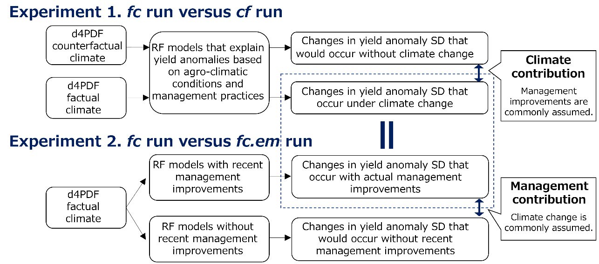
Fig. S1. Simulation experiment design. These two experiments aim at detecting the contributions of climate and management practices to changes in yield anomaly SD in 2001–2019.

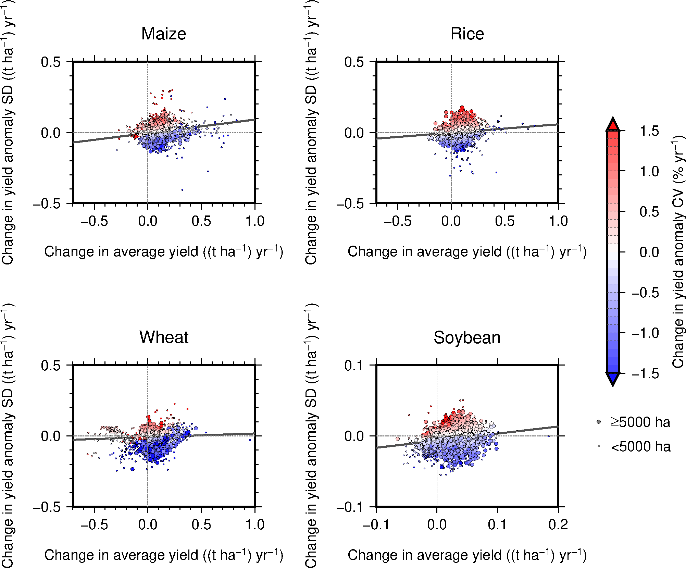

Fig. S2. Annual rate of change in average yield against annual rate of change in yield anomaly SD. Symbol colors indicate annual rate of change in yield anomaly CV. Symbol size represents grid harvested area of particular crop. Solid lines indicate the best-fitted regression line to represent the average relationship. Data shown here include multiple seasons, if any (maize and rice, major and secondary seasons; and wheat, winter and spring seasons). The range of the X- and Y-axes for soybean differs from those of the other crops.

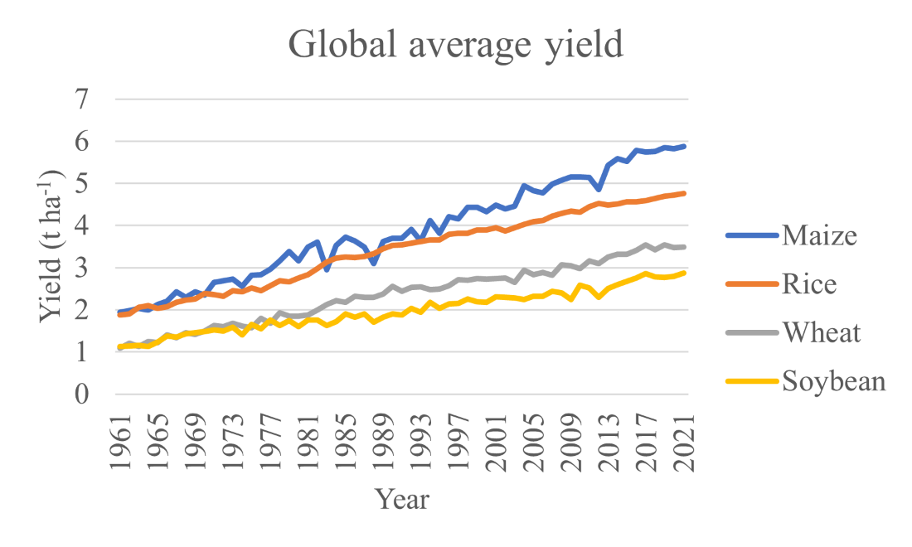
Fig. S3. Global average yields of the crops. Data for the period 1961–2021 were obtained from FAO statistical database.

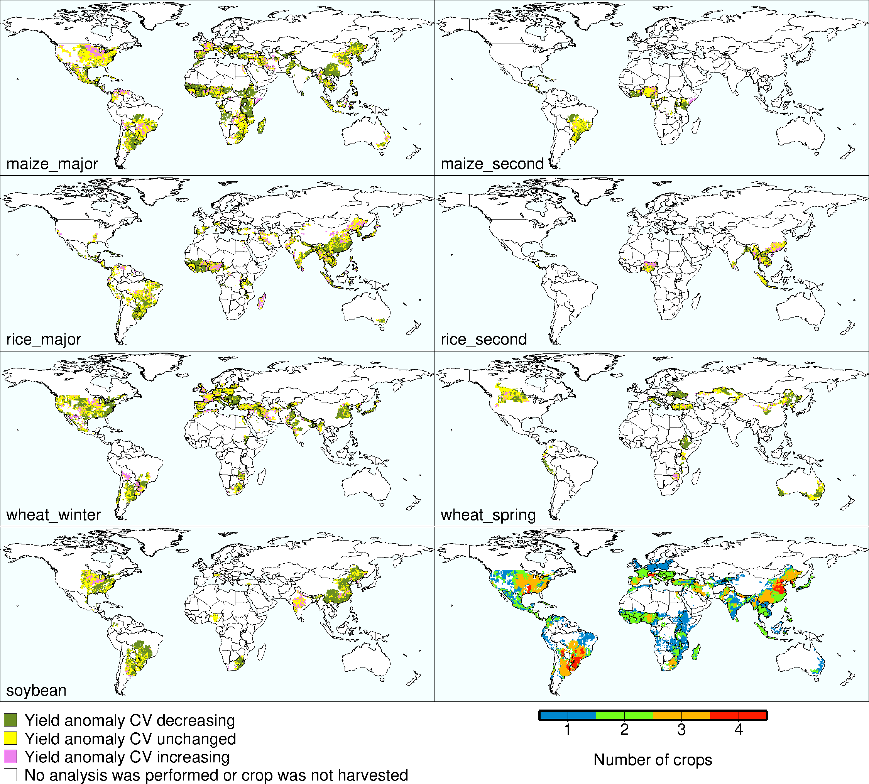
Fig. S4. Global maps of recent changes in yield anomaly CV. The number of crops considered in this study that were harvested in 2010 is also shown.

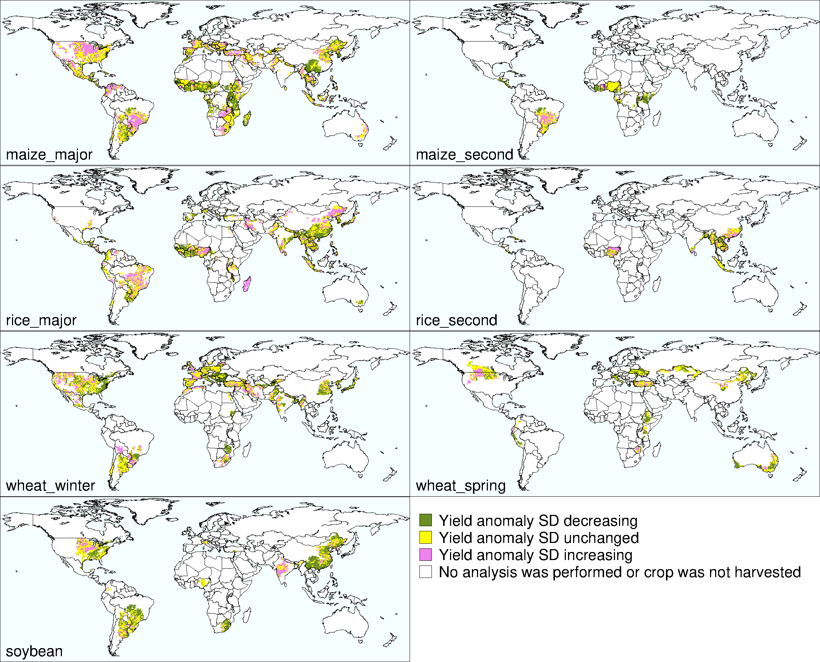
Fig. S5. Global maps of recent changes in yield anomaly SD.

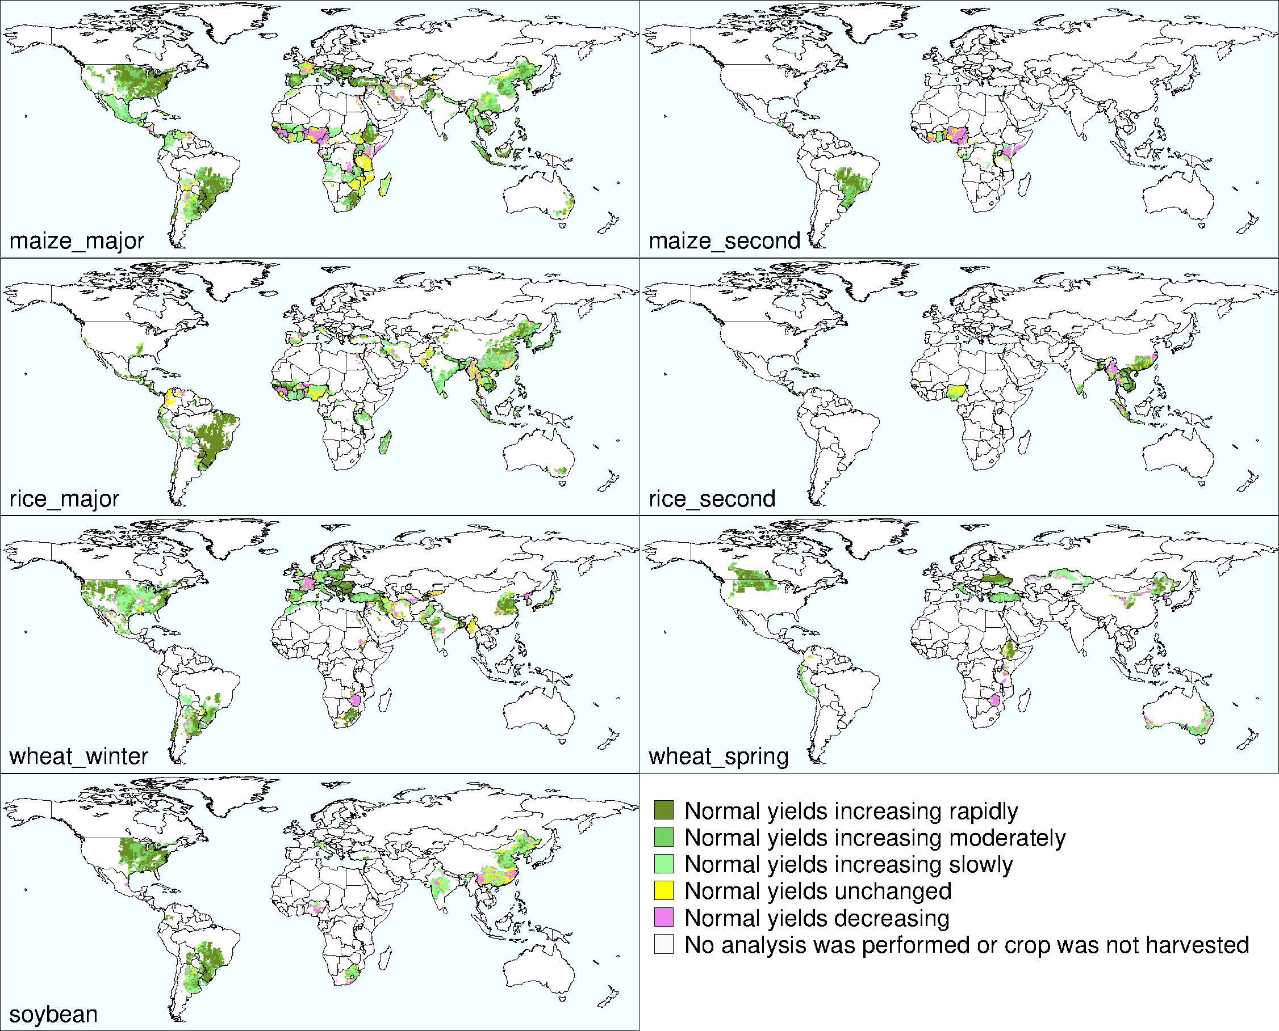
Fig. S6. Global maps of recent changes in average yield. Classes of increasing yield are classified by growth rate: rapidly, upper one-third of grid rates; moderately, middle one-third of the grid rates; and slowly, lower one-third of the grid rate.

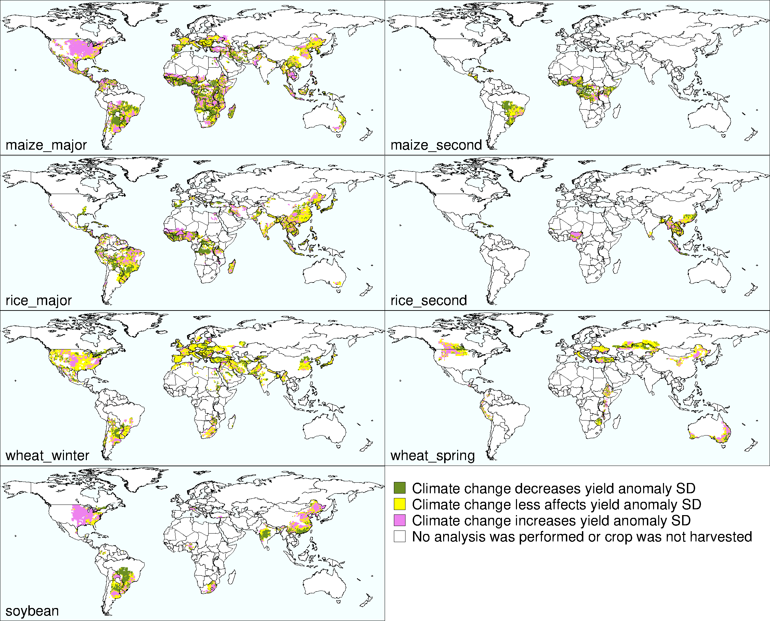
Fig. S7. Global maps of contribution of climate to change in yield anomaly SD.

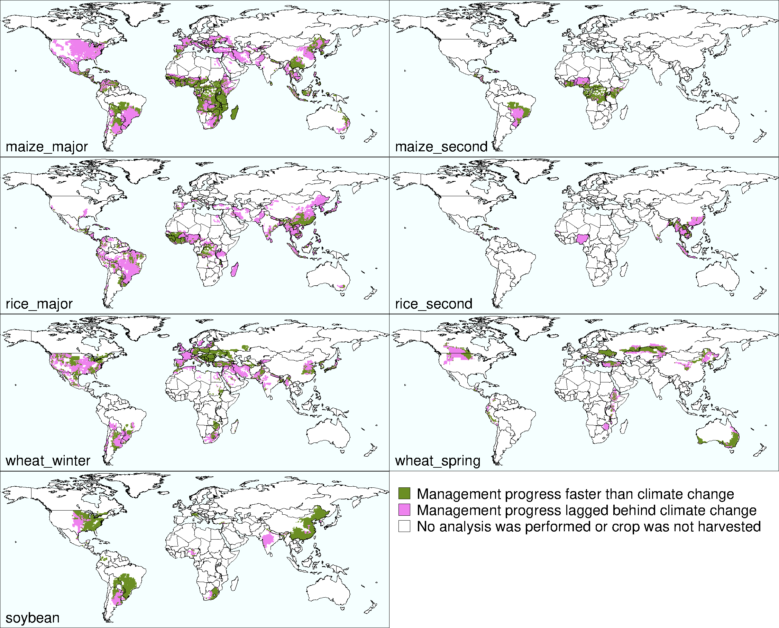
Fig. S8. Contribution of management practices to global changes in the yield anomaly SD.

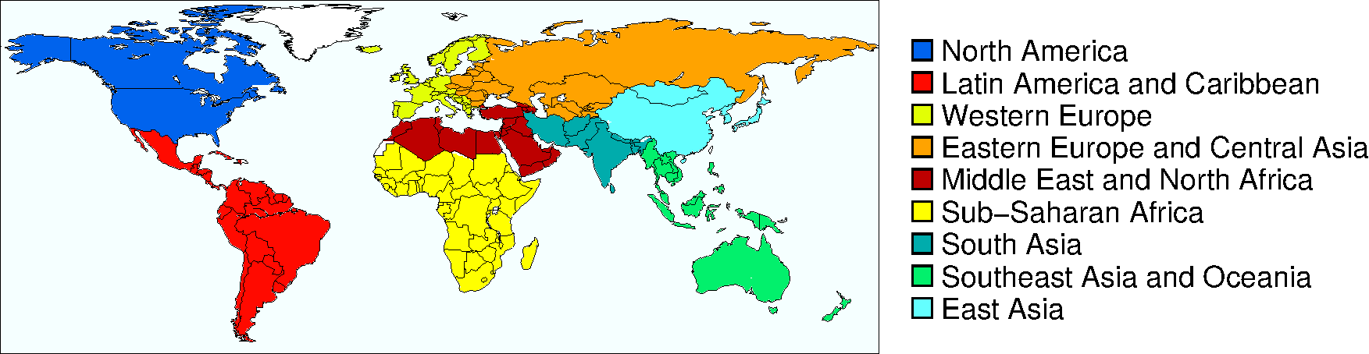
Fig. S9. The classification of world regions used in this study.

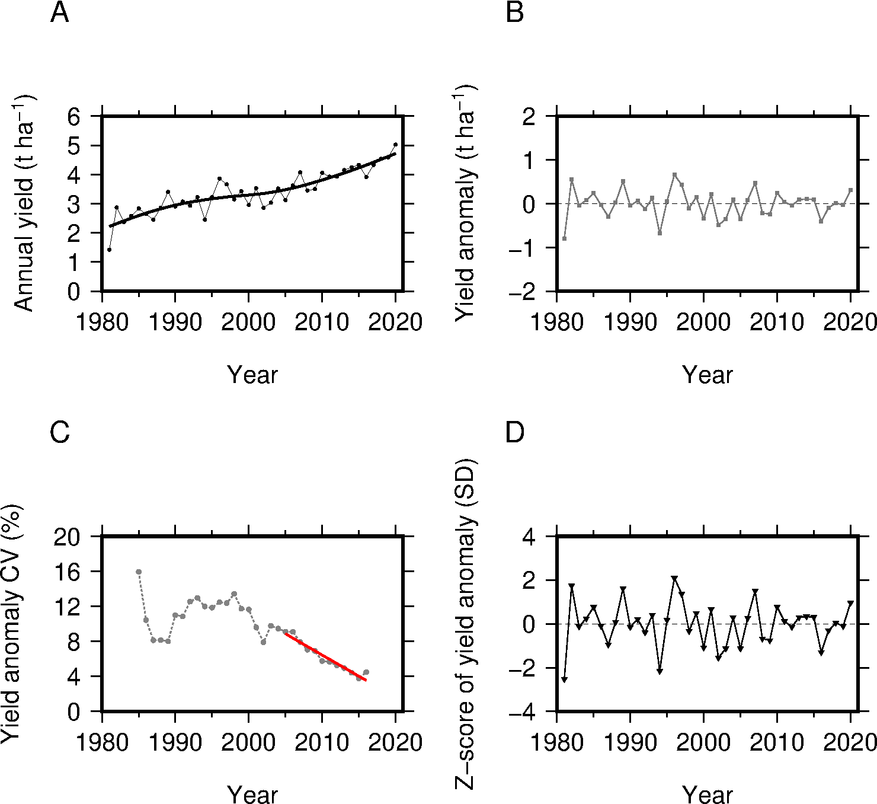

Fig. S10. Processing of annual yield data. Annual time series of actual and average yields (A), yield anomaly in 1981–2020 (actual yield minus average yield) (B), the coefficient of variation (CV) of yield anomaly calculated using a 9-year centered moving window and the best fitted line to the CV time series in 2005–2016 that indicates the recent change in yield stability for the period 2001–2020 (C). The z-scored yield anomaly used in the random forest models is shown for reference (D). Data extracted from major-season (Kharif) rice in Odisha, India (21.25°N, 85.75°E) in the grid yield dataset are shown for explanatory purposes.

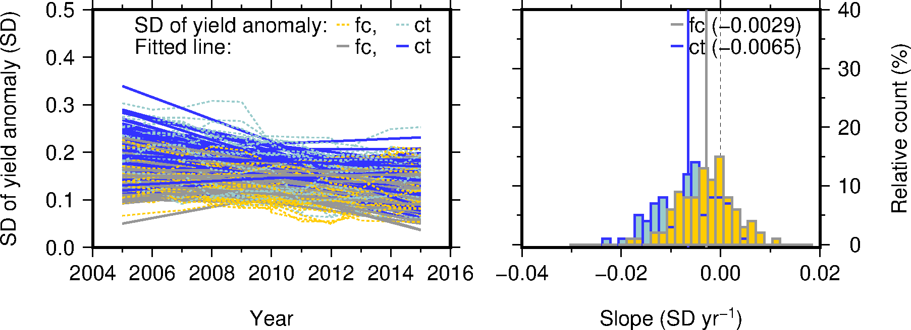
Fig. S11. Example of estimating climate contribution. Regression lines fitted to annual time series of the standard deviation (SD) of factual (fc) and counterfactual (cf) yield anomalies in 2005–2015 to detect the climate change impacts on recent yield stability and the corresponding histograms of the slope value.

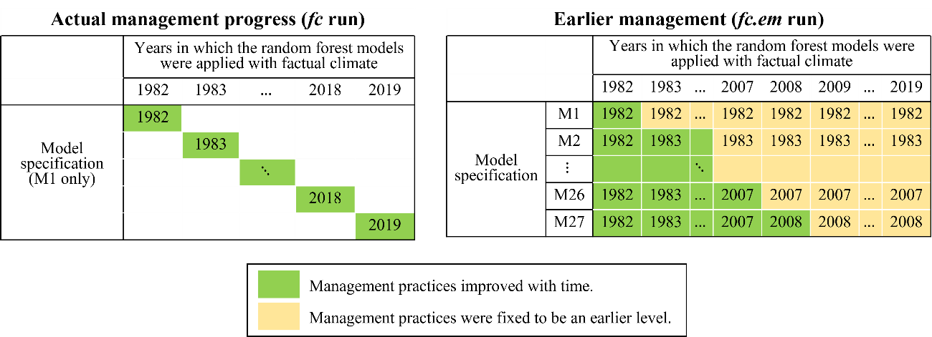
Fig. S12. Random forest model settings used to quantify the contribution of management practices.

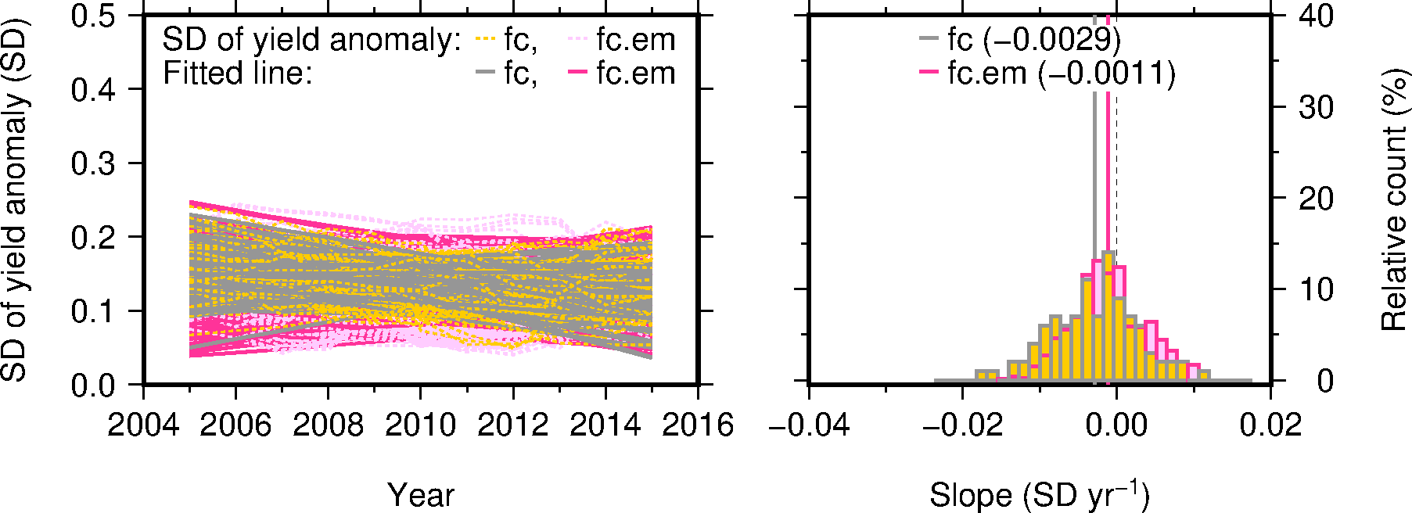
Fig. S13. Example of quantifying the contributions of management practices. Regression lines fitted to annual time series of the standard deviation (SD) of factual yield anomaly in 2005–2015 to compare conditions with and without recent improvements in management practices (fc and fc.em, respectively) and the corresponding histograms of the slope value.

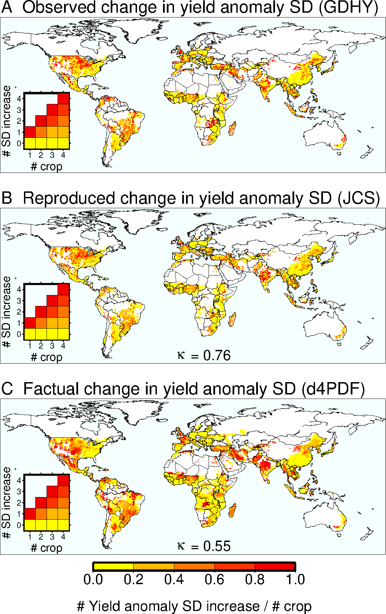
Fig. S14. Random forest model performance in reproducing recent pattern of change in yield anomaly SD. (A) Observed increase in yield anomaly SD, as presented in Fig. 2 B. (B) Reproduced increase in yield anomaly SD based on the random forest models and JCS actual climate (C) reproduced increase in yield anomaly SD based on the models and d4PDF factual climate. Trends for the period 2001–2020 for A and B and 2001–2019 for C are tested using the two-sided Mann-Kendall test. In C, yield anomaly SD is classified to as “increasing” when at least on-third or more, out of 100 members, showed a significantly positive slope value in factual yield anomaly SD series. Cohen’s kappa statistics (κ) calculated for each of JCS actual climate-based reproduction (B) and d4PDF factual climate-based reproduction (C) against observed pattern derived from grid yield dataset (GDHY) (A) are shown as the indication of similarity in geographic pattern between two datasets.

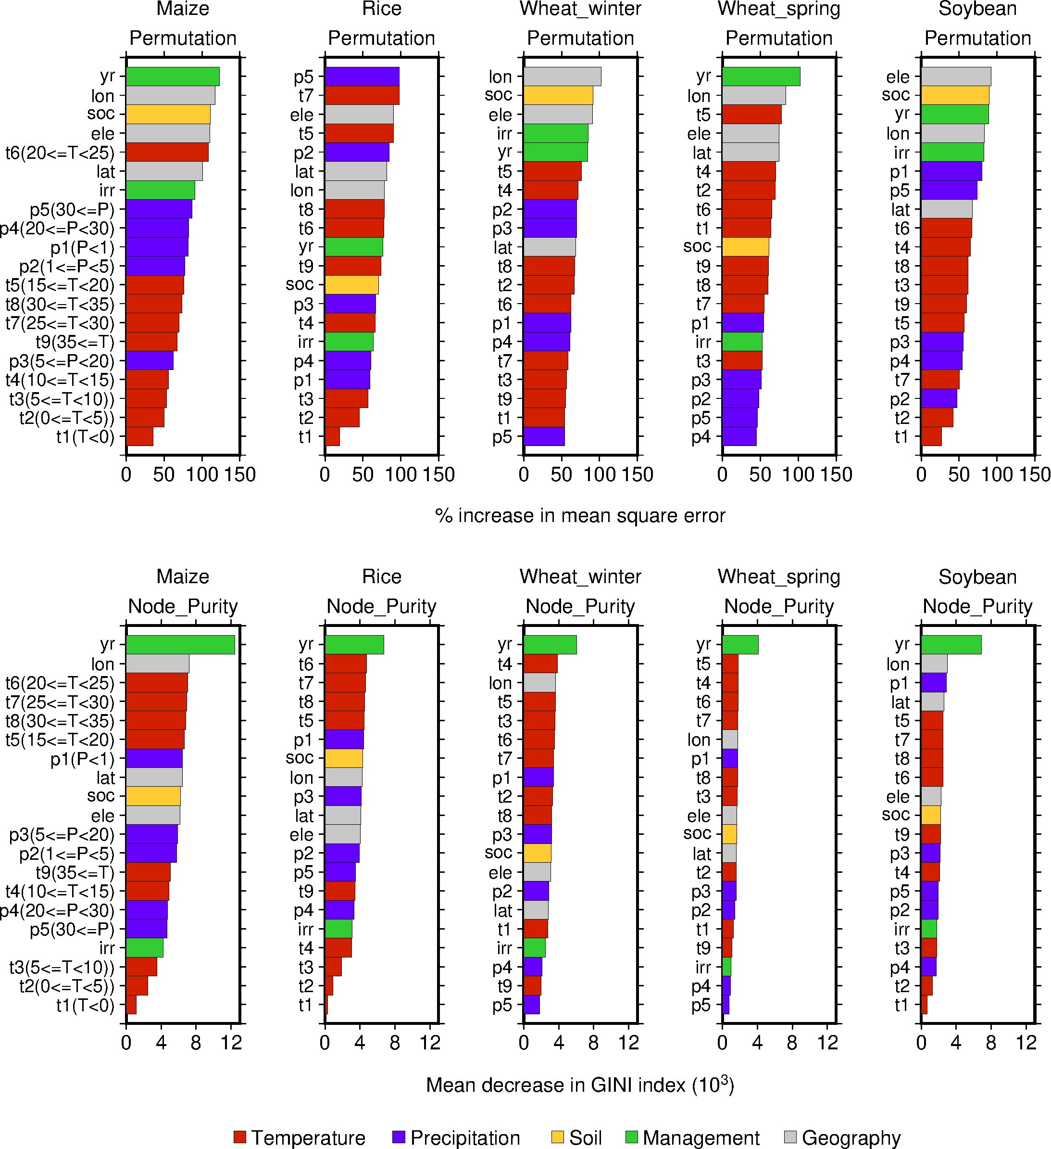
Fig. S15. The importance of soil, climate, management, and geographic factors. Importance measures (the percent increase in mean square error and the mean decrease in GINI index) were calculated for the random forest models trained based on z-scored yield anomalies and JCS actual climate data for the period 1982–2020.

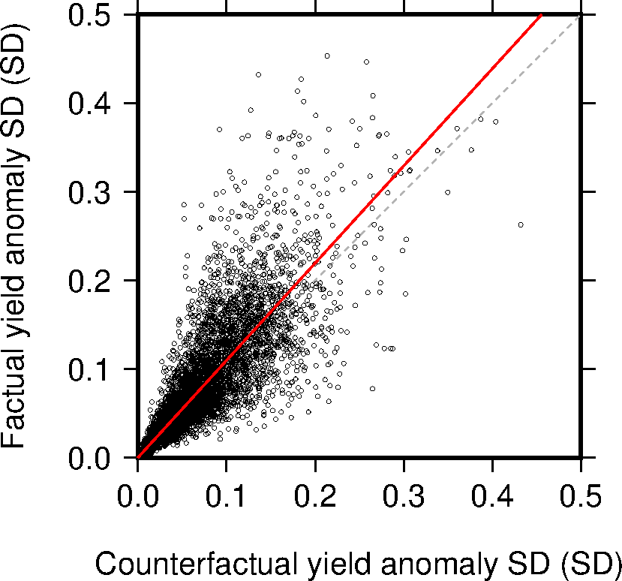
Fig. S16. Comparison between country-level multi-crop-aggregated factual and counterfactual yield anomaly SD. The grid factual and counterfactual yield anomalies of the individual crops derived from the random forest models were aggregated to the country scale for each member (the crop-specific grid harvested area in 2010 were used as the weights). Data for 2015 that represent the period 2011–2019 are shown. The red line indicates the best-fit linear regression with intercept forced to be zero (the slope value = 1.097, n=8000, p<0.001, t-test, and R² = 0.861). The number of countries with effective data based on grid data is fewer with that based on FAO country data due to missing modeled grid yield anomalies.

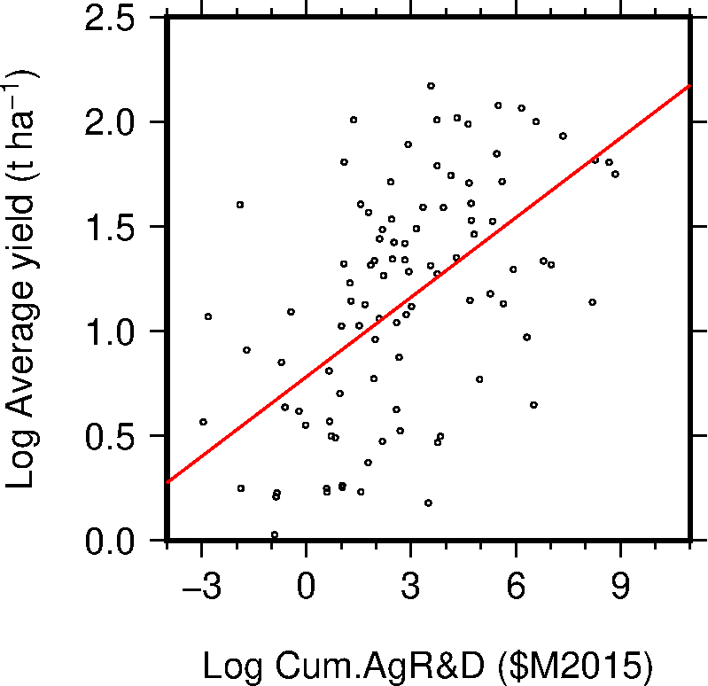
Fig. S17. Relationship between R&D and yield increase. Natural log of the cumulative annual R&D expenditure for the four crops since 1995 versus natural log of average yield. The original data are the same as Fig. 1 A. The red line shows best-fit linear regression (the slope = 0.127; the intercept = 0.781, n=99, p<0.01, t-test, and R² = 0.300).

Table S1. Area shares of the climate-management categories by crop and region. See Fig. 4 caption for region codes.
Region code | Climate-management category | Area share (% of harvested area)
Region code | Climate-management category | Maize | Soybean | Rice | Wheat | 4crops
NAm | Keep-pace | 1 | 69 | 2 | 44 | 35
NAm | Lagged-behind | 99 | 31 | 98 | 56 | 65
LAmCa | Keep-pace | 24 | 62 | 27 | 41 | 47
LAmCa | Lagged-behind | 76 | 38 | 73 | 59 | 53
WEu | Keep-pace | 13 | 100 | 16 | 30 | 27
WEu | Lagged-behind | 87 | 0 | 84 | 70 | 73
EEuCAs | Keep-pace | 18 | - | - | 93 | 74
EEuCAs | Lagged-behind | 82 | - | - | 7 | 26
MENAf | Keep-pace | 12 | 27 | 2 | 41 | 37
MENAf | Lagged-behind | 88 | 73 | 98 | 59 | 63
SSAf | Keep-pace | 78 | 59 | 40 | 63 | 69
SSAf | Lagged-behind | 22 | 41 | 60 | 37 | 31
SAs | Keep-pace | 15 | 1 | 28 | 38 | 27
SAs | Lagged-behind | 85 | 99 | 72 | 62 | 73
SEAsO | Keep-pace | 53 | 100 | 15 | 16 | 20
SEAsO | Lagged-behind | 47 | 0 | 85 | 84 | 80
EAs | Keep-pace | 32 | 93 | 35 | 39 | 41
EAs | Lagged-behind | 68 | 7 | 65 | 61 | 59
World | Keep-pace | 32 | 61 | 26 | 48 | 40
World | Lagged-behind | 68 | 39 | 74 | 52 | 60

Table S2. Variables used in the random forest models.
Category | Symbol | Description | Unit
Response variable
Crop yield | y | Z-scored yield anomaly | SDª
Explanatory variables
Geography | ele | Elevation | m
Geography | lon | Longitude | °E
Geography | lat | Latitude | °N
Climate | t1 | 1st hourly temperature bin (hourly temperature (T)<0 °C) | Fraction^{b}
Climate | t2 | 2nd hourly temperature bin (0≤T<5) | Fraction
Climate | t3 | 3rd hourly temperature bin (5≤T<10) | Fraction
Climate | t4 | 4th hourly temperature bin (10≤T<15) | Fraction
Climate | t5 | 5th hourly temperature bin (15≤T<20) | Fraction
Climate | t6 | 6th hourly temperature bin (20≤T<25) | Fraction
Climate | t7 | 7th hourly temperature bin (25≤T<30) | Fraction
Climate | t8 | 8th hourly temperature bin (30≤T<35) | Fraction
Climate | t9 | 9th hourly temperature bin (35≤T) | Fraction
Climate | p1 | 1st daily precipitation bin (daily precipitation (P)<1 mm) | Fraction^{c}
Climate | p2 | 2nd daily precipitation bin (1≤P<5) | Fraction
Climate | p3 | 3rd daily precipitation bin (5≤P<20) | Fraction
Climate | p4 | 4th daily precipitation bin (20≤P<30) | Fraction
Climate | p5 | 5th daily precipitation bin (30≤P) | Fraction
Soil | soc | Topsoil soil organic carbon content | kg C m^{–2}
Management | irr | Irrigation intensity (the irrigated area divided by harvested area) | Fraction
Management | yr | Year representing levels of management practice other than irrigation | year
ª Yield anomaly values were scaled using the standard deviation (SD) of yield anomaly for the period 1981–2020 from one grid cell to another.
^{b} Fraction of exposure hours to total hours from planting to harvesting. The same applies to other temperature bins.
^{c} Fraction of exposure days to total days from planting to harvesting. The same applies to other precipitation bins.

Table S3. Summary of random forest model specifications used in this study.
Objective | Run | Climate | Description | Period
Model evaluation | act | JCS actual | The model was trained using JCS actual climate data and used for the assessment of model performance. | 1982–2020
Detecting contributions of climate change and management practices | fc | d4PDF factual | The model trained in the act run was used, while d4PDF factual climate data was input to the model. | 1982–2019
 | ct | d4PDF counter-factual | Same as the fc run except using d4PDF counterfactual climate data as the input. | 1982–2019
 | fc.em | d4PDF factual | The model trained in act run was used keeping management variable values (irrigation and year) equal to earlier years (1982 to 2008) to estimate yield anomaly for the period 1982–2019 using d4PDF factual climate data. | 1982–2019

Table S4. Average ranking of variable importance in the random forest models and their uncertainty associated with different methods. Average rank was calculated over the crops considered here.
Variable | Permutation | Variable | Node purity
Variable | Average rank | Variable | Average rank
ele | 3.0 | yr | 1.0
lon | 3.2 | lon | 4.2
yr | 4.0 | t5(15<=T<20) | 4.4
soc | 5.8 | t6(20<=T<25) | 4.6
lat | 7.0 | t7(25<=T<30) | 5.0
t5(15<=T<20) | 7.8 | p1(P<1) | 6.2
t6(20<=T<25) | 8.8 | t8(30<=T<35) | 6.8
irr | 9.2 | t4(10<=T<15) | 9.8
t4(10<=T<15) | 10.8 | soc | 9.8
t8(30<=T<35) | 11.0 | lat | 9.8
p5(30<=P) | 11.0 | ele | 10.6
p2(1<=P<5) | 12.0 | p3(5<=P<20) | 11.4
p1(P<1) | 12.2 | t3(5<=T<10)) | 13.4
t7(25<=T<30) | 12.4 | p2(1<=P<5) | 13.6
t9(35<=T) | 13.6 | t9(35<=T) | 14.8
p3(5<=P<20) | 14.0 | t2(0<=T<5)) | 15.8
t2(0<=T<5)) | 15.2 | p5(30<=P) | 16.6
p4(20<=P<30) | 15.2 | irr | 16.8
t3(5<=T<10)) | 16.2 | p4(20<=P<30) | 17.0
t1(T<0) | 17.6 | t1(T<0) | 18.4

