Figure S1: Heart-evoked potentials.
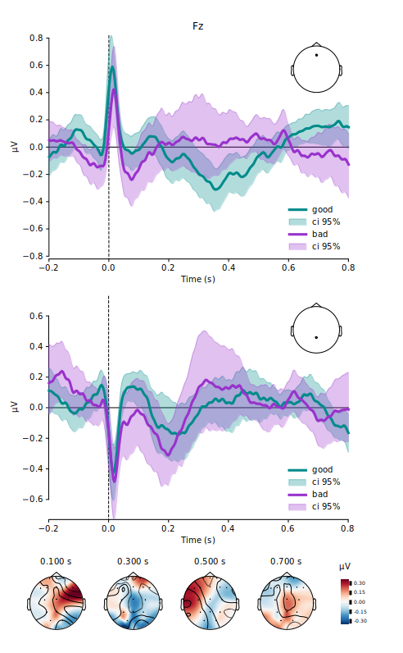
Figure S1 caption - heart-evoked potentials (HEPs) between patients who recovered consciousness before hospital discharge (green), and those who did not (purple) for electrode Fz (top) and Pz (bottom). In addition to spatial presentation of the HEP difference between groups from 100ms to 700ms. The hear bar presents the activity in micro-volt. Good denotes the group with recovery of consciousness and bad denotes the group with no recovery of consciousness before discharge. No difference was found between the two groups.

Figure S2: Heart rate and heart rate variability.
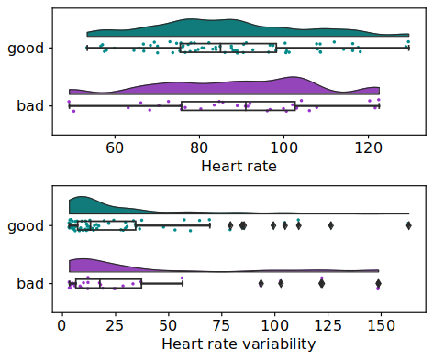
Figure S2 caption – heart rate and heart rate variability comparison between patients who recovered consciousness before hospital discharge (green), and those who did not (purple). No difference was found between the two groups.

Figure S3: R-squared of variables
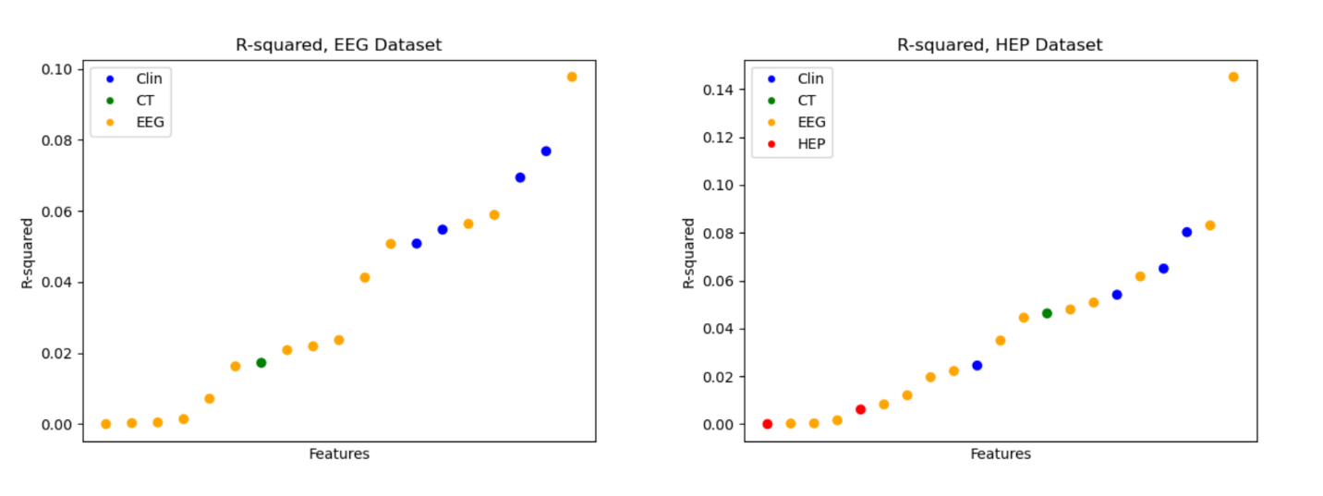
Figure S3 caption – The proportion of variance in recovery of consciousness explained by the features. For the EEG dataset, Age (r2 = 0.076) and Beta power mEmCh (r2 = 0.098) were the best predictors of the Clinical and EEG features, respectively. For the HEP dataset, Right reactivity (r2 = 0.08), Beta power mEmCh (r2 = 0.145), and Cz 0-600 ms (r2 = 0.006) were the best predictors of the Clinical, EEG, and HEP features, respectively.

Table S1: AUCs and 95% Confidence Intervals of different machine learning models in predicting recovery of consciousness before discharge.
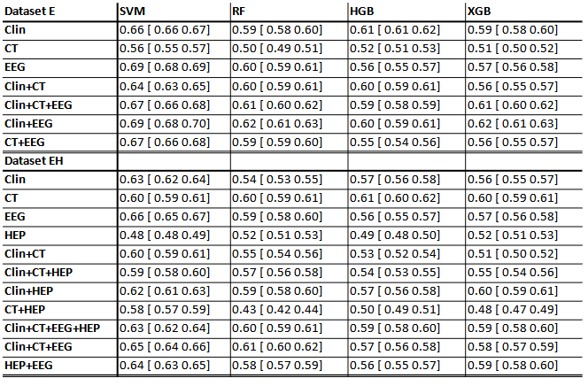
Abbreviations: Dataset E, the EEG dataset; Dataset EH, the EEG and heart evoked potentials dataset; Clin, clinical variables; CT, computed tomography; EEG, electroencephalogram; HEP, heart evoked potentials; SVM, support vector machine; RF, random forest; HGB, histogram-based gradient boosting; XGB, XGBoost.

