Low frequency of the wild-type freezing-tolerance LsCBF7 allele among lettuce population suggest a negative selection during domestication and breeding

Sunchung Park^{1,*}, Ainong Shi², and Beiquan Mou³
¹U.S. Department of Agriculture, Agricultural Research Service, Beltsville, MD 20705, USA
²Horticulture Dept., University of Arkansas, Fayetteville, AR 72701, USA
³U.S. Department of Agriculture, Agricultural Research Service, Salinas, CA 93905, USA

*Correspondence to Sunchung Park (Sunchung.park@usda.gov); ORCID: 0000-0002-7398-9476
Ainong Shi (ashi@uark.edu); ORCID: 0000-0002-1066-7920
Beiquan Mou (Beiquan.mou@usda.gov); ORCID: 0000-0002-6135-9944

Supplementary information
Supplementary Figure S1-4
Supplementary Table S1-6

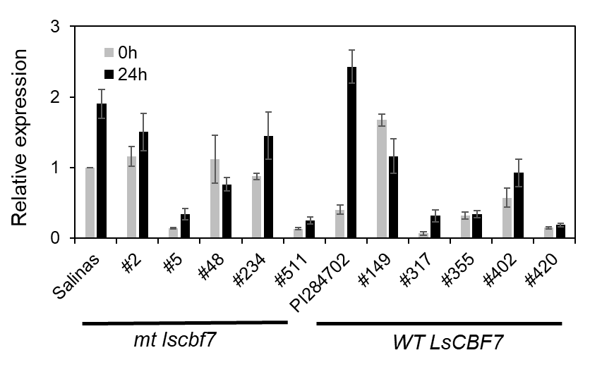

Fig. S1 LsGOLS2 expression in response to low temperatures in accessions carrying mutant or wild-type LsCBF7 alleles. Five accessions, each for mutant (mt lscbf7) or wild-type (WT LsCBF7) accessions, were randomly selected to assess LsGOLS2 expression. Accession ID numbers are shown on the x-axis. Salinas and PI 284702 were included as controls. Gene expression was determined by qRT-PCR in plants grown at 20°C (0 h) and exposed to 4°C for 24 hours. Error bars represent the standard error of three biological replicates.

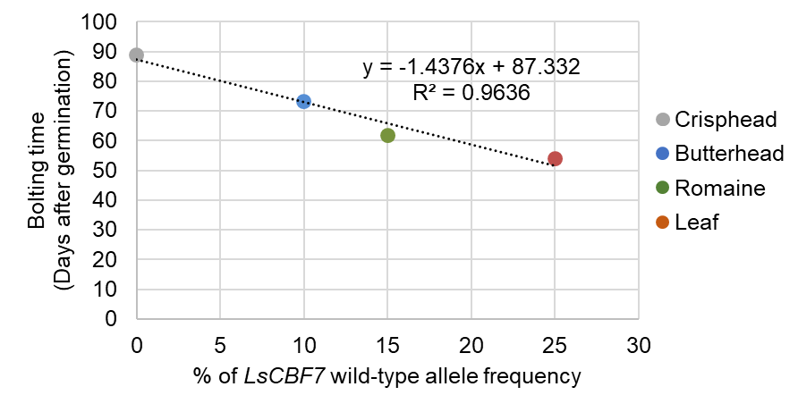

Fig. S2 Strong negative correlation between the frequency of LsCBF7 wild-type allele and bolting time in four horticultural types. The linear regression line and the R-square value are shown on the graph.

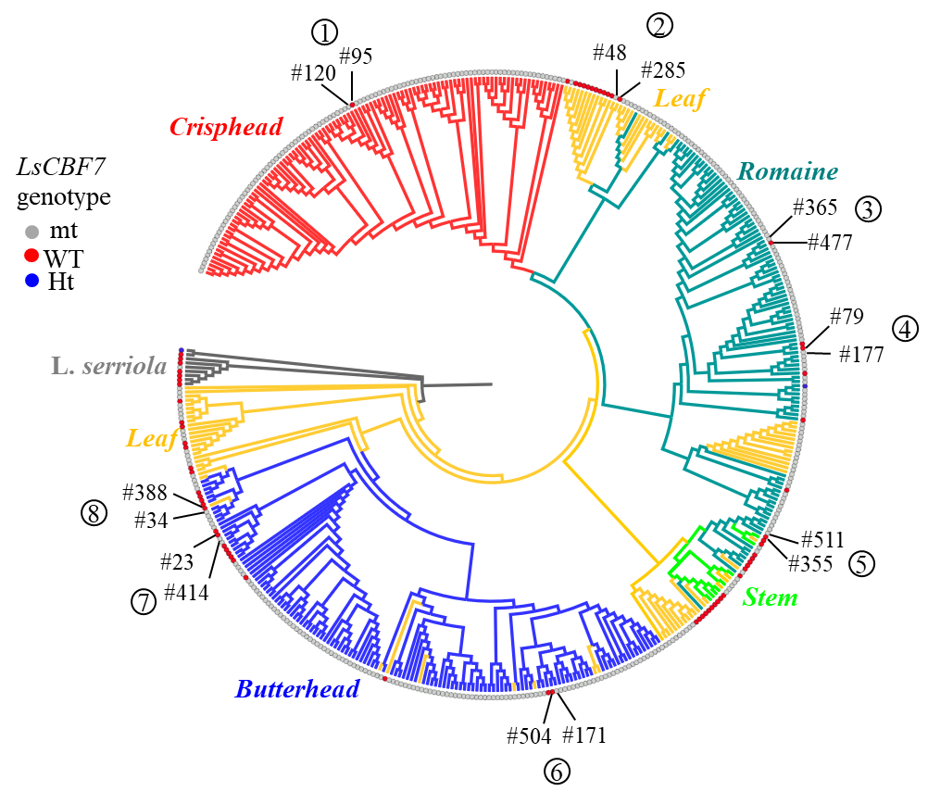

Fig. S3 Genetic relationships of 441 accessions and their LsCBF7 genotypes. A neighbor-joining tree was previously constructed based on 186,000 SNP (Park et al, 2021), and the LsCBF7 genotypes (mt-mutant; WT-wild-type; Ht-Heterozygous) identified in this study were overlaid onto each accession. The numbers in the circles represent group identifiers (as shown in Fig. S4) for pairs of accessions, with their corresponding IDs listed below.

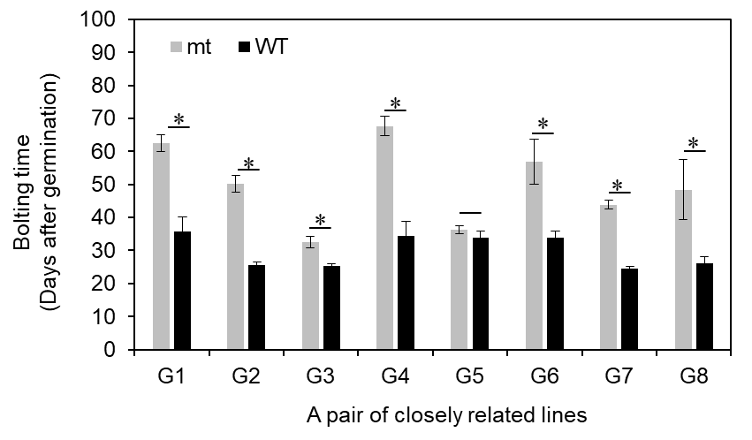
Fig. S4 Accessions with the wild-type LsCBF7 allele bolted significantly earlier than those with the mutant allele. For each pair of genetically closely related accessions, selection was based on the neighbor-joining tree shown in Fig. S3. Error bars indicate standard deviation (n=5). Significance was tested by Student’s t-test (** <0.01, * <0.05).

Supplementary Tables
Table S1. List of plant species from Asterid or Rosid clades whose protein databases were used for identification of lettuce GOLS gene family

Table S2. List of genes selected as GOLS-like genes through BLASTP search using Arabidopsis genes as queries
Table S3. List of the 577 Lactuca accessions used for LsCBF7 allele genotyping

Table S4. Primers used for quantitative RT-PCR and rhAmp SNP genotyping

Table S5. Genes significantly induced in PI 284702 compared to Salinas plants with log2 fold-change (logFC) >1 and FDR = 0.01

Table S6. Pairwise F_{ST} value among L. serriola and two LsCBF7 allelic groups of L. sativa

Table S7. Heterozygosity (H_{exp}) and Shared allele frequency (SAF) among L. serriola and two LsCBF7 allelic groups of L. sativa

