SUPPLEMENTARY INFORMATION

Highly Efficient On-surface Synthesis of Fused N-heterocyclic derivatives
Alejandro Jiménez-Martín,^{†1,2,3} Tatiana Munteanu,^{†4} Qifan Chen,^{†2,5} Simon Pascal,^{4,6} Aura Tintaru,⁴ Benjamin Mallada,^{1,2} Pingo Mutombo,² Olivier Siri,⁴* Pavel Jelínek,^{1,2}* and Bruno de la Torre¹*

¹ Regional Centre of Advanced Technologies and Materials, Czech Advanced Technology and Research Institute, Palacký University Olomouc, Šlechtitelů 241/27, Olomouc, Czech Republic
² Institute of Physics of the Czech Academy of Sciences, Cukrovarnická 10, 16200, Prague 6, Czech Republic
³ Faculty of Nuclear Sciences and Physical Engineering, Czech Technical University in Prague, Brehova 7, 115 19 Prague 1, Czech Republic
⁴ Aix Marseille Univ., CNRS UMR 7325 Centre Interdisciplinaire de Nanoscience de Marseille (CINaM), Campus de Luminy, 13288 Marseille cedex 09, France.
⁵ Faculty of Mathematics and Physics, Charles University, V Holešovičkách 2/747, 180 00 Praha, Czech Republic.
⁶ Université de Nantes, CEISAM UMR 6230, CNRS, Nantes F-44000, France.

* Correspondence to: jelinekp@fzu.cz (P.J.), olivier.siri@univ-amu.fr (O.S.) and bruno.de@upol.cz (B.T.)
† These authors contributed equally to this work.

Contents
Methods
Synthesis of the materials
Figures S1 to S12
NMR spectra
HRMS spectra
References

Methods
SPM experiments
Experiments were conducted in a custom-build scanning tunneling microscope (STM)/non-contact atomic force microscope (nc-AFM) system (CreaTec Fischer & Co. GmbH) in an ultra-high vacuum (UHV) environment with a base pressure below 5 x 10⁻¹⁰ mbar hosting a low temperature (4.2 K) cryostat. The Au(111) substrate was prepared by standard cycles of Ar⁺ sputtering and annealing at 800 K. Images were acquired with a Pt/Ir tip attached to a qPlus sensor¹ (resonant frequency ≈ 30 kHz; stiffness ≈ 1800 N m⁻¹; Q ≈ 70k) by applying a bias voltage to the sample. For nc-AFM imaging, we used a frequency modulation method by keeping the oscillation amplitude constant at 50 pm. Sharp metallic tips were obtained by gentle indentations on the bare surface. For AFM imaging, a single CO molecule was picked up by the tip-apex after dosing on the cold sample. The images were analyzed with the WSxM software.²
The molecular precursor 3 was outgassed in UHV for several hours and then thermally sublimated in UHV onto the clean Au(111) substrate kept at room temperature from a tantalum crucible maintained at 120 ºC. After annealing step at 100 ºC, the sample was transferred to the STM stage held at 4.2 K for further characterization.
Calculation of the molecular yield
For data statistics, several hundred monomers of final products were considered. It is important to mention that only molecules found on surface are considered for statistics analysis, there is no information about desorbed molecules. However, the coverage before and after the reaction process is very similar, indicating that desorption is minimal.
QM/MM calculations
For the QM/MM simulations we have employed the Fireball/AMBER software.³ The classical part is the metal surface, and to define its forces we employ the interface force-field, whereas the quantum region, consisting of the molecule and one gold adatom, is treated at the BLYP-DFT level with the Fireball software,⁴ a local-orbital DFT code which employs an optimized basis set of pseudo-atomic orbitals. The forces thus obtained are then managed by AMBER and integrated to derive the dynamics.⁵ We have employed a combination of Umbrella Sampling Simulations (US) and Steered Molecular Dynamics (SMD) to unveil the features of the reaction mechanism and calculate the free energy profiles of the reactions.^{6–8} Before the US or SMD, we have performed a QM/MM geometry optimization followed by a thermalization under 300 K to stabilize the system. We use the Langevin thermostat as implemented in AMBER to simulate the canonical ensemble.⁹ We use the Alan Grossfield´s implementation for the Weighted Histogram Analysis Method (WHAM)¹⁰ to calculate free energy profiles associated to each reaction from the US. On each of these cases, an initial SMD is employed to drag the corresponding reaction coordinate and generate structures which can be used as seeds for each US window.
DFT calculations
We performed Density Functional Theory calculations as implemented in the FHI-aims code¹¹ in order to obtain the electronic properties of all the free-standing molecules. First, they were thoroughly relaxed using the hybrid functional B3LYP (Becke, 3-parameter, Lee–Yang-Parr)^{12,13} to get an optimized structure. Then, they were linked together to form one-dimensional chains following the models derived from the experimental findings. These chains were again relaxed to optimize their lattice constants. Note that all the calculations were performed using the Tkachenko-Scheffler treatment of the van der Waals interactions.¹⁴ The structural optimization was stopped when the remaining atomic forces and the total energy were found below 10⁻⁵ eV and 10⁻² eV/Å and respectively. A Monkhorst-Pack grid of 1x18x1 was used for the integration of the Brillouin zone.
AFM simulations
AFM image simulations were carried up using the ProbeParticle code^{15,16} that takes into account the electrostatic and the van der Waals (vdW) between the CO tip and the surface. The DFT densities were used to determine the Pauli repulsion and the van de Waals interactions. The electrostatic forces were calculated from the Hartree potential obtained from DFT calculations. All the simulations were performed with a lateral stiffness of (k)=0.25 N/m.
dI/dV simulations
We simulated dI/dV maps using the PP-STM code¹⁷ with an CO rigid tip. The eigenstates needed for the simulations of the one-dimensional chain bands were calculated with the Fhi-aims code. The dI/dV figures were obtained at characteristic energy positions corresponding to the valence and conduction bands respectively. We set the Lorentzian width parameter for broadening of the eigenstates to 5 meV.
Synthesis of the materials
Reagents
All reagents and solvents were purchased from Merck and were used as received. Column chromatography was performed on silica gel 60 (230–400 mesh).
Analytical methods and apparatus.
1H nuclear magnetic resonance (NMR) spectra were recorded on a JEOL ECS400 NMR spectrometer at 300 K and ¹³C, ¹H‐¹³C HSQC and ¹H‐¹H NOESY NMR spectra were recorded on a Bruker Avance DRX 500 NMR spectrometer (Karlsruhe, Germany) operating at Larmor frequency of 500.13 MHz for ¹H and 125.77 MHz for ¹³C and equipped with a double resonance broadband fluorine observe (BBFO) 5 mm probe head. ¹³C–NMR spectrum was recorded following the uniform driven equilibrium Fourier transform (UDEFT) pulse sequence (90° excitation pulse) with ¹H decoupling during signal acquisition and flip back pulse at the end of acquisition to decrease relaxation delay d1 and NOE (performed with adiabatic pulse),¹⁸ the relaxation delay has been set at 4s and the acquisition time was set at 360ms. For each analyzed sample, depending on the compound concentration, 3 k up to 5 k free induction decays (FID) 64 k complex data points were collected using a spectral width of 30000 Hz (240 ppm). 2D correlation spectra ¹H‐¹³C HSQC (Heteronuclear Single Quantum Correlation) and ¹H‐¹H NOESY (Nuclear Overhauser Effect SpectroscopY) were recorded using gradient pulse sequences and conventional acquisition parameters, as described in the literature.¹⁹ NMR chemical shifts are given in ppm (𝛿) relative to Me₄Si using solvent residual peaks as internal standards (CDCl₃: 𝛿 = 7.26 ppm for ¹H and 77.2 for ¹³C; DMSO-d₆: 𝛿 = 2.50 ppm for ¹H and 39.5 for ¹³C). HRMS experiments were recorded with a Synapt G2 HDMS Q/TOF (Manchester, UK) equipped with an electrospray source operating in positive mode. Samples were introduced at 10 μL.min⁻¹ flow rate (capillary voltage +2.8 kV, sampling cone voltage: +20 V) under a nitrogen curtain gas flow of 100 L.h⁻¹, heated at 35 °C. Accurate mass measurements were performed using LockSpray interface and reference ions from CH₃COONa external standard. Prior to analysis, the samples were dissolved and further diluted in methanol (Sigma‐Aldrich, St‐Louis, MO, USA) doped with 3 mM ammonium acetate. Analysis of the data was conducted using MassLynx 4.1 programs, provided by Waters.
3,6-Diimino-2,5-bis((triisopropylsilyl)ethynyl)cyclohexa-1,4-diene-1,4-diamine (1)
The synthesis of ligand 1 was adapted from a literature procedures²⁰⁻²² with the additional of a supplementary oxidation step before final purification. Into a pressure tube containing 5,6-dinitro-4,7-bis[2-(triisopropylsilyl)ethynyl-2,1,3-benzothiadiazole] (906 mg, 1.543 mmol, 1 equiv.) and zinc powder (1.917 g, 23.330 mmol, 19 equiv.) were added ethanol (96% aq., 72 mL), glacial AcOH (18 mL) and hydrochloric acid (1 M aq., 9 mL). The tube was closed with a Teflon® seal. The suspension was stirred for 30 min at 60 °C and then 5 h at 90 °C. The reaction mixture was cooled down to room temperature and poured into 180 mL of H₂O. The pH was adjusted to 6-7 using 10% aqueous NaOH, then the solution was extracted several times with Et₂O (total volume ca. 250 mL). The combined organic layers were dried over anhydrous Na₂SO₄, filtered and evaporated under reduced pressure. The obtained dark-brown residue was then dissolved in 70 mL of anhydrous CH₂Cl₂, degassed with argon bubbling for 10 minutes and oxidized with p-chloranil (414 mg, 1.683 mmol, 1.1 equiv.) for 3 h at 25 °C. After solvent evaporation, the solid was purified by silicagel column chromatography using CH₂Cl₂/petroleum ether (8:2) as eluent to afford the product 1 as a brown-reddish powder (500 mg, 1.010 mmol, 65 % yield). The ¹H NMR characterization was comparable to the previously reported results,²³ however the retardation factor and melting point were different although they were checked multiple times. R_{f} = 0.65 (SiO₂, CH₂Cl₂/petroleum ether, 80:20). ¹H NMR (CDCl₃, 400 MHz,): 𝛿 = 9.59 (br s, 2H, NH), 5.63 (br s, 4H, NH₂), 1.14 (s, 42 H, CH(CH₃)₂).
3,6-Diimino-2,5-bis(ethynyl)cyclohexa-1,4-diene-1,4-diamine (3)
In a dried Schlenk flask under Ar, 170 mg (0.34 mmol, 1 equiv.) of 1 were dissolved in 10 mL distilled THF. A 0 °C ice bath was set up and 0.82 mL of tetra-n-butylammoium fluoride solution (1 M in THF, 0.82 mmol, 2.4 equiv) were dropwise added. After the addition, the cold bath was removed and the reaction was stirred at room temperature for 1 h. Then the solvent was evaporated under reduced pressure, the solid was taken in H₂O and ultrasonicated, followed by vacuum filtration and Et₂O wash. The collected precipitate was dried to give 3 as a brown powder (m = 59 mg, 0.32 mmol, 93% yield). ¹H NMR (DMSO-d₆, 400 MHz): 𝛿 = 9.48 (br, 2H, NH), 6.70 (br, 4H, NH₂), 4.74 (s, 2H, CH). No ¹³C NMR spectrum could be recorded due to poor solubility of the compound. HRMS (ESI+) calculated for [M+H]⁺: 185.0822 (C₁₀H₉N₄₊), found: 185.0823.
3,7-Diimino-2-(triisopropylsilyl)-5-[2-(triisopropylsilyl)ethynyl]-4,7dihydro-3H-indol-6-amine (2)
The synthesis of 2 was adapted from a published protocol²⁴ (conditions screening in Table 1). In a Schlenk tube under Ar, compound 3 (13 mg, 0.026 mmol, 1 equiv.) was dissolved in 2 mL anhydrous 1,2-dichloroethane (DCE) and HAuCl₄•3H₂O (3 mg, 0.0076 mmol, 0.3 equiv.) was added. The mixture was heated at 85 °C for 3 h. The solution was cooled down to room temperature and purified by silicagel column chromatography using CH₂Cl₂/EtOH (95:5) as eluent to afford 2 as a brown solid (7 mg, 0.014 mmol, 54%). R_{f} = 0.8 (SiO₂, CH₂Cl₂/EtOH, 95:5). ¹H NMR (CDCl₃, 400 MHz): 𝛿 = 9.81 (br s, 1H, NH), 9.08 (br, 1H, NH), 6.63 (s, 1H, CH), 5.73 (br, 2H, NH₂), 4.22 (br, 1H, NH), 1.14 (m, 21 H, CH(CH₃)₂). 1.07 (m, 21 H, CH(CH₃)₂). ¹³C NMR (CDCl₃, 500 MHz): 𝛿 = 158.8 (2C overlapped), 157.1 (2C overlapped), 150.6 (C), 132.6 (C), 120.1 (C), 114.9 (CH), 105.1 (C), 99.0 (C), 18.8 (CH3), 18.6 (CH₃), 11.2 (CH), 11.1 (CH) (*acetone traces at 30 ppm). ¹H‐¹³C HSQC spectra confirms the presence of a C-H bond between the tertiary C found at 114 ppm and the proton at 6.63 ppm as well as the isopropyl C-H bonds correlation. ¹H‐¹H NOESY show an interspatial correlation between the CH of the indole ring and the Si^{i}Pr₃ protons. HRMS (ESI+) calculated for [M+H]⁺: 497.3490 (C₂₈H₄₉N₄Si₂⁺), found: 497.3490.

Entry | Q  (conc, M) | HAuCl₄•3H₂O  (% mmol) | Solvent | Temperature | Reaction time (h) | Outcome
1 | 0.007 | 10-15 | MeCN | 70 °C | 72 | 2 (17% yield)
2 | 0.013 | 10-15 | DCE | 85 °C | 24 | 2 (33% yield)
3 | 0.013 | 30 | DCE | 85 °C | 3 | 2 (54% yield)
4 | 0.013 | 50 | DCE | 85 °C | 24 | Traces of 2,  And  unidentified fraction
5 | 0.026 | 30 | DCE | 85 °C | 24 | Decomposition
6 | 0.013 | 10-15 | DCE | 25 °C | 24 | no product identified, starting material traces
7 | 0.013 | 10-15 | DCE | 25 °C → 85 °C | 48 | 2 (37% yield)
Table 1. Experimental conditions screening towards compound 2.

Figures S1 to S12
Figure S1. ORTEP top view (left) and side view (right) of 2. Bond lengths (Å): C(1)-C(2) = 1.185, C(2)-C(3) = 1.431, C(3)-C(4) = 1.466, C(4)-C(5) = 1.453, C(5)-N(1) = 1.356, N(1)-C(6) = 1.378, C(6)-C(7) = 1.394, C(7)-C(8) = 1.412, C(8)-C(9) = 1.445, C(9)-C(10) = 1.489, C(10)-C(3) = 1.378, C(5)-C(8) = 1.377, C(4)-N(2) = 1.287, C(9)-N(4) = 1.282, C(10)-N(3) = 1.346. Ellipsoid plots at 50 % probability level.

X-Ray Note:
X-ray diffraction studies confirmed the formation of a fused pyrrolo-benzoquinonediimine derivative incorporating the C≡C triple bond (Figure S1). Examination of the bond distances within the C(1)-C(2)-C(8)-C(7) moiety of 2 does not show the expected bond equalization for an aromatic pyrrole. This observation can be explained by the fused pyrrolo-benzoquinonediimine arrangement in which the shared carbon–carbon bond C(5)-C(8) = 1.377 Å corresponds to a C=C double bond to respect the conjugation (not delocalization) of the π system of the benzoquinonediimine unit. A side view of the structure of 2 shows a co-planar geometry of the conjugated π-system favored by weak N(3)-H•••N(4) and N(1)-H•••N(2) interactions (2.334 and 2.764 Å, respectively) but also between the N-H hydrogens and the C≡C triple bond [N(2)-H•••C(2) = 2.583 Å and N(3)-H•••C(2) = 2.489 Å]. Importantly, the C(9)-C(10) and C(4)-C(5) bond lengths have a single bond character (1.489 and 1.466 Å, respectively), indicating the preservation of a coupling principle between two pi-conjugated subunits. Accordingly, examination of the bond distances within the N(3)-C(10)-C(3)-C(4)-N(2) moiety clearly indicates a conjugation of the π electrons.

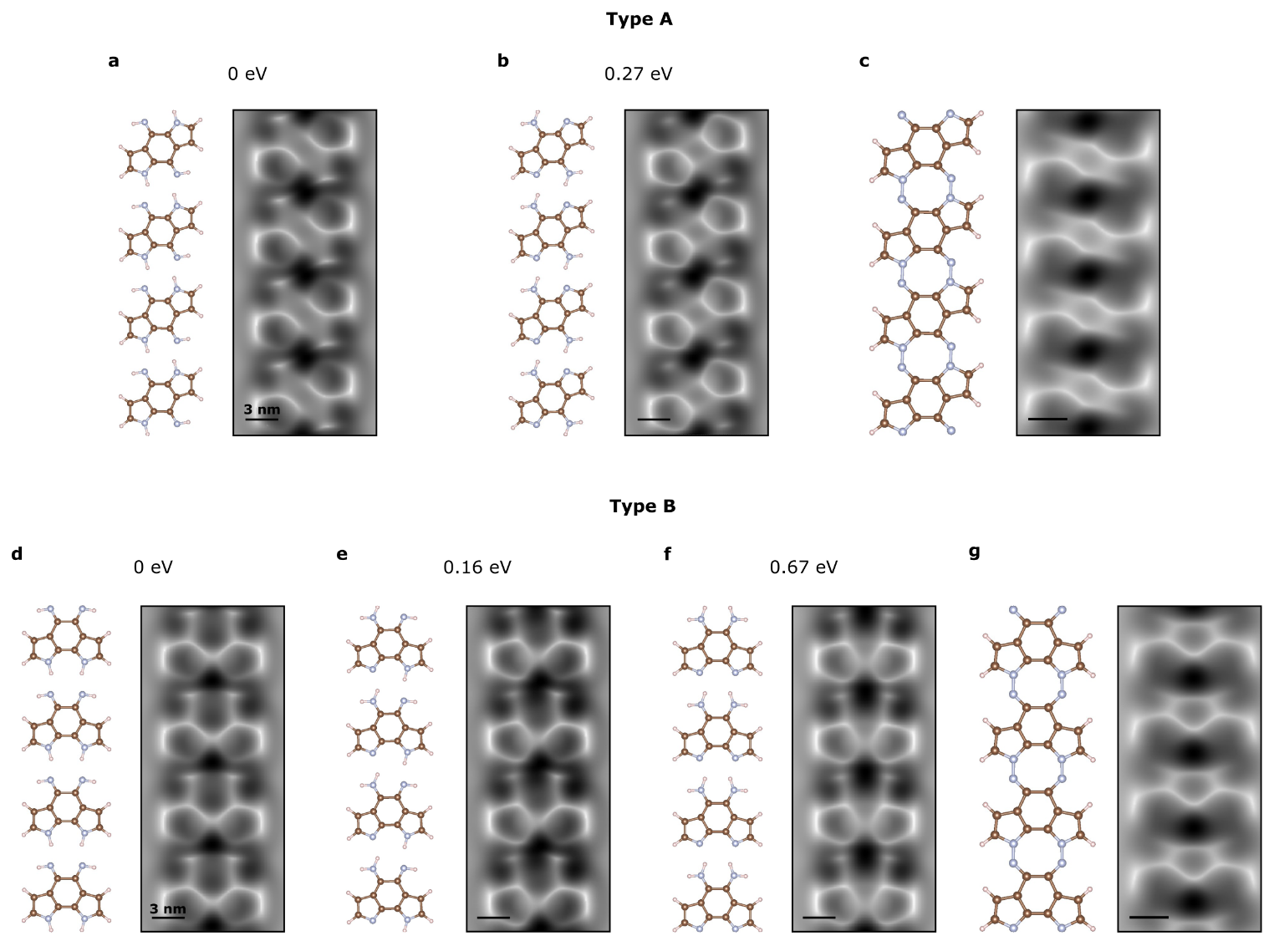
Figure S2. Energy of gas-phase and simulated nc-AFM images of chains for different H configurations. Type A models for a) 1H, b) 2H and c) 0H in the centered N configurations ordered by their differences in energy. Type B models for d) 1H, e) 2H/1H and f) 2H in the centered N conformations showing the energies between them.

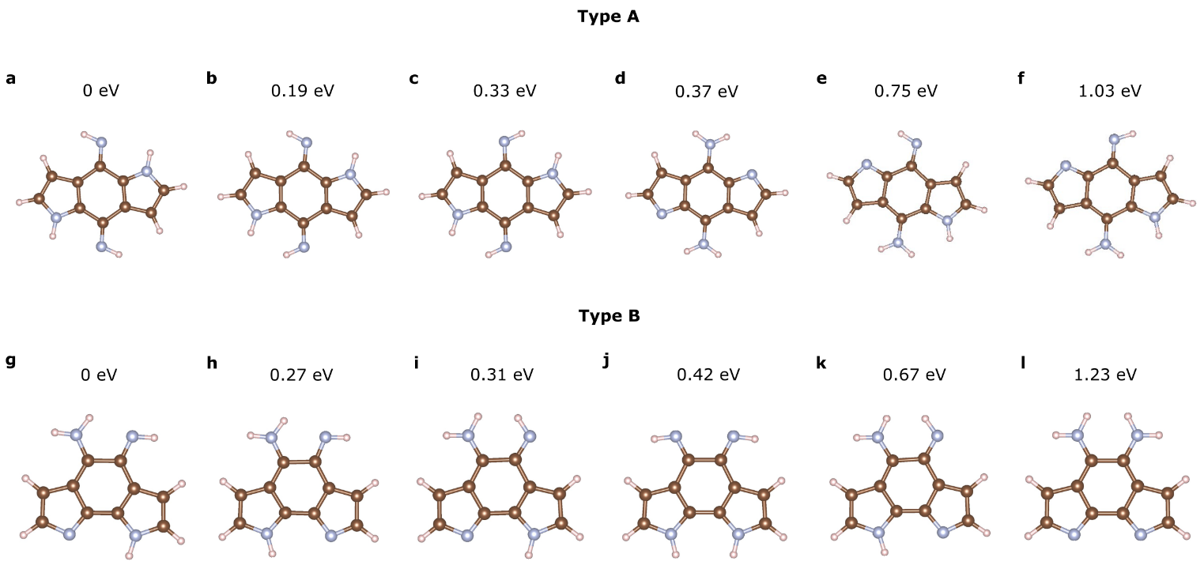
Figure S3. Gas-phase energies products for different H configurations. Type A molecular conformations with a) 1H left/right, b) 1H left/left, c) 1H right/left, d) 2H, e) 1H/2H left and f) 1H/2H right in the centred nitrogen atom ordered by their differences in energy. Type B g) 2H/1H/1H right/right, h) 2H/1H/1H right/left, i) 2H/1H/1H left/right, j) 1H/1H/2H, k) 2H/1H/1H left/left, l) 2H/2H conformations with the DFT energies configurations.

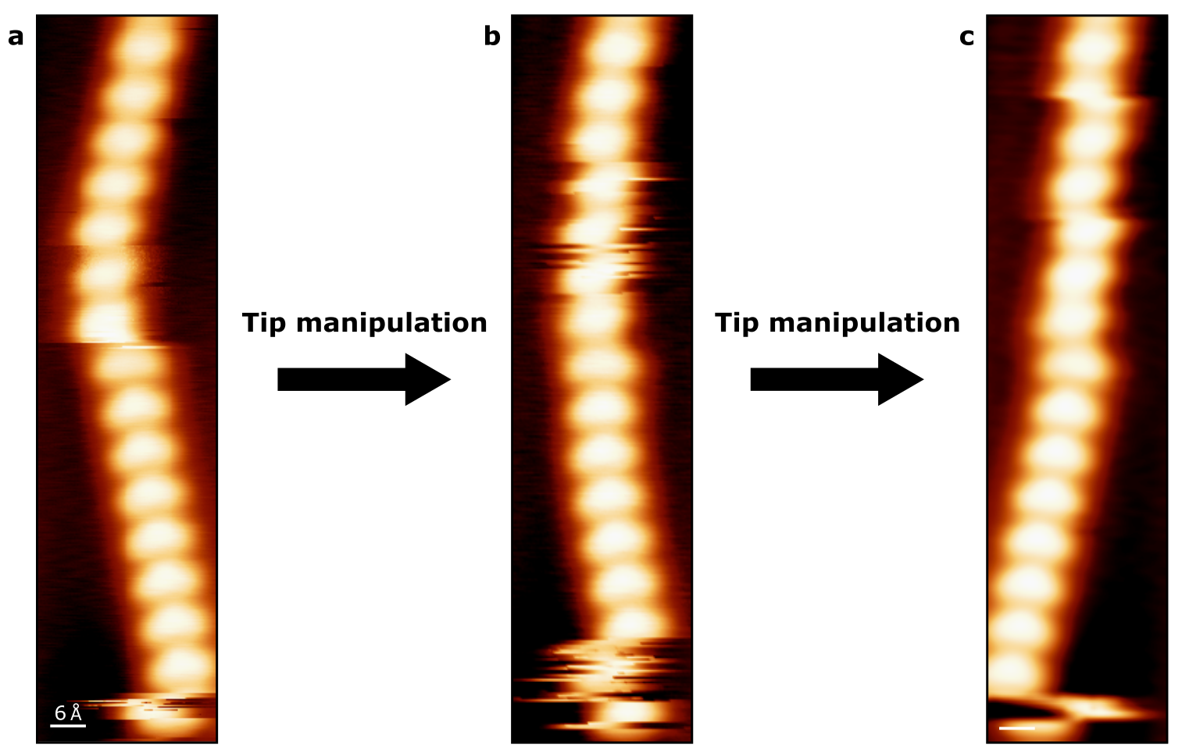
Figure S4. STM-Tip manipulation of the chains. The movable molecular chain makes hard to perform the dI/dV maps. a) STM topographic close-up image of a chain before the manipulation (1 V, 5 pA), b) STM image of the state of the chain after tip-manipulation (1 V, 10 pA, V_{rms} = 3 mV), c) STM topographic image of the chain after tip-manipulation (1 V, 5 pA, V_{rms} = 3mV).

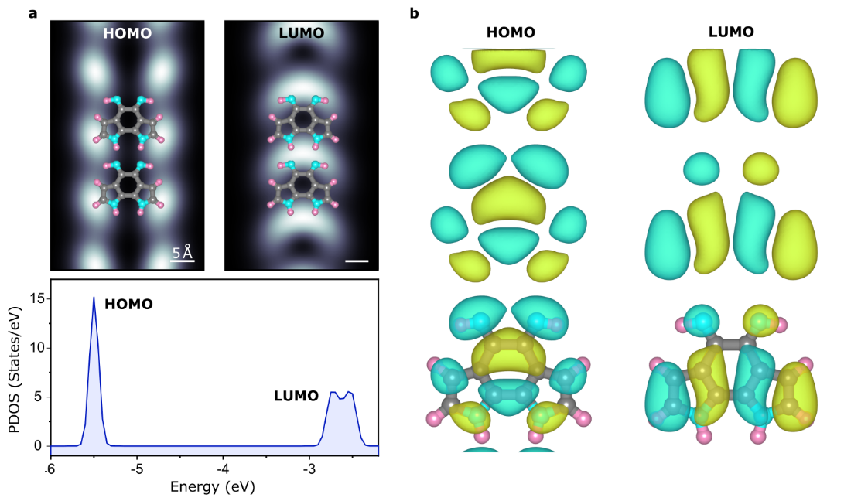
Figure S5. Electronic characterization of final product 5. a) Calculated PDOS of the HOMO (left) and LUMO (right) with the DFT calculated LDOS for 5 structure. c) Canonical DFT orbitals of HOMO and LUMO of 5.

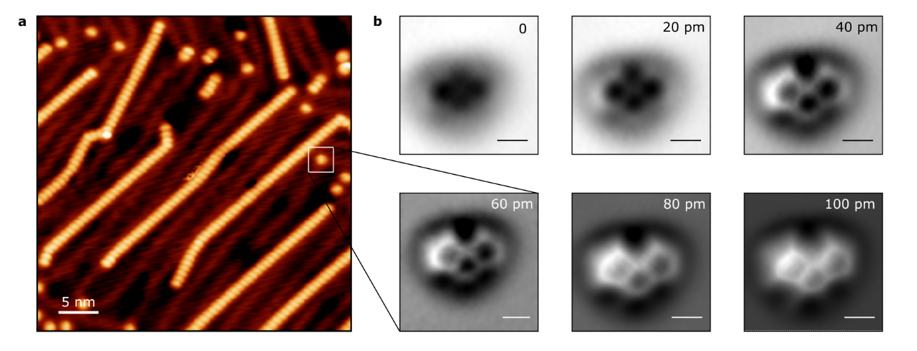
Figure S6. De-hydrogenated final product 5. b) STM topography overview of products 4 and 5, including de-hydrogenated 5. b) Close nc-AFM images performed by 20 pm tip steps.

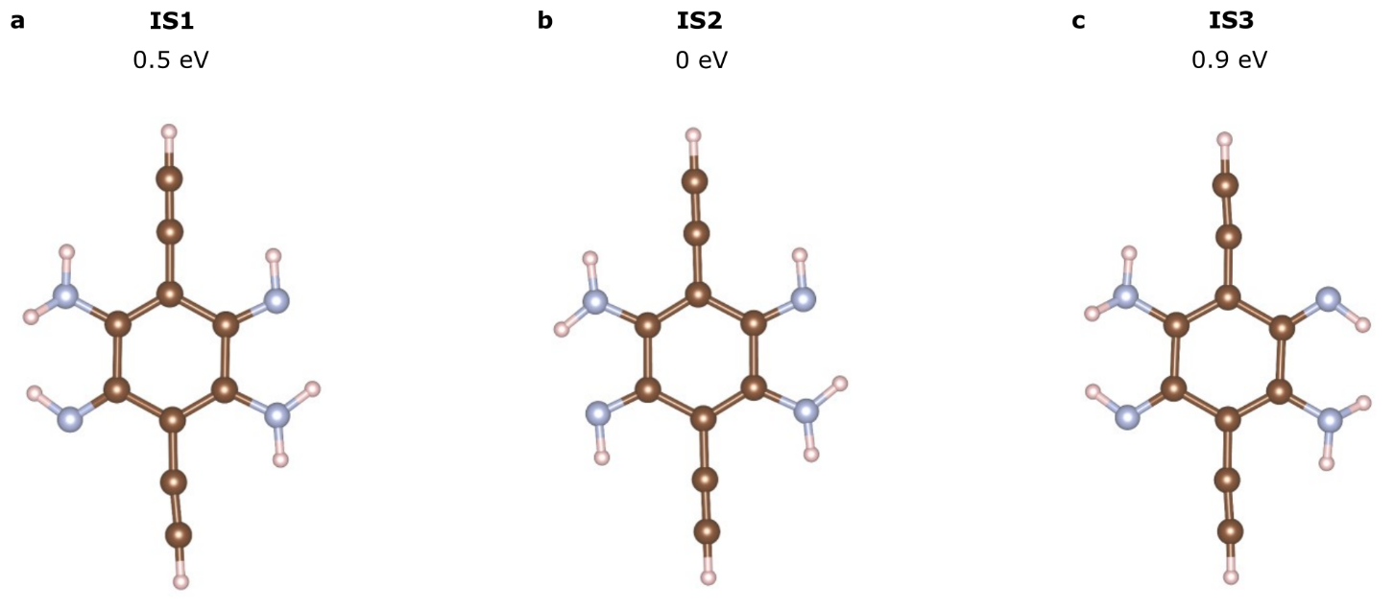
Figure S7. Gas-phase models of molecular precursor 3. a) IS1 up/up H, b) IS2 down/up H and c) IS3 up/down H configurations models view displaying the differences in energy between them.

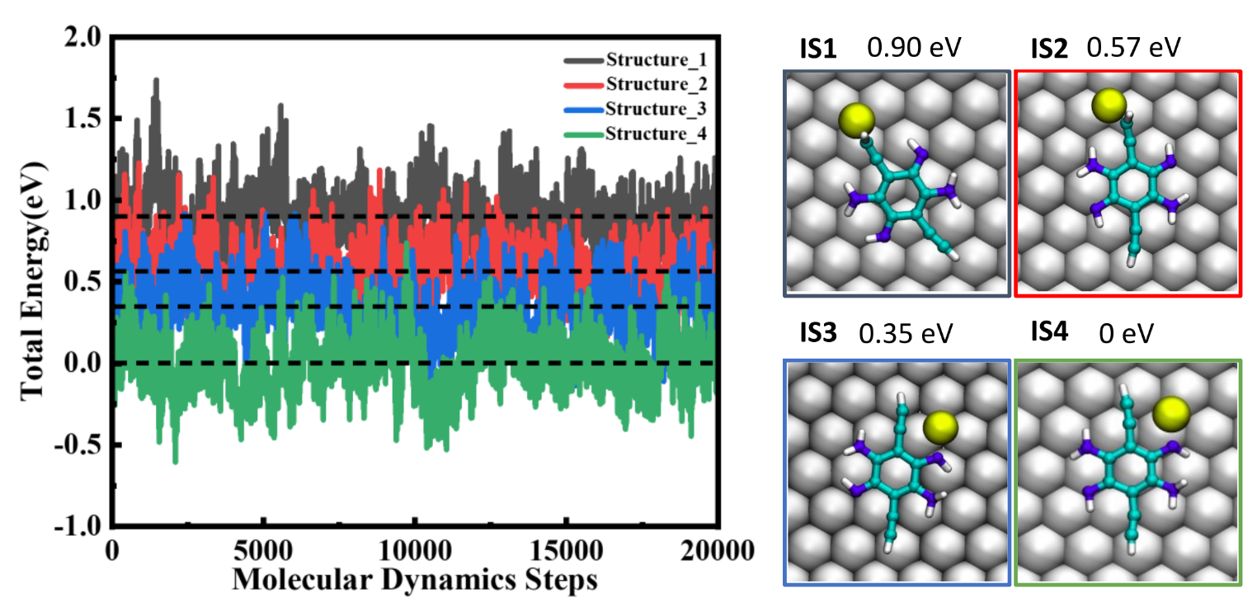
Figure S8. Energy calculation of the initial state precursor on the surface. Molecular dynamic calculations for different molecular precursor configurations with a top-view snapshot image and their respective energies.

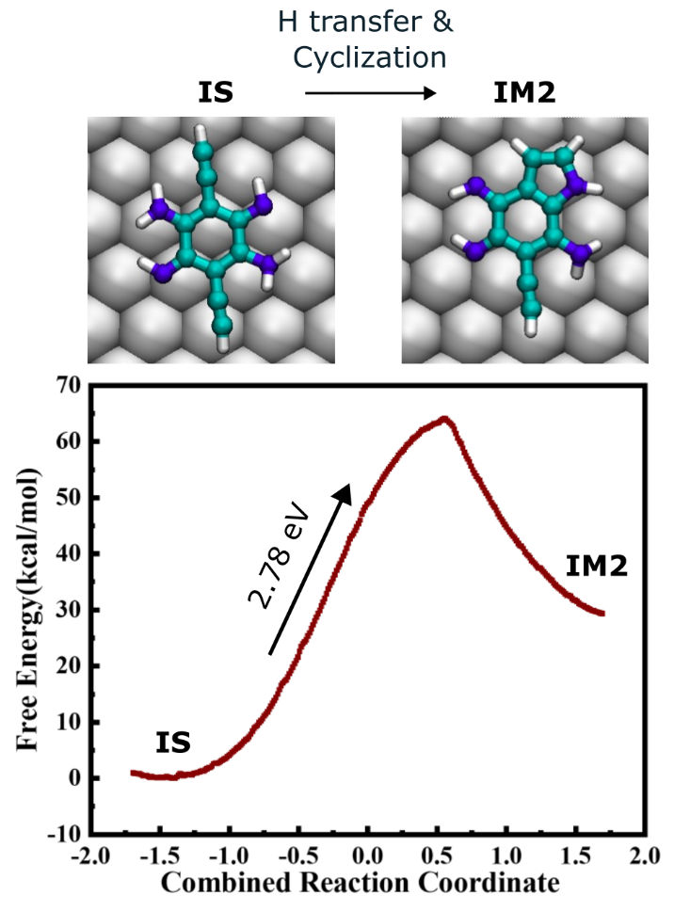
Figure S9. First ring closure reaction without Au adatom. Free energy profile and simulated images of the reaction showing the high energy necessary for hydrogen transfer and cyclization processes without the Au adatom.

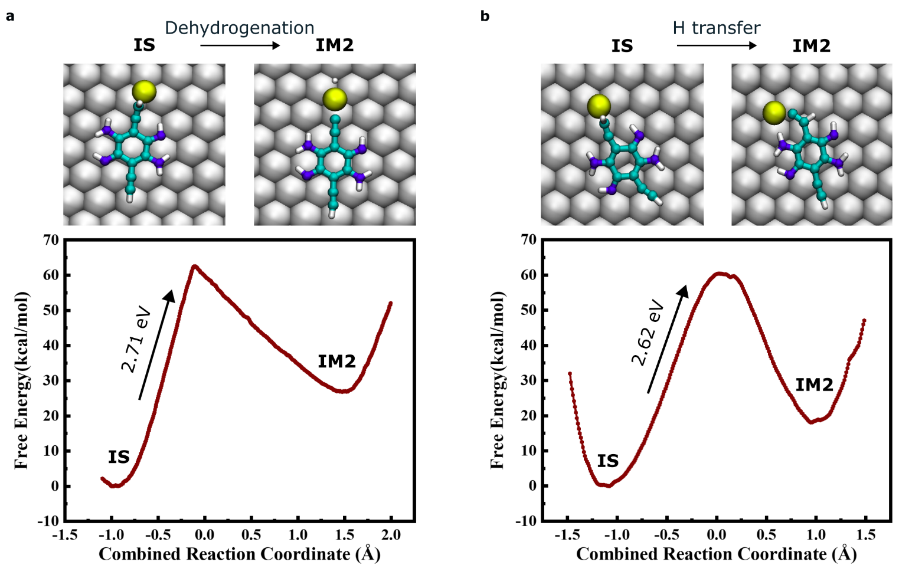
Figure S10. Competing processes of surface-catalysed hydrogen modification for initial state. a) Activation energy profile of dehydrogenation reaction from initial state (IS) to intermediate state 2 (IM2). b) Free-energy profile of hydrogen transfer from molecular precursor (IS) to intermediate state 2 (IM2).

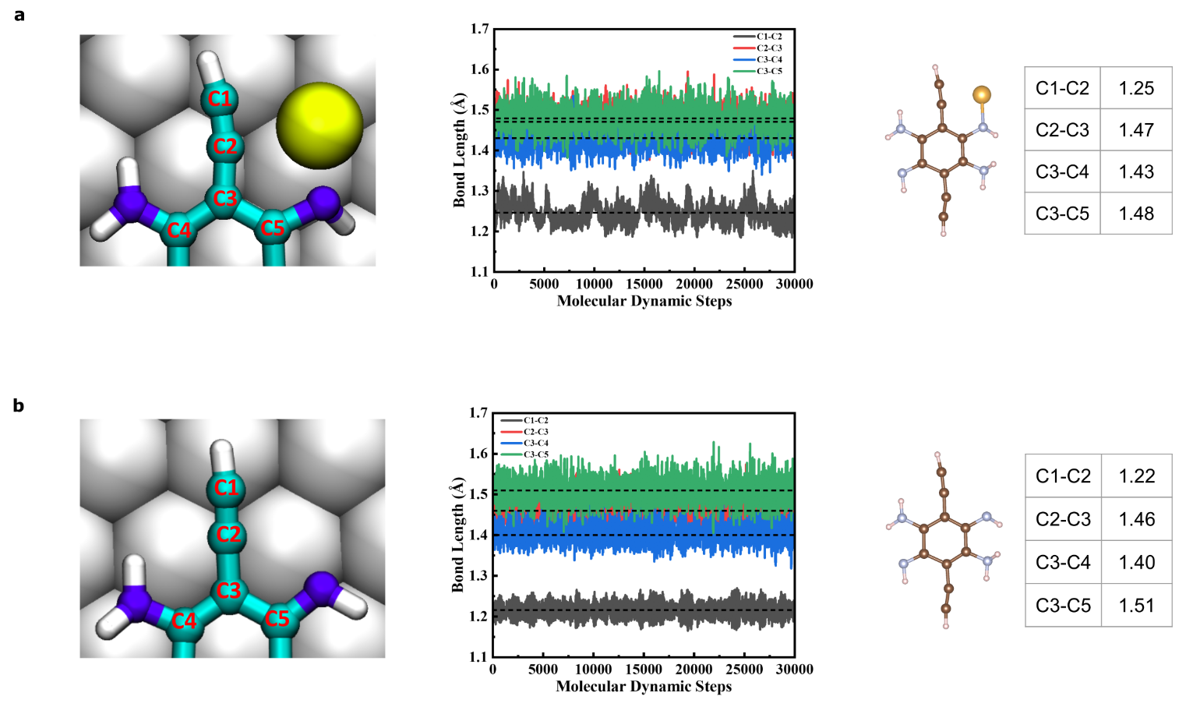
Figure S11. Effect of gold(0) in the bond length of alkyne. Molecular dynamic calculations of the C-C bond length in the alkyne environment by taking into account the a) gold(0) b) no gold adatom effect.

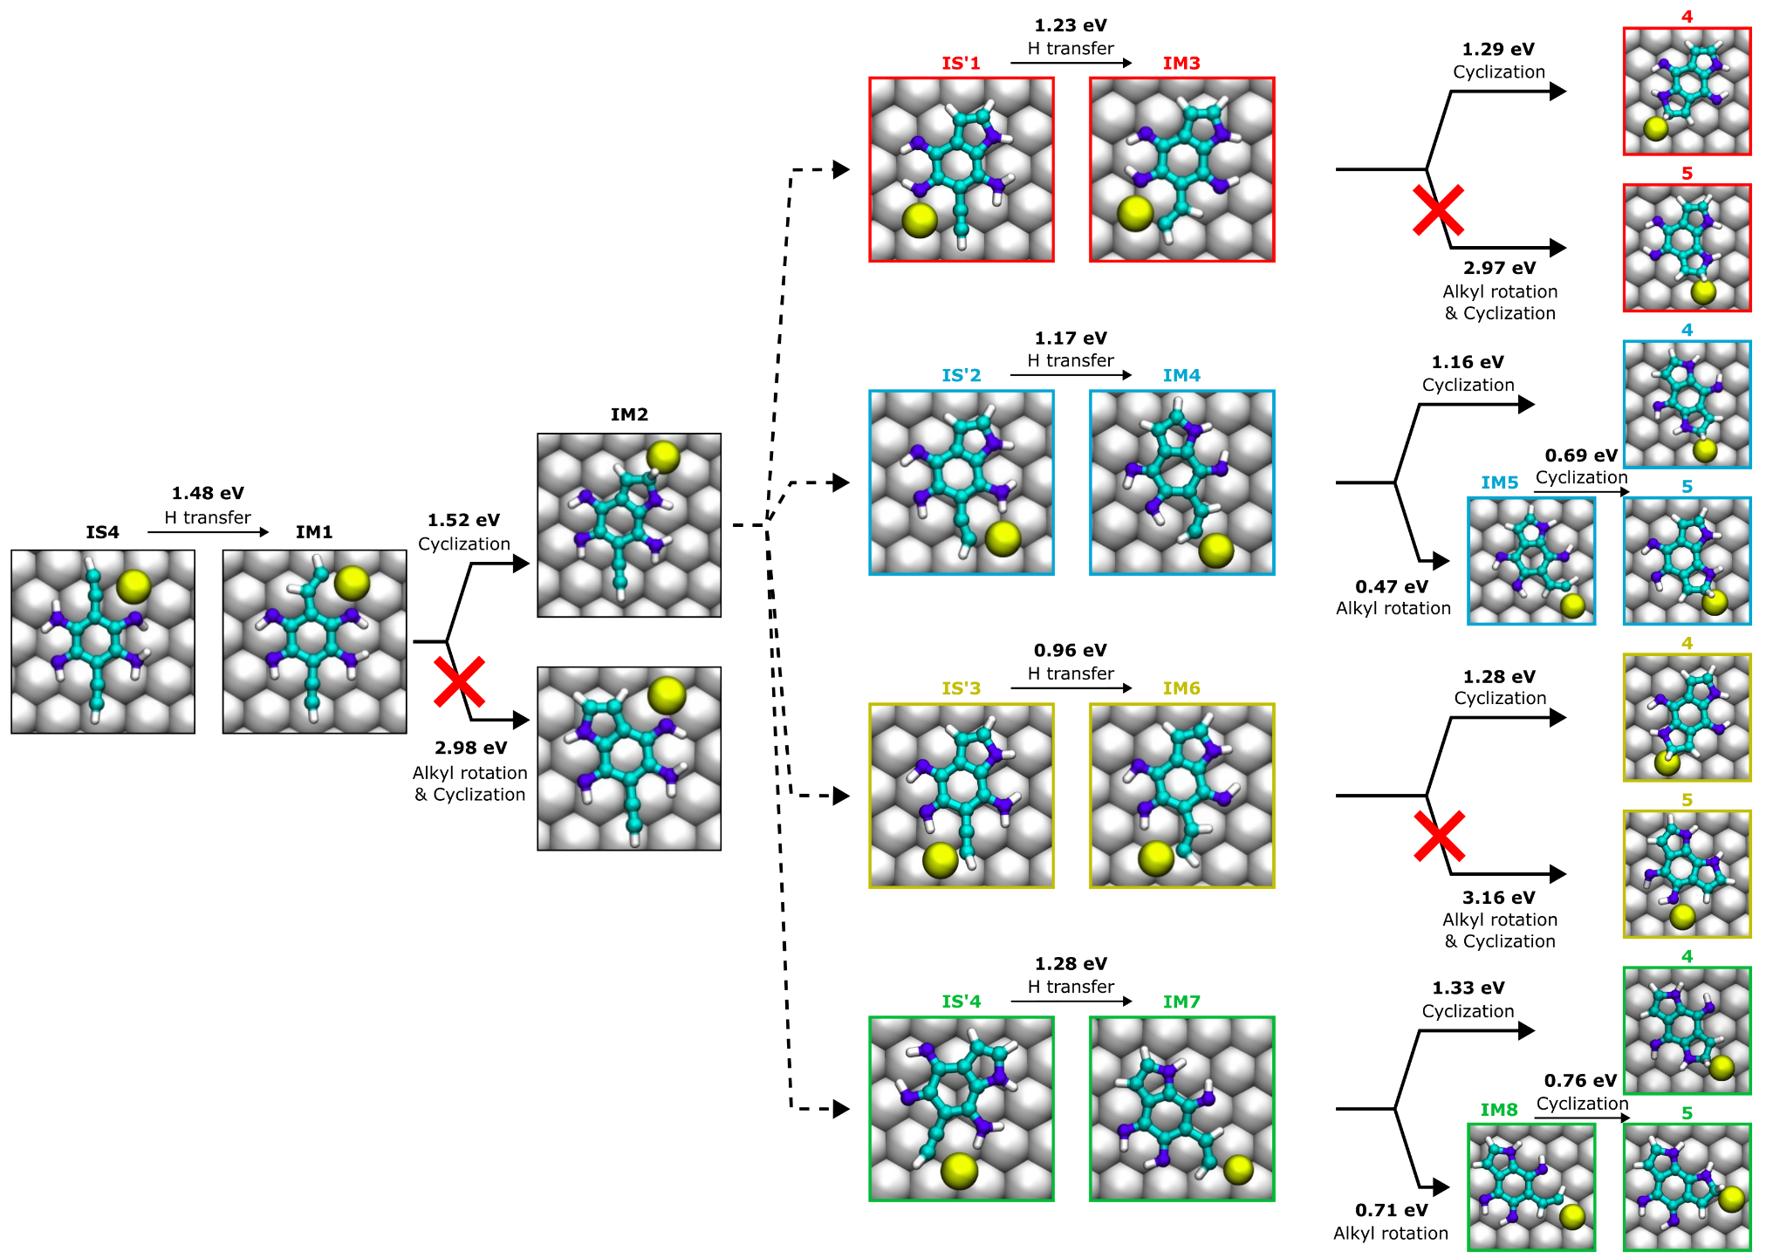
Figure S12. General scheme of the reaction pathways.
NMR Spectra

Figure S13. ¹H NMR (400 MHz, CDCl₃) of compound 1.

Figure S14. ¹H NMR (400 MHz, DMSO-d6) of compound 3.
Figure S15. ¹H NMR (400 MHz, CDCl₃) of compound 2.
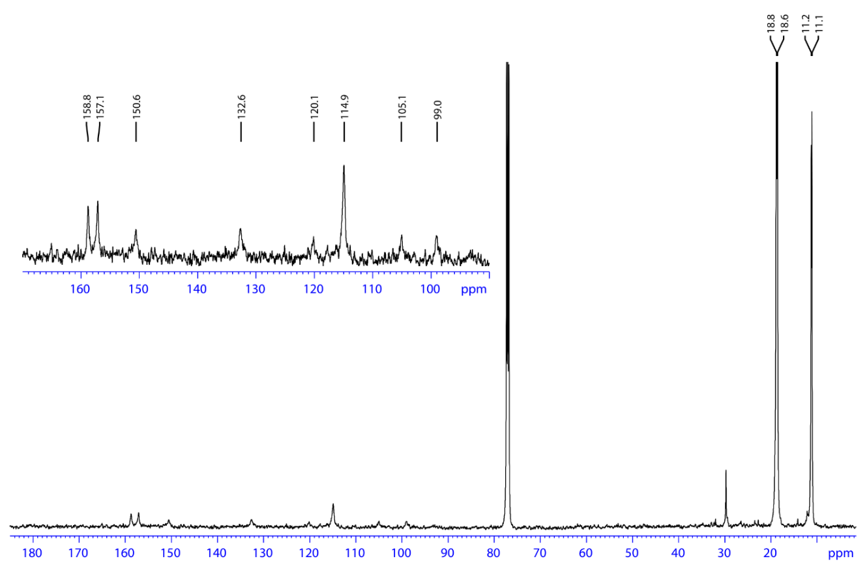
Figure S16. ¹³C NMR (500 MHz, CDCl₃) of compound 2.
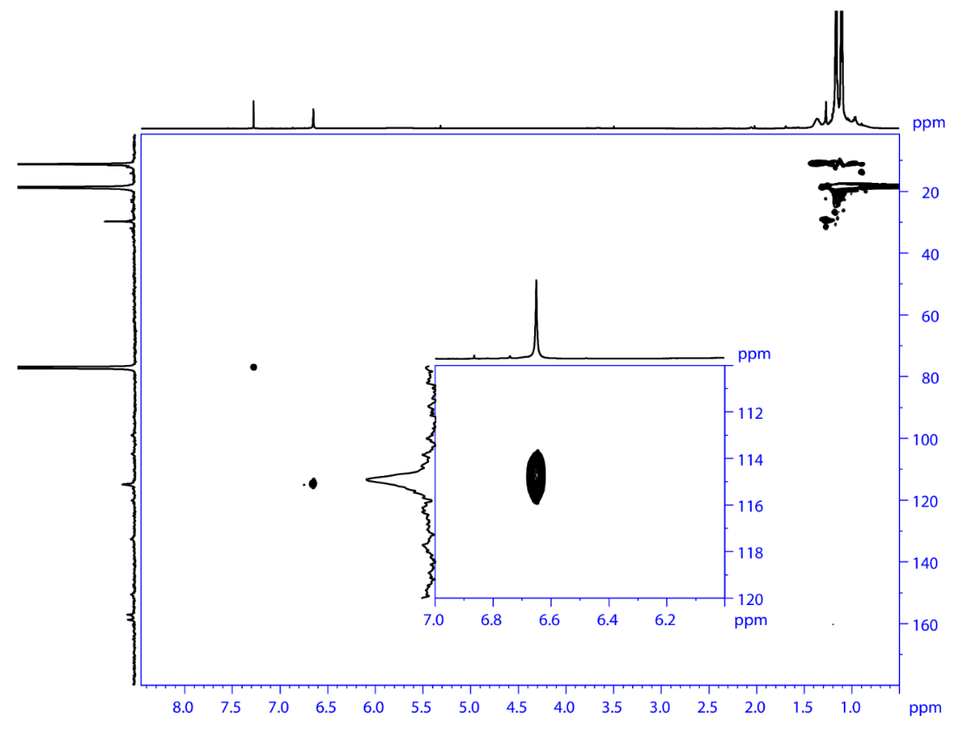
Figure S17. ¹H‐¹³C HSQC NMR (500 MHz, CDCl₃) of compound 2.
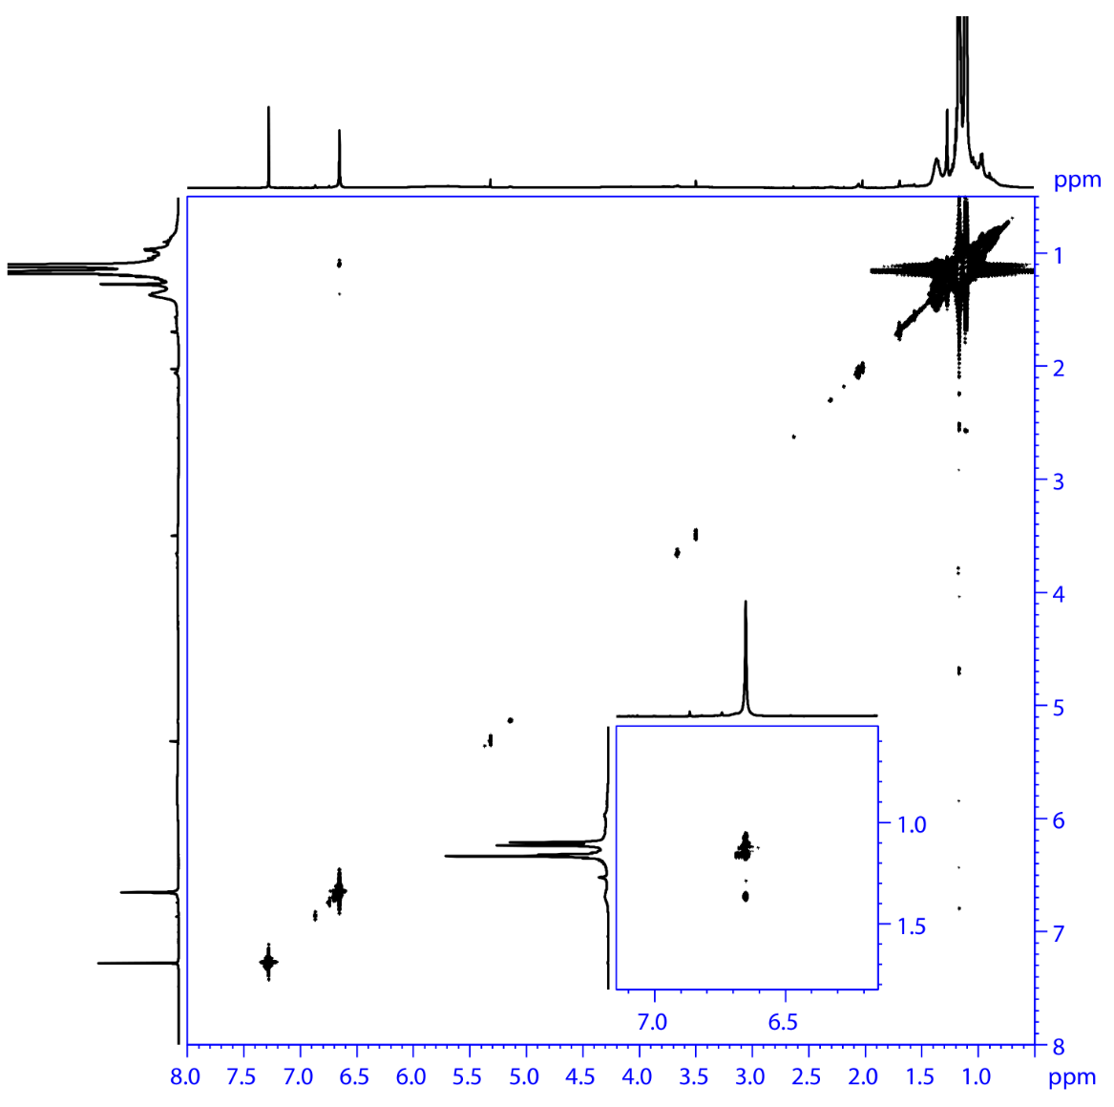
Figure S18. ¹H‐¹H NOESY NMR (500 MHz, CDCl₃) of compound 2.
HRMS spectra
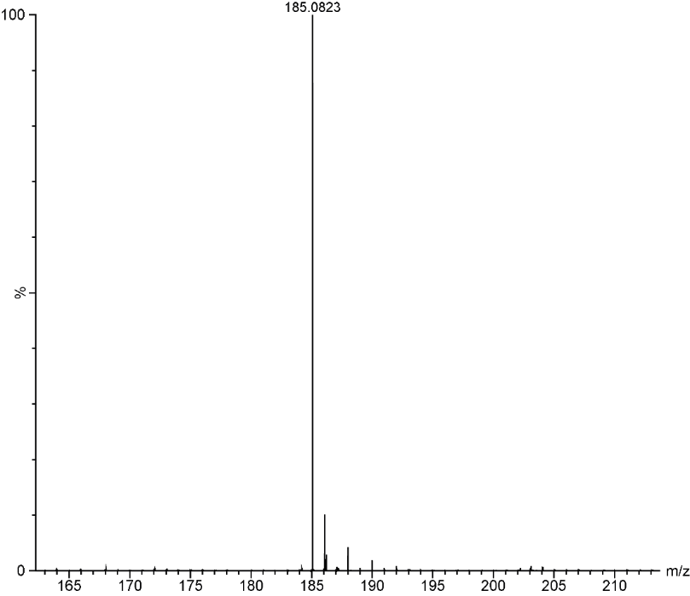
Figure S19. HRMS spectrum of compound 3.
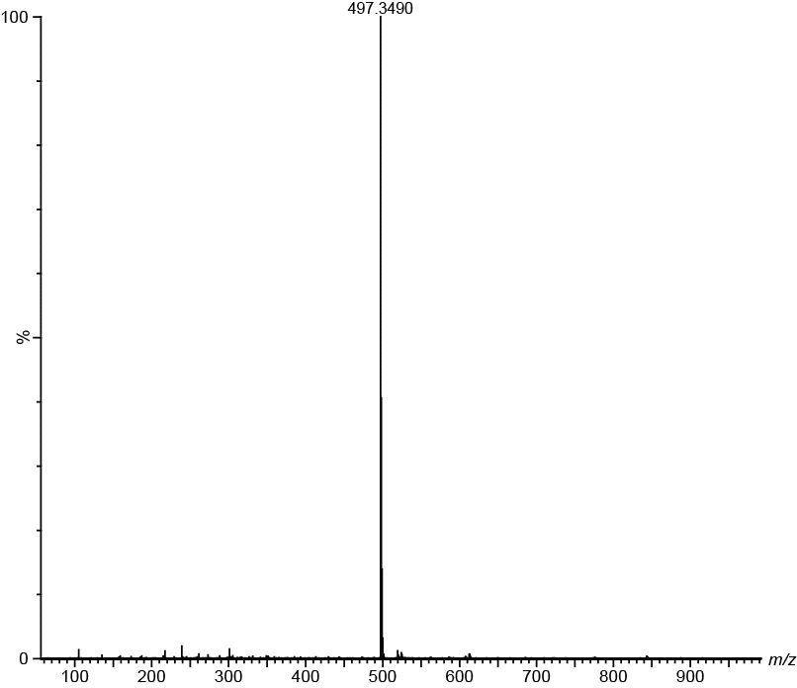
Figure S20. HRMS spectrum of compound 2.

References
1. Giessibl, F. J. The qPlus Sensor, a Powerful Core for the Atomic Force Microscope. Review of Scientific Instruments 90, 011101 (2019).
2. Horcas, I., Fernández, R., Gómez-Rodríguez, J. M., Colchero, J., Gómez-Herrero, J. & Baro, A. M. WSXM: A Software for Scanning Probe Microscopy and a Tool for Nanotechnology. Review of Scientific Instruments 78, 013705 (2007).
3. Mendieta-Moreno, J. I., Walker, R. C., Lewis, J. P., Gómez-Puertas, P., Mendieta, J. & Ortega, J. Fireball/Amber: An Efficient Local-Orbital DFT QM/MM Method for Biomolecular Systems. J. Chem. Theory Comput. 10, 2185–2193 (2014).
4. Lewis, J. P., Jelínek, P., Ortega, J., Demkov, A. A., Trabada, D. G., Haycock, B., Wang, H., Adams, G., Tomfohr, J. K., Abad, E., Wang, H. & Drabold, D. A. Advances and Applications in the FIREBALL Ab Initio Tight-Binding Molecular-Dynamics Formalism. physica status solidi (b) 248, 1989–2007 (2011).
5. Pearlman, D. A., Case, D. A., Caldwell, J. W., Ross, W. S., Cheatham, T. E., DeBolt, S., Ferguson, D., Seibel, G. & Kollman, P. AMBER, a Package of Computer Programs for Applying Molecular Mechanics, Normal Mode Analysis, Molecular Dynamics and Free Energy Calculations to Simulate the Structural and Energetic Properties of Molecules. Computer Physics Communications 91, 1–41 (1995).
6. Case, D. A., Cheatham III, T. E., Darden, T., Gohlke, H., Luo, R., Merz Jr., K. M., Onufriev, A., Simmerling, C., Wang, B. & Woods, R. J. The Amber Biomolecular Simulation Programs. Journal of Computational Chemistry 26, 1668–1688 (2005).
7. Darve, E. & Pohorille, A. Calculating Free Energies Using Average Force. The Journal of Chemical Physics 115, 9169–9183 (2001).
8. Izrailev, S., Stepaniants, S., Isralewitz, B., Kosztin, D., Lu, H., Molnar, F., Wriggers, W. & Schulten, K. Steered Molecular Dynamics. In Computational Molecular Dynamics: Challenges, Methods, Ideas; Deuflhard, P., Hermans, J., Leimkuhler, B., Mark, A. E., Reich, S., Skeel, R. D., Eds.; Lecture Notes in Computational Science and Engineering; Springer: Berlin, Heidelberg, pp 39–65 (1999).
9. Pastor, R. W., Brooks, B. R. & Szabo, A. An Analysis of the Accuracy of Langevin and Molecular Dynamics Algorithms. Molecular Physics 65, 1409–1419 (1968).
10. Kumar, S., Rosenberg, J. M., Bouzida, D., Swendsen, R. H. & Kollman, P. A. THE Weighted Histogram Analysis Method for Free-Energy Calculations on Biomolecules. I. The Method. Journal of Computational Chemistry 13, 1011–1021 (1992).
11. Blum, V., Gehrke, R., Hanke, F., Havu, P., Havu, V., Ren, X., Reuter, K. & Scheffler, M. Ab Initio Molecular Simulations with Numeric Atom-Centered Orbitals. Computer Physics Communications 180, 2175–2196 (2009).
12. Becke, A. D. Density‐functional Thermochemistry. I. The Effect of the Exchange‐only Gradient Correction. The Journal of Chemical Physics 96, 2155–2160 (1992).
13. Stephens, P. J., Devlin, F. J., Chabalowski, C. F. & Frisch, M. J. Ab Initio Calculation of Vibrational Absorption and Circular Dichroism Spectra Using Density Functional Force Fields. J. Phys. Chem. 98, 11623–11627 (1994).
14. Tkatchenko, A. & Scheffler, M. Accurate Molecular Van Der Waals Interactions from Ground-State Electron Density and Free-Atom Reference Data. Phys. Rev. Lett. 102, 073005 (2009).
15. Hapala, P., Temirov, R., Tautz, F. S. & Jelínek, P. Origin of High-Resolution IETS-STM Images of Organic Molecules with Functionalized Tips. Phys. Rev. Lett. 113, 226101 (2014).
16. Hapala, P., Kichin, G., Wagner, C., Tautz, F. S., Temirov, R. & Jelínek, P. Mechanism of High-Resolution STM/AFM Imaging with Functionalized Tips. Phys. Rev. B 90, 085421 (2014).
17. Krejčí, O., Hapala, P., Ondráček, M. & Jelínek, P. Principles and Simulations of High-Resolution STM Imaging with a Flexible Tip Apex. Phys. Rev. B 95, 045407 (2017).
18. Piotto, M., Bourdonneau, M., Elbayed, K., Wieruszeski, J.-M. & Lippens, G. New DEFT Sequences for the Acquisition of One-Dimensional Carbon NMR Spectra of Small Unlabelled Molecules. Magnetic Resonance in Chemistry 44, 943–947 (2006).
19. Braun, S., Kalinowski, H. O. & Berger, S. 100 and more basic NMR experiments: A practical course. Weinheim: VCH (1996).
20. An, C., Zhou, S. & Baumgarten, M. Condensed Derivatives of Thiadiazoloquinoxaline as Strong Acceptors. Crystal Growth & Design 15, 1934–1938 (2015).
21. Wagner, C., Hübner, O., Kaifer, E. & Himmel, H.-J. Probing the Proton-Coupled Electron-Transfer (PCET) Reactivity of a Cross-Conjugated Cruciform Chromophore by Redox-State-Dependent Fluorescence. Chemistry – A European Journal 25, 3781–3785 (2019).
22. Tam, T. L., Li, H., Wei, F., Tan, K. J., Kloc, C., Lam, Y. M., Mhaisalkar, S. G. & Grimsdale, A. C. One-Pot Synthesis of 4,8-Dibromobenzo[1,2-c;4,5-C′]Bis[1,2,5]Thiadiazole. Org. Lett. 12, 3340–3343 (2010).
23. Biegger, P., Schaffroth, M., Brödner, K., Tverskoy, O., Rominger, F. & Bunz, U. H. F. Bisalkynylated 3,6-Diiminocyclohexa-1,4-Diene-1,4-Diamine. Chem. Commun. 51, 14844–14847 (2015).
24. Heckershoff, R., Maier, S., Wurm, T., Biegger, P., Brödner, K., Krämer, P., Hoffmann, M. T., Eberle, L., Stein, J., Rominger, F., Rudolph, M., Freudenberg, J., Dreuw, A., Hashmi, A. S. K. & Bunz, U. H. F. Cyclopentannulated Dihydrotetraazapentacenes. Chemistry – A European Journal 28, e202104203 (2022).

