Supplement
Variables | COPD  N=11 | ILD  N=10 | PAH  N=10 | Smokers  N=10 | Controls  N=11 | p-value
mPAP, mmHg  N=9/5/10/0/0 | 37 (27-45) | 25 (21-37) | 41 (37-50) | - | - | n.s.
PAWP, mmHg  N=9/5/10/0/0 | 10 (7-11) | 5 (4-18) | 8 (6-11) | - | - | n.s.
RAP, mmHg  N=9/5/10/0/0 | 5 (4-12) | 3 (2-6) | 6 (4-9) | - | - | n.s.
PVR, WU  N=9/5/10/0/0 | 4.8 (4.0-9.3) | 2.7 (2.1-6.0) | 7.1 (4.8-10.6) | - | - | n.s.
TPR, WU  N=9/5/10/0/0 | 7.1 (5.9-12.4) | 7.6 (4.2-10.8) | 9 (6-13) | - | - | n.s.
CI, mL/min*m²  N=9/5/10/0/0 | 2.2 (1.9-2.8) | 2.0 (1.9-2.0) | 2.6 (2.1-2.9) | - | - | n.s.
Table S1. Data of right heart catheterization: Abbreviations: mPAP = mean pulmonary artery pressure, PAWP= pulmonary artery wedge pressure, RAP= right atrial pressure, PVR= pulmonary vascular resistance, TPR= total pulmonary resistance, CI= cardiac index. Continuous variables are expressed as median and interquartile range.

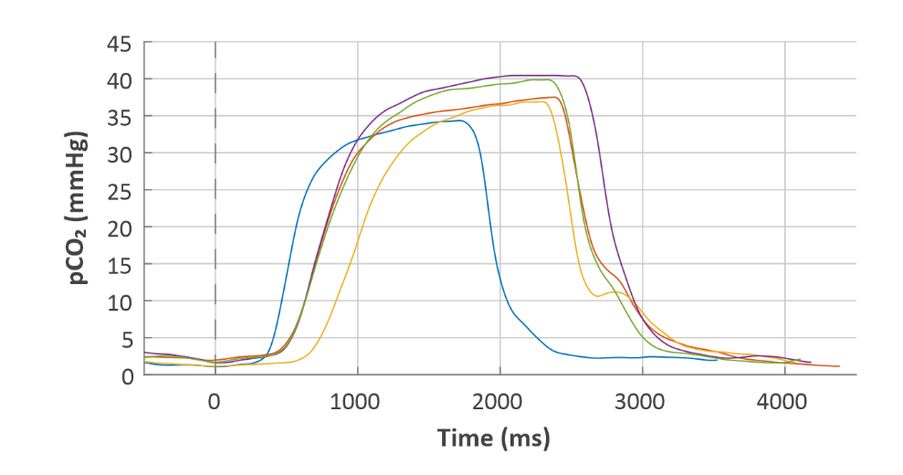
Figure S1. Five consecutive expiratory CO₂ partial pressure (pCO₂) tracings over time, triggered to the start of expiration in a healthy smoker. Note the huge variability of the individual tracings.

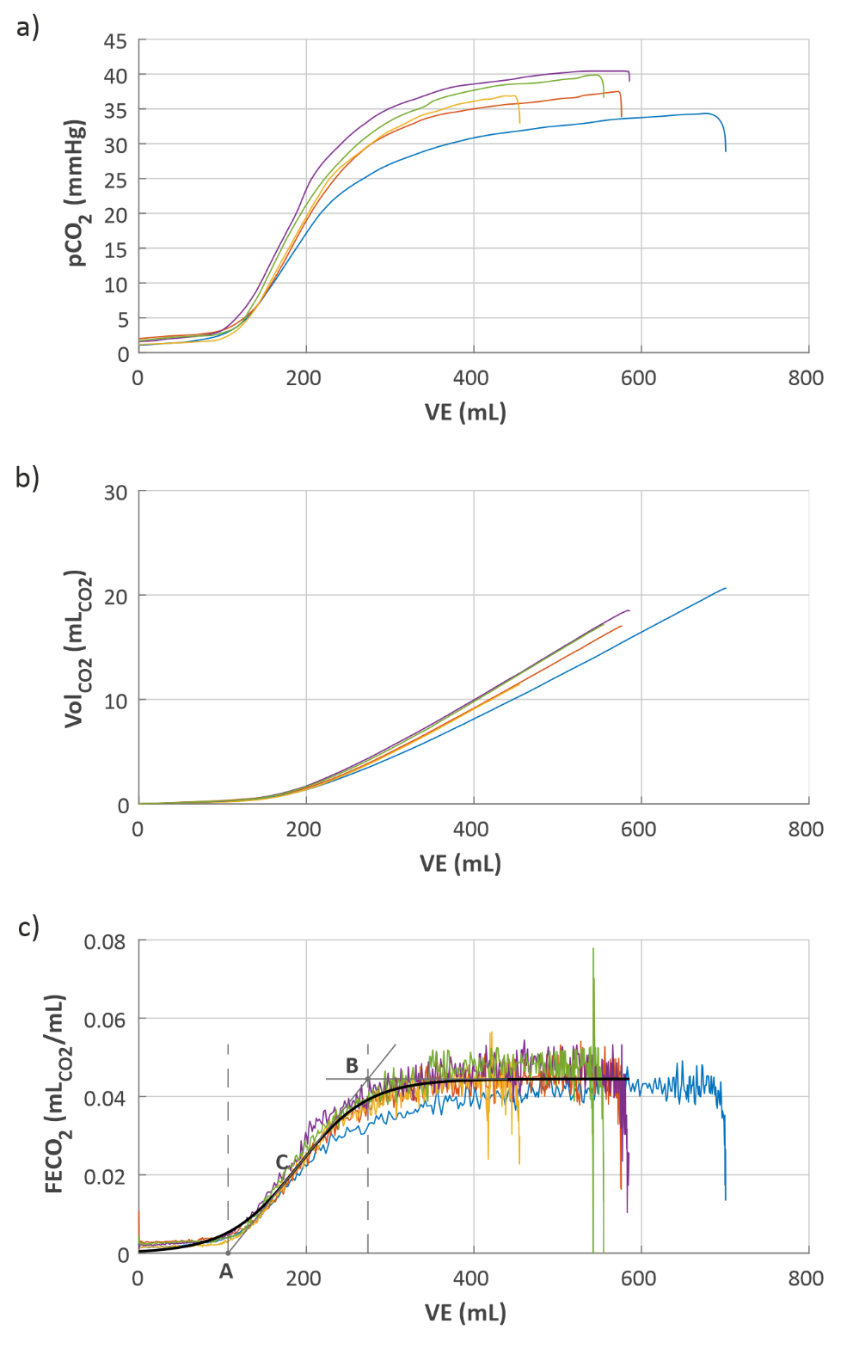
Figure S2. Fitting process of the CO₂ tracings. Same five breaths as in Fig S1, now plotting the CO₂ partial pressure (pCO₂; a), the exhaled volume of CO₂ (Vol_{CO2}; b) and the fraction of exhaled CO₂ volume (FECO₂; c) over the exhaled volume. Due to hyperventilation, the last breaths (red and blue) carried less CO₂ per exhaled volume than the first breaths.
$$\frac{1}{EqCO2}$$

