Supplementary figures

Network pharmacology and in silico-based study for the identification of promissory polyphenols for the treatment of sickle cell anemia
Lila Rosa Maturana Pérez¹., Johana Márquez Lázaro²., Neyder Contreras Puentes²., Antístio Álvis Amador³., Albeiro Marrugo Padilla^{4*}.

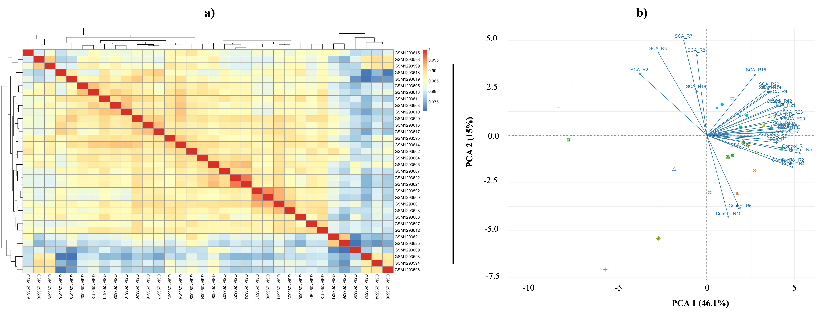

Fig. S1 Intra-group repeatability analysis (a) and principal component analysis of GSE53441 data set samples (b). Each point on the scatterplot represents a sample, with PC1 and PC2 serving as the X and Y axes, respectively. The larger the distance between the two samples in this PCA diagram, the greater the difference in gene expression patterns between the two samples.

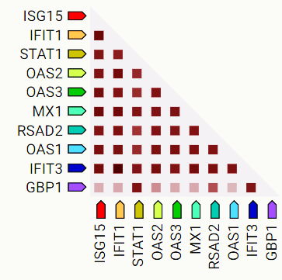

Fig. S2 I Co-expression of central hub genes in humans. Scores were based on RNA expression patterns and protein coregulation provided by the ProteomeHD database (https://www.proteomehd.net/proteomehd).

