Supplementary Materials for

Nacre-like surface nanolaminates induces superior fatigue resistance in gradient pure titanium

Yong Zhang^{1,4}, Chenyun He^{1,4}, Qin Yu^{2,4}, Xiao Li¹, Xiaogang Wang³, Ji Wang¹, Chao Jiang³, Yunfei Jia¹, Xian-Cheng Zhang¹*, Binhan Sun¹*, Robert O. Ritchie²*, Shan-Tung Tu¹
¹Key Laboratory of Pressure Systems and Safety, Ministry of Education, School of Mechanical and Power Engineering, East China University of Science and Technology, Shanghai 200237, PR China;
²Department of Materials Science and Engineering, University of California, Berkeley, CA 94720, USA;
³State Key Laboratory of Advanced Design and Manufacturing for Vehicle Body, College of Mechanical and Vehicle Engineering, Hunan University, 410082, Changsha, China.
⁴These authors contributed equally: Yong Zhang, Chenyun He, Qin Yu.
*E-mail: xczhang@ecust.edu.cn; binhan.sun@ecust.edu.cn; roritchie@lbl.gov

The PDF file includes:

Materials and Methods
Supplementary Note 1 and 2
Figs. S1 to S16
References

Materials and Methods
Sample preparation
The material investigated in this study is commercial pure titanium (TA2), which is composed of a single α phase with equiaxed grains (average size ~35 μm). The raw materials in the form of sheet were machined into dog-bone shaped cylindrical rods (gauge diameter 4 mm). The ultrasonic surface rolling process (USRP) was applied at ambient temperature on the whole gauge section. During USRP, a static extrusion force with ultrasonic vibration was imposed to the sample surface. The detailed parameters of the USRP process are: static force 800 N, rotational speed 750 r/min, vibration amplitude 10 μm, axial feeding rate 10 mm/min, frequency of ultrasonic mechanical vibration 20 kHz, and processing times 4.
The ultrahigh shear strain (up to ~23.5) and shear strain rate (up to 3×10³ s⁻¹) imposed by the USPR treatment promotes the generation of dislocations (particularly geometrically necessary dislocations (GNDs) that need to accommodate the high strain gradient of up to ~5.7×10⁵ m⁻¹) and suppresses their annihilation by recovery^{1,2}. The simultaneous intervention of high-frequency ultrasonic impact (intensity of 2.1 × 10³ W/cm²) introduces an oscillatory stress and acoustic softening effect, which also increases the dislocation multiplication rate and mobility while inhibiting the formation of severe deformation-induced damage³. The high dislocation generation speed and the suppressed dynamic recovery essentially induce the formation of recrystallized grains⁴ which further become elongated as a response to the high shear deformation, generating nano-scaled laminated grains in the surface layer.
Mechanical testing
The dog-bone sheet samples for tensile and fatigue testing were machined from the USRP treated dog-bone rods (Fig. 1a). The gauge dimensions of the tensile and fatigue specimens were 10 mm × 4 mm × 2 mm and 8 mm × 4 mm × 1 mm, respectively. Tensile tests were conducted using an Instron 8801 servo-hydraulic testing machine (Instron Corporation, Norwood, MA, USA) at a constant crosshead speed corresponding to a nominal strain rate of 5×10⁻⁴ /s. The uniaxial tension-tension fatigue tests were carried out with a frequency of 10 Hz and a stress ratio of 0.1 at ambient temperature. Fatigue crack growth tests were performed on fatigue specimens with a single-edge notch (30 μm in depth) under the conventional ΔK-increasing condition based on ASTM standard E647-15e1⁵. An SEM built-in fatigue testing system (Shimadzu SEM-Servo Pulser) was employed to enable in situ observation of the crack path during the fatigue process. To eliminate the mechanical notch effect, a moderate load (maximum stress 260 MPa) was applied to carefully produce a pre-crack with a length of ~20 μm at the notch tip prior to the start of data acquisition. Fatigue tests were conducted at room temperature using a constant amplitude sinusoidal loading with an applied stress ratio of 0.1 and a loading frequency of 10 Hz. The nominal stress intensity range ΔK was calculated based on the following equations⁶:
where W is the width of the sample and is the applied stress range. The real-time crack length a was recorded based on in situ SEM observation. The crack propagation rate was determined using the 7-point incremental polynomial method documented in ASTM standard E647-15e1⁵. Fatigue testing was terminated when the microcrack propagated to a depth of ~500 μm, which corresponds to the depth of the deformation layer in the gradient structure. For all mechanical testing conducted in this study, at least two samples were tested to ensure the repeatability.
Microstructure characterization
The microstructure of the specimens before and after fatigue testing and the crack trajectory were characterized using secondary electron (SE) imaging, electron channeling contrast imaging (ECCI) and electron backscatter diffraction (EBSD) (using a Zeiss-Merlin and a Zeiss Crossbeam 340 scanning electron microscopy (SEM) instrument). Samples for EBSD and ECCI were finally polished with a 0.05 μm colloidal silica suspension containing 30 vol.% H₂O₂. The acquired EBSD data (grain size, local misorientation and twin interface) were analyzed using the TSL OIM software package.
The microstructure details of the surface nanolaminates and the fatigue cracks within them were examined using a transmission electron microscope (TEM, FEI Talos F200X, operated at 200 kV). The samples for TEM before and after fatigue testing were ground and mechanically polished with SiC papers down to a thickness of 80 μm. Areas near the rolling face of the USRP treated specimen was then carefully thinned by ion milling to characterize each region of the gradient structure. Double beam ion thinning was conducted using a 1051 TEM Mill Fischione machine (Fischione Instruments, Pittsburgh, PA, USA) at 6 kV Ar+ ions with an incidence angle of 8°. The crack-tip regions within the nanolaminates for TEM observation were processed at 30 kV and 2-6 nA with Ga ion sources. Final milling was performed with a 2 kV and 24 pA Ga ion beam.
Nano-indentation tests were performed on a Bruker Hysitron TriboScope, using a Berkovich shaped indenter with a load of 100 mN. Residual stress assessment was carried out using a Proto-I X-ray Diffraction (XRD) MG40P FS STD residual stress tester with Cu-Ka radiation at a wavelength of 1.5406 Å. An electrochemical polishing technique using an etching solution comprised of 10% HClO₄ and 90% CH₃OH was adopted to remove the material layer by layer. The XRD measurement parameters were set to an acceleration voltage of 20 kV and a current of 4 mA. Data analysis was carried out using the sin2φ method⁷, with a Bragg angle of 142° and selection of the {213} diffraction crystal plane of the α-phase.
Atomistic simulations
Molecular Dynamics (MD) simulations were carried out using the Large-scale Atomic/Molecular Massively Parallel Simulator (LAMMPS)⁸ and the embedded atom method (EAM) potentials for Ti⁹. The constructed model consisted of twelve grains, with dimensions of 420 nm in length, 200 nm in height, and 4.425 nm in thickness. The total number of atoms in the simulation was ~21,000,000. Periodic boundary conditions were applied in all three directions. The initial structure was first energy minimized using a conjugate-gradient algorithm, and then relaxed at 300 K using a Nose-Hoover thermostat for 50 ps in the constant temperature constant volume (NVT) ensemble and 100 ps in the constant pressure constant temperature constant pressure (NPT) ensemble to stabilize the microstructure. During the fatigue loading, the model was under the NPT ensemble at 300 K. The stress-controlled cyclic loading was applied in the direction that was parallel to the laminated direction with a constant stress ratio of 0.1. The Ovito software¹⁰ was used to visualize the model and analyze the data.

Supplementary Note 1 – Cyclic loading-induced microstructure change of nanolaminates with different configurations of grain boundaries
To further demonstrate the influence of grain boundary types within the nanolaminates layer on its structural stability, we conducted MD simulations on two additional configurations (Supplementary Fig. 9). One comprises predominantly high-angle grain boundaries (HAGBs) (denoted as Nanolaminates S1), often observed in metallic materials subjected to severe plastic deformation¹¹. The other consists of mainly low-angle grain boundaries (LAGBs) (referred to as Nanolaminates S2), firstly reported by Liu et al. ¹ in pure Ni.
Upon cyclic loading of nanolaminates S1, recrystallization is observed in hard-orientation grains near the triple junctions, as shown in Supplementary Fig. 9b. With increasing cycles, these recrystallized grains tend to coarsen through consuming the surrounding grains ^{12,13}. Such grain coarsening following fatigue-induced grain recrystallization has also been observed in our unpublished work of nanolaminated nickel. The grain recrystallization (and the following grain coarsening) results in microstructural softening, as supported by the modeling results which show an increasing strain amplitude upon cyclic loading (Supplementary Fig. 9e). As shown in Supplementary Fig. 9d, in Nanolaminates S2, there is an observed annihilation of horizontal LAGBs under cyclic loading, due to the emission and gliding of partial dislocations. This process leads to an essential increase in lamellar thickness.

Supplementary Note 2 – Effects of crack deflection in the nanolaminated layer on crack propagation resistance
According to the framework of the linear elastic fracture mechanics, the effective stress intensity factor can be calculated by the combination of mode I and mode II stress intensity factors (k₁ and k₂), following the relationship , where k₁ and k₂ are closely related to the crack deflection angles θ (the first kinked angle) and α (the second kinked angle)¹⁴; their relationships are expressed as follows:
The magnitude of the ratio is plotted in Supplementary Fig. 14 for various combinations of θ and α. The calculation shows that the crack-tip driving force of the presented nanolaminated layer can be effectively reduced by roughly 0.56 times assuming a double crack deflection of 90 degree, resulting in a more than 3 times increase in the energy required to separate the crack surfaces, following the relation G $=\frac{k_{1}^{2}+k_{2}^{2}}{E}$ , where G represents the energy release rate and E is the elastic modulus¹⁵⁻¹⁷.

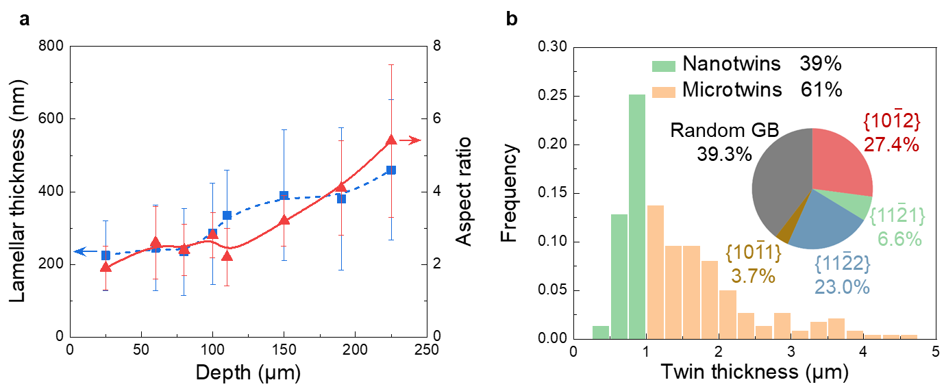

Supplementary Fig. 1. Microstructural features of the surface-nanolaminated gradient Ti. a, Lamellar thickness and aspect ratio as a function of depth in the nanolaminated layer of our gradient Ti. b, Statistical analysis on multi-variant twins in the sub-surface layer of our gradient Ti, showing the distribution of the twin thickness as well as the length fraction for different types of deformation twins. The analysis was based on the EBSD data.

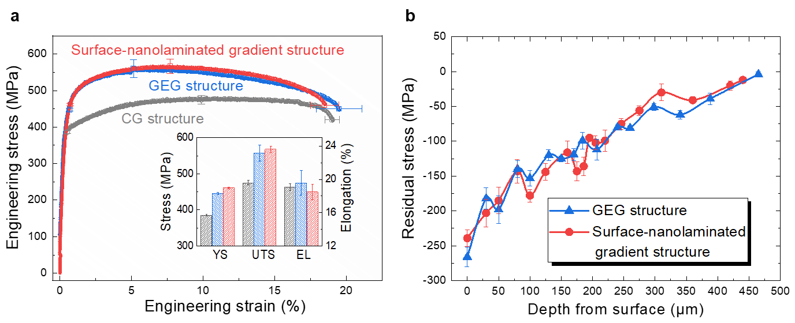

Supplementary Fig. 2. Mechanical properties of pure Ti with homogeneous and gradient structures. a, Tensile properties of surface-nanolaminated gradient structure, in comparison to the homogeneous coarse-grained (CG) and gradient equiaxed-grained (GEG) structures. YS: yield strength, UTS: ultimate tensile strength, EL: total elongation; b, Variation in residual stress as a function of depth from the surface for the two types of gradient structures.

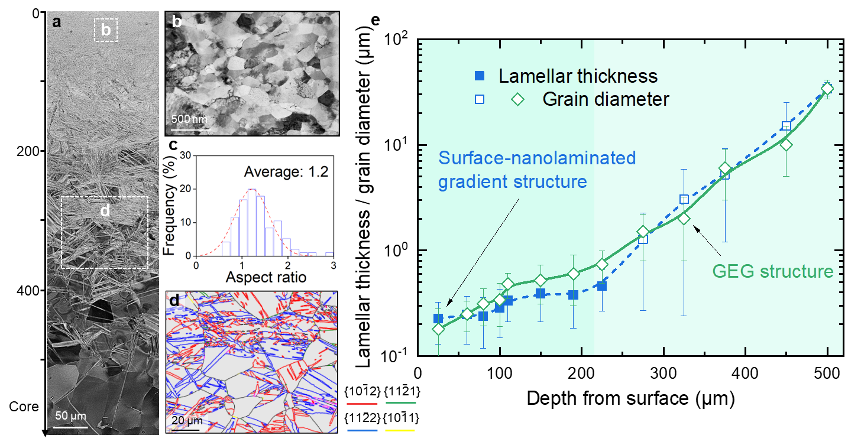

Supplementary Fig. 3. Characterization of the gradient equiaxed-grained (GEG) structure. a, Electron channeling contrast (ECC) image depicting the overall GEG structure up to a depth of ~480 μm. b, Scanning transmission electron microscopy bright-field (STEM-BF) image taken from the depth of 40 μm in a, showing equiaxed ultrafine grains. c, Distribution of the aspect ratio of the equiaxed ultrafine-grained (UFG) layer. d, EBSD interface map probed from the multi-variant twinned region as outlined by the white rectangular frame in a. e, Comparison of the characteristic length scale of grains at different depth between the two types of gradient structures.

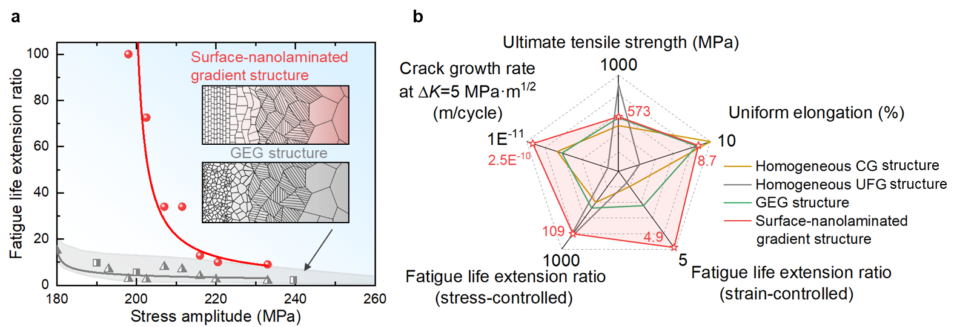

Supplementary Fig. 4. Comparison of the mechanical properties among different types of microstructures. a, Fatigue life extension ratio for the two types of gradient Ti presented in this study. The fatigue life extension ratio is defined as the ratio of the fatigue life of the specific gradient structure to the CG counterpart. b, Radar diagram comparing mechanical properties and fatigue performance among different types of microstructures.
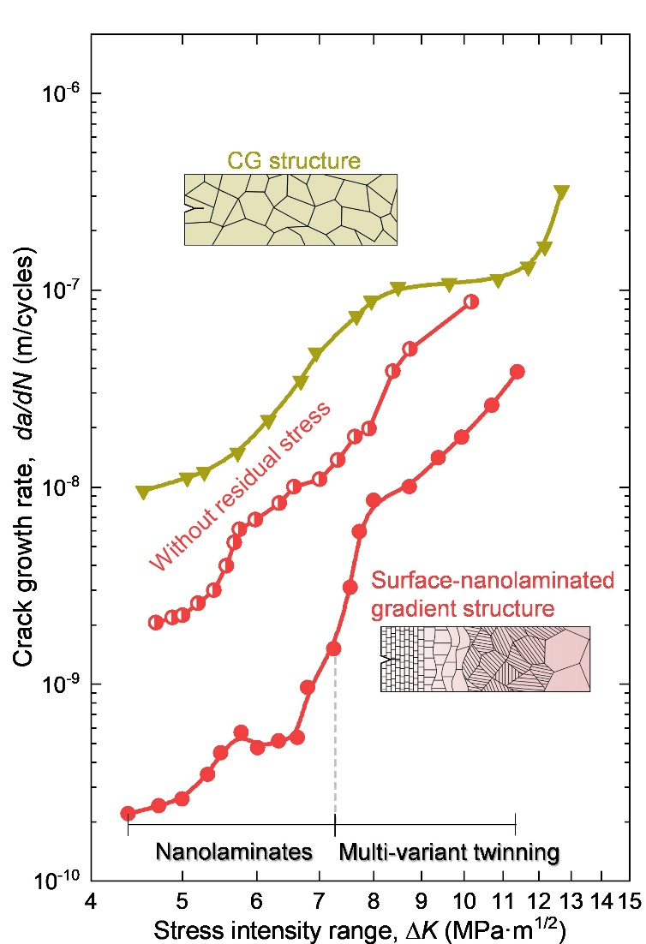

Supplementary Fig. 5. Fatigue crack growth rates da/dN as a function of applied stress intensity range ΔK for our surface-nanolaminated gradient Ti with and without residual stress, in comparison with the homogeneous CG structure. The low-temperature annealing (at 200 ˚C for 100 h) was adopted to relieve the residual stress of the USPR processed gradient Ti without significantly changing other microstructure parameters (such as grain scale and dislocation density).

Supplementary Fig. 6. Correlation between hardness and yield strength in pure Ti¹⁸⁻²⁴, showing a nearly linear relationship between the two properties.

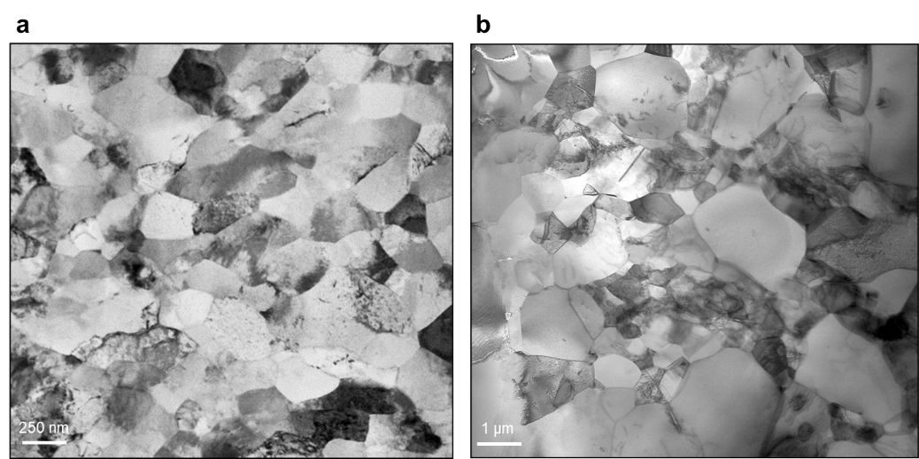

Supplementary Fig. 7. Fatigue induced microstructural coarsening within the equiaxed UFG layer in the GEG sample. a,b, STEM-BF images showing the surface microstructure (taken from the depth of ~40 μm) of the GEG specimen before (a) and after (b) cyclic loading for 1.8×10⁴ cycles at the stress amplitude of 216 MPa. A significant grain coarsening by approximately 5-10 times induced by cyclic loading is observed.

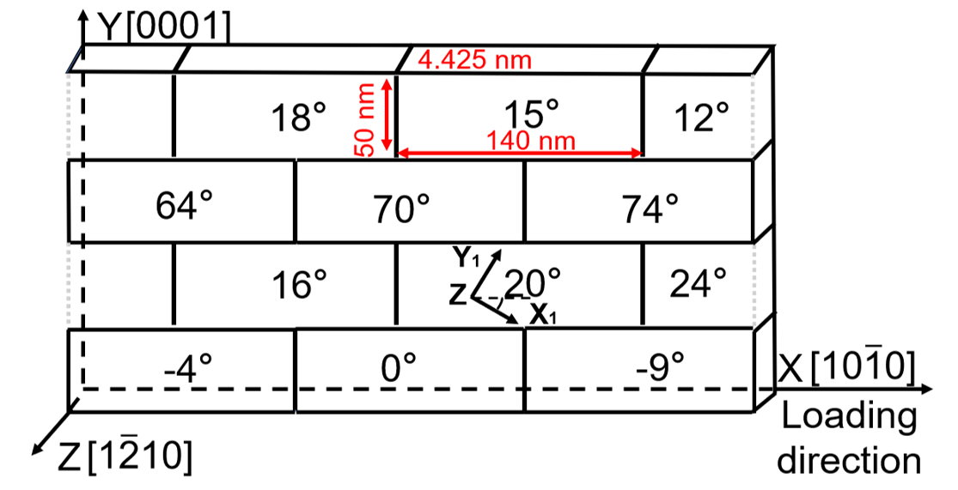

Supplementary Fig. 8. Schematic diagram showing the setup of the MD simulation. Fatigue loading was applied along the X axis. Each grain has the dimensions of $\text{140 ×50 ×4.4 }{\text{nm}}^{\text{3}}$ with an aspect ratio of ~2.8. The low-angle grain boundaries are distributed perpendicular to the loading direction, and the high-angle grain boundaries are distributed parallel to the loading direction.

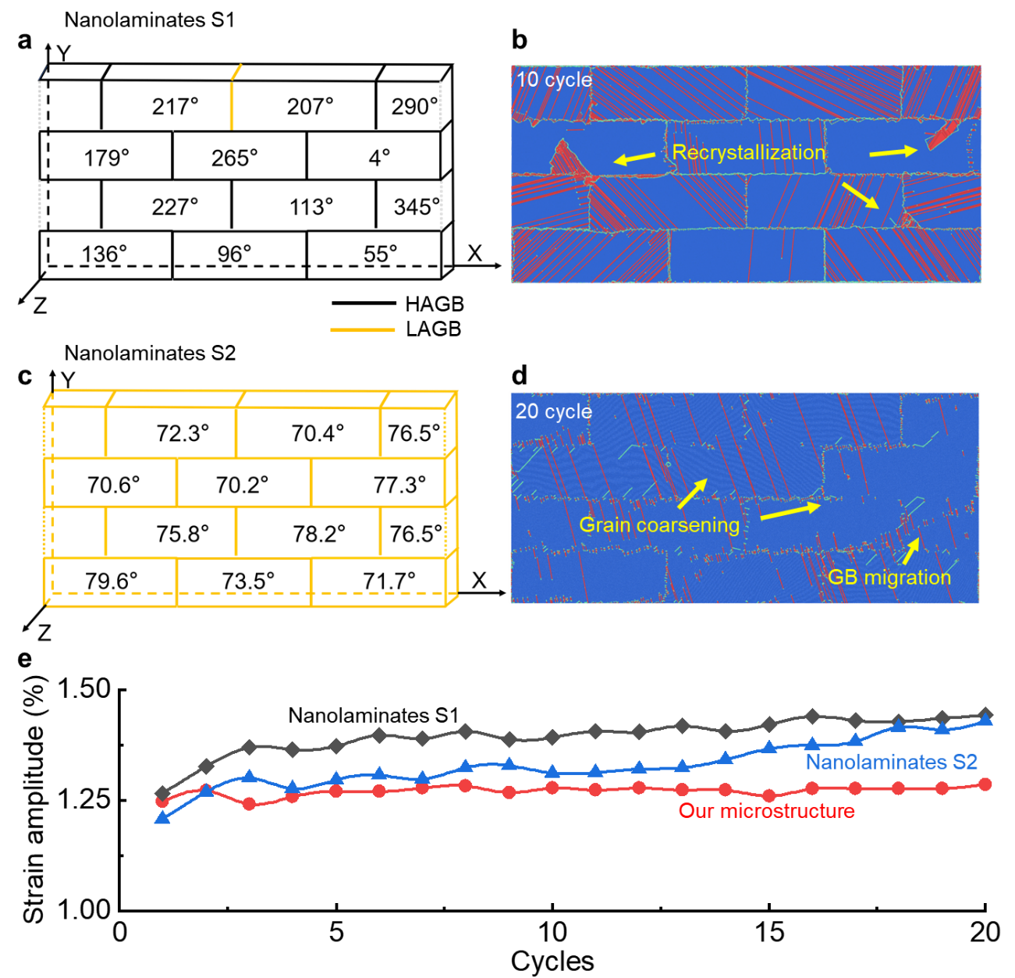

Supplementary Fig. 9. Microstructural changes of the nanolaminates with different configurations of boundary misorientations. a,b, Atomic simulations revealing the configurations of the interfaces in the Nanolaminates S1 (a) and S2 (b) after cyclic loading (b,d). e, Cyclic responses of the nanolaminates with different configurations. It shows the cyclic softening behavior of Nanolaminates S1 and S2, as strain amplitude increasing upon fatigue loading.

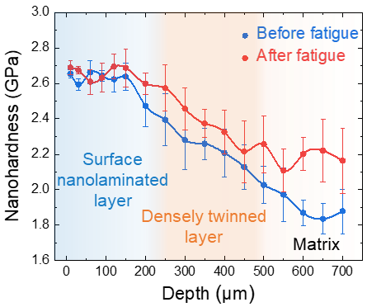

Supplementary Fig. 10. Change in the hardness value as a function of depth in our surface-nanolaminated gradient Ti before and after cyclic loading for 1.4×10⁵ cycles at the stress amplitude of 216 MPa.

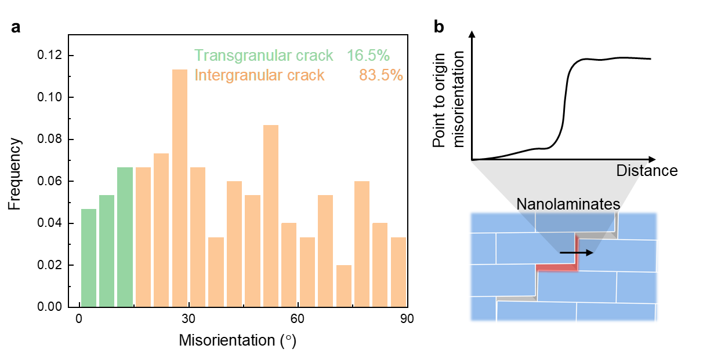

Supplementary Fig. 11. Statistical analysis of crack types in the surface nanolaminated layer. a,b, Distribution (a) and schematic diagram (b) of local misorientations between the two grains adjacent to the fatigue crack. A higher misorientation value (above 15˚) indicates an intergranular cracking mode.

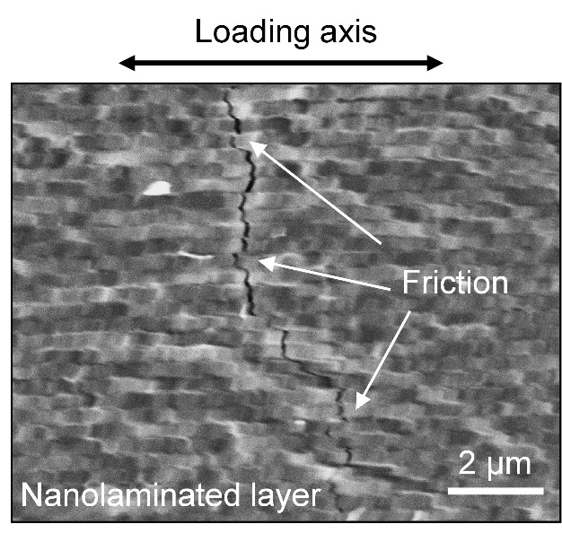

Supplementary Fig. 12. The trajectory of the crack tips in the surface nanolaminated layer. The frictional sliding between mating crack surfaces can be observed.

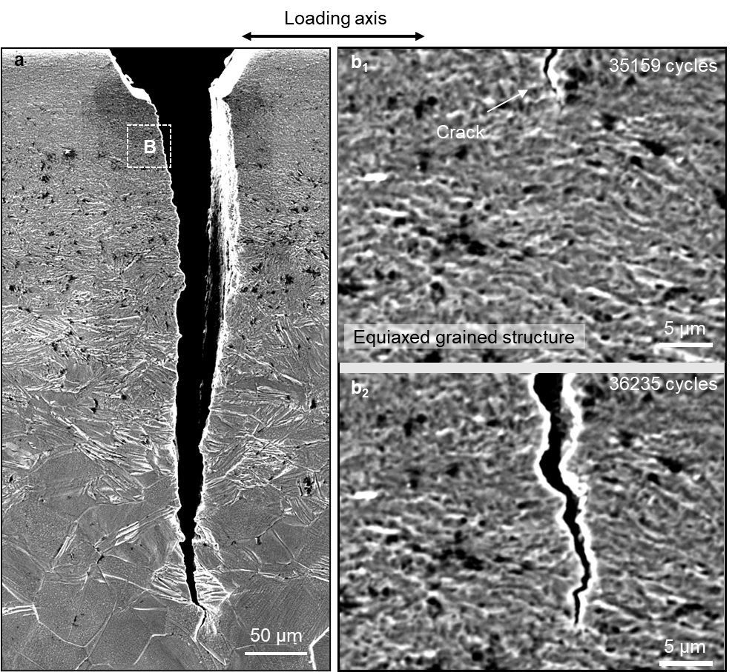

Supplementary Fig. 13. SE images of fatigue crack path in the GEG structure. a, Overview SE image. b, The trajectory of the crack tip in the equiaxed UFG layer for the crack extension from 45 μm (b₁) to 62 μm (b₂).

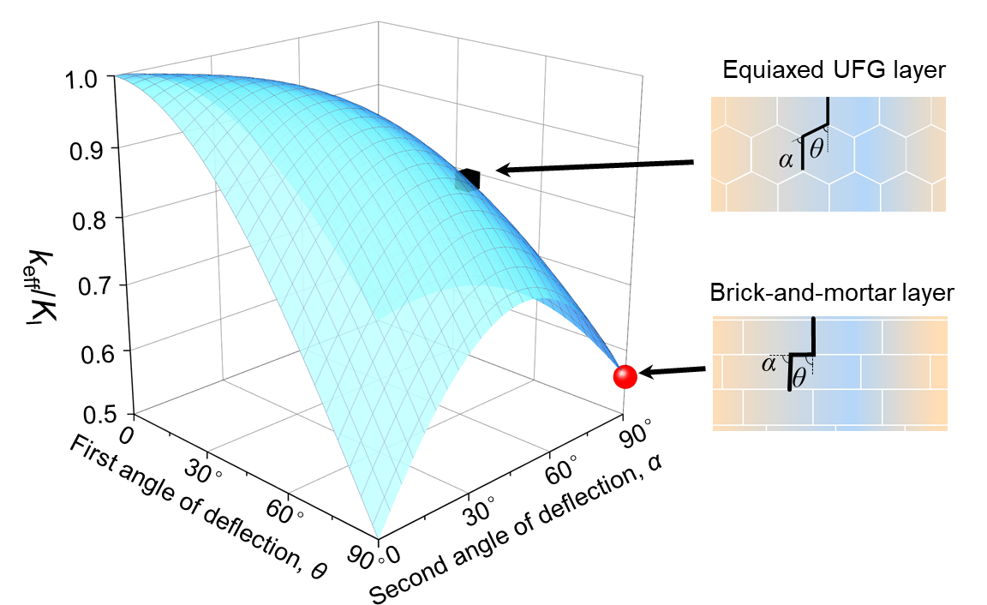

Supplementary Fig. 14. The ratio between the effective stress intensity factor (k_{eff}) and initial stress intensity factor (K_{I}) for double crack defection scenarios (schematically shown on the right side).

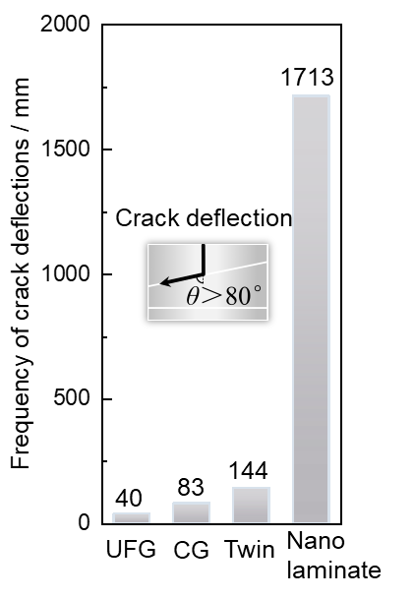

Supplementary Fig. 15. Frequency of crack deflection per 1 mm of crack advance within different microstructures. The data include the UFG structure at the surface region of the GEG structure, the CG structure, and the multi-variant twinned and nanolaminated layer of our gradient structure. The deflection with an angle larger than 80 degrees is considered as an effective deflection here.

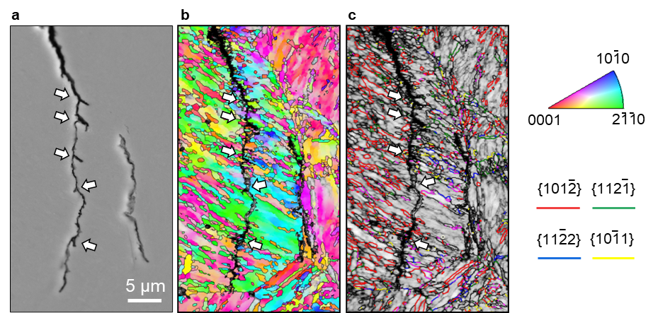

Supplementary Fig. 16. a-c SE (a), IPF plus image quality (IQ) (b) and interface plus IQ (c) maps showing the crack trajectory in the multi-variant twinned layer, which demonstrates frequent crack branching events (some of them are marked by arrows).

References
1. Liu, X. C., Zhang, H. W. & Lu, K. Strain-induced ultrahard and ultrastable nanolaminated structure in nickel. Science 342, 337-340 (2013).
2. Liu, X. C., Zhang, H. W. & Lu, K. Formation of nano-laminated structure in nickel by means of surface mechanical grinding treatment. Acta Mater. 96, 24-36 (2015).
3. Siu, K. W., Ngan, A. H. W. & Jones, I. P. New insight on acoustoplasticity – Ultrasonic irradiation enhances subgrain formation during deformation. Int. J. Plast. 27, 788-800 (2011).
4. Lei, L. et al. Gradient nanostructure, phase transformation, amorphization and enhanced strength-plasticity synergy of pure titanium manufactured by ultrasonic surface rolling. J. Mater. Process. Technol. 299 (2022).
5. ASTM, E647-15e1 Standard Test Method for Measurement of Fatigue Crack Growth Rates. (2015).
6. Tada, H., Paris, P. & Irwin, G. The stress analysis of cracks handbook, Del Research Corporation, St. Louis, Missouri (1973).
7. Cullity, B. D. Elements of X-ray Diffraction. (Addison-Wesley Publishing, 1956)
8. Plimpton, S. Fast Parallel Algorithms for Short-Range Molecular Dynamics. J. Comput. Phys. 117, 1-19 (1995).
9. Ackland, G. J. Theoretical study of titanium surfaces and defects with a new many-body potential. Philos. Mag. A 66, 917-932 (1992).
10. Stukowski, A. Visualization and analysis of atomistic simulation data with OVITO–the Open Visualization Tool. Modell. Simul. Mater. Sci. Eng. 18 (2010).
11. Shang, Z. et al. Gradient nanostructured steel with superior tensile plasticity. Sci. Adv. 9, eadd9780 (2023).
12. Liu, R., Tian, Y. Z., Zhang, Z. J., Zhang, P. & Zhang, Z. F. Fatigue strength plateau induced by microstructure inhomogeneity. Mater. Sci. Eng., A 702, 259-264 (2017).
13. Pan, Q. S., Long, J. Z., Jing, L. J., Tao, N. R. & Lu, L. Cyclic strain amplitude-dependent fatigue mechanism of gradient nanograined Cu. Acta Mater. 196, 252-260, doi:10.1016/j.actamat.2020.06.047 (2020).
14. Suresh, S. Crack deflection: implications for the growth of long and short fatigue cracks. Metall. Trans. A 14, 2375-2385 (1983).
15. Salvadori, A., Wawrzynek, P. A. & Ingraffea, A. R. Energy dissipation in the mixed mode growth of cracks at the interface between brittle materials. Int. J. Fract. 181, 257-271 (2013).
16. Liu, Z.-E. & Wei, Y. An analytical solution to the stress fields of kinked cracks. J. Mech. Phys. Solids 156 (2021).
17. Xiao, S., Wang, H.-L., Liu, B. & Hwang, K.-C. The surface-forming energy release rate based fracture criterion for elastic–plastic crack propagation. J. Mech. Phys. Solids 84, 336-357 (2015).
18. Khodabakhshi, F., Haghshenas, M., Eskandari, H. & Koohbor, B. Hardness−strength relationships in fine and ultra-fine grained metals processed through constrained groove pressing. Mater. Sci. Eng., A 636, 331-339 (2015).
19. Hyun, C.-Y., Lee, J.-H. & Kim, H.-K. Microstructures and mechanical properties of ultrafine grained pure Ti produced by severe plastic deformation. Res. Chem. Intermed. 36, 629-638 (2010).
20. Attar, H., Calin, M., Zhang, L. C., Scudino, S. & Eckert, J. Manufacture by selective laser melting and mechanical behavior of commercially pure titanium. Mater. Sci. Eng., A 593, 170-177 (2014).
21. Fattah-alhosseini, A., Reza Ansari, A., Mazaheri, Y., Karimi, M. & Haghshenas, M. An Investigation of mechanical properties in accumulative roll bonded nano-grained pure titanium. Mater. Sci. Eng., A 688, 218-224 (2017).
22. Stolyarov, V., Zhu, Y., Lowe, T., Islamgaliev, R. & Valiev, R. A two step SPD processing of ultrafine-grained titanium. Nanostruct. Mater. 11, 947-954 (1999).
23. Stolyarov, V. V., Zhu, Y. T., Lowe, T. C. & Valiev, R. Z. Microstructure and properties of pure Ti processed by ECAP and cold extrusion. Mater. Sci. Eng., A 303, 82-89 (2001).
24. Stolyarov, V. V., Zhu, Y. T., Alexandrov, I. V., Lowe, T. C. & Valiev, R. Z. Grain refinement and properties of pure Ti processed by warm ECAP and cold rolling. Mater. Sci. Eng., A 343, 43-50 (2003).

