Supporting Material
A new class of Chalcone-phosphonates derivatives as Anticancer Agents: Synthesis, spectral characterization, molecular docking and in vitro anti-proliferative evaluation

- Dimethyl 3-oxo-1,3-diphenylpropylphosphonate 3a
Yield: 82% (white solid ). mp 112˚C. IR (KBr) ν: 3397.66, 1651.71, 1238.94, 1053.18 cm⁻¹; ¹H NMR (400 MHz, CDCl3) (ppm): 7.82-7.80(m, 2H), 7.41-7.29 (5H), 7.19-7.10(m, 3H ), 4.01-3.88 (m, 1H), 3.69-3.47(m, 5H), 3.39-3.35 (m, 3H); ¹³C NMR (100 MHz, CDCl3): 196.10, 136.97, 133.32, 128.61, 126.30, 54.60, 39.11, 20.87, 16.13; HRMS (ESI) m/z calcd for C₁₇H₁₉O₄PNa⁺ [M + Na]⁺, 341.0898 ; Found 341.0931.
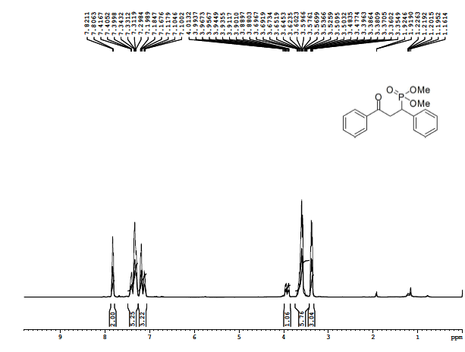
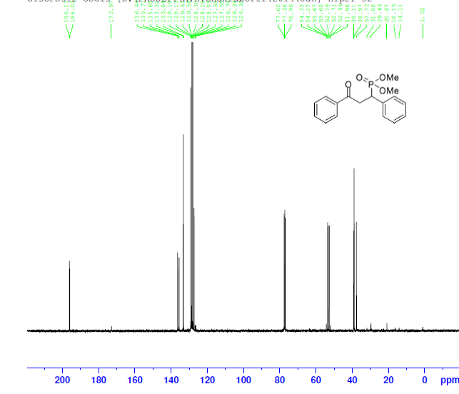
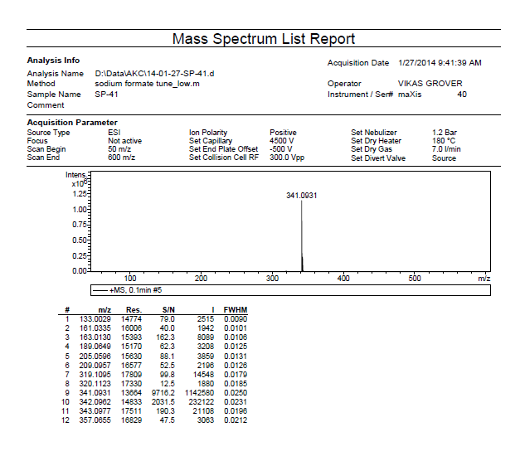
- Diethyl 3-oxo-1,3-diphenylpropylphosphonate 3b
Yield: 76% (Brownish oily liquid). IR (KBr) 3058, 2979, 1687, 1250.55, 1053.16 cm⁻¹; ¹H NMR (CDCl₃, 400 MHz) (ppm): 7.9329-7.9303 (d, 2H), 7.22-7.25 (m, 1H), 7.14 (t, J = 7.48 Hz, 2H), 6.69 (t, J = 7.32 Hz, 1H), 6.58 (d, J = 8.28, 2H), 4.26 (s, 2H), 3.90 (s, 1H); 13C NMR (100 MHz, CDCl₃): 168.2, 161.5, 153.5, 137.5, 136.2, 128.5, 126.9, 126.7, 125.3, 124.5, 121.6, 42.9; HRMS (ESI) m/z calcd for C₁₅H₁₂N₂OSNa⁺ [M + Na]⁺, 291.0568; Found 291.0560.
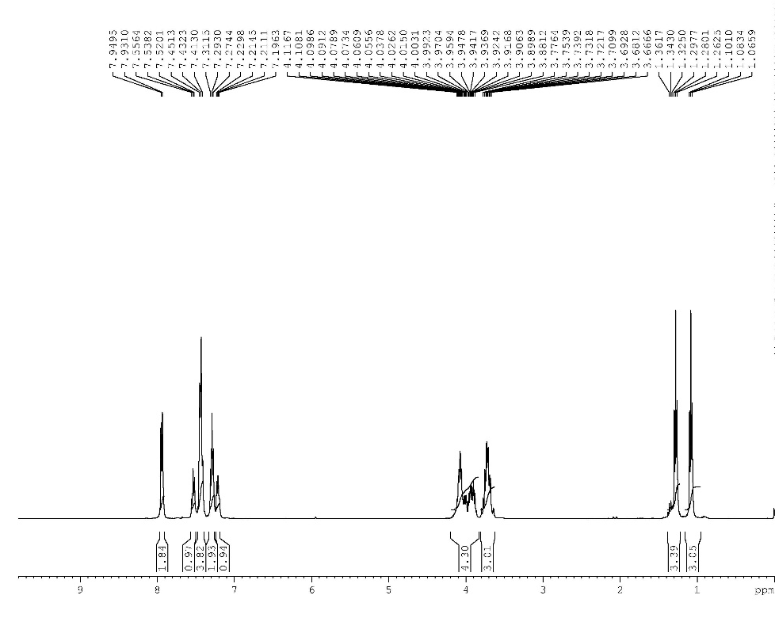

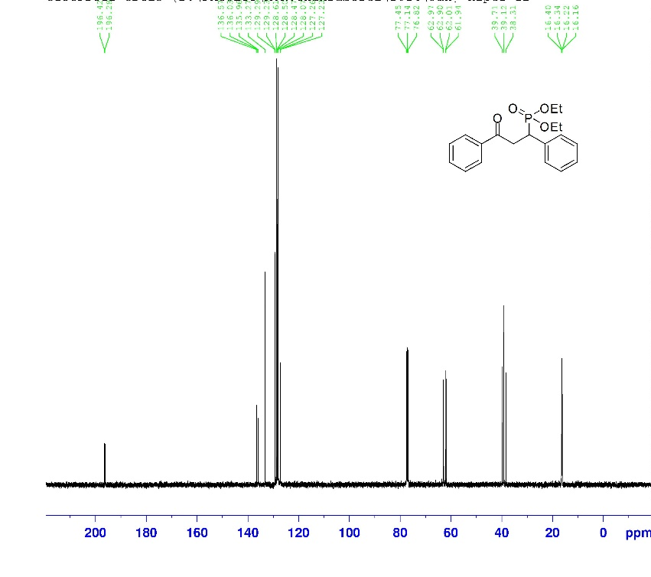
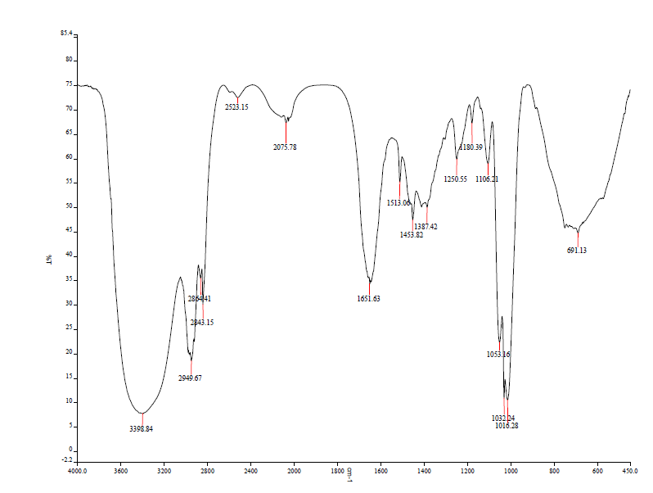
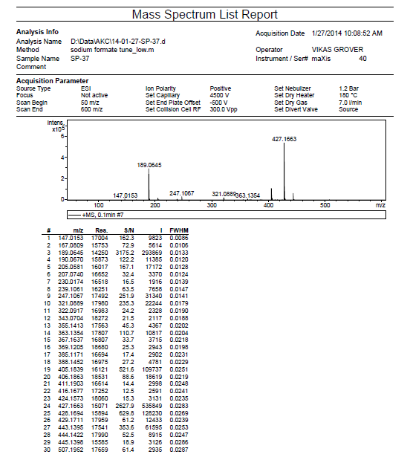
- Diisopropyl 3-oxo-1,3-diphenylphosphonate 3c
Yield:73 % (brown oily liquid). IR (KBr): 3058, 2979, 1687, 1232.06, 1023.33 cm-1. 1H NMR (400 MHz, CDCl3) δ (ppm): 7.84 (d, J = 1.04 Hz, 2H), 7.52 (t , J = 6.92 Hz, 1H), 7.46-7.41 ( m, 4H), 7.29-7.25 (m, 2H),7.21-7.17 (m,1H), 4.77-4.65 (m, 1H), 4.46-4.38(m, 1H), 3.94-3.85 (m,1H), 3.64-3.59 (m,1H), 3.80-3.72 (m,1H) 1.22 (d, J=6.16 Hz, 3H). 13C NMR (100 MHz, CDCl3) δ (ppm) 196.73, 136.33, 133.22, 129.51, 128.58, 128.10, 127.13, 71.66, 39.45, 24.26, 23.14. HRMS (ESI): m/z for C21H27O4PNa+ [M + Na]+, calc.: 397.1598 ; observed: 397.1558.
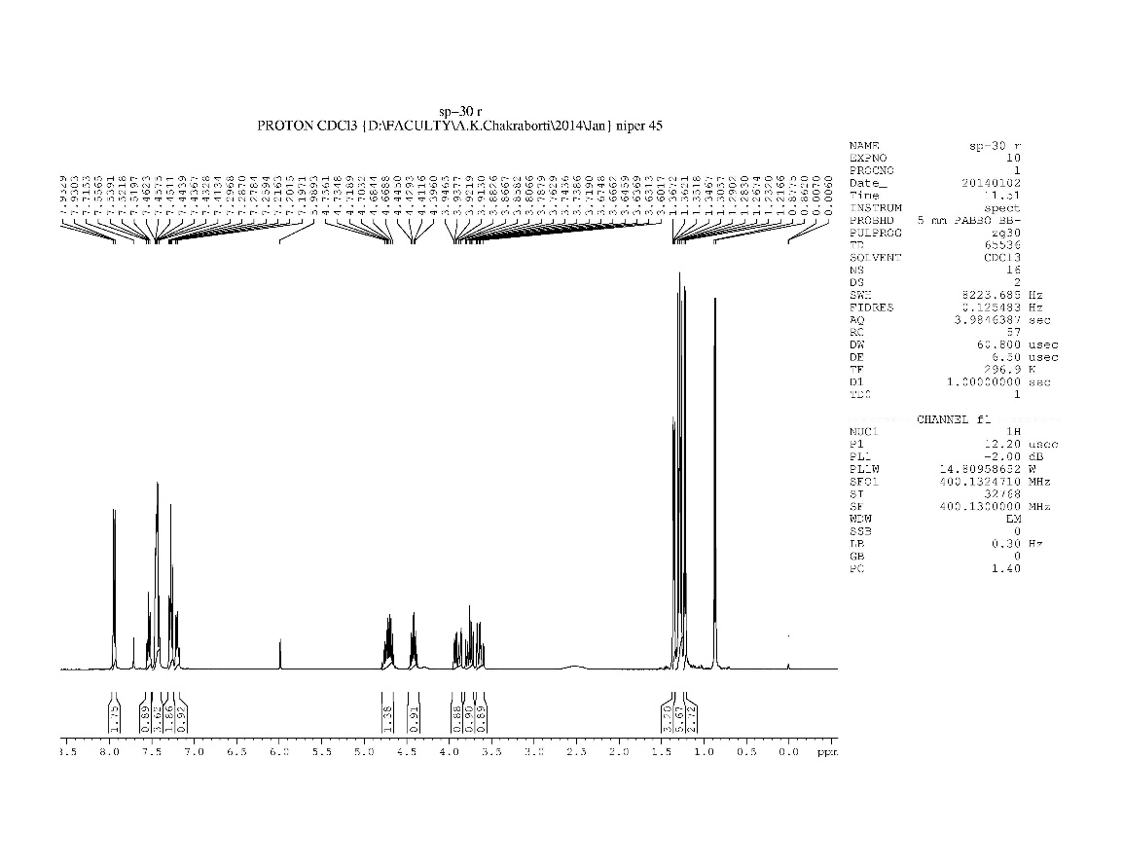
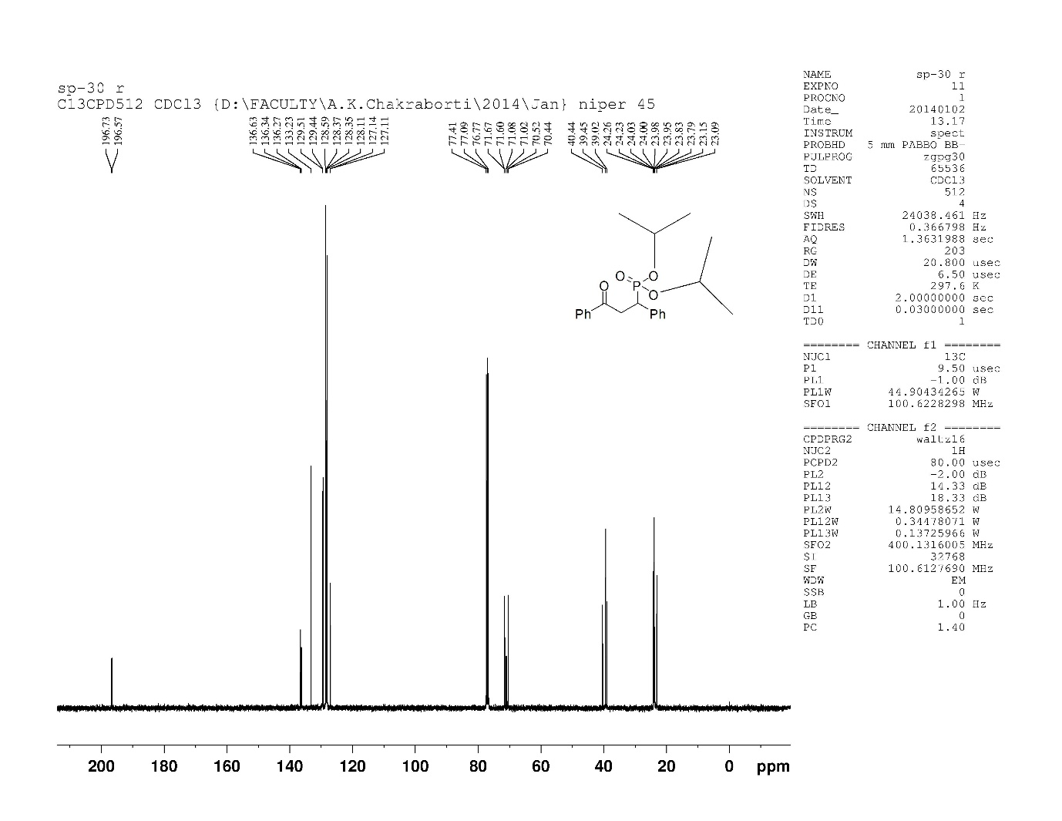
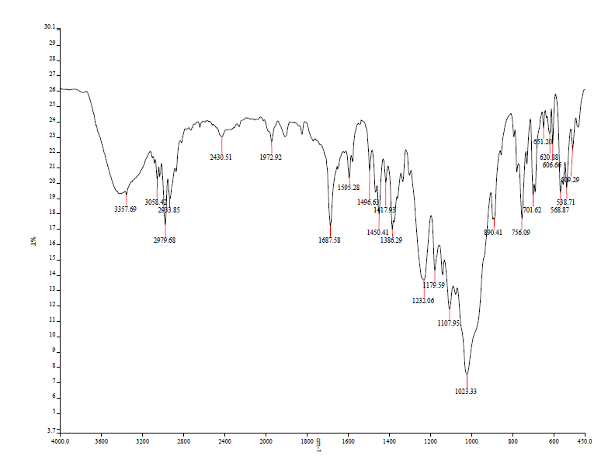
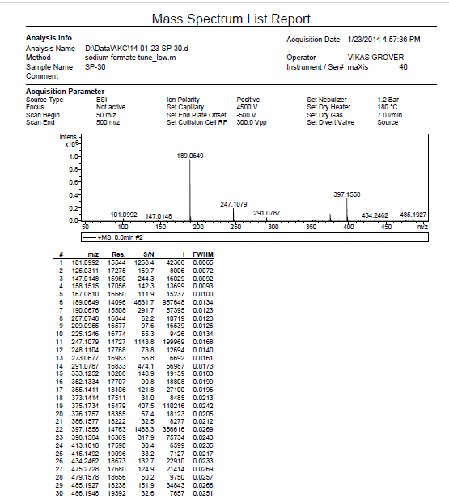
- Dibutyl 1,3-diphenylallylphosphonate 3d
Yield: 66% (yellowish oily liquid). IR (KBr) 3058, 2979, 1687 1235.15, 1027.36 cm⁻¹; ¹H NMR (CDCl₃, 400 MHz) (ppm): 7.8524-7.8321 (d, 2H), 7.4396-7.3989 (m, 2H), 7.2566-7.2344 (d, J = 8.908 Hz, 2H), 6.69 (t, J = 7.32 Hz, 2H), 6.58 (d, J = 8.28, 2H), 4.26 (s, 2H), 2.4003 (s, 3H); ¹³C NMR (100 MHz, CDCl₃):195.92, 137.02, 132.94, 129.30, 128.43, 127.06, 133.32, 66.51, 40.09, 32.56, 32.38, 18.69, 13.32; HRMS (ESI) m/z calcd for C₂₁H₂₇O₄PNa⁺ [M+Na]⁺, 397.1598; Found 397.1558.
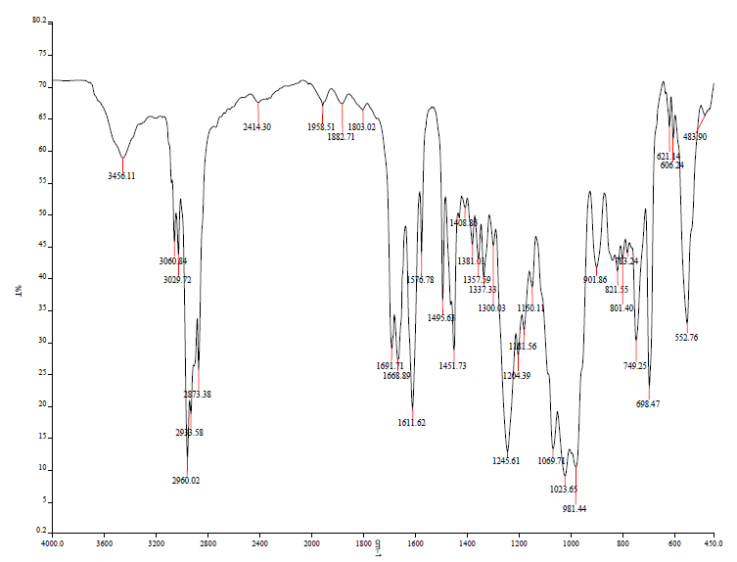
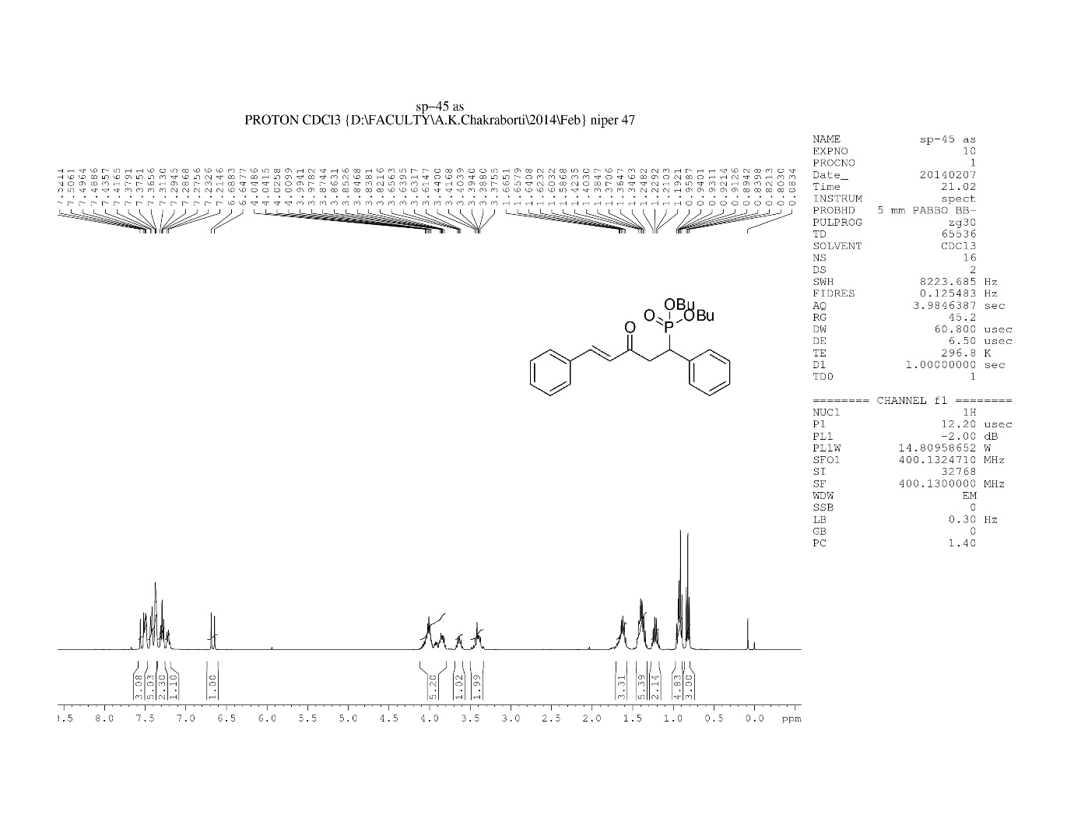
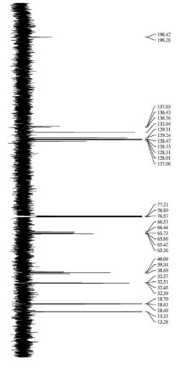
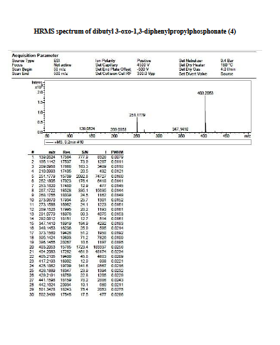
- Diethyl 3-(4-fluorophenyl)-3-oxo-1-phenylpropylphosphonate 3e
Yield: 64% (yellow semisolid). IR (KBr) ν: 3457.45, 3107.74, 1688.86, 1597.98, 1507.19, 1496.69, 1235.77, 1158.34, 1098.56, 1031.39, 966.74 cm⁻¹; ¹H NMR (400 MHz, CDCl3) δ (ppm): 7.91-7.86(m, 2H), 7,36-7.34(m, 2H), 7.23-7.16(m, 2H), 7.15-7.11(m, 1H), 7.05-6.99(m, 2H), 4,04-3.94(m, 2H), 3.90-3.77(m, 2H), 3.69-3.54 (m, 3H), 1.20 (t, J= 7.04Hz, 3H), 0.99 (t, J= 7.04Hz, 3H); ¹³C NMR (100 MHz, CDCl3) δ (ppm): 194.79, 164.57, 135.90, 130.81, 129.26,128.54, 115.84, 63.07, 39.76, 29.69, 16.33. HRMS (ESI) m/z C₁₉H₂₂FO₄PNa⁺[M + Na]⁺, 387.1098.
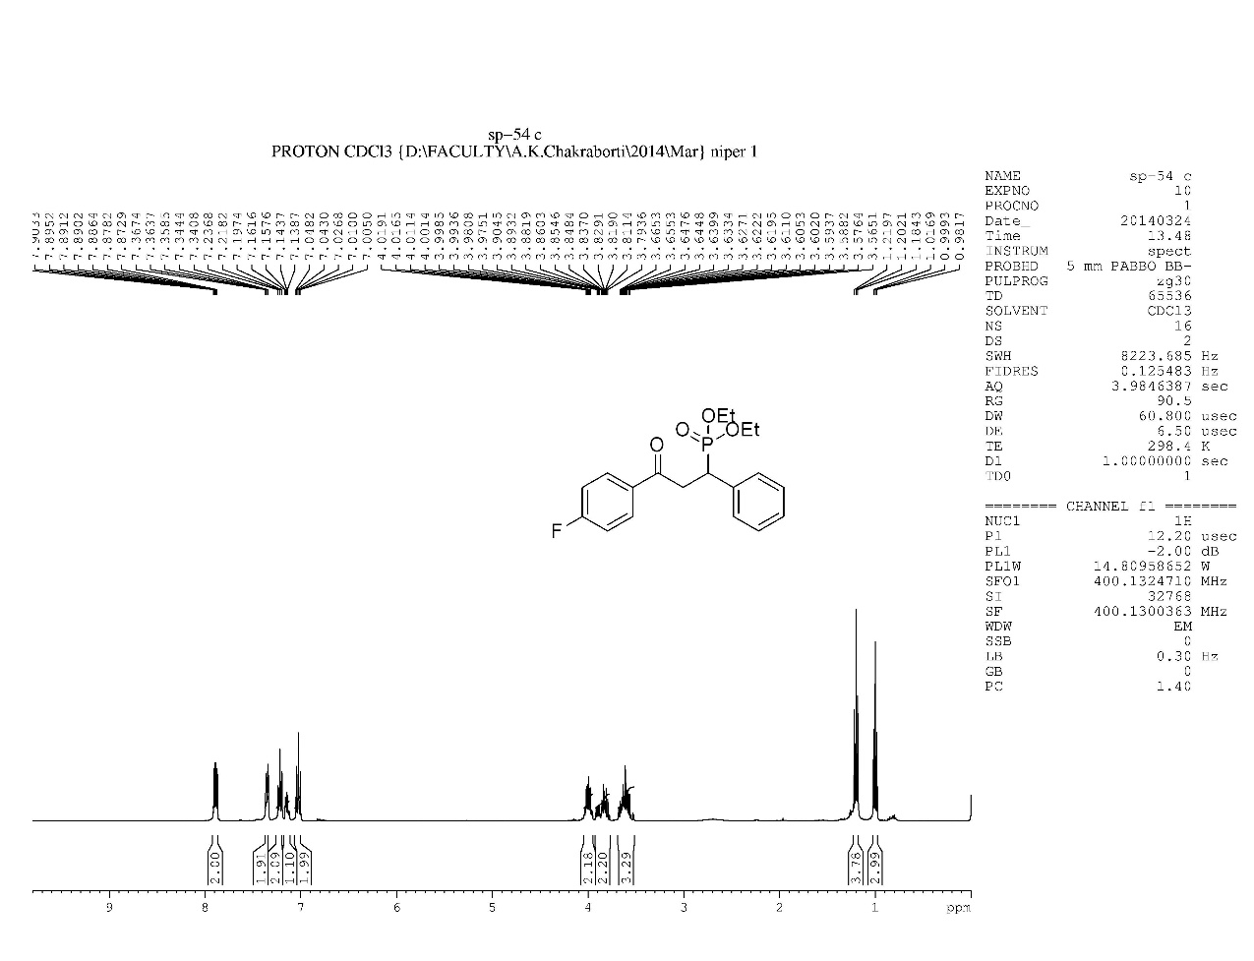
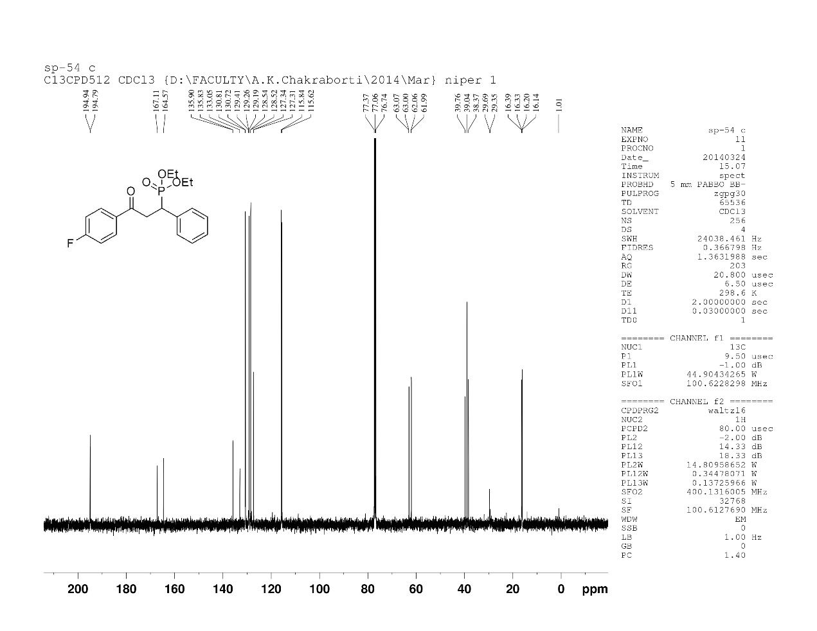
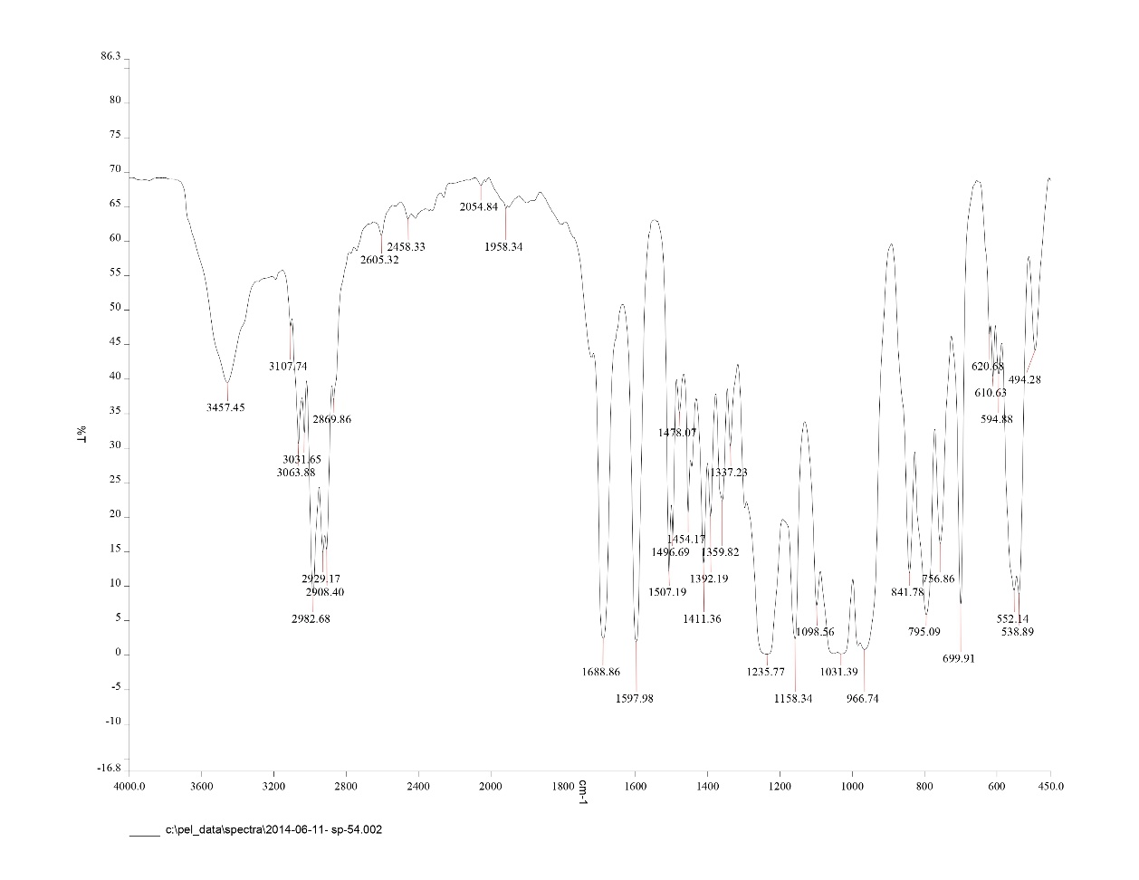
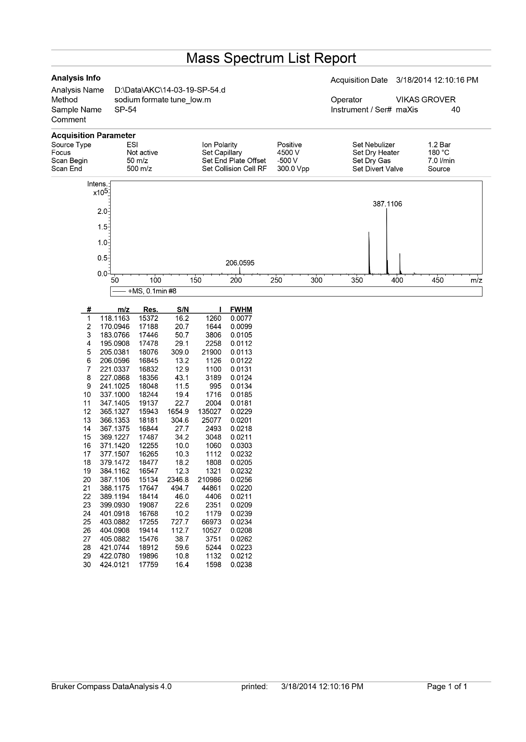
- Diethyl 1-(4-fluorophenyl)-3-oxo-3-phenylpropylphosphonate 3f
Yield: 72% (yellow semisolid). IR (KBr) ) ν: 3062.39, 2871.21, 2345.30 1966.29, 1894.91, 1688.93, 1598.05, 1478.08, 1391.89, 1355.99, 1231.70, 1162.08, 1051.34, 967.52 cm-1; 1H NMR (400 MHz, CDCl3) δ (ppm): 7.99-7.95 (m, 2H), 7.58-7.54 (m, 2H), 7.47-7.40 (m, 2H), 6.99 (t, J=8.52 Hz, 2H), 4.14-4.05 (m, 2H), 4.00-3.89 (m, 2H), 3.82-3.61 (m, 3H), 1.26 (t, J=7.04Hz, 3H), 1.11 (t, J=7.04Hz, 3H); 13C NMR (100 MHz, CDCl3) δ (ppm): 196.34, 163.3, 160.80, 136.45, 133.41, 131.80, 115.54, 6 3.04, 39.20, 29.70, 18.71. HRMS (ESI) m/z C₁₉H₂₂FO₄PNa⁺[M + Na]⁺, 387.1140.
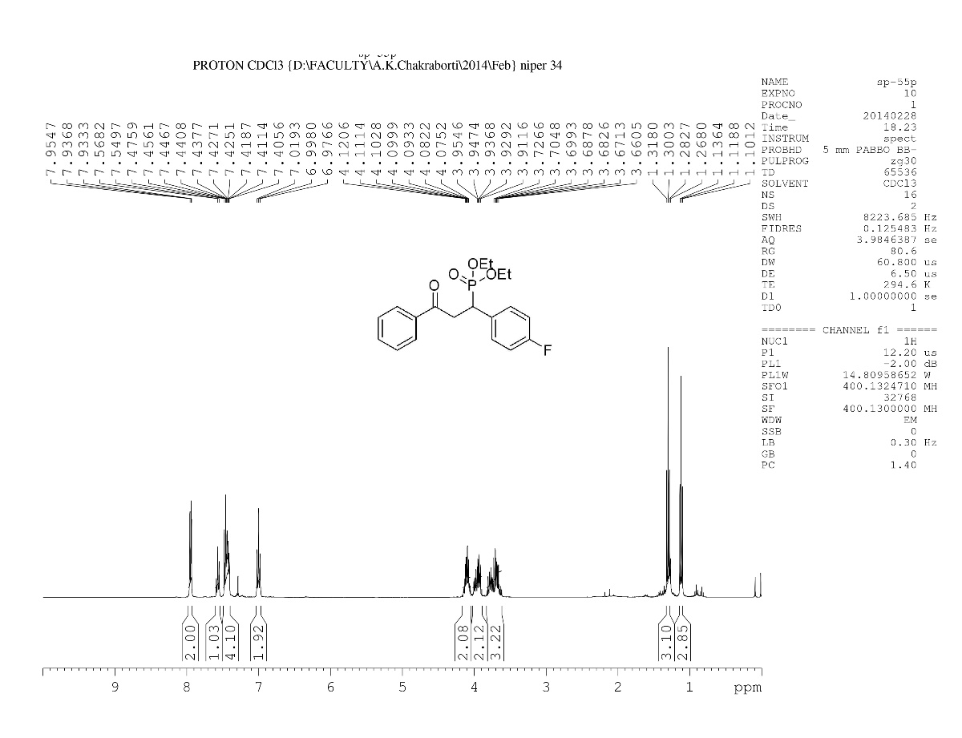
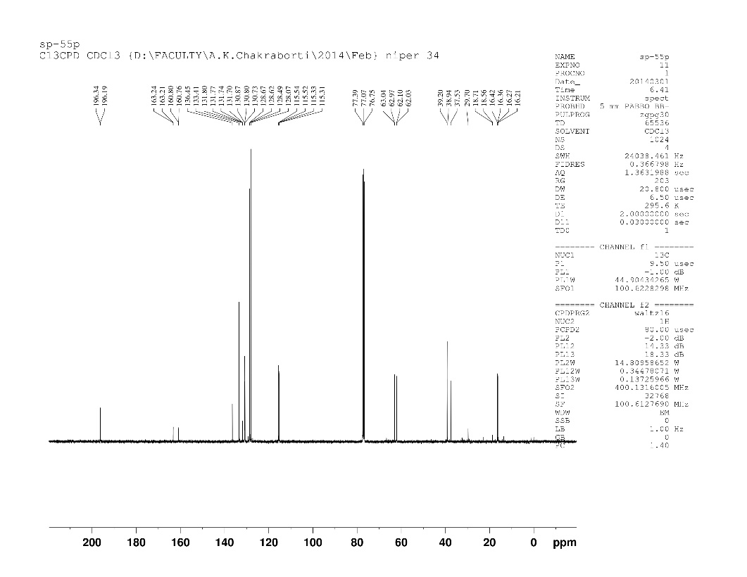
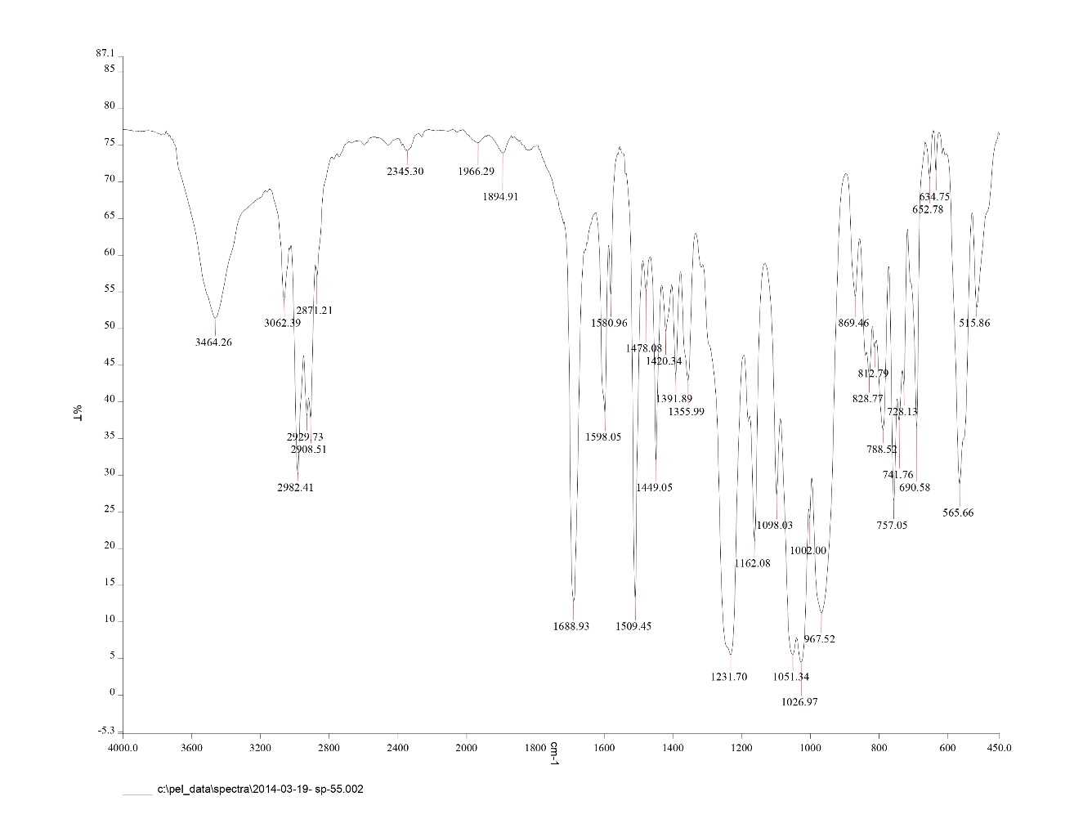
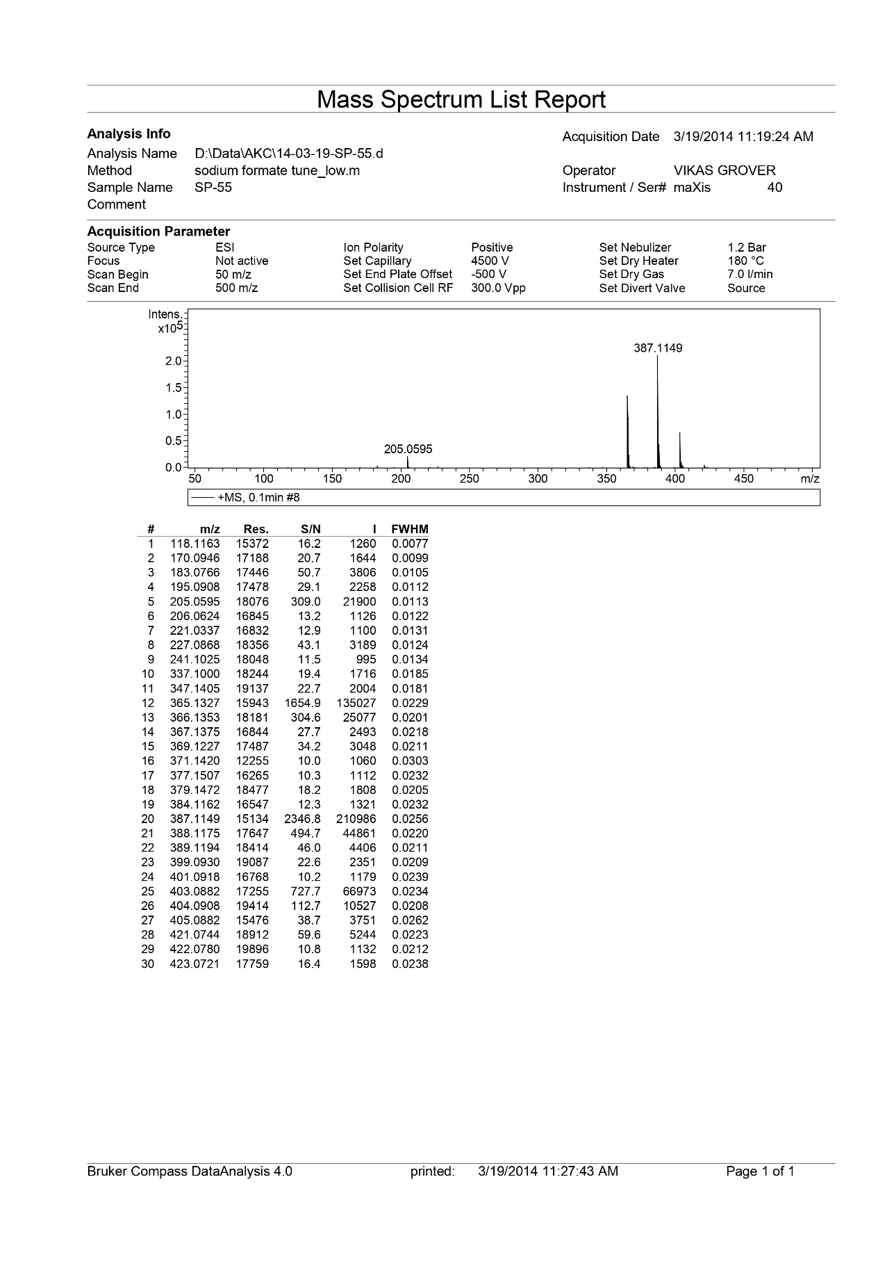
- Diethyl 3-(4-methoxyphenyl)-3-oxo-1-phenylpropylphosphonate 3g
Yield: 70% (yellow oily liquid). IR (KBr): 3410.74, 2926.64, 2852.55, 1710.85, 1449.54 cm-1; 1H NMR (400 MHz, CDCl₃) (ppm): 7.9423-7.9377 (dd, J= 1.84 Hz, 2H), 7.55-7.53 (m, 1H), 7.46-7.42 (m, 2H), 7.37-7.34 (m, 2H), 6.84-6.82 (d, J= Hz, 2H) 4.10-4.06 (m, 2H), 3.95-3.89 (m, 2H), 3.775 (s, 3H), 3.76-3.64 (m, 2H) 1.35-1.26 (m, 3H), 1.13-1.09 (m, 2H), ¹³C NMR (100 MHz, CDCl₃) δ (ppm): 196.72, 158.67, 139.13, 136.65, 133.14, 130.45, 128.78, 114.39, 70.79, 60.27, 39.51, 33.76, 29.63, 23.99; HRMS (ESI) m/z calcd for C₂₀H₂₅O₅PNa⁺ [M+Na]⁺, 399.1298; Found 399.1258.
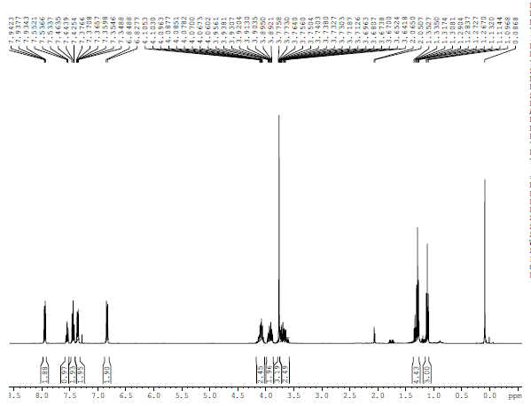
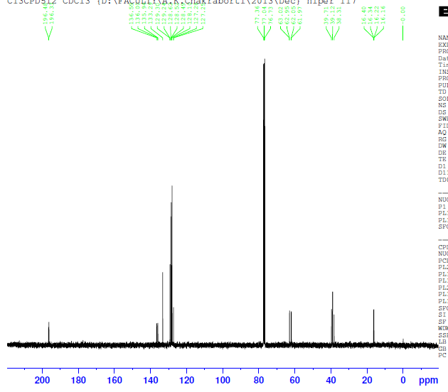
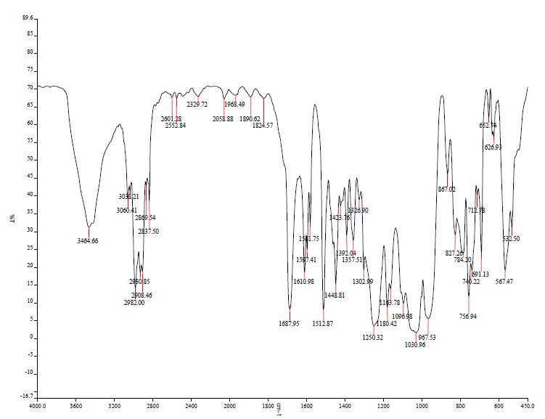
- Diisopropyl (3-(4-methoxyphenyl)-3-oxo-1-phenylpropyl)phosphonate 3h
Yield: 64% (brownish oily liquid). IR (KBr): 3410.74, 2926.64, 2852.55, 1710.85, 1449.54 cm-1; 1H NMR (400 MHz, CDCl₃) (ppm): 7.89-7.87 (m, 2H), 7.47-7.45 (t, J= 8 Hz, 1H), 7.39-7.31 (m, 4H), 6.78-6.76 (d, J= 8 Hz, 2H), 4.65-4.63 (m, 1H) 4.39-4.37 (m, 4H), 3.95-3.89 (m, 2H), 3.775 (s, 3H), 3.76-3.64 (m, 2H), 3.69-3.55 (m, 4H) 1.32-1.29 (m, 2H), 1.26-1.22 (m, 3H), 1.19-1.18 (m, 3H), ¹³C NMR (100 MHz, CDCl₃) δ (ppm): 194.72, 156.67, 136.13, 132.65, 131.11, 130.35, 127.16, 114.39, 72.29, 57.27, 39.51, 33.76, 29.63, 23.99; HRMS (ESI) m/z calcd for C₂₂H₂₉O₅PNa⁺ [M+Na]⁺, 427.1758; Found 427.2222.

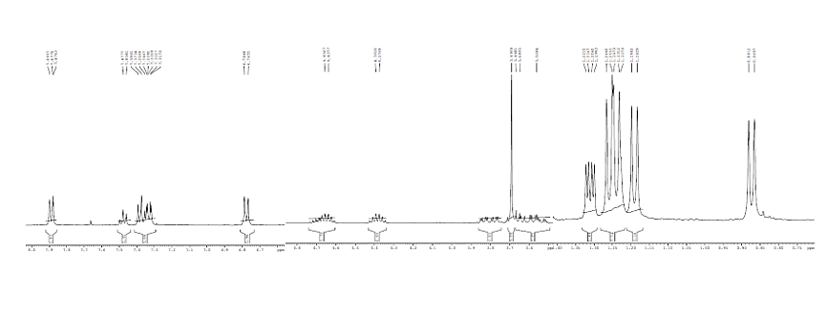
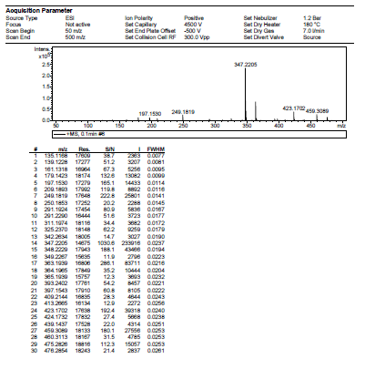
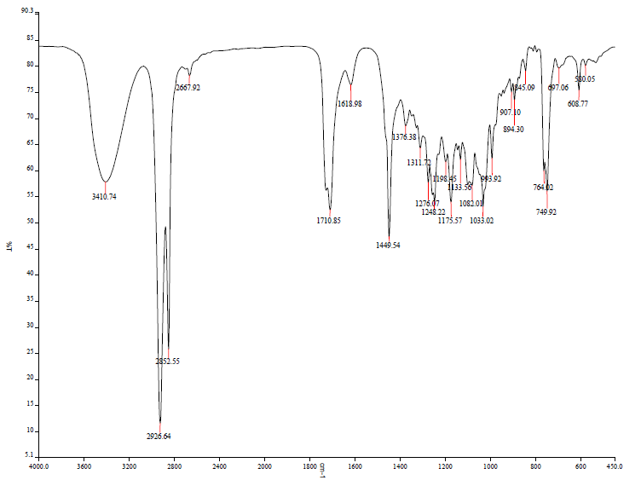
- diethyl 3-(4-fluorophenyl)-1-(4-methoxyphenyl)-3-oxopropylphosphonate 3i
Yield: 69% (yellow oily liquid). IR (KBr) ν: 3431.70, 1686.22, 1232.40, 1027.62 cm-1; 1H NMR (400 MHz, CDCl3) δ (ppm): 8.00-7.96 (m, 2H), 7.37-7.34 (m, 2H), 7.14-7.10 (m, 2H), 6.85(d, J= 8.4Hz, 2H), 4.11-4.07(m, 2H), 3.95-3.85 (m, 2H), 3.78 (s, 3H), 3.76-3.70 (m, 1H), 3.65-3.61 (m,2H), 1.30 (t, J= 7.04, 3H), 1.11 (t, J= 7.04, 3H); 13C NMR (100 MHz, CDCl3) δ (ppm): 195.01, 167.02, 158.75, 133.04, 115.7 6, 62.95, 39.09, 37.43, 20.94. HRMS (ESI) m/z Calcd for C₂₀H₂₄FO₅P Na+[M + H]⁺, 395.1450, Found, 395.1426.
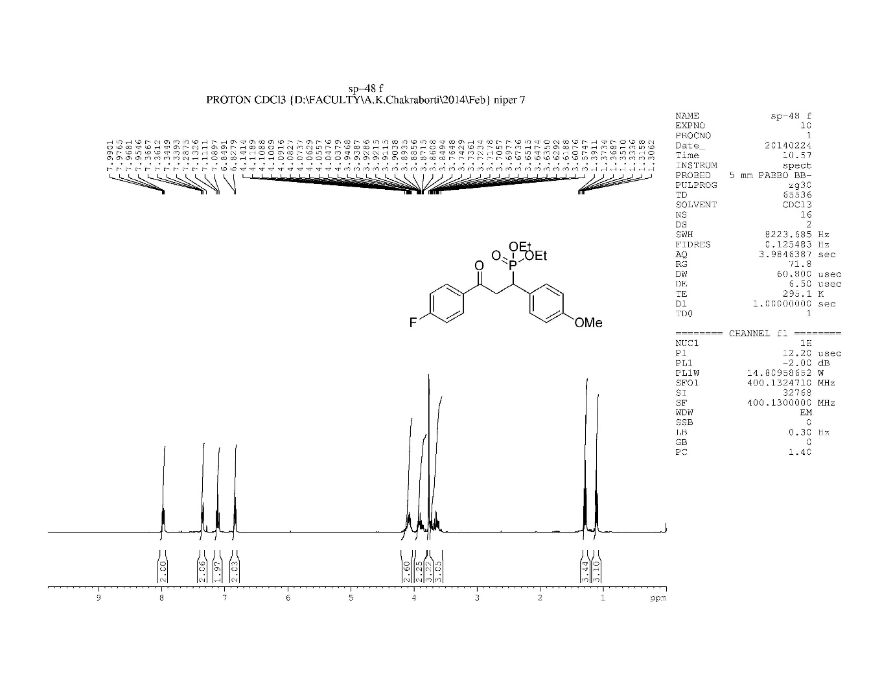
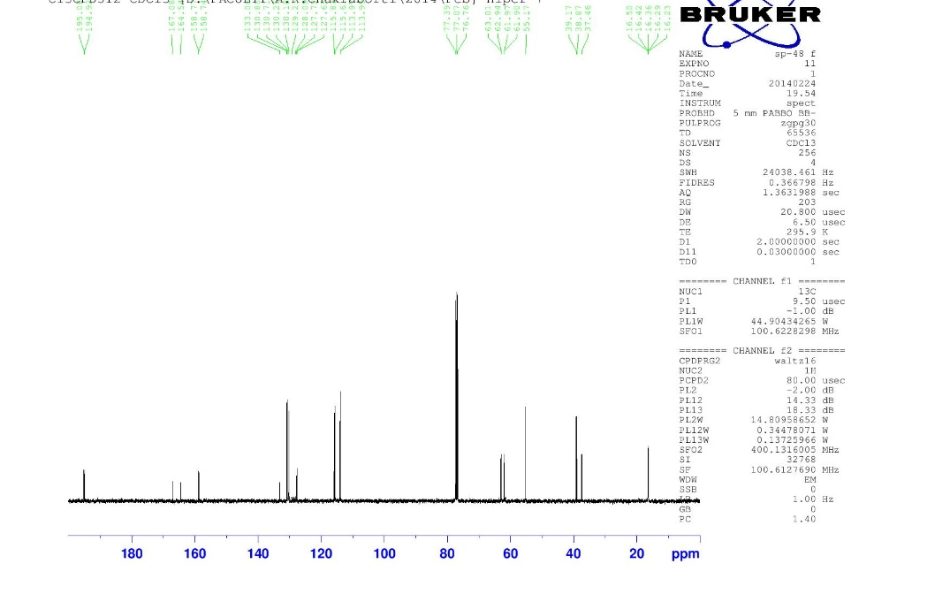
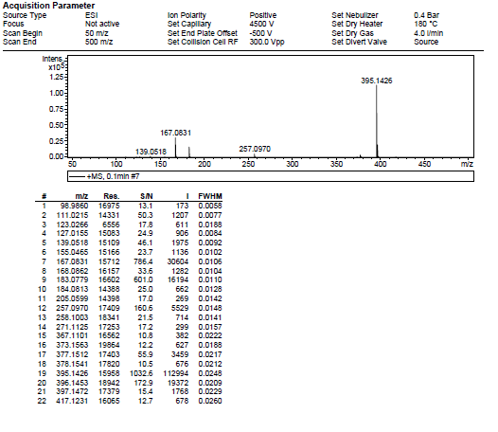
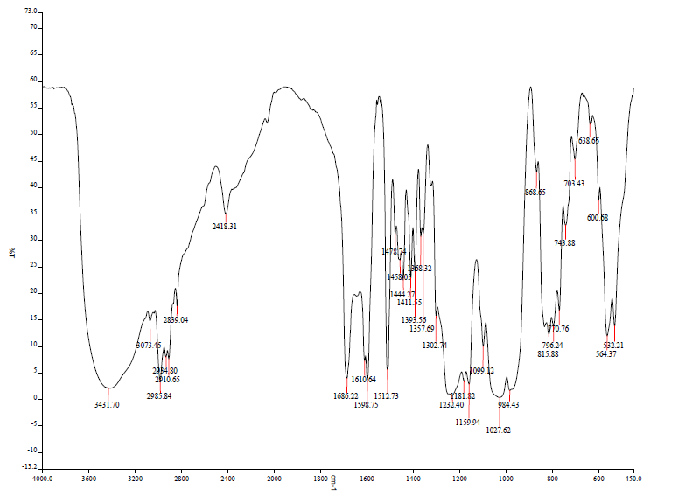
- Diethyl (3-(4-fluorophenyl)-1-(4-methoxyphenyl)-3-oxopropyl)phosphonate 3j
Yield: 52% (yellow oily liquid). IR (KBr) ν: 3431.70, 1686.22, 1232.40, 1027.62 cm-1; 1H NMR (400 MHz, CDCl3) δ (ppm): 7.99-7.95 (d, 2H), 7.13-7.08 (t, 2H), 6.84-6.82 (d, J= 8Hz, 2H), 4.14-4.03 (m, 3H), 3.94-3.84 (m, 2H), 3.74 (m, 3H), 3.71-3.57 (m, 3H), 1.31-1.26 (t, J= 17.24 Hz, 3H), 1.12-1.09 (t, J= 14.12 Hz, 3H); 13C NMR (100 MHz, CDCl3) δ (ppm): 195.92, 167.22, 164.78, 158.77, 133.05, 130.87, 115.49, 63.97, 55.17, 39.09, 16.50. HRMS (ESI) m/z Calcd for C20H24FO5P Na+[M + H]+, 395.1450, Found, 395.1426.
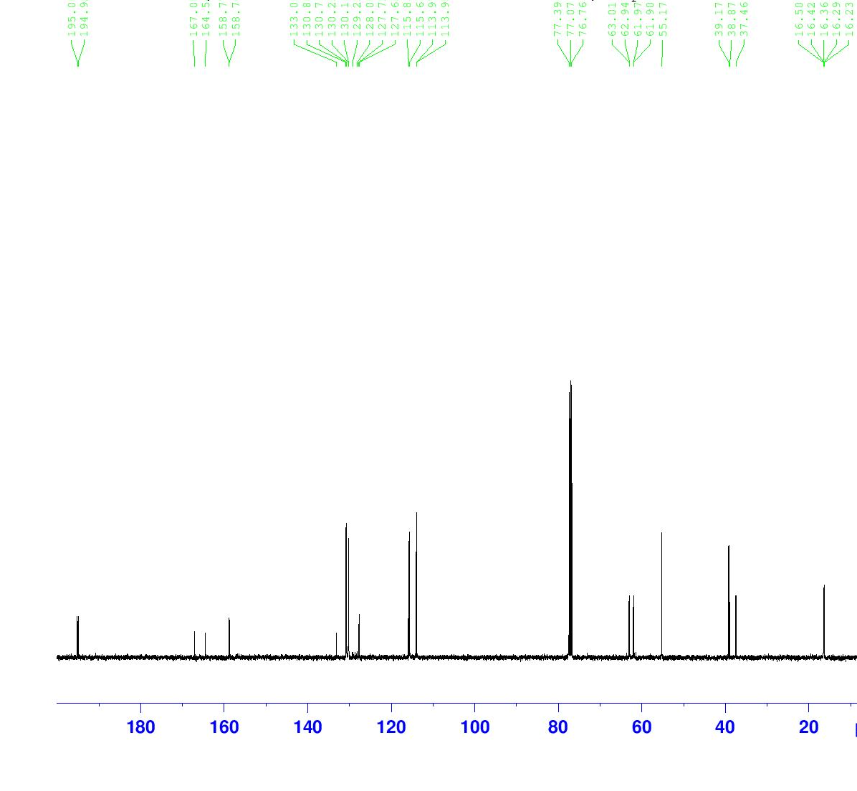
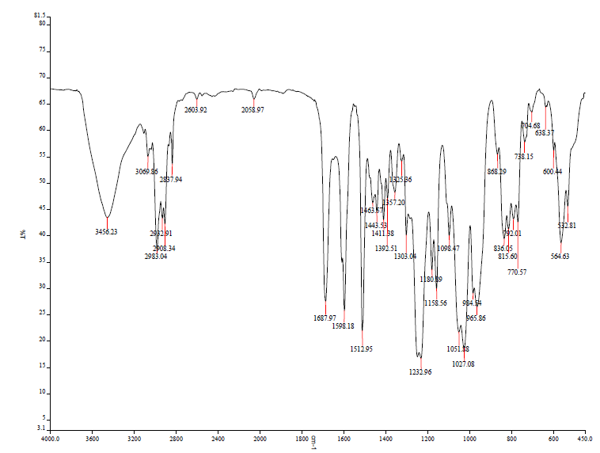
- Diethyl (1-(4-fluorophenyl)-3-oxo-3-(p-tolyl)propyl)phosphonate 3k
Yield: 62% (yellow oily liquid). IR (KBr) ν: 3431.70, 1686.22, 1232.40, 1027.62 cm⁻¹; ¹H NMR (400 MHz, CDCl₃) δ (ppm): 7.85-7.83 (d, J= 8.04 Hz, 2H), 7.43-7.39 (m, 2H), 7.25-7.23 (d, J= 8Hz, 2H), 7.009-6.966 (t, J= 17.24 Hz, 2H), 4.07-4.00 (m, 2H), 3.98-3.89 (m, 2H), 3.82-3.57 (m, 3H), 2.40 (m, 3H), 1.31-1.26 (t, J= 17.24 Hz, 3H), 1.13-1.09 (t, J= 14.12 Hz, 3H); ¹³C NMR (100 MHz, CDCl₃) δ (ppm): 195.92, 163.22, 160.78, 144.24, 134.05, 130.87, 115.49, 62.97, 39.09, 37.43, 29.68, 16.34. HRMS (ESI) m/z Calcd for C₂₀H₂₄FO₄P Na⁺[M + H]⁺, 395.1450, Found, 395.1426.
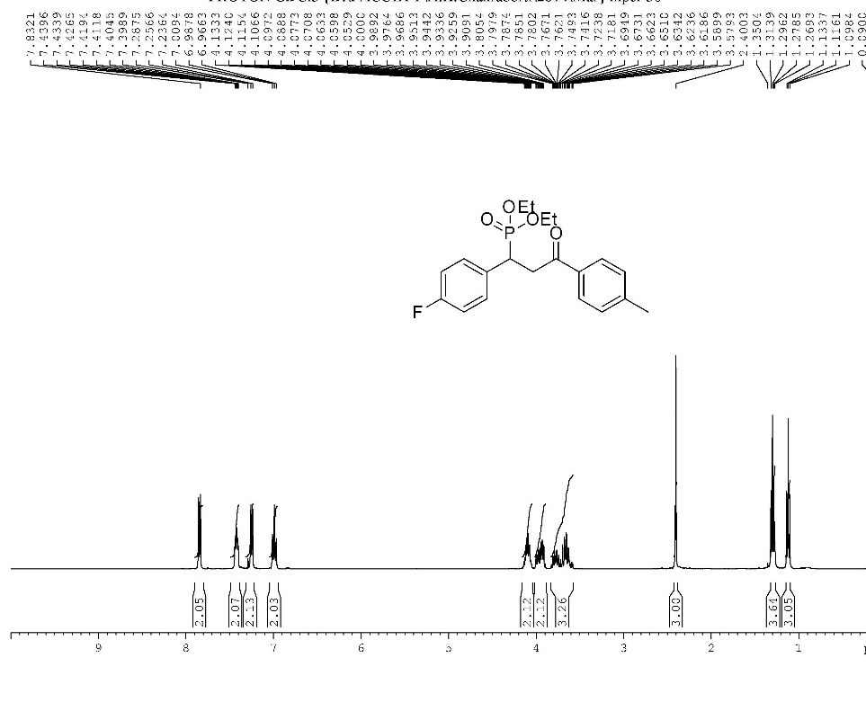
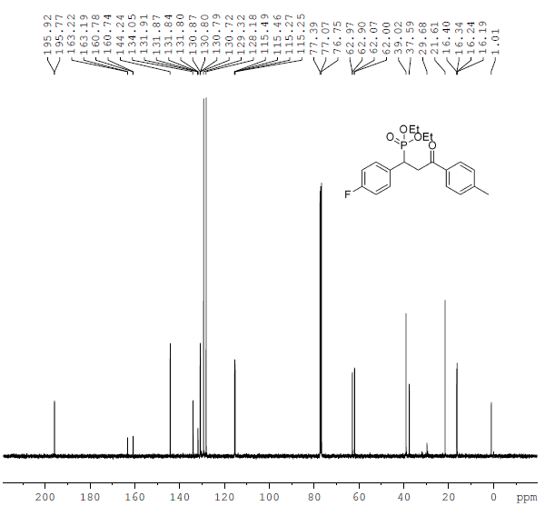
- Diethyl (1-(4-chlorophenyl)-3-(4-fluorophenyl)-3-oxopropyl)phosphonate 3l
Yield: 55% (yellow oily liquid). IR (KBr) ν: 3476.35, 2987.65, 1686.45, 1598.93, 1492.01, 1480.84,1411.72, 1395.76, 1007.10, 816.00, 799.86; ¹H NMR (400 MHz, CDCl3) δ (ppm): 7.97-7.94 (m, 2H), 7.38-7.35 (m, 2H), 7.13-7.08 (m, 2H), 4.14-4.04 (m, 2H), 3.95-3.86 (m, 2H), 3.82-3.54 (m, 3H), 1.26 (t, J= 7.04Hz, 3H), 1.11 (t, J= 7.04Hz, 3H); ¹³C NMR (100 MHz, CDCl3) δ (ppm): 194.67, 167.20, 167.20, 164.66, 134.56, 133.24, 132.88, 130.80, 128.72, 115.92, 63.14, 39.20, 29.68, 16.40. HRMS (ESI) m/z calcd; C₁₉H₂₁ClFO₄P Na⁺ [M + Na]⁺, 421.0798; Found 421.0763
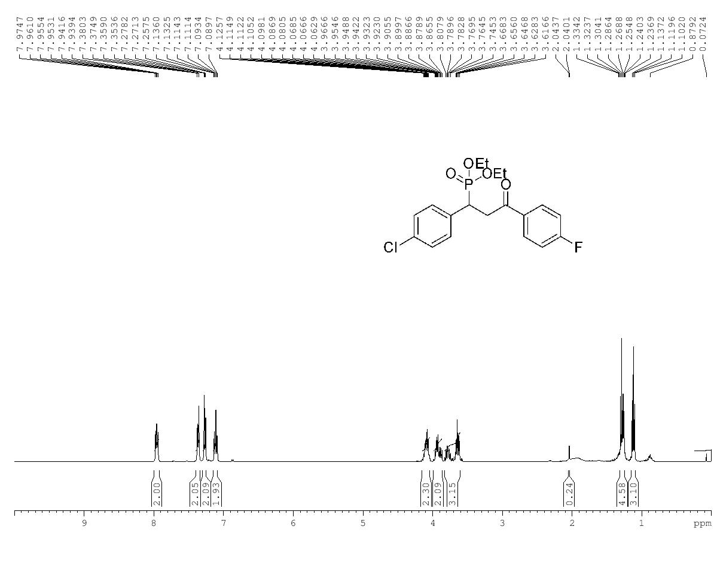
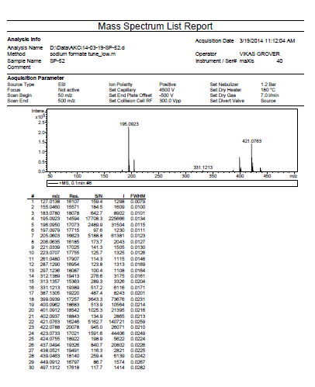
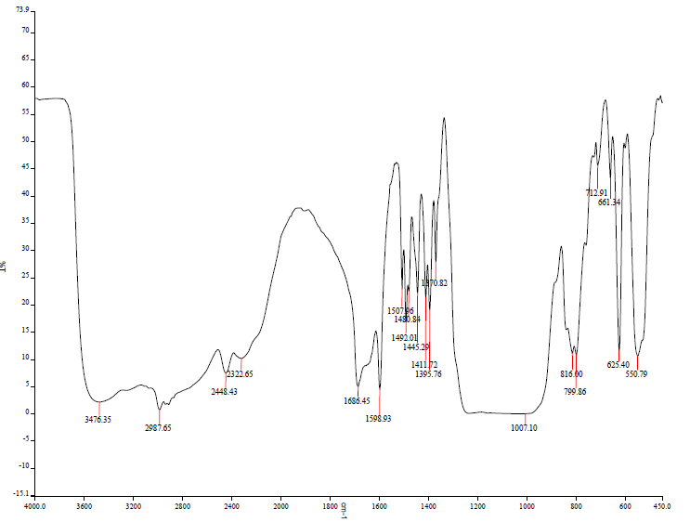
- Diethyl 1-(2-chlorophenyl)-3-(4-fluorophenyl)-3-oxopropylphosphonate 3m
Yield: 52% (yellow oily liquid). IR (KBr): 3459,3067.93, 2983.84, 1690.68, 1055.49, 969.57; ¹H NMR (400 MHz, CDCl₃) δ 8.00-7.96, (m, 2H), 7.52, (d, 1.72, 1H), 7.41 (d, 7.8, 1H), 7.23-7.09(m, 4H), 4.66-4.57 (m, 1H), 4.19-4.10 (m, 2H), 3.93-3.87 (m, 1H), 3.78-3.71 (m, 3H), 1.31 (t, J= 7.08Hz, 3H), 1.09 (t, J= 7.04Hz, 3H). ¹³C NMR (100 MHz, CDCl₃) δ (ppm): 194.40, 167.03, 164.49, 135.18, 134.04, 132.76, 130.76, 129.67, 129.08, 128.26, 126.89, 62.93, 39.19, 18.02, and 16.42. HRMS (ESI) m/z calcd for C₁₉H₂₁ClFO₄P H⁺[M + H]⁺, 399.7957; Found 399.0937
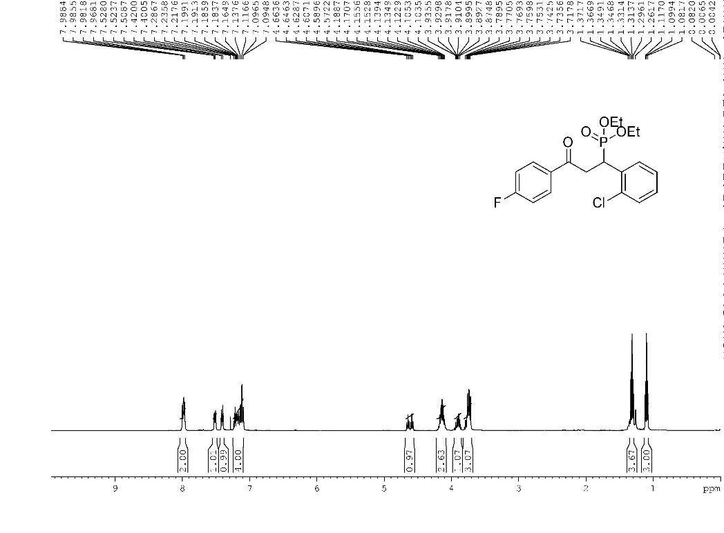
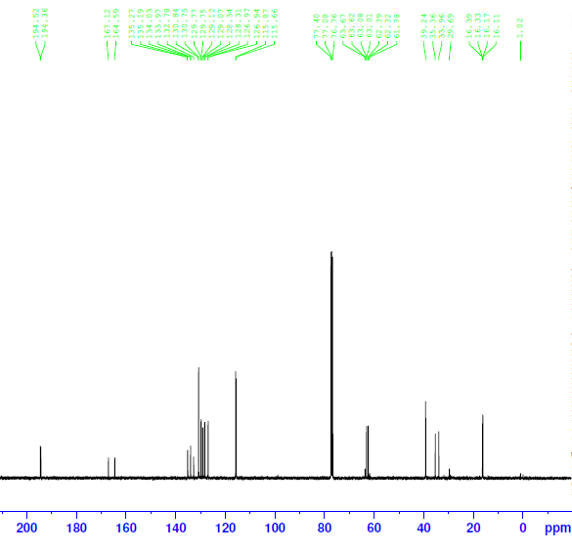
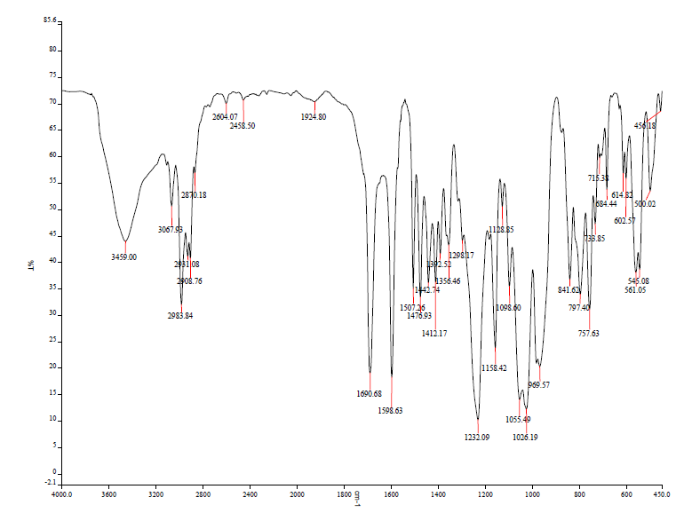
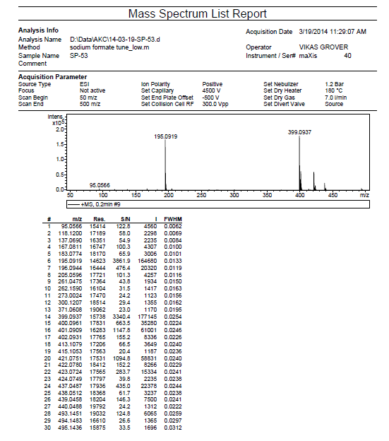
- Diethyl 3-oxo-1-phenylbutylphosphonate 3n
Yield: 49% (Brownish oily liquid). IR (KBr); 2987 cm-1, 2428, 1688, 1371 cm⁻¹; ¹H NMR (CDCl3, 400 MHz) (ppm): 7.38-7.33 (m, 2H), 7.28 (t, J=7.28 Hz, 2H), 7.23-7.19 (m, 1H), ¹³C NMR (100 MHz, CDCl₃): 204.94, 160.78, 144.24, 131.97, 129.32, 128.18, 115.49, 62.97, 39.02, 21.61, 16.34; HRMS (ESI) m/z calcd for C₁₄H₂₁O₄PH⁺[M + H]⁺, 284.1207; Found 285.1259
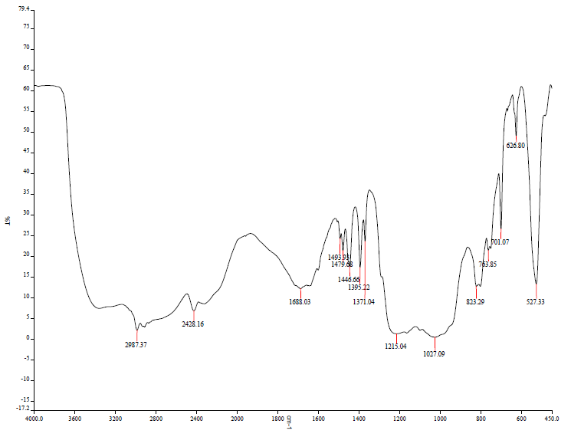
- Dimethyl 3-oxo-1,5-diphenylpennt-4-enylphosphonate 3o
Yield: 56% (yellow oily liquid). IR (KBr): 3444.72, 2985.01, 2089.59, 1659.38, 1613.83 cm⁻¹; 7.54-7.51 (m, 3H), 7.45-7.35 (m, 5H), 7.33-7.27 (m, 2H), 7.25-7.23 (m, 1H), 6.70 (d, J= 16.24 Hz, 1H), 3.99-3.90 (m, 1H), 3.87-3.78 (m, 2H), 3.74 (d, J= 10.72Hz, 3H), 3.48 (d, J= 10.52Hz, 3H); ¹³C NMR (100 MHz, CDCl₃) δ (ppm): 196.34, 163.3, 160.80, 136.45, 133.41, 131.80, 115.54, 6 3.04, 39.20, 29.70, 18.71. HRMS (ESI) m/z calcd for C₁₉H₂₁O₄PNa⁺[M + Na]⁺, 367.1098 ; Found 367.1080.
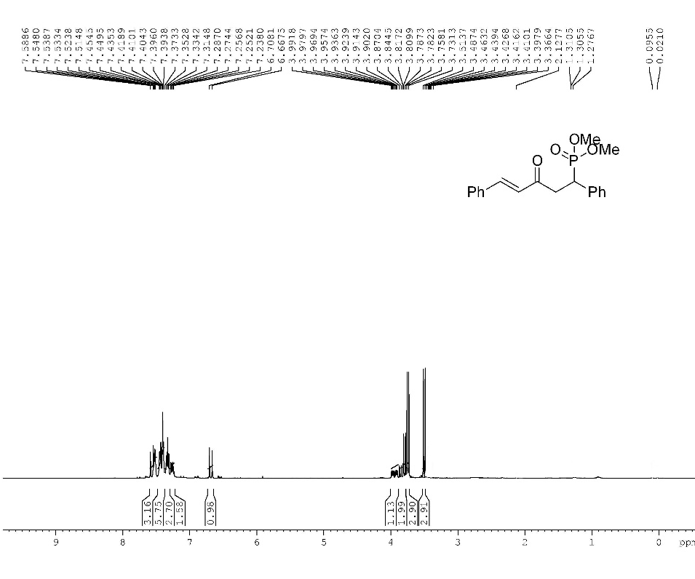
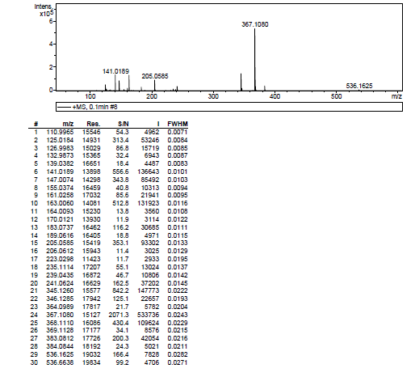
16. Diethyl 3-oxo-1,5-diphenylpennt-4-enylphosphonate 3p
Yield: 67% (yellow oily liquid). IR (KBr): 3444.72, 2985.01, 2089.59, 1659.38, 1613.83 cm⁻¹; ¹H NMR (CDCl₃, 400 MHz) (ppm): 7.58-7.45 (m, 3H), 7.44-7.38 (m, 5H), 7.36-7.28 (m, 2H), 7.25-7.21 (m, 1H), 6.68 (d, J= 16.24 Hz, 1H), 4.16-4.04 (m,2H), 3.96-3.85 (m, 2H), 3.77-3.69 (m, 1H), 3.67-3.34 (m, 2H), 1.31 (t, J= 7.04Hz, 3H), 1.09 (t, J= 7.04Hz, 3H) );¹³C NMR (100 MHz, CDCl3): 195.96, 142.89, 130.35, 129.27, 128.35, 127.12, 126.15, 62.74, 40.16, 38.76; HRMS (ESI) m/z calcd for C₁₉H₂₁O₄P H⁺[M + H]⁺, 345.1253 ; Found 345.1270.
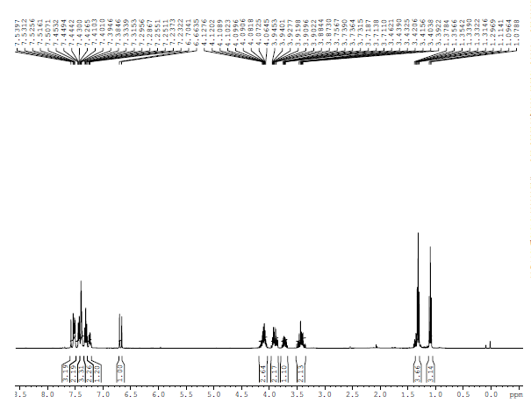
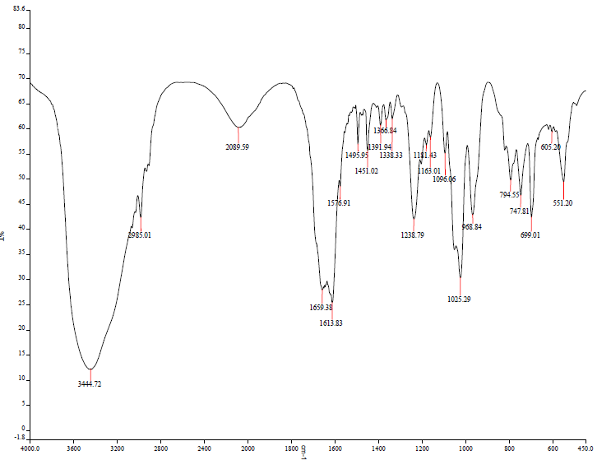
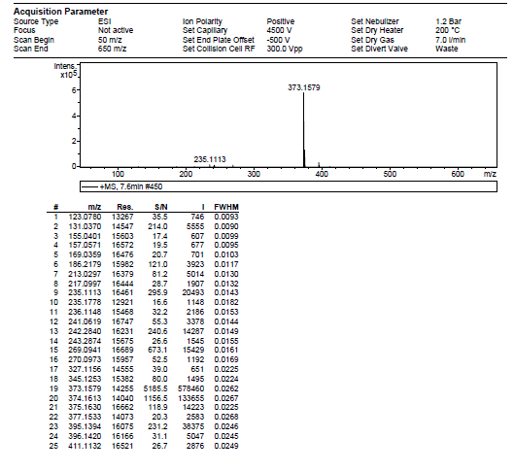
17. Diisopropyl 3-oxo-1, 5-diphenylpent-4-enylphosphonate 3q
Yield: 59% (yellow oily liquid). IR (KBr) cm⁻¹; 3329.77, 2975.95, 1691.04, 1614.20 cm-1; ¹H NMR (CDCl₃, 400 MHz) (ppm): 7.52-7.44 (m, 3H), 7.43-7.39 (m, ,2H), 7.38-7.36 (m, 3H), 7.32-7.28 (m, 2H), 7.24-7.19 (m, 1H), 6.67 (d, J= 16.24Hz, 1H), 4.74-4.66 (m, 1H), 4.44-4.36 (m, 1H), 3.85-3.76 (m, 1H), 3.50-3.30 (m, 2H), 1.32 (q, J= 6.18Hz, 6H), 1.24 (d, J= 12.16 Hz, 3H), 0.86 (d, J= 6.2Hz, 3H); ¹³C NMR (100 MHz, CDCl₃): 196.65, 143.08,134.04, 130.58, 129.50, 128.94, 126.05, 70.43, 39.11, 24.30, 23.08. HRMS (ESI) m/z calcd for C₂₃H₂₉O₄P H⁺ [M + Na]⁺, 423.1870 ; Found 423.1707
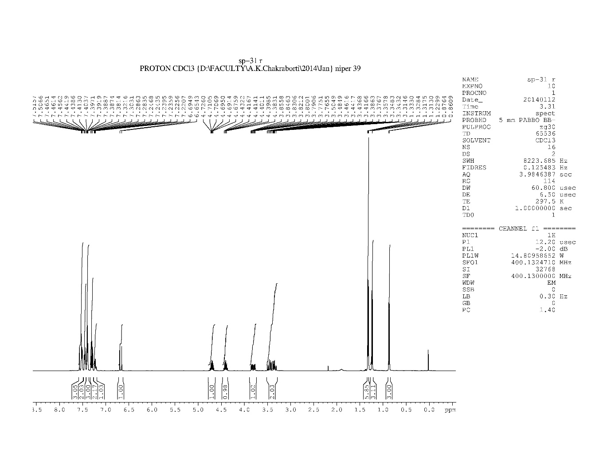
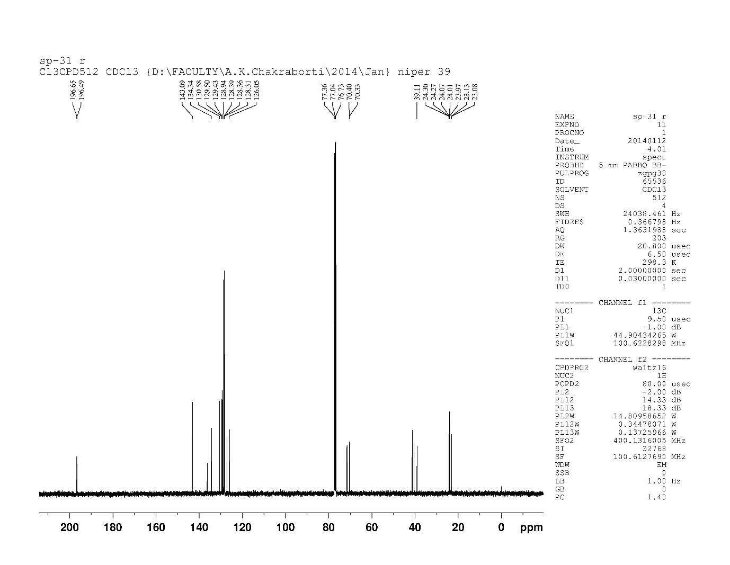
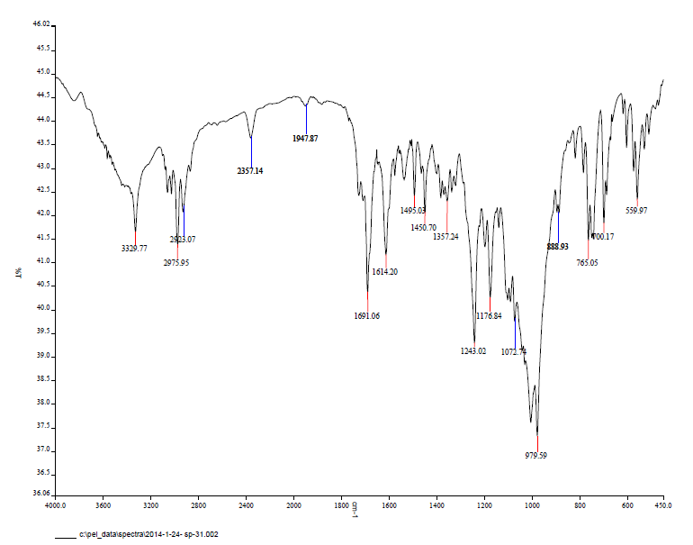
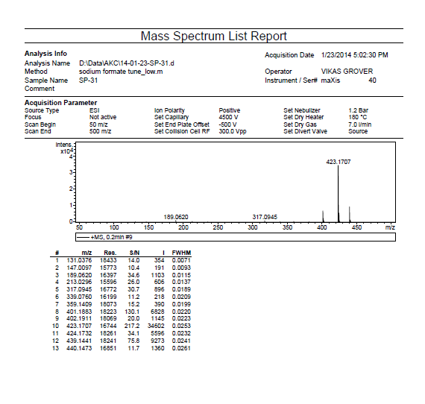
18. Dibutyl 3-oxo-1,5-diphenyl-4-enylphosphonate 3r
Yield: 52% (Yellow oily liquid). IR (KBr) cm⁻¹; 3456.11, 3060.84, 2960.02, 1691.71, 1668.89, 1023.63; 1H NMR (CDCl3, 400 MHz) (ppm):7.56-7.48 (m, 3H), 7.43-7.36 (m, 5H), 7.31-7.27 (m, 2H), 7.23-7.19 (m, 1H), 6.66 (d, J= 16.24Hz, 1H), 4.10-3.80 (m, 5H), 3.65-3.61 (m, 1H), 3.59-3.34 (m, 1H), 1.73-1.58 (m, 3H), 1.42-1.32 (m, 3H), 1.26-1.17 (m, 2H), 0.95-.89 (m, 3H), 0.82 (t, J= 7.2 Hz, 3H), ¹³C NMR (100 MHz, CDCl₃): 196.21, 143.20, 136.02, 134.28, 128.94, 127.25, 125.95, 66.57, 40.99, 32.40, 24.52, 18.76, 13.62; HRMS (ESI) m/z calcd for C₂₅H₃₃O₄PNa⁺ [M + Na]⁺ 451.2020; Found 451.1998
