Supplementary Information for

Globally distributed marine Gemmatimonadota have unique genomic potentials

Xianzhe Gong^{1,2*}, Le Xu¹, Marguerite V. Langwig², Zhiyi Chen^{1,3}, Shujie Huang¹, Duo Zhao¹, Lei Su⁴, Yan Zhang⁴, Christopher A. Francis⁵, Jihua Liu^{1*}, Jiangtao Li^{4*}, Brett J. Baker^{2, 6*}

- Institute of Marine Science and Technology, Shandong University, Qingdao, Shandong, China
- Department of Marine Science, Marine Science Institute, University of Texas at Austin, TX, USA
- State Key Laboratory of Microbial Technology, Shandong University, Qingdao, Shandong, China
- State Key Laboratory of Marine Geology, Tongji University, Shanghai, China
- Departments of Earth System Science & Oceans, Stanford University, CA USA
- Department of Integrative Biology, University of Texas at Austin, TX USA
*Corresponding Authors: Xianzhe Gong xianzhe.gong@gmail.com; Jihua Liu liujihua1982@foxmail.com; Jiangtao Li jtli@tongji.edu.cn; Brett J. Baker acidophile@gmail.com

This PDF file includes:

Supplementary Figs. 1-21

Other Supplementary Information for this manuscript includes the following:

Description of Supplementary Tables 1-15

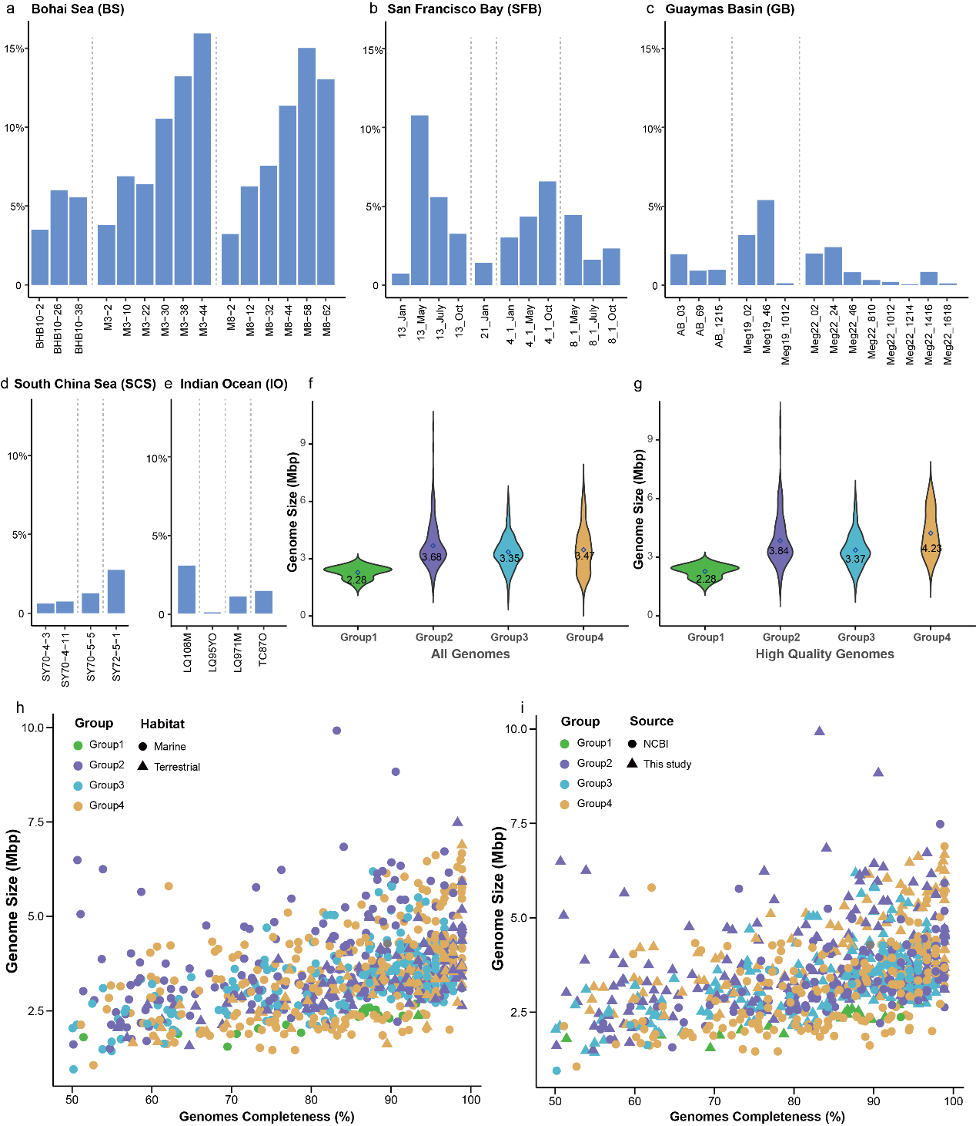

Supplementary Fig. 1 Normalized relative abundance of Gemmatimonadota recovered from five different sites and genome sizes of Gemmatimonadota. Normalized relative abundance of 427, 26, 31, 4, and 7 genomes recovered from 15 sediment samples in Bohai Sea (a), 11 sediment samples in San Francisco Bay (b), 14 sediment samples in Guaymas Basin (c), 4 sediment samples in South China Sea (d), and 4 biomat and oxide samples in Indian Ocean (e), respectively. Genome sizes of all Gemmatimonadota genomes (f) and 245 high-quality MAGs in this study (g) in four groups. Genome size vs estimated completeness of each Gemmatimonadota genome in four groups with different shapes showing their habitats (h) and sources (i).

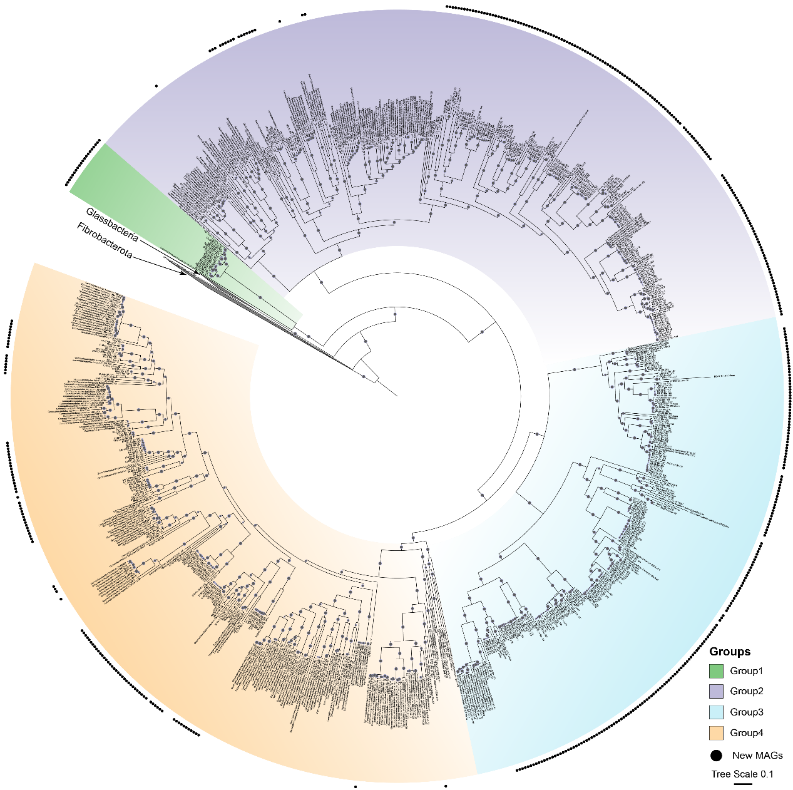

Supplementary Fig. 2 Phylogeny of Gemmatimonadota. A maximum likelihood phylogenetic tree of 851 genomes including the 495 metagenome-assembled genomes (MAGs) (completeness >50% and contamination <10%) described in this study. The phylogeny is based on concatenated protein alignment of 120 single-copy markers in GTDB. The four groups are marked in different background colors with black dots indicating the newly recovered MAGs. Bootstraps are shown in purple circles (≥75).

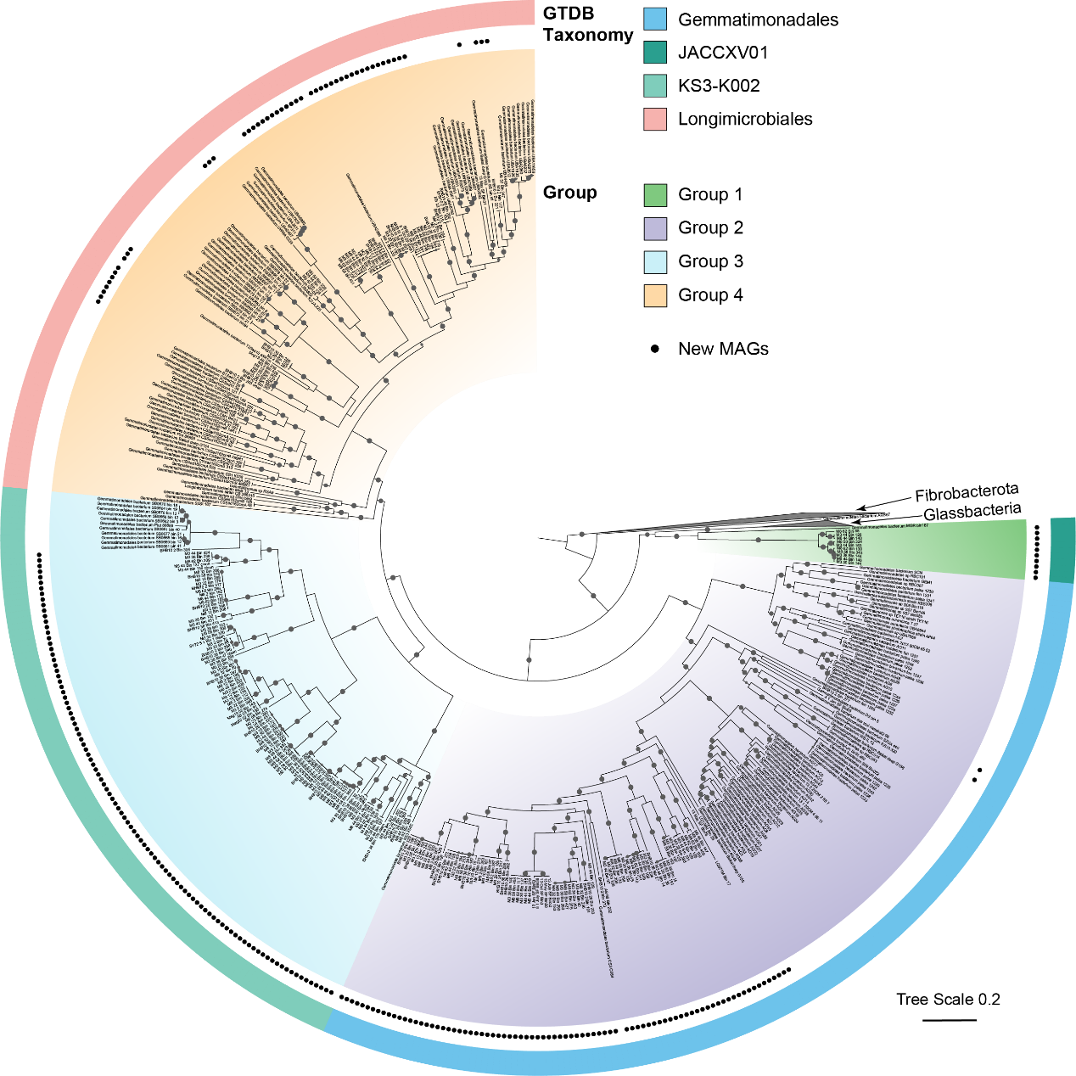

Supplementary Fig. 3 Phylogeny of Gemmatimonadota. A maximum likelihood phylogenetic tree of 456 genomes including the 245 metagenome-assembled genomes (MAGs) (completeness >80% and contamination <5%) described in this study. The phylogeny is based on 37 concatenated ribosomal protein encoding genes identified using PhyloSift. The four groups are marked in different background colors with black dots indicating the newly recovered MAGs. The outer ring indicates the taxonomy assigned by GTDB-Tk v1.5.1 with release 202. Bootstraps are shown in purple circles (≥75).

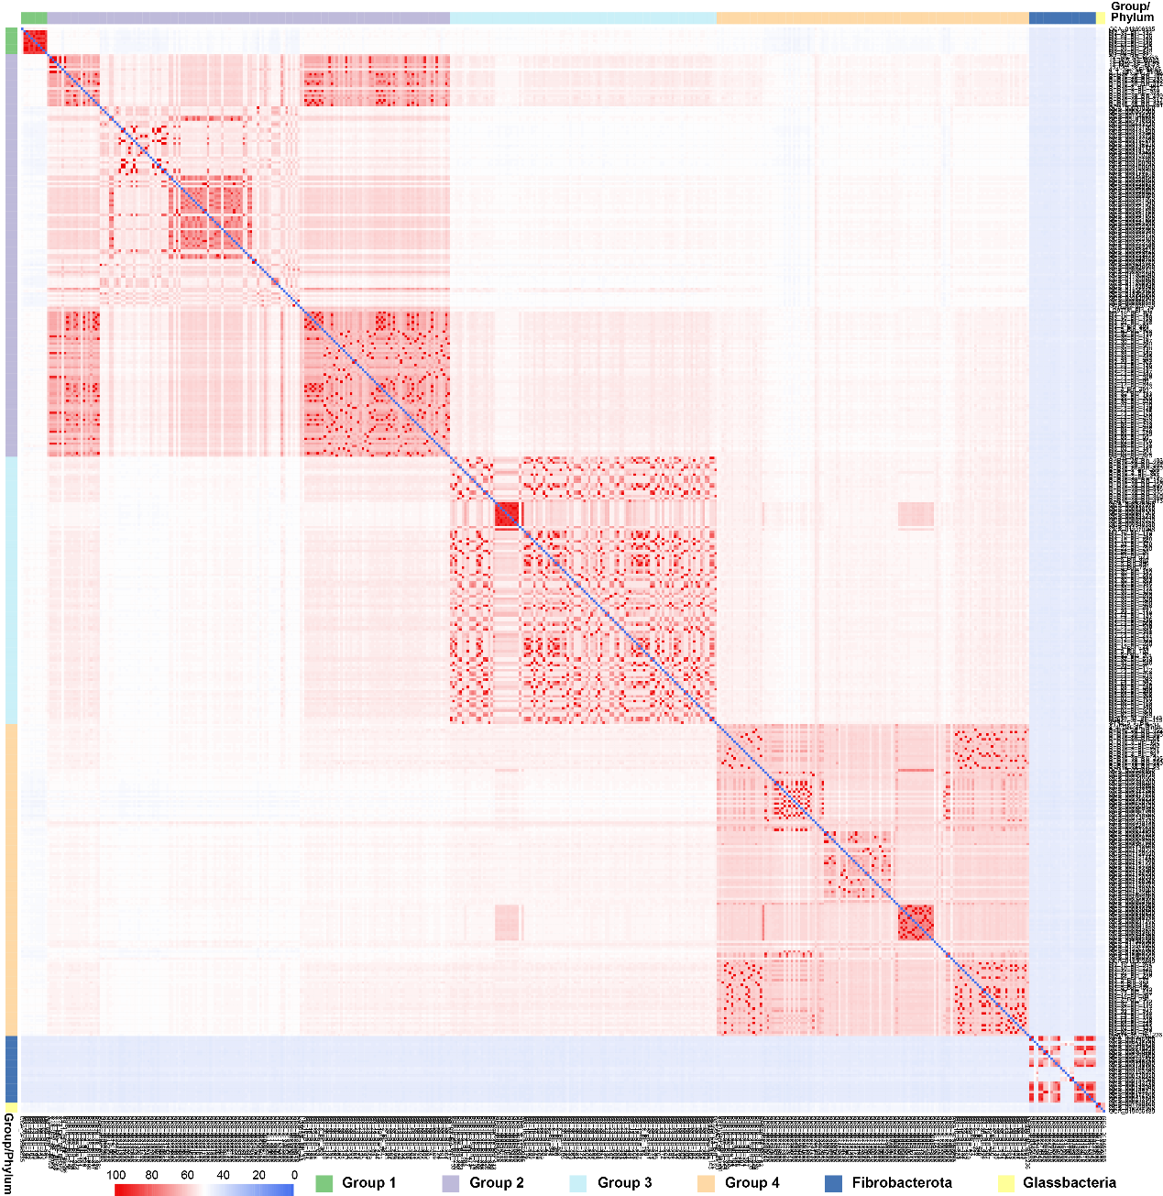Supplementary Fig. 4 Average amino acid identity (AAI) of genomes including Gemmatimonadota. Heatmap using pheatmap package in R based on AAI for each genome pair. Fibrobacterota and Glassbateria genomes were used as reference genomes in the heatmap to show the distinct AAI of four Gemmatimonadota groups compared to other genomes. Genome self-comparisons are presented in blue.

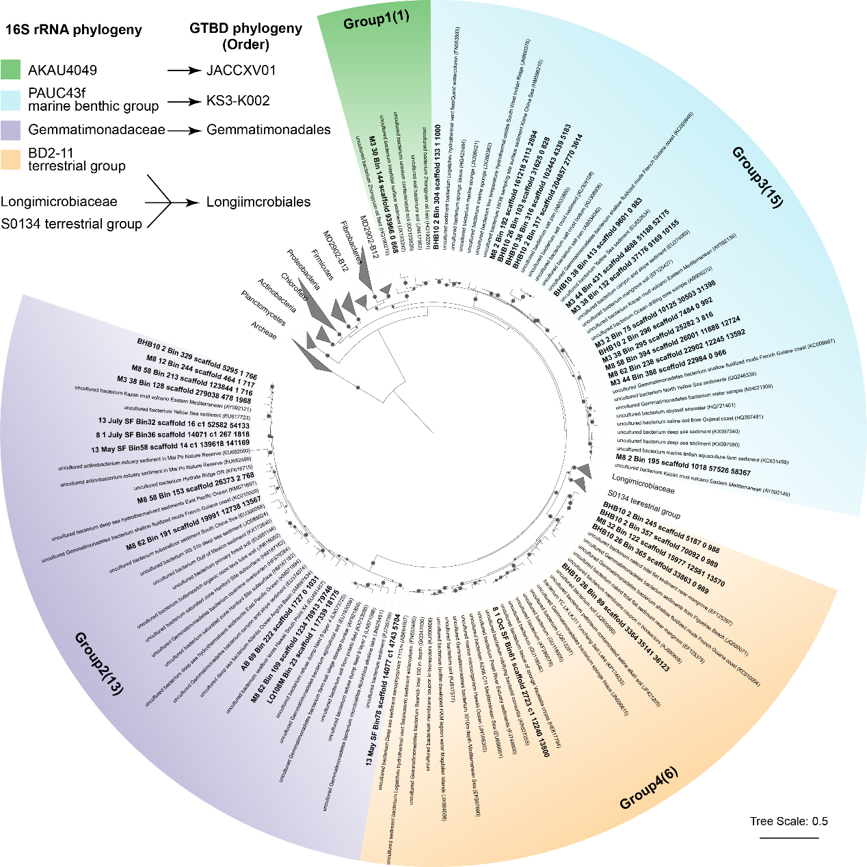Supplementary Fig. 5 Maximum likelihood phylogenetic tree of 16S rRNA genes in these novel bacteria. Sequences recovered from the genomes in this study are shown in bold. The four groups are marked in different background colors. The tree was generated using RAxML in the ARB software package.

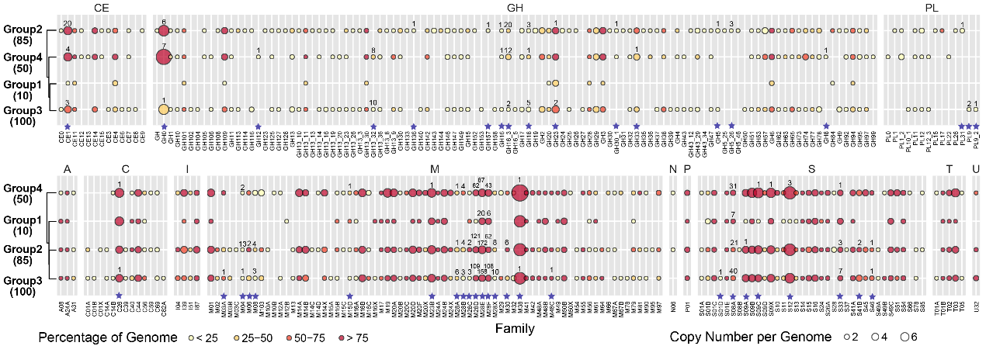Supplementary Fig. 6 Carbohydrate-active enzymes (CAZyme) and peptidase encoded by genomes in this study. (a) CAZymes, including carbohydrate esterase (CE), glycoside hydrolase (GH), and polysaccharide lyase (PL), identified in the four Gemmatimonadota groups. (b) Peptidases, classified as family aspartic (A), cysteine (C), unassigned inhibitors (I), metallo (M), asparagine (N), mixed (P), serine (S), threonine (T), and unknown (U) by the MEROPS database identified in the four Gemmatimonadota groups. Colors filled in the circle denote the percentage of genomes within one group encode the gene. Sizes of the circle denote the average number of gene copies identified in the genome within one group. Asterisk denotes the family identified with potential secretion signal, with a number on top of the circle representing the number of sequences identified with potential secretion signal using PSORTb v3.0. Numbers in brackets denote the total number of genomes in each group. The cluster using pheatmap package in R is based on the normalized data considering the equal contribution by the percentage of genome containing the enzyme and the average copy number per genome in the group.

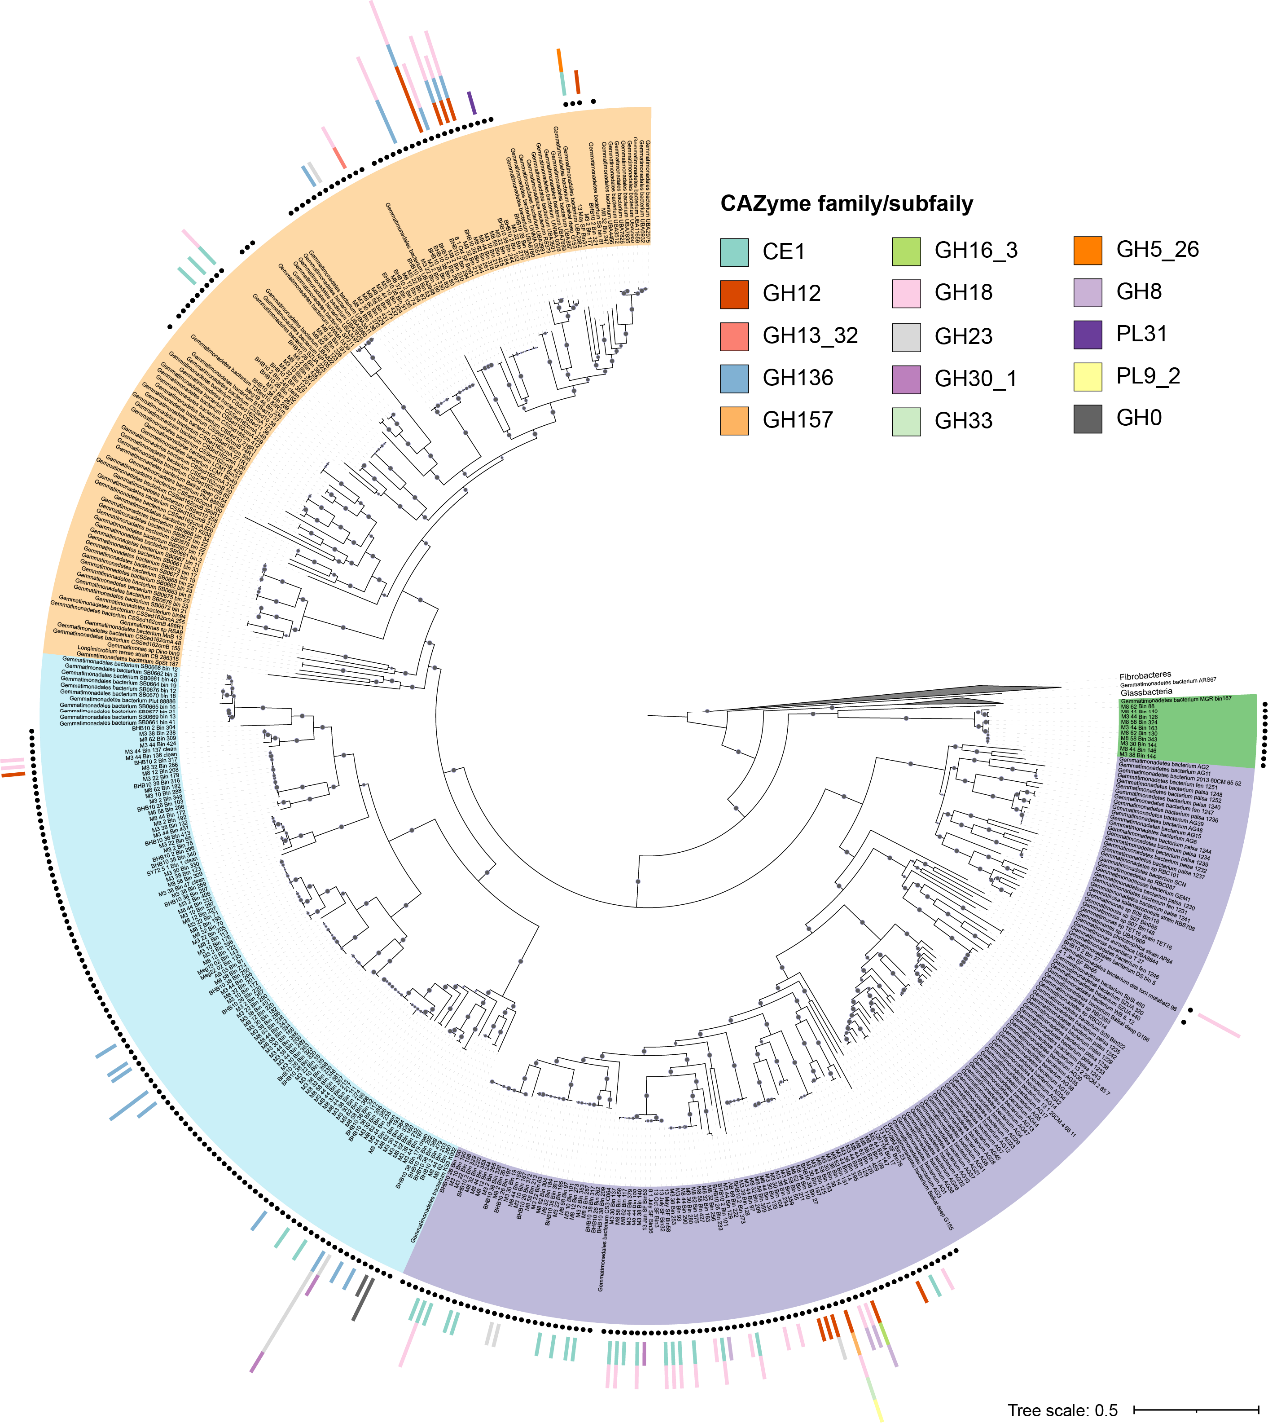Supplementary Fig. 7 Distribution of predicted extracellular CAZymes in each genome. The backbone is the maximum likelihood phylogenetic tree of 456 genomes including the 245 MAGs as shown in Figure 1. The four groups are marked in different background colors with black dots indicating the newly recovered MAGs. The outer bar represents the number of genes in each MAG.

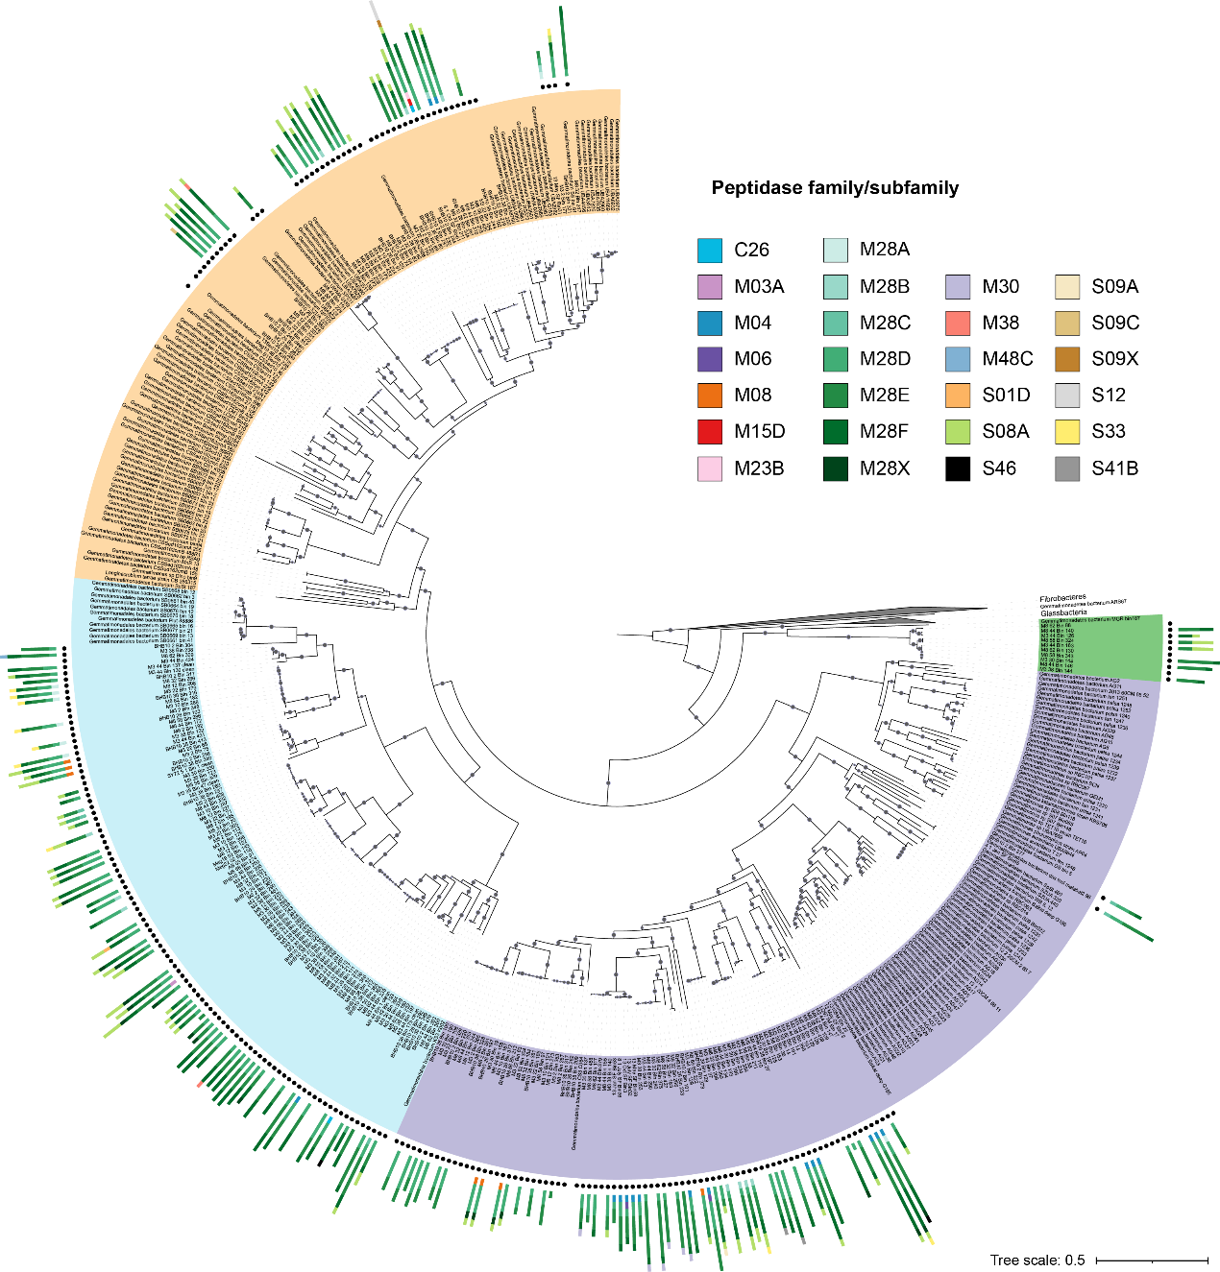Supplementary Fig. 8 Distribution of predicted extracellular peptidases in each genome. The backbone is the maximum likelihood phylogenetic tree of 456 genomes including the 245 MAGs as shown in Figure 1. The four groups are marked in different background colors with black dots indicating the newly recovered MAGs. The outer bar represents the number of genes in each MAG.

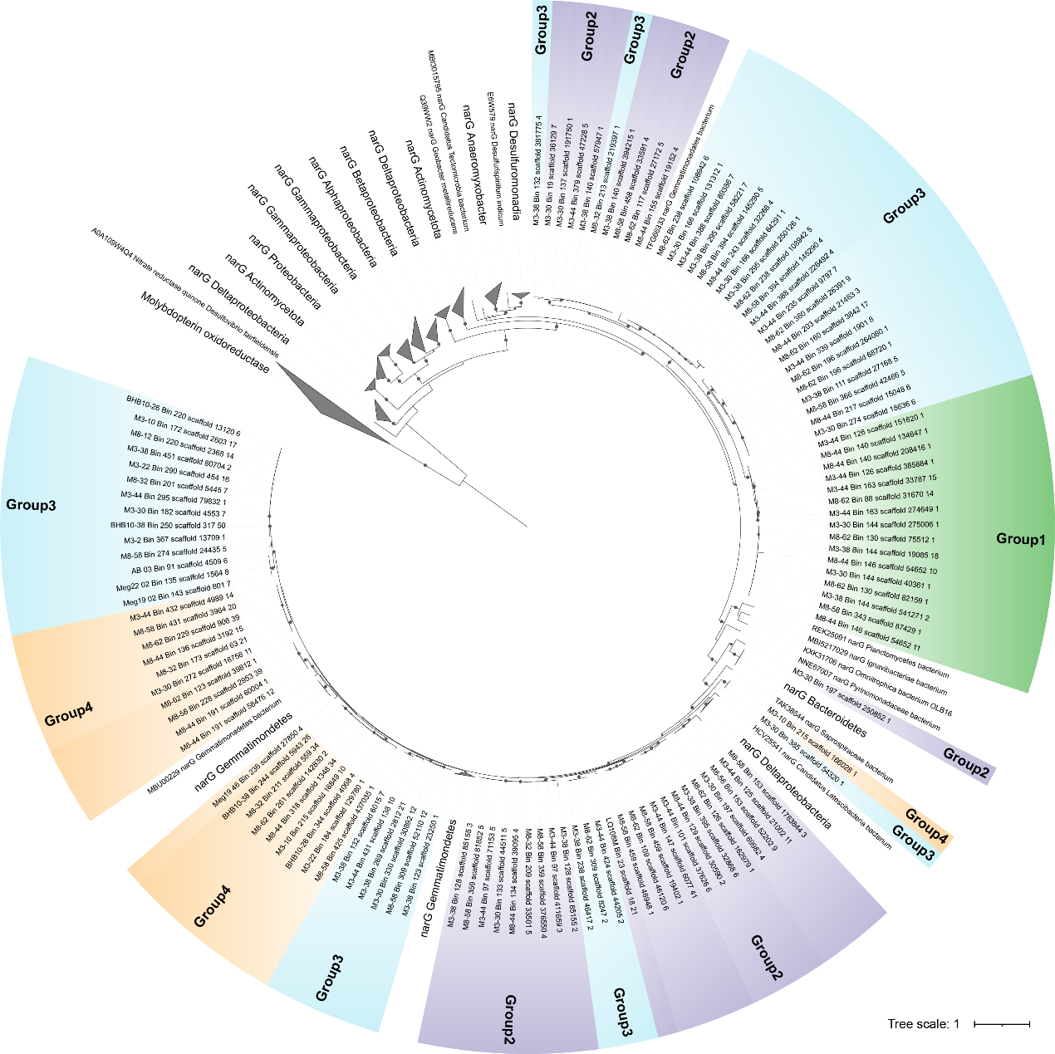Supplementary Fig. 9 Maximum likelihood phylogenetic tree of genes encoding for membrane-bound nitrate reductase (NarG). Bootstrap values ≥80 are shown in circles. Sequences were aligned using MAFFT v7.471, trimmed using trimAl v1.4. The phylogenetic tree was constructed using IQ-TREE v2.1.2.

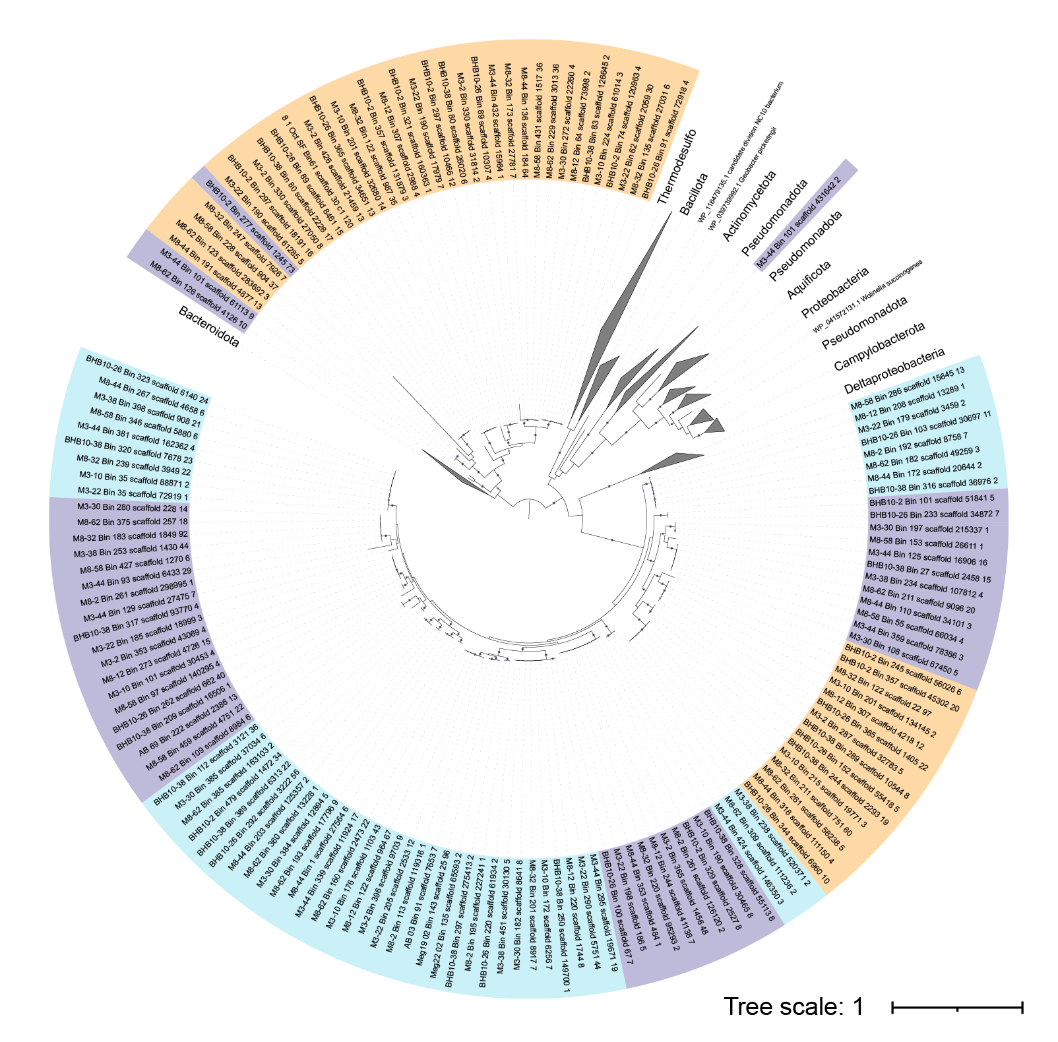Supplementary Fig. 10 Maximum likelihood phylogenetic tree of genes encoding for periplasmic nitrate reductase (NapA). Bootstrap values ≥80 are shown in circles. Sequences were aligned using MAFFT v7.471, trimmed using trimAl v1.4. The phylogenetic tree was constructed using IQ-TREE v2.1.2.

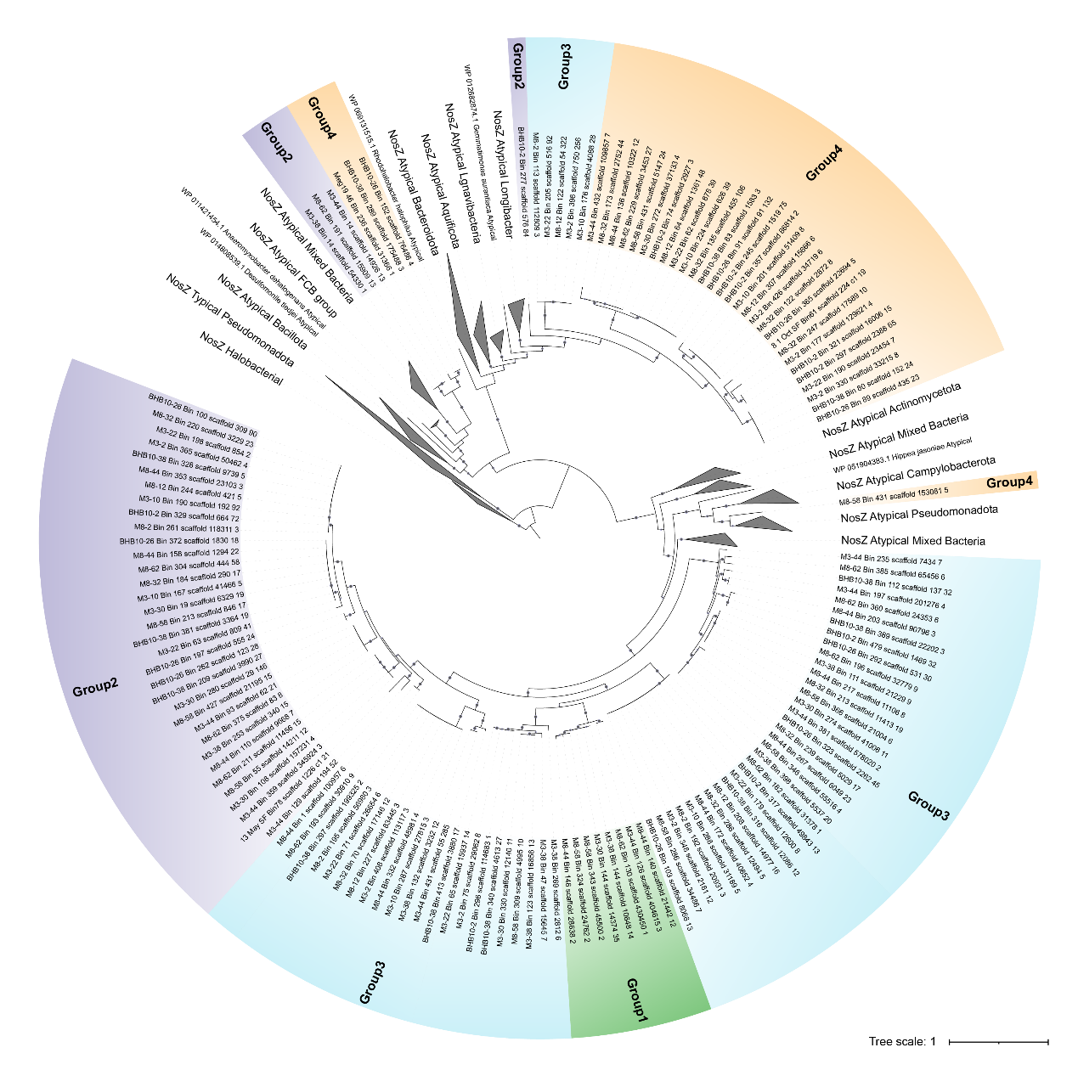Supplementary Fig. 11 Maximum likelihood phylogenetic tree of genes encoding for nitrous oxide reductase (NosZ). Bootstrap values ≥80 are shown in circles. Sequences were aligned using MAFFT v7.471, trimmed using trimAl v1.4. The phylogenetic tree was constructed using IQ-TREE v2.1.2.

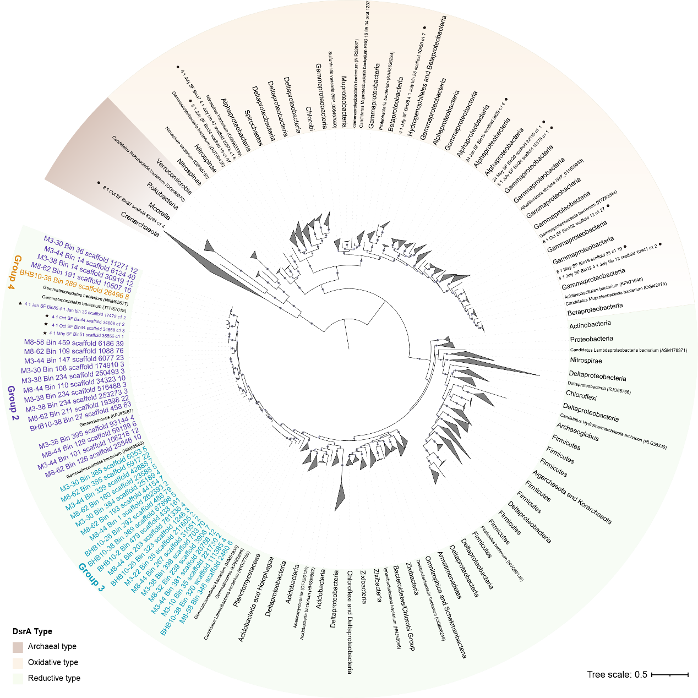Supplementary Fig. 12 Maximum likelihood phylogenetic tree of genes encoding alpha subunit of dissimilatory sulfite reductase (DsrA). Bootstrap values ≥80 are shown in circles. Sequences were aligned using MAFFT v7.471, trimmed using BMGE v1.12. The phylogenetic tree was constructed using IQ-TREE v2.1.2.

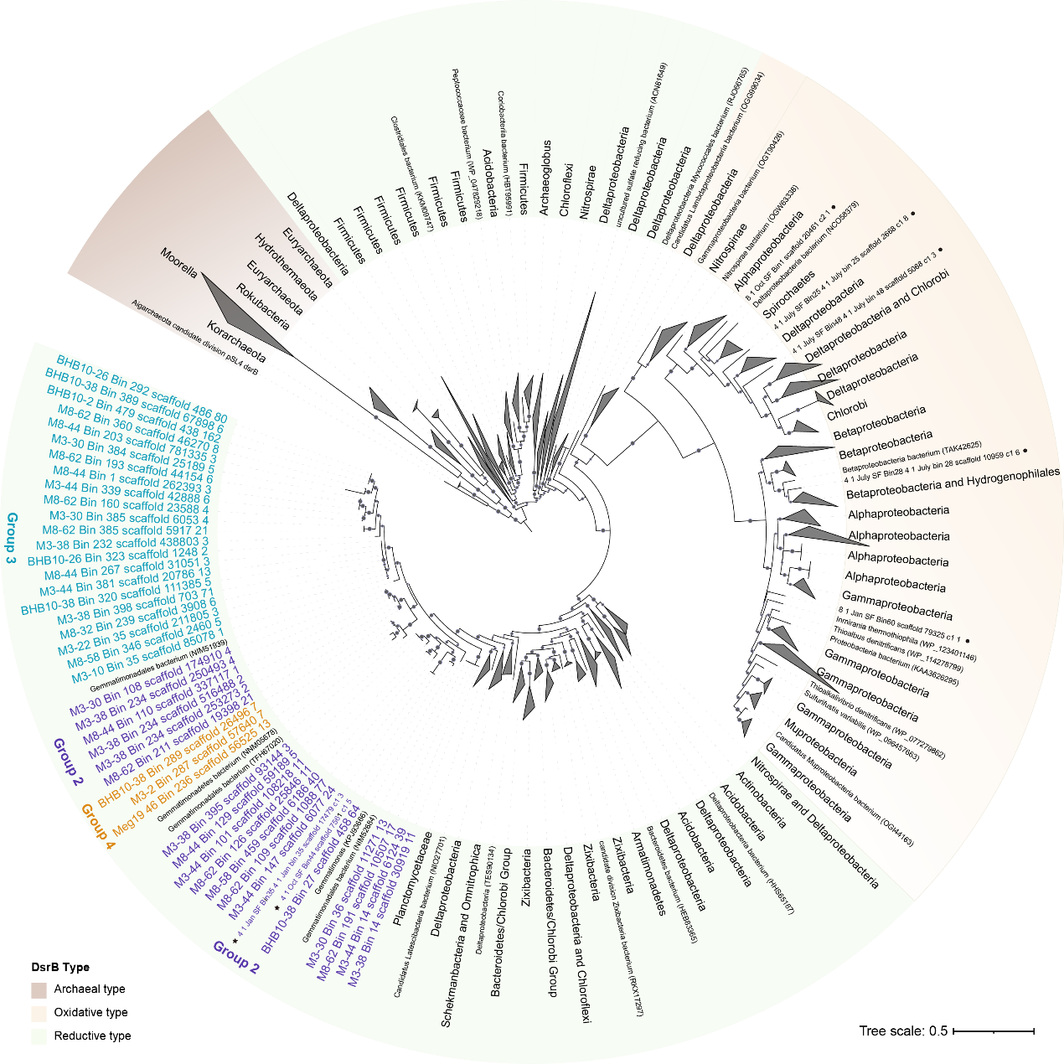Supplementary Fig. 13 Maximum likelihood phylogenetic tree of genes encoding for beta subunit of dissimilatory sulfite reductase (DsrB). Bootstrap values ≥80 are shown in circles. Sequences were aligned using MAFFT v7.471, trimmed using BMGE v1.12. The phylogenetic tree was constructed using IQ-TREE v2.1.2.

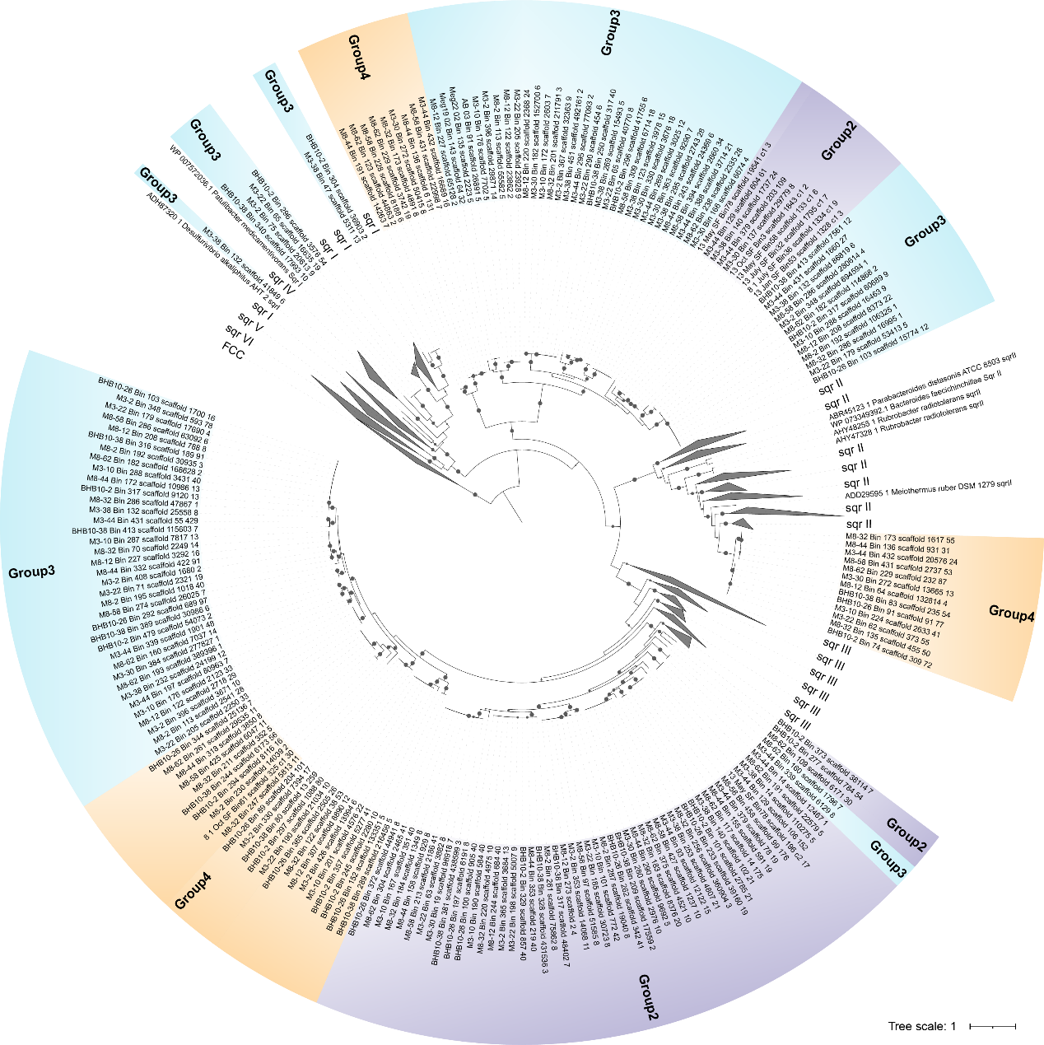Supplementary Fig. 14 Maximum likelihood phylogenetic tree of genes encoding for sulfide-quinone reductase (SQR). Bootstrap values ≥80 are shown in circles. Sequences were aligned using MAFFT v7.471, trimmed using trimAl v1.4. The phylogenetic tree was constructed using IQ-TREE v2.1.2.

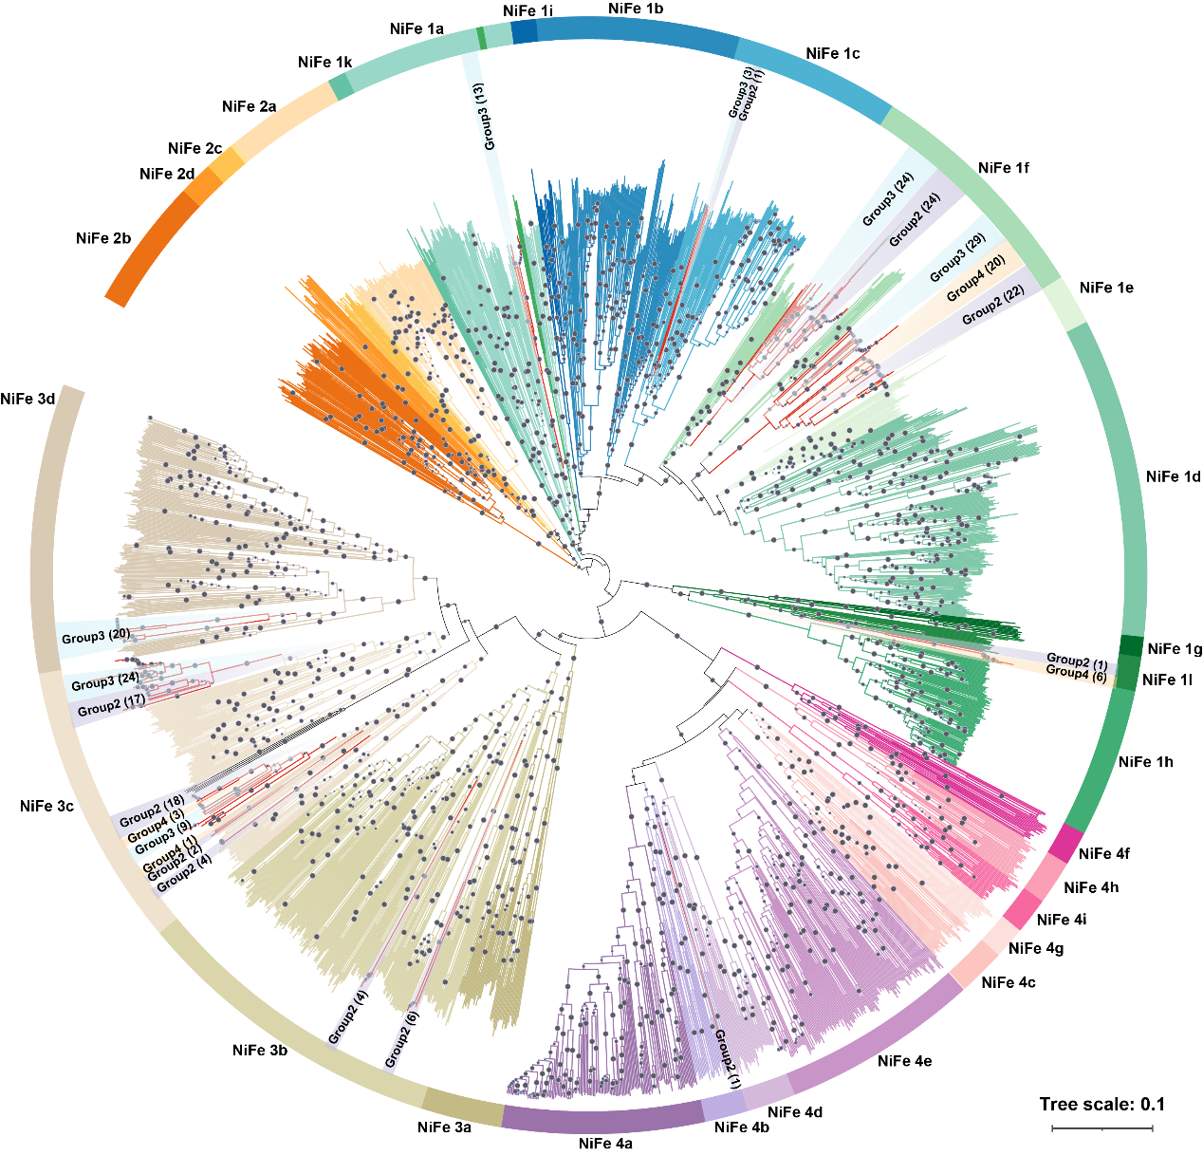Supplementary Fig. 15 Neighbour joining phylogenetic tree of NiFe hydrogenases from Gemmatimonadota MAGs. Bootstrap values ≥80 are shown in circles. Sequences were aligned using Clustalw v2.1. The phylogenetic tree was constructed using MEGA 11.

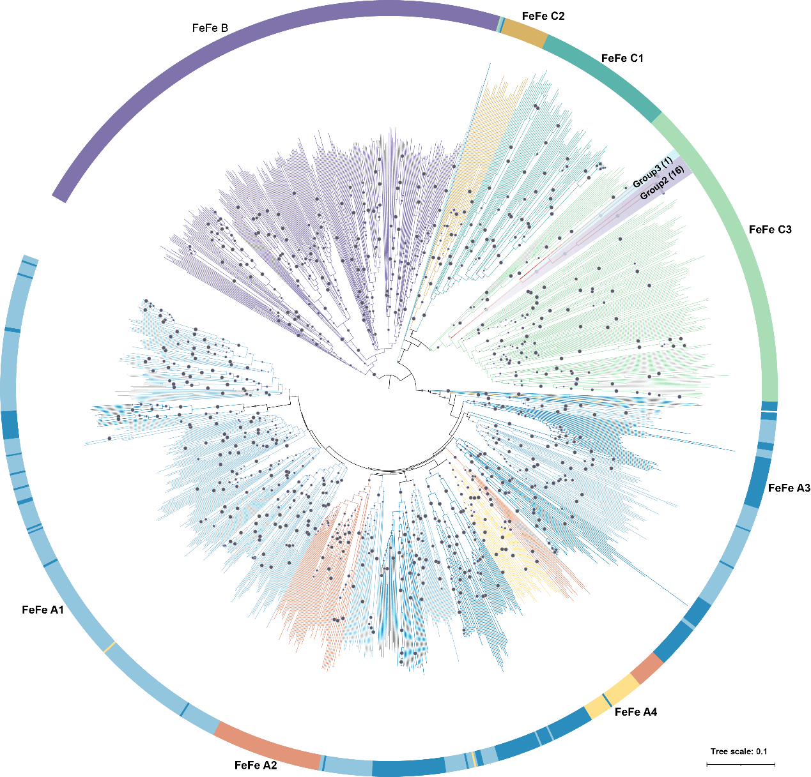Supplementary Fig. 16 Neighbour joining phylogenetic tree of FeFe hydrogenases from Gemmatimonadota MAGs. Bootstrap values ≥80 are shown in circles. Sequences were aligned using Clustalw v2.1. The phylogenetic tree was constructed using MEGA 11.

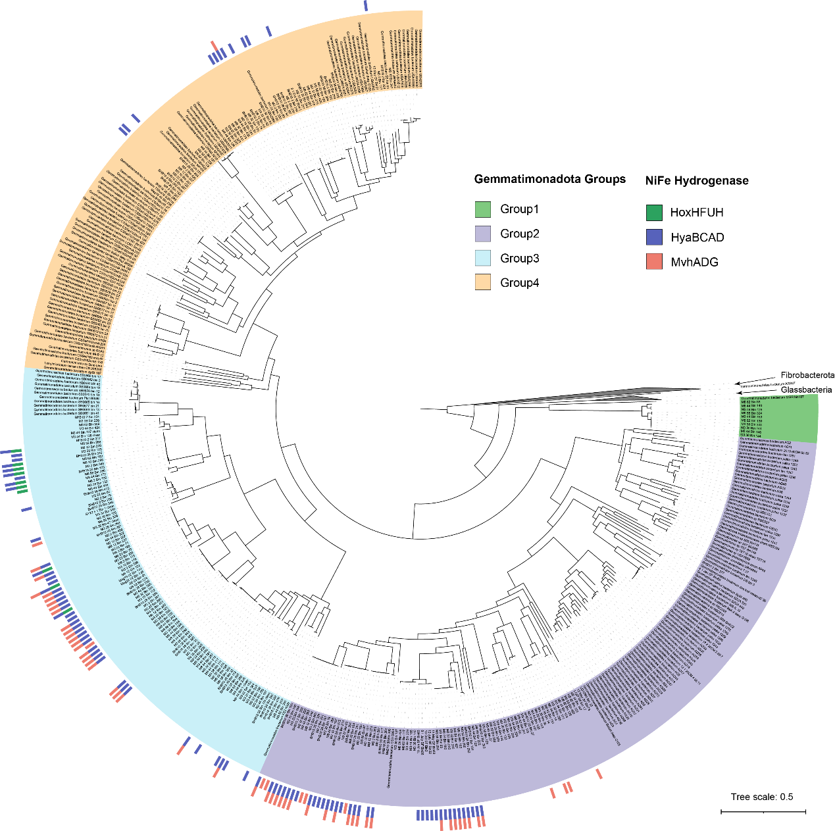Supplementary Fig. 17 Distribution of NiFe hydrogenase in each genome. The backbone is the maximum likelihood phylogenetic tree of 456 genomes including the 245 MAGs as shown in Figure 1. The four groups are marked in different background colors. The outer bar represents the number of genes in each MAG.

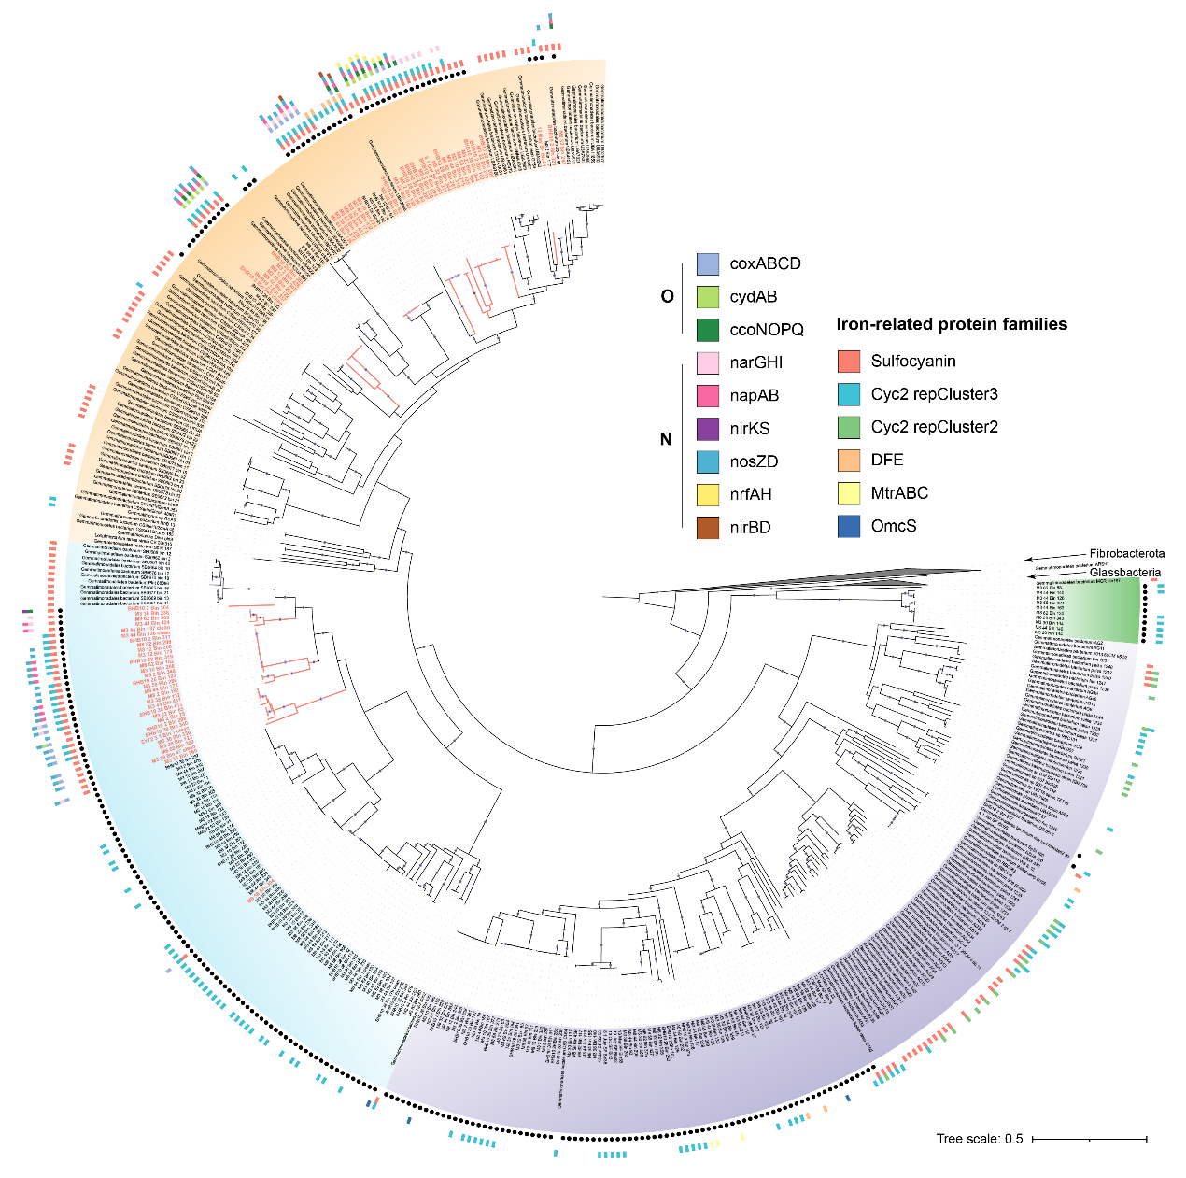Supplementary Fig. 18 Distribution of genes associated with oxygen, nitrogen, and iron cycling in each genome. The backbone is the maximum likelihood phylogenetic tree of 456 genomes including the 245 MAGs as shown in Figure 1. The four groups are marked in different background colors with black dots indicating the newly recovered MAGs. The outer bar represents the number of genes in each MAG. The red branches and names represent MAGs, mainly in Group3 and Group4, containing sulfocyanin. Bootstrap values ≥75 are shown in circles.

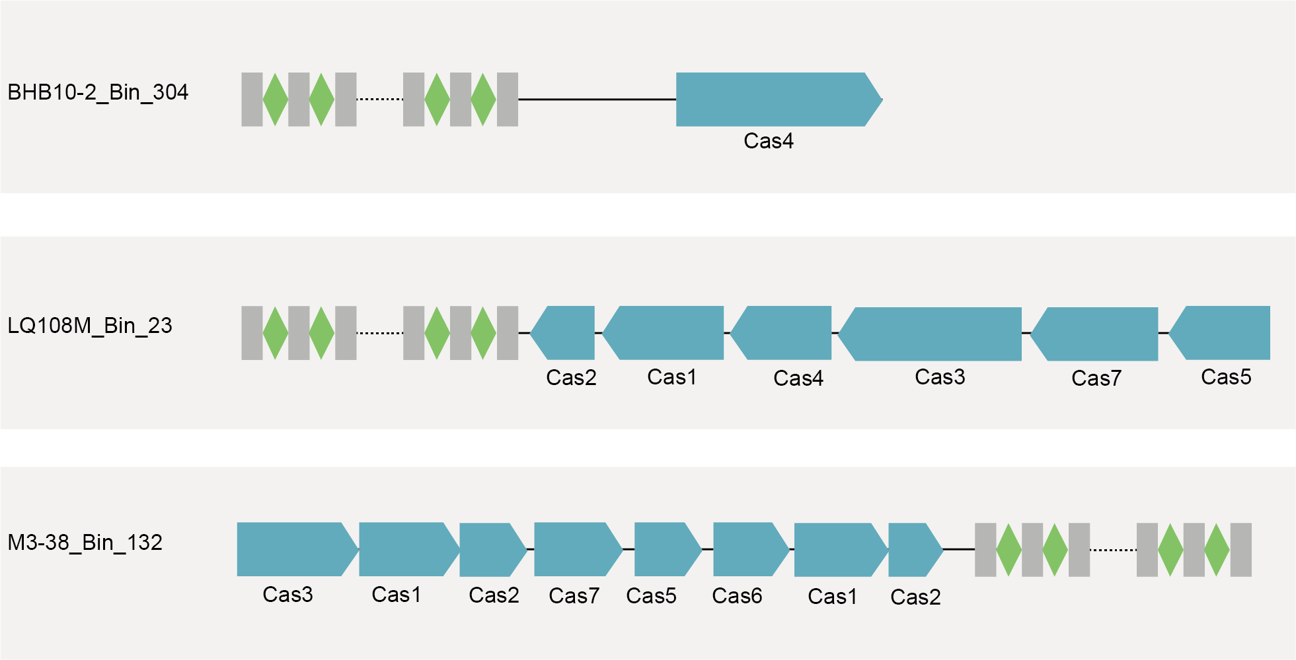Supplementary Fig. 19 CRISPR-Cas identified in three Gemmatimonadota MAGs.

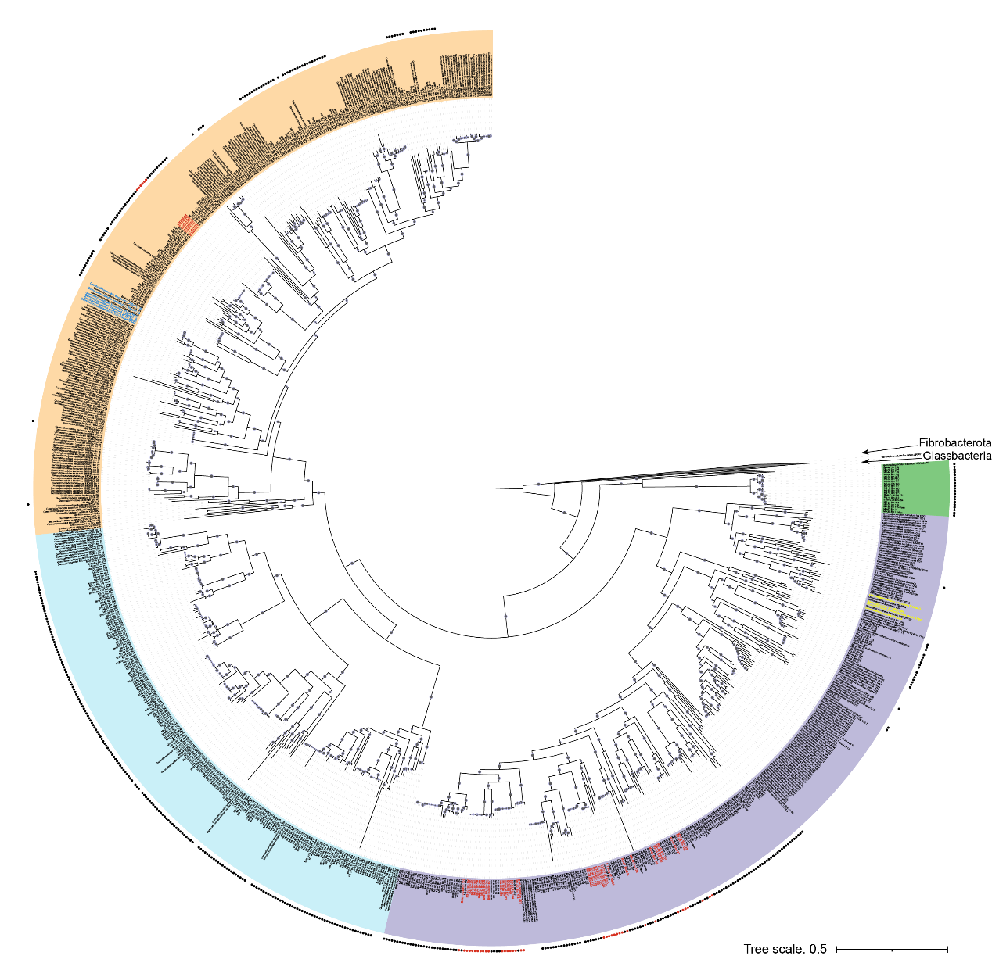Supplementary Fig. 20 Distribution of genes for photosynthesis in each genome. The backbone is the maximum likelihood phylogenetic tree of 456 genomes including the 245 MAGs as shown in Figure 1. The four groups are marked in different background colors with dots indicating the newly recovered MAGs. Red represents MAGs containing RbcL in this study. Blue represents five MAGs, recovered from Soda Lakes, containing Calvin–Benson–Bassham cycles (RbcS, RbcL, and PRK). Yellow represents four MAGs, recovered from lakes, containing photosynthetic gene clusters (PGCs). Bootstrap values ≥75 are shown in circles.

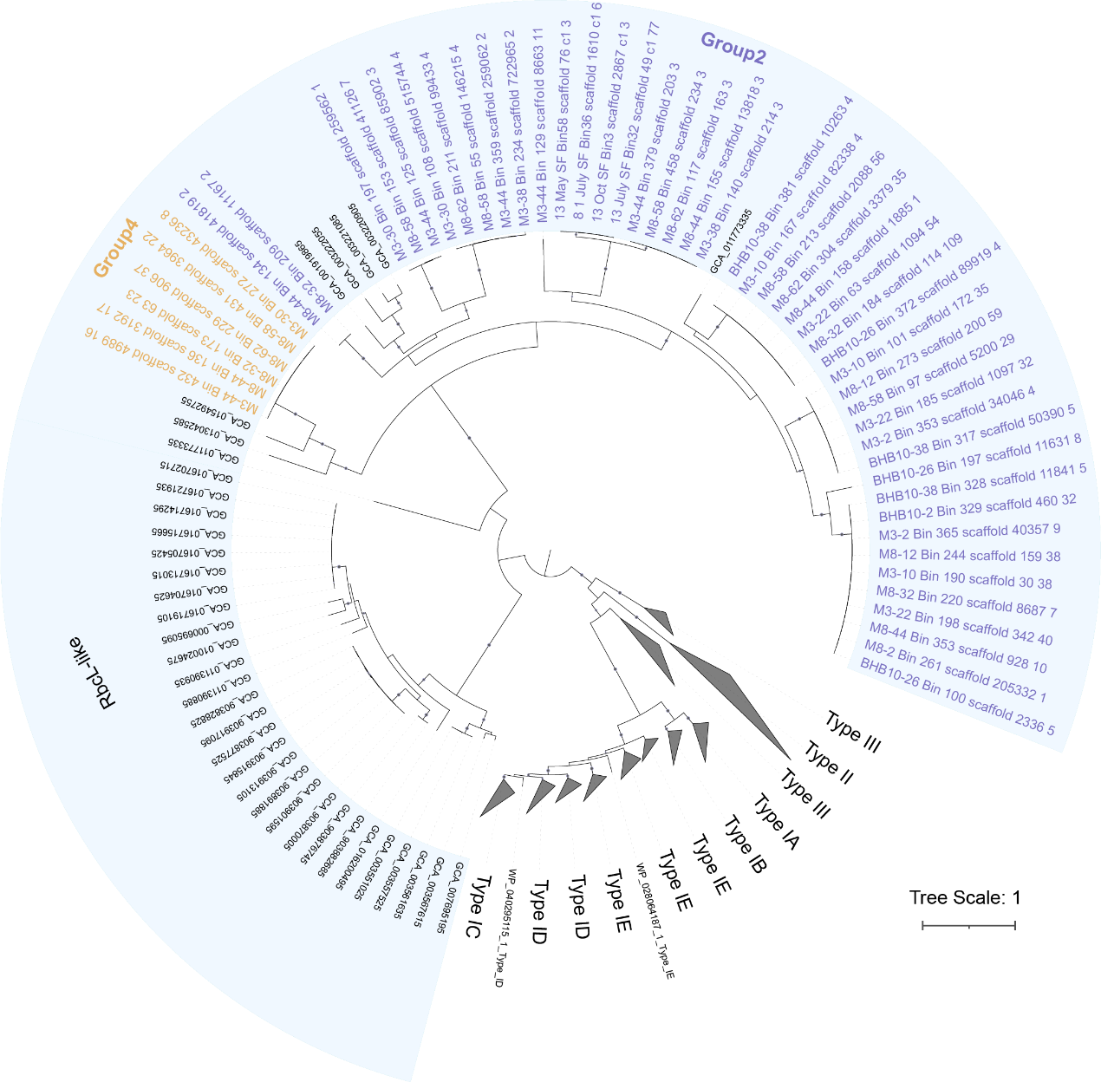Supplementary Fig. 21 Maximum likelihood phylogenetic tree of genes encoding for large subunit of ribulose 1,5-bisphosphate carboxylase/oxygenase (RuBisCO, RbcL) and RbcL-like proteins. Sequences identified in this study are marked in purple (Group2) and yellow (Group4). Bootstrap values ≥80 are shown in circles. Sequences were aligned using MAFFT v7.471, trimmed using trimAl v1.4. The phylogenetic tree was constructed using IQ-TREE v2.1.2.

