Supporting information

A tentative role of vibration-based communication in locust collective behavior
Rakesh Das ^{a,b}, Izhak David,^{b} Amir Ayali ^{b,c,}* and Bat-El Pinchasik ^{a,}*
ª School of Mechanical Engineering, Faculty of Engineering, Tel-Aviv University, Tel-Aviv, 6997801, Israel
^{b} School of Zoology, Faculty of Life Sciences, Tel-Aviv University, Tel-Aviv, 6997801, Israel
^{c} Sagol School for Neuroscience, Tel-Aviv University, Tel-Aviv, 6997801, Israel

Corresponding authors: ayali@tauex.tau.ac.il; pinchasik@tauex.tau.ac.il

Locust-induced vibration measurements
We demonstrate a spontaneous jumping-induced vibration signal generated by a single locust on the substrate at a time when no other locusts were in the arena (Figure 1c). Additional jumping events (n=15) by different locusts (n=3) during the experiment were recorded and averaged in order to obtain the jump-like amplitude. The jump-like signal was characterized by a sinusoidal pulse with a 1.57 ± 0.37 mm/s peak-to-peak velocity amplitude, a frequency of 84.7 ± 2.9 Hz (n=15), and a duration of 100 ms.
The representative walk-like signal is shown in Figure 1d. This signal corresponds to a small group of 15 locusts, randomly walking on the substrate. We performed 4 experiments, with durations of 5 min each, with different groups of 15 locusts each. Here as well, we considered the maximum amplitudes of the transient waveforms, and averaged the maximum amplitudes and frequency of the signals from the different experiments.
The FFT of the jump-like signal (Figure 1c) implies that it consists of single frequency component, characteristic to the substrate. The FFT of the walk-like signal (Figure 1d) implies that this signal has many frequency components, ranging from 58-120 Hz. We characterized the walk-like signal as a sinusoidal pulse with a velocity amplitude of 0.58 ± 0.32 mm/s, a frequency of 88 ± 30 Hz (n = 22), and a varying duration of 200-400 ms. To calculate the average frequency of the walk-like signal, first we measured all the frequency components of each event and determined the range. We averaged the frequency ranges of 22 events from 4 different experiments. In random walking, the frequency components are sparse, therefore, the broad standard deviation.
We also recorded substrate vibration signals generated by the collective marching of 100 locusts on a substrate made of the same material and thickness, but with larger diameter. We performed 3 experiments, with duration of 30 min each. From these experiments, we extracted 12 march-like signals. A typical march-like signal is shown in Figure 2d. We characterized the march-like signal as a sinusoidal pulse with a velocity amplitude of 1 ± 0.35 mm/s (n=12), a frequency of 141 ± 27 Hz (n=12), and a varying duration of 80-120 ms. We measured the maximum amplitudes of each transient signal and its frequency components, and averaged them in order to characterize the amplitudes of march-like signals. In all frequencies, the most dominating frequency component was determined and averaged. The dominating frequency is repetitive and is attributed to the frequency of the synchronized stepping of locusts. At the moment of synchronization, the amplitude became maximal.
In summary, three distinctive locomotion-induced vibration signals were obtained by averaging 15 events from 3 different locusts for jumping, 22 events for non-coordinated walking, and 12 events for a group of 100 locusts for marching.

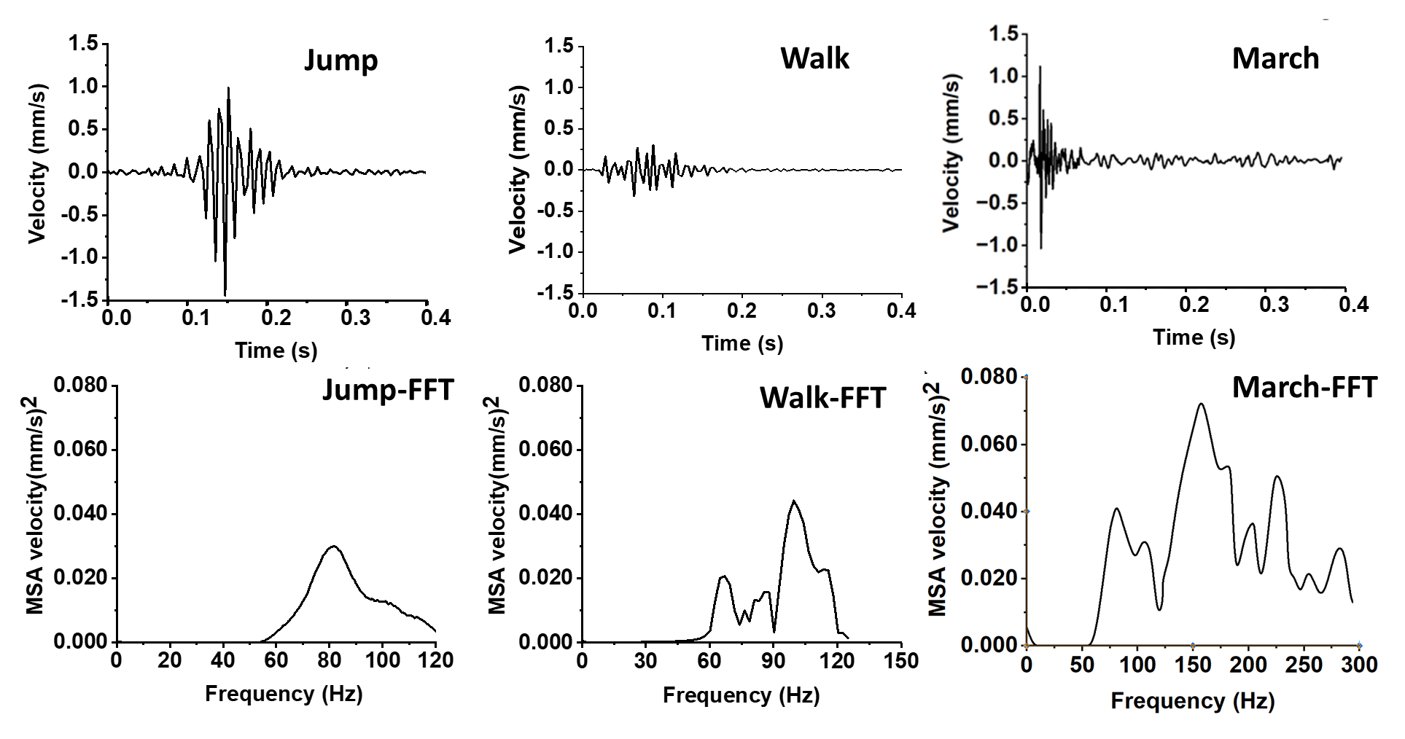
Figure S1. Additional examples of vibration signals generated by jumping, walking, and coordinated marching (top), and their corresponding FFT spectra (bottom).
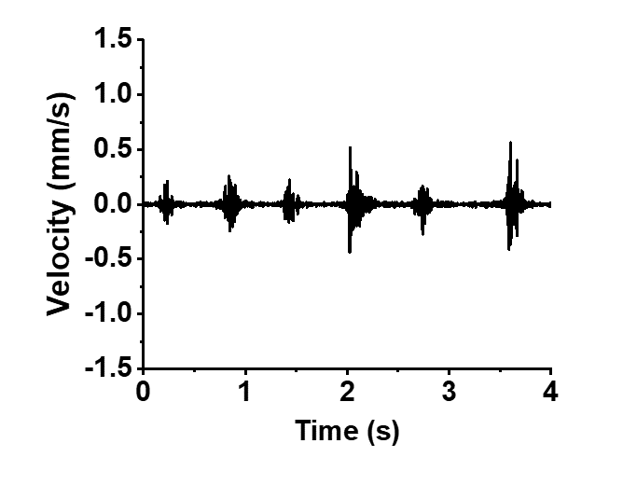
Figure S2. Vibration signals generated by walking locusts for an extended time.

Electrophysiological responses of vibration sensors in the locust legs
In order to determine the sensitivity of the locust leg vibrational sensors to external vibrations, stimuli of varying frequencies, amplitudes, and durations were directly applied to the leg of a locust, tethered in a walking-like posture (Figure 3a). For each tested frequency, a threshold was defined as the lowest excitation velocity for which a neural response was obtained for at least three out of four pulses in a fixed frequency stimulus. Figure 3b depicts the sensory threshold curve for the leg nerve. We used the average of four measurements for each data point in the plot. Representative examples of a characteristic nerve response, above and below the threshold, are shown in Figures 3c and 3d, respectively. The sensory intensity threshold decreases with increasing frequency. Namely, at high frequencies, the mechanosensory neurons respond to stimuli of lower intensity. The neural activity during a stimulus, above the sensory threshold, includes distinct multi-unit (i.e., comprising the activity of different neurons) large amplitude action potentials during the stimulus (Figure 3c). The small amplitude spikes seen outside the time frame of the vibrational signal, or when the signal was below the sensory threshold, may represent non-vibrational related sensory neurons or motor neurons (although there were no leg movements). The duration of vibration pulses did not have an effect on the sensory threshold.
The three types of locust locomotion-related vibrational stimuli are marked in red in the sensory response plot in Figure 3b. The stimulus of a jump-like signal is just on the threshold curve (i.e. able to generate a response) while the walk-like signal is below the threshold. The green region denotes the stimuli range corresponding to the march-like signals. As discussed previously, the march-like signal has a complex waveform, consisting several frequency components of varying amplitudes. A major part of the march-like stimuli range is above the threshold.

