Supplementary Material
Facile synthesis of KOH and ball milling co-modified wheat straw-derived biochar for the efficient adsorption of methylene blue in aqueous solution
Huaiyan Li ¹, Kongyong Ouyang ¹, Xinrui Weng ¹, Lei Wu ², Xinshun Li ¹, Yanhong Shi ¹, Ningyuan Zhang ³, Yunhua Zhang ¹*, Hui Li ¹*

¹ Anhui Province Key Laboratory of Farmland Ecological Conservation and Pollution Prevention, College of Resources and Environment, Anhui Agricultural University, Hefei 230026, China;
² Anhui Provincial Academy of Eco-environmental Science Research, Hefei 230061, China
³ Hefei NO.1 High School, Hefei 230601, China;
* Correspondence: zhpaper@126.com (Hui Li), yunhua9681@163.com (Yunhua Zhang)

This supplementary information contains:
Table S1 Elemental composition on the SEM-EDS of Biochar, KOH-Biochar, BM-Biochar and KOH-BM-Biochar
Table S2 Weber-Morris intraparticle diffusion model in the adsorption process of MB onto Biochar, KOH-Biochar, BM-Biochar and KOH-BM-Biochar
Table S3 Thermodynamics parameters for the adsorption of MB onto KOH-BM-Biochar
Figure S1. KOH-BM-Biochar prepared route with the two-step KOH activated pyrolysis and ball milling co-modified method
Element |  | Biochar | KOH-Biochar | BM-Biochar | KOH-BM-Biochar
C | Wt(%) | 53.31 | 83.53 | 34.63 | 80.42
C | μ | 0.58 | 0.31 | 0.38 | 0.31
C | Atomic(%) | 64.04 | 87.47 | 45.76 | 85.44
N | Wt(%) | 0.42 | - | 0.68 | -
N | μ | 0.48 | - | 0.33 | -
N | Atomic(%) | 0.42 | - | 0.77 | -
O | Wt(%) | 30.31 | 15.16 | 39.49 | 16.53
O | μ | 0.49 | 0.31 | 0.32 | 0.31
O | Atomic(%) | 27.32 | 11.96 | 39.23 | 13.19
Si | Wt(%) | 15.77 | 0.93 | 25.04 | 2.72
Si | μ | 0.19 | 0.04 | 0.19 | 0.05
Si | Atomic(%) | 8.13 | 0.42 | 14.17 | 1.24
Atomic ratio O/C |  | 0.43 | 0.14 | 0.86 | 0.15
Table S1 Scanning electron microscopy-energy dispersive X-ray energy spectroscopy (SEM-EDS) of Biochar, KOH-Biochar, BM-Biochar and KOH-BM-Biochar

Adsorbent | Weber-Morris
Adsorbent | Kp1(mg·g⁻¹·min^{-0.5})) | C1 | (R1)² | Kp2(mg·g⁻¹·min^{-0.5})) | C2 | (R2)² | Kp3(mg·g⁻¹·min^{-0.5})) | C3 | (R3)²
Biochar | 0.043 | 16.468 | 0.0071 | 0.022 | 14.994 | 0.0026 | 0.174 | 20.002 | 0.8226
KOH-Biochar | 1.409 | 84.943 | 0.5415 | 0.956 | 87.722 | 0.9648 | 0.105 | 103.127 | 0.6878
BM-Biochar | 1.909 | 30.633 | 0.8282 | 0.054 | 48.166 | 0.0091 | 2.217 | 34.360 | 0.9981
KOH-BM-Biochar | 2.333 | 129.728 | 0.7548 | 1.650 | 138.408 | 0.9146 | 1.562 | 137.169 | 0.8701
Table S2 Weber-Morris intraparticle diffusion model in the adsorption process of MB onto Biochar, KOH-Biochar, BM-Biochar and KOH-BM-Biochar

Temperature(ºC) | K_{F}(L·mg⁻¹) | K_{e}º | ΔGº (kJ·mol⁻¹) | ΔHº (kJ·mol⁻¹) | ΔSº (J·mol⁻¹·K⁻¹)
25 | 49.61 | 18549179 | -41.46 | 19.72 | 205.46
35 | 68.02 | 25432678 | -43.66 | 19.72 | 205.46
45 | 81.73 | 30558847 | -45.57 | 19.72 | 205.46
Table S3 Thermodynamics parameters for the adsorption of MB onto KOH-BM-Biochar

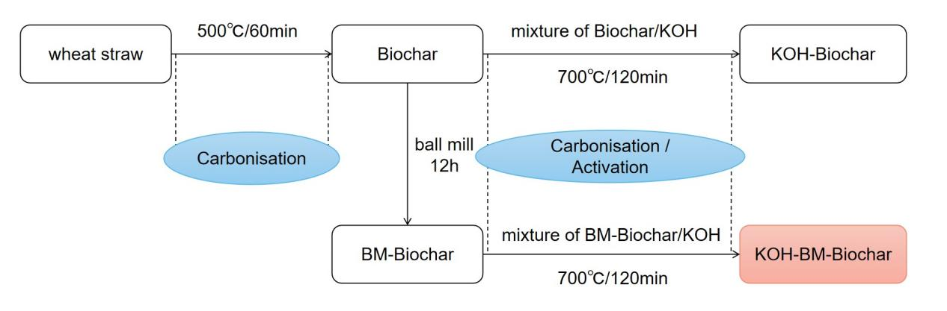
Figure S1. KOH-BM-Biochar prepared route with the two-step KOH activated pyrolysis and ball milling co-modified method

