Supplementary Materials

Supplementary Methods

Details concerning the anatomical and functional data preprocessing steps

Anatomical data preprocessing included T1-weighted (T1w) image bias field correction (Tustison et al. 2010), brain extraction (Avants et al. 2008), tissue segmentation of cerebrospinal fluid (CSF), white-matter (WM) and grey-matter (GM) using FAST (FSL 5.0.10, Zhang et al., 2001), surface reconstruction using recon-all (FreeSurfer 6.0.0, Daleet al., 1999), volume-based spatial normalization to MNI space through nonlinear registration (ANTs 2.2.0). Functional resting-state data preprocessing included slice-timing correction using 3dTshift from AFNI (Cox & Hyde 1997), motion correction using MCFLIRT (FSL v5.0.9) and co-registration with 6 degrees of freedom of the BOLD reference to the T1w reference using boundary-based registration (Greve and Fischl 2009). Motion correcting transformations, BOLD-to-T1w transformation and T1w-to-template (MNI) warp were concatenated and applied in a single step using antsApplyTransforms (ANTs v2.1.0) using Lanczos interpolation. A set of physiological regressors were extracted to allow for component-based noise correction (CompCor, Behzadi et al. 2007). After high-pass filtering the time-series, principal components were estimated. Those retained were sufficient to explain 50 percent of the variance.

Details concerning the anatomical and functional data preprocessing steps

To assess alterations in connectome gradient mapping, we applied generalised Canonical Correlation Analysis (gCCA) to 3-dimensional arrays constituted of parcels x timepoints x subjects using the mvlearn Python module. gCCA extracts a pair of basis vectors from the resting-state timeseries that maximise the mean of correlation coefficients between the pairwise spatial maps of the subjects and derives a set of shared components across individuals. These components, orthogonal linear combinations of the variables within each set, best explain the variability both within and between sets and represent a shared feature of connectivity, with the canonical coefficient of each feature representing its contribution in the final linear combination. To ensure the same features were extracted in each group, this dimensionality reduction analysis was applied to all subjects together and then subjects were subdivided into FTD variant groups or controls. The functional connectome was thus decomposed into latent components (or gradients), which explain varying levels of variance in connectivity and discriminate across levels of the cortical hierarchy. For each subject, parcel-specific gradient embedding values reflect the similarity in connectivity pattern along the given gradient axis, resulting in a continuous coordinate system where distance represents connectivity.

Supplementary Figures

Supp. Fig. 1

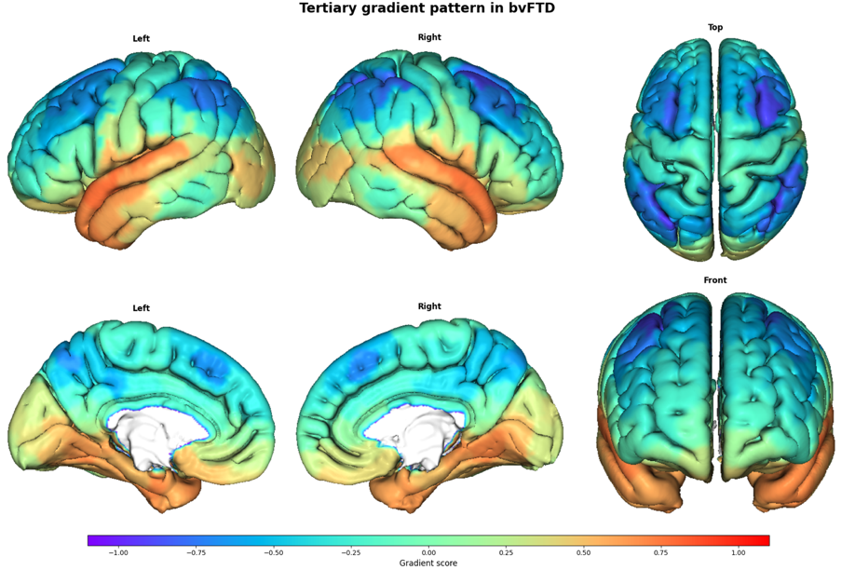

Embedding values for the tertiary gradient in controls projected on the cortical surface.

Supp. Fig. 2

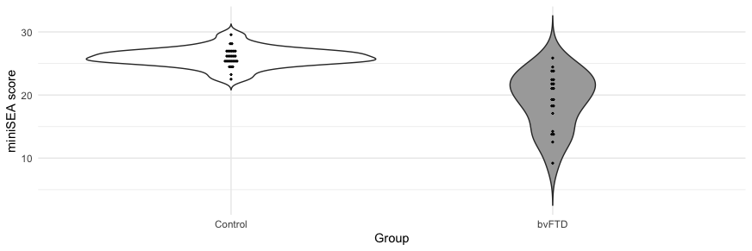

Violin plot of bvFTD and control groups’ performance on the miniSEA task. bvFTD = behavioural-variant FTD; miniSEA= mini Socioemotional Assessment

Supp. Fig. 3
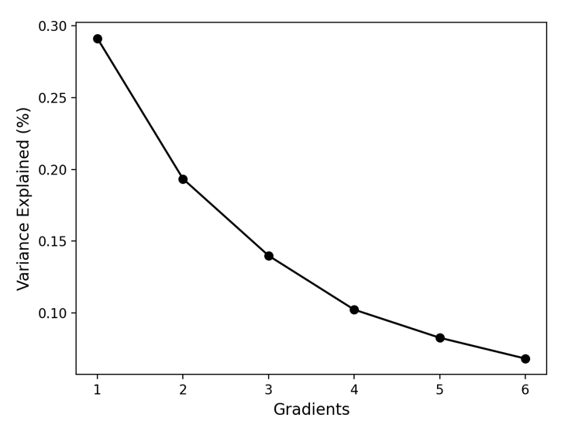

Scree plot showing percentage of variance explained by each gradient in controls. The principal gradient (gradient 1) explained 29% of the variance, while the secondary gradient (gradient 2) explained a further 19%.

Supp. Table 1

Statistical results from the mixed model comparing parcel principal and secondary gradient embedding values within resting-state networks between controls and each FTD group.
Principal gradient
Contrast | Network | estimate | SE | z-ratio | p-value | corrected p-value
bvFTD  vs  controls | Dorsal attentional | 0.021 | 0.009 | 2.28 | 0.07 | 0.09
bvFTD  vs  controls | Default-mode | -0.084 | 0.007 | -12.79 | <0.0001 | <0.0001
bvFTD  vs  controls | Frontoparietal | 0.021 | 0.009 | 2.45 | 0.04 | 0.06
bvFTD  vs  controls | Limbic | 0.016 | 0.012 | 1.31 | 0.29 | 0.33
bvFTD  vs  controls | Salience | 0.049 | 0.009 | 5.38 | <0.0001 | <0.0001
bvFTD  vs  controls | Sensorimotor | 0.001 | 0.007 | 0.17 | 0.87 | 0.87
bvFTD  vs  controls | Visual | 0.045 | 0.008 | 5.66 | <0.0001 | <0.0001
svPPA  vs  controls | Dorsal attentional | -0.006 | 0.012 | -0.51 | 0.61 | 0.61
svPPA  vs  controls | Default-mode | -0.007 | 0.009 | -0.79 | 0.43 | 0.60
svPPA  vs  controls | Frontoparietal | 0.025 | 0.012 | 2.14 | 0.04 | 0.08
svPPA  vs  controls | Limbic | -0.084 | 0.016 | -5.08 | <0.0001 | <0.0001
svPPA  vs  controls | Salience | 0.012 | 0.012 | 0.94 | 0.52 | 0.61
svPPA  vs  controls | Sensorimotor | 0.026 | 0.010 | 2.67 | 0.01 | 0.04
svPPA  vs  controls | Visual | -0.012 | 0.011 | -1.08 | 0.42 | 0.60
nfvPPA  vs  controls | Dorsal attentional | 0.007 | 0.012 | 0.57 | 0.61 | 0.84
nfvPPA  vs  controls | Default-mode | -0.038 | 0.008 | -4.52 | <0.0001 | <0.0001
nfvPPA  vs  controls | Frontoparietal | -0.023 | 0.011 | -2.10 | 0.04 | 0.08
nfvPPA  vs  controls | Limbic | -0.012 | 0.015 | -0.77 | 0.44 | 0.77
nfvPPA  vs  controls | Salience | -0.002 | 0.012 | -0.14 | 0.89 | 0.89
nfvPPA  vs  controls | Sensorimotor | 0.058 | 0.009 | 6.44 | <0.0001 | <0.0001
nfvPPA  vs  controls | Visual | 0.004 | 0.010 | 0.36 | 0.72 | 0.84

Secondary gradient
Contrast | Network | estimate | SE | z-ratio | p-value | corrected p-value
bvFTD  vs  controls | Dorsal attentional | -0.029 | 0.010 | -2.92 | 0.01 | 0.01
bvFTD  vs  controls | Default-mode | 0.022 | 0.007 | 3.14 | 0.005 | 0.007
bvFTD  vs  controls | Frontoparietal | -0.032 | 0.009 | -3.38 | 0.002 | 0.004
bvFTD  vs  controls | Limbic | -0.037 | 0.013 | -2.80 | 0.007 | 0.009
bvFTD  vs  controls | Salience | 0.069 | 0.010 | 6.93 | <0.0001 | <0.0001
bvFTD  vs  controls | Sensorimotor | -0.085 | 0.008 | -10.90 | <0.0001 | <0.0001
bvFTD  vs  controls | Visual | 0.086 | 0.009 | 9.82 | <0.0001 | <0.0001
svPPA  vs  controls | Dorsal attentional | 0.022 | 0.014 | 1.65 | 0.15 | 0.26
svPPA  vs  controls | Default-mode | 0.008 | 0.010 | 0.88 | 0.57 | 0.57
svPPA  vs  controls | Frontoparietal | 0.014 | 0.013 | 1.10 | 0.31 | 0.36
svPPA  vs  controls | Limbic | -0.057 | 0.018 | -3.16 | 0.004 | 0.01
svPPA  vs  controls | Salience | -0.015 | 0.013 | -1.09 | 0.27 | 0.36
svPPA  vs  controls | Sensorimotor | -0.054 | 0.010 | -5.19 | <0.0001 | <0.0001
svPPA  vs  controls | Visual | 0.063 | 0.012 | 5.33 | <0.0001 | <0.0001
nfvPPA  vs  controls | Dorsal attentional | 0.006 | 0.013 | 0.46 | 0.65 | 0.65
nfvPPA  vs  controls | Default-mode | 0.004 | 0.009 | 0.46 | 0.64 | 0.65
nfvPPA  vs  controls | Frontoparietal | 0.012 | 0.012 | 1.01 | 0.31 | 0.44
nfvPPA  vs  controls | Limbic | -0.040 | 0.017 | -2.39 | 0.02 | 0.03
nfvPPA  vs  controls | Salience | 0.078 | 0.013 | 6.18 | <0.0001 | <0.0001
nfvPPA  vs  controls | Sensorimotor | -0.111 | 0.010 | -11.29 | <0.0001 | <0.0001
nfvPPA  vs  controls | Visual | 0.077 | 0.011 | 6.95 | <0.0001 | <0.0001

Supp. Fig. 4

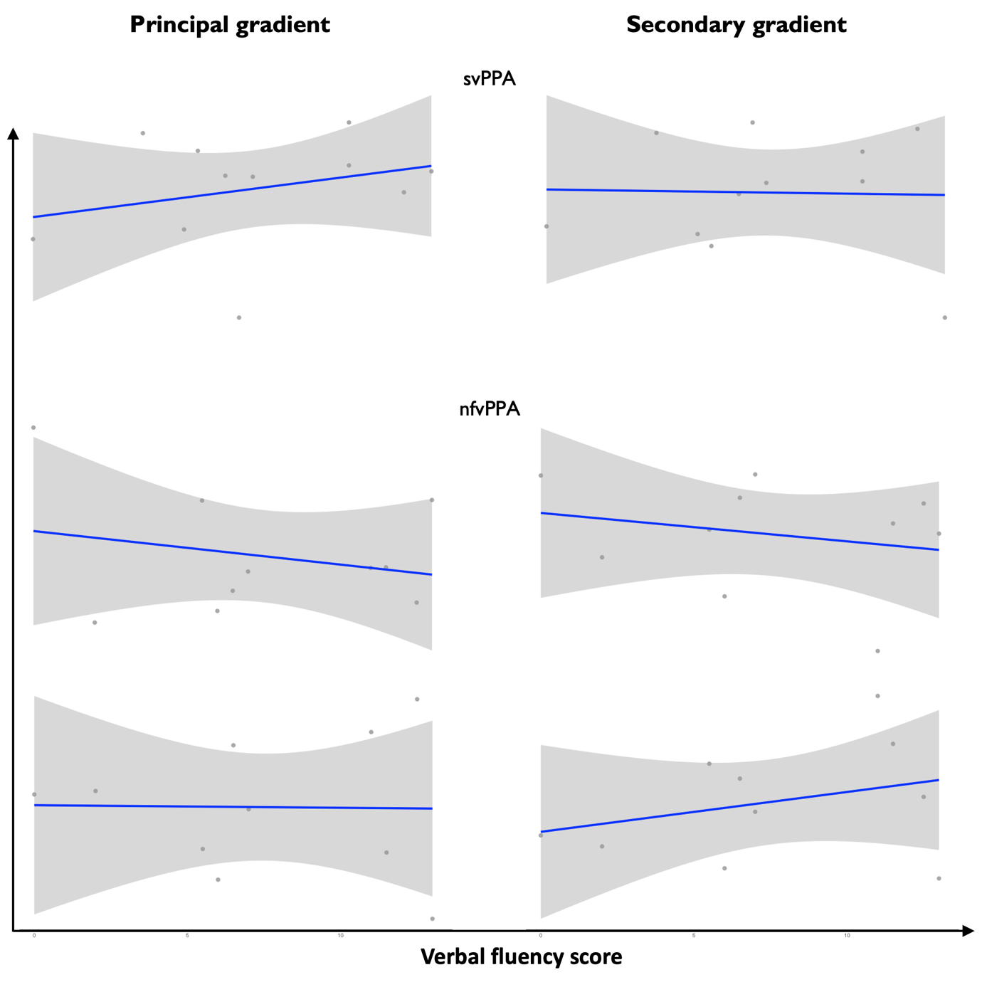

Linear relationships between verbal fluency and extreme-end networks’ embedding values along the principal (left) and secondary (right) gradients in svPPA (top) and nfvPPA (bottom) patients. Correlations were not computed due to limited sample sizes.

