Supporting file
Nanoarchitectonics of Zanthoxylum armatum DC. Seed Derived Zinc Chloride Activated Carbon as Negatrode Material for Supercapacitor Applications
Deval Prasad Bhattarai¹, Khem Raj Shrestha², Puspa Lal Homagai¹, Timila Shrestha¹, Pawan Kumar Mishra¹, Hari Bhakta Oli¹, Ganesh Prasad Awasthi³, Changho Yu ^{3,4*}, Ram Lal (Swagat) Shrestha^{1*}
¹Department of Chemistry, Amrit Campus, Tribhuvan University, Kathmandu, Nepal
²Nanomaterials Lab, Department of Applied Science and Chemical Engineering, Pulchowk Campus, Institute of Engineering, Tribhuvan University, Kathmandu, Nepal
³Division of Convergence Technology Engineering, Jeonbuk National University, Jeonju, Jeollabuk-do, 54896, Republic of Korea
⁴Department of Energy Storage/Conversion Engineering of Graduate School (BK21 FOUR), Jeonbuk National University, Jeonju, Jeollabuk-do, 54896, Republic of Korea
*To whom correspondence to be addressed: goody0418@jbnu.ac.kr and ram.shrestha@ac.tu.edu.np,
Fig. S1 FESEM image and EDX spectrum with elemental analysis of ZAC-1000

Fig. S2 A) BET analysis of nitrogen adsorption-desorption isotherm B) Pore-size distribution curve for ZAC-600 sample

Fig. S3 A) BET analysis of nitrogen adsorption-desorption isotherm B) Pore-size distribution curve for ZAC-800 sample

Fig. S4 A) CV plot at various scan rate from 10 to 100 mV s⁻¹ B) galvanostatic charge-discharge plot at various current density (1-15 A g⁻¹) for ZAC-800 electrode

Fig. S5 A) CV plot at various scan rate from 10 to 100 mV s⁻¹ B) galvanostatic charge-discharge plot at various current density (1-15 A g⁻¹) for ZAC-600 electrode.

Fig.S6 Schematic diagram of theoretical EIS curve.

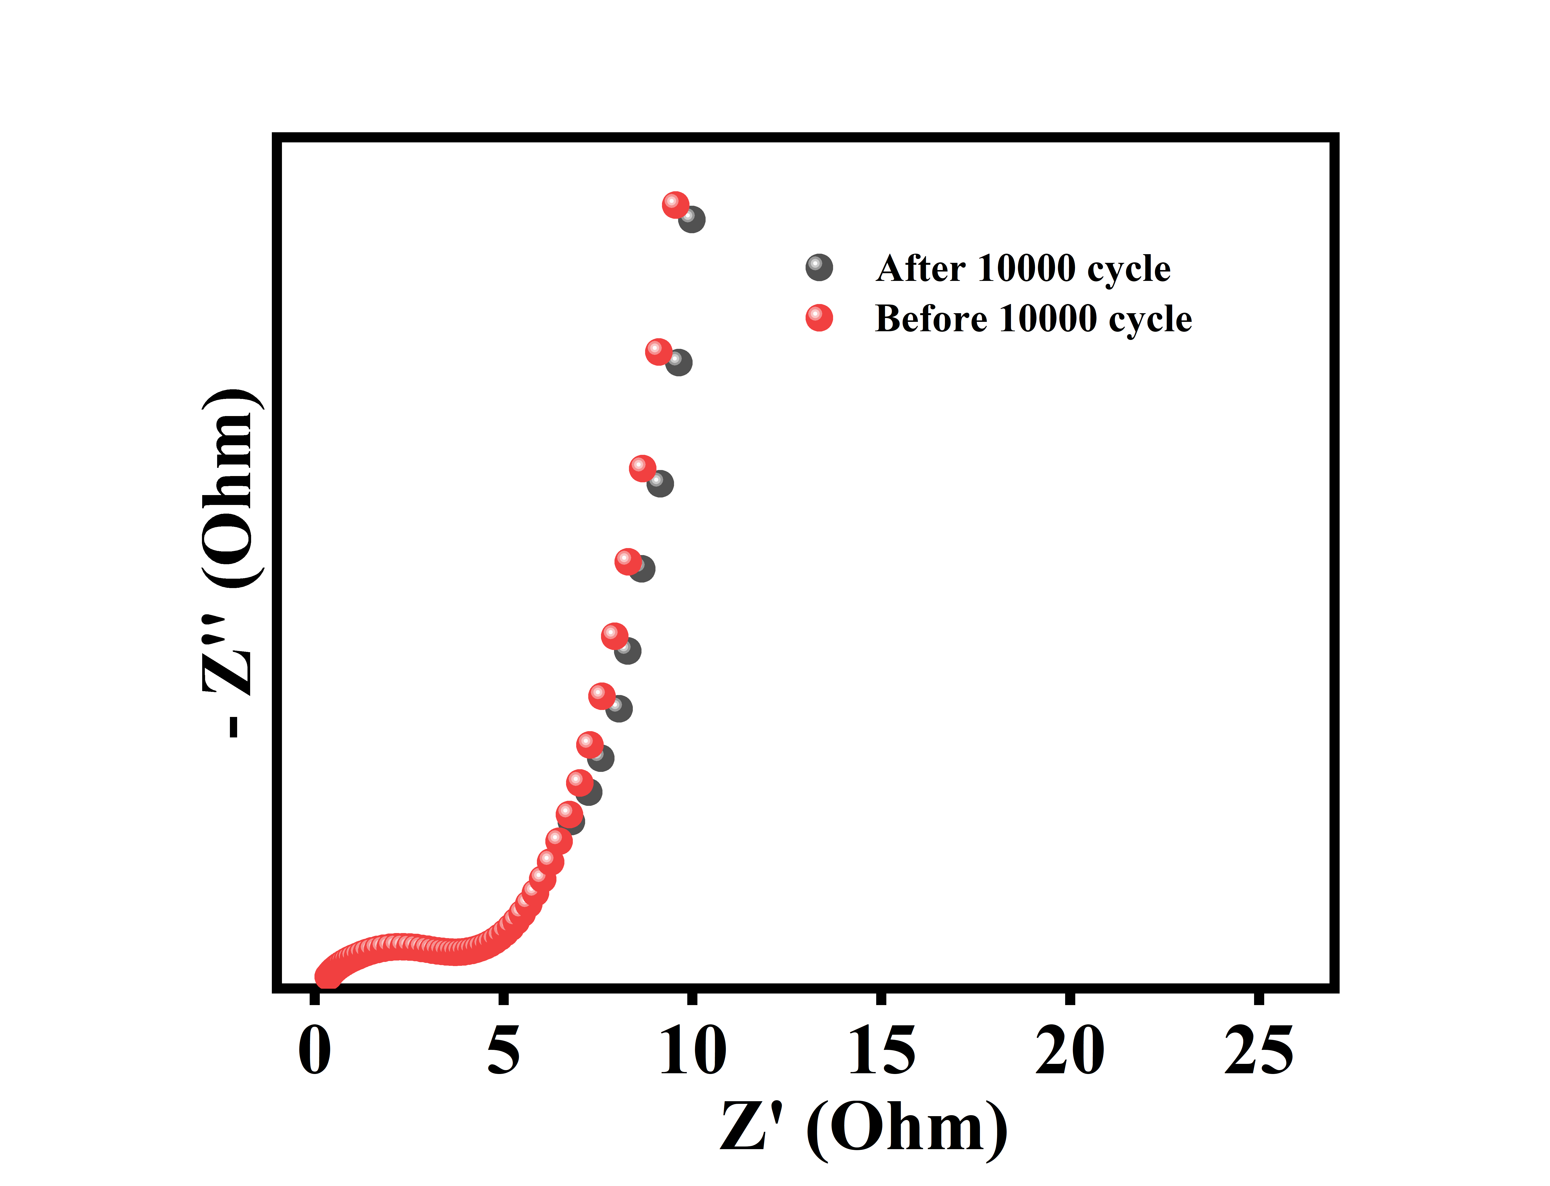

Fig. S7 The EIS Nyquist curve of ZAC-1000 electrode before and after 10000 cycle life.

