Supplementary Information for

Quantitating the Summer Moisture Sources over Northwest China and Its Annual Variations in Dry and Wet years

Peng Qian¹, Bin Zhu^{1*}, Tong Zhu², Chenwei Fang¹, Chunsong Lu¹, Haishan Chen³, Hong Liao⁴

¹ Collaborative Innovation Centre on Forecast and Evaluation of Meteorological Disasters, Key Laboratory for Aerosol-Cloud-Precipitation of China Meteorological Administration, Key Laboratory of Meteorological Disaster, Ministry of Education (KLME), Special test field of National Integrated meteorological observation, Nanjing University of Information Science and Technology, Nanjing, China
²IMSG at NOAA, NESDIS/STAR, 5830 University Research Ct., College Park, MD, USA
³Key Laboratory of Meteorological Disaster, Ministry of Education/International Joint Research Laboratory on Climate and Environment Change/Collaborative Innovation Center on Forecast and Evaluation of Meteorological Disasters, and School of Atmospheric Sciences, Nanjing University of Information Science and Technology, and NUIST–University of Readin International Research Institute, Nanjing, China
⁴ Jiangsu Key Laboratory of Atmospheric Environment Monitoring and Pollution Control, Jiangsu Collaborative Innovation Center of Atmospheric Environment and Equipment Technology, Joint International Research Laboratory of Climate and Environment Change, School of Environmental Science and Engineering, Nanjing University of Information Science and Technology, Nanjing, China

Corresponding author: Bin Zhu, binzhu@nuist.edu.cn

This file includes:
Supplementary Figures 1–2

Supplementary Figure 1

Model assessment
Previous studies have validated the ability of GPCP, CMAP, and NCEP can capture the spatial and temporal variations of precipitation in East Asia and Europe, respectively^{1,2}. Supplementary Fig. 1a-d present a comparison of the distribution of precipitation between these three data and that simulated by CAM5.1. The result shows that southern and southeastern Asia and central Africa experience heavy precipitation during summer (June-August), while precipitation over NWC is generally less and mainly concentrated in the western part. Precipitation is higher in the eastern and western parts of the Tibetan Plateau and lower in the central part³, and our simulations reasonably captures these characteristics. We also evaluate the model results for Eurasia at 850hPa using reanalysis water vapor and wind field data from ERA5 (Supplementary Fig.1e-f). The southern part of Asia is dominated by a strong southwesterly monsoon at 850hPa in summer, with water vapor content column up to 55 kg m⁻². The Eurasian continent is dominated by a weak northwesterly wind at 850hPa, with a decreasing trend of water vapor content column from west to east, ranging from 20-30 kg m⁻². In general, the spatial distribution of water vapor content simulated by the CAM5.1 is close to that of ERA5 data, so the model provides a reasonable simulation of the magnitude and distribution of water vapor content and the horizontal wind field over Eurasia.

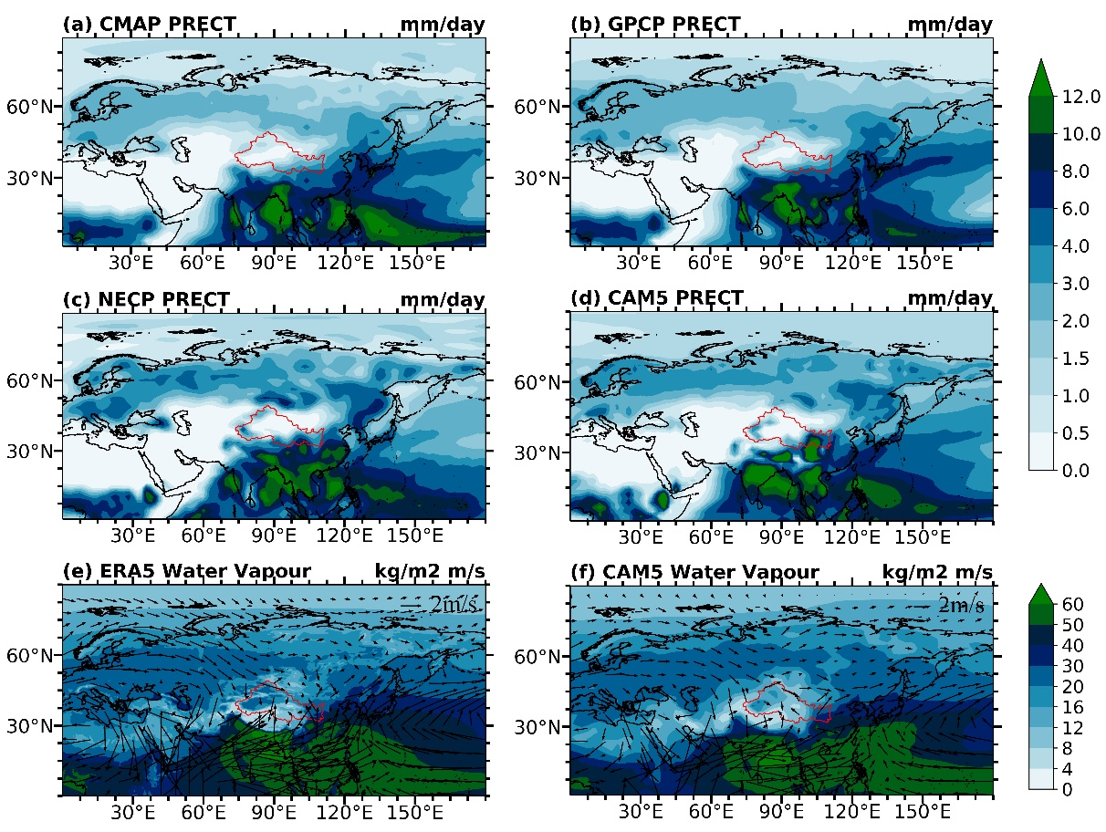
Supplementary FIG. 1. Comparison of CMAP, GPCP and NECP precipitation data (mm d⁻¹, a-c), ERA5 water vapor column content (kg m⁻²) and 850hpa horizontal wind field (m s⁻¹, e) and CAM5.1 simulated precipitation, water vapor column content and 850hpa horizontal wind field (d; f) for the summer period of 1982-2021
Supplementary Figure 2

Causes of differences in precipitation-conversion efficiency
Supplementary Fig. 2 provides further insight into the distribution of water vapor and precipitation over NWC. The water vapor transported from NA and EUP is primarily concentrated in the western part of the NWC, while the precipitation conversion efficiency in the northwest of the above area is low. This phenomenon occurs due to the influence of westerly flow around the plateau and the formation of anticyclones on the northern side of the plateau, which generate sinking air currents at around 200-850hPa. These sinking air currents inhibit precipitation production, despite the presence of a substantial amount of water vapor. In contrast, the water vapor amount transported from the STP and SEC is concentrated in the southeast of the NWC. The water vapor transported by the southwest airflow to the water vapor convergence area is conducive to the formation of precipitation, and the easterly water vapor transport is affected by the topography, forcing the warm and humid air to rise, which is conducive to the rapid formation of precipitation by the available water vapor. Therefore, the precipitation conversion efficiency is high here.

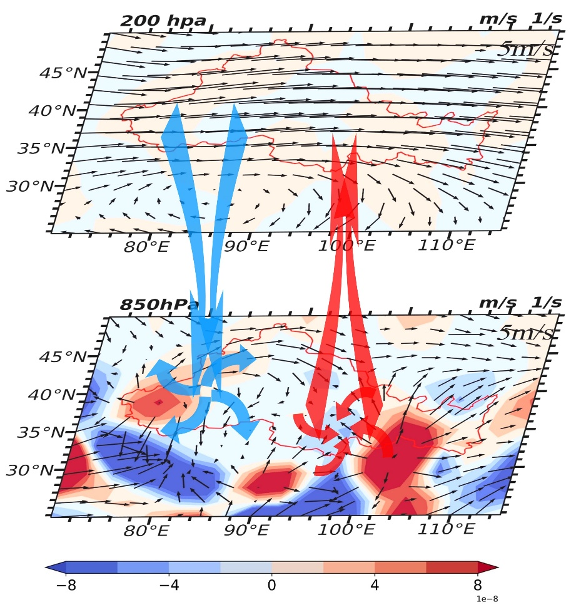
Supplementary FIG. 2. Horizontal divergence (s⁻¹) and horizontal wind field (m⁻¹) at 200hPa and 850hPa in the NWC during the summer of 1982-2021 (Horizontal flux dispersion and horizontal wind fields are averaged over 1982-2021)

REFERENCE
- Ma, L. et al. Evaluation of precipitation from the ERA‐40, NCEP‐1, and NCEP‐2 Reanalyses and CMAP‐1, CMAP‐2, and GPCP‐2 with ground‐based measurements in China. Journal of geophysical research: atmospheres. 114, (2009).
- Sun, Q. et al. A review of global precipitation data sets: Data sources, estimation, and intercomparisons. Reviews of Geophysics. 56, 79-107 (2018).
- Danabasoglu, G. et al. The Community Earth System Model Version 2 (CESM2). Journal of Advances in Modeling Earth Systems. 12, e2019MS001916 (2020).

