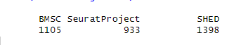
Figure S1. Three stem cells were analyzed by rPCA by Seurat.

