Fig. S1. Correlation analysis (Fig. S1A) and PCA score plot (Fig. S1B) of the transcriptome profiles between W, Y, DP, and DR
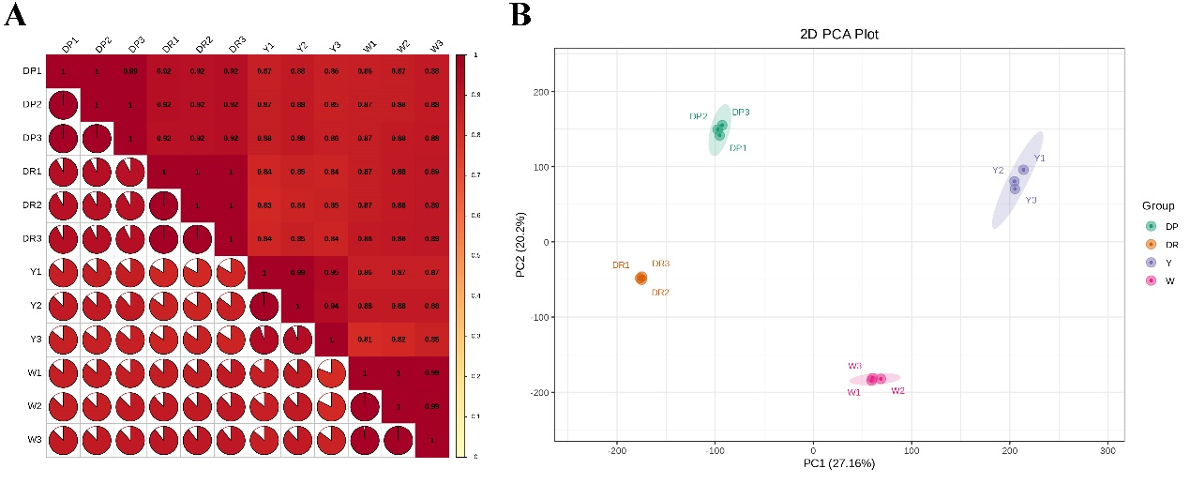

Fig. S2. GO analysis of the DEGs between W and Y (Fig. S2A), between W and DP (Fig. S2B), between W and DR (Fig. S2C)

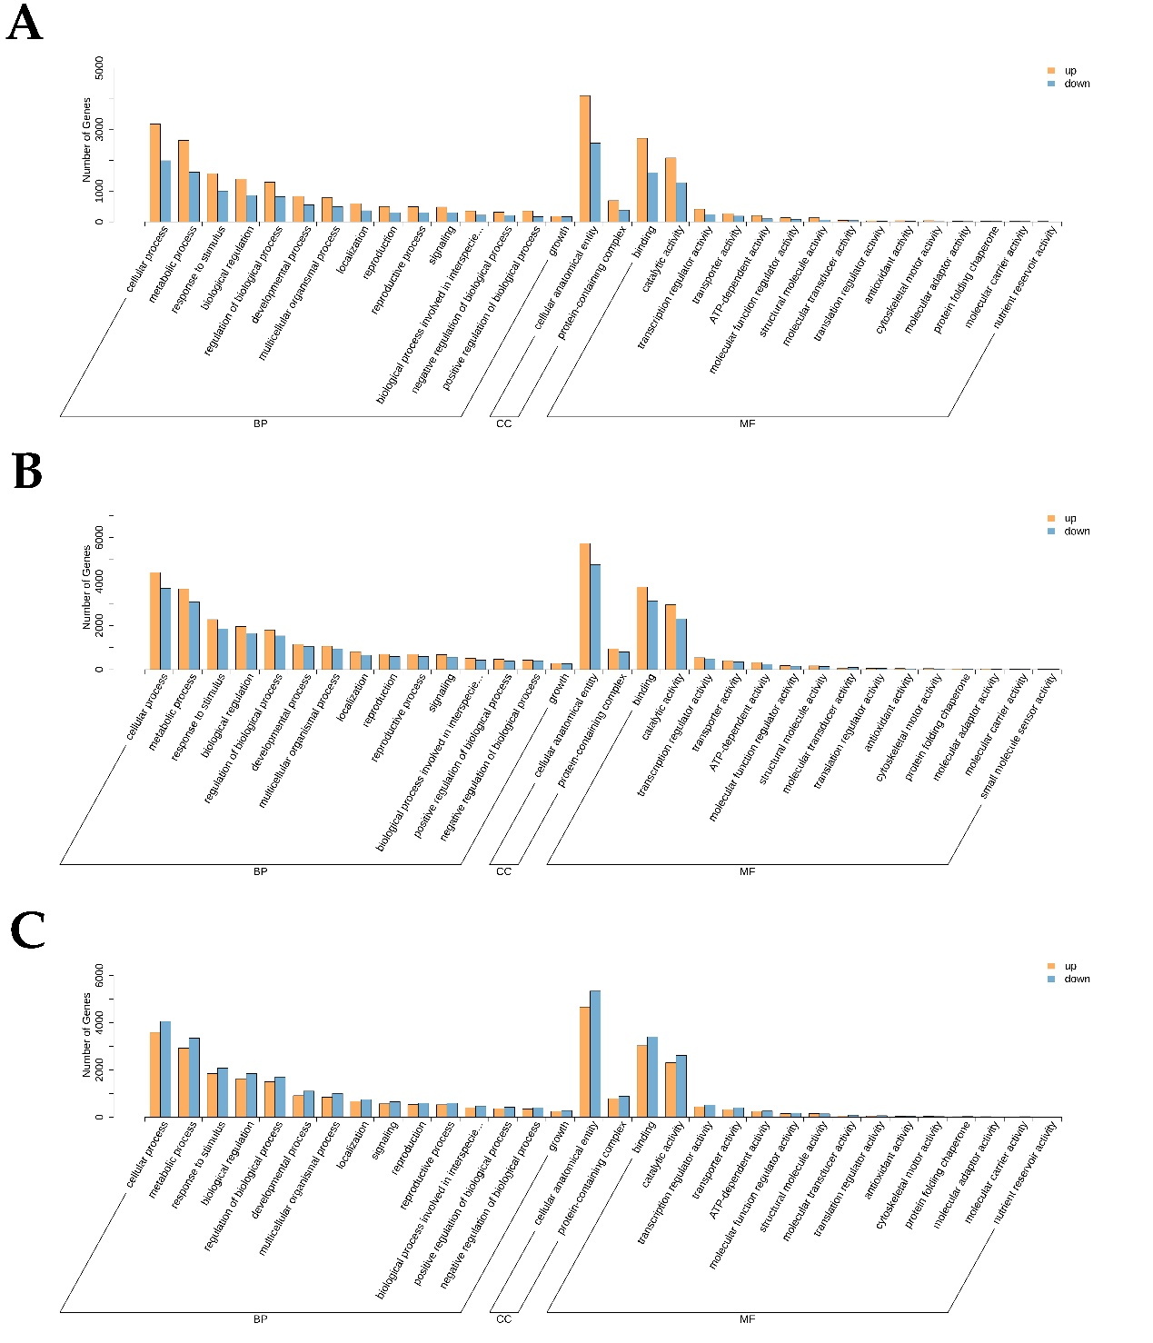

Fig. S3. KEGG analysis of the DEGs between W and Y (Fig. S3A), between W and DP (Fig. S3B), between W and DR (Fig. S3C)
Fig. S4. The cluster dendrogram results of 22 genes expression modules, present with different colors (Fig. S4A), The relationship analysis between genes module and 9 differentially accumulated metabolites (Fig. S4B).

