Supplementary Figures

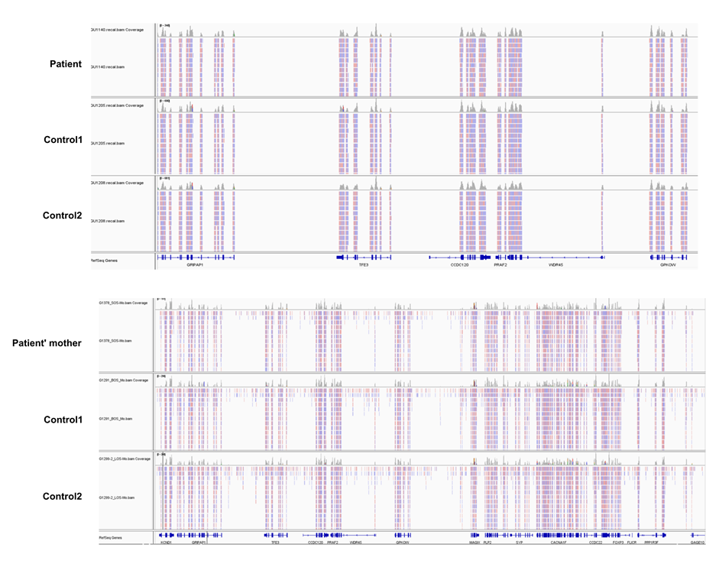

Supplementary Figure S1
The integrative genomics viewer (IGV) depicting the Xp11.23p11.22 region

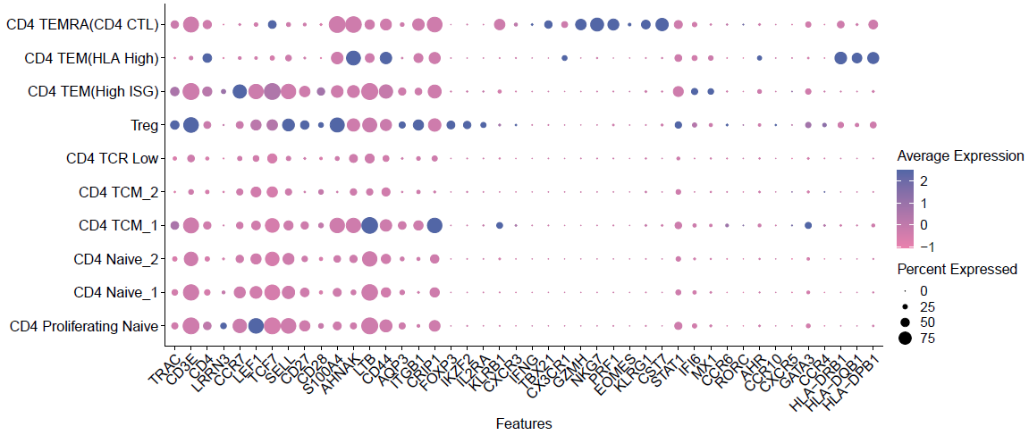
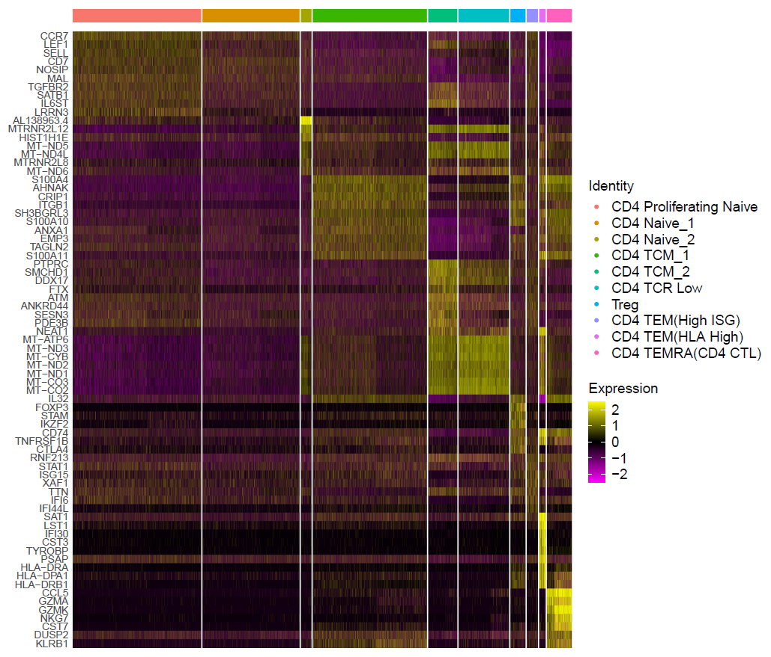
A
B

Supplementary Figure S2
(A) Heatmap representing the differentially expressed genes in identified clusters of CD4 T cells.
(B) Dot plot depicting gene expression levels and percentage of cells expressing genes associated with CD4 T cell
phenotypes.

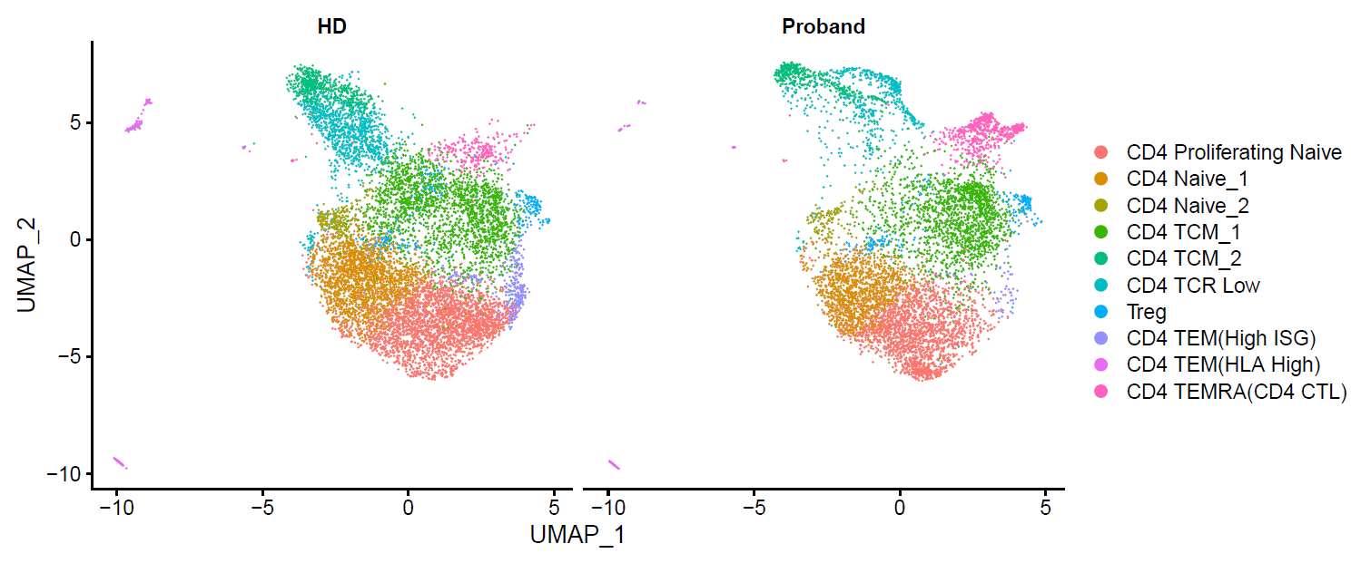
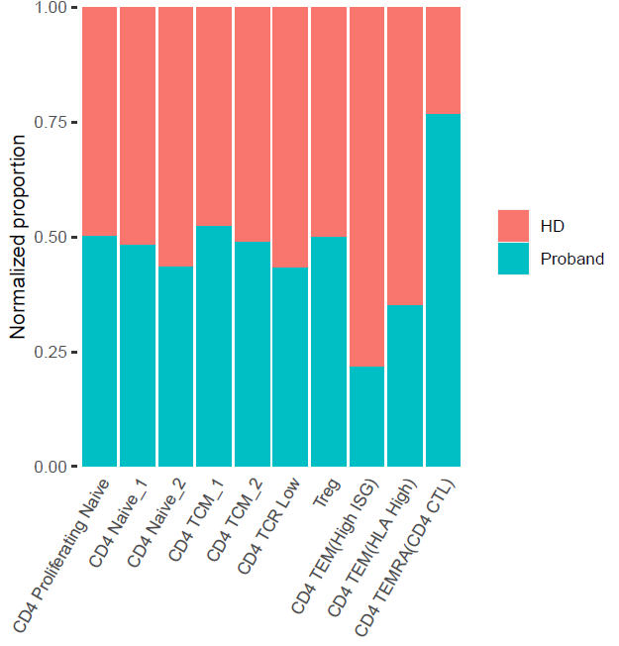
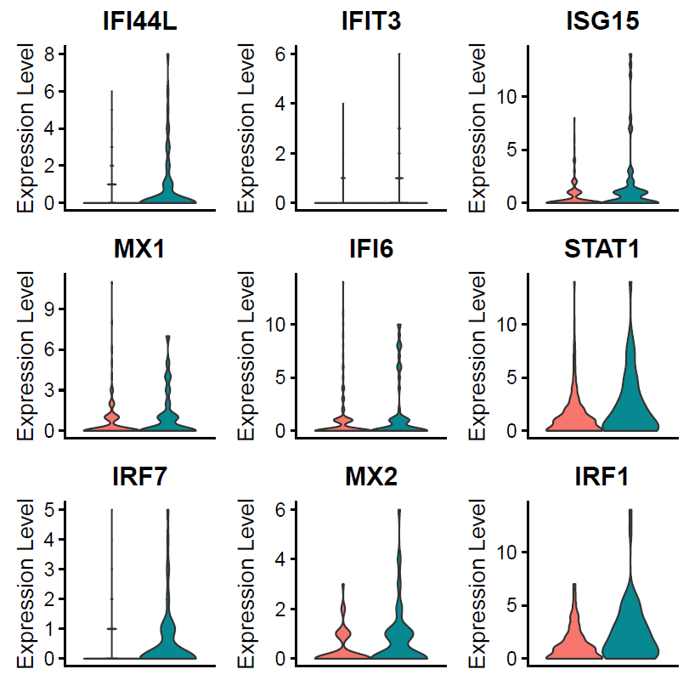
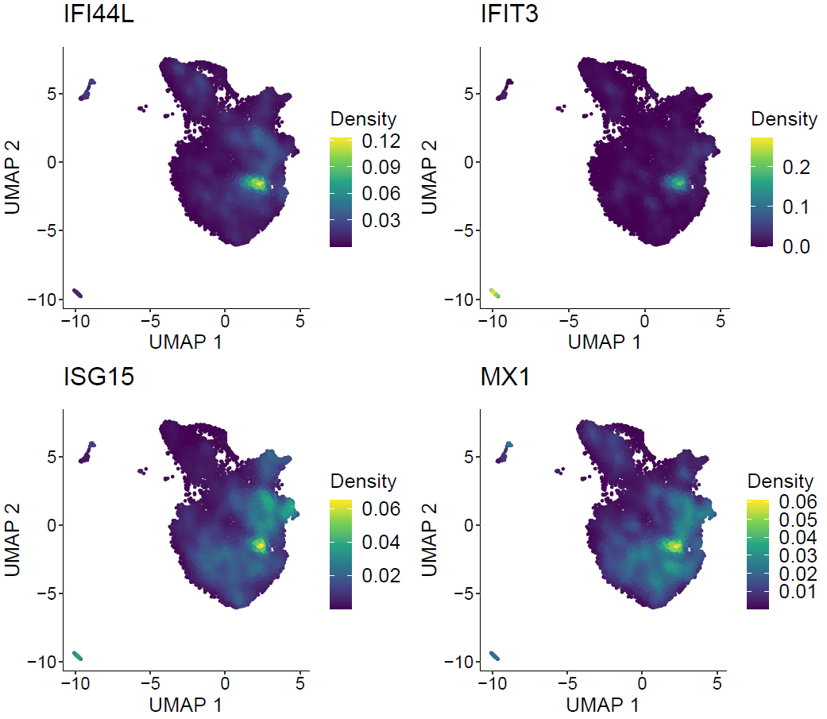
A
C
B
D

Supplementary Figure S3
(A) UMAP cluster divided by sample.
(B) Compositions of cell cluster by sample.
(C) Density plot produced by the Nebulosa package, showing the expression of High ISG related gene.
(D) Violin plots display the expression of High ISG signature genes between HD and Proband.

