Supplementary Information
for
Targeting CTLA-4 in cancer cells induces senescence via DNA-PKcs-STING-AKT axis

Je-Jung Lee^{#1,2,*}, Woo Joong Rhee^{#1,2}, So Young Kim^{1,3}, Jisun Lee^{1,3}, Su Ful Jung^{1,3}
In Ho Park^{2,5}, Jeon-Soo Shin^{1–4,*}

¹Department of Microbiology, Yonsei University College of Medicine, Seoul, South Korea.
²Institute for Immunology and Immunological Diseases, Yonsei University College of Medicine, Seoul, South Korea.
³Brain Korea 21 FOUR Project for Medical Science, Yonsei University College of Medicine, Seoul, South Korea.
⁴Center for Nanomedicine, Institute for Basic Science (IBS), Yonsei University, Seoul, South Korea.
⁵Department of Biomedical Sciences, Yonsei University College of Medicine, Seoul, South Korea.
#Contributed equally.

*Corresponding Authors:
Jeon-Soo Shin: Department of Microbiology, Yonsei University College of Medicine, 50-1 Yonsei-ro, Seodaemun-gu, Seoul 03722, South Korea
Tel: +82-2-2228-1816, Fax: +82-2-392-7088, E-mail: jsshin6203@yuhs.ac

Je-Jung Lee: Department of Microbiology, Yonsei University College of Medicine, 50-1 Yonsei-ro, Seodaemun-gu, Seoul 03722, South Korea
Tel: +82-2-2228-0800, Fax: +82-2-392-7088

Supplementary Figures

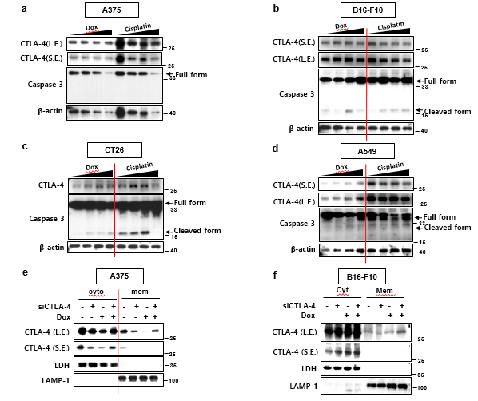

Supplementary Fig 1. CTLA-4 expression in cancer cells. Cells were treated with Doxorubicin or Cisplatin in a dose dependent, and WB was performed on day 2 (A-D). Cells were treated with siC or siCTLA-4, 1 day before 100 ng/ml Dox treatment. Then fractionation was performed (E, F).

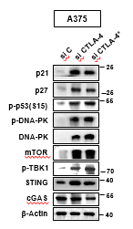
Supplementary Fig 2. CTLA-4 depletion induces senescence in human melanoma cells. A375 cells were treated with 100nM siC, siCTLA-4 and siCTLA-4*, and WB was performed with indicated antibodies on day 3 post treatment (A). A375 cells were treated with anti-CTLA-4 antibody 1 day before Dox treatment and WB was performed on day 2 post 100 ng/ml Dox treatment (B).

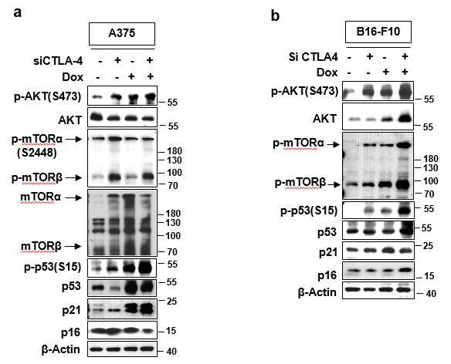
Supplementary Fig 3. CTLA-deficiency induces senescence via AKT pathway. A375 and B16-F10 cells were treated with 100 nM siC and siCTLA-4, respectively 1 day before treatment with or without 100 ng/ml Dox, and WB was performed on day 2 post Dox treatment with indicated antibodies (A-B) (S.E.; short exposure, L.E.; long exposure).

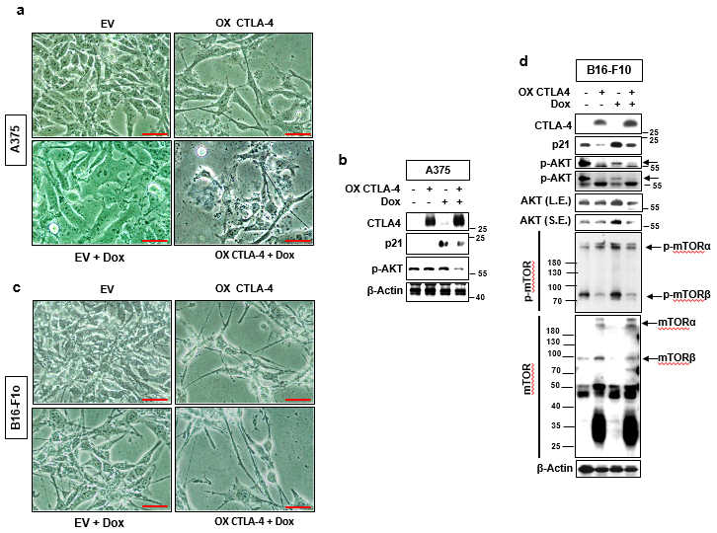
Supplementary Fig 4. CTLA-4 overexpression prevents senescence A375 cells were overexpressed with CTLA-4 or empty vector (EV), respectively 1 day before Dox or vehicle treatment. Then morphological changes (A) and WB were carried out with indicated antibodies on day 2 post100 ng/m Dox treatment (B). B16-F10 cells were overexpressed of CTLA-4 or empty vector (EV), respectively 1 day before Dox or vehicle treatment. Then morphological change analysis (C) and WB were performed with indicated antibodies on day 2 post 100 ng/ml Dox treatment (D). Scale bars, 20 μm. (S.E.; short exposure, L.E.; long exposure).

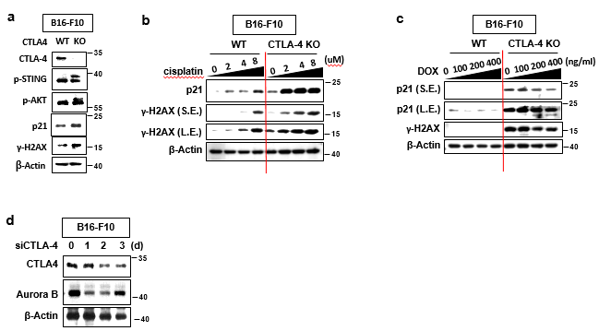
Supplementary Fig 5. CTLA-4-deficiency causes DNA damage response. B16-F10 ^{CTLA-4 KO} cells were generated and WB was performed with indicated antibodies (A). B16-F10 ^{WT} and B16-F10 ^{CTLA-4 KO} cells were exposed to Cisplatin and Dox, respectively as indicated concentration, then WB was performed on day 2 post drugs treatment (B, C). B16-F10 cells were treated with siCTLA-4 in a time dependent manner and WB was performed with indicated antibodies (D). (S.E.; short exposure, L.E.; long exposure).

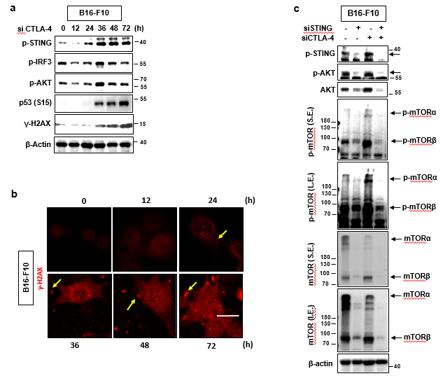
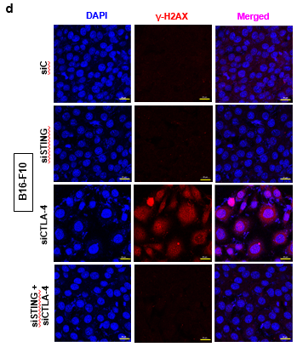
Supplementary Fig 6. STING signaling regulates CTLA4-depletion-induces via AKT signaling modulation. B16-F10 cells were treated with siCTLA-4 in a time dependent manner as indicated, and WB (A) and IF (B) analysis were carried out with indicated antibodies. Cells were treated with 100 nM siC and siSTING, respectively 1 day before treatment with or without siCTLA-4. Then WB with indicated antibodies (C) and IF assay for γ-H2AX with DAPI (D) were performed on day 3 post siC or siCTLA-4 treatment. Scale bars, 20 μm (B, D). (S.E.; short exposure, L.E.; long exposure).
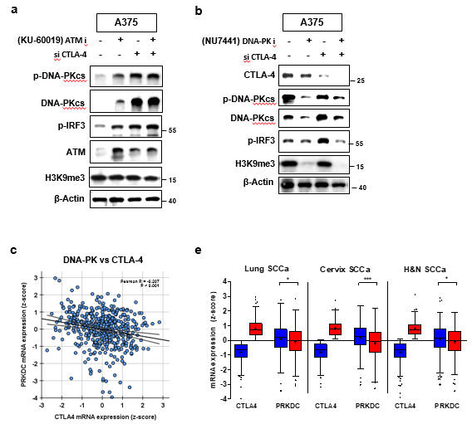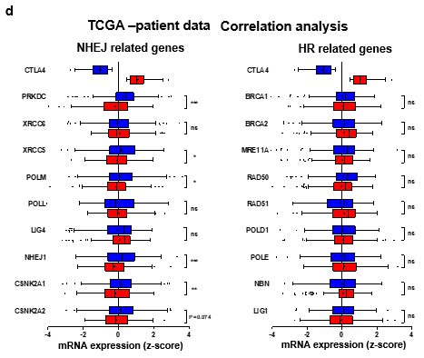
Supplementary Fig 7. DNA-PK mediates CTLA-4-depletion induced senescence.
A375 cells were treated with ATM inhibitor (KU-60019) (A) or DAN-PK inhibitor (NU7441) (B) at 6 hours before siC or siCTLA-4 treatment and WB was performed with indicated antibodies on day 3 post siRNA treatment. mRNA expression z-scores of human cutaneous melanoma patients from the TCGA PanCancer Atlas were obtained via cBioPortal for Cancer Genomics (https://www.cbioportal.org). The correlation between CTLA4 mRNA expression z-score and the mRNA expression z-scores of DNA-PKcs (C). Based on the CTLA4 expression level, patients were categorized into CTLA4 high group and CTLA4 low group, and Student's T test was used to compare the gene expression levels between the groups (D). Among various cancer patients’ data, lung squamous cell carcinoma patients, cervical squamous cell carcinoma, and head and neck squamous cell carcinoma patients were used to analysis (E).

Supplementary Table 1
siRNA sequence

siControl
Sense: CCUACGCCACCAAUUUCGU
Antisense: ACGAAAUUGGUGGCGUAGG

siCTLA-4 (h)
Sense: CCCAAAUUACGUGUACUAC
Antisense: GUAGUACACGUAAUUUGGG

siCTL-A4 (h)*
Sense: CGGAACCCAGAUUUAUGUA
Antisense: UACAUAAAUCUGGGUUCCG

siDNA-PKcs (h)
Sense: GAUCGCACCUUACUCUGUU
Antisense: AACAGAGUAAGGUGCGAUC

siAKT (m)
Sense: UGCCCUUCUACAACCAGGA
Antisense: UCCUGGUUGUAGAAGGGCA

siAKT (h)
Sense: GCACUUUCGGCAAGGUGAU
Antisense: AUCACCUUGCCGAAAGUGC

si STING (m)
Sense: GGAUCCGAAUGUUCAAUCA
Antisense: UGAUUGAACAUUCGGAUCC

si-STING (h)
Sense: CCUCAUCAGUGGAAUGGAA
Antisense: UUCCAUUCCACUGAUGAGG

Supplementary Table 2
Materials Lists
Penicillin-streptomycin (Life Technologies, Waltham, MA, USA)
CLLA-4 plasmid (HG11159-NY) was obtained from Sino Biological (Wayne, PA, USA)
FuGene HD reagent (Promega, Madison, WI, USA)
RNAiMAX (Invitrogen, Carlsbad, CA, USA)
siRNA duplexes against mouse CTLA-4(sc-42767), DNA-PK(sc-35201) were obtained from Santa Cruz Biotechnology (Dallas, TX, USA)
Neutralizing anti-CTLA4 mouse antibody(UC10-4B9) were purchased from BioLegend (Seoul, Korea)
Dox was obtained from Calbiochem (San Diego, CA, USA)
Nu 7441(S2638) was purchased from Selleck Chemicals (Houston, TX, USA)
Horseradish peroxidase (HRP)-conjugated anti-rabbit and anti-mouse antibodies were obtained from Santa Cruz Biotechnology (Dallas, TX, USA)
Antibodies against p-IRF3(29047), STING(13647), p-TBK1(5483), antibodies from Cell Signaling Technologies, Inc. (Danvers, MA, USA)
p-AKT(4058), AKT(9272), p-mTOR(2971), mTOR(2983), b-actin(4967), tri-H3K9(13969), p53(S15)(9284), secondary antibodies from Cell Signaling Technologies, Inc. (Danvers, MA, USA)
DNA-PKcs(ab32566), γ-H2AX(ab11174), p16(ab51243) from Abcam (Cambridge, MA, USA), p21(556431), p27(610242, BD Biosciences) from BD Biosciences (Franklin Lakes, NJ, USA)
CTLA-4(ab237712) from Abcam (Cambridge, MA, USA).
p53 (sc-47698) from Santa Cruz Biotechnology (Dallas, TX, USA)
p-STING(AF7416) from Affnit (Nottingham, England)
Normal rabbit IgG or normal mouse IgG (Santa Cruz Biotechnology)
protein A magnetic beads (Millipore, Billerica, MA, USA)
CELLEventTM Senescence Green Detection Kit, C10850, invitrogen, Waltham, MA, USA
GraphPad Prism 5 (GraphPad Software, Inc., La Jolla, CA, USA)
Bioneer, Inc. (Daejeon, Korea).
BioLegend (Seoul, Korea)
Calbiochem (San Diego, CA, USA).
Selleck Chemicals (Houston, TX, USA).
protein A magnetic beads (Millipore, Billerica, MA, USA)
an inverted phase-contrast microscope (Olympus, Tokyo, Japan)

