Supplementary Material
Study 1
Balancing within the number comparison task
The 96 trials of the number comparison task were presented in blocks of 16 trials of either the cheating or the computer task, resulting in three blocks of each task variant. We chose to present one task at a time over an event-related design to reduce cognitive load for switching between tasks. Task blocks were presented in alternating order with a 10 second pause between blocks. Block order (i.e., experiment starting with the computer vs. cheating task) was balanced between participants to avoid any confounding effect with participants’ subsequent behavior. Importantly, the number of wins reported in the cheating task did not depend on block order (Z = 0.16, p = .869, 95% CI [-3.55, 3.94]).
In the computer task, the numbers and operator were generated as such that 50% of the trials were win trials. In parallel, the generation of the second number in the cheating task was manipulated to have an equal number of trials with a high vs. low chance of winning. For example, in trials with a larger than operator (>) the number following the operator would be randomly generated from 2-49 to increase the chance of winning (high win chance) or from 51-99 to decrease the chance of winning (low win chance). Within each block, the win-condition, operators, and distribution of points were also balanced (see Figure S1) and presented in randomized order. This procedure was chosen to minimize potential confounding effects between blocks, for example that a computer task block with low payoff results in participants cheating more often to compensate for the previous payoff. Additionally, the finger of the right hand (index vs. middle finger) that was used for indicating whether participants have won (‘yes’ vs. ‘no’) was balanced within the sample to avoid systematic effects on reaction times.
Experimenter effect
In case participants explicitly asked the experimenter about the possibility to cheat (or made any remark in that direction), the experimenter replied in a standardized manner. They reminded the participant of the instruction (they first have to think of a number and keep this number in mind before the operator and the second number are presented), but also told them that we are not able to track whether they complied with these instructions. We chose to keep the standardized answer as vague as possible to avoid any influence on participants’ decision about cheating, especially avoiding them to think that we can directly observe dishonest behavior. The experimenter wrote down whenever the participant had some kind of question to be able to check whether these participants’ number of wins and decision to cheat differed from participants who did not talk to the experimenter about the possibility of cheating. Importantly, participants with no question (n = 48), a general question (n = 7), and a specific question/remark about the possibility to cheat (n = 10) did not differ in the number of wins in the cheating task (one-way ANOVA, F(2,62) = 0.07, p = .932). Thus, talking to the experimenter had no effect on participants’ cheating behavior.
Reward sensitivity replication
As a direct replication of the association between reward sensitivity and the amount of cheating found in other studies (Abe & Greene, 2014; Speer et al., 2020), we extracted mean betas from nucleus accumbens (anatomical subcortical atlas; Pauli et al., 2018) and from a meta-analytically derived striatal reward cluster (Bartra et al., 2013). Results of these analyses are shown in Figure S2. The full regression results are in Table S9‒Table S12.
Nucleus accumbens activation predicts the number of wins in the cheating task (b = 21.49.11, SE = 7.31, t(62) = 2.94, p = .005, R²_{adjusted} = .11). However, temptation can only predict reward sensitivity in nucleus accumbens at trend level (b = 0.02, SE = 0.01, t(61) = 2.00, p = 0.050). The larger striatal cluster shows a better prediction of the number of wins (b = 24.05, SE = 5.77, t(61) = 4.17, p < .001, R²_{adjusted} = .21). Also temptation can significantly predict striatal reward sensitivity (b = 0.02, SE = 0.01, t(60) = 2.33, p = .023, R²_{adjusted} = .07).
Taken together, we were able to directly replicate previous findings and further show that using broader masks, including a larger reward-related striatal brain region (Bartra et al., 2013) as well as a brain mask including a broader reward anticipation network (Yarkoni et al., 2011), can even better predict the frequency of potential cheating than the anticipatory nucleus accumbens activation alone.
Intrinsic value extracted from alternative reward ROI
Moreover, we performed an additional repeated measures ANOVA on the brain activation extracted from an alternative reward ROI. We aimed to replicate the intrinsic value in another more restricted ROI limited to the striatal and vmPFC clusters (Bartra et al., 2013). The results are in Table S5 and Figure S4. The effect of interest (non-win_{cheating} > non-win_{computer}) is highly significant (Δ = 0.37, t(64) = 3.90, p < .001). There is a difference between wins and non-wins in the computer task at trend level (Δ = 0.19; t(64) = 1.98, p = .051) and no significant difference between non-wins in the cheating and wins in the computer task (Δ = 0.18; t(64) = 1.49, p = .141).

Study 2
All participants who made an error in the computer task were assigned to the computer non-win condition. Therefore, to avoid that any effect is driven by this group, all analyses that include the computer non-win condition were again computed without these participants (n = 113, resulting in a group size of n = 422).
None of the results reported in the main manuscript changed. The reduction in mood after forgoing the bonus was still stronger for participants in the computer condition then in the cheating condition (preregistered analysis; Δ_{mood} = 0.80, t(855) = 6.78, p < .001, d = 0.46, 95% CI [0.57, 1.04]). Baseline mood did not differ between groups (F(3, 1888) = 0.56, p = .641) and the 2×2×2 repeated measures ANOVA still shows the significant three-way interaction for time, task and response (F(1, 1888) = 29.10, p < .001; see Table S8).

Supplementary Figures
Figure S1
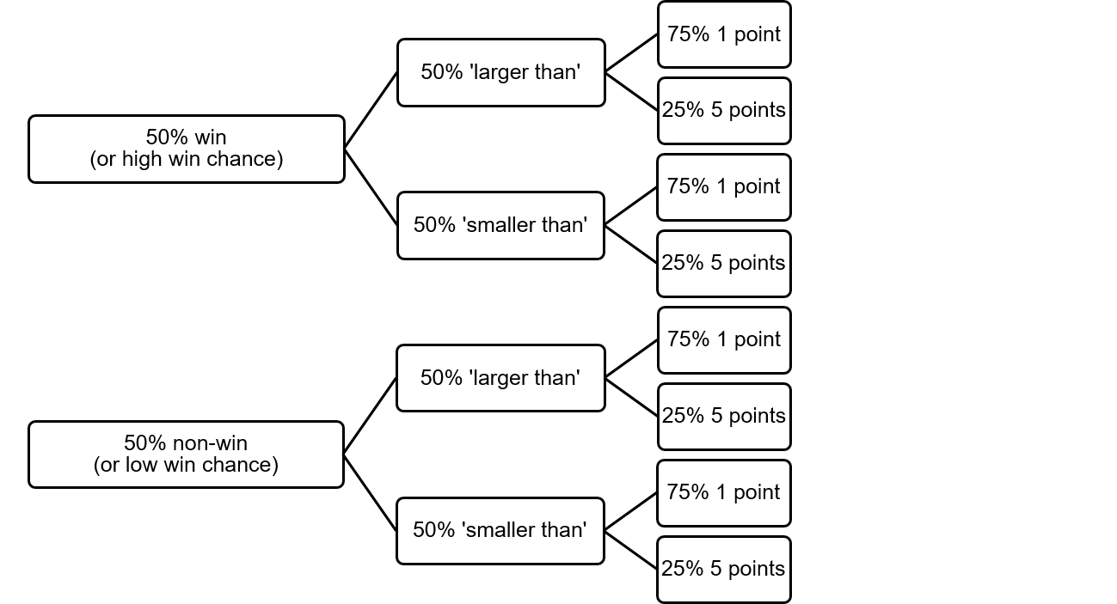
Schematic depiction of the balancing of trials within each block. In the computer task, 50% of the trials are win trials, where the first and second number are generated so that their relationship is always correct with respect to the operator (the opposite is true for non-win trials). Thus, if participants do not make an error and press ‘win’ within 3 seconds in the computer task, they win sixteen points in each computer block (six one-point trials and two five-point trials). The chance of winning in the cheating task is manipulated by generating either lower or higher random numbers (from 2-49 or 51-98, respectively), depending on the win-condition and operator of the current trial. For example, for a trial with a high chance of winning with a smaller-than operator, a higher random number (from 51-98) would be generated to make it more likely that participants think of a suitable number (e.g., X < 62, with X being the number that participants think of themselves in the beginning of the trial). In contrast, in a trial with a low chance of winning the smaller random number (from 2-49) would be generated to make it less likely that participants think of a number that results in winning when remaining honest.
Figure S2
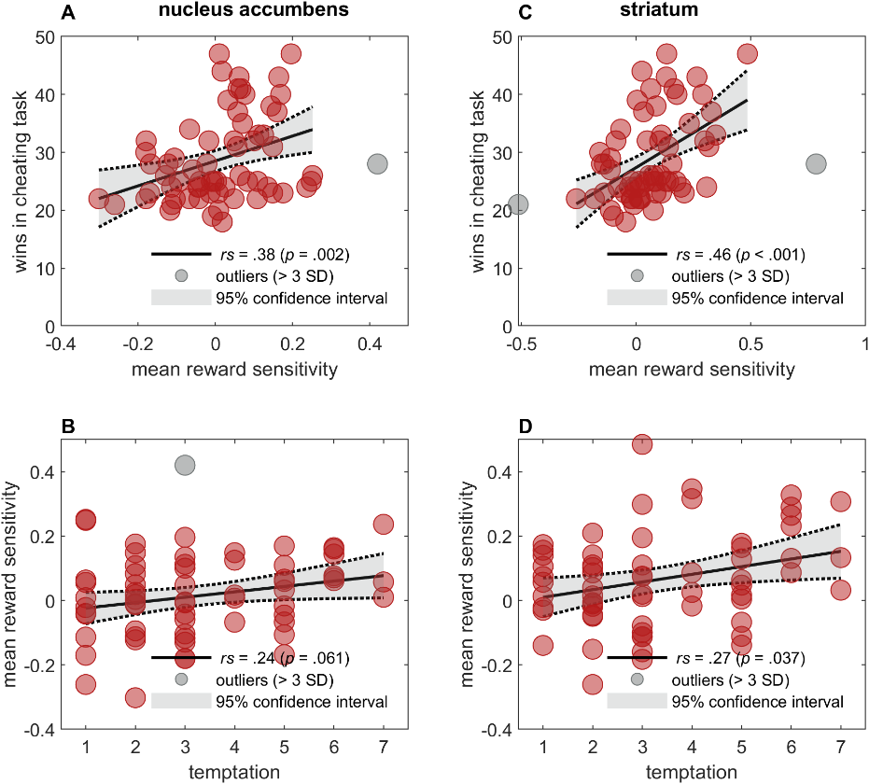
Additional correlation analyses for reward sensitivity signal derived from alternative regions of interest. Mean activity extracted from a subcortical nucleus accumbens brain mask (Pauli et al., 2018) correlates with participants’ number of wins in the cheating task (A), but only at trend-level with their temptation rating (B). Mean activity extracted from a larger meta-analytically derived striatal reward mask (Bartra et al., 2013) correlates with participants’ number of wins in the cheating task (C) and also with their and temptation rating (D).

Figure S3
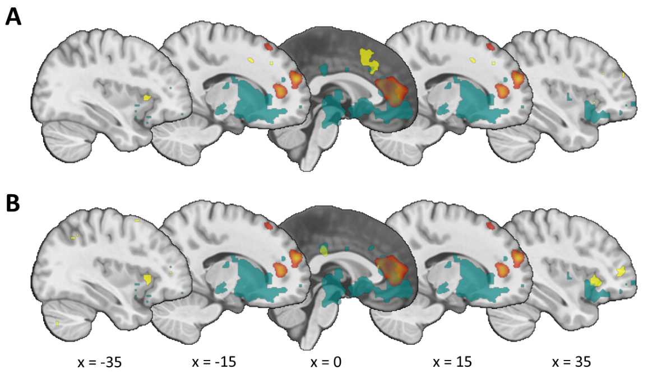
Overlap between main contrast of interest (Non-win_{cheating} > Non-win_{computer}, p_{FWE} < .05) and meta-analytic masks from Neurosynth (Yarkoni et al., 2011). The full-brain contrast shows a substantial overlap with the a priori defined reward outcome ROI (blue-green; n = 251 voxels, corresponding to 29.6% of the voxels reaching the significance threshold in the contrast). (A) No overlap between full-brain contrast and reward outcome ROI with ‘conflict’ regions (yellow; n = 0 voxels). (B) Negligible overlap between full-brain contrast and reward outcome ROI with ‘cognitive control’ regions (yellow; n = 4 voxels).

Figure S4
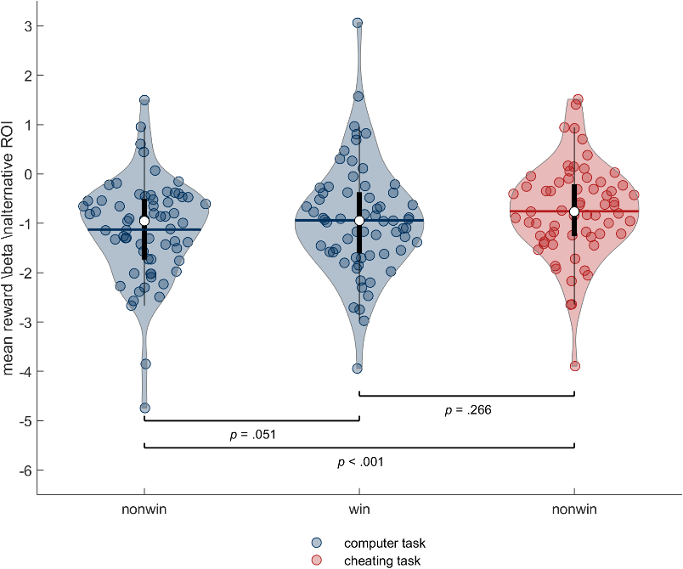
Results from repeated measures ANOVA on extracted betas from the alternative reward ROI (includes striatum and vmPFC from Bartra et al., 2013) showing the effect of response (uncorrected p-values from t-tests).

Supplementary Tables
Table S1
Regression predicting number of wins in the cheating task from participants’ temptation and reward sensitivityª
Predictor | b | SE | t | p
(Intercept) | 20.71 | 1.56 | 13.32 | < .001
temptation | 2.32 | 0.42 | 5.50 | < .001
reward sensitivityª | 25.73 | 9.10 | 2.83 | .006
Note: Adjusted R² = 0.45; model predicts number of wins significantly better than constant model (F(59) = 25.60, p = .001).
ª Reward sensitivity defined as mean activation extracted from reward anticipation mask during the anticipation phase of both tasks.

Table S2
Results of full brain win > non-win contrast in the decision phase
MNI coordinates
x | y | z | AAL3 label | hemisphere | t_{Peak} | n_{Voxels} | p_{FWE}
-41 | 38 | 8 | Inferior frontal gyrus, triangular part | L | 7.68 | 65 | < .001
-11 | 11 | 2 | Caudate nucleus | L | 6.82 | 66 | < .001
-17 | 2 | -8 | Lenticular nucleus, Pallidum | L | 6.51 | - | -
14 | 5 | -5 | Lenticular nucleus, Pallidum | R | 6.38 | 21 | < .001
-8 | -20 | -11 | Red Nucleus | L | 6.27 | 13 | .001
8 | -35 | 35 | Middle cingulate and paracingulate gyri | R | 5.98 | 17 | < .001
Note: Results are family-wise error corrected with a cluster size of k ≥ 10 voxels. MNI coordinates, labels (AAL3 toolbox for SPM)(Rolls et al., 2020) and t value refer to peak voxel; the number of voxels and family-wise error corrected p value refer to the cluster level. Further local maxima within the same cluster (> 8 mm from other peaks) are given in gray without an entry in the columns for number of voxels and p_{FWE}.

Table S3
Results of full brain non-win_{cheating} > non-win_{computer} contrast in the decision phase
MNI coordinates
x | y | z | AAL3 label | hemisphere | t_{Peak} | n_{Voxels} | p_{FWE}
20 | 59 | 23 | Superior frontal gyrus, dorsolateral | R | 8.13 | 720 | < .001
8 | 50 | 11 | Anterior cingulate cortex, pregenual | R | 8.03 | - | -
-8 | 41 | 8 | Anterior cingulate cortex, pregenual | L | 7.80 | - | -
56 | -50 | 32 | Angular gyrus | R | 7.08 | 70 | < .001
26 | 32 | 47 | Superior frontal gyrus, dorsolateral | R | 6.92 | 61 | < .001
14 | 29 | 59 | Superior frontal gyrus, dorsolateral | R | 5.64 | - | -
Note: Results are family-wise error corrected with a cluster size of k ≥ 10 voxels. MNI coordinates, labels (AAL3 toolbox for SPM)(Rolls et al., 2020) and t value refer to peak voxel; the number of voxels and family-wise error corrected p value refer to the cluster level. Further local maxima within the same cluster (> 8 mm from other peaks) are given in gray without an entry in the columns for number of voxels and p_{FWE}.

Table S4
Results from one-way ANOVA for the effect of response on extracted betas from reward outcome mask
 | SumSq | DF | MeanSq | F | p
(Intercept) | 12.99 | 1 | 12.99 | 45.01 | < .001
Error | 18.48 | 64 | 0.29
Response | 0.60 | 2 | 0.30 | 5.61 | .007
Error | 6.88 | 128 | 0.05
Note: Mean activation from reward outcome mask depending on participants’ response. Greenhouse-Geisser corrected p value.

Table S5
Results from one-way ANOVA for the effect of response on extracted betas from the alternative reward region of interest
 | SumSq | DF | MeanSq | F | p
(Intercept) | 172.47 | 1 | 172.47 | 70.05 | < .001
Error | 157.58 | 64 | 2.46
Response | 4.44 | 2 | 2.22 | 6.26 | .004
Error | 45.47 | 128 | 0.36
Note: Mean activation from an alternative ROI based on striatum and vmPFC clusters (Bartra et al., 2013), replicating the main effect of response. Greenhouse-Geisser corrected p value.

Table S6
Results of full brain non-win_{cheating} > [non-win_{computer}, win_{computer}, win_{cheating}] contrast in the decision phase
MNI coordinates
x | y | z | AAL3 label | hemisphere | t_{Peak} | n_{Voxels} | p_{FWE} | p_{uncorrected}
23 | 56 | 26 | Superior frontal gyrus, dorsolateral | R | 8.21 | 871 | < .001 | < .001
11 | 26 | 62 | Superior frontal gyrus, medial | R | 5.41 | - | - | -
-5 | 29 | 20 |  | L | 4.80 | - | - | -
  Anterior cingulate cortex, supracallosal
14 | -77 | -8 | Lingual gyrus | R | 5.99 | 83 | .032 | .024
8 | -83 | -2 | Lingual gyrus | R | 4.85 | - | - | -
-68 | -32 | 20 | SupraMarginal gyrus | L | 5.35 | 277 | < .001 | < .001
-47 | -26 | 17 | Rolandic operculum | L | 4.48 | - | - | -
-41 | -17 | 26 | Rolandic operculum | L | 4.04 | - | - | -
56 | -53 | 32 | Angular gyrus | R | 5.07 | 545 | < .001 | < .001
68 | -26 | 23 | SupraMarginal gyrus | R | 4.90 | - | - | -
56 | -20 | 20 | Rolandic operculum | R | 4.80 | - | - | -
-41 | 23 | -14 | Posterior orbital gyrus | L | 4.95 | 49 | .157 | .084
-14 | -83 | -5 | Lingual gyrus | L | 4.78 | 30 | .405 | .163
47 | 11 | -38 | Inferior temporal gyrus | R | 4.46 | 61 | .088 | .054
53 | 2 | -29 | Middle temporal gyrus | R | 3.85 | - | - | -
-8 | 26 | 59 | Superior frontal gyrus, medial | L | 4.34 | 21 | .615 | .256
-17 | -47 | -59 | Lobule IX of cerebellar hemisphere | L | 4.32 | 16 | .750 | .341
50 | 26 | 5 | Inferior frontal gyrus, triangular part | R | 4.08 | 33 | .350 | .159
-23 | -2 | 23 | Caudate nucleus | L | 4.03 | 29 | .425 | .163
-23 | -11 | 23 | Caudate nucleus | L | 3.75 | - | - | -
-5 | -53 | 11 | Precuneus | L | 3.92 | 38 | .273 | .134
-8 | -62 | 20 | Cuneus | L | 3.70 | - | - | -
-14 | -53 | 14 | Precuneus | L | 3.70 | - | - | -
47 | -32 | -5 | Middle temporal gyrus | R | 3.68 | 13 | .830 | .402
-20 | 53 | 29 | Superior frontal gyrus, dorsolateral | L | 3.66 | 11 | .878 | .444
Note: Results from uncorrected whole-brain contrast with a cluster size of k ≥ 10 voxels. MNI coordinates, labels (AAL3 toolbox for SPM)(Rolls et al., 2020) and t value refer to peak voxel; the number of voxels and p values (both FWE-corrected and uncorrected) refer to the cluster level. Further local maxima within the same cluster (> 8 mm from other peaks) are given in gray without an entry in the columns for number of voxels and p.

Table S7
Results from 2×2×2 repeated ANOVA for the effect of time, task and response on assessed momentary mood in the online study
 | SumSq | DF | MeanSq | F | p
(Intercept) | 145,291.81 | 1 | 145,291.81 | 30,023.81
Task | 52.66 | 1 | 52.66 | 10.88 | .001
Response | 825.08 | 1 | 825.08 | 170.50 | < .001
Task:response | 38.83 | 1 | 38.83 | 8.02 | .005
Error | 9,683.30 | 2,001 | 4.84
(Intercept):time | 205.24 | 1 | 205.24 | 215.63 | < .001
Task:time | 47.60 | 1 | 47.60 | 50.01 | < .001
Response:time | 916.70 | 1 | 916.70 | 963.13 | < .001
Task:response:time | 24.18 | 1 | 24.18 | 25.40 | < .001
Error (time) | 1,904.50 | 2,001 | 0.95
Note: Change in participants’ mood depending on time of measurement (pre/post), task (cheating/computer) and response (win/non-win). The sample includes participants with an erroneous response (n = 113), resulting in n = 535 participants in the computer non-win condition.

Table S8
Results from 2×2×2 repeated ANOVA for the effect of time, task and response on assessed momentary mood in the online study (participants with erroneous response excluded)
 | SumSq | DF | MeanSq | F | p
(Intercept) | 135,790.67 | 1 | 135,790.67 | 28,382.14
Task | 74.31 | 1 | 74.31 | 15.53 | < .001
Response | 868.04 | 1 | 868.04 | 181.43 | < .001
Task:response | 58.14 | 1 | 58.14 | 12.15 | .001
Error | 9,032.90 | 1,888 | 4.78
(Intercept):time | 203.55 | 1 | 203.55 | 224.88 | < .001
Task:time | 49.80 | 1 | 49.80 | 55.02 | < .001
Response:time | 885.29 | 1 | 885.29 | 978.05 | < .001
Task:response:time | 26.34 | 1 | 26.34 | 29.10 | < .001
Error (time) | 1,708.90 | 1,888 | 0.91
Note: Change in participants’ mood depending on time of measurement (pre/post), task (cheating/computer) and response (win/non-win). Participants with an erroneous response (n = 113) were excluded from the analysis, resulting in n = 422 participants in the computer non-win condition.

Table S9
Regression predicting number of wins in the cheating task from participants’ reward sensitivityª in the nucleus accumbens
Predictor | b | SE | t | p
(Intercept) | 28.52 | 0.90 | 31.88 | < .001
reward sensitivityª | 21.49 | 7.31 | 2.94 | .005
Note: Adjusted R² = 0.11; model predicts number of wins significantly better than constant model (F(62) = 8.65, p = .005).
ª Reward sensitivity defined as mean activation extracted from anatomical nucleus accumbens mask during the anticipation phase of both tasks.

Table S10
Regression predicting temptation to cheat from participants’ reward sensitivityª in the nucleus accumbens
Predictor | b | SE | t | p
(Intercept) | -0.04 | 0.03 | -1.28 | .206
temptation | 0.02 | 0.01 | 2.00 | .050
Note: Adjusted R² = 0.05; model does not predict temptation significantly better than constant model (F(61) = 3.99, p = .050).
ª Reward sensitivity defined as mean activation extracted from anatomical nucleus accumbens mask during the anticipation phase of both tasks.

Table S11
Regression predicting number of wins in the cheating task from participants’ reward sensitivityª in the striatum
Predictor | b | SE | t | p
(Intercept) | 27.39 | 0.92 | 29.77 | < .001
reward sensitivityª | 24.05 | 5.77 | 4.17 | < .001
Note: Adjusted R² = 0.21; model predicts number of wins significantly better than constant model (F(61) = 17.40, p = .001).
ª Reward sensitivity defined as mean activation extracted from meta-analytical striatum mask during the anticipation phase of both tasks.

Table S12
Regression predicting temptation to cheat from participants’ reward sensitivityª in the striatum
Predictor | b | SE | t | p
(Intercept) | -0.01 | 0.04 | -0.36 | .719
temptation | 0.02 | 0.01 | 2.33 | .023
Note: Adjusted R² = 0.07; model predicts number of wins significantly better than constant model (F(60) = 5.42, p = .023).
ª Reward sensitivity defined as mean activation extracted from meta-analytical striatum mask during the anticipation phase of both tasks.

