Supplementary Information

Supplementary text
Reward sensitivity replication (Study 1)
As a direct replication of the association between reward sensitivity and the amount of cheating^{1,2}, we extracted mean betas from nucleus accumbens (anatomical subcortical atlas)³ and from a meta-analytically derived striatal reward cluster⁴. Results of these analyses are shown in Supplementary Figure 2. Full results of regressions are in Supplementary Table 8‒Supplementary Table 11.
Nucleus accumbens activation predicts the number of wins in the cheating task, b = 21.49.11, SE = 7.31, t(62) = 2.94, p = .005, R²_{adjusted} = .11. However, temptation can only predict reward sensitivity in nucleus accumbens at trend level, b = 0.02, SE = 0.01, t(61) = 2.00, p = 0.050. The larger striatal cluster shows a better prediction of the number of wins, b = 24.05, SE = 5.77, t(61) = 4.17, p < .001, R²_{adjusted} = .21. Also temptation can significantly predict striatal reward sensitivity, b = 0.02, SE = 0.01, t(60) = 2.33, p = .023, R²_{adjusted} = .07.
Taken together, we were able to directly replicate previous findings and further show that using broader masks, including a larger reward-related striatal brain region⁴ as well as a brain mask including differential regions related to reward anticipation⁵, can even better predict the frequency of potential cheating than the anticipatory nucleus accumbens activation alone.

Exclusion of participants making an error in the computer condition (Study 2)
All participants who made an error in the computer task were assigned to the computer non-win condition. Therefore, to avoid that any effect is driven by this group, we computed the all analyses that include the computer non-win condition without these participants (n = 113, resulting in a group size of n = 422).
None of the results reported in the main manuscript changed. The reduction in mood after losing was still stronger for participants in the computer condition then in the cheating condition (preregistered analysis; M_{Δmood} = 0.80, t(855) = 6.78, 95% CI [0.57, 1.04], d = 0.46, p < .001). Baseline mood did not differ between groups (F(3, 1888) = 0.56, p = .641) and the 2×2×2 repeated measures ANOVA still shows the significant three-way interaction for time, task and response (F(1, 1888) = 29.10, p < .001; see Supplementary Table 13).

Supplementary Figures

Supplementary Figure 1: Data from N = 1000 simulated experiments with N =70 “honest” participants each.
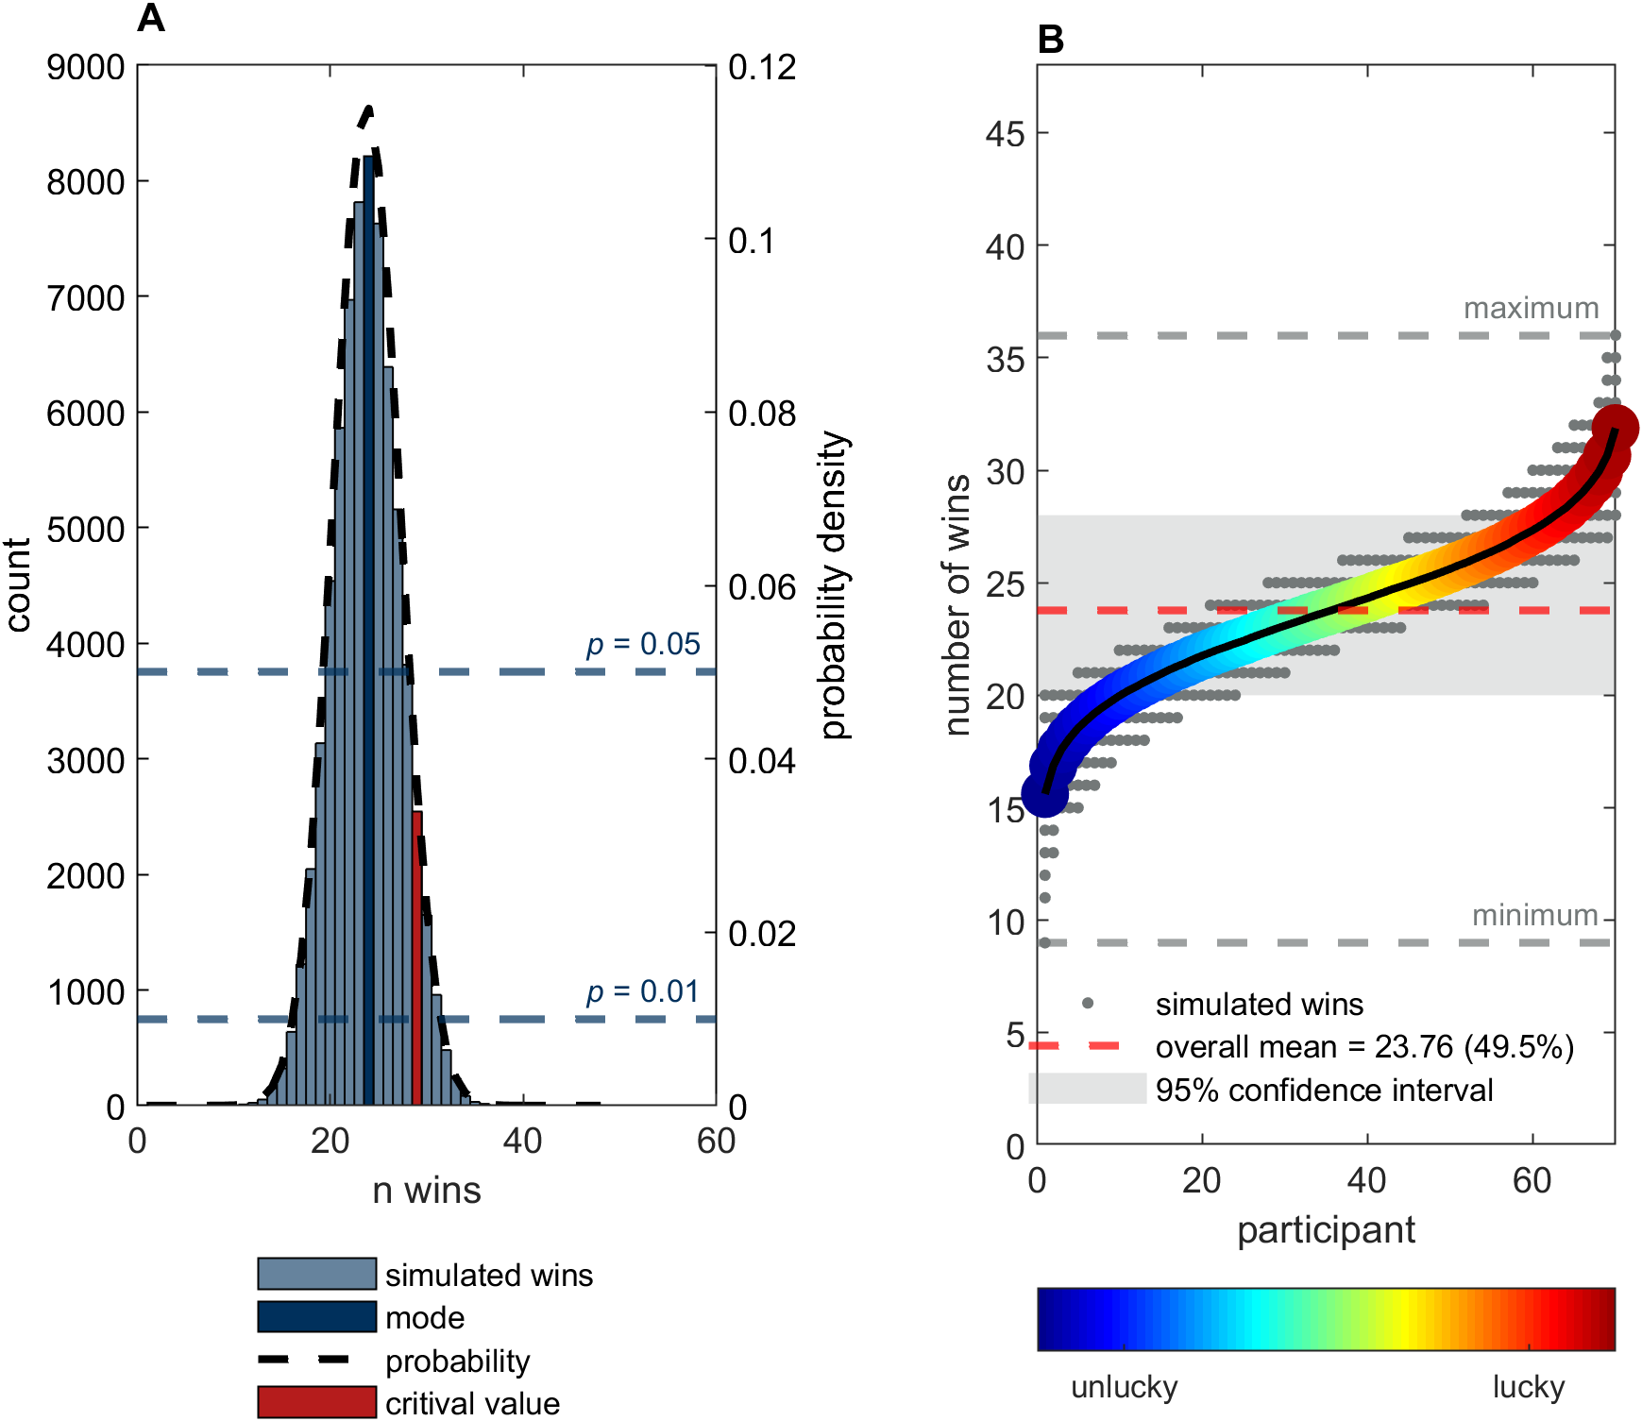
(A) Simulation data shows that the expected number of wins in a completely honest sample should follow a normal distribution with M = 23.76 (SD = 3.46, Mdn = 24, range 9-36, 95% CI [20-28]). Twenty-nine wins or more in the cheating task exceed the upper confidence bound for a significant difference from the expected number of wins at p < .05. (B) Individual data from simulated participants (grey dots) sorted by number of wins. The shaded area shows the 95% confidence interval. Again, completely honest participants may be (un)lucky when generating random numbers in the cheating task and responding honestly, but the probability of exceeding the critical threshold of 28 wins in the cheating task when remaining honest is lower than 5%. The maximum number of wins generated in this simulation was 36, which corresponds to an honest win-rate of 75.00%.
Supplementary Figure 2: Additional correlation analyses for reward sensitivity signal derived from alternative ROIs.
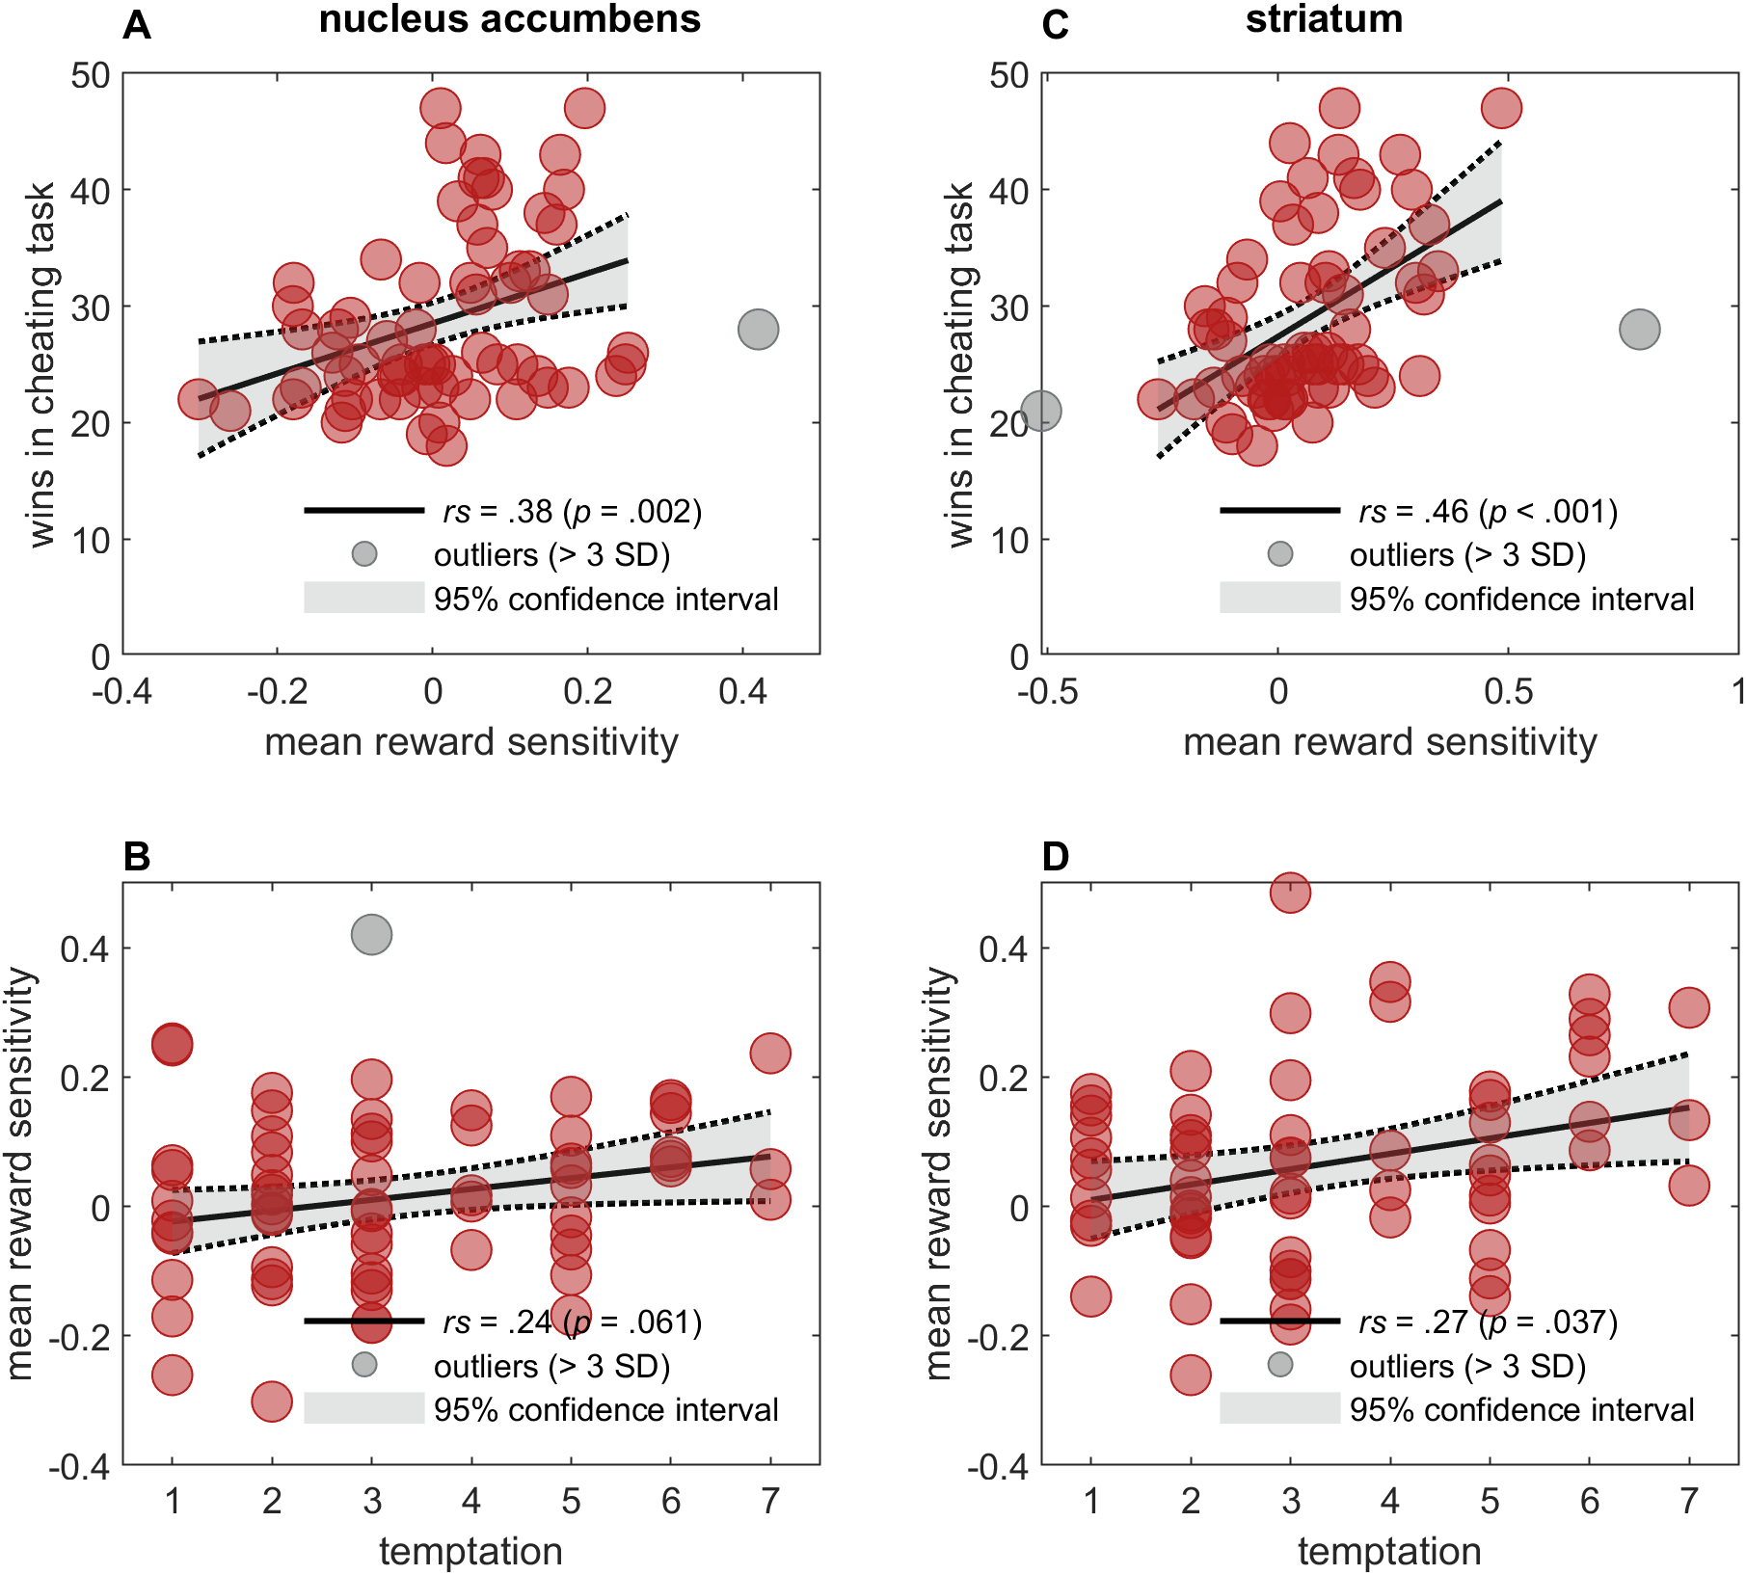
(A and B) Mean activity extracted from subcortical nucleus accumbens brain mask ³ correlates with participants’ number of wins in the cheating task (A), but only marginally with their temptation rating (B). (C and D) Mean activity extracted from larger meta-analytically derived striatal reward mask ⁴ correlates with participants’ number of wins in the cheating task (C) and also with their and temptation rating (D).
Supplementary Figure 3: Schematic depiction of the balancing of trials within each block.
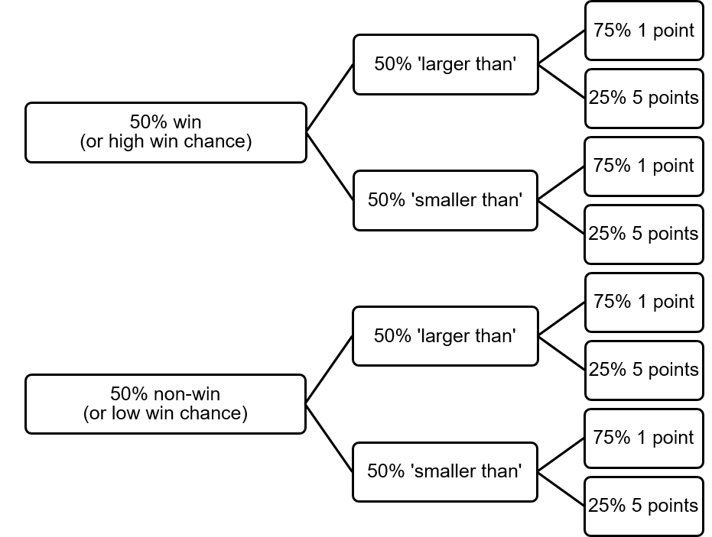
In the computer task, 50% of the trials are win-trials, where the first and second number are generated so that their relationship is always correct with respect to the operator (the opposite is true for non-win trials). Thus, if participants do not make an error in the computer task, they win sixteen points in each computer block (six one-point trials and two five-point trials). The chance of winning in the cheating task is manipulated by generating either lower or higher random numbers (from 2-49 or 51-98, respectively), depending on the win-condition and operator of the current trial. For example, for a trial with a high chance of winning with a smaller-than operator, a higher random number (from 51-98) was generated to make it more likely that participants think of a suitable number (e.g., X < 62, with X being the number that participants think of themselves in the beginning of the trial).
Supplementary Tables

Supplementary Table 1: Regression predicting number of wins in the cheating task from participants’ temptation to cheat.
Predictor | b | SE | t | p
(Intercept) | 19.87 | 1.56 | 12.77 | < .001
temptation | 2.69 | 0.42 | 6.46 | < .001
Note. Adjusted R² = 0.39; model predicts number of wins significantly better than constant model (F(62) = 41.70, p < .001).
Supplementary Table 2: Regression predicting number of wins in the cheating task from participants’ reward sensitivityª.
Predictor | b | SE | t | p
(Intercept) | 28.36 | 0.88 | 32.24 | < .001
reward sensitivityª | 38.17 | 10.44 | 3.66 | < .001
Note. Adjusted R² = 0.17; model predicts number of wins significantly better than constant model (F(61) = 13.40.70, p = .001).
ª Reward sensitivity defined as mean activation extracted from reward anticipation mask during the anticipation phase of both tasks.
Supplementary Table 3: Results of full brain win > non-win contrast in the outcome phase.
MNI coordinates
x | y | z | AAL3 label | hemisphere | t_{Peak} | n_{Voxels} | p_{FWE}
-41 | 38 | 8 | Inferior frontal gyrus, triangular part | L | 7.68 | 65 | < .001
-11 | 11 | 2 | Caudate nucleus | L | 6.82 | 66 | < .001
-17 | 2 | -8 | Lenticular nucleus, Pallidum | L | 6.51 | - | -
14 | 5 | -5 | Lenticular nucleus, Pallidum | R | 6.38 | 21 | < .001
-8 | -20 | -11 | Red Nucleus | L | 6.27 | 13 | .001
8 | -35 | 35 | Middle cingulate and paracingulate gyri | R | 5.98 | 17 | < .001
Notes. Results are family-wise error corrected with a cluster size of k ≥ 10 voxels. MNI coordinates, labels (AAL3 toolbox for SPM)⁶ and t value refer to peak voxel; the number of voxels and family-wise error corrected p value refer to the cluster level. Further local maxima within the same cluster (> 8 mm from other peaks) are given in gray without an entry in the columns for number of voxels and p_{FWE}.
Supplementary Table 4: Results of full brain non-win_{cheating} > non-win_{computer} contrast in the outcome phase.
MNI coordinates
x | y | z | AAL3 label | hemisphere | t_{Peak} | n_{Voxels} | p_{FWE}
20 | 59 | 23 | Superior frontal gyrus, dorsolateral | R | 8.13 | 720 | < .001
8 | 50 | 11 | Anterior cingulate cortex, pregenual | R | 8.03 | - | -
-8 | 41 | 8 | Anterior cingulate cortex, pregenual | L | 7.80 | - | -
56 | -50 | 32 | Angular gyrus | R | 7.08 | 70 | < .001
26 | 32 | 47 | Superior frontal gyrus, dorsolateral | R | 6.92 | 61 | < .001
14 | 29 | 59 | Superior frontal gyrus, dorsolateral | R | 5.64 | - | -
Notes. Results are family-wise error corrected with a cluster size of k ≥ 10 voxels. MNI coordinates, labels (AAL3 toolbox for SPM)⁶ and t value refer to peak voxel; the number of voxels and family-wise error corrected p value refer to the cluster level. Further local maxima within the same cluster (> 8 mm from other peaks) are given in gray without an entry in the columns for number of voxels and p_{FWE}.
Supplementary Table 5: Results from one-way ANOVA for the effect of response on extracted betas from reward mask.
 | SumSq | DF | MeanSq | F | p
(Intercept) | 12.99 | 1 | 12.99 | 45.01 | < .001
Error | 18.48 | 64 | 0.29
Response | 0.60 | 2 | 0.30 | 5.61 | .007
Error | 6.88 | 128 | 0.05
Note. Mean activation from reward outcome mask depending on participants’ previous response. Greenhouse-Geisser corrected p value.
Supplementary Table 6: Results of full brain non-win_{cheating} > [non-win_{computer}, win_{computer}] contrast in the outcome phase.
MNI coordinates
x | y | z | AAL3 label | hemisphere | t_{Peak} | n_{Voxels} | p_{FWE} | p_{uncorrected}
23 | 56 | 29 | Superior frontal gyrus, dorsolateral | R | 8.54 | 1984 | < .001 | < .001
29 | 32 | 47 | Superior frontal gyrus, dorsolateral | R | 6.60 | - | - | -
-5 | 29 | 17 | Anterior cingulate cortex, supracallosal | L | 6.56 | - | - | -
56 | -50 | 35 | Angular Gyrus | R | 6.01 | 533 | < .001 | < .001
50 | -62 | 23 | Middle temporal gyrus | R | 4.88 | - | - | -
53 | -38 | 32 | SupraMarginal gyrus | R | 4.63 | - | - | -
-38 | 23 | -14 | Posterior orbital gyrus | L | 5.36 | 89 | .025 | .008
-11 | -59 | 20 | Precuneus | L | 5.14 | 135 | .004 | .004
-5 | -53 | 11 | Precuneus | L | 4.76 | - | - | -
23 | 20 | 17 | Caudate nucleus | R | 5.1 | 116 | .008 | .005
23 | -5 | 23 | Caudate nucleus | R | 4.33 | - | - | -
17 | 5 | 23 | Caudate nucleus | R | 4.24 | - | - | -
-23 | -2 | 23 | Caudate nucleus | L | 5.00 | 90 | .024 | .008
-23 | -14 | 23 | Caudate nucleus | L | 4.89 | - | - | -
-23 | 11 | 20 | Caudate nucleus | L | 3.85 | - | - | -
50 | 11 | -38 | Inferior temporal gyrus | R | 4.62 | 105 | .013 | .006
56 | 5 | -29 | Middle temporal gyrus | R | 4.54 | - | - | -
-68 | -41 | 32 | SupraMarginal gyrus | L | 4.61 | 96 | .018 | .008
35 | 17 | -11 | Insula | R | 4.59 | 121 | .007 | .005
47 | 29 | -8 | IFG pars orbitalis | R | 4.46 | - | - | -
47 | 29 | 2 | Inferior frontal gyrus, triangular part | R | 4.22 | - | - | -
-8 | 26 | 59 | Superior frontal gyrus, medial | L | 4.27 | 25 | .516 | .173
32 | 5 | -11 | Lenticular nucleus, Putamen | R | 4.16 | 21 | .617 | .196
8 | -53 | 32 | Middle cingulate & paracingulate gyri | R | 4.04 | 63 | .081 | .024
11 | -53 | 23 | Precuneus | R | 3.89 | - | - | -
11 | -53 | 47 | Precuneus | R | 3.65 | - | - | -
32 | -26 | -17 | Parahippocampal gyrus | R | 4.00 | 33 | .353 | .113
23 | -14 | -23 | Parahippocampal gyrus | R | 3.74 | - | - | -
-17 | -47 | -59 | Lobule IX of cerebellar hemisphere | L | 3.89 | 11 | .878 | .402
-59 | -56 | 32 | Angular gyrus | L | 3.65 | 22 | .591 | .196
Notes. Results from uncorrected whole-brain contrast with a cluster size of k ≥ 10 voxels. MNI coordinates, labels (AAL3 toolbox for SPM)⁶ and t value refer to peak voxel; the number of voxels and p values (both FWE-corrected and uncorrected) refer to the cluster level. Further local maxima within the same cluster (> 8 mm from other peaks) are given in gray without an entry in the columns for number of voxels and p.
Supplementary Table 7: Results of full brain non-win_{cheating} > [non-win_{computer}, win_{computer}, win_{cheating}] contrast in the outcome phase.
MNI coordinates
x | y | z | AAL3 label | hemisphere | t_{Peak} | n_{Voxels} | p_{FWE} | p_{uncorrected}
23 | 56 | 26 | Superior frontal gyrus, dorsolateral | R | 8.21 | 871 | < .001 | < .001
11 | 26 | 62 | Superior frontal gyrus, medial | R | 5.41 | - | - | -
-5 | 29 | 20 |  | L | 4.80 | - | - | -
  Anterior cingulate cortex, supracallosal
14 | -77 | -8 | Lingual gyrus | R | 5.99 | 83 | .032 | .024
8 | -83 | -2 | Lingual gyrus | R | 4.85 | - | - | -
-68 | -32 | 20 | SupraMarginal gyrus | L | 5.35 | 277 | < .001 | < .001
-47 | -26 | 17 | Rolandic operculum | L | 4.48 | - | - | -
-41 | -17 | 26 | Rolandic operculum | L | 4.04 | - | - | -
56 | -53 | 32 | Angular gyrus | R | 5.07 | 545 | < .001 | < .001
68 | -26 | 23 | SupraMarginal gyrus | R | 4.90 | - | - | -
56 | -20 | 20 | Rolandic operculum | R | 4.80 | - | - | -
-41 | 23 | -14 | Posterior orbital gyrus | L | 4.95 | 49 | .157 | .084
-14 | -83 | -5 | Lingual gyrus | L | 4.78 | 30 | .405 | .163
47 | 11 | -38 | Inferior temporal gyrus | R | 4.46 | 61 | .088 | .054
53 | 2 | -29 | Middle temporal gyrus | R | 3.85 | - | - | -
-8 | 26 | 59 | Superior frontal gyrus, medial | L | 4.34 | 21 | .615 | .256
-17 | -47 | -59 | Lobule IX of cerebellar hemisphere | L | 4.32 | 16 | .750 | .341
50 | 26 | 5 | Inferior frontal gyrus, triangular part | R | 4.08 | 33 | .350 | .159
-23 | -2 | 23 | Caudate nucleus | L | 4.03 | 29 | .425 | .163
-23 | -11 | 23 | Caudate nucleus | L | 3.75 | - | - | -
-5 | -53 | 11 | Precuneus | L | 3.92 | 38 | .273 | .134
-8 | -62 | 20 | Cuneus | L | 3.70 | - | - | -
-14 | -53 | 14 | Precuneus | L | 3.70 | - | - | -
47 | -32 | -5 | Middle temporal gyrus | R | 3.68 | 13 | .830 | .402
-20 | 53 | 29 | Superior frontal gyrus, dorsolateral | L | 3.66 | 11 | .878 | .444
Notes. Results from uncorrected whole-brain contrast with a cluster size of k ≥ 10 voxels. MNI coordinates, labels (AAL3 toolbox for SPM)⁶ and t value refer to peak voxel; the number of voxels and p values (both FWE-corrected and uncorrected) refer to the cluster level. Further local maxima within the same cluster (> 8 mm from other peaks) are given in gray without an entry in the columns for number of voxels and p.
Supplementary Table 8: Regression predicting number of wins in the cheating task from participants’ reward sensitivityª in the nucleus accumbens.
Predictor | b | SE | t | p
(Intercept) | 28.52 | 0.90 | 31.88 | < .001
reward sensitivityª | 21.49 | 7.31 | 2.94 | .005
Note. Adjusted R² = 0.11; model predicts number of wins significantly better than constant model (F(62) = 8.65, p = .005).
ª Reward sensitivity defined as mean activation extracted from anatomical nucleus accumbens mask during the anticipation phase of both tasks.
Supplementary Table 9: Regression predicting temptation to cheat from participants’ reward sensitivityª in the nucleus accumbens.
Predictor | b | SE | t | p
(Intercept) | -0.04 | 0.03 | -1.28 | .206
temptation | 0.02 | 0.01 | 2.00 | .050
Note. Adjusted R² = 0.05; model does not predict temptation significantly better than constant model (F(61) = 3.99, p = .050).
ª Reward sensitivity defined as mean activation extracted from anatomical nucleus accumbens mask during the anticipation phase of both tasks.
Supplementary Table 10: Regression predicting number of wins in the cheating task from participants’ reward sensitivityª in the striatum.
Predictor | b | SE | t | p
(Intercept) | 27.39 | 0.92 | 29.77 | < .001
reward sensitivityª | 24.05 | 5.77 | 4.17 | < .001
Note. Adjusted R² = 0.21; model predicts number of wins significantly better than constant model (F(61) = 17.40, p = .001).
ª Reward sensitivity defined as mean activation extracted from meta-analytical striatum mask during the anticipation phase of both tasks.
Supplementary Table 11: Regression predicting temptation to cheat from participants’ reward sensitivityª in the striatum.
Predictor | b | SE | t | p
(Intercept) | -0.01 | 0.04 | -0.36 | .719
temptation | 0.02 | 0.01 | 2.33 | .023
Note. Adjusted R² = 0.07; model predicts number of wins significantly better than constant model (F(60) = 5.42, p = .023).
ª Reward sensitivity defined as mean activation extracted from meta-analytical striatum mask during the anticipation phase of both tasks.
Supplementary Table 12: Results from 2×2×2 repeated ANOVA for the effect of time, task and response on assessed momentary mood in the online study.
 | SumSq | DF | MeanSq | F | p
(Intercept) | 145291.81 | 1 | 145291.81 | 30023.81
Task | 52.66 | 1 | 52.66 | 10.88 | .001
Response | 825.08 | 1 | 825.08 | 170.50 | < .001
Task:response | 38.83 | 1 | 38.83 | 8.02 | .005
Error | 9683.30 | 2001 | 4.84
(Intercept):time | 205.24 | 1 | 205.24 | 215.63 | < .001
Task:time | 47.60 | 1 | 47.60 | 50.01 | < .001
Response:time | 916.70 | 1 | 916.70 | 963.13 | < .001
Task:response:time | 24.18 | 1 | 24.18 | 25.40 | < .001
Error (time) | 1904.50 | 2001 | 0.95
Note. Change in participants’ mood depending on time of measurement (pre/post), task (cheating/computer) and response (win/non-win). The sample includes participants with an erroneous response (n = 113), resulting in n = 535 participants in the computer non-win condition.
Supplementary Table 13: Results from 2×2×2 repeated ANOVA for the effect of time, task and response on assessed momentary mood in the online study (participants with erroneous response excluded).
 | SumSq | DF | MeanSq | F | p
(Intercept) | 135790.67 | 1 | 135790.67 | 28382.14
Task | 74.31 | 1 | 74.31 | 15.53 | < .001
Response | 868.04 | 1 | 868.04 | 181.43 | < .001
Task:response | 58.14 | 1 | 58.14 | 12.15 | .001
Error | 9032.90 | 1888 | 4.78
(Intercept):time | 203.55 | 1 | 203.55 | 224.88 | < .001
Task:time | 49.80 | 1 | 49.80 | 55.02 | < .001
Response:time | 885.29 | 1 | 885.29 | 978.05 | < .001
Task:response:time | 26.34 | 1 | 26.34 | 29.10 | < .001
Error (time) | 1708.90 | 1888 | 0.91
Note. Change in participants’ mood depending on time of measurement (pre/post), task (cheating/computer) and response (win/non-win). Participants with an erroneous response (n = 113) were excluded from the analysis, resulting in n = 422 participants in the computer non-win condition.
Supplementary References

1. Abe, N. & Greene, J. D. Response to Anticipated Reward in the Nucleus Accumbens Predicts Behavior in an Independent Test of Honesty. Journal of Neuroscience 34, 10564–10572 (2014).
2. Speer, S. P. H., Smidts, A. & Boksem, M. A. S. Cognitive control increases honesty in cheaters but cheating in those who are honest. Proc. Natl. Acad. Sci. U.S.A. 117, 19080–19091 (2020).
3. Pauli, W. M., Nili, A. N. & Tyszka, J. M. A high-resolution probabilistic in vivo atlas of human subcortical brain nuclei. Sci Data 5, 180063 (2018).
4. Bartra, O., McGuire, J. T. & Kable, J. W. The valuation system: A coordinate-based meta-analysis of BOLD fMRI experiments examining neural correlates of subjective value. NeuroImage 76, 412–427 (2013).
5. Yarkoni, T., Poldrack, R. A., Nichols, T. E., Van Essen, D. C. & Wager, T. D. Large-scale automated synthesis of human functional neuroimaging data. Nat Methods 8, 665–670 (2011).
6. Rolls, E. T., Huang, C.-C., Lin, C.-P., Feng, J. & Joliot, M. Automated anatomical labelling atlas 3. NeuroImage 206, 116189 (2020).

