Basic magnesium sulfate@TiO₂ composite for efficient adsorption and photocatalytic degradation of 4-dodecylmorpholine in brine

Zhongmei Song ^{a,d}, Huifang Zhang ^{a,∗}, Liang Ma^{a,d}, Miao Lu^{a,d}, Chengyou Wu^{b,∗}, Qingqing Liu ^{c}, Xuefeng Yu ^{c}, Haining Liu ^{a,∗}, Xiushen Ye ª, Zhen Ma ^{c}, Zhijian Wuª

ª Key Laboratory of Green and High-end Utilization of Salt Lake Resources, Qinghai Institute of Salt Lakes, Chinese Academy of Sciences, Xining 810008, China
^{b} Qinghai University, Xining 810016, China
^{c} Qinghai Salt Lake Industry Co., Ltd., Golmud 816000, China
^{d} University of Chinese Academy of Sciences, Beijing 100049, China

Contents:
Text sections:
S1. Adsorption isotherms
S2. Adsorption kinetics
S3. Adsorption thermodynamics
S4. Density functional theory (DFT) calculation methods
Tables: 8
Figures: 4
S1. Adsorption isotherms
The adsorption isotherm of the prepared BMS@TiO₂ was analyzed using the Langmuir, and Freundlich models. The mathematical expressions are shown in Eq. (S1) ~ (S2), respectively [1].
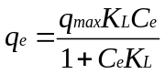 (S1)
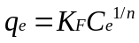 (S2)
Where q_{e}, q_{max}, and C_{e} represent the equilibrium adsorption (mg·g⁻¹), the maximum adsorption (mg·g⁻¹), and the equilibrium concentration of DMP (mg·L⁻¹), respectively. K_{L}, K_{F}, and n represent Langmuir, and Freundlich’s constants, respectively.
S2. Adsorption kinetics
As the prediction of the adsorption speed is essential in the surface adsorption process, several kinetics models such as the pseudo-first-order, and pseudo-second-order are applied to evaluate the kinetics behavior of BMS@TiO₂. Eq. (S3) ~ (S4) show the mathematical expression of the pseudo-first-order, and pseud-second-order [2].
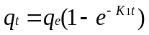 (S3)
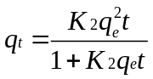 (S4)
Where q_{t} and q_{e} represent the DMP adsorption capacity at a certain time (mg·g⁻¹) and its equilibrium adsorption capacity (mg·g⁻¹), K₁ (h⁻¹) and K₂ (g·mg⁻¹·h⁻¹) are the kinetics constants of pseudo-first order and pseudo-second order, respectively, and t is the adsorption time (h).
S3. Adsorption thermodynamics
The thermodynamics parameters, such as the thermodynamic equilibrium constant (K_{eq}), Gibbs free energy (ΔG), standard enthalpy of adsorption (ΔH°), and standard entropy of adsorption (ΔS°) for the removal of DMP using BMS@TiO₂ are determined by applying the Van’t Hoff equations as expressed by Eq. (S5) ~ (S7) [3, 4].
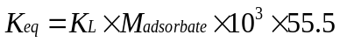 (S5)
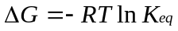 (S6)
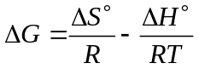 (S7)
Here K_{L}, and K_{eq} represent the Langmuir constant and the standard thermodynamic equilibrium constant of adsorption, respectively. The K_{L} constant is simply recalculated as dimensionless by multiplying it by 55.5 (the number of moles of water per liter of solution). M_{adsorbate} represents the molar mass of DMP. ΔG (kJ mol⁻¹), ΔH° (kJ mol⁻¹), and ΔS° (J mol⁻¹·K⁻¹) represent the standard Gibbs free energy, enthalpy, and entropy of adsorption. R (8.314 J·mol⁻¹·K⁻¹) is the universal gas constant, and T represent the absolute temperature (K).
S4. Density functional theory (DFT) calculation methods
The theoretical calculations were performed via the Gaussian 16 suite of programs [5]. The structure of the studied molecules was fully optimized at the B3LYP-D3BJ/def2-SVP level of theory. The solvent effect was included in the calculations using the solvation model based on the density (SMD) model. The vibrational frequencies of the optimized structures were carried out at the same level. The structures were characterized as a local energy minimum on the potential energy surface by verifying that all the vibrational frequencies were real. The Visual Molecular Dynamics (VMD) program [6] was used to plot the color-filled iso-surface graphs to visualize the molecular orbitals and the molecular electrostatic potential (MESP).

Tables
Table S1. Key physicochemical properties of dodecylmorpholine [7].
Molecular  formula | C₁₆H₃₃NO | 2-D structure | 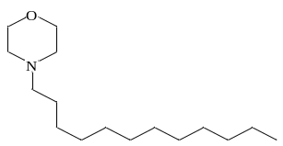
Molecular weight  (g·mol⁻¹) | 255.44 | 3-D structure
Density  (25℃)  (g·cm⁻³) | 0.859 | Octanol-water partition coefficient  log K_{ow} | 5.05
Water solubility  (25℃)  (mg·L⁻¹) | insoluble | Boiling point (℃) | 321

Table S2. Elemental composition in BMS and BMS@TiO₂.
Elementals | Elemental measurement
 | BMS |  | BMS@TiO₂
 | Mass  fraction/% | Atom  fraction | Mass  fraction/% | Atom  fraction
Oxygen (O) | 59.3 | 0.2 | 55.3 | 0.2
Magnesium (Mg) | 27.9 | 0.2 | 31.8 | 0.2
Sulfur (S) | 6.9 | 0.1 | 8.3 | 0.1
Carbon (C) | 5.9 | 0.3 | 3.2 | 0.3
Titanium (Ti) | 0.0 | 0.0 | 1.4 | 0.1

Table S3. Pore features of BMS and BMS@TiO₂.
Sample | BET surface area  (m²·g⁻¹) | Pore volume  (cm³·g⁻¹) | Average pore  diameter (nm)
BMS | 35.30 | 0.084 | 9.53
BMS@TiO₂ | 37.24 | 0.083 | 8.95

Table S4. Kinetic model parameters of adsorption for DMP onto BMS@TiO₂.
Model | Parameter | Values
Pseudo-first-order | K₁ (h⁻¹) | 0.2128
Pseudo-first-order | q_{e} (mg·g⁻¹) | 5.5131
Pseudo-first-order | R² | 0.9349
Pseudo-second-order | K₂ (g·mg⁻¹·h⁻¹) | 0.1635
Pseudo-second-order | q_{e} (mg·g⁻¹) | 5.4905
Pseudo-second-order | R² | 0.9907

Table S5. Isotherm model parameters of adsorption for DMP onto BMS@TiO₂.
Model | Temperature | Parameter | Values
Langmuir | 25℃ | q_{max} (mg·g⁻¹) | 12.8927
Langmuir | 25℃ | K_{L} (L·mg⁻¹) | 0.0279
Langmuir | 25℃ | R² | 0.9995
Langmuir | 35℃ | q_{max} (mg·g⁻¹) | 8.5984
Langmuir | 35℃ | K_{L} (L·mg⁻¹) | 0.0784
Langmuir | 35℃ | R² | 0.9977
Langmuir | 45℃ | q_{max} (mg·g⁻¹) | 7.5442
Langmuir | 45℃ | K_{L} (L·mg⁻¹) | 0.1657
Langmuir | 45℃ | R² | 0.9947
Freundlich | 25℃ | K_{F} (L·g⁻¹) | 0.5798
Freundlich | 25℃ | n⁻¹ | 0.6697
Freundlich | 25℃ | R² | 0.9949
Freundlich | 35℃ | K_{F} (L·g⁻¹) | 1.2853
Freundlich | 35℃ | n⁻¹ | 0.4673
Freundlich | 35℃ | R² | 0.9706
Freundlich | 45℃ | K_{F} (L·g⁻¹) | 2.2493
Freundlich | 45℃ | n⁻¹ | 0.3146
Freundlich | 45℃ | R² | 0.9072

Table S6. The thermodynamic parameters of adsorption for DMP onto BMS@TiO₂.
T (℃) | ΔH° (kJ·mol⁻¹) | ΔS° (J·mol⁻¹·K⁻¹) | ΔG (kJ·mol⁻¹)
25 | 70.40 | 343.58 | -31.94
35 | 70.40 | 343.58 | -35.67
45 | 70.40 | 343.58 | -38.80

Table S7. Binding energy of elements on BMS@TiO₂ surface before and after adsorption
Atomic orbital | Binding energy  before adsorption (eV) | Binding energy  after adsorption(eV) | Binding energy  offset(eV)
Mg1s | 1303.68 | 1303.16 | -0.52
O1s | 531.10 | 530.90 | -0.20
Ti2p | 457.81 | 457.80 | -0.01
S2p | 168.60 | 168.75 | +0.15

Table S8. Kinetic model parameters of photodegradation for DMP by BMS@TiO₂.
 | Pseudo-first order |  | Pseudo-second order
Parameter | k₁ (h⁻¹) | R² | k₂ (h·mg⁻¹) | R²
Values | 0.2281 | 0.9813 | 0.6081 | 0.9187

Figures
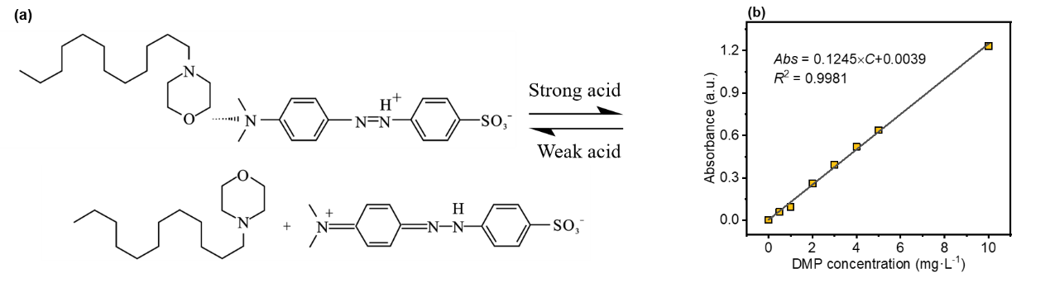
Fig. S1. (a) Schematic diagram of the formation and decomposition process of methyl orange and DMP complexes, and (b) DMP concentration standard curve.

Fig. S2. XRD patterns of effect of co-existing salt: (a) KCl, (b) NaCl, and (c) MgCl₂, (d) XRD patterns of 1 mol·L⁻¹ ionic strength with different salts.
Fig. S3. (a) SEM images, (b) XRD patterns, (c) FTIR spectra, and (d) XPS full-scan spectra for BMS@TiO₂ before and after adsorption.
Fig. S4. (a) TOC removal efficiency of DMP adsorbed on BMS@TiO₂ by photocatalytic degradation, (b) Total gas chromatogram of DMP at 0, 12, and 16 hours of photocatalytic degradation by BMS@TiO₂, and (c) Mass spectra of main substances appeared in the gas chromatogram.

References
- Gao, M.W., Li, B., Liu, J., Hu, Y.N., Cheng, H.F. Adsorption behavior and mechanism of p-arsanilic acid on a Fe-based metal-organic framework. J. Colloid Interface Sci. 629, 616-627 (2023).
- Tseng, R.L., Wu, P.H., Wu, F.C., Juang, R.S. A convenient method to determine kinetic parameters of adsorption processes by nonlinear regression of pseudo-nth-order equation. Chem. Eng. J. 237, 153-161 (2014).
- Hasanzadeh, M., Simchi, A., Shahriyari Far, H. Nanoporous composites of activated carbon-metal organic frameworks for organic dye adsorption: Synthesis, adsorption mechanism and kinetics studies. J. Ind. Eng. Chem. 81, 405-414 (2020).
- Zhou, X.Y., Zhou, X. The unit problem in the thermodynamic calculation of adsorption using the Langmuir equation. Chem. Eng. Commun. 201, 1459-1467 (2014).
- Frisch, M.J. et al. Gaussian 16 Revision A 03 (Gaussian, 2016).
- Humphrey, W., Dalke, A., Schulten, K. VMD: Visual molecular dynamics. J. Mol. Graphics 14, 33-38(1996).
- U.S. Environmental Protection Agency. Comptox Chemicals Dashboard. https://comptox.epa.gov/dashboard/chemical/details/DTXSID4042171 (accessed January 23, 2024).

∗ Corresponding authors. E-mail addresses: zhanghf@isl.ac.cn (H.F. Zhang); wuchengyou86@163.com; liuhn@isl.ac.cn (H.N. Liu).

