Table 1 | Optimization of the reaction conditionsª
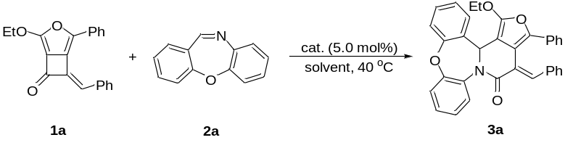
Entry | Cat. | Solvent | Yield^{b} (%)
1 | Rh(COD)₂BF₄ | DCE | 32
2 | Pd₂(dba)₃ | DCE | ND
3 | Ni(COD)₂ | DCE | NR
4 | Cu(OTf)₂ | DCE | 15
5 | AgSbF₆ | DCE | 25
6 | [Ru(p-cymene)Cl₂]₂ | DCE | NR
7 | PPh₃AuNTf₂ | DCE | ND
8 | IPrAuNTf₂ | DCE | 62
9 | BrettphosAuNTf₂ | DCE | 26
10 | JohnPhosAu(MeCN)SbF₆ | DCE | 56^{c}
11 | IPrAuNTf₂ | DCM | 50
12 | IPrAuNTf₂ | THF | NR
13 | IPrAuNTf₂ | toluene | NR
14 | IPrAuNTf₂ | PhCF₃ | 46
15 | IPrAuNTf₂ | MeCN | 89(88)^{c}
16 | IPrAuNTf₂ | EtOAc | NR
17^{d} | IPrAuNTf₂ | MeCN | 78
ªThe reaction was carried out on a 0.1 mmol scale: to a solution of 1a (37.9 mg, 0.12 mmol, 1.2 equiv.), and 2a (19.5 mg, 0.1 mmol, 1.0 equiv.) in 1.0 mL solvent, was added a solution of catalyst (5.0 mol%) in 1.0 mL of same solvent via syringe under argon atmosphere at 40 ºC, and the reaction mixture was stirred for 18 h under these conditions. ^{b}Determined by ¹H NMR analysis of the crude reaction mixture based on internal standard (1,3,5-trimethoxybenzene). ^{c}Result in parentheses is isolated yield. ^{d}The reaction was conducted in 60 ºC. ND = not detected. NR = no reaction. DCE = dichloroethane, DCM = dichloromethane, THF = tetrahydrofuran.

Table 2 | Substrate scope for the [4+2]-cycloadditionª
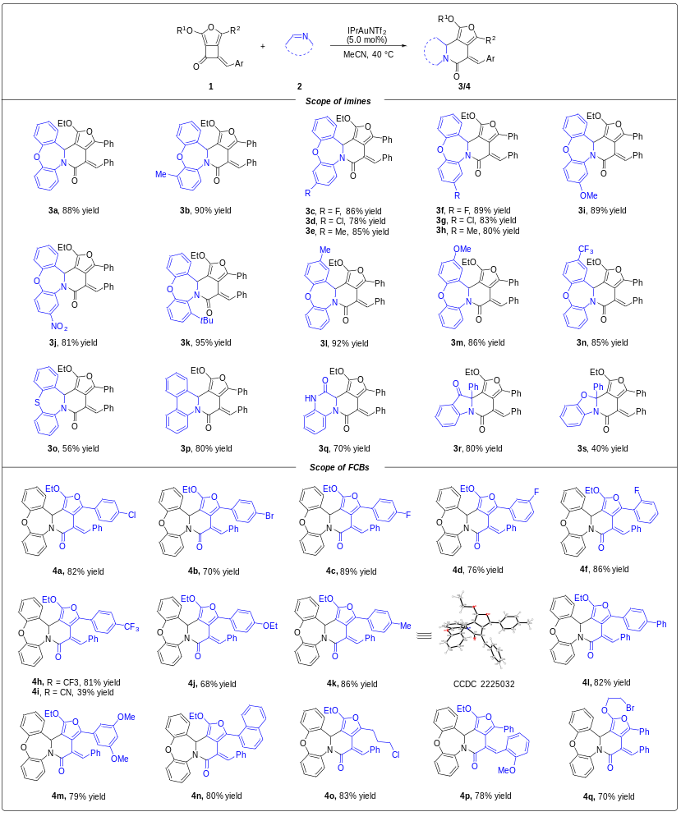
ªThe reaction was carried out on a 0.1 mmol scale: 1 (0.12 mmol, 1.2 equiv.), 2 (0.1 mmol, 1.0 equiv.), and IPrAuNTf₂ (4.3 mg, 5.0 mol%), MeCN (2.0 mL) was added via syringe under argon atmosphere at 40 ºC, and the reaction mixture was stirred for 18 h under these conditions. Yields given are isolated yields.

Table 3 | Substrate scope for the [4+4]-cycloaddition^{a,b}
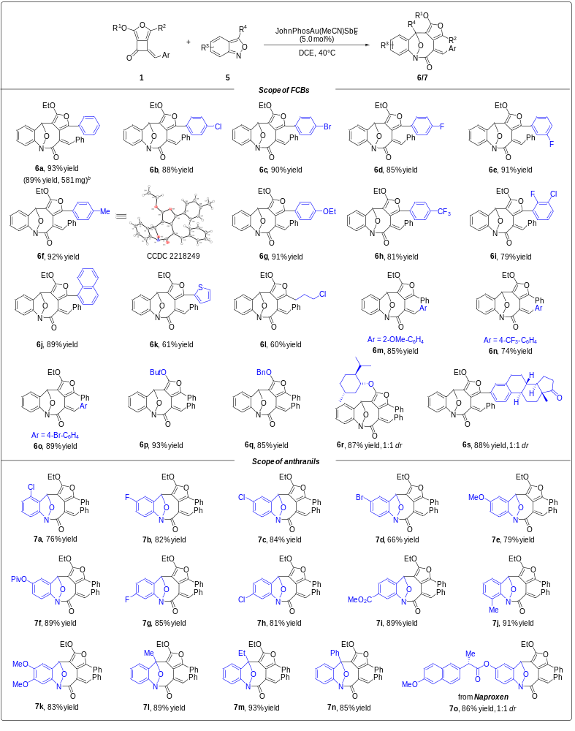
ªThe reaction was carried out on a 0.1 mmol scale: to a solution of 1 (0.1 mmol, 1.0 equiv.) and 5 (0.11 mmol, 1.1 equiv.) in 1.0 mL DCE, was added a solution of JohnPhosAu(MeCN)SbF₆ (3.9 mg, 5.0 mol%) in 1.0 mL DCE via syringe under argon atmosphere at 40 ºC, and the reaction mixture was stirred for 12 h under these conditions. Yields given are isolated yields. ^{b}The reaction was carried out on a 1.5 mmol scale.

Table 4 | Substrate scope for the enantioselective [4+2]-cycloaddition
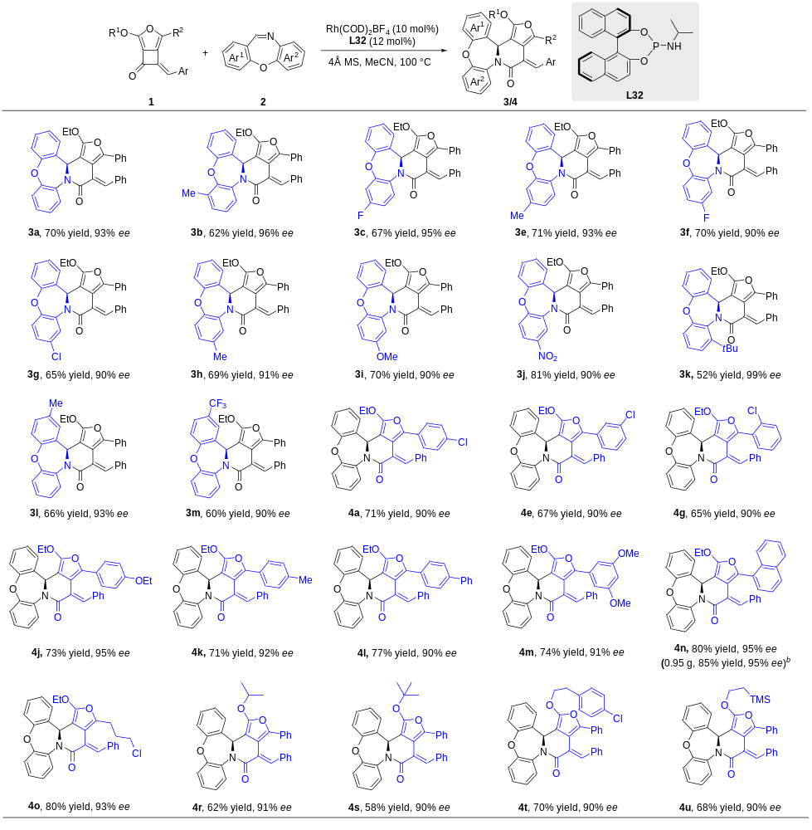
ªThe reactions were performed on a 0.1 mmol scale: FCBs 1 (0.12 mmol, 1.2 equiv.), imines 2 (0.1 mmol, 1.0 equiv.), Rh(COD)₂BF₄ (4.1 mg, 10 mol%), 4Å MS (50 mg), and chiral ligand L32 (4.5 mg, 12 mol%) in MeCN (2.0 mL) under argon atmosphere at 100 °C for 12 h. Yields given are isolated yields. The enantiomeric excess was determined by chiral HPLC analysis. ^{b}The reaction was carried out on a 2.0 mmol scale.

