A 3.55-μm ultrathin, skin-like mechanoresponsive, compliant, and seamless ionic conductive electrode for epidermal electrophysiological signal acquisition and human-machine-interaction

Likun Zhang^{1,2,3#}, Zhenglin Chen^{1,2,3#}*, Huazhang Ying^{1,2}, Zhicheng Du^{1,2,3}, Ziwu Song¹, Jiaju Chen², Xi Yuan^{1,2}, Canhui Yang⁴, Vijay Pandey^{1,2}, Can Yang Zhang^{2,3}, Dongmei Yu⁵, Wenbo Ding¹, Xinhui Xing^{2,3}, Jiansong Ji⁶, Chenggang Yan^{7,8}*, Peiwu Qin^{1,2,3}*

1 Tsinghua-Berkeley Shenzhen Institute, Tsinghua Shenzhen International Graduate School, Tsinghua University, Shenzhen, China
2 Institute of Biopharmaceutical and Health Engineering, Shenzhen International Graduate School, Tsinghua University, Shenzhen, Guangdong, China
3 Key Lab for Industrial Biocatalysis, Ministry of Education, Department of Chemical Engineering, Tsinghua University, Beijing 100084, China
4 Soft Mechanics Lab, Department of Mechanics and Aerospace Engineering, Southern University of Science and Technology, Shenzhen, China
5 School of Mechanical, Electrical & Information Engineering, Shandong University, Weihai, Shandong, China.
6 Key Laboratory of Imaging Diagnosis and Minimally Invasive Intervention Research, The Fifth Affiliated Hospital of Wenzhou Medical University, Lishui, Zhejiang Province, 323000, China.
7 School of Automation, Hangzhou Dianzi University, Hangzhou, Zhejiang Province, 310018, China
8 Lishui Institute of Hangzhou Dianzi University, Lishui, Zhejiang Province, 323000, China
# These authors contributed equally to this work and should be considered as co-first authors.
* Corresponding author's emails: zhenglin.chen@sz.tsinghua.edu.cn; pwqin@sz.tsinghua.edu.cn.
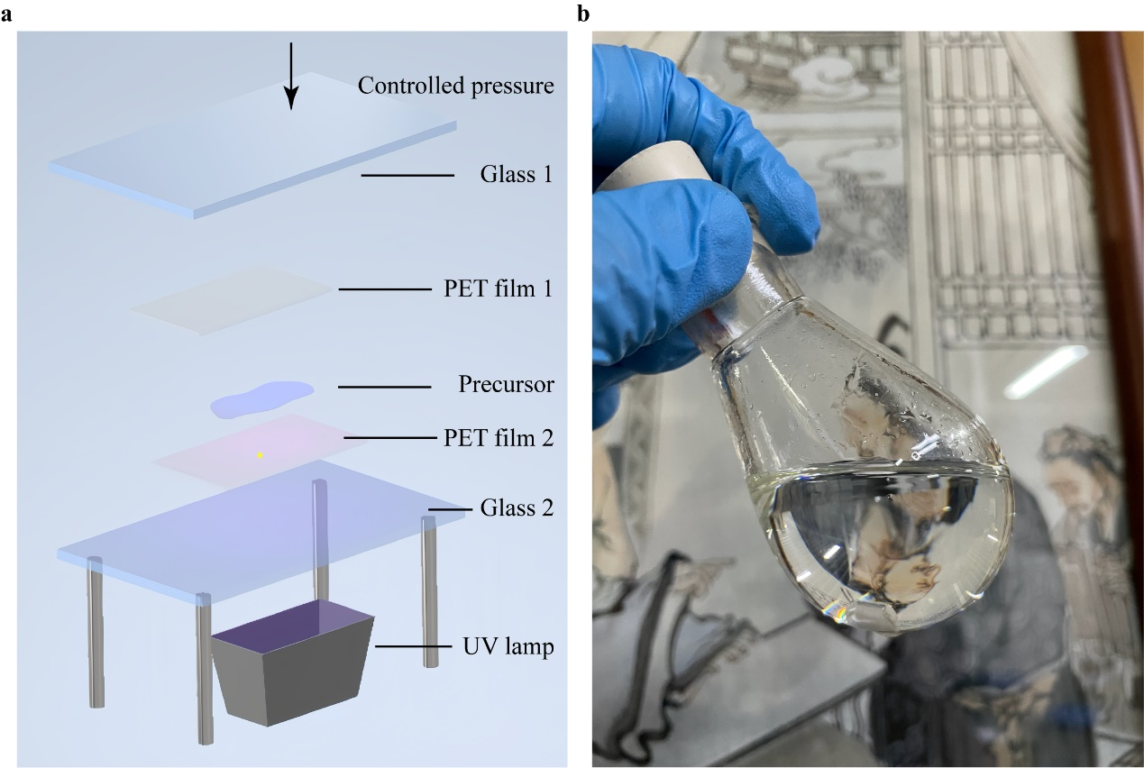
Supplementary Figure 1. Structure of the device and precursor solution. a The setup of the device for preparing ultrathin CEAB film. b The transparent precursor solution.
Supplementary Figure 2. AFM height 3D image of CEAB film.
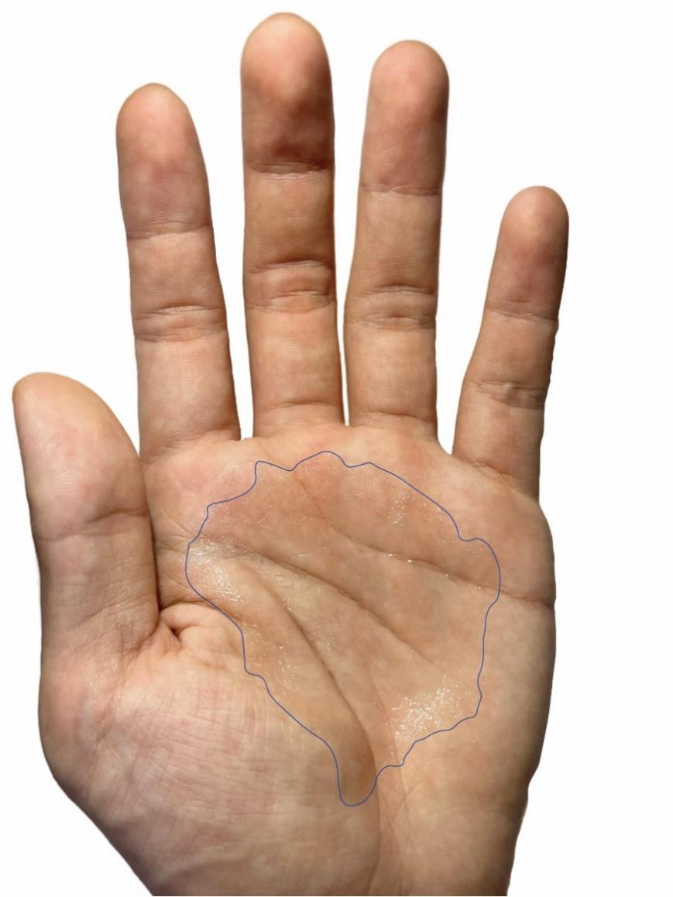
Supplementary Figure 3. The 200 μm thick CEAB film is applied to the palm, which can effectively replicate the complex and curved rough surface across a large area.

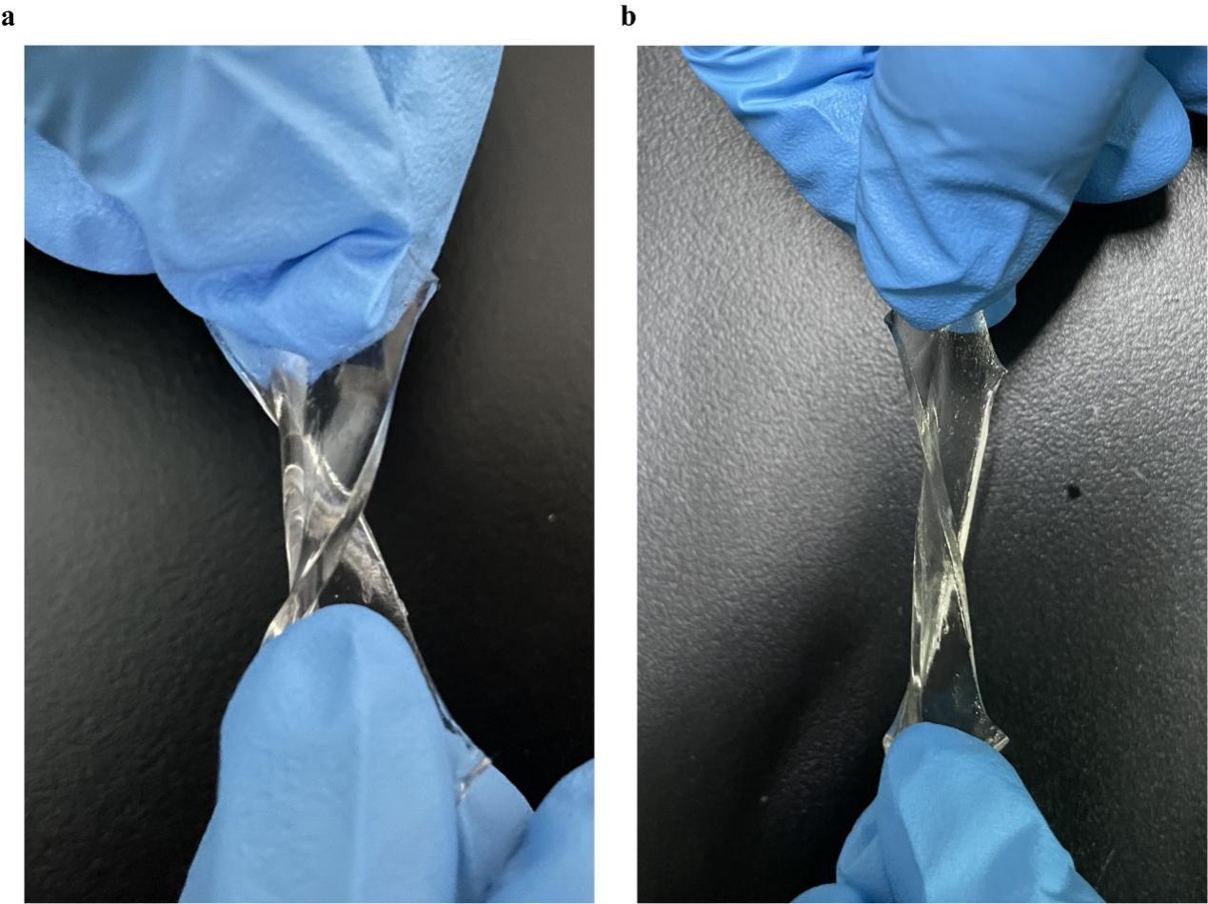
Supplementary Figure 4. CEAB film is flexible and twisted at a 25 ℃ and b after stored at -30 ℃ for 1 h.

Supplementary Figure 5. a CEAB film conductivity at different temperatures. b The relationship between ionic conductivity and temperature follows the Vogel-Fulcher-Tammann (VFT) relationship. The fitted data is consistent with the experimental data.

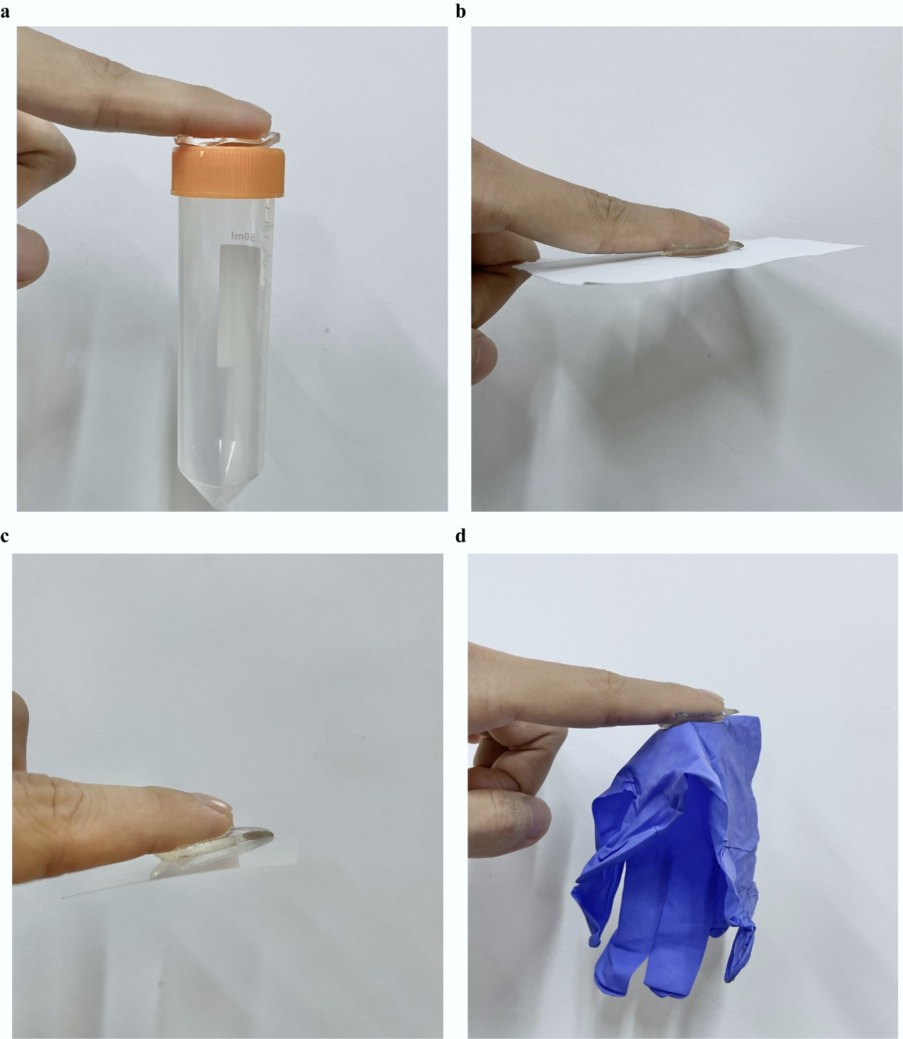
Supplementary Figure 6. Adhesive behaviors of 2 mm CEAB film to various substrates a plastic tube b paper (cellulose) c PET film d rubber glove.
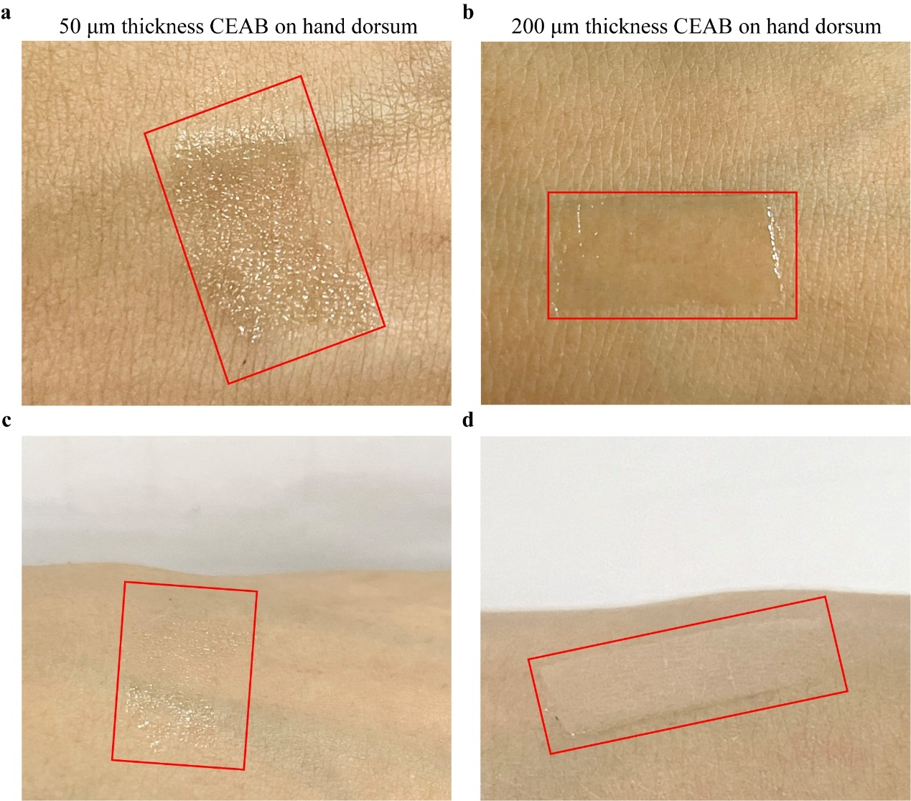
Supplementary Figure 7. The digital photograph of 50 (a and c), and 200 (b and d) μm thick CEAB film adherent to human skin closely.
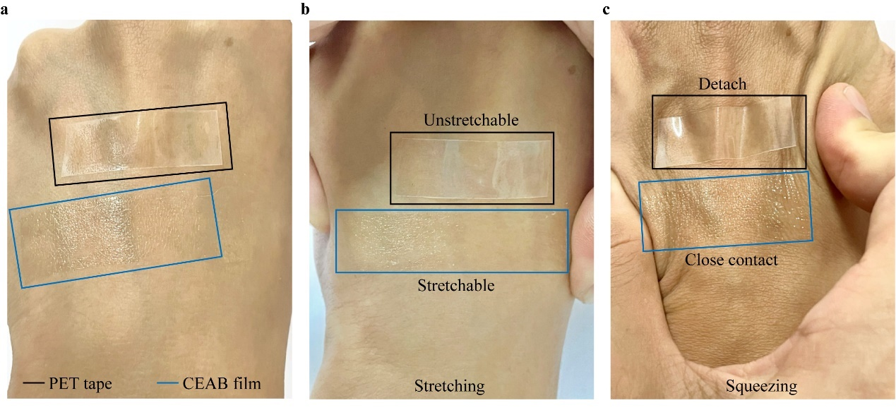
Supplementary Figure 8. Digital images of 50 μm CEAB (blue) film without (a) and under deformation behaviors induced by stretching (b) and squeezing (c) the local skin. A 50 μm PET (black) tape is used as a contrast.
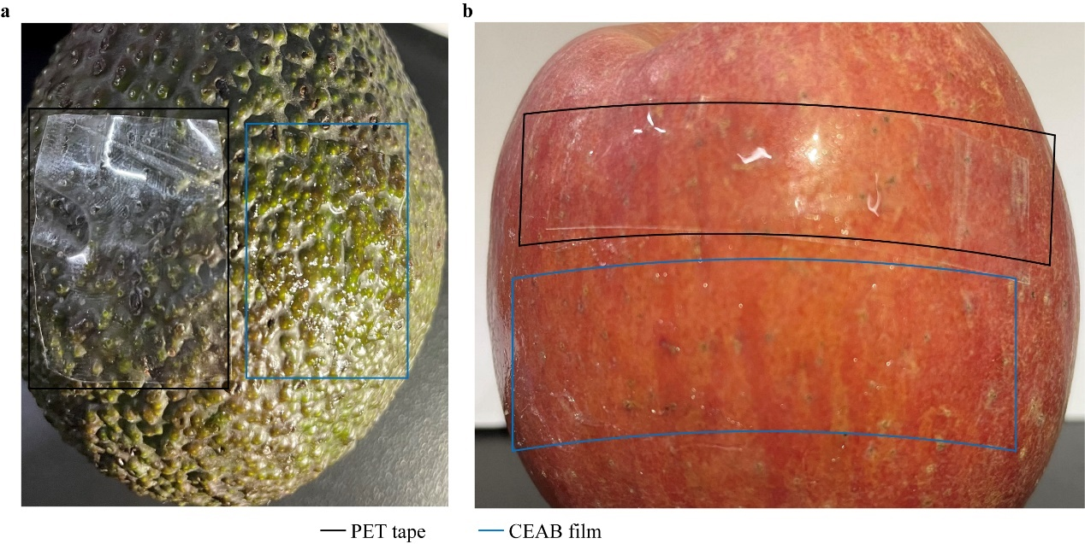
Supplementary Figure 9. Conformal behavior of 50 μm CEAB (blue) film adherent to fruits with different surface roughness. a avocado and b apple. A 50 μm PET (black) tape is used as a contrast.
Supplementary Figure 10. a Impedance change of CEAB electrode attached to the skin for 1 h. b CEAB and Ag/AgCl electrode/skin contact impedance at 10, and 100 Hz respectively.
Supplementary Figure 11 The EMG biopotential of six gestures collected by b CEAB electrodes and a AgCl/Ag gel electrode.
Supplementary Figure 12 Individual feature importance contributing to RF models for depression classification.
Supplementary Figure 13 Statistical histogram by visualizing the relationship of feature values and numbers in terms of the 4 paramount feature types: a attention mean, b origin σ c low γ mean d δ mean.
Supplementary Figure 14 a Loss and b accuracy of training set and test set during the training process of the CNN algorithm for gesture recognition.
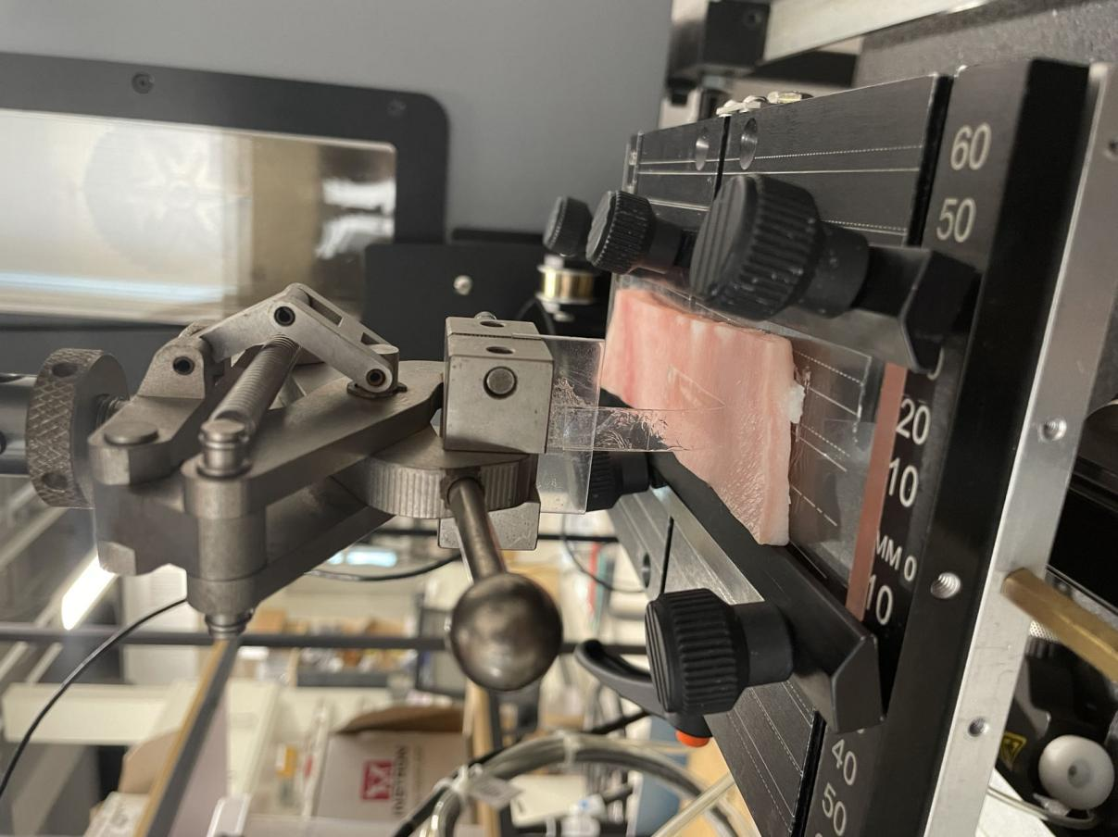
Supplementary Figure 15 A photograph illustrates the configuration employed for the 90-degree peeling test. A 100 μm thick PET is glued on the other surface of the CEAB film to prevent elongation in the peeling direction.

