Going ballistic: a new method for interfacial energy gap determination
Xuehua Zhou^{a*}, Yushu Chenª, Qingxia Liª, Shixing Yangª, Chao Han ^{b,c*}

ª Anhui Province Key Laboratory of Optoelectronic and Magnetism Functional Materials, Key Laboratory of Functional Coordination Compounds of Anhui Higher Education Institutes, School of Chemistry and Chemical Engineering, Anqing Normal University, Anqing 246011, P. R. China.
^{b} The Second Affiliated Hospital of Zhejiang Chinese Medical University, Hangzhou 310000, China.
^{c} Southern Medical University, Guangzhou, 510515, China.
* Corresponding author
E-mail: zhouxuehua_246420@163.com
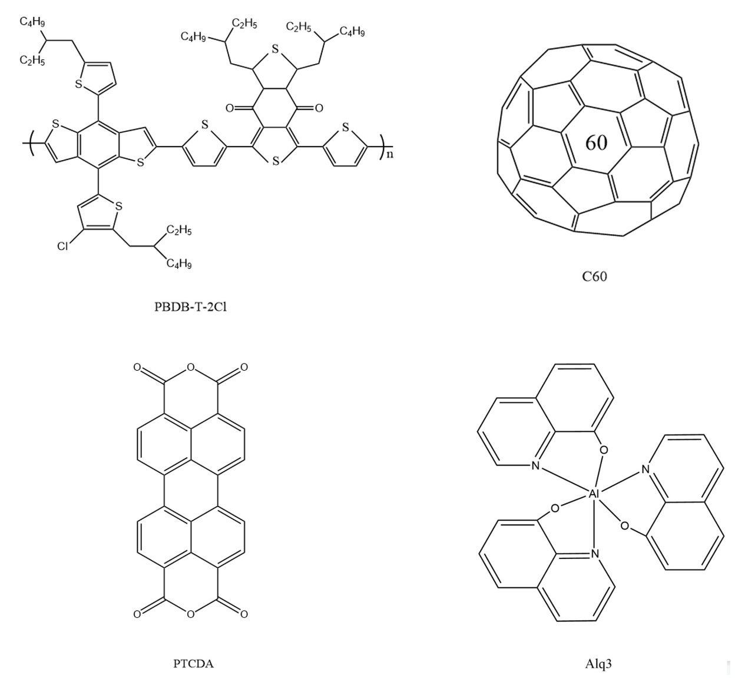 Supplementary Figure 1 Chemical structures of PBDB-T-2Cl, C₆₀, PTCDA and Alq3
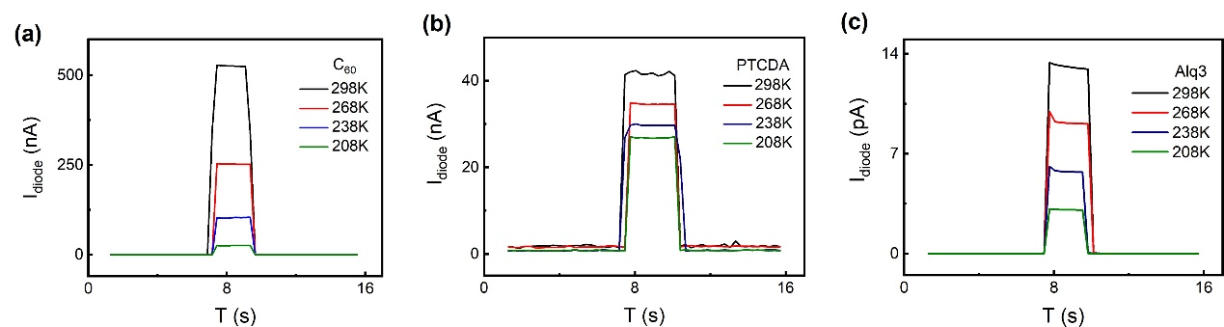
Supplementary Figure 2 Curves of the relationship between photo-response current and time. (a) temperature-dependent I_{diode}-T curves of C₆₀, (b) temperature-dependent I_{diode}-T curves of PTCDA, (c) temperature-dependent I_{diode}-T curves of Alq3

Supplementary Table 1 Measured electrical bandgap of molecular semiconductors in comparison to literature reports.
Molecule | LUMO  (eV) | HOMO  (eV) | Energy gap  (eV) | Error bar (eV) | Reported Value  (eV) | References
PBDB-T-2Cl | −3.58 | -5.58 | 2 | ±0.03 | 1.95~2.02 | [1~3]
C₆₀ | -4.00 | -6.40 | 2.4 | ±0.02 | 1.70~2.40 | [4~6]
PTCDA | -4.47 | -6.69 | 2.22 | ±0.02 | 2.20~2.22 | [7~9]
Alq3 | -3.16 | -5.82 | 2.66 | ±0.03 | 2.5~2.7 | [10~13]

Notes and references
[1] Atxabal, A., Braun, S., Arnold, T., Sun, X., Parui, S., Liu, X., Gozalvez, C., Llopis, R., Mateo-Alonso, A., Casanova, F., Ortmann, F., Fahlman, M. & Hueso, L. E. Energy Level Alignment at Metal/Solution-Processed Organic Semiconductor Interfaces. Adv. Mater. 29, 1606901 (2017)
[2] Lami, V., Hofstetter, Y. J., Butscher, J. F. & Vaynzof, Y. Energy Level Alignment in Ternary Organic Solar Cells. Adv. Electron. Mater. 6, 2000213 (2020)
[3] Zhao, J., Yao, C., Ali, M. U., Miao, J. & Meng, H. Recent advances in high–performance organic solar cells enabled by acceptor–donor–acceptor–donor–acceptor (A–DA’D–A) type acceptors. Mater. Chem. Front. 4, 3487-3504 (2020)
[4] An, N., Cai, Y., Wu, H., Tang, A., Zhang, K., Hao, X., Ma, Z., Guo, Q., Ryu, H. S. Woo, H. Y., Sun, Y. & Zhou, Solution-Processed Organic Solar Cells with High Open-Circuit Voltage of 1.3 V and Low Non-Radiative Voltage Loss of 0.16 VE. Adv. Mater. 32, 2002122 (2020)
[5] Lee, M., Kim, D., Lee, Y. K., Koo, H., Lee, K. T. & Chung, In. Indene-C Bisadduct Electron Transporting Material with the High LUMO Level Enhances Open–Circuit Voltage and Efficiency of Tin-Based Perovskite Solar Cells. ACS Appl. Energy Mater. 3, 6, 5581–5588 (2020)
[6] Zhao, Y., Liu, X., Li, L., Wang, S., Li, Y., Xie, H. & Niu, D. Modification of ultrathin C60 interlayer on electronic structure and molecular packing of C8–BTBT on HOPG. Phys. Chem. Chem. Phys. 22, 25264-25271 (2020)
[7] Atxabal, A., Arnold, T., Parui, S., Zuccatti, E., Cinchetti, M., Casanova, F., Ortmann, Frank. & Hueso, L. E. Molecular spectroscopy in a solid–state device. Mater. Horiz. 6, 1663-1668 (2019)
[8] Martínez, J. I., Abad, E., Flores, F., Ortega, J. & Brocks, G. Barrier height formation for the PTCDA/Au(111) interface. J. Chem. Phys. 390, 14–19 (2011)
[9] Wu, C. I., Hirose, Y., Sirringhaus, H. & Kahn, A. Electron-hole interaction energy in the organic molecular semiconductor PTCDA.Chem. Phys. Lett. 272, 43-47 (1997)
[10] Schlaf, R., Parkinson, B. A., Lee, P. A., Nebesny, K. W. & Armstrong, N. R. HOMO/LUMO Alignment at PTCDA/ZnPc and PTCDA/ClInPc Heterointerfaces Determined by Combined UPS and XPS Measurements. J. Phys. Chem. B. 103, 2984-2992 (1999)
[11] Wang N., Yu J., Zang Y. & Jiang Y. Photocurrent analysis of organic photovoltaic cells based on CuPc/C60 with Alq3 as a buffer layer. Chin. Phys. B. 19, 038602 (2010)
[12] Liu, Z., Tian, M., Wang, N. Influences of Alq3 as electron extraction layer instead of Ca on the photo-stability of organic solar cells. J. Power. Sources. 250,105–109 (2014)
[13] Kao, P., Chu, S., Huang, H., Tseng, Z., & Chen, Y. Improved efficiency of organic photovoltaic cells using tris (8-hydroxy-quinoline) aluminum as a doping material. Thin. Solid. Films. 517, 5301–5304 (2009)

