Carbon Nanotube-Encapsulated Cobalt for High-Efficiency Zinc-Air Flow Battery: Integration of Single Atom Catalysis and Space Confinement
Mufei Liuª, Jinqiao Dong^{b}, Hongxing Dongª, Guiling Wangª, Jing Zhao*^{,a}

ªKey Laboratory of Superlight Materials and Surface Technology of Ministry of Education, College of Materials Science and Chemical Engineering, Harbin Engineering University, Harbin, Heilongjiang 150001, PR China
Mufei Liu, Jing Zhao, Hongxing Dong, & Guiling Wang
^{b}School of Chemistry and Chemical Engineering, Frontiers Science Center for Transformative Molecules and State Key Laboratory of Metal Matrix Composites, Shanghai Jiao Tong University, Shanghai, 200240, China
Jinqiao Dong
Corresponding author
Correspondence to Jing Zhao

Supplementary Figures

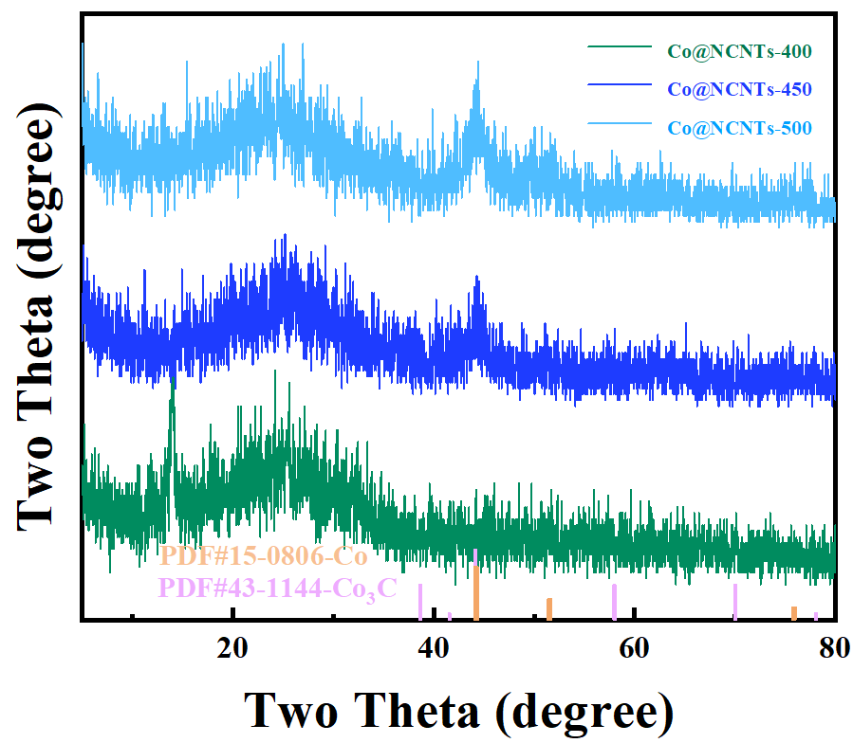
Supplementary Fig. 1. XRD pattern of Co@CoN₃/CNTs-400, Co@CoN₃/CNTs-450, and Co@CoN₃/CNTs-500

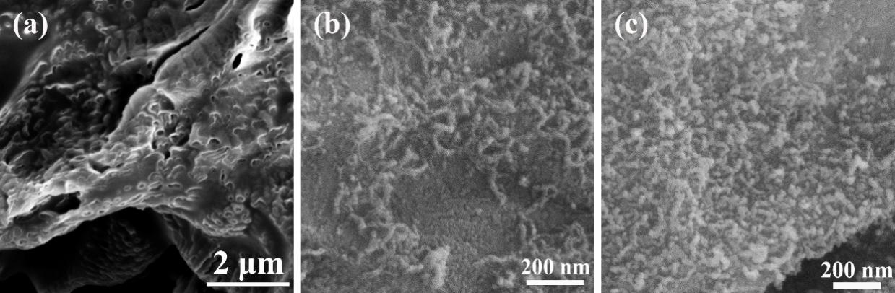
Supplementary Fig. 2. SEM image of (a) Co@CoN₃/CNTs-400, (b) Co@CoN₃/CNTs-450 and (c) Co@CoN₃/CNTs-500

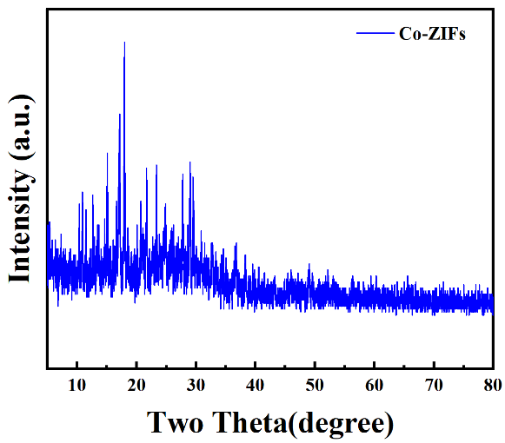
Supplementary Fig. 3. XRD pattern of Co-ZIFs precursor.
Supplementary Fig. 3. presented the XRD patterns of Co@CoN₃/CNTs precursor. It was clearly observed that the diffraction peaks matched well with those of ZIF-67, which showed that the as-prepared pristine Co@CoN₃/CNTs materials has high crystallinity and similar imidazole zeolite skeleton.^{[1, 2]}

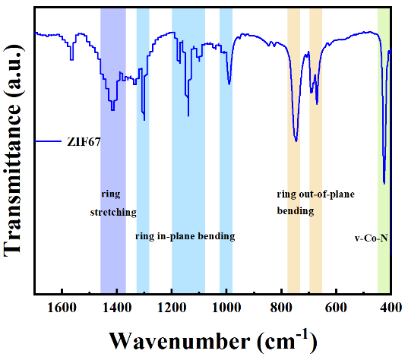
Supplementary Fig. 4. FTIR pattern of Co-ZIFs precursor
As shown in Supplementary Fig. 4, the FT-IR spectrum of Co@CoN₃/CNTs precursor were detected to measure the chemical bonding information. The corresponding ring stretching, ring in plane bending, ring out-of-plane bending and the vibration peaks of Co-N were observed.^{[3]}

Supplementary Fig. 5. SEM image of (a) Co@CoN₃/CNTs-600, (b) Co@CoN₃/CNTs-700, (c) Co@CoN₃/CNTs-900

Supplementary Fig. 6. O elemental mapping of Co@CoN₃/CNTs-800

Supplementary Fig.7. O elemental mapping of Co@CoN₃/CNTs-800A

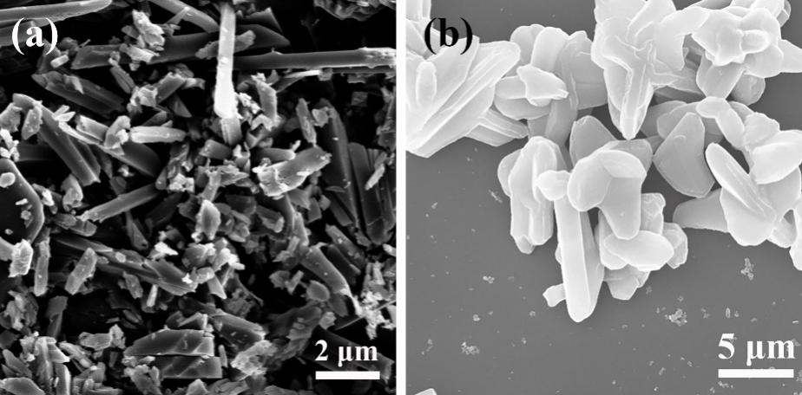
Supplementary Fig. 8. SEM image of (a) Co-ZIFs(1:2) and (b) Co-ZIFs(1:4)

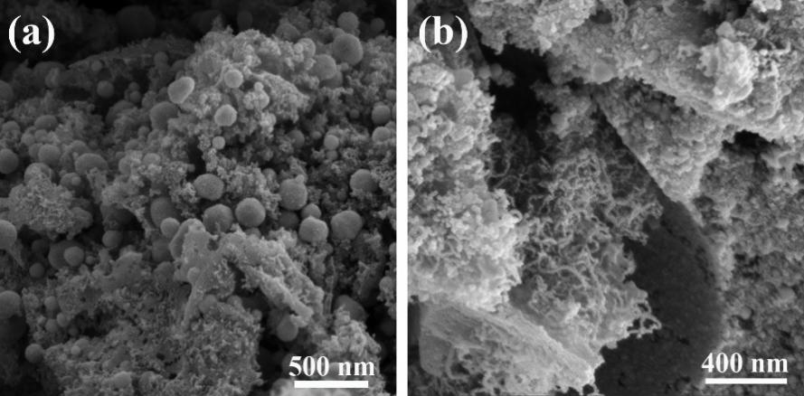
Supplementary Fig. 9. SEM image of (a) Co@CoN₃/CNTs(1:2)-800, and (b) Co@CoN₃/CNTs(1:4)-800.

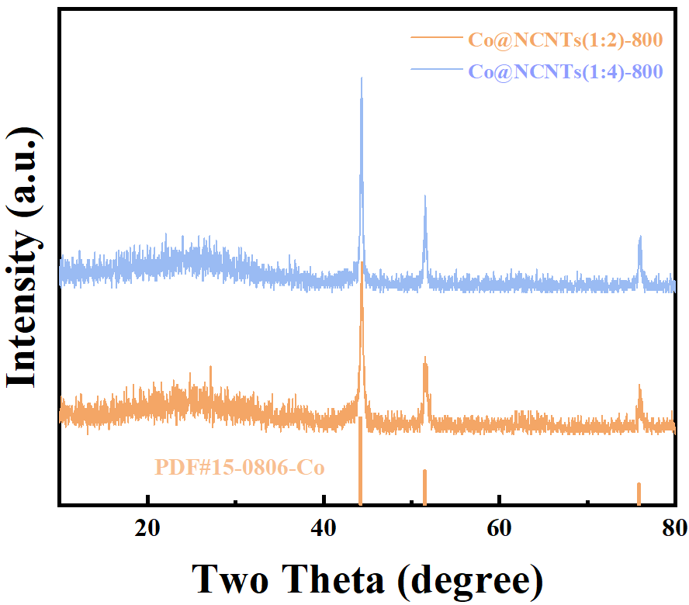
Supplementary Fig. 10. XRD pattern of (a) Co@CoN₃/CNTs(1:2)-800, and (b) Co@CoN₃/CNTs(1:4)-800.

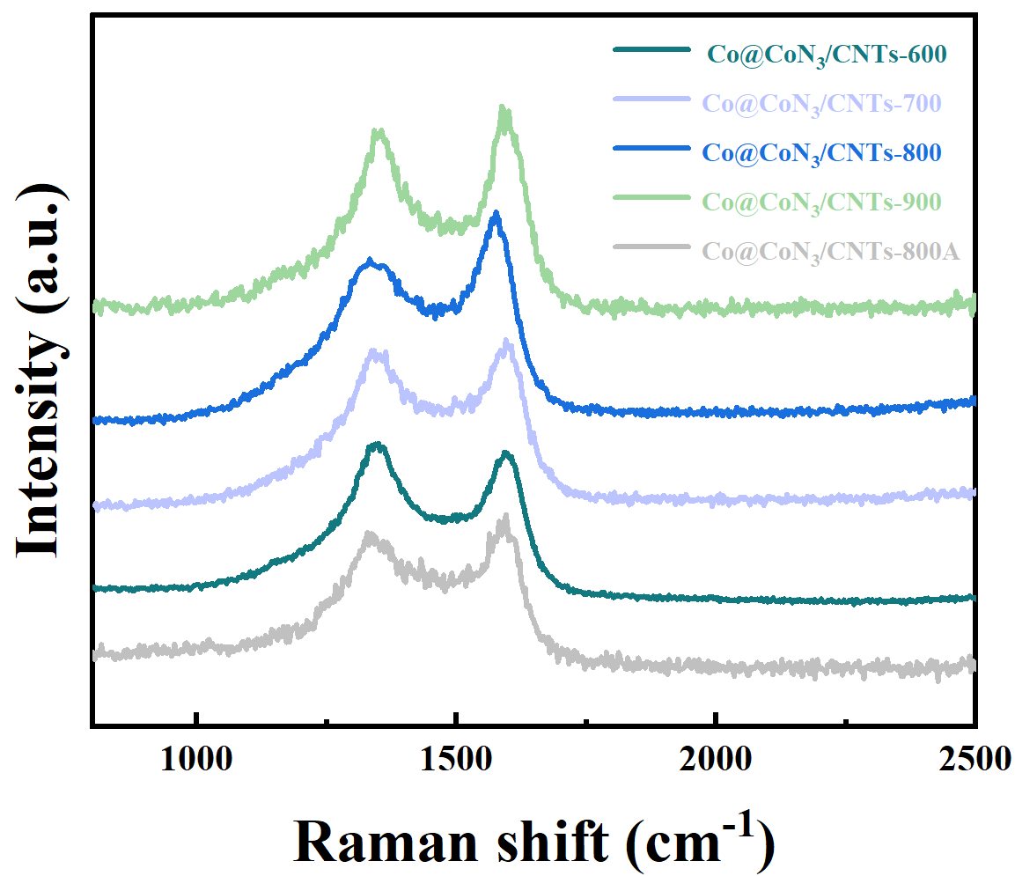
Supplementary Fig. 11. Raman spectrum, of the Co@CoN₃/CNTs-600, Co@CoN₃/CNTs-700, Co@CoN₃/CNTs-800, Co@CoN₃/CNTs-900, and Co@CoN₃/CNTs-800A.

Supplementary Fig. 12. High-resolution XPS spectra of (a) C 1s and (b) O1s of the Co@CoN₃/CNTs-600, Co@CoN₃/CNTs-700, Co@CoN₃/CNTs-800, Co@CoN₃/CNTs-900, and Co@CoN₃/CNTs-800A.

Supplementary Fig. 13. High-resolution XPS spectra of (a) Co 2p, (b) N 1s and (c) C 1s and (d) O1s of the Co@CoN₃/CNTs(1:2)-800, and Co@CoN₃/CNTs(1:4)-800.

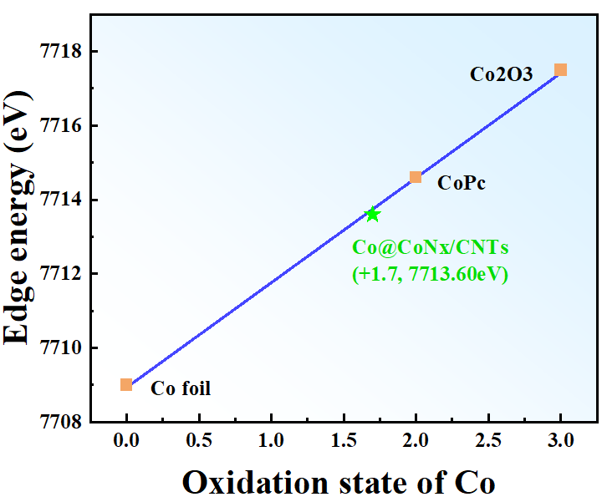
Supplementary Fig. 14. The average oxidation state of Co in Co@CoN₃/CNTs-800.

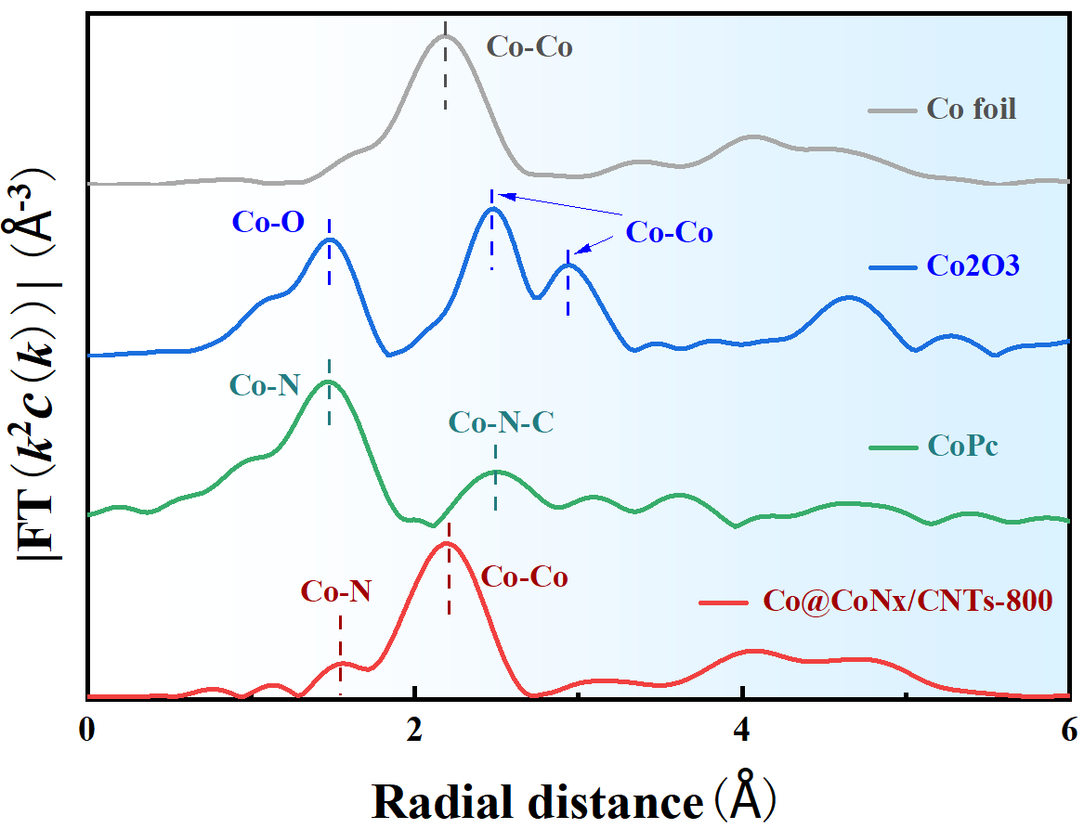
Supplementary Fig. 15. k²-weighted χ(k)-function of Co-EXAFS spectra of Co@CoN₃/CNTs-800, CoPc, Co foil, and Co₂O₃.

Supplementary Fig. 16. (a) LSV curves, (b) corresponding Tafel slopes and (c) corresponding electron-transfer numbers (n) of Co@CoN₃/CNTs-600. (d) LSV curves, (e) corresponding Tafel slopes and (f) corresponding n of Co@CoN₃/CNTs-700. (g) LSV curves, (h) corresponding Tafel slopes and (i) corresponding n of Co@CoN₃/CNTs-900. Rotating speeds from 400 to 2500 rpm; all the samples are tested in O₂-saturated 0.1 M KOH.

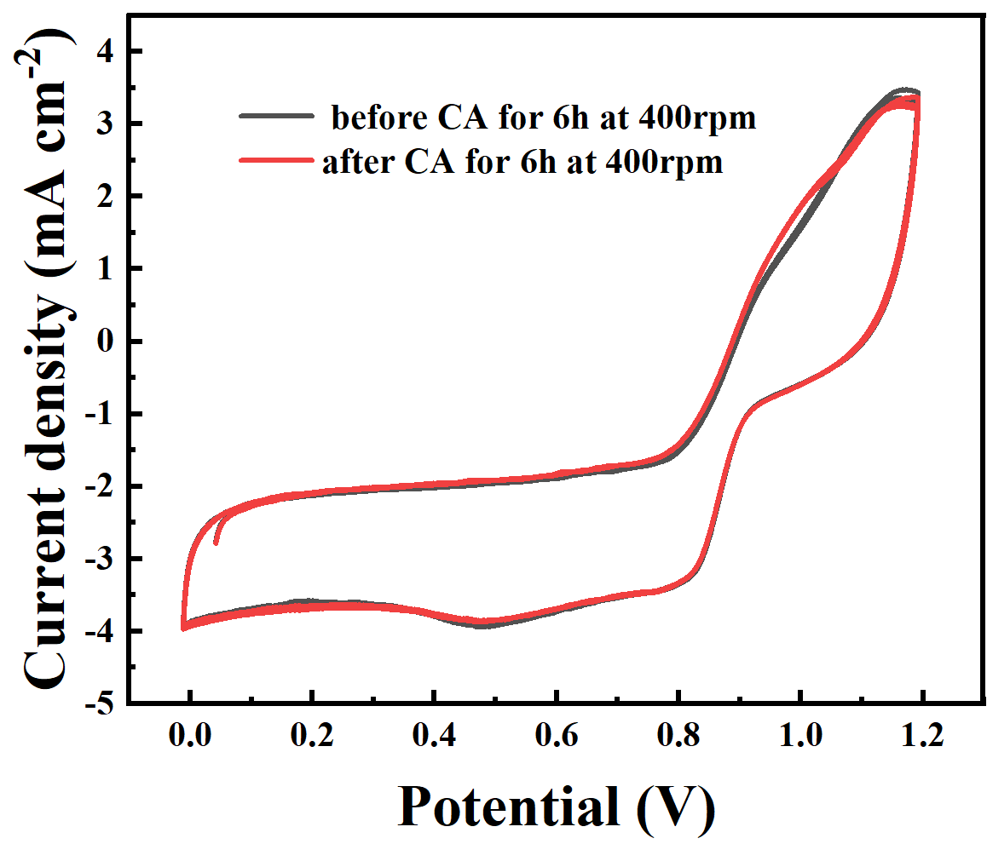
Supplementary Fig. 17. Cyclic stability curve of Co@CoN₃/CNTs-800, a comparison of CV curves of Co@CoN₃/CNTs 800 for ORR at 1600 rpm, CA tests are measured at 400 rpm under 0.7 V vs. RHE for 6h.

Supplementary Fig. 18. ORR performance test after acid treatment of Co@CoN₃/CNTs-800A.

Supplementary Fig. 19. CV curves of (a) Co@CoN₃/CNTs-600, (b) Co@CoN₃/CNTs-700, (c) Co@CoN₃/CNTs-800 and (d) Co@CoN₃/CNTs-900 at different scan rates. The plots of the current density at 1.11 V versus RHE the scan rate to determine the corresponding double layer capacitance (Cdl) of the Co@CoN₃/CNTs.

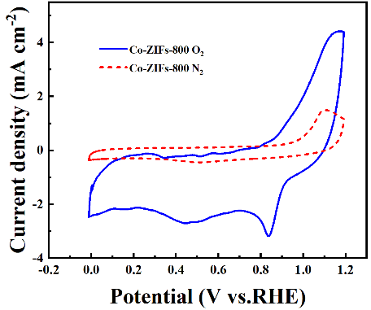
Supplementary Fig. 20. the comparison of CV in O₂ and N₂ of Co@CoN₃/CNTs-800.

Supplementary Fig. 21. ORR performance test of Co@CoN₃/CNTs(1:2)-800.

Supplementary Fig. 22. ORR performance test of Co@CoN₃/CNTs(1:4)-800.

Supplementary Fig. 23. The equivalent circuit was used for modeling the measured electrochemical response. R_{s} is related to solution resistance, R_{ct} stands for interfacial charge transfer, CPE1 represents double-layer capacitance, R_{p} corresponds to the resistance of the electrode inner film and CPE2 is related to the dielectric properties.

Supplementary Tables

Supplementary Table 1. XPS results of samples.
Sample | Co (at.%) | N (at.%) | C (at.%) | O  (at.%)
Co@CoN₃/CNTs-600 | 3.28 | 10.33 | 74.40 | 11.99
Co@CoN₃/CNTs-700 | 3.22 | 6.70 | 79.89 | 10.19
Co@CoN₃/CNTs-800 | 2.61 | 4.16 | 82.23 | 11.00
Co@CoN₃/CNTs-900 | 2.42 | 2.93 | 86.75 | 7.90
Co@CoN₃/CNTs-800A | 1.05 | 6.41 | 87.31 | 5.23
Co@CoN₃/CNTs(1:2)-800 | 2.79 | 4.02 | 80.98 | 12.21
Co@CoN₃/CNTs(1:4)-800 | 2.49 | 4.22 | 82.89 | 10.40

Supplementary Table 2. Relative contents of different N species of the as-prepared samples.
N Species at% | Oxidized N | Graphitic N |  | Pyrrolic N | Co-N₃ | Pyridinic N
Co@CoN₃/CNTs-600 | -- | 10.1 |  | 25.9 | 33.3 | 30.7
Co@CoN₃/CNTs-700 | -- | 16.3 |  | 23.2 | 28.7 | 31.8
Co@CoN₃/CNTs-800 | 22.3 | 34.2 | 9.7 |  | 14.1 | 19.7
Co@CoN₃/CNTs-900 | 27.6 | 35.0 | 7.7 |  | 8.1 | 21.6
Co@CoN₃/CNTs-800A | 9.3 | 22.6 | 25.0 |  | 17.2 | 25.9
Co@CoN₃/CNTs(1:2)-800 | 3.6 | 17.4 | 33.4 |  | 8.1 | 37.5
Co@CoN₃/CNTs(1:4)-800 | 7.4 | 16.1 | 38.1 |  | 6.6 | 31.8

Supplementary Table 3. Co-EXAFS data fitting results of Co@CoN₃/CNTs-800.
Sample | Path | CNª | R(Å)^{b} | σ² (Å²)^{c} | ΔE₀(eV)^{d} | R factor
Co K-edge (Ѕ₀²=0.867)
Co foil | Co-Co | 12* | 2.494 | 0.0073 | 10.8 | 0.0054
CoPc | Co-N | 4.0 | 1.920 | 0.0032 | 9.4 | 0.0020
CoPc | Co-N-C | 6.0 | 2.942 | 0.0092 | 9.7 | 0.0020
Co₂O₃ | Co-O | 6.0 | 1.913 | 0.0032 | -6.6 | 0.0042
Co₂O₃ | Co-Co | 6.0 | 2.860 | 0.0045 | -6.3 | 0.0042
Co₂O₃ | Co-Co | 6.0 | 3.344 | 0.0036 | -6.3 | 0.0042
Co₂O₃ | Co-Co | 4.0 | 3.448 | 0.0064 | -6.3 | 0.0042
Co@CoN₃/CNTs-800 | Co-N | 2.7 | 1.900 | 0.0029 | 4.5 | 0.0033
Co@CoN₃/CNTs-800 | Co-Co | 4.9 | 2.491 | 0.0059 | 9.2 | 0.0033

ªCN, coordination number; ^{b}R, the distance between absorber and backscatter atoms; ^{c}σ², the Debye Waller factor value; ^{d}ΔE₀, inner potential correction to account for the difference in the inner potential between the sample and the reference compound; R factor indicates the goodness of the fit. S0² was fixed to 0.867, according to the experimental EXAFS fit of Co foil by fixing CN as the known crystallographic value. * This value was fixed during EXAFS fitting, based on the known structure of Co foil, CoPc and Co₂O₃. Fitting conditions: k range：2.0 - 12.0; R range: 1.0-3.0; fitting space: R space; k-weight = 3. A reasonable range of EXAFS fitting parameters: 0.800 < Ѕ₀² < 1.000; CN > 0; σ² > 0 Å²; |ΔE₀| < 10 eV; R factor < 0.02.

Supplementary Table 4. Comparison of electrocatalytic ORR of Co@CoN₃/CNTs 800 with other nonnoble metal electrocatalysts.
Sample | E_{1/2}(V) | E₀ (V) | References
Co@CoN₃/CNTs-800 | 0.84 | 0.92 | This work
Co-Co₃O₄@NAC | 0.795 | 0.935 | 4
CoN-HPCNF-900 | 0.81 | 0.84 | 5
MnCoNi-C-D | 0.82 | 0.91 | 6
Ni|MnO/CNF | 0.83 | 0.90 | 7
CoMn₂O₄-S₂ | 0.76 | 0.83 | 8
FeN₄/CN | ~0.9 | 0.835 | 9

Supplementary Table 5. ORR results of samples.

Sample | E_{1/2} (V) | E₀ (V) | J_{k} at 0.80V (mA cm⁻²) | J_{k} at 0.84V (mA cm⁻²)
Co@CoN₃/CNTs 600 | 0.79 | 0.91 | 3.87 | 1.47
Co@CoN₃/CNTs 700 | 0.82 | 0.92 | 7.62 | 2.78
Co@CoN₃/CNTs-800 | 0.84 | 0.92 | 16.35 | 5.24
Co@CoN₃/CNTs 900 | 0.82 | 0.90 | 7.11 | 2.27
Co@CoN₃/CNTs 800A | 0.82 | 0.90 | 7.54 | 1.93
Pt-C | 0.83 | 0.97 | 12.49 | 5.15

Supplementary Table 6. EIS fitting parameters for the Co@CoN₃/CNTs-800 catalyst in 0.1 M KOH at various
Potential (V vs. RHE) | R_{s} (Ω) | R_{ct} (Ω)
1 | 4.33 | 1970
0.9 | 4.24 | 1781
0.8 | 4.03 | 261
0.7 | 4.22 | 432
0.6 | 4.20 | 1231
0.5 | 4.27 | 1489
0.4 | 4.31 | 1542

Supplementary Table 7. Stability of Zn-air batteries between this work and other recently reported results.
Sample | Discharge  time (h) | Current density (mA cm⁻²) | Reference
Co@CoN₃/CNTs-800 | 700 | 5 | This work
CANPc(Fe/Co) | ~100 | 5 | 10
MesoCoNC  @GF | 20 | 5 | 11
Zn/CoN-C | >28 | 5 | 12
O-NGM-800 | 10 | 5 | 13
Co-N, B-CSs | >3 | 10 | 14
2D Fe-N-C | 135 | 5 | 15
Fe  SAs/MC(950) | >100 | 5 | 16
Co/PC | >90 | 100 | 17

Supplementary References

[1] J. Zhou, et al. Boosting Specific Capacity for Supercapattery by In Situ Formation
of Amorphous Ni-Co-Borate on MOF-Derived Ni-Co-LDH Nanosheet Array. ACS
Appl. Energy Mater. 3, 12046-12053 (2020).
[2] G. Wei, et al. Ultrathin Metal-Organic Framework Nanosheet-Derived Ultrathin
Co₃O₄ Nanomeshes with Robust Oxygen-Evolving Performance and Asymmetric
Supercapacitors. ACS Appl. Mater. Interfaces10, 23721-23730 (2018)
[3] Q. Ma, et al. Tuning the Adsorption Selectivity of ZIF-8 by Amorphization.
Chemistry - A European Journal 26, 13137-13141 (2020).
[4] X. Zhong, et al. Co single-atom anchored on Co₃O₄ and nitrogen-doped active
carbon toward bifunctional catalyst for zinc-air batteries. Appl. Catal. B-Environ. 260,
118188 (2020).
[5] Wei Peng, et al. ZIF-67-derived Co nanoparticles anchored in N doped hollow
carbon nanofibers as bifunctional oxygen electrocatalysts. Chem. Eng. J. 407, 127157
(2021).
[6] Xiaorui Wang, et al. Metal-Organic Framework-Derived Trimetallic
Nanocomposites as Efficient Bifunctional Oxygen Catalysts for Zinc-Air Batteries.
ACS Appl. Mater. Interfaces 13, 33209-33217 (2021).
[7] D. Ji, et al. Engineering of the Heterointerface of Porous Carbon Nanofiber-
Supported Nickel and Manganese Oxide Nanoparticle for Highly Efficient Bifunctional
Oxygen Catalysis. Adv. Funct. Mater. 30, 1910568 (2020).
[8] Z. Zhang, et al. S-doped CoMn₂O₄ with more high valence metallic cations and
oxygen defects for zinc-air batteries. J. Power Sources 491, 229584 (2021).
[9] Y.-H. Han, et al. Electronic structure engineering to boost oxygen reduction activity
by controlling the coordination of the central metal. Energy Environ. Sci. 11, 2348-
2352 (2018).
[10] S. Yang, et al. Two-Dimensional Conjugated Aromatic Networks as High-Site-
Density and Single-Atom Electrocatalysts for the Oxygen Reduction Reaction. Angew.
Chem. Int. Edit. 58, 14724-14730 (2019).
[11] S. Li, C. et al. Active Salt/Silica-Templated 2D Mesoporous FeCo-Nx-Carbon as
Bifunctional Oxygen Electrodes for Zinc-Air Batteries. Angew. Chem. Int. Edit. 57,
1856 (2018).
[12] Z. Lu, B. et al. An Isolated Zinc-Cobalt Atomic Pair for Highly Active and Durable
Oxygen Reduction. Angew. Chem. Int. Edit. 58, 262 (2019).
[13] M. Wang, et al. Oxidizing Vacancies in Nitrogen-Doped Carbon Enhance Air-
Cathode Activity. Adv. Mater. 31, 1803339 (2019).
[14] Y. Guo, et al. Carbon Nanosheets Containing Discrete Co-Nx-By-C Active Sites
for Efficient Oxygen Electrocatalysis and Rechargeable Zn-Air Batteries. ACS Nano
12, 1894 (2018).
[15] R. Yuan, et al. Two-Dimensional Hierarchical Fe–N–C Electrocatalyst for Zn-Air
Batteries with Ultrahigh Specific Capacity. ACS Mater. Lett. 2, 35 (2020).
[16] Z. K. Yang, et al. Confined Pyrolysis within a Nanochannel to Form a Highly
Efficient Single Iron Site Catalyst for Zn-Air Batteries. ACS Energy Lett. 3, 2383
(2018).
[17] T. Zhou, et al. Nanopore Confinement of Electrocatalysts Optimizing Triple
Transport for an Ultrahigh-Power-Density Zinc-Air Fuel Cell with Robust Stability.
Adv. Mater. 32, 2003251 (2020).

