SupPlementary material
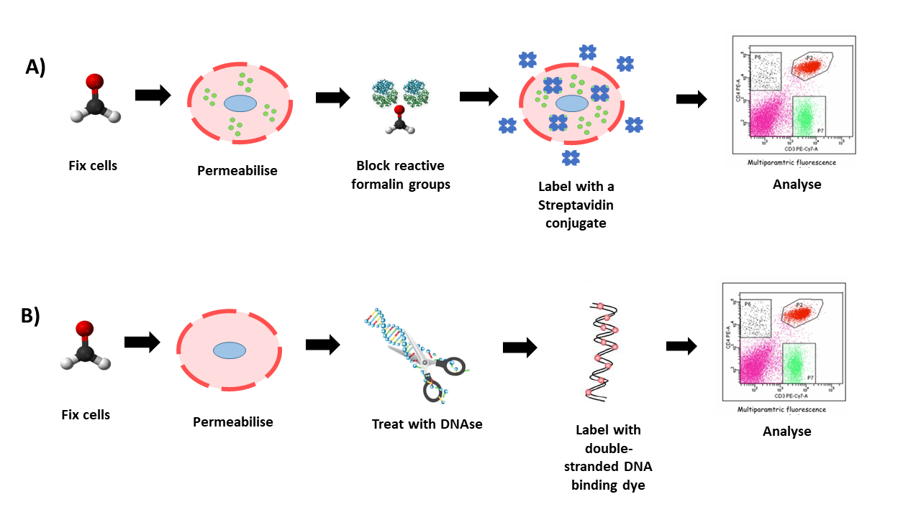

Supplementary Figure 1. Outline of the experimental workflow.
(a) Permeabilisation assay. Cells were fixed in formalin for 24h, after which they were exposed to a permeabilisation agent for 25 min. Reactive formalin groups were blocked with BSA for 30 min. After this the cells were labelled with the SAv conjugate for 30 min. Excess SAv conjugate was washed away and cells analysed by flow cytometry. (b) Nuclease assay. Fixed cells were permeabilised for 25 min, after which they were treated with Benzonase nuclease for 30 min. Cells were labelled with CytoPhase violet for 1 h and analysed by flow cytometry.

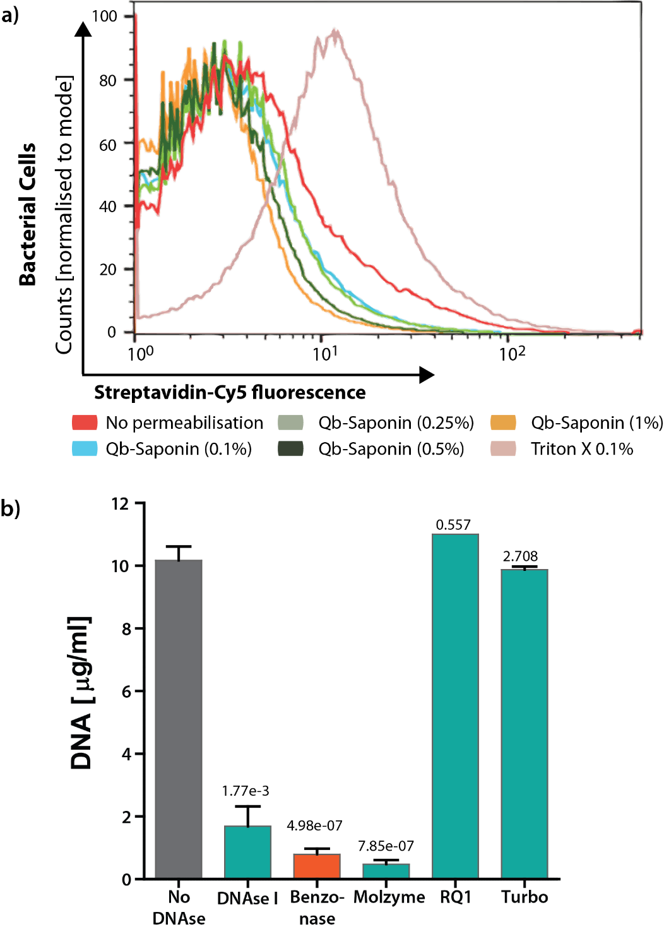
Supplementary Figure 2. Optimising host DNA depletion.
(a) Saponin titration. Histogram for Cy5 fluorescence intensity. E. coli cells were permeabilised with increasing concentrations of Saponin. Saponin treated cells showed no increase in fluorescence intensity even with 10X higher concentrations. (b) DNAse screen. 5 commercially available DNAses were tested for their capacity to deplete DNA from 5 x 10⁶ FF 4T1 cells. Bar plot shows DNA yield after DNA purification. Benzonase was the most cost-effective strategy.

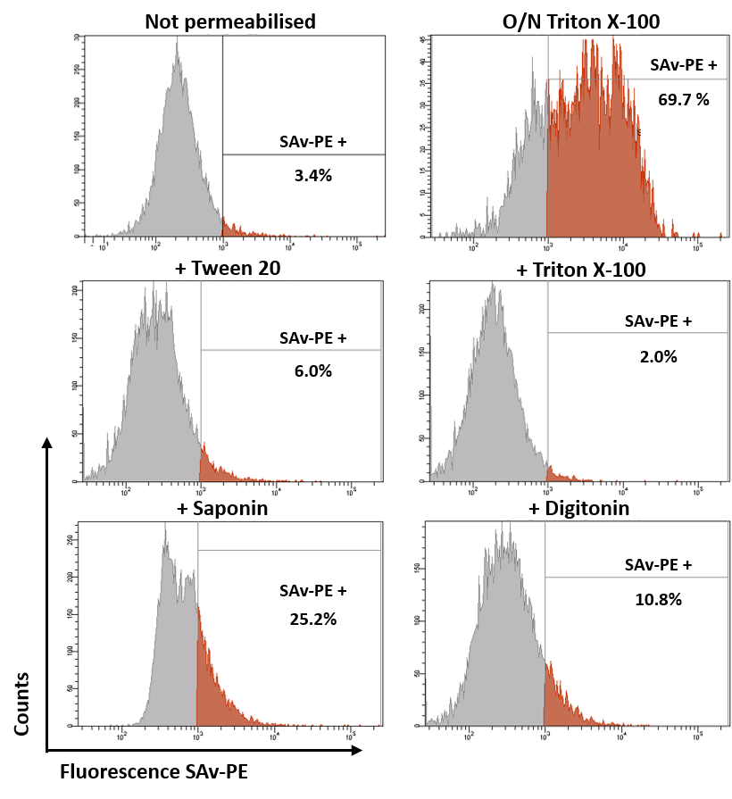
Supplementary Figure 3. Internalisation of a 360KDa molecule. 4T1 cells were permeabilised and labelled with SAv-PE (360 KDa). An overnight incubation with Triton X served as positive control (top right). With all permeabilisation agents tested for SAv-Cy5 (60 KDa) the overall increase in signal for SAv-PE was much lower than that observed for SAv-Cy5. Under the studied conditions (30 min permeabilisation) larger pores are induced by Saponin (25%) and Digitonin (10.8%), while the signal from cells treated with Tween 20 (6%) and Triton X (2%) resembled that of untreated cells (3.4% SAv-PE+).

