Supplementary information for

Demystifying in vivo non-resonant Raman spectroscopy of the human retina

Ryan Sentosa et al.

*Corresponding author. Email: rainer.leitgeb@meduniwien.ac.at

This file includes:

Supplementary Text
Tables. S1 to S3
Figs. S1 to S2

Supplementary Text
Unlike resonant Raman spectroscopy measurement which limits the molecular information to electronic chromophores^{1,2}, we observed rich spectral information in the Raman fingerprint region (400 cm⁻¹ to 1800 cm⁻¹) by using the non-resonant approach. To critically analyze the acquired Raman signal, we compared our observation to the anatomic molecular constituents originated from the measurement location itself. Three different retina layers might contribute to our acquired Raman signal, namely the superficial nerve fiber layer (SNFL), the prelaminar region (PR), and the laminar region (LR)³. The main components of these layers are the axons from the retinal ganglion cells (RGCs) accounting for approximately 90% of the total composition, the glial cells, predominantly astrocytes in the subnuclear layer (SNL) and microglia in the peripheral and lateral (PR/LR) regions, extracellular matrix, comprising collagens and elastin (main components of lamina cribrosa in the LR), glycoproteins, and proteoglycans, and finally blood vessels^{4,5}. Recent ribonucleic acid (RNA) sequencing analysis has also listed the relevant cells that populate this neural retina environment, including glial cells, fibroblasts, endothelial cells, mural cells and immune-related cells⁶. The axons transport molecules between the synapse (RGCs) and its soma (lateral geniculate nucleus)⁷. The main constituents of axons are the cytoskeletal proteins (e.g. microtubules, neurofilaments and actin filaments)^{8–11}, the axonal membrane, mitochondria, transport proteins and neurotransmitters⁴. The astrocytes fasciculate the axons to form nerve fiber bundles, supply glucose to the neural cells and act as a limiting membrane to the surrounding (blood-optic nerve and vitreous)³. To support its role and shape, the astrocytes show an abundance of intermediate proteins, such as green fibrillary acidic protein (GFAP), vimentin and nestin^{12,13}.
Neurofilament proteins (NfP) are the main cytoskeletal proteins of the axons¹⁴. Although they have 5 different forms and lengths in humans, they have a similar backbone, which can be divided into an alpha-helical rod domain, an amino-terminal head domain and a variable-length carboxyl-terminal end domain¹⁵. The distribution of these neurofilaments is heterogeneous along the optic nerve, but dominated by the neurofilament heavy chain (NFH), the phosphorylated NFH (NFHp) and the neurofilament medium chain (NFM)^{14,16}. The tail segment of NFM and NFH is rich in glutamic acid, lysine, alanine, proline and serine^{17,18}.
The lipid distribution on the eye is heterogeneous^{19,20}. In the optic nerve head region, phosphatidylcholine (PC) and sphingomyelin (SM) are abundant, with some contribution of phosphatidylserine (PS) and phosphatidylethanolamine (PE). These phospholipids are the building blocks of the axonal and cell membranes.
Based on this knowledge, we list the tentative assignment of the Raman bands observed from our measurement in the Supplementary Table S1. Briefly, the acquired Raman spectra show a contribution of the major macromolecules, i.e. carbohydrates, proteins, lipids and nucleic acids.

Table S1. Tentative assignment of the observed Raman spectroscopy measurement from human optic nerve head in vivo
Observed  Raman peak | Carbohydrates |  | Protein |  | Lipid |  | DNA/RNA
479 | 484(peak)  (307-596)²¹  518²¹  542²¹ | β(CCO), β(COC), β(OCO) glycogen  β(CCO), β(COC), β(OCO) β-saccharide  β(CCO), β(COC), β(OCO) α-saccharide |  |  | 415²²  429^{22,23} | PI  β(CH₂,ring) cholesterol (+ester)
502(s) | 484(peak)  (307-596)²¹  518²¹  542²¹ |  |  |  |  |  | 500²⁴  504²⁴ | T  G
511 | 484(peak)  (307-596)²¹  518²¹  542²¹ |  | 510^{24,25} | ν(S-S)  cystine (ggg) | 519^{22,26} | δ_{ring} PI
524 | 484(peak)  (307-596)²¹  518²¹  542²¹ |  | 525^{24,25} | ν(S-S)  cystine (ggt or tgg) | 524²² | PS
536 | 484(peak)  (307-596)²¹  518²¹  542²¹ |  | 540^{24,25} | ν(S-S)  cystine (tgt) | 538^{22,26} | β(CH_{2,ring)} cholesterol ester
552 | 484(peak)  (307-596)²¹  518²¹  542²¹ |  |  |  | 548^{22,26} | β(CH_{2,ring)} cholesterol | 549-580²⁶ | A, C, T, G (weak)
575 | 484(peak)  (307-596)²¹  518²¹  542²¹ |  | 578²⁷ | Trp | 576^{22,26} | β(C-OH) PI | 549-580²⁶ | A, C, T, G (weak)
594 | 484(peak)  (307-596)²¹  518²¹  542²¹ |  |  |  | 595²² | PS
603(s) |  |  |  |  | 608^{22,26} | δ_{ring} cholesterol | 599²⁴ | C
618 (sh) |  |  | 621^{27–29} | Phe ring breathing | 614^{22,26} | δ_{ring} cholesterol ester
644 |  |  | 643^{27,28}  630-670²⁴ | Tyr Ring breathing  ν(C-S) gauche Met
664 |  |  | 664^{26,30} | ν(C-S) cysteine
674 |  |  |  |  |  |  | 671²⁴  673²⁴ | T  δ₆,_{ring} G
680 (s) |  |  | 680^{31,32} | Pyrrole ring deformation heme protein
703 |  |  | 700-745²⁴ | ν(C-S) trans Met | 702^{22,23} | δ_{ring} cholesterol (ester)
721 (m) |  |  |  |  | 719^{22,26} | ν_{s}(N⁺(CH₃)₃) PC, SM | 731²⁴ | A
751(w) |  |  | 751(771)^{26,33}  750^{26,32} | Phe ring breathing  Pyrrole ring breathing heme protein | 733^{22,26} | ν(C-N) PS | 745²⁴  752²⁴ | ν(-O-P-O) Z-DNA  T
761 (sh) |  |  | 758^{27,28} | δ_{5,ring} Trp | 759^{22,23} | ν(C-N) ethanolamine PE
776 (m) |  |  |  |  | 776^{22,26} | δ_{inositol} PI
785 (m) |  |  |  |  | 787²² | PS | 784(785, 788)²⁴  790²⁴ | C (U, T)  ν(-O-P-O) B-DNA
804 (sh) |  |  |  |  |  |  | 807²⁴ | ν(-O-P-O) A-DNA
823 |  |  | 817³⁴  817(826)³³  825²⁸ | ν(C-C) protein  Phe  Tyr
834 |  |  |  |  |  |  | 835²⁴ | ν(-O-P-O) B-DNA
849 | 848^{21,22,35,36} | ν(C-C), β(CH) α-saccharide | 847³⁷  848³⁸  850²⁸ | Lys  Ala  Tyr
858 | 856^{21,35} | ν(COC), β(CC), ring breathing, β(CH) of C-1 glycogen | 856^{30,34,39}  856³³ | Pro  Phe | 860²² | phosphatidic acid
874 | 868^{21,22,35,36} | ν(C-C), β(CH) β-saccharide | 877^{26,34,39} | hydroxyproline | 875^{22,26} | ν_{as}(N⁺(CH₃)₃)  PC
881 |  |  | 880²⁷ | Trp | 882^{23,26} | ν_{as}(N⁺(CH₃)₃) SM
889 | 894^{21,22,35,36} | β(CCH), β(CCO) β-saccharide |  |  | 892^{22,23} | ρ(CH₃) and ρ(CH₂) fatty acid
915 (s) | 916^{21,22,35,36} | β(CCH), β(CCO) α-saccharide | 911³⁰  922³³ | Pro  Phe
932 (s, sh) |  |  | 934^{28,29} | N-C_{α}-C (α-helix) skeletal mode
946 | 941^{21,35} | ν_{s}(C-O-C) glycogen of glycosidic bond
956  974  988 | 950-996²⁹ | ν(C-C), ρ(CH₂) skeletal mode | 950-996²⁹ | ν(C-C), ρ(CH₂) skeletal mode | 950-996²⁹ | ν(C-C), ρ(CH₂) skeletal mode | 980²⁴ | monophosphates
1005 |  |  | 1004²⁷ | δ_{ring} Phe
1010 |  |  | 1012²⁷ | δ_{6,ring} Trp
1029 | 1022 (sh)^{21,35} | ν(C-O), ν(C-C) glucose | 1032^{27,33} | β(CH) Phe
1046 | 1050^{21,35} | ν(C-O), ν(C-C) glycogen | 1030-1170²⁹ | ν(C-N), ν(C-C), ρ_{as}(NH₃) amino acids
1061 | 1066^{21,35} | ν(C-O), ν(C-C) glucose | 1030-1170²⁹ | ν(C-N), ν(C-C), ρ_{as}(NH₃) amino acids | 1065^{22,23} | ν_{as}(C-C), ν(C-O)
1080 |  |  | 1030-1170²⁹ | ν(C-N), ν(C-C), ρ_{as}(NH₃) amino acids
1087 | 1088^{21,35} | β(C-OH), β(CH) glycogen | 1030-1170²⁹ | ν(C-N), ν(C-C), ρ_{as}(NH₃) amino acids | 1087²³  1096²² | ν_{s}(C-C) (gauche)  ν(PO₂⁻) | 1095-1099²⁴ | ν_{s}(PO₂⁻)
1134 | 1128^{21,35}  1130^{21,35} | ν(CC), ν(CO), β(COH) glucose  ν(CO), ν(CC), β(COH), ν_{s}(COC) in glycosidic link, ring breathing glycogen | 1030-1170²⁹ | ν(C-N), ν(C-C), ρ_{as}(NH₃) amino acids | 1131^{22,23} | ν_{s}(C-C) fatty acid
1159 |  |  | 1030-1170²⁹ | ν(C-N), ν(C-C), ρ_{as}(NH₃) amino acids
1173 |  |  | 1178^{27,40} | β(CH) Tyr | 1178²³ | ν(C-C) fatty acid
1207 |  |  | 1207^{27,40}  1210^{27,40} | ν(CC), β(CH) Phe  ν(CC), β(CH) Tyr
1245 (s) |  |  | 1225-1247⁴¹  1239-1245⁴²  1254-1262⁴² | β-sheet (amide III)  random coil (amide III) |  |  | 1232 (1242, 1245)²⁴ | U (T, C)
1267 (sh) | 1265^{21,35}  1262^{21,35} | τ(CH₂) saccharides  β(CH), β(CCH), β(OCH), β(COH) Glycogen | 1254-1267^{42,43} | random coil (amide III) | 1270^{22,23,44} | δ(=CH)  unsaturated fatty acid
1288 (sh) |  |  | 1270-1287⁴¹  1293(6)⁴³ | α-helix Protein (amide III)
1295 |  |  | ~1300-1400^{27,29,37,38,45} | ν_{s}(COO-) of base  β(CCH), ρ,τ,ω(CH₂) of side chains | 1298²² | τ(CH₂) fatty acid | 1295²⁴ | C
1310 |  |  | 1291-1324⁴¹ | β-turns  protein (amide III) |  |  | 1309²⁴ | A
1328 | 1333^{21,22}  1337²¹ | ω(CH₂) α-saccharide  β(COH), β(CH)  glycogen | 1340^{26,27} | Fermi resonance Trp |  |  | 1325²⁴  1340²⁴ | G  A
1359 | 1360^{21,22} | ω(CH₂) β-saccharide | 1361^{26,27} | Fermi resonance Trp |  |  | 1367 (1379)²⁴ | G (T)
1396 | 1387²¹ | β(CH₍₂₎) glycogen | ~1300-1400^{27,29,37,38,45} | ν_{s}(COO-) of base  β(CCH), ρ,τ,ω(CH₂) of side chains |  |  | 1380 (1397)²⁴ | A (T)
1451 | 1460^{21,35} | δ(CH₂), β(COH) glycogen  δ(CH₂) glucose | 1420-1452^{22,26} | δ(CH₂) protein | 1420-1470^{22,26,29} | δ_{sc}(CH₂), β(CH₂/CH₃)  phospholipids | 1416(1489)²⁴ | G, A
1502 |  |  | 1495²⁷ | β(CCH) Trp |  |  | 1512²⁴ | A
1549 |  |  | 1552^{26,27}  1558²⁹(1504-1565)⁴⁶ | ν_{5,ring}(C=C) Trp  protein (Amide II) |  |  | 1530²⁴ | C
1579 |  |  | 1579²⁷ | ν_{6,ring}(CC) Trp |  |  | 1578²⁴  1582²⁴ | G  A
1589 |  |  | 1586²⁷ | ν_{ring} (oop) Phe
1606 |  |  | 1604²⁷  1606²⁷ | ν_{as}(COO-) β_{as}(NH₃) Tyr  ν_{ring} (ip) Phe |  |  | 1606²⁴ | C
1620 |  |  | 1616²⁷  1621²⁷  1635^{26,42,47} | ν_{ring}(CC) Tyr  ν_{6,ring}(CC) Trp  β-sheet (Amide I)
1652 |  |  | 1653⁴³  1645-1657²⁴ | ν(C=O), β(NH) α-helix (Amide I) |  |  | 1647²⁴ | C
1660 |  |  | 1660-1665²⁴  1664-1669⁴² | unordered (Amide I)  β-strand (Amide I) | 1660²² | ν(C=C) unsaturated fatty acid | 1664²⁴ | T
1671 |  |  | 1677-1692^{26,42,43}  1640-1690⁴¹ | random coil and β-turns (Amide I)  β-turns (Amide I) | 1669²²  1674²²  1672²² | ν(C=C) cholesterol ester  ν(C=C) cholesterol  ν(C=O), β(N-H) SM
1692 |  |  | 1677-1692^{26,42,43}  1640-1690⁴¹ | random coil and β-turns (Amide I)  β-turns (Amide I) |  |  | 1681²⁴ | U
1710  1719  1734  1743  1750 |  |  |  |  | 1716(1732)²²  1734²²  1738²²  1729(1740)²² | PS  PI  PC  ν(C=O) ester bond

Vibration mode:
β: bending, δ: scissoring, δ_{ring}: ring in plane breathing, ρ: rocking, τ: twisting, ν: stretching, ν_{as}: asymmetric stretching, ν_{s}: symmetric stretching, ν_{(5/6),ring}: (5/6) ring in plane deformation, ω: wagging, ip: in plane, oop: out of plane.
s: strong, sh: shoulder, m: medium, w: weak.

Proteins:
Phe: phenylalanine, Trp: Tryptophan, Tyr: tyrosine, Pro: proline, Lys: lysine, Ala: alanine, Met: methionine, [S-S]: sulphur-sulfur, ggg: gauche gauche gauche, tgt: trans gauche trans. (C in protein column refers to the chemical element Carbon)

Lipids:
PI: phosphatidylinositol, PS: phosphatidylserine, PE: phosphatidylethanolamine, PC: phosphatidylcholine, SM: sphingomyelin.

RNA/DNA:
A: adenine, C: cytosine, T: thymine, G: guanine, U: uracil, [-O-P-O]: phosphodiester backbone, [PO₂⁻]: phosphodioxy group.

Table S2. Raman bands from intra-subject measurement based on Table S1
Statistically significant Raman band (cm⁻¹) | Tentative assignment
559-574 | glucose (sh), glycogen, tryptophan, cholesterol, phosphatidylinositol, nucleoside (w)
646-652 | tyrosine, methionine
937-938 | skeletal mode (carbohydrates, protein, lipids)
1637 | β-sheet of amide I
1643-1645 | α-helix of amide I, cytosine
1675-1678 | β-turn of amide I, cholesterol
1716-1724 | phosphatidylserine

Table S3. Raman bands from different age groups based on Table S1 (*p<0.05, **p<0.01, ***p<0.001, + positive difference, - negative difference)
Statistically significant Raman band (cm⁻¹) |  |  | Tentative assignment | Selected peak position | Spearman correlation coeff. w.r.t. age
(45-65) - <45 | >65 - (45-65) | >65 - <45 | Tentative assignment | Selected peak position | Spearman correlation coeff. w.r.t. age
 | 601-605 + | 595-611 + | PS, cholesterol, C | 603 | r = 0.296***
615-621 + |  |  | Phe, cholesterol ester | 618 | r = 0.136*
 | 657-661 - |  | Met, Cys (sh) | 654 | r = -0.131
753-757 - |  | 746-759 - | Phe, Trp, heme protein, PE, T, OPO Z-DNA | 751 | r = -0.319***
 | 791-810 + | 791-813 + | OPO A-DNA, B-DNA | 804 | r = 0.458***
905-932 + |  | 906-927 + | skeletal mode (carbohydrates, proteins, lipids) | 915 | r = 0.309***
 |  | 946-954 - | skeletal mode (carbohydrates, proteins, lipids) | 946 | r = -0.314***
1048-1075 - | 1058-1071 - | 1049-1084 -  1091-1136 - | skeletal mode (carbohydrates, proteins, lipids) | 1061 | r = -0.425***
1101-1124 - | 1114-1140 - | 1049-1084 -  1091-1136 - | skeletal mode, PO₂⁻ RNA/DNA | 1086 | r = -0.168*
1157-1169 + |  | 1159-1163 + | unassigned
1196-1246 + |  | 1202-1293 + | Phe, Tyr, β-sheet (amide III), U, T, C | 1207  1245 | r = 0.315***  r = 0.274***
1250-1298 + |  | 1202-1293 + | saccharides, α-helix (amide III) un(saturated) fatty acids | 1267  1288 | r = 0.467***  r = 0.322***
1318-1396 - | 1349-1418 + | 1318-1336 -  1370-1376 - | saccharide, glycogen, Trp, G, A, T | 1310  1328  1359  1396 | r = -0.191**  r = -0.335***  r = -0.180**  r = 0.127
1403-1427 - | 1349-1418 + |  | skeletal mode (carbohydrates, proteins, lipids), G | 1451 | r = -0.127
1446-1531 + | 1470-1491 -  1499-1512 - |  | skeletal mode (carbohydrates, proteins, lipids), A  Trp, A | 1502 | r = 0.139*
1613-1678 - |  | 1612-1667 -  1673-1680 - | Tyr, Trp, amide I, unsaturated fatty acids, cholesterol ester, C, T  cholesterol, SM | 1620  1652  1660  1671 | r = 0.321***  r = -0.426***  r = -0.415***  r = -0.340***
1704-1718 + |  |  | PS | 1745 | r = 0.482***
1728-1733 +  1736-1791 + | 1743-1748 + | 1734-1774 + | PS, PI | 1745 | r = 0.482***
1728-1733 +  1736-1791 + | 1743-1748 + | 1734-1774 + | PC, ester bond of lipids | 1745 | r = 0.482***
See the caption below Table S1 for description of the acronyms

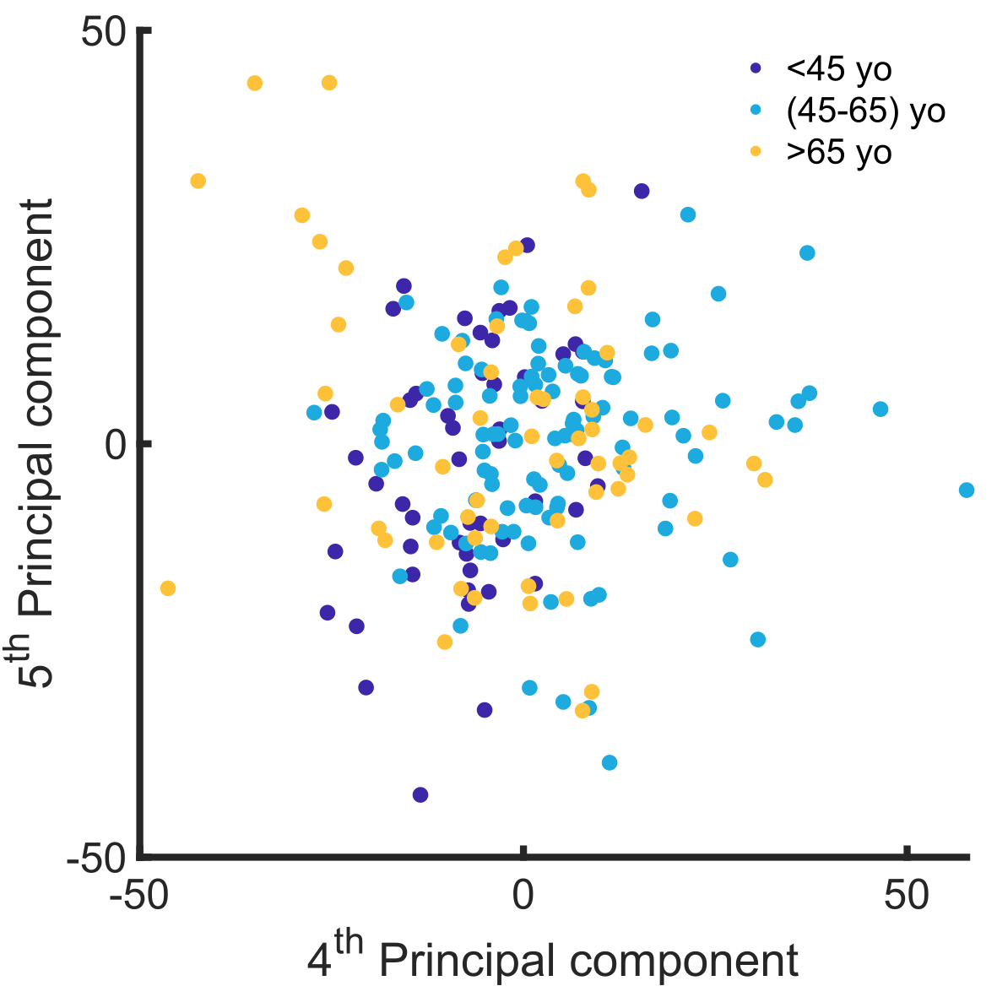

Fig. S1. PCA score plot of the 4th and 5th component. Description can be found in the Results section in the main text.

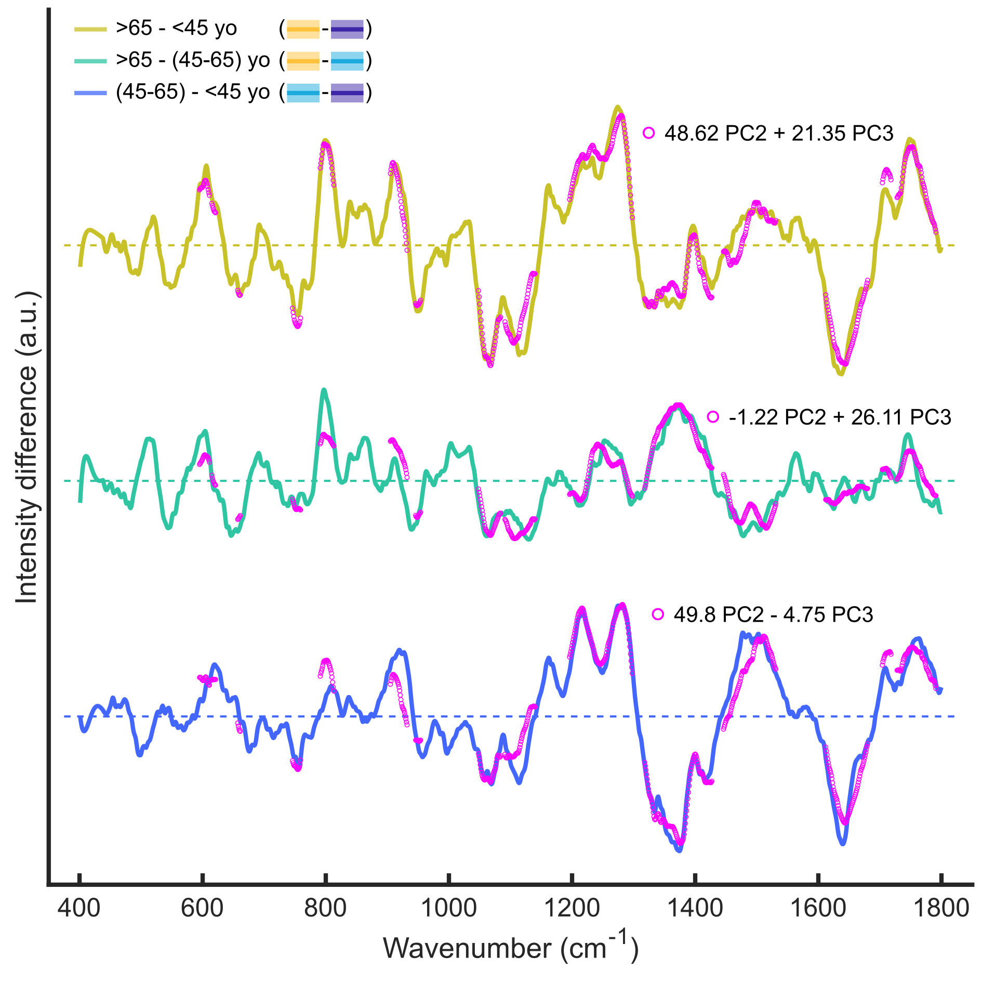

Fig. S2. Intensity difference between each group-pair (<45, (45-65), >65 yo) with the contribution of the 2nd and 3rd principal component. Description can be found in the Results section in the main text.

References

1. Li, B. et al. Imaging lutein and zeaxanthin in the human retina with confocal resonance Raman microscopy. Proc. Natl. Acad. Sci. U.S.A. 117, 12352–12358 (2020).
2. Cakir, B. et al. In vivo noninvasive mitochondrial redox assessment of the optic nerve head to predict disease. PNAS Nexus 2, pgad148 (2023).
3. J. Salazar, J. et al. Anatomy of the Human Optic Nerve: Structure and Function. in Optic Nerve (ed. M. Ferreri, F.) (IntechOpen, 2019). doi:10.5772/intechopen.79827.
4. Rizzo, J. Embryology, anatomy, and physiology of the afferent visual pathway. Clinical Neuro-Ophthalmology 3–82 (2005).
5. Lee, A. G. et al. Anatomy of the Optic Nerve and Visual Pathway. in Nerves and Nerve Injuries 277–303 (Elsevier, 2015). doi:10.1016/B978-0-12-410390-0.00020-2.
6. Monavarfeshani, A. et al. Transcriptomic analysis of the ocular posterior segment completes a cell atlas of the human eye. Proc. Natl. Acad. Sci. U.S.A. 120, e2306153120 (2023).
7. Guedes-Dias, P. & Holzbaur, E. L. F. Axonal transport: Driving synaptic function. Science 366, eaaw9997 (2019).
8. Kirkcaldie, M. T. K. & Collins, J. M. The axon as a physical structure in health and acute trauma. Journal of Chemical Neuroanatomy 76, 9–18 (2016).
9. Leterrier, C., Dubey, P. & Roy, S. The nano-architecture of the axonal cytoskeleton. Nat Rev Neurosci 18, 713–726 (2017).
10. Vassilopoulos, S., Gibaud, S., Jimenez, A., Caillol, G. & Leterrier, C. Ultrastructure of the axonal periodic scaffold reveals a braid-like organization of actin rings. Nat Commun 10, 5803 (2019).
11. Zhang, W. et al. Fano resonance line shapes in the Raman spectra of tubulin and microtubules reveal quantum effects. Biophysical Reports 2, 100043 (2022).
12. Cullen, P. F. & Sun, D. Astrocytes of the eye and optic nerve: heterogeneous populations with unique functions mediate axonal resilience and vulnerability to glaucoma. Front. Ophthalmol. 3, 1217137 (2023).
13. Lopez, N. N., Clark, A. F. & Tovar-Vidales, T. Isolation and characterization of human optic nerve head astrocytes and lamina cribrosa cells. Exp Eye Res 197, 108103 (2020).
14. Kang, M. H., Law-Davis, S., Balaratnasingam, C. & Yu, D.-Y. Sectoral variations in the distribution of axonal cytoskeleton proteins in the human optic nerve head. Experimental Eye Research 128, 141–150 (2014).
15. Yuan, A. & Nixon, R. A. Neurofilament Proteins as Biomarkers to Monitor Neurological Diseases and the Efficacy of Therapies. Front. Neurosci. 15, 689938 (2021).
16. Balaratnasingam, C., Morgan, W. H., Johnstone, V., Cringle, S. J. & Yu, D.-Y. Heterogeneous Distribution of Axonal Cytoskeleton Proteins in the Human Optic Nerve. Investigative Ophthalmology & Visual Science 50, 2824–2838 (2009).
17. Geisler, N., Kaufmann, E., Fischer, S., Plessmann, U. & Weber, K. Neurofilament architecture combines structural principles of intermediate filaments with carboxy-terminal extensions increasing in size between triplet proteins. The EMBO Journal 2, 1295–1302 (1983).
18. Yuan, A., Rao, M. V., Veeranna & Nixon, R. A. Neurofilaments and Neurofilament Proteins in Health and Disease. Cold Spring Harb Perspect Biol 9, a018309 (2017).
19. Zemski Berry, K. A., Gordon, W. C., Murphy, R. C. & Bazan, N. G. Spatial organization of lipids in the human retina and optic nerve by MALDI imaging mass spectrometry. Journal of Lipid Research 55, 504–515 (2014).
20. Anderson, D. M. G. et al. Lipid Landscape of the Human Retina and Supporting Tissues Revealed by High-Resolution Imaging Mass Spectrometry. J. Am. Soc. Mass Spectrom. 31, 2426–2436 (2020).
21. Wiercigroch, E. et al. Raman and infrared spectroscopy of carbohydrates: A review. Spectrochimica Acta Part A: Molecular and Biomolecular Spectroscopy 185, 317–335 (2017).
22. Krafft, C., Neudert, L., Simat, T. & Salzer, R. Near infrared Raman spectra of human brain lipids. Spectrochimica Acta Part A: Molecular and Biomolecular Spectroscopy 61, 1529–1535 (2005).
23. Czamara, K. et al. Raman spectroscopy of lipids: a review. J Raman Spectroscopy 46, 4–20 (2015).
24. Krafft, C. Raman Spectroscopy of Proteins and Nucleic Acids: From Amino Acids and Nucleotides to Large Assemblies. in Encyclopedia of Analytical Chemistry (ed. Meyers, R. A.) 1–15 (Wiley, 2018). doi:10.1002/9780470027318.a9611.
25. Nakamura, K. et al. Conformational changes in seventeen cystine disulfide bridges of bovine serum albumin proved by Raman spectroscopy. FEBS Letters 417, 375–378 (1997).
26. Pezzotti, G. Raman spectroscopy in cell biology and microbiology. J Raman Spectroscopy 52, 2348–2443 (2021).
27. Hernández, B., Pflüger, F., Adenier, A., Kruglik, S. G. & Ghomi, M. Vibrational Analysis of Amino Acids and Short Peptides in Hydrated Media. VIII. Amino Acids with Aromatic Side Chains: l -Phenylalanine, l -Tyrosine, and l -Tryptophan. J. Phys. Chem. B 114, 15319–15330 (2010).
28. Nemecek, D., Stepanek, J. & Thomas, G. J. Raman Spectroscopy of Proteins and Nucleoproteins. CP Protein Science 71, (2013).
29. Talari, A. C. S., Movasaghi, Z., Rehman, S. & Rehman, I. ur. Raman Spectroscopy of Biological Tissues. Applied Spectroscopy Reviews 50, 46–111 (2015).
30. Zhu, G., Zhu, X., Fan, Q. & Wan, X. Raman spectra of amino acids and their aqueous solutions. Spectrochimica Acta Part A: Molecular and Biomolecular Spectroscopy 78, 1187–1195 (2011).
31. Atkins, C. G., Buckley, K., Blades, M. W. & Turner, R. F. B. Raman Spectroscopy of Blood and Blood Components. Appl Spectrosc 71, 767–793 (2017).
32. Rygula, A. et al. Raman spectroscopy of proteins: a review: Raman spectroscopy of proteins. J. Raman Spectrosc. 44, 1061–1076 (2013).
33. Hernández, B., Pflüger, F., Kruglik, S. G. & Ghomi, M. Characteristic Raman lines of phenylalanine analyzed by a multiconformational approach. J Raman Spectroscopy 44, 827–833 (2013).
34. Martinez, M. G., Bullock, A. J., MacNeil, S. & Rehman, I. U. Characterisation of structural changes in collagen with Raman spectroscopy. Applied Spectroscopy Reviews 54, 509–542 (2019).
35. Dudek, M. et al. Raman Optical Activity and Raman spectroscopy of carbohydrates in solution. Spectrochimica Acta Part A: Molecular and Biomolecular Spectroscopy 206, 597–612 (2019).
36. Söderholm, S., Roos, Y. H., Meinander, N. & Hotokka, M. Raman spectra of fructose and glucose in the amorphous and crystalline states. Journal of Raman Spectroscopy 30, 1009–1018 (1999).
37. Hernández, B., Pflüger, F., Derbel, N., De Coninck, J. & Ghomi, M. Vibrational Analysis of Amino Acids and Short Peptides in Hydrated Media. VI. Amino Acids with Positively Charged Side Chains: l -Lysine and l -Arginine. J. Phys. Chem. B 114, 1077–1088 (2010).
38. Hernández, B., Pflüger, F., Nsangou, M. & Ghomi, M. Vibrational Analysis of Amino Acids and Short Peptides in Hydrated Media. IV. Amino Acids with Hydrophobic Side Chains: l -Alanine, l -Valine, and l -Isoleucine. J. Phys. Chem. B 113, 3169–3178 (2009).
39. Bergholt, M. S., Serio, A. & Albro, M. B. Raman Spectroscopy: Guiding Light for the Extracellular Matrix. Front. Bioeng. Biotechnol. 7, 303 (2019).
40. Hernández, B., Coïc, Y., Pflüger, F., Kruglik, S. G. & Ghomi, M. All characteristic Raman markers of tyrosine and tyrosinate originate from phenol ring fundamental vibrations. J Raman Spectroscopy 47, 210–220 (2016).
41. Krimm, S. & Bandekar, J. Vibrational Spectroscopy and Conformation of Peptides, Polypeptides, and Proteins. in Advances in Protein Chemistry vol. 38 181–364 (Elsevier, 1986).
42. Guiffo-Soh, G. et al. Vibrational Analysis of Amino Acids and Short Peptides in Hydrated Media. 3. Successive KL Repeats Induce Highly Stable β-Strands Capable of Forming Non-H-Bonded Aggregates. J. Phys. Chem. B 112, 1282–1289 (2008).
43. Guiffo-Soh, G., Hernández, B., Coïc, Y.-M., Boukhalfa-Heniche, F.-Z. & Ghomi, M. Vibrational Analysis of Amino Acids and Short Peptides in Hydrated Media. II. Role of KLLL Repeats To Induce Helical Conformations in Minimalist LK-Peptides. J. Phys. Chem. B 111, 12563–12572 (2007).
44. Motoyama, M., Nakajima, I., Ohmori, H., Watanabe, G. & Sasaki, K. A Raman Spectroscopic Method of Evaluating Fat Crystalline States and Its Application in Detecting Pork Fat. JARQ 52, 17–22 (2018).
45. Derbel, N. et al. Vibrational Analysis of Amino Acids and Short Peptides in Hydrated Media. I. L-glycine and L-leucine. J. Phys. Chem. B 111, 1470–1477 (2007).
46. Szekeres, G. P. & Kneipp, J. SERS Probing of Proteins in Gold Nanoparticle Agglomerates. Front. Chem. 7, 30 (2019).
47. Voicescu, M., Ionescu, S. & Nistor, C. L. Spectroscopic study of 3-Hydroxyflavone - protein interaction in lipidic bi-layers immobilized on silver nanoparticles. Spectrochimica Acta Part A: Molecular and Biomolecular Spectroscopy 170, 1–8 (2017).

