Nutritional ecology of a prototypical generalist predator, the red fox (Vulpes vulpes)

Balestrieri A.¹, Gigliotti S.^{2,3}, Caniglia R.⁴, Velli E. ⁴, Zambuto F.⁵, De Giorgi E.³, Mucci N.⁴, Tremolada P.¹ and Gazzola A.³

¹Dipartimento di Scienze e Politiche Ambientali, Università di Milano, via Celoria 26, 20133 Milano, Italy.

² Dipartimento di Biologia, Università di Padova, Via Ugo Bassi 58/B, 35131, Padova, Italy.

³ Dipartimento di Scienze della Terra e dell’Ambiente, Università di Pavia, I-27100 Pavia, Italy.

⁴Area per la Genetica della Conservazione, Istituto Superiore per la Protezione e la Ricerca Ambientale (ISPRA), via Ca’ Fornacetta 9, 40064 Ozzano Emilia, Bologna, Italy.

⁵ via R. Normanno 179, 92016 Ribera, Agrigento, Italy.

Table SI1 Variation (chi-squared test) in the frequency of occurrence of the major food items of the red fox in the five study areas (valleys of the rivers CH-Chalamy, CV-Cervo, EL-Elvo, SB-San Barthelemy and NO-Nomenon).
Food items | CH | SB | NO | EL | CV | χ² | P
Fruit | 21.6 | 38.5 | 21.4 | 14.2 | 4.9 | 45.2 | <0.001
Insects | 17.6 | 39.3 | 13.7 | 40.8 | 12.3 | 52.6 | <0.001
Birds | 4.8 | 4.3 | 1.5 | 2.5 | 4.9 | 3.3 | n.s.
Mice | 22.4 | 29.9 | 13.7 | 8.3 | 20.5 | 21.5 | <0.001
Dormice | 2.4 | 0.9 | 0.8 | 0.8 | 5.7 | 6.1 | n.s.
Voles | 12.8 | 21.4 | 7.6 | 48.3 | 40.2 | 80.0 | <0.001
Shrews | 5.6 | 0.0 | 0.8 | 20.8 | 21.3 | 63.6 | <0.001
Ungulates | 39.2 | 15.4 | 65.6 | 9.2 | 21.3 | 12.1 | <0.001

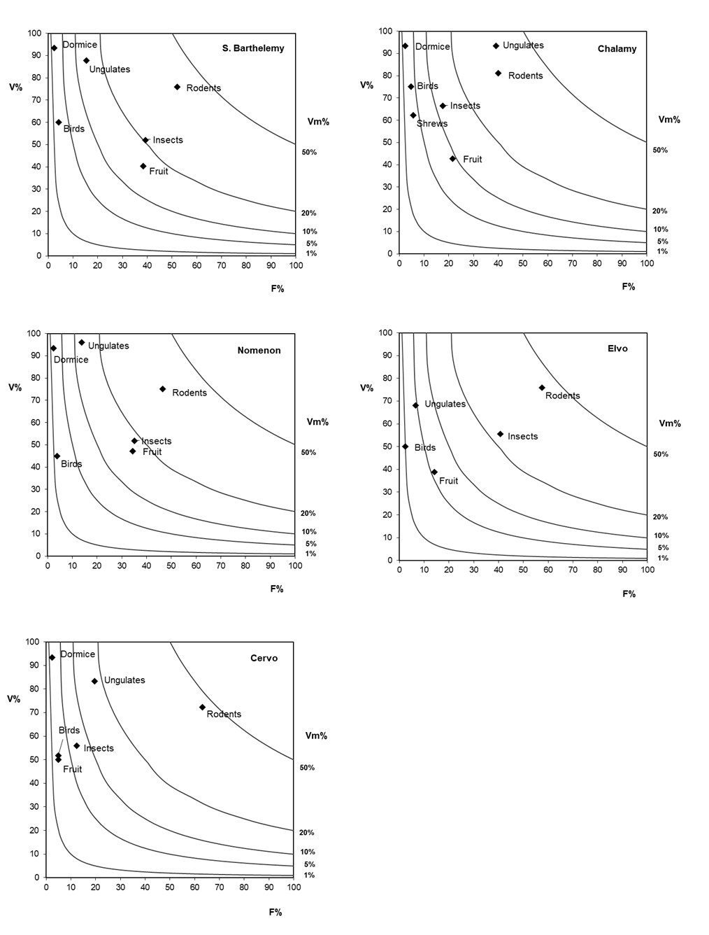
Figure SI1: Estimated volume (%V) of fox main food categories, whenever eaten, vs. their frequency of occurrence (%F) for the five study areas. Isopleths connect points of equal overall mean volume in the diet (Vm%); “Rodents” includes voles and mice.
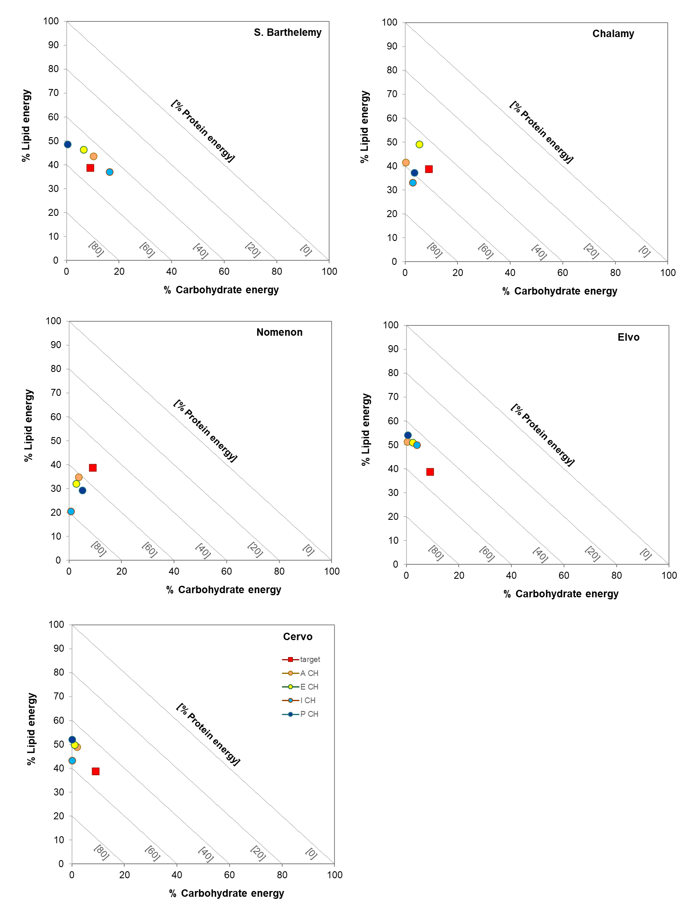
Figure SI2. Right-angles mixture triangles showing the seasonal macronutrient ratios for each study area, with respect to the intake target (as assessed by reviewing available literature data).

